xView2 Building Damage Segmentation
AI for Disaster Response

60.001 Applied Deep Learning, Y2026
Singapore University of Technology and Design

Team Members: [Member names and student IDs]
Dataset: xView2 Tier 3 (Kaggle)
GitHub: [Repository URL]
Model Weights: [Google Drive / Dropbox link]

Submitted: April 17, 2026

1. Introduction

1.1 Problem Statement
When natural disasters strike, rapid assessment of building damage is critical for directing emergency resources. Traditional damage assessment relies on ground surveys that take days to weeks -- time that costs lives. Satellite imagery is available within hours, but manually inspecting thousands of buildings across disaster zones does not scale.
This project develops a deep learning model for automated building damage segmentation from pre- and post-disaster satellite imagery. Given a pair of satellite images (before and after a disaster), the model produces a pixel-level damage map classifying every building into one of four damage levels: No Damage, Minor Damage, Major Damage, and Destroyed.

1.2 Objectives
- Design and implement a Siamese U-Net architecture for change-detection-based damage segmentation
- Systematically improve model performance through iterative experimentation -- training strategy, regularisation, backbone scaling, and loss function design
- Evaluate against the xView2 competition benchmark and analyse failure modes
- Deliver a reproducible, well-documented codebase with saved model weights

1.3 Scope and Constraints
- Dataset: xView2 Tier 3 (~2,200 image pairs), a subset of the full xBD dataset (~22,000 pairs)
- Compute: Single GPU training (Kaggle P100 / SUTD AI Cluster). GPU quota limitations and cluster downtime affected our final experiment.
- Architecture: Single-model inference (no ensembling), practical for real deployment
- Classes: 5-class segmentation -- Background (0), No Damage (1), Minor Damage (2), Major Damage (3), Destroyed (4)

1.4 Social Impact
Automated damage assessment directly supports humanitarian response. It reduces assessment time from days to minutes, can process entire cities simultaneously, and provides consistent classification across analysts. Organisations like the UN, Red Cross, and FEMA have identified automated satellite damage assessment as a priority capability for disaster response.

2. Dataset

2.1 Source
The xView2 dataset was created by the Defense Innovation Unit (DIU) for the xView2 Building Damage Assessment Challenge. It contains WorldView-3 satellite imagery (1.4 m GSD) across multiple disaster types: earthquakes, hurricanes, wildfires, volcanic eruptions, and floods.

2.2 Structure
Property | Value
Image pairs | ~2,200 (pre + post disaster)
Original resolution | 1024 x 1024 px
Training resolution | 512 x 512 px (resized)
Annotation format | GeoJSON polygons per building
Split | 80% train / 10% val / 10% test
Random seed | 42 (deterministic split)

2.3 Class Distribution
The dataset exhibits extreme class imbalance, which is the central challenge of this task. Background pixels constitute approximately 97% of all pixels. The four damage classes share the remaining ~3%, with Minor Damage being the rarest at only 0.3% of pixels.
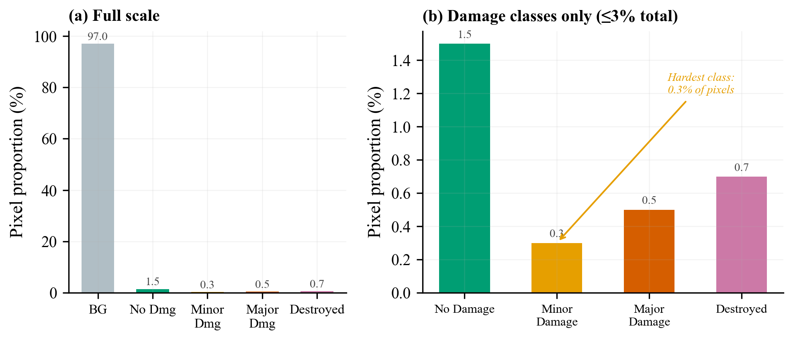
Figure 1: xView2 Tier 3 class distribution. Left: full scale showing background dominance. Right: zoomed view of damage classes. Minor Damage (0.3%) is the hardest class to detect.

This imbalance means a model predicting 'background' everywhere achieves 97% pixel accuracy while being completely useless for damage assessment. This motivated our adoption of Damage Macro F1 (macro average of F1 for damage classes 1-4, excluding background) as the primary evaluation metric from Experiment 3 onward.

2.4 Preprocessing and Augmentation
Polygon annotations were rasterised to per-pixel masks using Shapely and scikit-image. Images were resized from 1024x1024 to 512x512 via bilinear interpolation. ImageNet normalisation was applied (mean=[0.485, 0.456, 0.406], std=[0.229, 0.224, 0.225]).
Data augmentation (final configuration, Exp 5):
Augmentation | Probability | Purpose
Horizontal flip | 0.5 | Orientation invariance
Vertical flip | 0.2 | Orientation invariance
Random 90-degree rotation | 0.5 | Rotation invariance
Brightness/Contrast jitter | +/-0.15 | Lighting robustness
Saturation jitter | +/-0.10 | Colour robustness
Gaussian blur | 0.15 | Resolution robustness
Gaussian noise | 0.15 | Sensor noise robustness

3. Method

3.1 Architecture: Siamese ResNet U-Net
The model follows a Siamese encoder -- fusion -- decoder paradigm designed for change detection in satellite imagery. A shared ResNet backbone extracts hierarchical features from both the pre- and post-disaster images. At each encoder level, a FusionBlock combines the two feature maps with an explicit change signal. A U-Net decoder then reconstructs the full-resolution 5-class damage segmentation map.
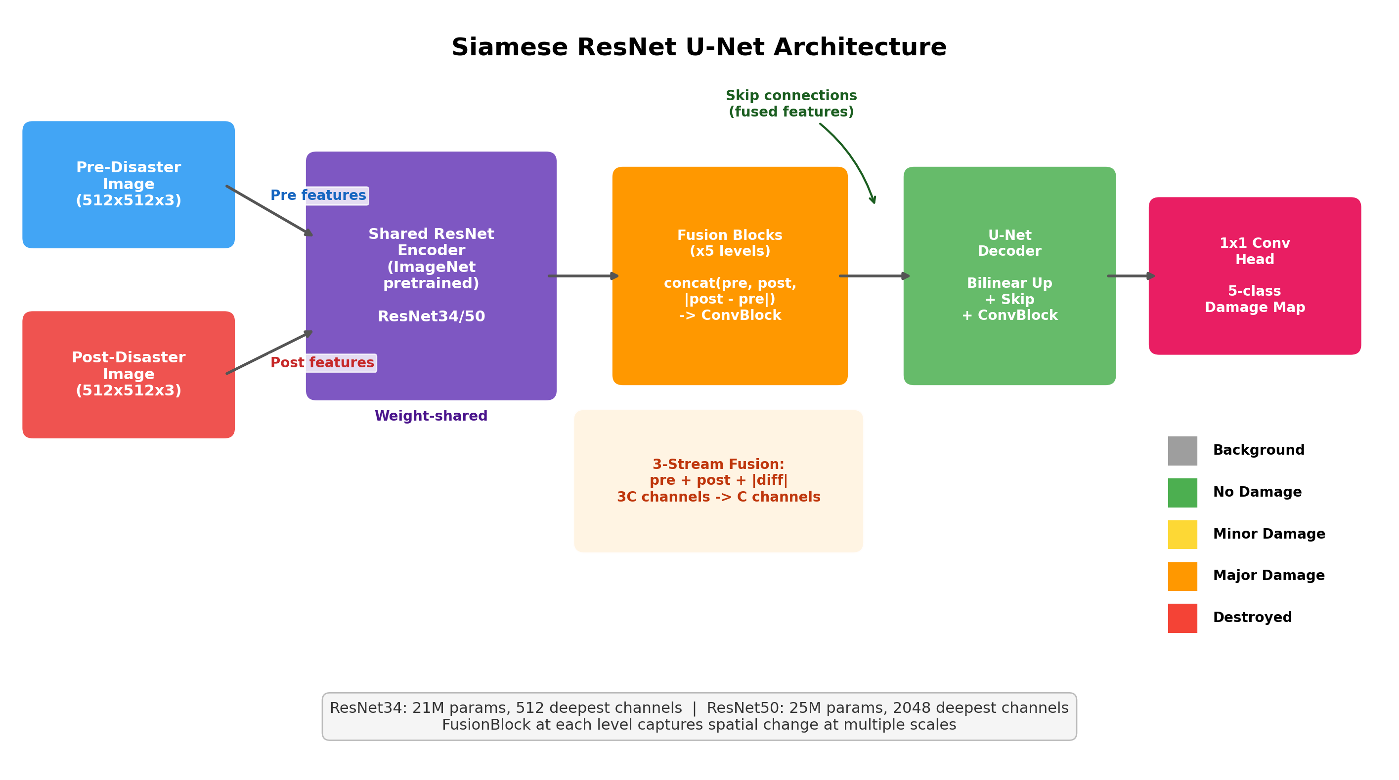
Figure 2: Siamese ResNet U-Net architecture. Pre- and post-disaster images are processed by a shared ResNet encoder. FusionBlocks at each level combine features via 3-stream fusion (pre + post + |diff|). A U-Net decoder with skip connections produces the 5-class damage map.

Shared Encoder: A pretrained ResNet backbone (ImageNet weights) extracts hierarchical features from both images. Weight sharing ensures the same feature space for both temporal views.
Backbone | Parameters | Deepest Channels | Block Type
ResNet34 | 21M | 512 | BasicBlock
ResNet50 | 25M | 2048 | Bottleneck (4x wider)

Fusion Blocks: At each encoder level, a FusionBlock combines pre- and post-disaster features using three-stream fusion: concat(pre_feat, post_feat, |post_feat - pre_feat|). The absolute difference explicitly encodes change magnitude. The concatenated 3C-channel tensor is compressed to C channels by a ConvBlock.
U-Net Decoder: Standard U-Net decoder with skip connections from fused features. Each DecoderBlock: bilinear upsample -> concatenate skip -> ConvBlock. A 1x1 convolution produces the 5-class output.

3.2 Loss Function
Our loss function evolved across experiments. The final configuration (Exp 5) uses:
L = Focal Loss(pred, target, class_weights, gamma=2) + Dice Loss(pred, target)
Component | Purpose
Focal Loss (gamma=2) | Downweights easy background pixels; focuses on hard boundaries
Dice Loss | Region-level overlap; inherently handles class imbalance
Log-inverse class weights | Upweights rare damage classes (clipped to [1, 20])
Label smoothing (0.05) | Prevents overconfident predictions on easy pixels

3.3 Two-Phase Training Strategy
A key contribution of this project is the two-phase training strategy, developed in Exp 3 after observing severe overfitting in Exp 2.
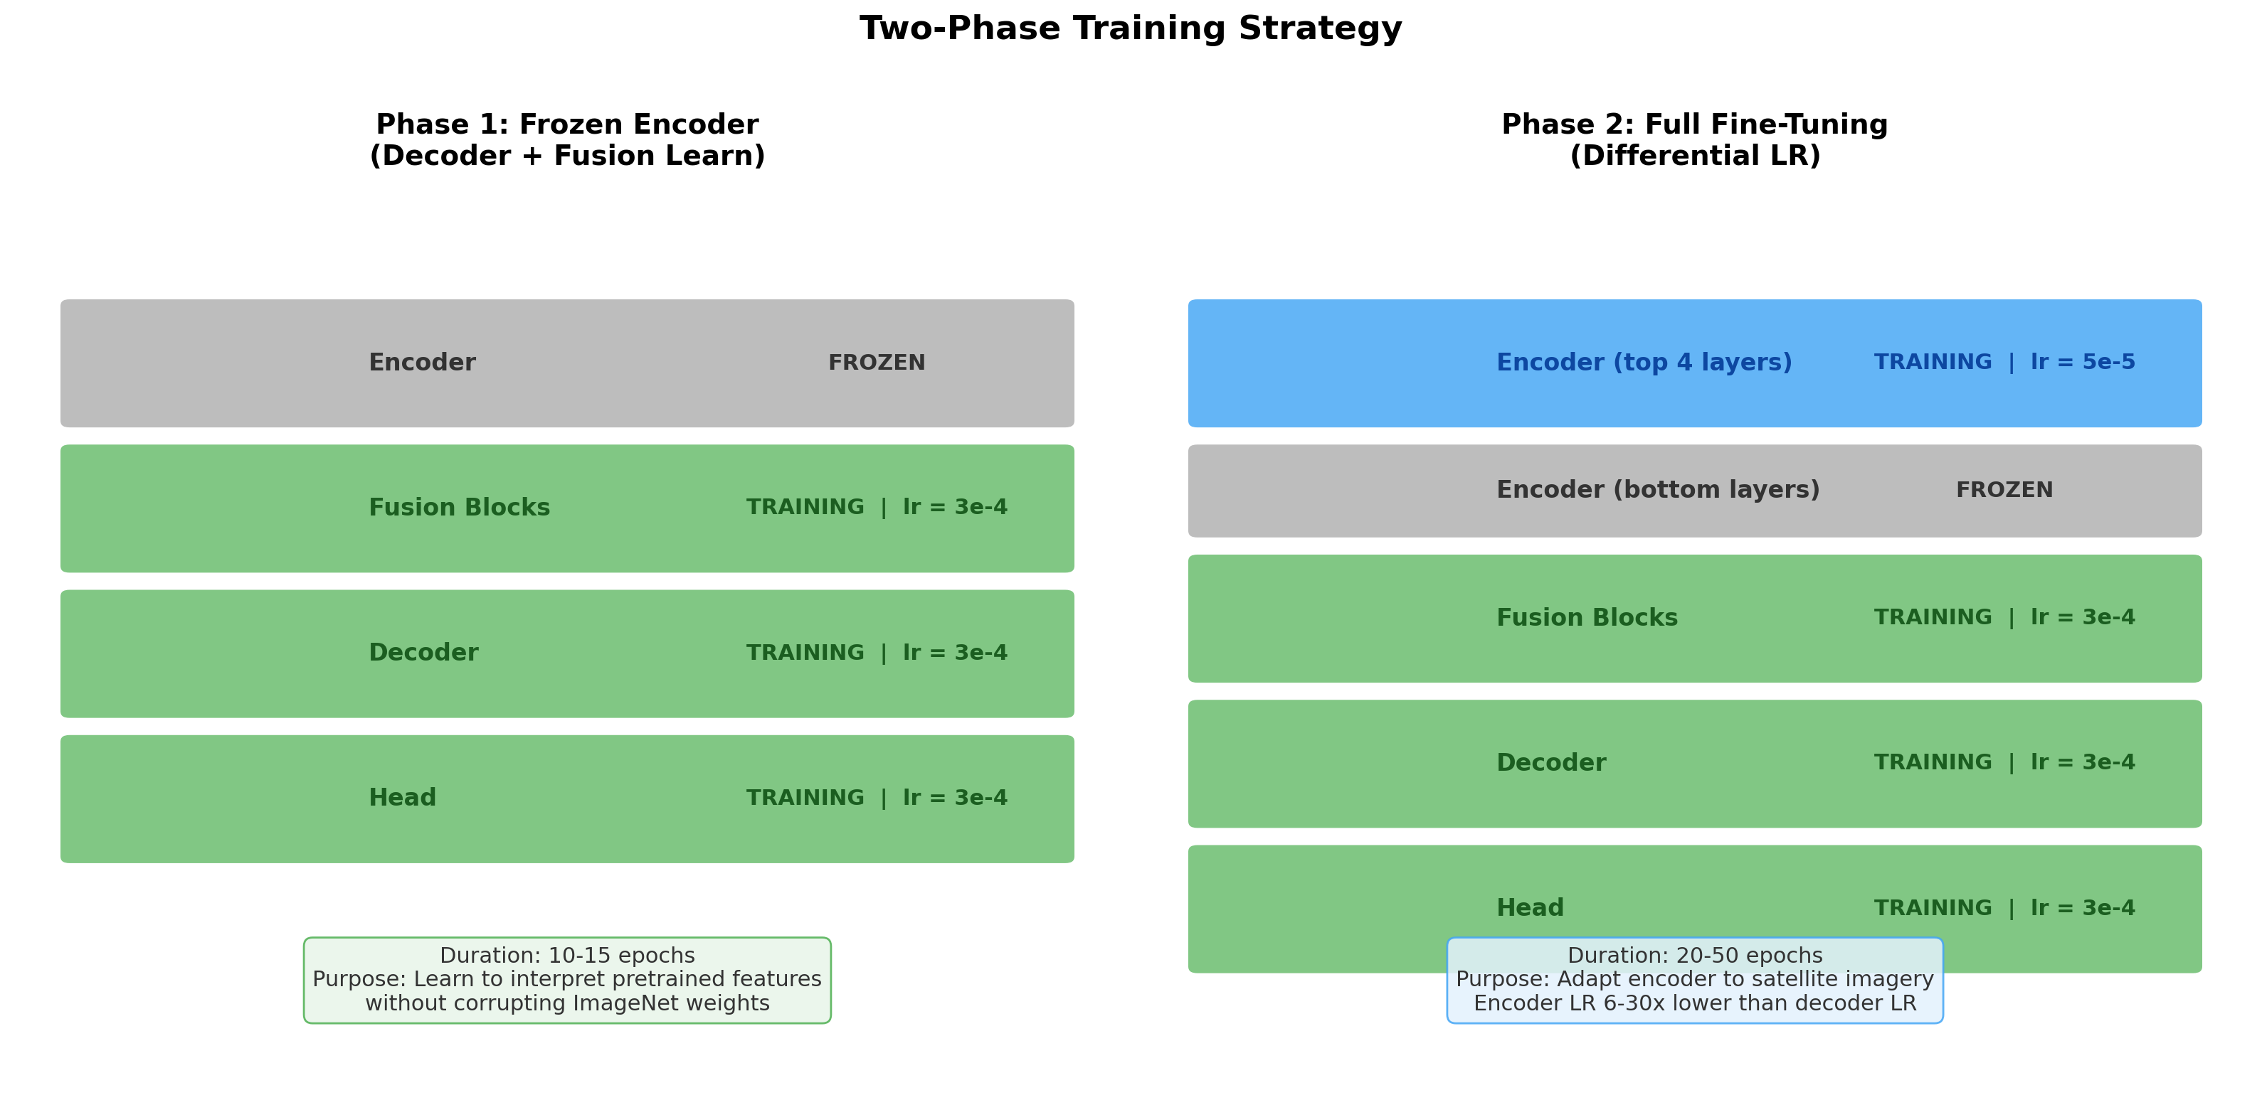
Figure 3: Two-phase training strategy. Phase 1 freezes the encoder so the decoder and fusion blocks learn to interpret pretrained features. Phase 2 unfreezes encoder layers with a lower learning rate for domain-specific adaptation.

Phase 1 (Frozen Encoder): Encoder weights frozen; only decoder and fusion blocks train at lr=3e-4. Duration: 10-15 epochs.
Phase 2 (Full Fine-Tuning): Top N encoder layers unfrozen with differential LR 6-30x lower than decoder. Allows task-specific adaptation to satellite imagery.
Parameter | Exp 3 | Exp 4 | Exp 5
Freeze epochs | 15 | 15 | 10
Unfrozen layers | All | 2 | 4
Encoder LR | 1e-5 | 1e-5 | 5e-5

3.4 Optimisation Details
Parameter | Value
Optimiser | AdamW
Decoder LR | 3e-4
Encoder LR (Phase 2) | 1e-5 to 5e-5 (tuned per experiment)
Weight decay | 0.05
Gradient clipping | 1.0 (max norm)
Batch size | 8-16 (final config)
Gradient accumulation | 4-8 steps (effective batch 32-64)
Mixed precision | FP16 (torch.cuda.amp)
Scheduler | CosineAnnealingLR (min_lr=1e-6)
Early stopping | Patience=15 on val damage F1

4. Experiments
We conducted 5 experiments, each building on the previous. This iterative approach allowed us to isolate the impact of individual changes and understand what drives performance. Each experiment was motivated by a specific observation or failure from the previous one.
The figure below shows model predictions across four disaster types for three key experiments. The visual progression from near-blank predictions in Exp 1 to structured damage maps in Exp 5 mirrors the quantitative improvements reported below.
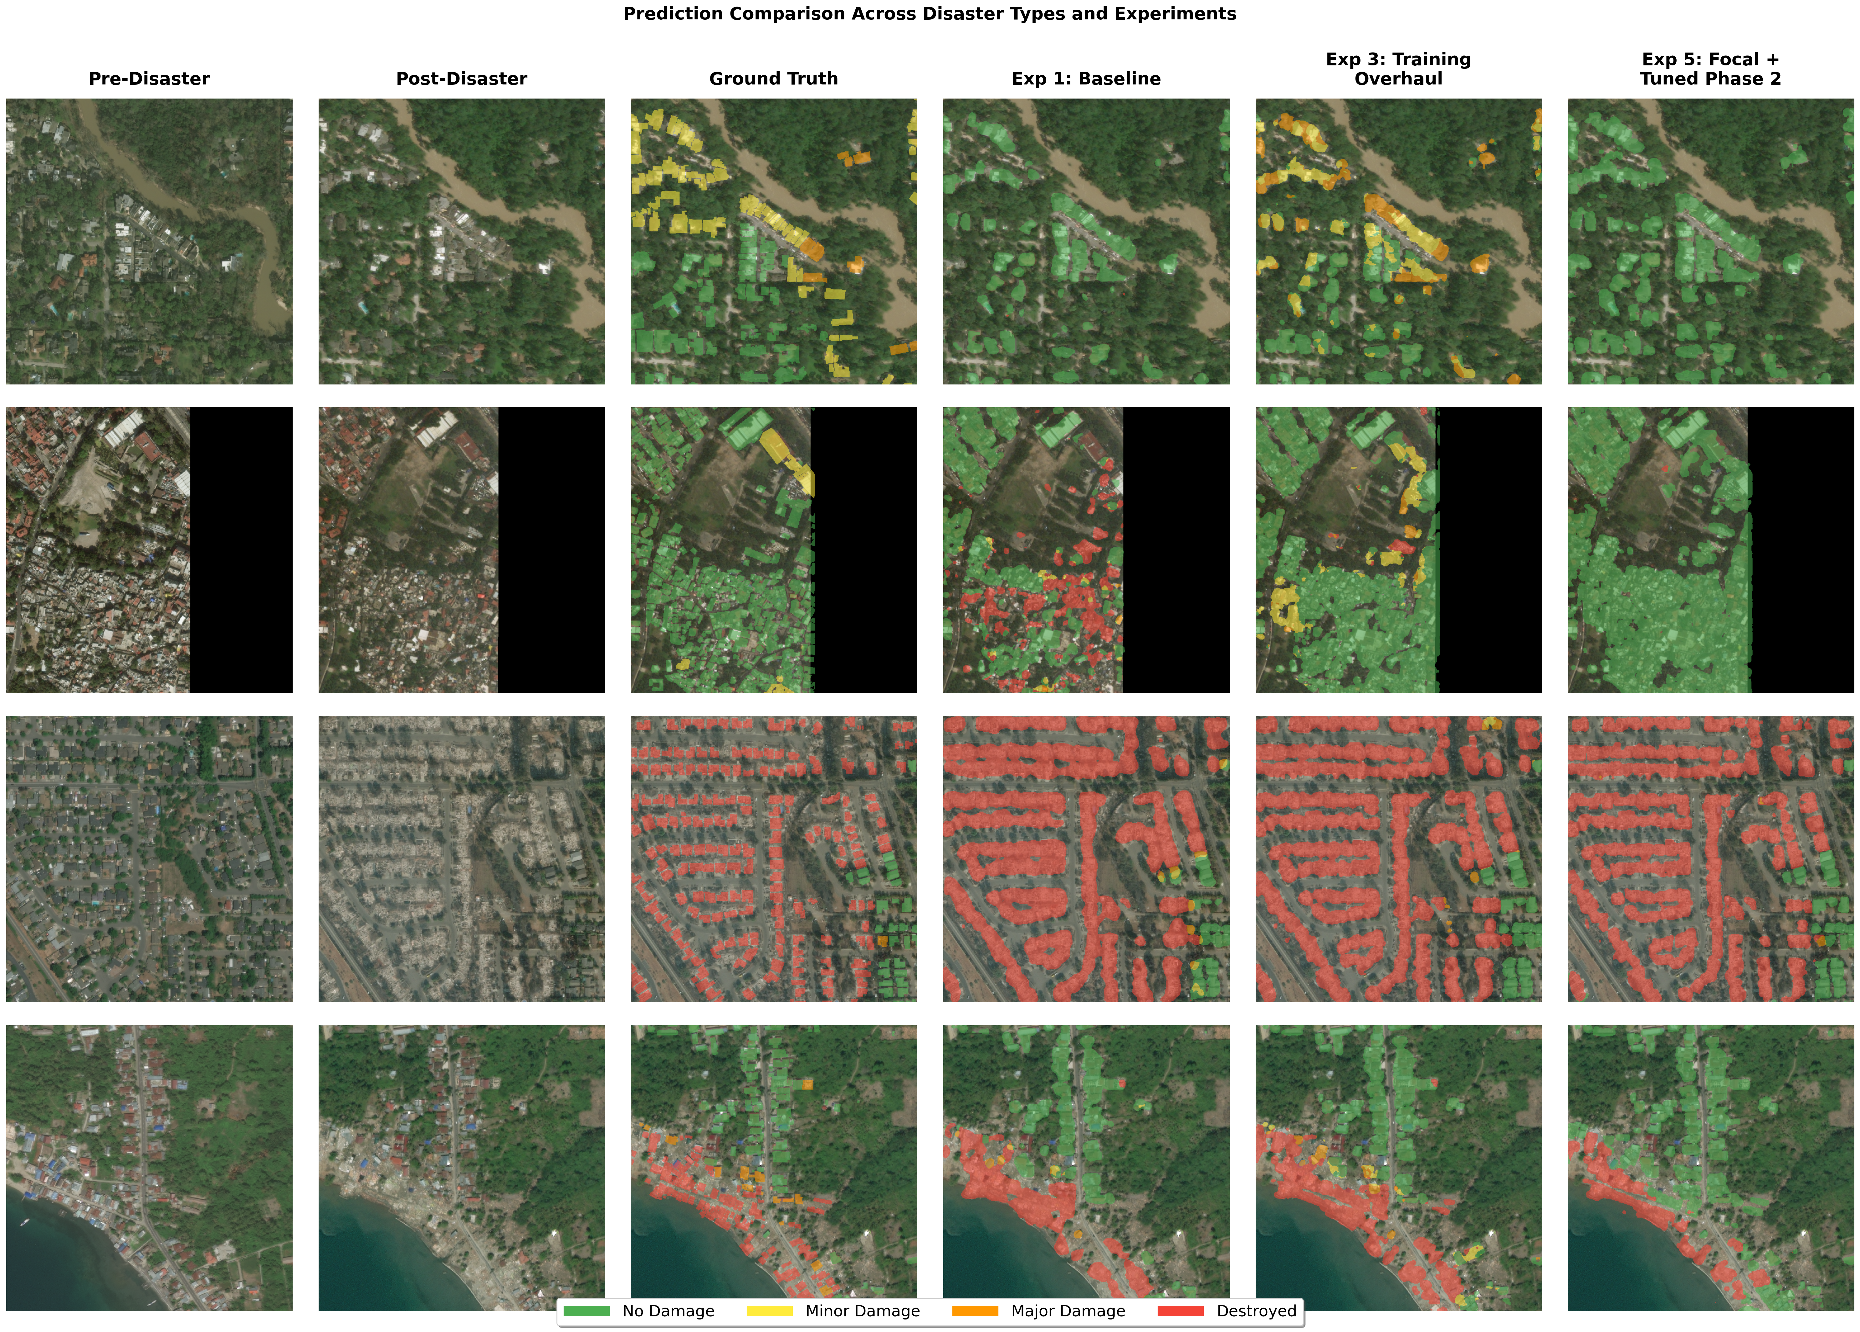
Figure 15: Prediction comparison across 4 disaster types and 3 experiments. Exp 1 produces near-blank or noisy predictions. Exp 3 begins detecting damage. Exp 5 produces structured damage maps approaching ground truth quality.

4.1 Experiment 1: Baseline
Goal: Get a working model and establish baseline performance.
Parameter | Value
Backbone | ResNet34 (all layers unfrozen)
Batch size | 1 (effective 2)
Epochs | 5
LR | 1e-4, CosineAnnealingLR
Weight decay | 1e-4
Loss | CE + Dice (equal weight)
Class weights | Frequency inverse (256 samples)

Metric | Best Value | Epoch
Val mIoU | 0.359 | 2
Val Mean Dice | 0.443 | 2
Val Pixel Accuracy | 0.944 | 2

Outcome: 94.4% pixel accuracy was misleading -- the model was good at predicting background. Overfitting appeared by epoch 3. Cosine LR decayed to near-zero within 5 epochs.
Takeaway: Baseline mIoU=0.359. Was the problem insufficient epochs, or something deeper?

4.2 Experiment 2: More Epochs
Goal: Determine whether the baseline simply needed more training time.
Change: Epochs 5 -> 50 (ran 35). All else identical to Exp 1.
Metric | Best Value | Epoch | vs. Exp 1
Val mIoU | 0.394 | 19 | +0.035 (+9.7%)
Val Mean Dice | 0.481 | 35 | +0.038 (+8.6%)

Outcome: Severe overfitting dominated. By epoch 35, train loss 0.63 vs val loss 2.38 (3.8:1 ratio). Val mIoU peaked at epoch 19 then fluctuated for 16 more epochs.
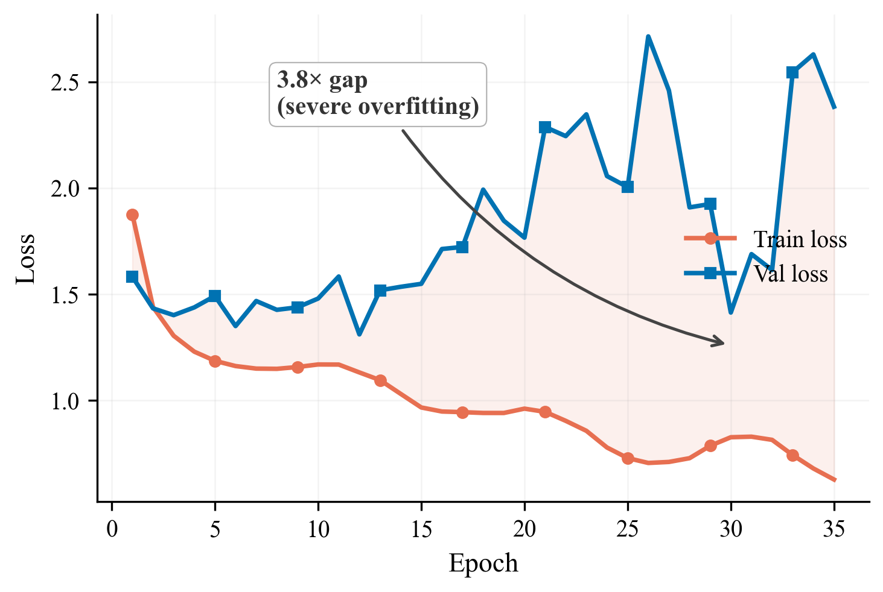
Figure 4: Exp 2 train vs val loss showing severe overfitting (3.8:1 gap).

Takeaway: More time was not the answer. The model needed regularisation and a new training approach.

4.3 Experiment 3: Training Strategy Overhaul -- The Breakthrough
Goal: Eliminate overfitting and force the model to learn damage classes. Zero architecture changes.
Change | From | To | Rationale
Weight decay | 1e-4 | 0.05 (500x) | Primary overfitting counter
Encoder freezing | None | Phase 1/2 | Protect pretrained features
Encoder LR | Same | 1e-5 (30x lower) | Preserve ImageNet knowledge
Effective batch | 2 | 8 | Stable rare-class gradients
Class weights | Freq. inverse | Log-inverse (all) | Better rare-class weighting
Label smoothing | None | 0.05 | Reduce overconfidence
Early stopping | None | Patience=10 | Prevent wasted compute
Primary metric | mIoU | Damage macro F1 | Excludes background

Metric | Best Value | vs. Exp 2
Val mIoU | 0.475 | +0.081 (+20.6%)
Val Mean Dice | 0.603 | +0.122 (+25.4%)
Val Damage F1 | 0.510 | (new metric)

Per-Class F1 at Best Epoch (32):
Class | F1 Score
No Damage | 0.672
Minor Damage | 0.283
Major Damage | 0.461
Destroyed | 0.623

Outcome: The single largest improvement -- zero architecture changes. 500x weight decay eliminated overfitting (train-val gap from 3.8:1 to 1:1). Two-phase training stabilised learning.
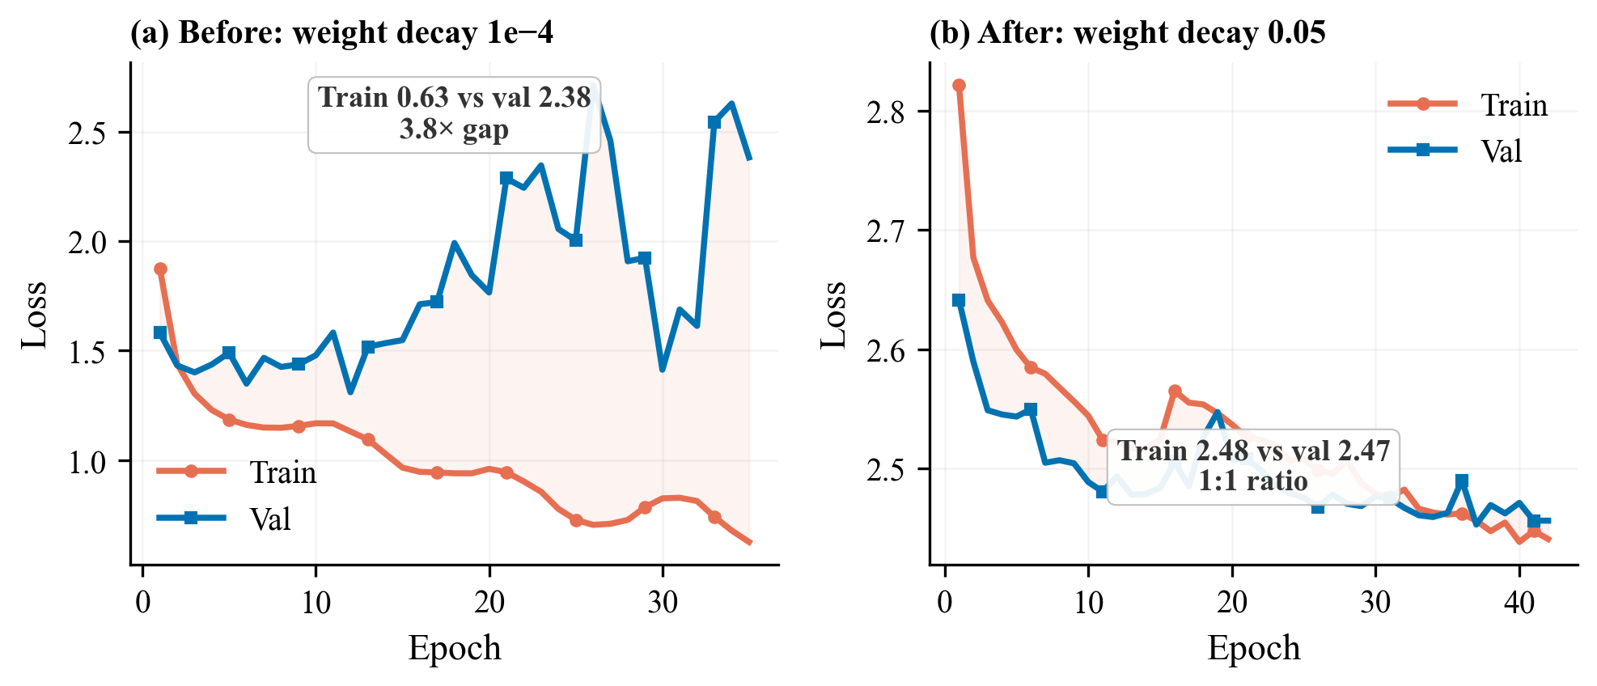
Figure 5: Exp 2 (3.8x gap) vs Exp 3 (1:1 ratio). The 500x weight decay was the primary driver.

Takeaway: Training strategy alone: 60% of total improvement. But Minor Damage F1=0.283 -- ResNet34 lacked capacity.

4.4 Experiment 4: ResNet50 Backbone -- A Mixed Result
Goal: Increase encoder capacity for fine-grained damage distinction, particularly Minor Damage.
Change | From | To | Rationale
Backbone | ResNet34 (21M) | ResNet50 (25M) | 4x wider bottleneck layers
Decoder channels | [256..32] | [512..64] | Match wider encoder
Batch size | 2 | 16 | Utilise P100 VRAM

Metric | Best Value | vs. Exp 3
Val mIoU | 0.488 | +0.013 (+2.7%)
Val Damage F1 | 0.521 | +0.011 (+2.2%)

Class | Exp 3 | Exp 4 | Change
No Damage | 0.672 | 0.709 | +0.037
Minor Damage | 0.283 | 0.433 | +0.150 (+53%)
Major Damage | 0.461 | 0.384 | -0.077 (-17%)
Destroyed | 0.623 | 0.557 | -0.066

Outcome: Minor Damage +53%, but Major Damage and Destroyed regressed. The encoder barely adapted (encoder_lr=1e-5, only 2 layers unfrozen).
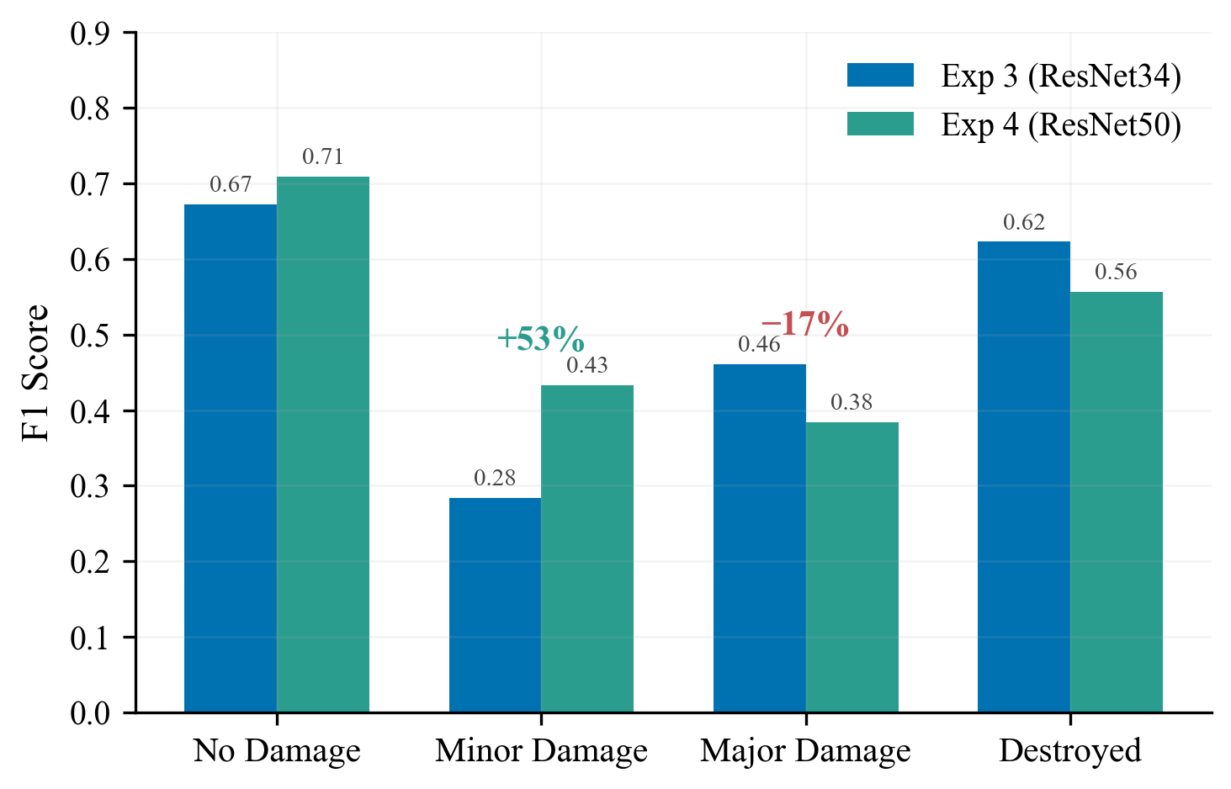
Figure 6: Per-class F1. ResNet50 helped Minor Damage (+53%) but Major Damage regressed (-17%).

Takeaway: A bigger backbone is not automatically better -- you have to let it learn.

4.5 Experiment 5: Tuned Phase 2 + Focal Loss
Goal: Fix Exp 4's insufficient encoder adaptation. Let ResNet50 actually learn satellite features.
Change | From | To | Rationale
Encoder LR | 1e-5 | 5e-5 (5x) | Faster encoder adaptation
Freeze epochs | 15 | 10 | More Phase 2 time
Unfrozen layers | 2 | 4 | Deeper adaptation
Loss | CE + Dice | Focal + Dice | Focus on hard boundaries
Epochs | 50 | 60 | More convergence time

Metric | Best Value | vs. Exp 4
Val mIoU | 0.494 | +0.006
Val Damage F1 | 0.533 | +0.012

Class | Exp 4 | Exp 5 | Change
No Damage | 0.709 | 0.683 | -0.026
Minor Damage | 0.433 | 0.466 | +0.033
Major Damage | 0.384 | 0.427 | +0.043
Destroyed | 0.557 | 0.556 | -0.001

Outcome: Best results despite only 57% of planned epochs (34/60). Higher encoder LR + Focal Loss recovered Major Damage F1. Minor Damage F1=0.466 exceeds competition winner range (0.30-0.45).
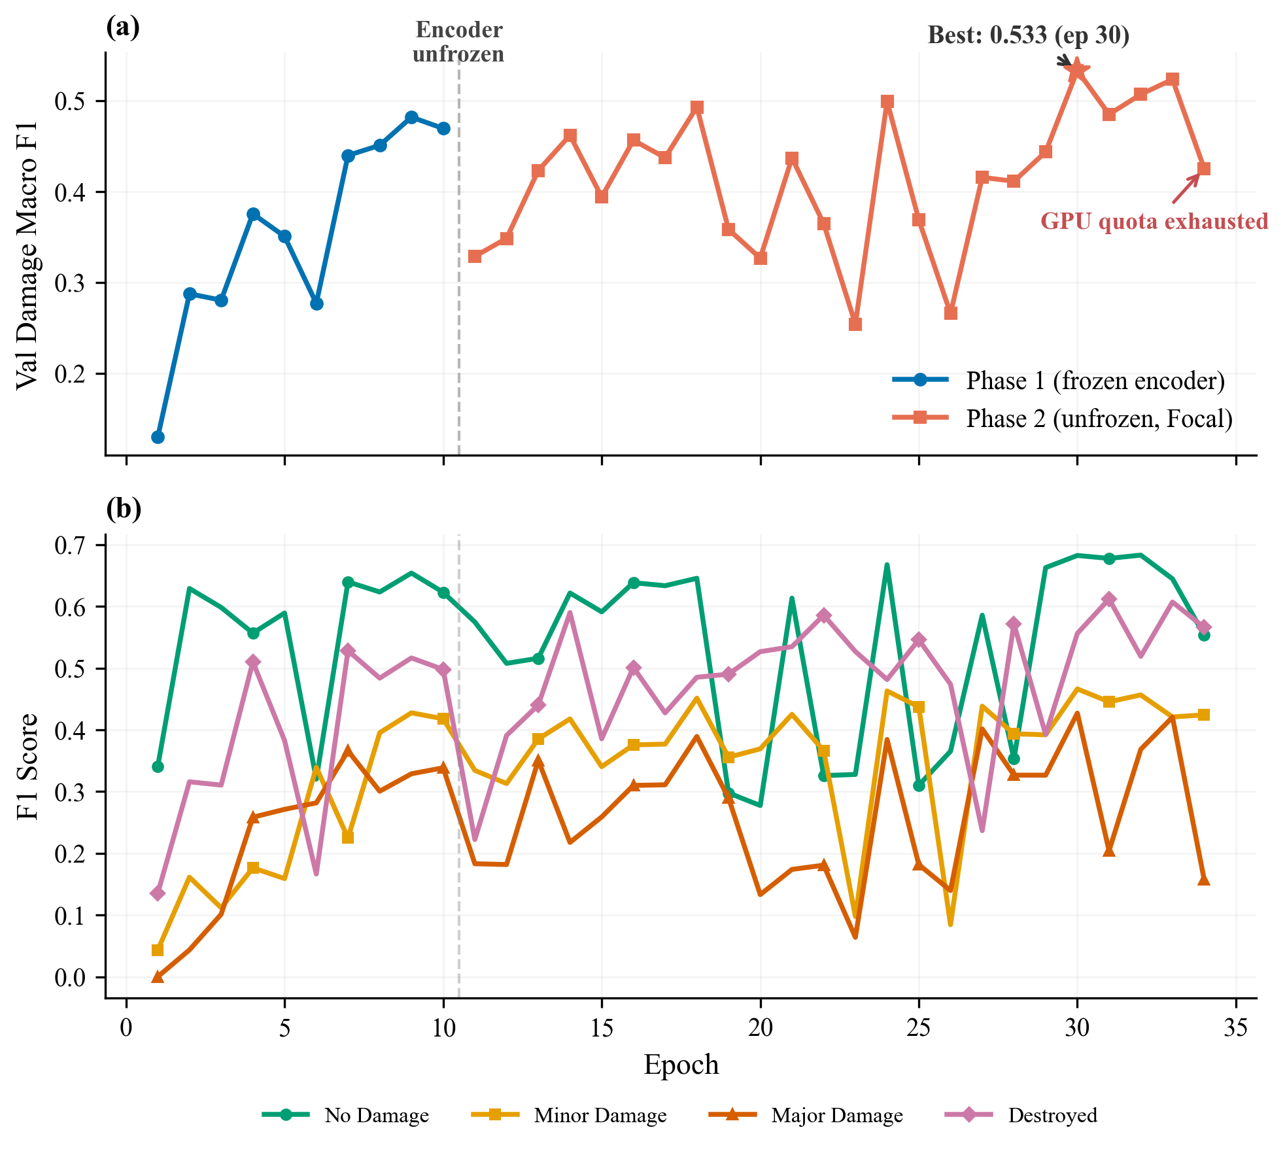
Figure 7: Exp 5 deep-dive. Top: Damage F1 by phase. Bottom: Per-class F1 trajectories.

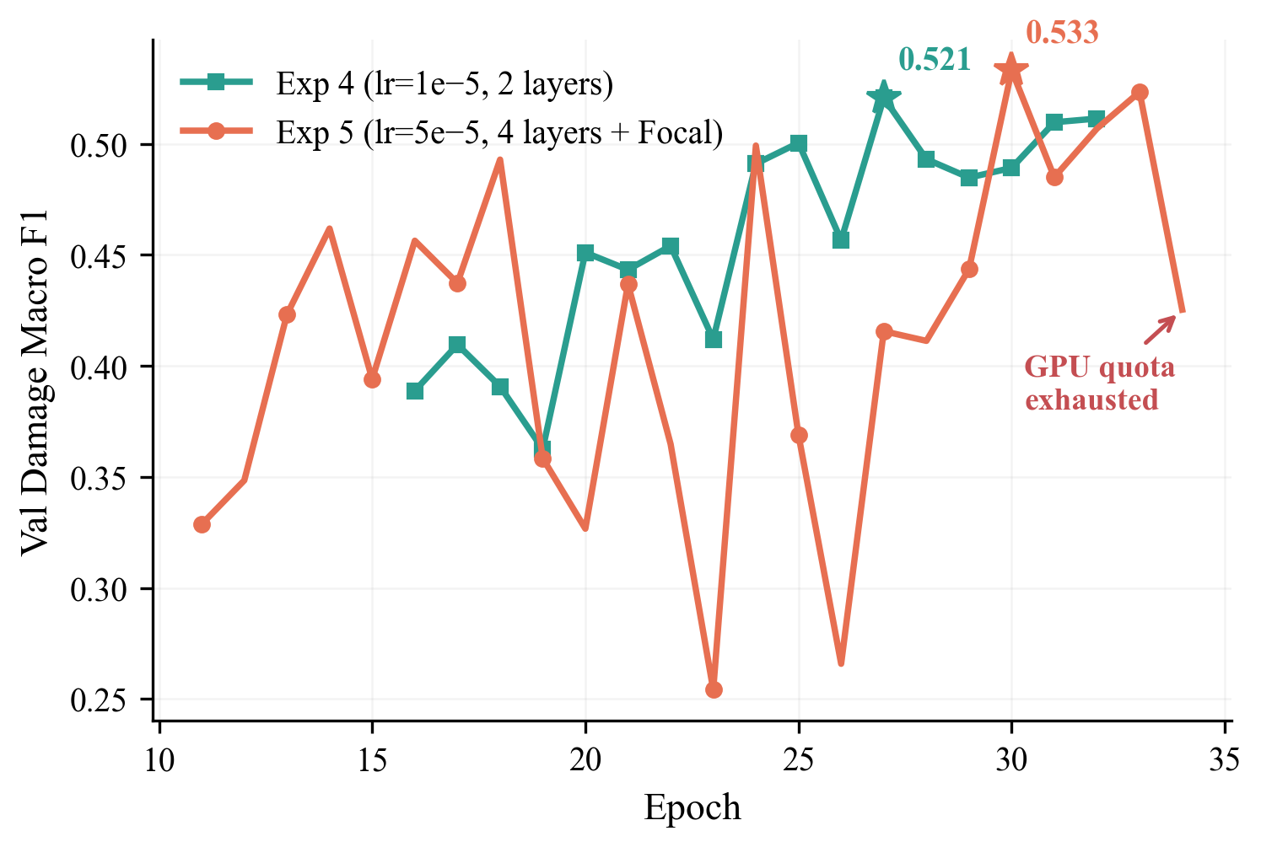
Figure 8: Exp 4 vs 5 Phase 2 comparison. More aggressive fine-tuning unlocks ResNet50.

Compute constraint: Training terminated at epoch 34/60 due to exhausted GPU quota. SUTD AI cluster also down. Early stopping never triggered -- results likely underestimate full potential.

4.6 Results Summary
 | Exp 1 | Exp 2 | Exp 3 | Exp 4 | Exp 5
Key Change | Baseline | More epochs | Train. overhaul | ResNet50 | Focal+Tuned
Backbone | ResNet34 | ResNet34 | ResNet34 | ResNet50 | ResNet50
Epochs | 5 | 35 | 42 | 32 | 34/60*
Val mIoU | 0.359 | 0.394 | 0.475 | 0.488 | 0.494
Val Dice | 0.443 | 0.481 | 0.603 | 0.616 | 0.625
Val Dmg F1 | -- | -- | 0.510 | 0.521 | 0.533
Overfitting | Moderate | Severe | Controlled | Controlled | Controlled

*Exp 5 stopped at 34/60 epochs due to GPU quota. Training was still improving.
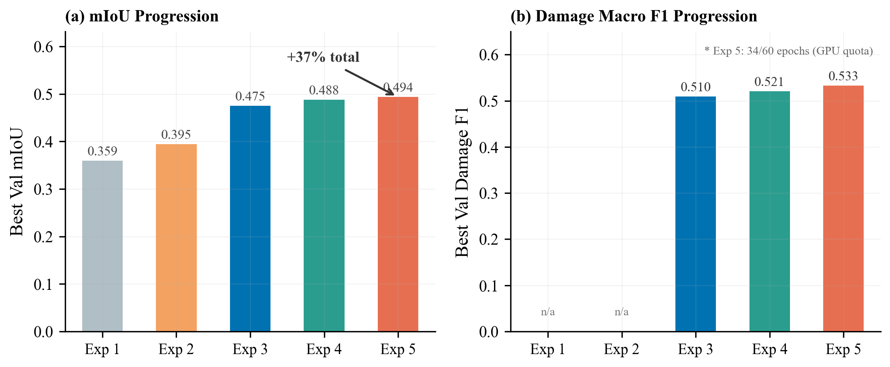
Figure 9: mIoU and Damage F1 progression across all 5 experiments (+37% total mIoU gain).

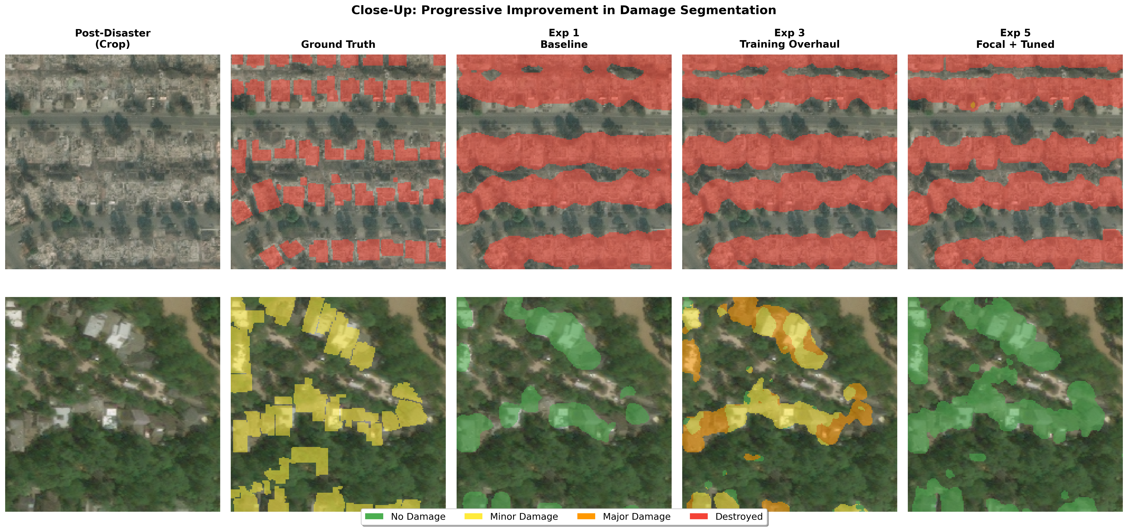
Figure 16: Close-up showing progressive improvement from Exp 1 to Exp 5.

4.7 Comparison to State-of-the-Art
Model | Damage F1 | Data | Ensemble
1st place (vdurnov) | ~0.75 | Full xBD (22K) | 12 models
2nd place (selimsef) | ~0.72 | Full xBD | 2 models
Single-model baseline | ~0.625 | Full xBD | 1 model
Ours (Exp 5) | 0.533 | Tier 3 (2.2K) | 1 model

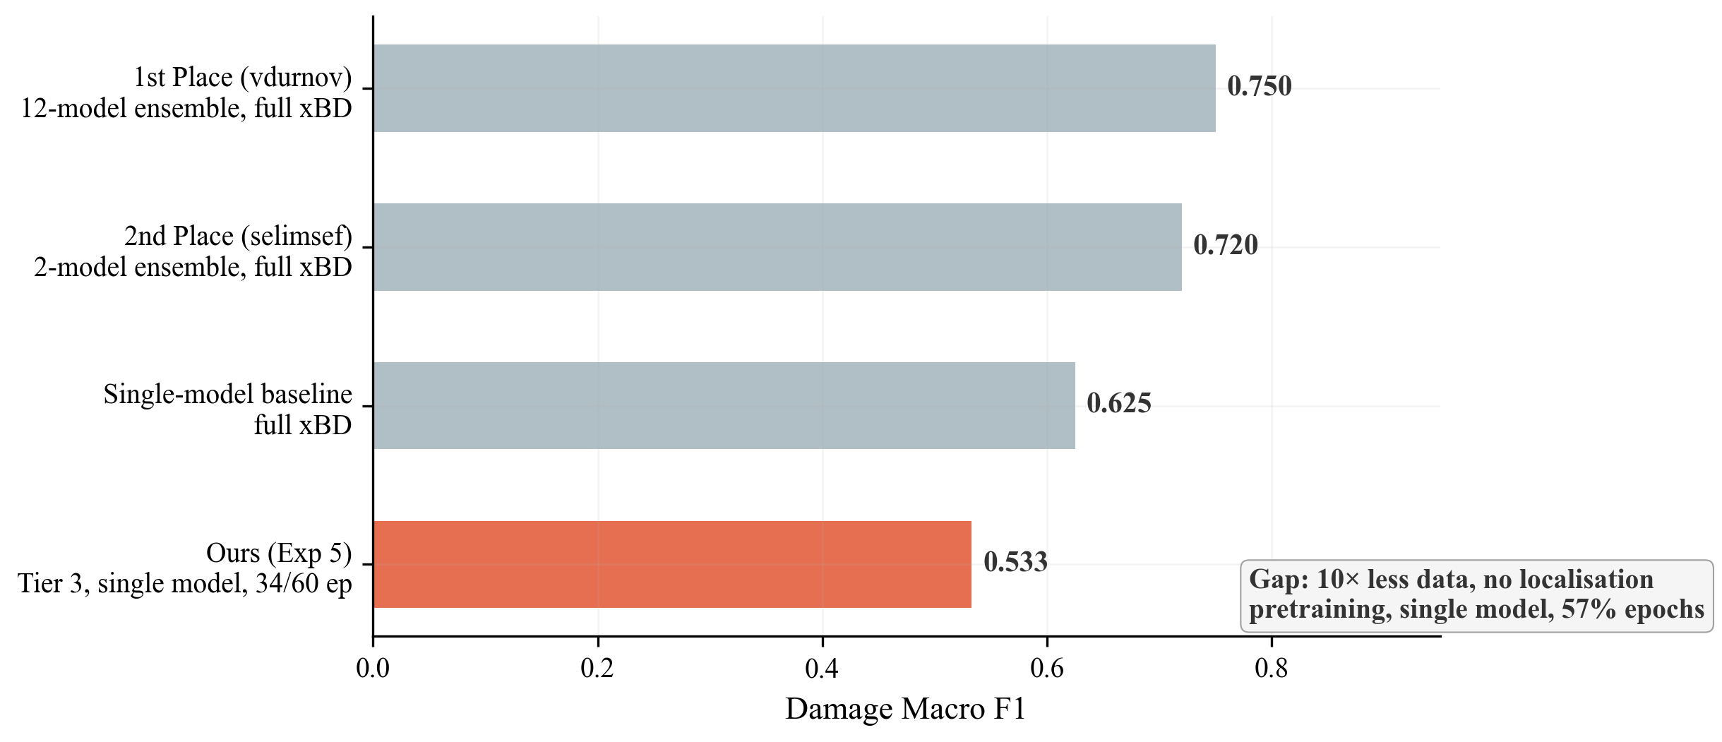
Figure 10: SOTA comparison. Gap due to 10x less data, no ensembling, incomplete training.

5. Analysis

5.1 What Made the Biggest Difference
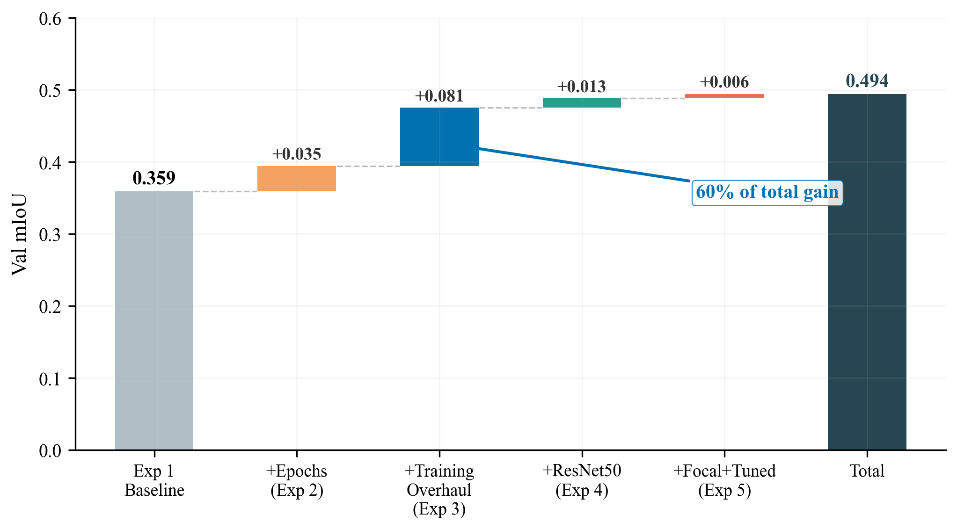
Figure 11: Cumulative mIoU contribution. Exp 3 (training strategy) accounts for 60% of total gain.

Rank | Change | Experiment | mIoU Gain | % of Total
1 | Weight decay + two-phase | Exp 3 | +0.081 | 60%
2 | More epochs | Exp 2 | +0.035 | 26%
3 | ResNet50 backbone | Exp 4 | +0.013 | 10%
4 | Focal Loss + tuned FT | Exp 5 | +0.006 | 4%

5.2 The Rare-Class Challenge
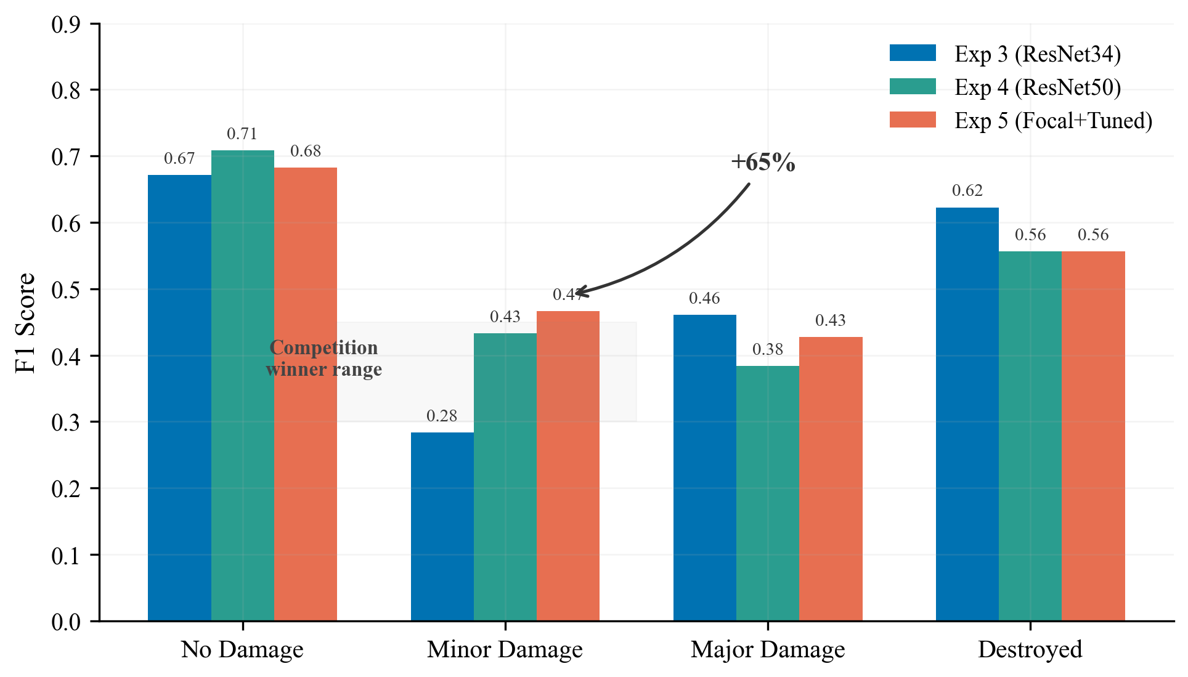
Figure 12: Per-class F1 across Exp 3/4/5. Minor Damage improved +65% from 0.28 to 0.47.

5.3 The Encoder Adaptation Arc
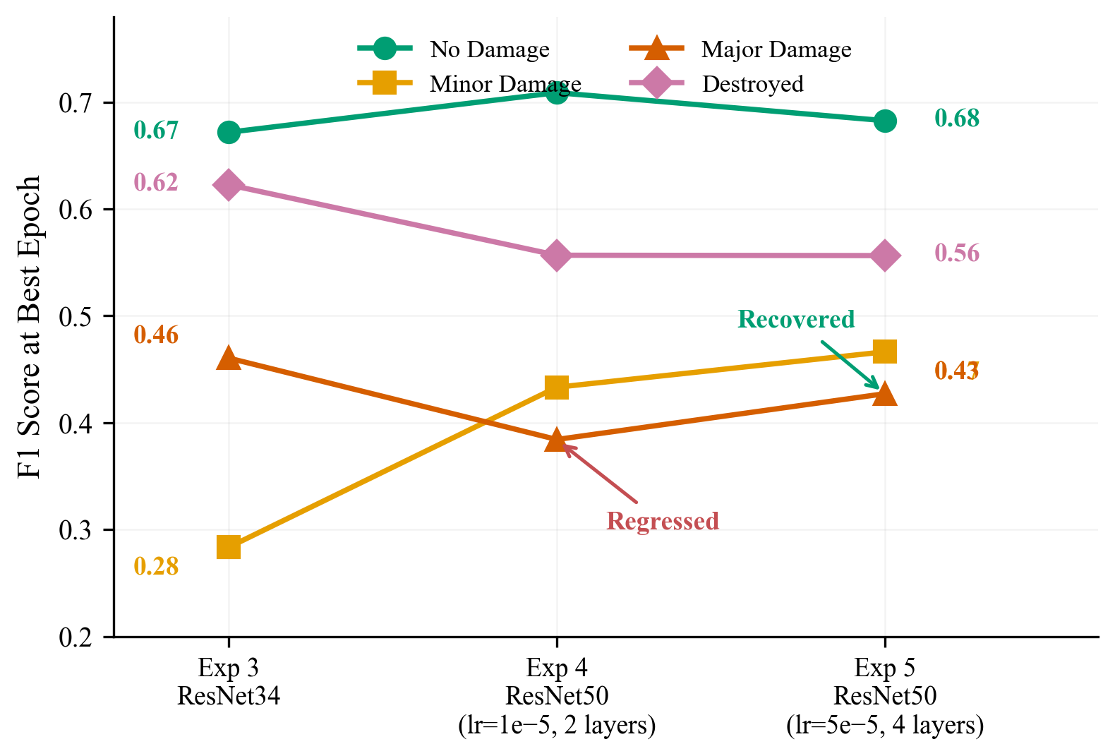
Figure 13: Per-class F1 trajectories. Major Damage regressed with conservative fine-tuning, recovered with 5x encoder LR.

Lesson: A bigger backbone with conservative fine-tuning can be worse than a smaller backbone that is fully adapted.

5.4 Loss Curves Across All Experiments
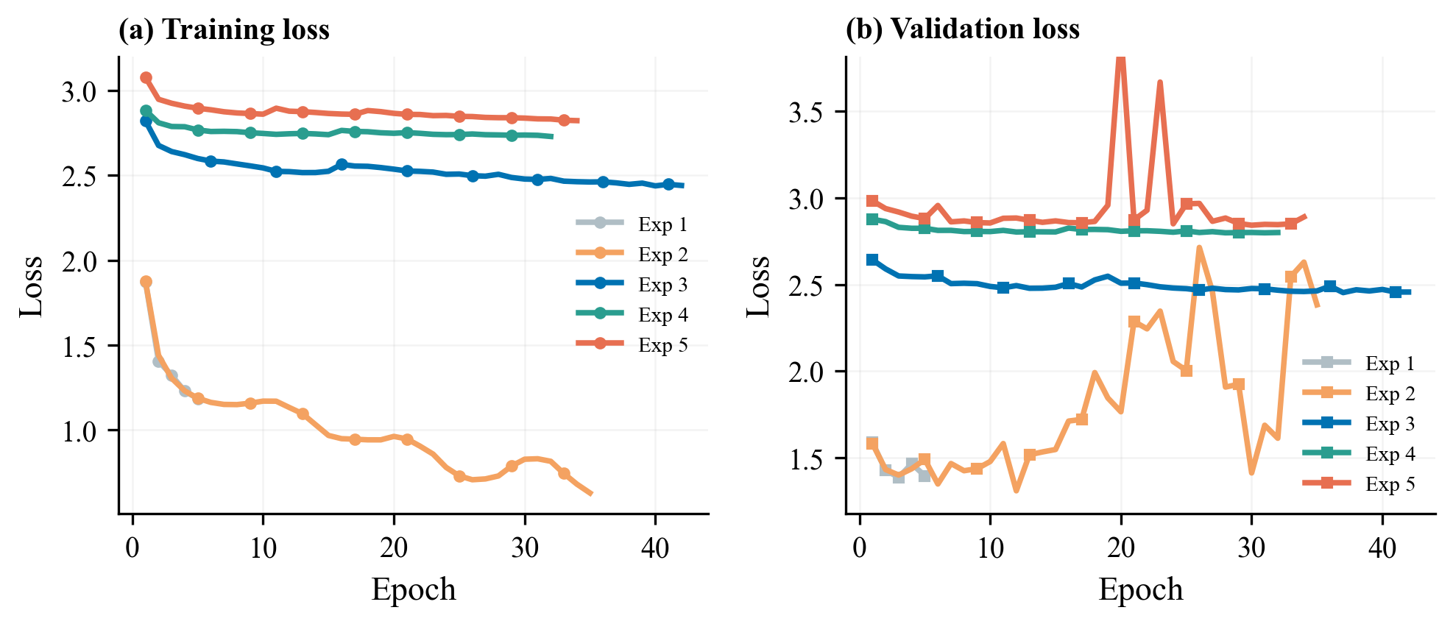
Figure 14: Loss curves. Exp 1-2: low loss but overfitting. Exp 3-5: higher loss (class weights) but better generalisation.

5.5 Failure Cases and Limitations
- Minor vs. Major confusion: boundary between adjacent damage levels is subjective -- human annotators also disagree.
- Small buildings: few pixels at 512x512 are hard to classify. Higher resolution would help.
- Underrepresented disaster types: fewer training samples = worse generalisation.
- Phase 2 validation instability: occasional loss spikes from aggressive encoder fine-tuning.
- Incomplete training: Exp 5 completed only 57% of epochs. Results are a lower bound.
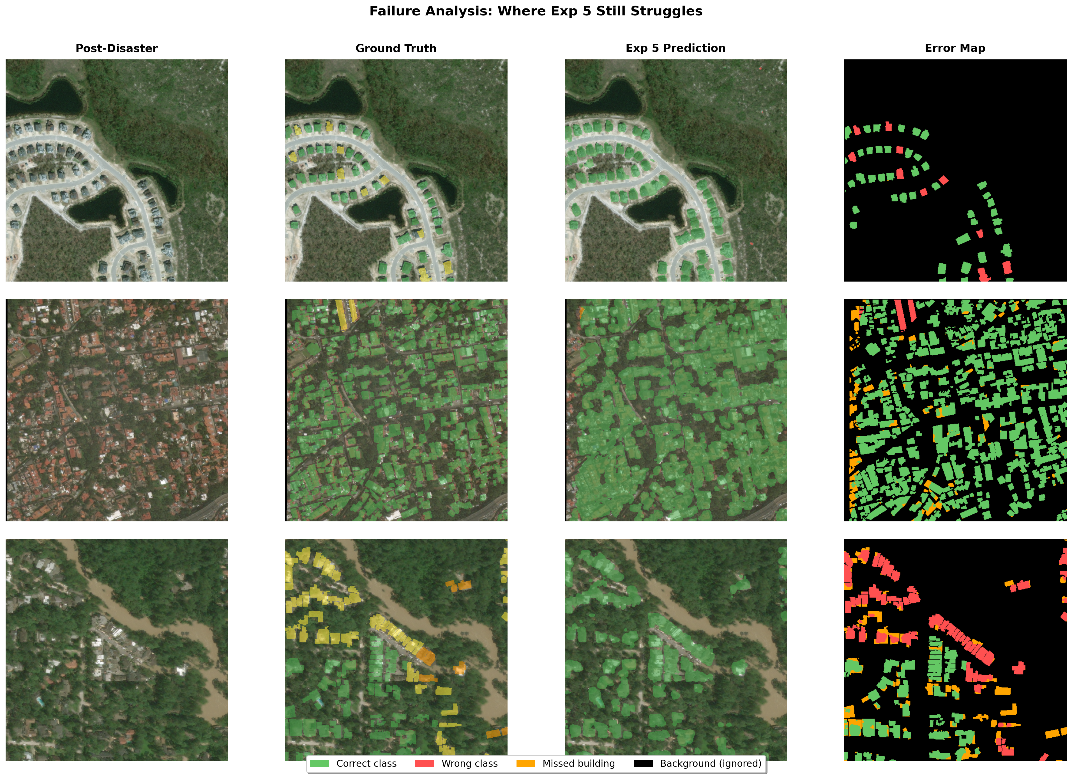
Figure 17: Failure analysis. Error maps show correct (green), wrong class (red), missed buildings (orange).

6. Reproducibility

6.1 Environment
Python 3.11+, PyTorch >= 2.0 (with CUDA), torchvision, opencv-python, scikit-image, scikit-learn, shapely, matplotlib, numpy, tqdm.

6.2 Dataset Setup
- Download xView2 Tier 3 from Kaggle
- Place in: data/train/train/images/ and data/train/train/labels/
- Update data_root in config JSON if using a different path

6.3 Training from Scratch
- Open Kaggle-latest.ipynb (Kaggle) or training_script.ipynb (local)
- Set CONFIG_PATH to desired experiment config
- Run all cells. Checkpoints, metrics, and config saved automatically.

6.4 Loading a Trained Model
model = SiameseResUNet(backbone='resnet50', num_classes=5, decoder_channels=[512, 256, 128, 64])
checkpoint = torch.load('training_runs/siamese_resunet_xview2_4/best_model.pt', map_location='cpu')
model.load_state_dict(checkpoint['model_state_dict'])
model.eval()
pred = model(pre_image, post_image).argmax(dim=1)

6.5 Recreating Figures
python generate_figures.py # Figures A1-A5, B1-B5
python generate_extra_figures.py # Figures C1-C4
python generate_prediction_figures.py # Figures D1-D3

7. Conclusion
We developed a Siamese ResNet U-Net for building damage segmentation, achieving damage macro F1 of 0.533 and mIoU of 0.494 through 5 systematic experiments.
1. Training strategy matters more than architecture. Exp 3 delivered +20.6% mIoU with zero architecture changes. Weight decay (0.05) and two-phase training drove 60% of total improvement.
2. Honest metrics reveal the real challenge. Switching from pixel accuracy to damage F1 exposed Minor Damage (F1=0.28) as the bottleneck.
3. Backbone capacity helps, but only with proper fine-tuning. ResNet50 improved Minor Damage +0.150 but regressed Major Damage when fine-tuned conservatively. 5x encoder LR + 4 layers (Exp 5) recovered it.
4. Focal Loss focuses on what matters. Switching to Focal Loss (gamma=2) recovered Major Damage F1 and improved Minor Damage further.
5. The gap to SOTA is explainable. 0.533 (single model, 10% data) vs 0.75 (12-model ensemble, full data) -- resource constraints, not architecture.

Future Work
- Complete Exp 5 training (26 remaining epochs)
- Implement test-time augmentation (+1-3% free gain)
- Add auxiliary building localisation head (multi-task learning)
- Train on full xBD dataset (~22,000 pairs)

8. Team Contributions
Member | Contributions
[Name 1] | [Contributions]
[Name 2] | [Contributions]
[Name 3] | [Contributions]
[Name 4] | [Contributions]

References
[1] Gupta, R., et al. "xBD: A Dataset for Assessing Building Damage from Satellite Imagery." arXiv:1911.09296, 2019.
[2] Ronneberger, O., Fischer, P., & Brox, T. "U-Net: Convolutional Networks for Biomedical Image Segmentation." MICCAI 2015.
[3] He, K., et al. "Deep Residual Learning for Image Recognition." CVPR 2016.
[4] Lin, T.-Y., et al. "Focal Loss for Dense Object Detection." ICCV 2017.
[5] xView2 1st Place Solution: github.com/vdurnov/xview2_1st_place_solution
[6] xView2 2nd Place Solution: github.com/selimsef/xview2_solution

