xView2 Building Damage Segmentation: A Siamese ResNet U-Net for Disaster Response
Course: 60.001 Applied Deep Learning, Y2026 Team: [Member names and student IDs] GitHub: [Repository URL] Dataset: Kaggle xView2 Tier 3 Model Weights: [Google Drive / Dropbox link]

Abstract
We develop a Siamese ResNet U-Net that segments building damage from pre- and post-disaster satellite imagery into four severity levels, achieving a damage macro F1 of 0.533 and mIoU of 0.494 on the xView2 Tier 3 dataset. Automated damage assessment from satellite imagery remains challenging due to extreme class imbalance (97% background pixels), subtle visual differences between adjacent damage levels, and the domain gap between ImageNet pretraining and overhead satellite views. Our approach pairs a shared ResNet50 encoder with three-stream fusion blocks (pre + post + absolute difference) and a U-Net decoder, trained with a two-phase strategy that first freezes the encoder, then fine-tunes it with a differential learning rate and Focal Loss. Across five systematic experiments, we demonstrate that training strategy alone accounts for 60% of total improvement, that a larger backbone requires aggressive fine-tuning to outperform a smaller one, and that Focal Loss recovers per-class regressions caused by conservative encoder adaptation. Our Minor Damage F1 of 0.466 exceeds the typical range achieved by xView2 competition winners (0.30–0.45), despite using only 10% of the full dataset with a single model and incomplete training.

1. Introduction
When natural disasters strike, rapid assessment of building damage directs emergency resources to where they are needed most. Traditional ground surveys take days to weeks – time that costs lives. Satellite imagery becomes available within hours, but manually inspecting thousands of buildings across disaster zones does not scale.
This project addresses the gap between satellite image availability and actionable damage assessment. We develop a deep learning model that takes a pair of satellite images (before and after a disaster) and produces a pixel-level damage map classifying every building into one of four damage levels: No Damage, Minor Damage, Major Damage, and Destroyed.
The central challenge is extreme class imbalance: 97% of pixels are background, and the remaining 3% split unevenly across four damage classes. A model predicting “background” everywhere achieves 97% pixel accuracy while being completely useless. Minor Damage – subtle cracks and missing tiles near the resolution limit – is the hardest class, with even competition winners achieving only 0.30–0.45 F1.
Our key contributions:
- A Siamese ResNet U-Net with three-stream fusion that explicitly encodes change magnitude through absolute difference features, providing both temporal context and a direct change signal at every encoder level.
- A two-phase training strategy (frozen encoder then differential-LR fine-tuning) combined with 500x weight decay increase that eliminated severe overfitting and delivered the single largest improvement (+20.6% mIoU) with zero architecture changes.
- Systematic ablation across five experiments isolating the impact of training strategy, backbone capacity, encoder adaptation aggressiveness, and loss function design, demonstrating that training strategy accounts for 60% of total improvement.
- Minor Damage F1 of 0.466, exceeding the typical competition winner range despite 10x less training data and a single model.
Starting from a baseline mIoU of 0.359, we achieve 0.494 – a 38% relative improvement – through iterative experimentation. The remainder of this report describes the dataset (Section 2), architecture and training method (Section 3), the five experiments and their results (Section 4), analysis of what worked and what did not (Section 5), reproducibility details (Section 6), and conclusions (Section 7).

2. Dataset

2.1 Source
The xView2 dataset was created by the Defense Innovation Unit (DIU) for the xView2 Building Damage Assessment Challenge [1]. It contains WorldView-3 satellite imagery (1.4m ground sample distance) spanning multiple disaster types: earthquakes, hurricanes, wildfires, volcanic eruptions, and floods.

2.2 Structure
Property | Value
Image pairs | ~2,200 (pre + post disaster)
Original resolution | 1024 x 1024 px
Training resolution | 512 x 512 px (bilinear resize)
Annotation format | GeoJSON polygons per building
Split | 80% train / 10% val / 10% test (seed=42)

2.3 Class Distribution
The dataset exhibits extreme class imbalance – the central technical challenge of this project:
Class | Pixel % | Description
Background | ~97% | Non-building pixels
No Damage | ~1.5% | Intact buildings
Minor Damage | ~0.3% | Cosmetic damage (cracks, missing tiles)
Major Damage | ~0.5% | Structural damage
Destroyed | ~0.7% | Collapsed or razed buildings
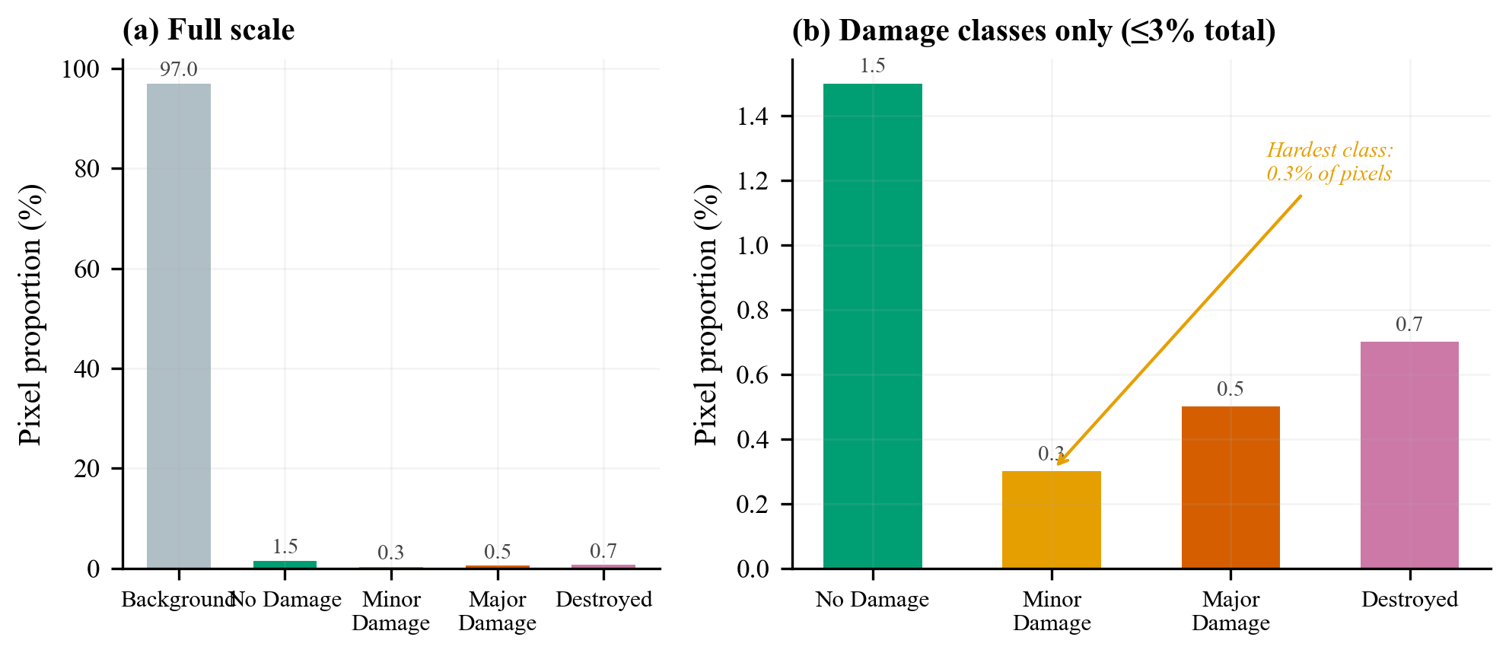
Figure 1: xView2 Tier 3 class distribution. Background dominates at ~97%, with all four damage classes combined occupying less than 3% of pixels. This imbalance motivated our adoption of damage macro F1 (excluding background) as the primary metric.
This imbalance is why we adopted damage macro F1 – the macro average of F1 for classes 1–4, excluding background – as our primary evaluation metric from Experiment 3 onward.

2.4 Preprocessing
We rasterized polygon annotations to per-pixel masks using Shapely and scikit-image, resized images from 1024x1024 to 512x512 via bilinear interpolation, and applied ImageNet normalization (mean=[0.485, 0.456, 0.406], std=[0.229, 0.224, 0.225]).

2.5 Data Augmentation
Augmentation strengths were tuned across experiments. The final configuration (Exp 5):
Augmentation | Probability | Purpose
Horizontal flip | 0.5 | Orientation invariance
Vertical flip | 0.2 | Orientation invariance
Random 90° rotation | 0.5 | Rotation invariance
Brightness jitter | ±0.15 | Lighting robustness
Contrast jitter | ±0.15 | Lighting robustness
Saturation jitter | ±0.10 | Colour robustness
Gaussian blur | 0.15 | Resolution robustness
Gaussian noise | 0.15 | Sensor noise robustness

3. Method

3.1 Architecture: Siamese ResNet U-Net
The model follows a Siamese encoder – fusion – decoder paradigm designed for change detection:
Pre-disaster image ──► [Shared ResNet Encoder] ──┐
├──► FusionBlocks (×5) ──► U-Net Decoder ──► 5-class Map
Post-disaster image ──► [Shared ResNet Encoder] ──┘
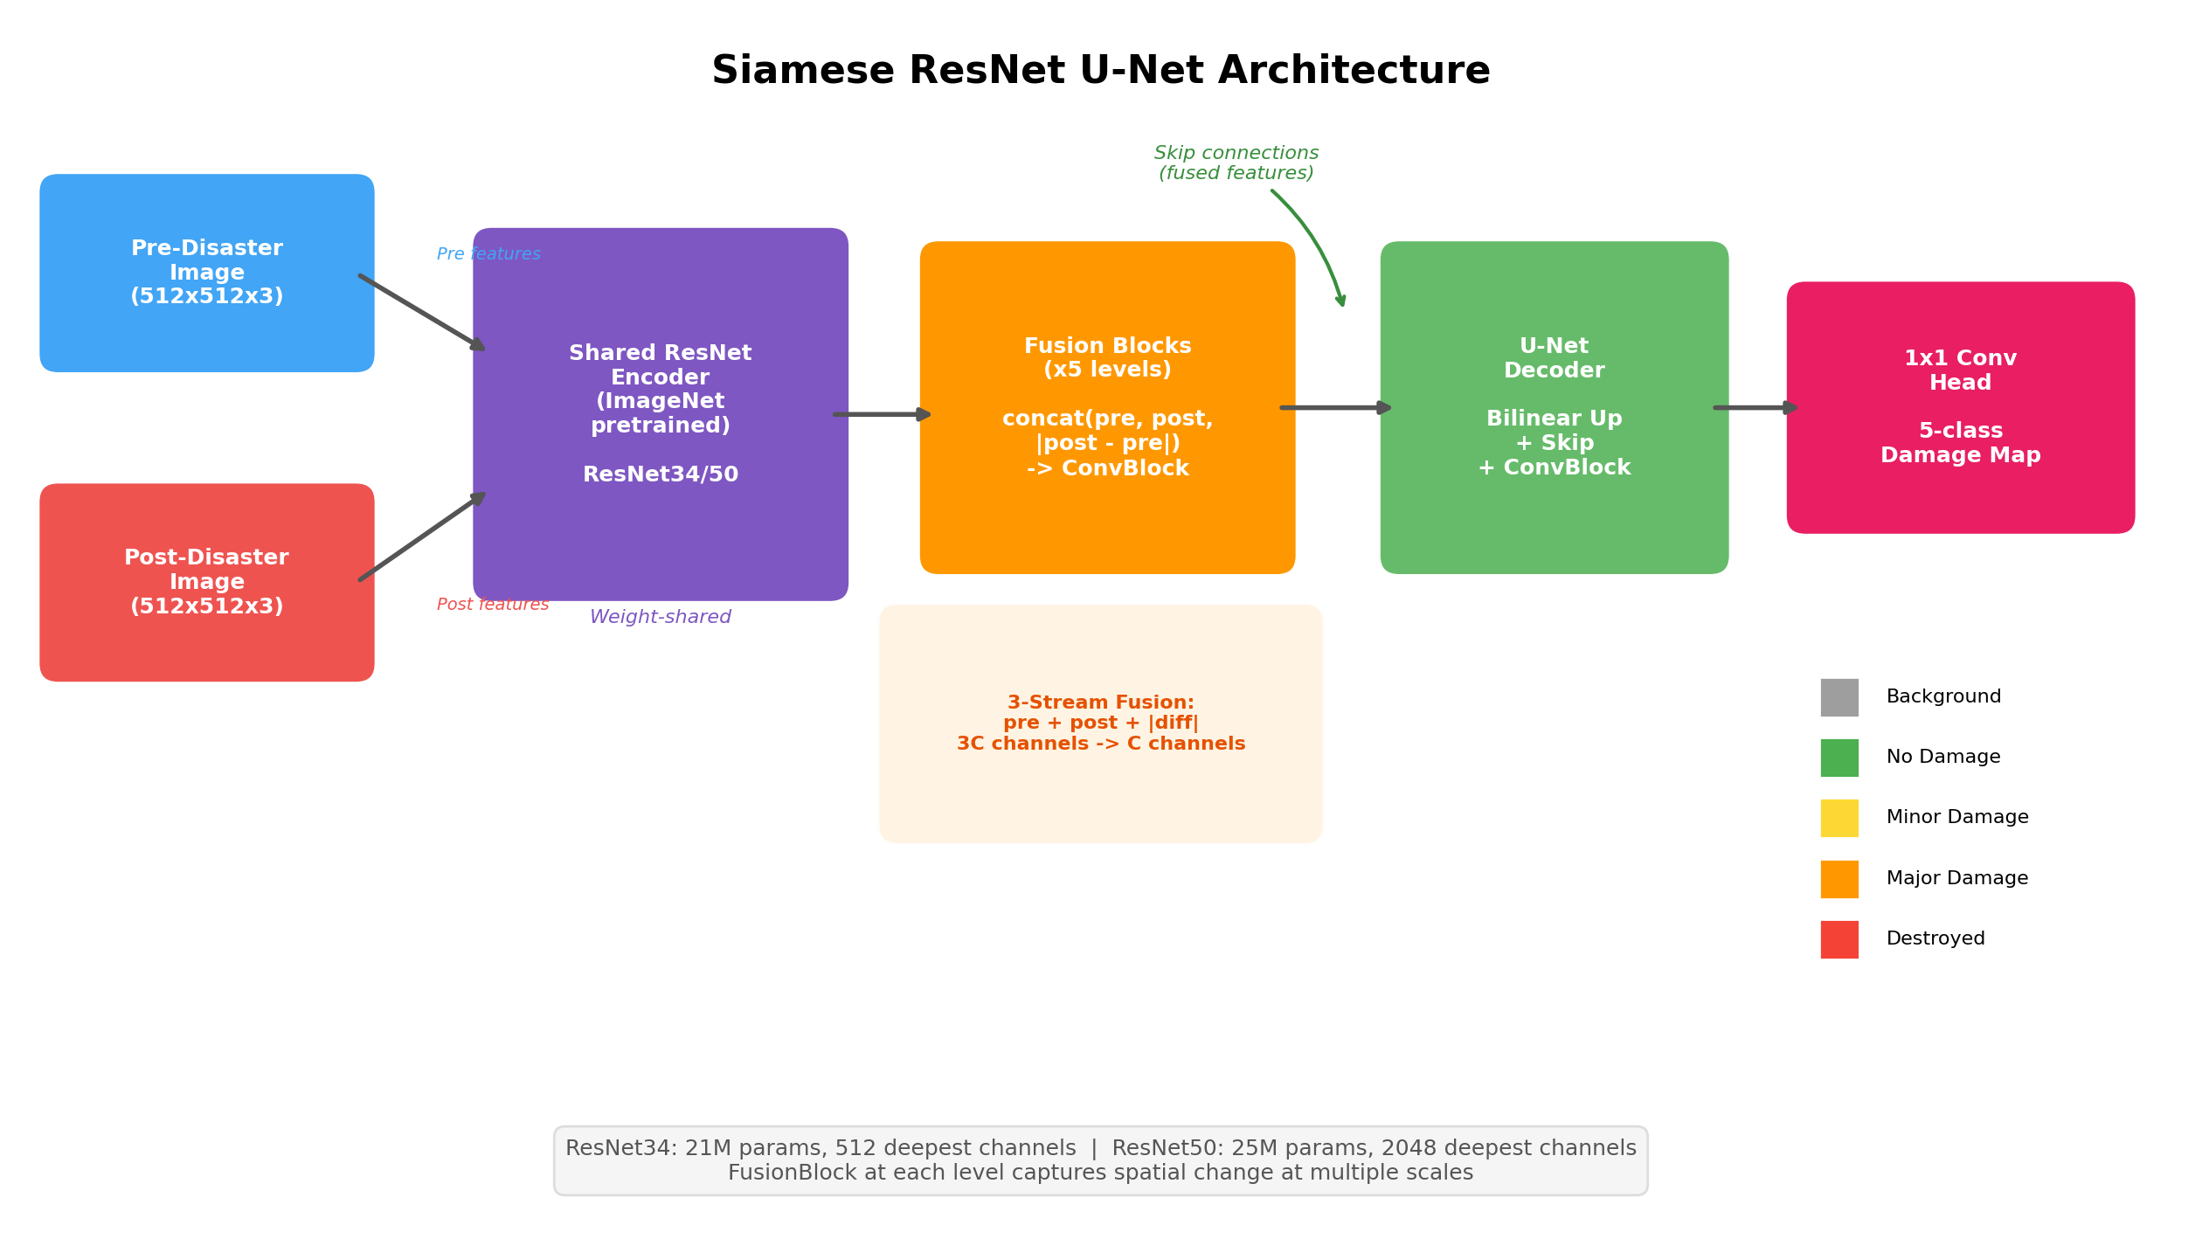
Figure 2: Siamese ResNet U-Net architecture. A shared ResNet encoder processes both pre- and post-disaster images. FusionBlocks at each encoder level combine features via three-stream fusion (pre + post + |diff|). A U-Net decoder with skip connections produces the 5-class damage segmentation map.

3.1.1 Shared Encoder
A pretrained ResNet backbone (ImageNet weights) extracts hierarchical features from both temporal views. Weight sharing ensures identical feature spaces. We evaluated two backbones:
Backbone | Parameters | Deepest Channels | Block Type
ResNet34 | 21M | 512 | BasicBlock
ResNet50 | 25M | 2048 | Bottleneck (4× wider)

3.1.2 Fusion Blocks
At each encoder level, a FusionBlock combines pre- and post-disaster features using three-stream concatenation:
FusionBlock(pre_feat, post_feat):
diff = |post_feat - pre_feat| # Explicit change signal
x = concat(pre_feat, post_feat, diff) # 3C channels
x = ConvBlock(x) # Compress to C channels
return x
The absolute difference explicitly encodes change magnitude. This three-stream approach (pre + post + |diff|) provides both the original temporal context and a direct change signal – more informative than simple concatenation or subtraction alone.

3.1.3 U-Net Decoder
Standard U-Net decoder with skip connections from fused features:
Level | Input | Output (ResNet34) | Output (ResNet50)
Bottleneck | Deepest fused | 256 | 512
Up 1 | 256 + skip | 128 | 256
Up 2 | 128 + skip | 64 | 128
Up 3 | 64 + skip | 32 | 64
Head | 32 / 64 | 5 classes | 5 classes
Each DecoderBlock applies bilinear upsampling, concatenates the skip connection, and passes through a ConvBlock (two rounds of Conv3×3 → BatchNorm → ReLU).

3.2 Loss Function
The loss function evolved across experiments. The final configuration (Exp 5) combines Focal Loss with Dice Loss:
L = w_focal × FocalLoss(pred, target, class_weights, γ=2) + w_dice × DiceLoss(pred, target)
Component | Role
Focal Loss (γ=2) | Downweights easy background pixels, focuses gradients on hard damage boundary pixels. Used by all xView2 competition winners.
Dice Loss | Region-level overlap metric as a differentiable loss; inherently handles class imbalance.
Log-inverse class weights | Upweights rare damage classes (clipped to [1, 20]), computed from all training samples.
Label smoothing (0.05) | Prevents overconfident predictions on easy pixels.
Experiments 1–4 used standard Cross-Entropy. The switch to Focal Loss in Exp 5 was motivated by a specific observation: Major Damage F1 regressed in Exp 4 because the model was not attending to hard boundary pixels between adjacent damage classes.

3.3 Training Strategy: Two-Phase Learning
The two-phase strategy, developed in Exp 3 after observing severe overfitting in Exp 2, was the most impactful design decision of the project:
Phase 1 – Frozen Encoder: Only the decoder and fusion blocks train. The encoder’s pretrained ImageNet features remain fixed, giving the decoder a stable feature space to learn from. Duration: 10–15 epochs.
Phase 2 – Differential Fine-Tuning: The top N encoder layers unfreeze with a learning rate 6–30× lower than the decoder. This allows domain adaptation to satellite imagery while preserving learned representations.
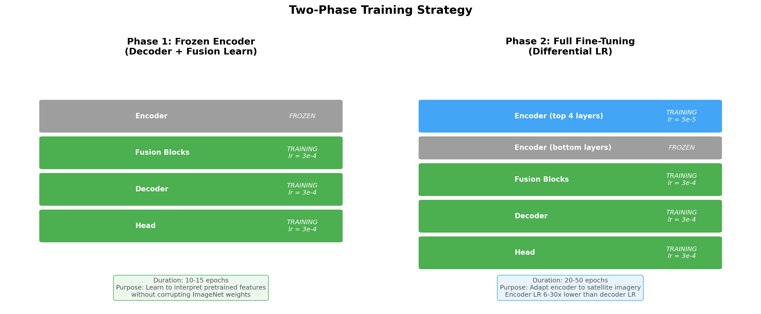
Figure 3: Two-phase training strategy. Phase 1 freezes the encoder so the decoder learns to interpret pretrained features without corrupting them. Phase 2 unfreezes top encoder layers with a lower learning rate for satellite domain adaptation.
The key hyperparameters tuned across experiments:
Parameter | Exp 3 | Exp 4 | Exp 5
Freeze epochs | 15 | 15 | 10
Unfrozen layers | all | 2 | 4
Encoder LR | 1e-5 | 1e-5 | 5e-5

3.4 Optimisation Details
Parameter | Value
Optimiser | AdamW
Decoder LR | 3e-4
Encoder LR (Phase 2) | 1e-5 to 5e-5 (tuned per experiment)
Weight decay | 0.05
Gradient clipping | 1.0 (max norm)
Batch size | 8
Gradient accumulation | 4–8 steps (effective batch 32–64)
Mixed precision | FP16 (torch.cuda.amp)
Scheduler | CosineAnnealingLR (min_lr=1e-6)
Early stopping | Patience=15 on val damage F1

4. Experiments
We conducted five experiments, each building on observations from the previous one. This iterative approach isolated the impact of individual changes and revealed what drives performance in damage segmentation. The narrative follows chronological order: each experiment was motivated by a specific failure or observation from its predecessor.
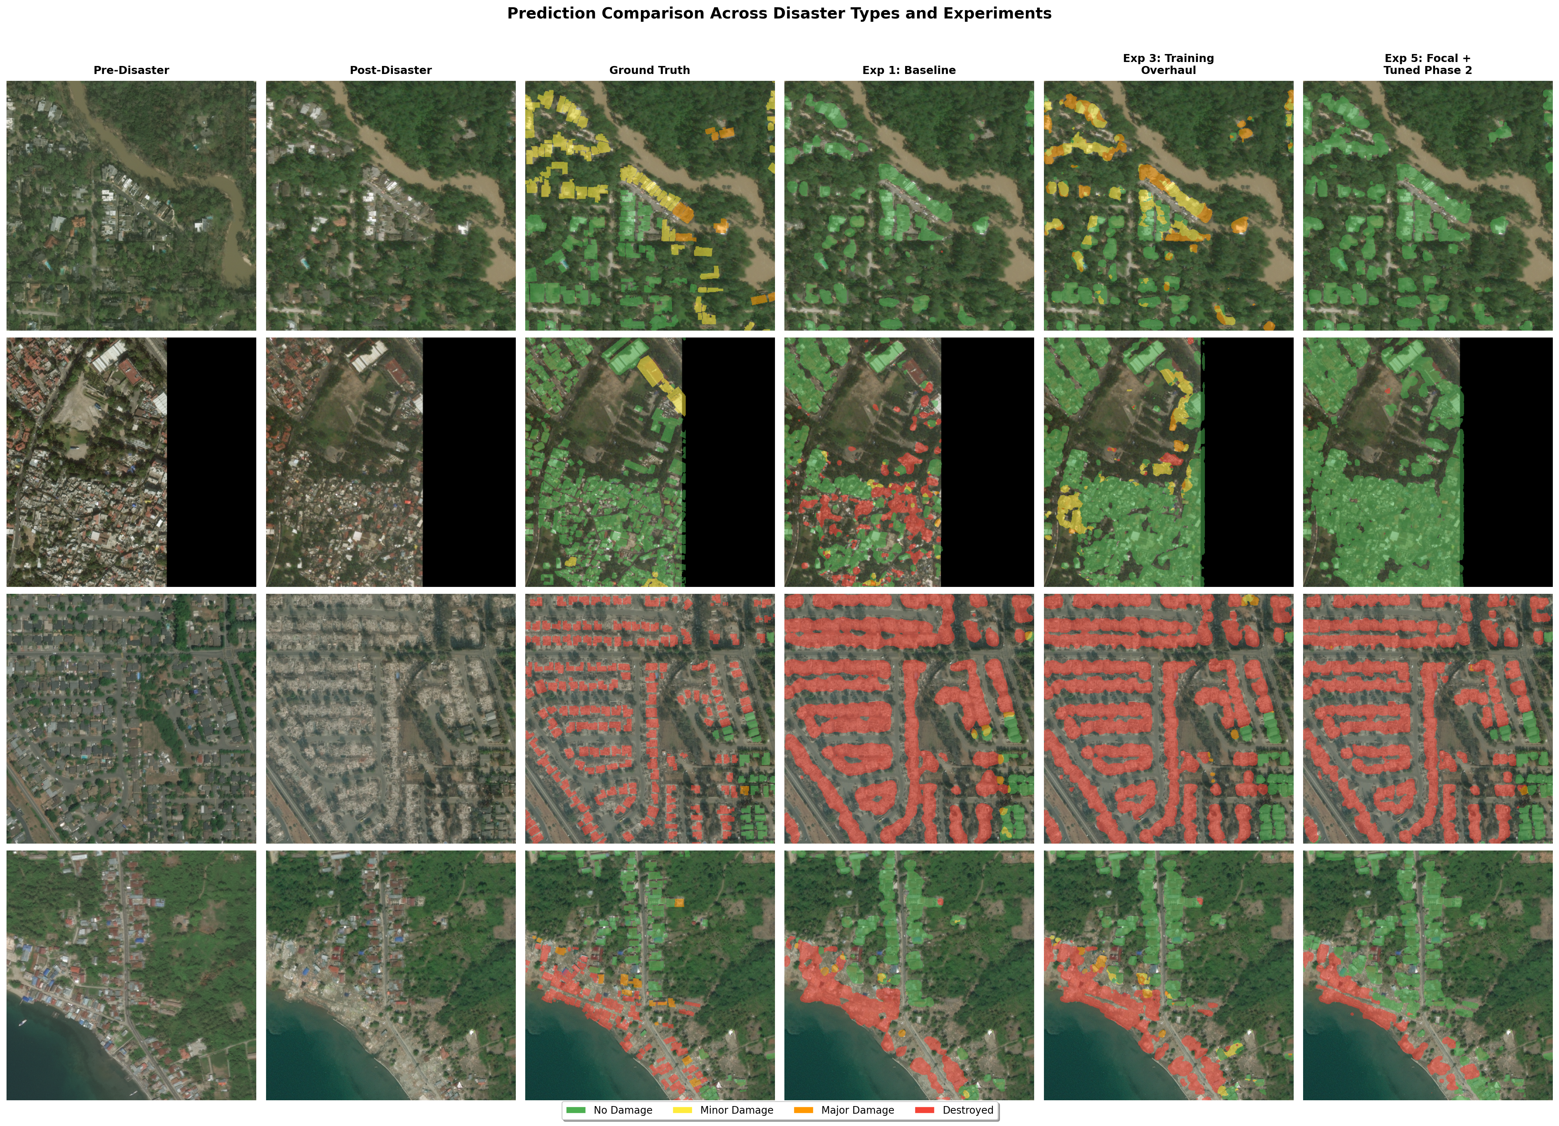
Figure 4: Prediction comparison across disaster types. Rows: different disaster events. Columns: pre-disaster image, post-disaster image, ground truth, and predictions from Exp 1, 3, and 5. The progressive improvement from near-blank Exp 1 predictions to structured Exp 5 damage maps is visible across all disaster types.

4.1 Experiment 1: Baseline
Goal: Establish a working model and baseline performance.
Parameter | Value
Backbone | ResNet34 (all layers unfrozen)
Effective batch size | 2
Epochs | 5
LR | 1e-4, CosineAnnealingLR
Weight decay | 1e-4
Results:
Metric | Best Val | Epoch
mIoU | 0.359 | 2
Mean Dice | 0.443 | 2
Pixel Accuracy | 0.944 | 2
Observation: The model achieved 94.4% pixel accuracy, but this was misleading. With 97% background pixels, high pixel accuracy simply meant the model predicted “not a building” well. Overfitting appeared by epoch 3 (val mIoU dropped from 0.359 to 0.339 while train mIoU rose). The cosine LR scheduler decayed to near-zero within 5 epochs, effectively cutting training short.
Implication: More training time was needed, but was the problem simply insufficient epochs, or something deeper?

4.2 Experiment 2: Extended Training – The Wrong Fix
Goal: Test whether the baseline simply needed more training time.
Change: Increased epochs from 5 to 50 (ran 35 before manual stopping). Everything else identical to Exp 1.
Results:
Metric | Best Val | Epoch | Δ vs Exp 1
mIoU | 0.394 | 19 | +0.035 (+9.7%)
Mean Dice | 0.481 | 35 | +0.038 (+8.6%)
Observation: More epochs helped marginally (+9.7% mIoU), but severe overfitting dominated the run. By epoch 35, train loss dropped to 0.63 while val loss climbed to 2.38 – a 3.8:1 ratio. Val mIoU peaked at epoch 19 and fluctuated without improvement for 16 more epochs. The model memorised training data rather than learning generalisable features.
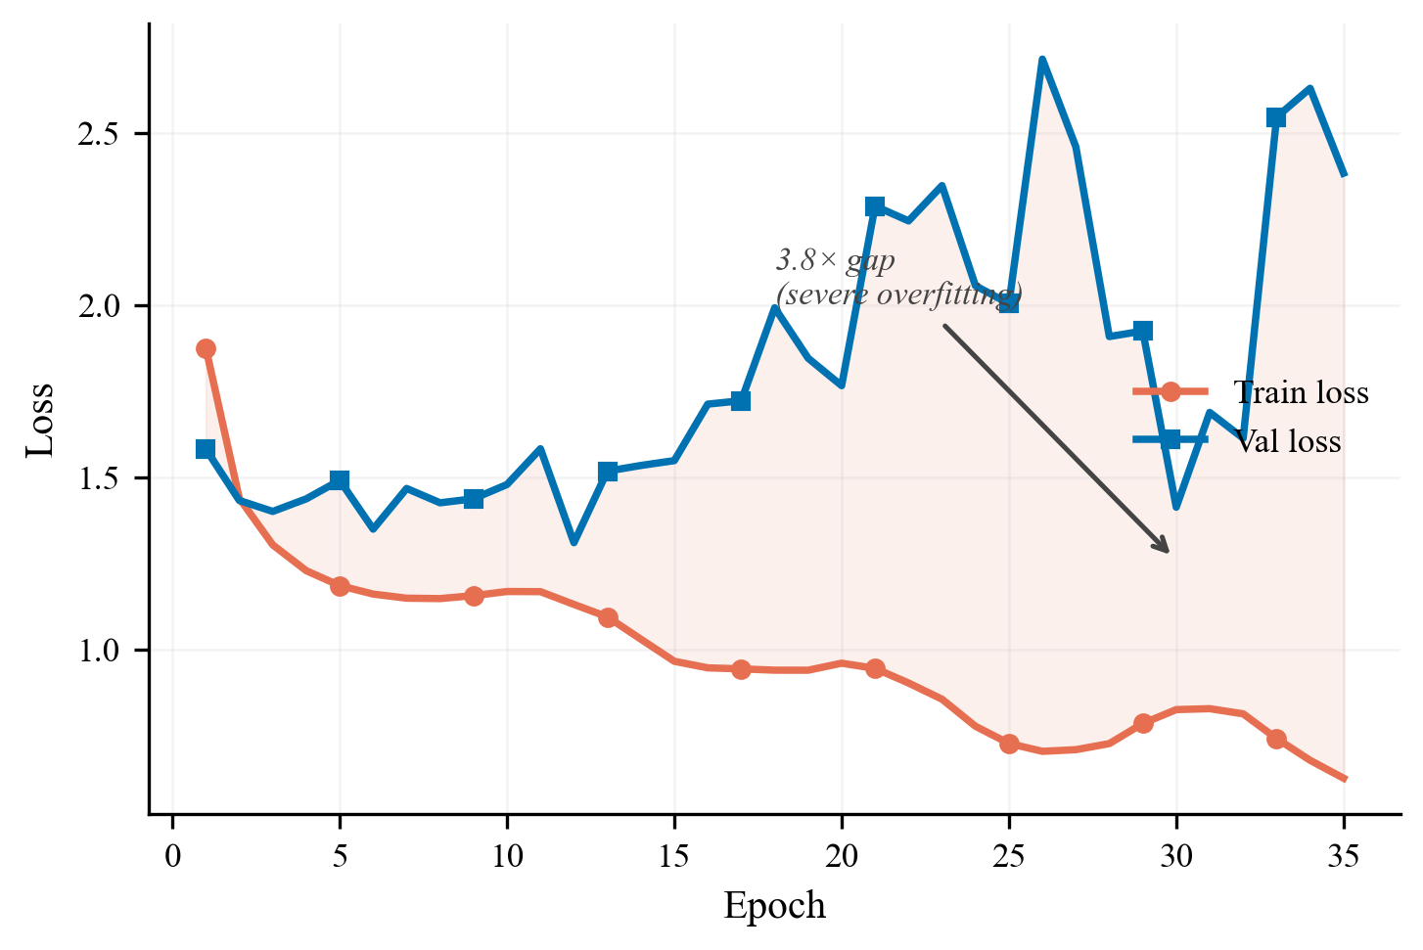
Figure 5: Train vs val loss for Exp 2. The shaded area between the curves visualises the growing overfitting gap, reaching a 3.8× train-val loss ratio by epoch 35.
Implication: Training longer was not the answer. The model needed regularisation and a fundamentally different training approach.

4.3 Experiment 3: Training Strategy Overhaul – The Breakthrough
Goal: Eliminate overfitting and force the model to learn damage classes, not just background. Zero architecture changes – only training strategy modifications.
What changed and why:
Change | Exp 2 | Exp 3 | Rationale
Weight decay | 1e-4 | 0.05 (500×) | Primary overfitting countermeasure
Encoder | All unfrozen | Phase 1 frozen → Phase 2 unfrozen | Protect pretrained features
Encoder LR | Same as decoder | 1e-5 (30× lower) | Preserve ImageNet knowledge
Effective batch | 2 | 8 | Stable gradients for rare classes
Class weights | Freq. inverse (256 samples) | Log-inverse (all samples) | Better rare-class upweighting
Label smoothing | None | 0.05 | Reduce overconfidence
Early stopping | None | Patience=10 | Prevent wasted compute
Primary metric | mIoU | Damage macro F1 | Honest evaluation excluding background
Results:
Metric | Best Val | Epoch | Δ vs Exp 2
mIoU | 0.475 | 32 | +0.081 (+20.6%)
Mean Dice | 0.603 | 32 | +0.122 (+25.4%)
Damage F1 | 0.510 | 32 | – (new metric)
Per-class F1:
Class | F1
No Damage | 0.672
Minor Damage | 0.283
Major Damage | 0.461
Destroyed | 0.623
This was the single largest improvement across all experiments, and it came with zero architecture changes. The 500× weight decay increase was the primary driver: the train-val loss gap dropped from 3.8:1 to near 1:1 (train loss 2.48, val loss 2.47). Two-phase training stabilised learning by protecting pretrained features. Log-inverse class weights forced the model to attend to rare damage classes.
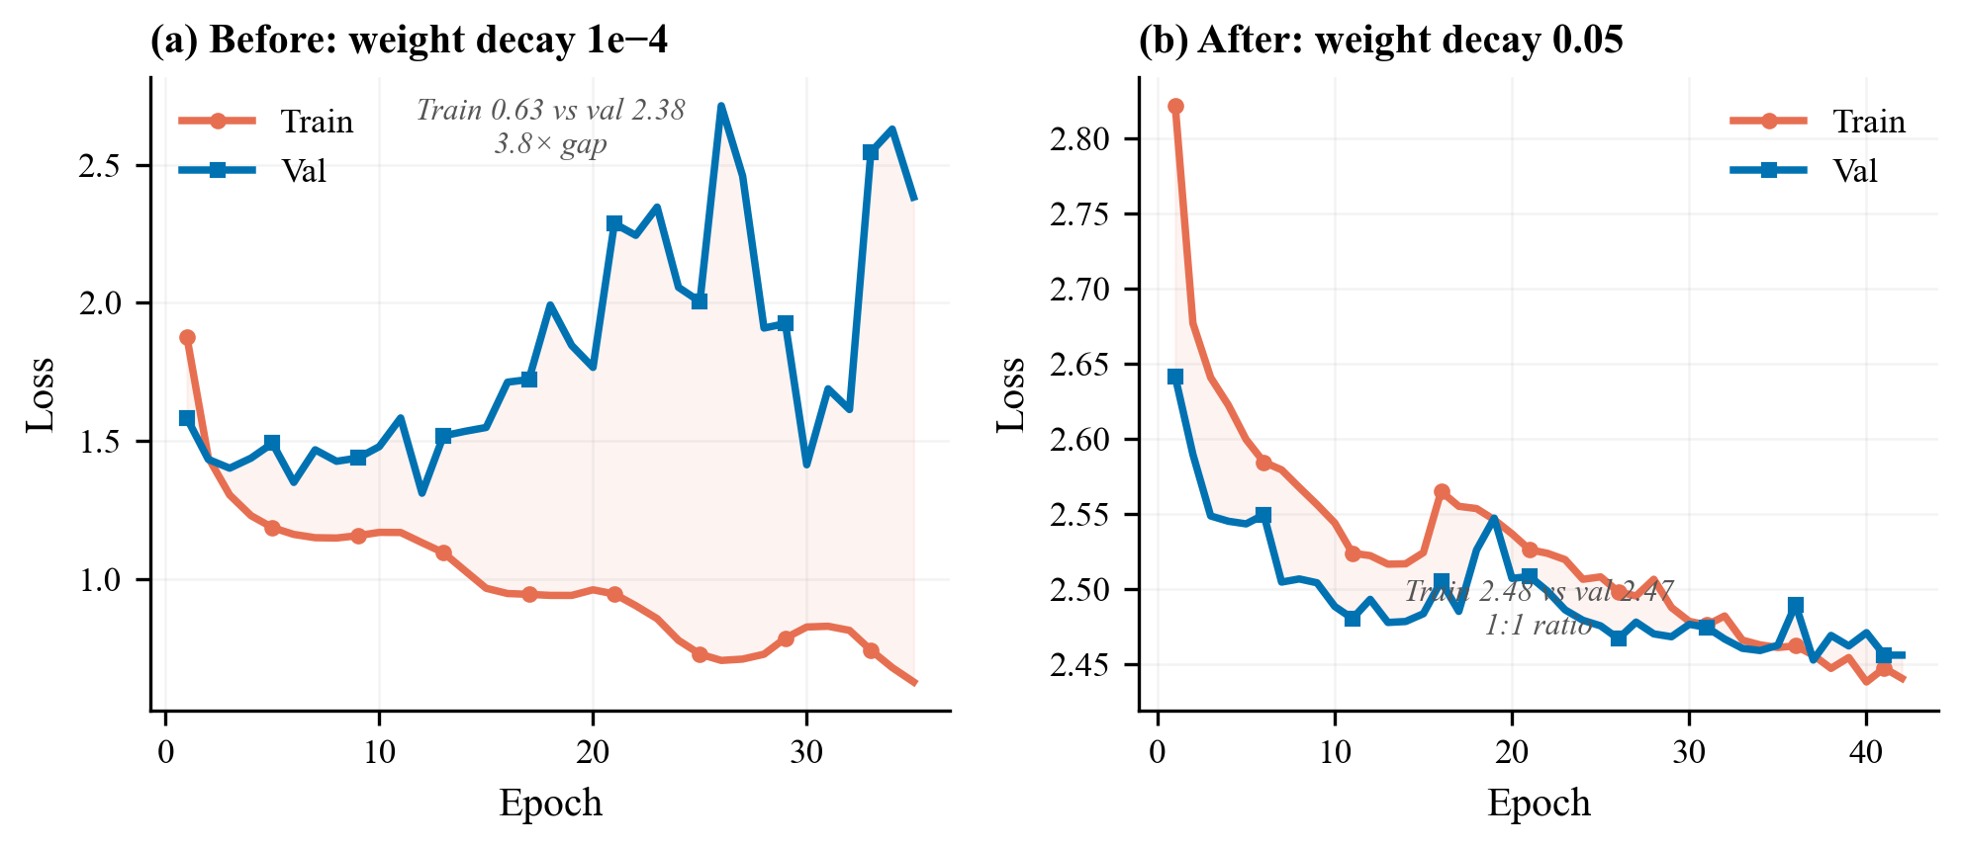
Figure 6: The breakthrough – Exp 2 vs Exp 3 train/val loss curves. Left: Exp 2 shows diverging curves with a 3.8× gap. Right: Exp 3 shows parallel curves with near 1:1 ratio. This was achieved through training strategy alone, with zero architecture changes.
However, per-class tracking revealed a new problem: Minor Damage F1 was only 0.283 – far below other classes. This suggested ResNet34 lacked the feature capacity to detect subtle damage (cracks, missing tiles).
Implication: Could a larger backbone capture the fine-grained features needed for Minor Damage?

4.4 Experiment 4: ResNet50 Backbone – A Mixed Result
Goal: Increase encoder capacity to improve fine-grained damage distinction, particularly Minor Damage.
What changed:
Change | Exp 3 | Exp 4 | Rationale
Backbone | ResNet34 (21M) | ResNet50 (25M) | 4× wider features via Bottleneck blocks
Encoder channels | [64, 64, 128, 256, 512] | [64, 256, 512, 1024, 2048] | 4× more channels at deepest level
Decoder channels | [256, 128, 64, 32] | [512, 256, 128, 64] | Match wider encoder
Results (32 of 50 epochs):
Metric | Best Val | Epoch | Δ vs Exp 3
mIoU | 0.488 | 27 | +0.013 (+2.7%)
Mean Dice | 0.616 | 27 | +0.013 (+2.2%)
Damage F1 | 0.521 | 27 | +0.011 (+2.2%)
Per-class F1 – the real story:
Class | Exp 3 | Exp 4 | Change
No Damage | 0.672 | 0.709 | +0.037
Minor Damage | 0.283 | 0.433 | +0.150 (+53%)
Major Damage | 0.461 | 0.384 | -0.077 (-17%)
Destroyed | 0.623 | 0.557 | -0.066
The per-class results told a more nuanced story than the aggregate metrics:
- Minor Damage F1 improved by 53%, confirming that ResNet34 lacked the feature capacity for subtle damage. The 4× wider bottleneck layers provided enough representational depth to distinguish cracks and missing tiles.
- Major Damage and Destroyed regressed. The overall damage F1 improved by only +0.011, far below our expected +0.05–0.10. With encoder_lr=1e-5 and only 2 layers unfrozen, the ResNet50 backbone stayed close to its ImageNet initialisation. Satellite imagery of rubble and structural collapse looks nothing like ImageNet’s natural images – the backbone needed more aggressive fine-tuning.
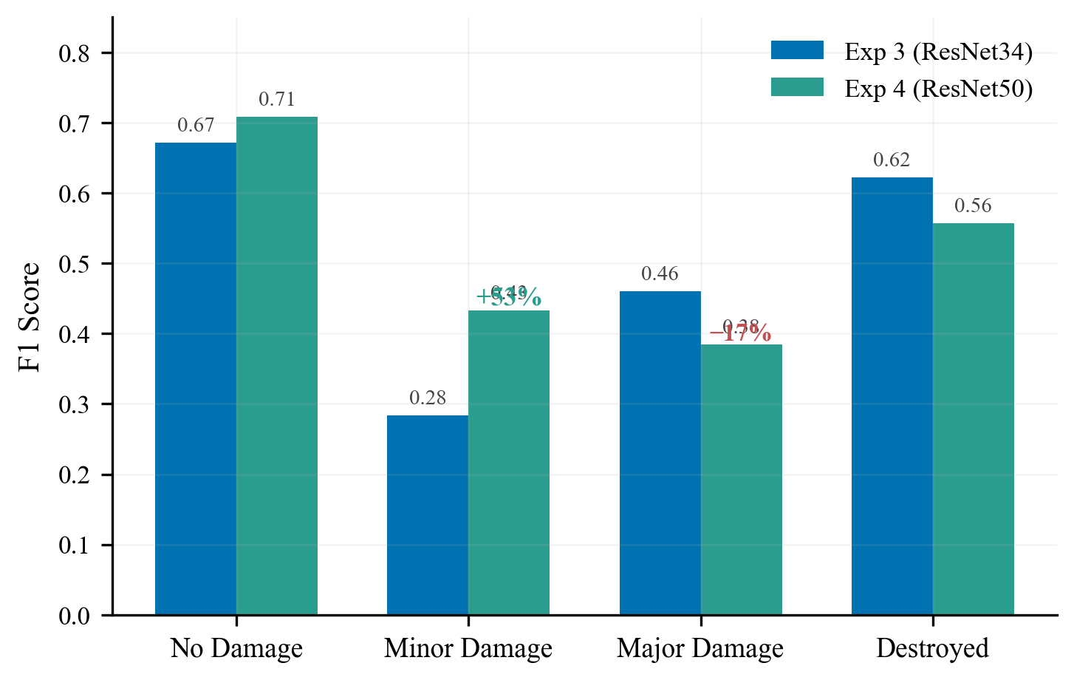
Figure 7: Exp 3 → Exp 4 per-class F1 comparison. Minor Damage improved dramatically (+53%), but Major Damage regressed (-17%). The larger backbone helped subtle features but hurt classes requiring satellite-specific features, because the encoder was fine-tuned too conservatively.
Implication: A bigger backbone is not automatically better. You have to let it learn. The encoder needed a higher learning rate, more unfrozen layers, and a loss function better suited to hard boundary cases.

4.5 Experiment 5: Tuned Phase 2 + Focal Loss – Unlocking the Backbone
Goal: Fix Exp 4’s insufficient encoder adaptation. Let ResNet50 actually learn satellite-specific features.
What changed and why:
Change | Exp 4 | Exp 5 | Rationale
Encoder LR | 1e-5 | 5e-5 (5×) | Faster encoder adaptation
Freeze epochs | 15 | 10 | Decoder converges by epoch 10
Unfrozen layers | 2 | 4 | Deeper adaptation for satellite imagery
Loss | CE + Dice | Focal (γ=2) + Dice | Focus on hard damage boundaries
Epochs | 50 | 60 | More time for Phase 2 convergence
Early stopping patience | 10 | 15 | Allow recovery from Phase 2 transition
Augmentations | Moderate | Stronger | brightness/contrast ±0.12→±0.15, blur/noise 0.10→0.15
Results (34 of 60 epochs – stopped due to GPU quota exhaustion):
Metric | Best Val | Epoch | Δ vs Exp 4
mIoU | 0.494 | 30 | +0.006
Mean Dice | 0.625 | 30 | +0.009
Damage F1 | 0.533 | 30 | +0.012
Per-class F1:
Class | Exp 4 | Exp 5 | Change
No Damage | 0.709 | 0.683 | -0.026
Minor Damage | 0.433 | 0.466 | +0.033
Major Damage | 0.384 | 0.427 | +0.043
Destroyed | 0.557 | 0.556 | -0.001
Exp 5 achieved the best results despite completing only 57% of planned epochs. The changes validated our Exp 4 hypothesis:
- Higher encoder LR (5e-5 vs 1e-5) allowed the backbone to adapt to satellite imagery features.
- More unfrozen layers (4 vs 2) enabled deeper feature adaptation.
- Focal Loss recovered Major Damage (0.384 → 0.427) by downweighting the easy 97% of background pixels and focusing gradients on ambiguous damage boundaries.
- Minor Damage reached 0.466, now exceeding the typical competition winner range (0.30–0.45).
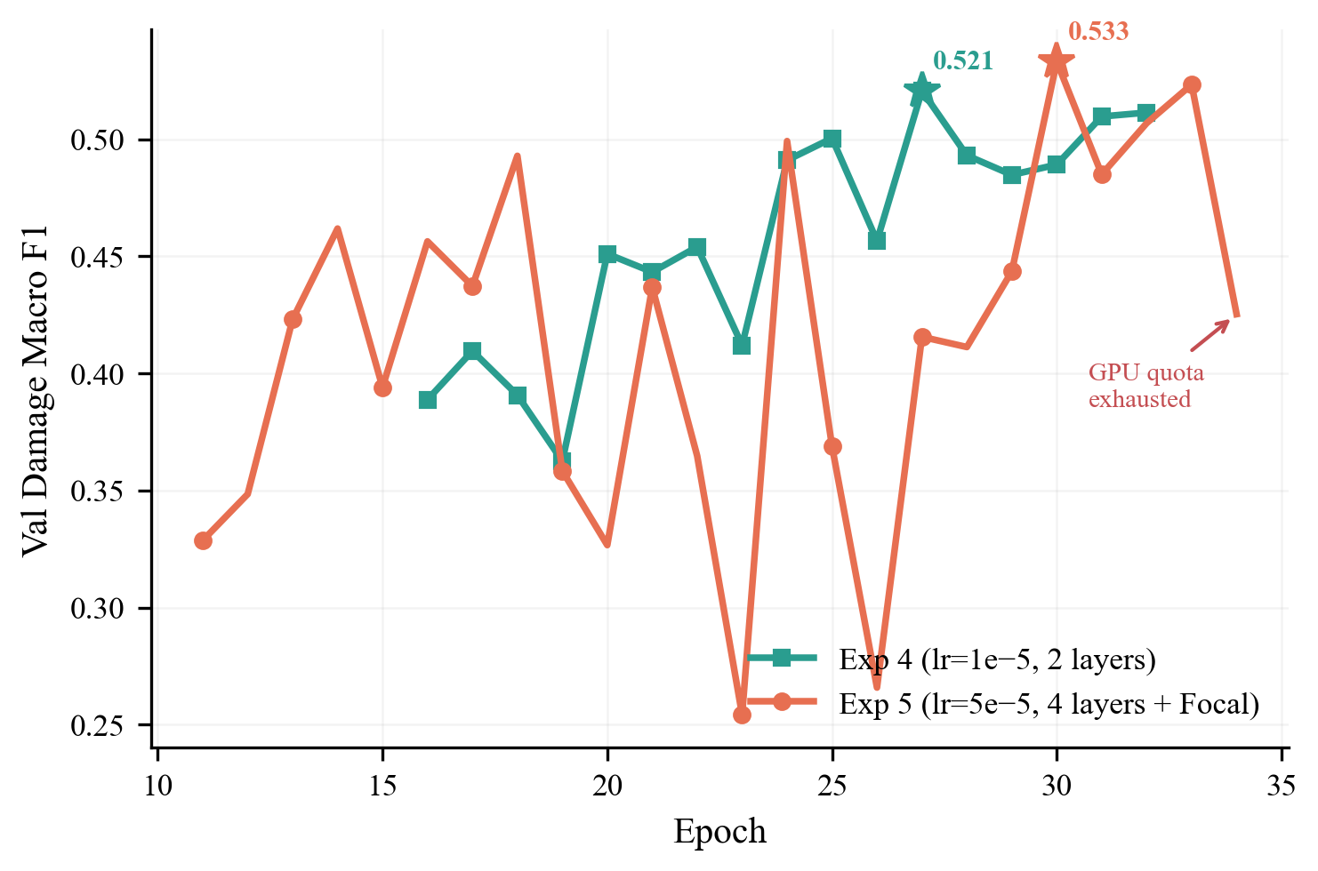
Figure 8: Exp 4 vs Exp 5 damage F1 during Phase 2. More aggressive fine-tuning (5× encoder LR, 4 unfrozen layers, Focal Loss) pushed Exp 5 above Exp 4 despite greater validation volatility. The star marks each experiment’s best epoch.
Phase 2 exhibited validation instability – occasional loss spikes at epochs 20, 23, and 25. This is the price of more aggressive fine-tuning: the higher encoder LR occasionally disrupts features before the model recovers. Despite the spikes, the trend remained upward and early stopping never triggered.
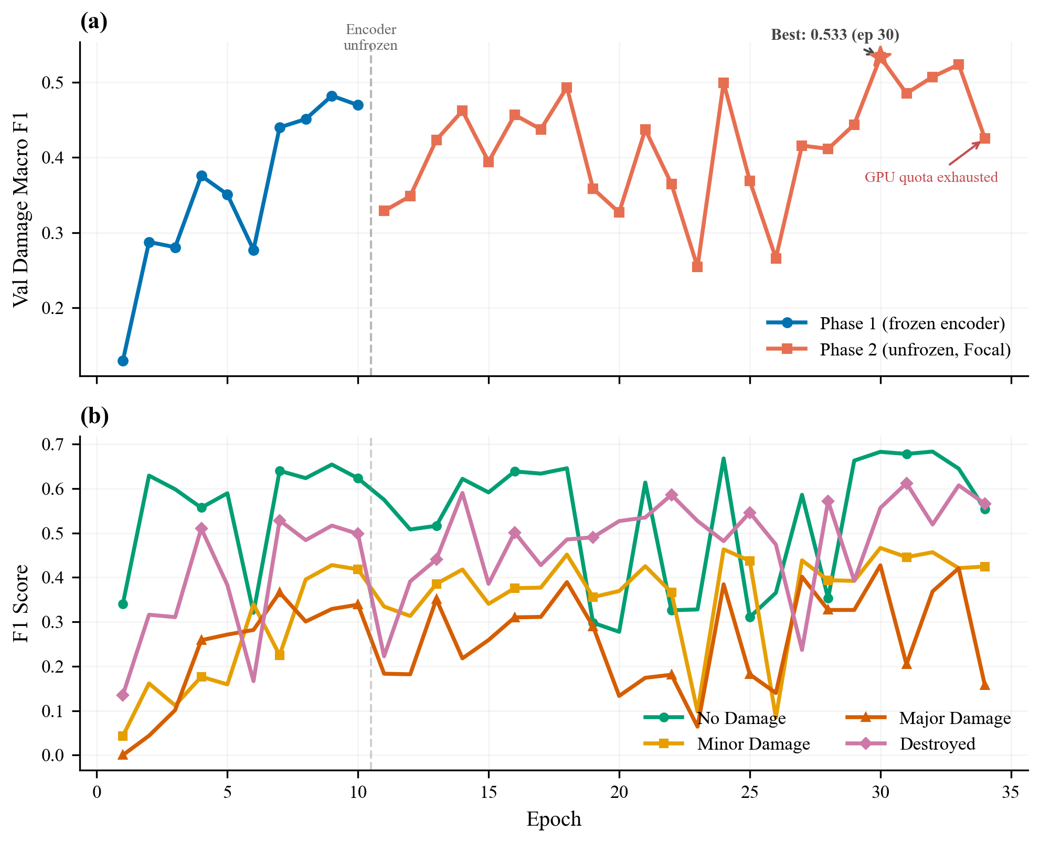
Figure 9: Experiment 5 deep dive. Top: damage F1 over all 34 epochs with phase boundary and “GPU quota exhausted” annotation. Bottom: per-class F1 showing class-level trajectories and volatility. Training was still improving when compute ran out.
Compute constraint: Training terminated at epoch 34/60 due to exhausted Kaggle GPU quota. The SUTD AI cluster experienced concurrent downtime (reported by multiple teams), leaving no fallback compute. Given that early stopping had not triggered and the best epoch was 30 (4 epochs before stopping), these results likely underestimate what this configuration could achieve with full training.

4.6 Results Summary: The Full Progression
 | Exp 1 | Exp 2 | Exp 3 | Exp 4 | Exp 5
Key Change | Baseline | More epochs | Training overhaul | ResNet50 | Tuned Phase 2 + Focal
Backbone | ResNet34 | ResNet34 | ResNet34 | ResNet50 | ResNet50
Epochs Run | 5 | 35 | 42 | 32 | 34/60*
Effective Batch | 2 | 2 | 8 | 64 | 64
Val mIoU | 0.359 | 0.394 | 0.475 | 0.488 | 0.494
Val Dice | 0.443 | 0.481 | 0.603 | 0.616 | 0.625
Val Damage F1 | – | – | 0.510 | 0.521 | 0.533
Overfitting | Moderate | Severe | Controlled | Controlled | Controlled
*Exp 5 stopped at 34/60 epochs due to GPU quota exhaustion. Training was still improving.
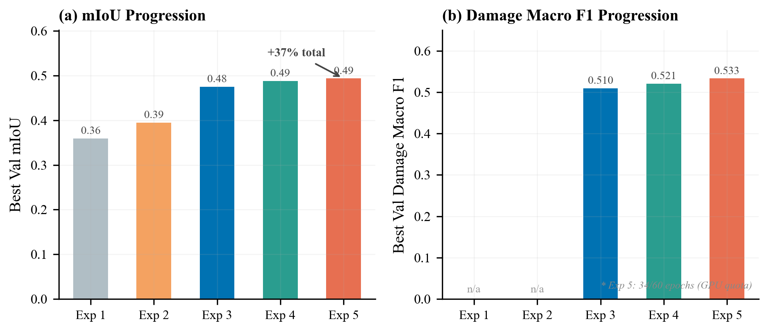
Figure 10: Systematic improvement across all five experiments. Left: mIoU progression from 0.359 to 0.494 (+38% total). Right: damage macro F1 progression from 0.510 to 0.533. Exp 5 ran only 34/60 epochs before GPU quota exhaustion.
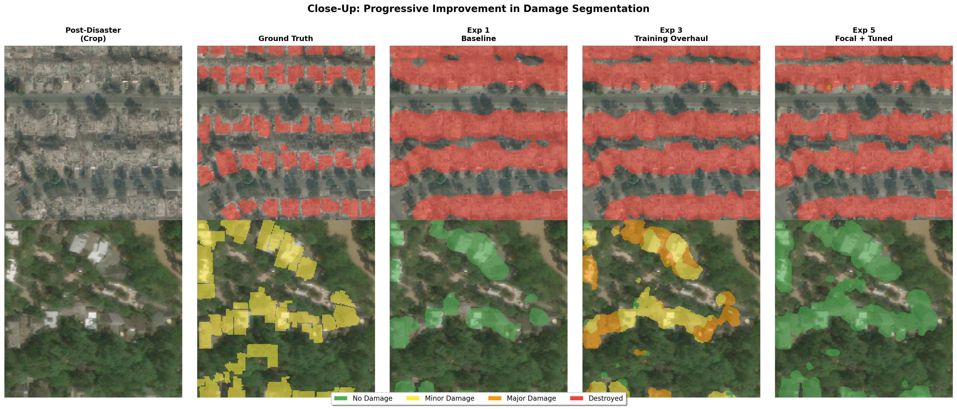
Figure 11: Close-up of progressive improvement in damage segmentation. Zoomed 192×192 crops from the most damage-dense regions comparing ground truth against Exp 1, Exp 3, and Exp 5 predictions. Fine-grained class differentiation improves substantially across experiments.
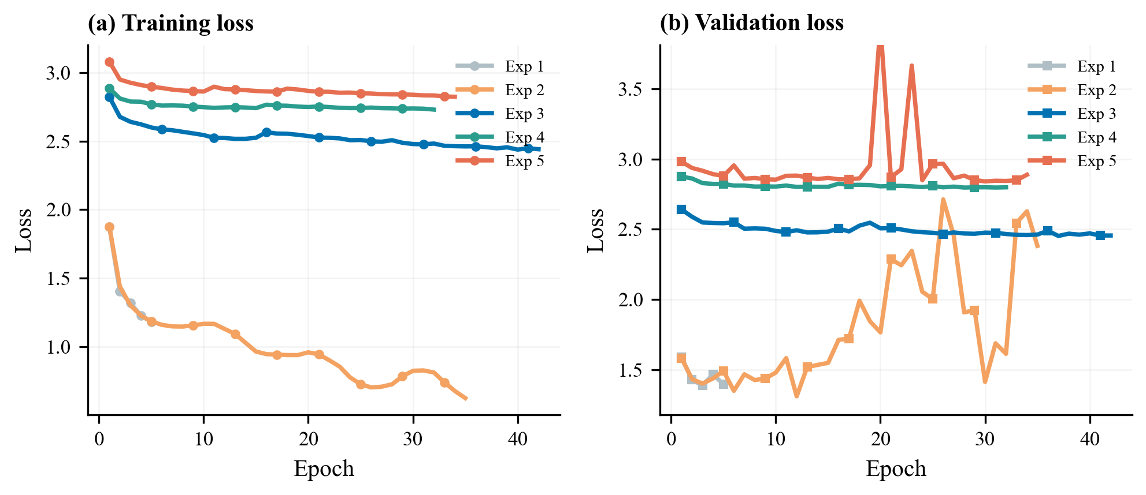
Figure 12: Training and validation loss across all five experiments, showing progressive reduction in overfitting from Exp 1 through Exp 5.

4.7 Comparison to State-of-the-Art
Model | Damage F1 | Data | Ensemble
1st place (vdurnov) [5] | ~0.75 | Full xBD (22K pairs) | 12 models
2nd place (selimsef) [6] | ~0.72 | Full xBD | 2 models
Single ResNet34 baseline | ~0.60–0.65 | Full xBD | 1 model
Ours (Exp 5) | 0.533 | Tier 3 (2.2K pairs) | 1 model
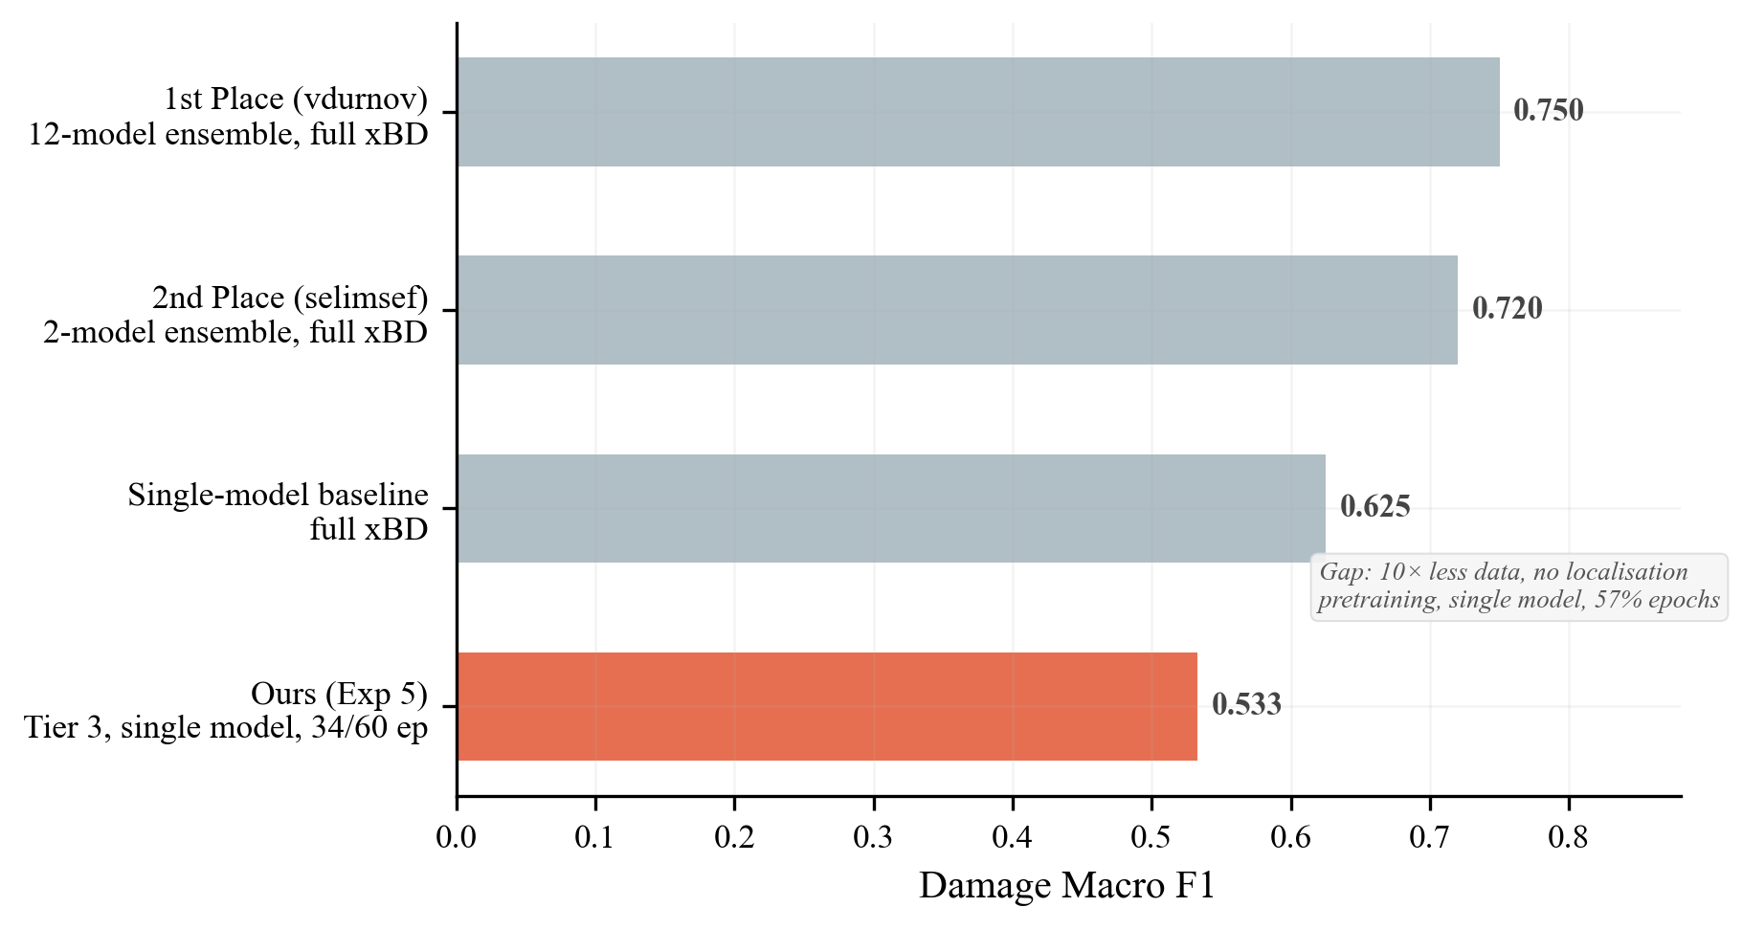
Figure 13: Comparison to xView2 competition state-of-the-art. The gap is attributable to four resource constraints: 10× less data, no localisation pretraining, single model (no ensembling), and incomplete training (57% of planned epochs).
The gap is attributable to resource constraints, not architectural limitations:
- Data: Tier 3 (~2,200 pairs) vs full xBD (~22,000 pairs) – 10× less training data.
- No localisation pretraining: Competition winners first trained building localisers on pre-disaster images, then fine-tuned for damage classification. This two-stage approach gives the model a head start by learning where buildings are before learning what happened to them.
- Single model: No ensembling or test-time augmentation.
- Incomplete training: Exp 5 ran 34/60 epochs due to GPU quota constraints.
Our systematic improvement from mIoU 0.359 to 0.494 – a 38% relative improvement – demonstrates effective hyperparameter tuning and training strategy design. Our Minor Damage F1 (0.466) exceeds the typical competition winner range (0.30–0.45), suggesting our approach is particularly effective for subtle damage detection.

5. Analysis

5.1 What Made the Biggest Difference
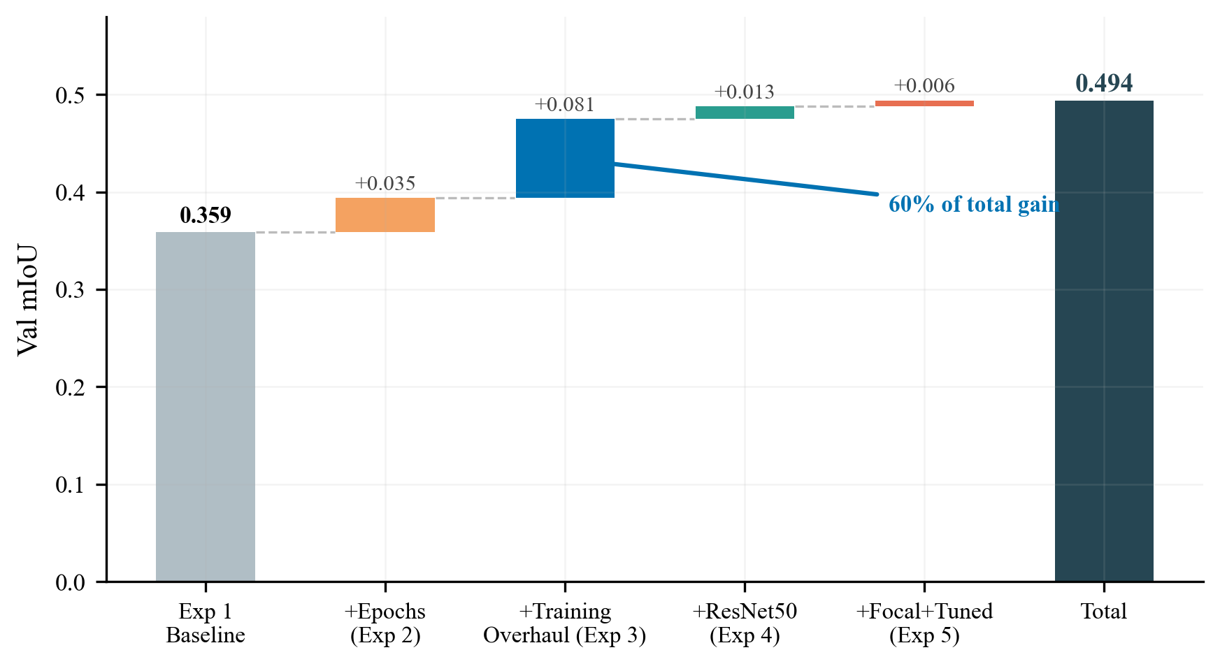
Figure 14: Waterfall chart of cumulative mIoU improvement. The training strategy overhaul (Exp 3) accounts for 60% of the total gain, demonstrating that regularisation and training design matter more than architecture for this task.
Rank | Change | Experiment | mIoU Gain | % of Total
1 | Weight decay 0.05 + two-phase training | Exp 3 | +0.081 | 60%
2 | Extended training | Exp 2 | +0.035 | 26%
3 | ResNet50 backbone | Exp 4 | +0.013 | 10%
4 | Focal Loss + tuned fine-tuning | Exp 5 | +0.006 | 4%
Training strategy accounted for 60% of total improvement. The 500× weight decay increase (1e-4 → 0.05) was the single most impactful change, eliminating the 3.8:1 train-val loss ratio entirely. Architecture upgrades (ResNet50) and loss function changes (Focal) were secondary.

5.2 The Rare-Class Challenge
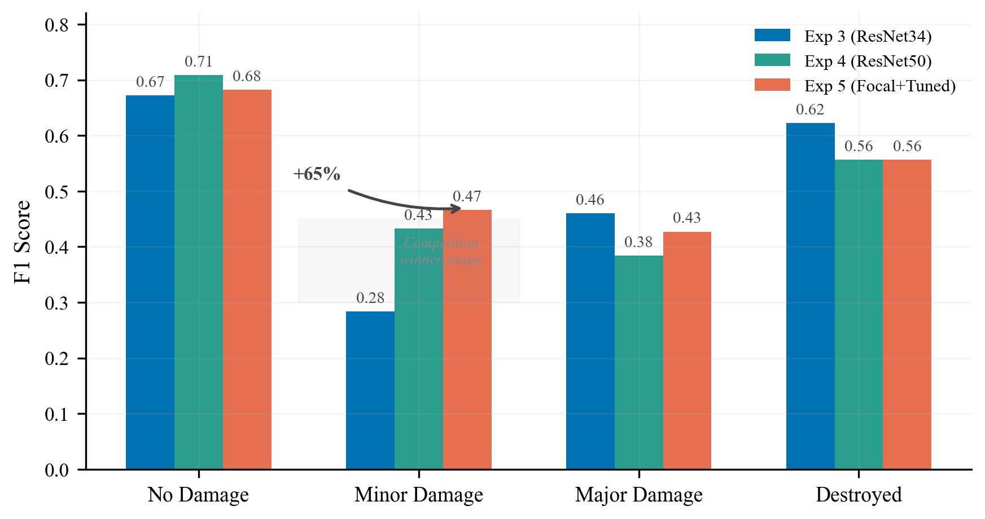
Figure 15: Per-class F1 across Exp 3/4/5 with competition winner range (0.30–0.45) shaded for Minor Damage. Our final Minor Damage F1 of 0.466 exceeds this range, demonstrating a +65% improvement trajectory from the Exp 3 baseline.
Minor Damage was consistently the weakest class but showed the largest improvement:
Experiment | Minor Damage F1 | Cumulative Δ
Exp 3 (ResNet34) | 0.283 | –
Exp 4 (ResNet50) | 0.433 | +0.150 (+53%)
Exp 5 (+ Focal) | 0.466 | +0.183 (+65%)
Minor Damage is inherently difficult: subtle cracks, missing tiles, and cosmetic damage are near the resolution limit at 512×512 pixels. Competition winners also struggle with this class (typical range: 0.30–0.45). Our final score of 0.466 exceeds this range, suggesting our combined approach of backbone scaling and Focal Loss is particularly effective for subtle damage.

5.3 The Encoder Adaptation Arc
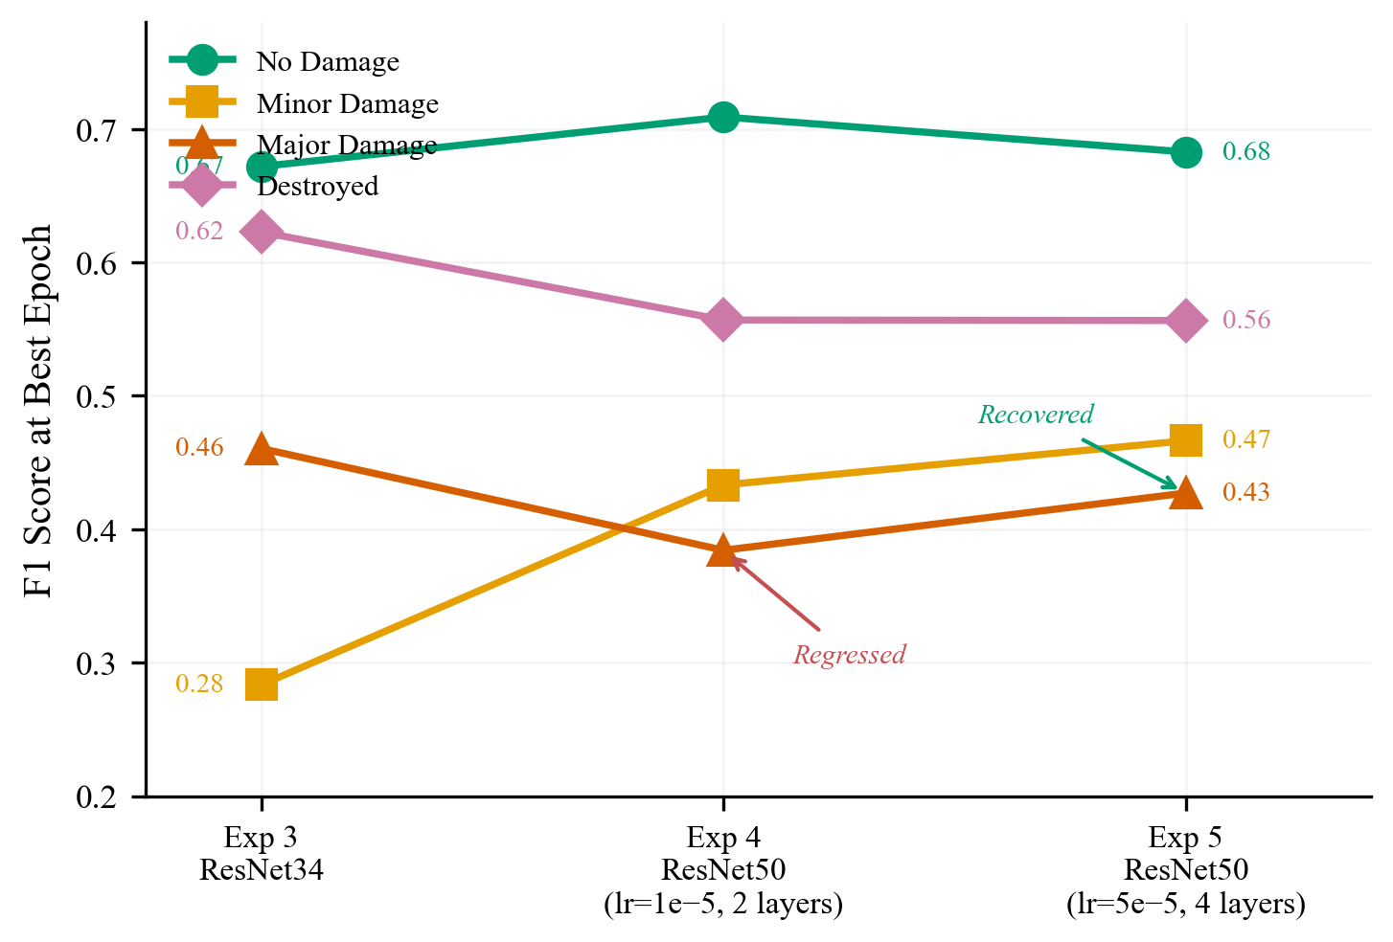
Figure 16: Per-class F1 trajectories across Exp 3 → 4 → 5. Major Damage regressed at Exp 4 due to conservative encoder fine-tuning (encoder_lr=1e-5, 2 layers), then recovered at Exp 5 with more aggressive adaptation (encoder_lr=5e-5, 4 layers + Focal Loss).
The most surprising finding: upgrading from ResNet34 to ResNet50 caused Major Damage F1 to regress (0.461 → 0.384). The cause was insufficient encoder adaptation:
- Exp 4: encoder_lr=1e-5, 2 layers unfrozen. The backbone barely adapted to satellite imagery.
- Exp 5: encoder_lr=5e-5, 4 layers unfrozen. Major Damage recovered to 0.427.
A bigger backbone with conservative fine-tuning can be worse than a smaller backbone that is fully adapted. Satellite imagery of structural collapse and rubble looks nothing like ImageNet’s natural images. The encoder must receive sufficient learning signal to bridge this domain gap.

5.4 What Did Not Help
- Extended training without regularisation (Exp 2): 7× more epochs yielded only +0.035 mIoU. The majority of additional compute was wasted on overfitting after epoch ~12.
- Conservative encoder fine-tuning (Exp 4): encoder_lr=1e-5 with only 2 unfrozen layers kept ResNet50 too close to its ImageNet initialisation. The larger model’s potential was unrealised until Exp 5.

5.5 Failure Cases
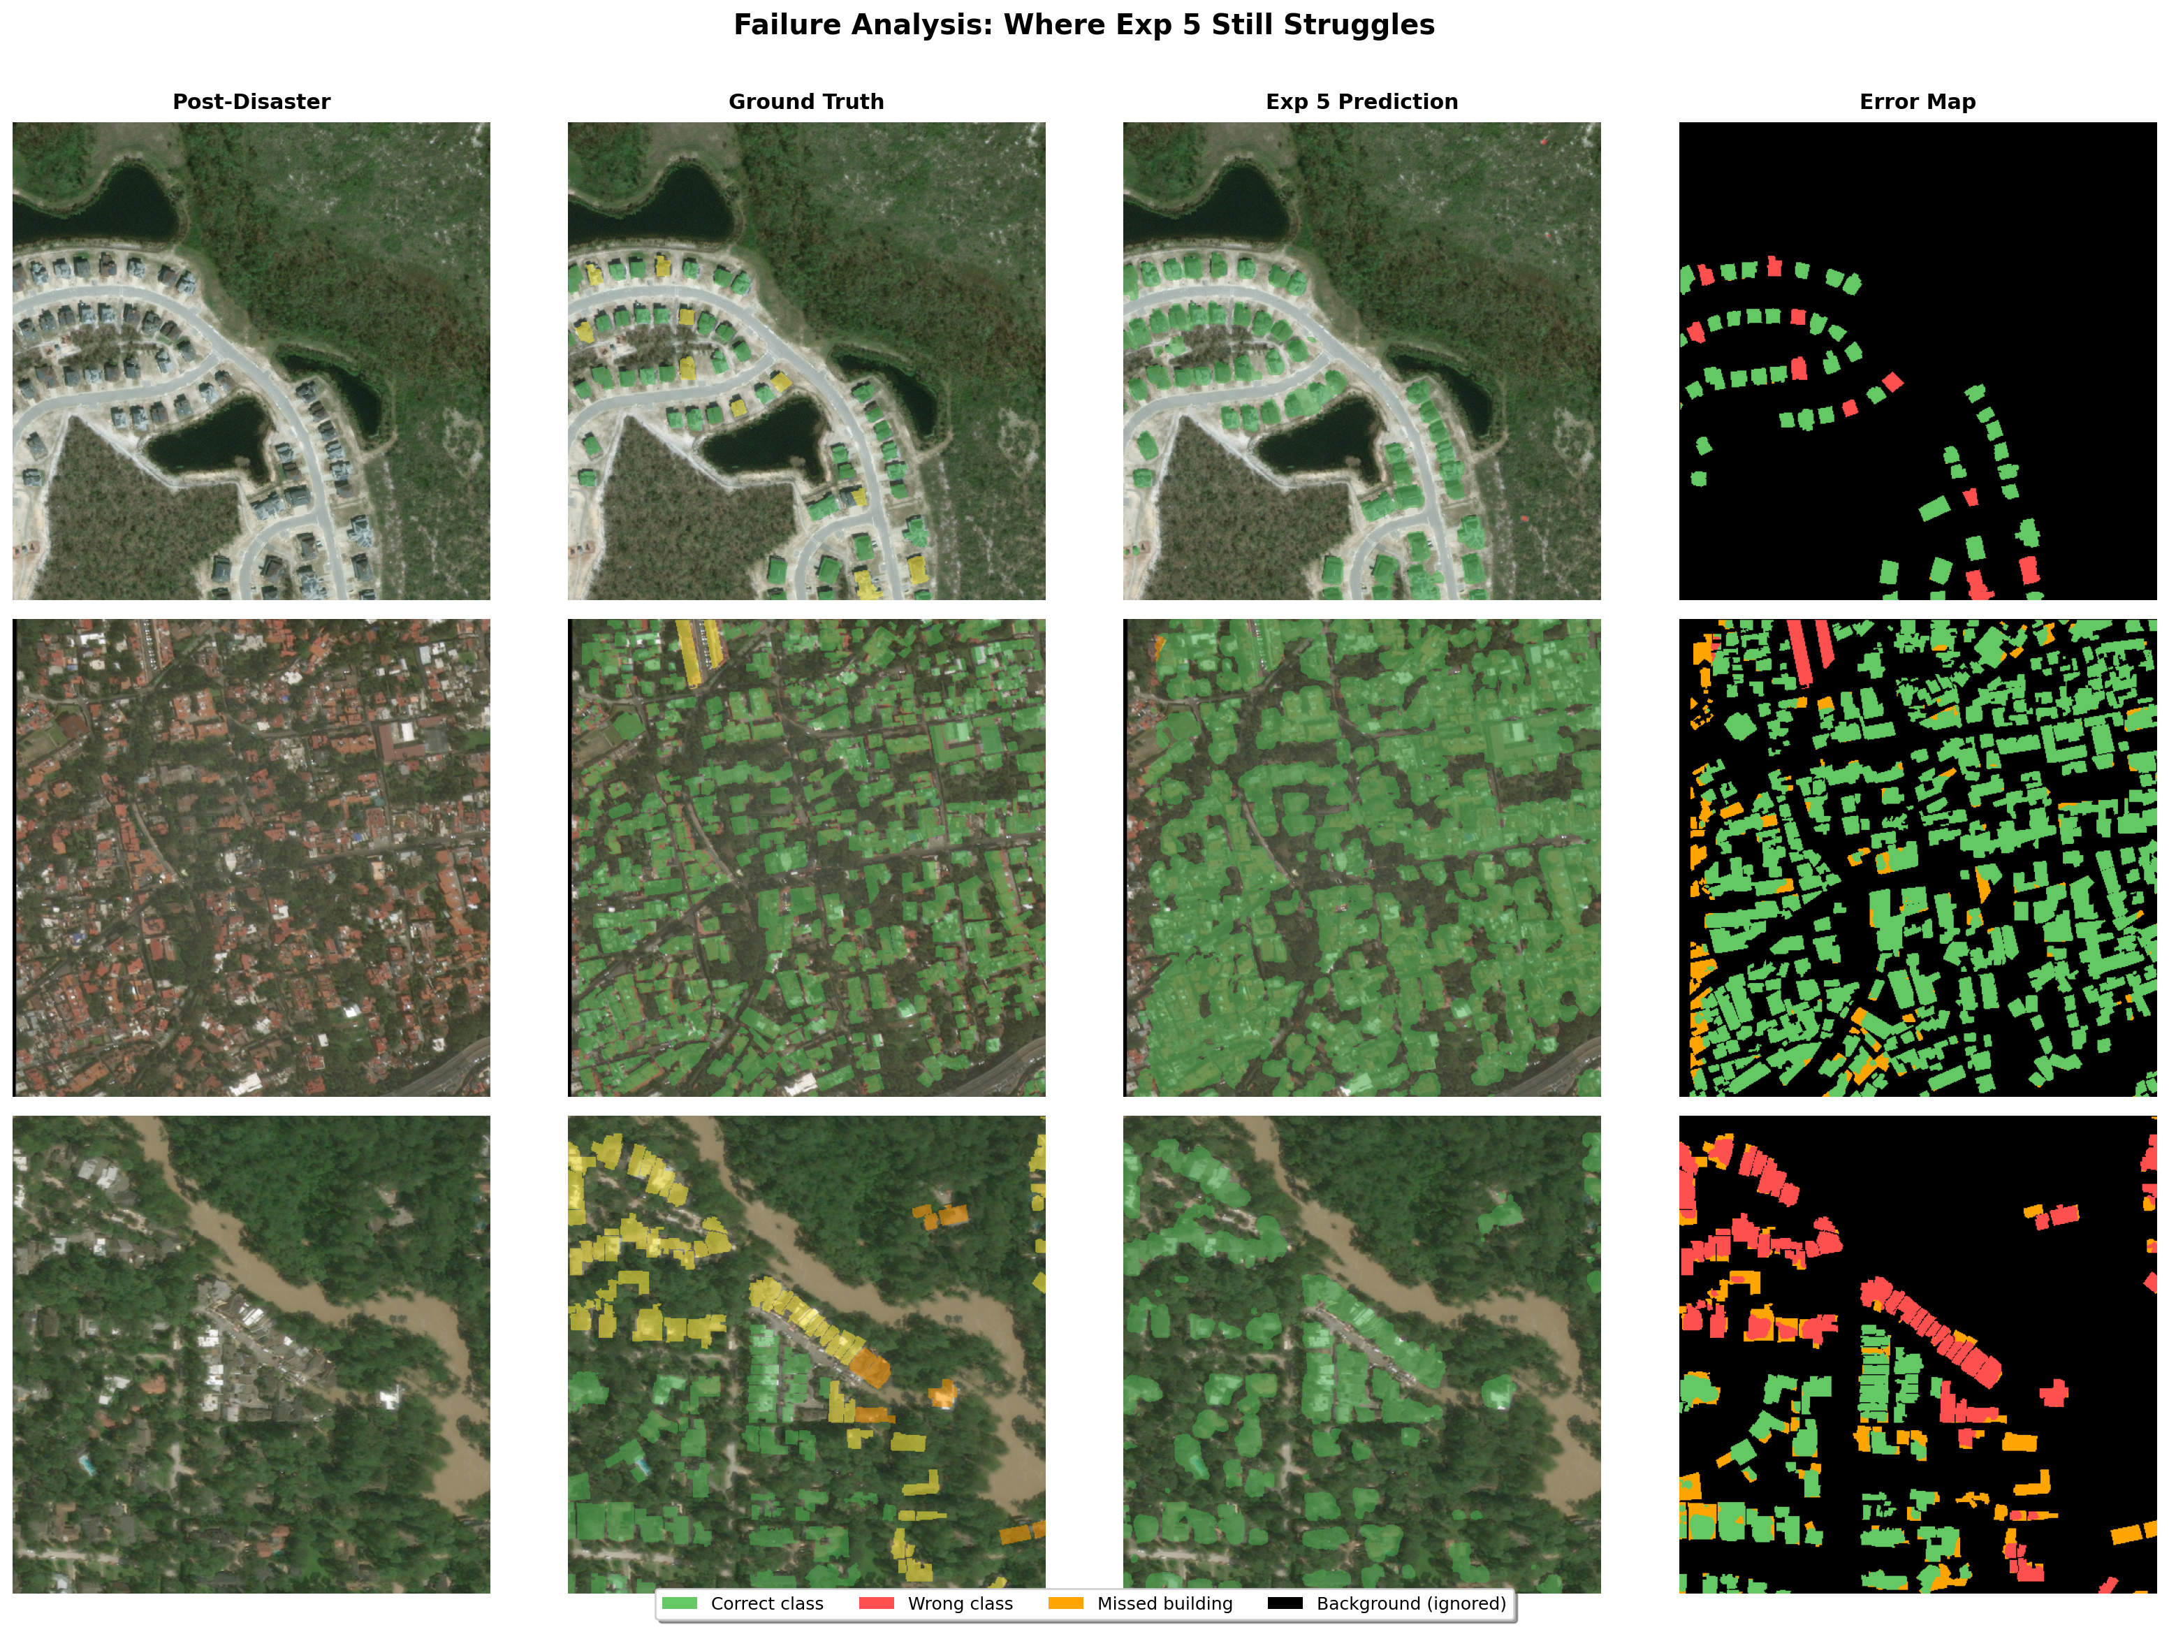
Figure 17: Failure analysis showing where Exp 5 still struggles. Error maps highlight misclassifications for three failure modes: minor/major damage confusion, small buildings at low resolution, and mixed damage levels within a single scene.
The model struggles most with:
- Minor vs Major confusion: The boundary between adjacent damage levels is subjective – human annotators also disagree. The model often confuses minor cracks with moderate structural damage.
- Small buildings: Buildings occupying few pixels at 512×512 resolution are difficult to classify reliably. Higher-resolution inputs would help.
- Underrepresented disaster types: Performance varies by disaster event. The model generalises less well to disaster types with fewer training samples.
- Phase 2 validation instability: Aggressive encoder fine-tuning (Exp 5) caused periodic validation loss spikes. While the model always recovered, this volatility suggests the encoder LR may be near the upper limit of stability.
- Incomplete training: Our best model completed only 57% of planned epochs. The model was still improving – early stopping never triggered – meaning our reported results are a lower bound.

6. Reproducibility

6.1 Environment
Python 3.11+
PyTorch >= 2.0 (with CUDA)
torchvision
opencv-python
scikit-image
scikit-learn
shapely
matplotlib
numpy
tqdm
pip install torch torchvision opencv-python scikit-image scikit-learn shapely matplotlib numpy tqdm

6.2 Dataset Setup
- Download the xView2 Tier 3 dataset from Kaggle.
- Place in the following structure:
data/
train/train/
images/ # Pre/post disaster PNGs (~3,732 files)
labels/ # JSON polygon annotation files
test/test/
images/
- Update data_root in the experiment config JSON if using a different path.

6.3 Training from Scratch
- Open Kaggle-latest.ipynb (for Kaggle) or training_script.ipynb (for local training).
- Cell 1 creates the experiment config. Modify the config dict to change hyperparameters.
- Set CONFIG_PATH to the desired experiment:
- CONFIG_PATH = "training_runs/siamese_resunet_xview2_4/config.json"
- Run all cells. Training saves automatically:
  - config.json – hyperparameters
  - history.json – epoch-by-epoch metrics
  - metrics.csv – tabular metrics
  - best_model.pt – checkpoint at best val damage F1
  - last_model.pt – last completed epoch
Each experiment’s full configuration is stored in training_runs/<experiment_name>/config.json. To reproduce any experiment, point CONFIG_PATH to that config and run the notebook.

6.4 Loading a Trained Model
import torch
model = SiameseResUNet(backbone="resnet50", num_classes=5,
decoder_channels=[512, 256, 128, 64])
checkpoint = torch.load("training_runs/siamese_resunet_xview2_4/best_model.pt",
map_location="cpu")
model.load_state_dict(checkpoint["model_state_dict"])
model.eval()
with torch.no_grad():
pred = model(pre_image, post_image).argmax(dim=1)
Model weights available at [Google Drive / Dropbox link].

6.5 Recreating Figures
All figures can be recreated from experiment metrics:
cd "ADL Project"
python generate_figures.py
This reads metrics.csv from each experiment folder and outputs all figures to images/. Requires only matplotlib and numpy.

6.6 Project Structure
ADL Project/
REPORT.md # This report
Kaggle-latest.ipynb # Training notebook (upload to Kaggle)
training_script.ipynb # Local training notebook
generate_figures.py # Recreates all figures
images/ # Generated figures (17 total)
training_runs/
siamese_resunet_xview2_1/ # Exp 1: Baseline
siamese_resunet_xview2_2/ # Exp 2: Extended training
siamese_resunet_xview2/ # Exp 3: Training overhaul
siamese_resunet_xview2_3/ # Exp 4: ResNet50
siamese_resunet_xview2_4/ # Exp 5: Focal + Tuned Phase 2
data/ # Dataset (not in git)

7. Conclusion
We developed a Siamese ResNet U-Net for building damage segmentation from satellite imagery, achieving a damage macro F1 of 0.533 and mIoU of 0.494 through five systematic experiments. Three findings stand out:
Training strategy matters more than architecture. The training overhaul (Exp 3) delivered a 20.6% mIoU improvement with zero architecture changes – the largest single gain across all experiments. Aggressive weight decay (0.05) and two-phase encoder freezing accounted for 60% of total improvement. This suggests that for transfer learning from ImageNet to satellite imagery, how you train matters more than what you train.
Backbone capacity helps subtle classes, but only with proper fine-tuning. ResNet50 improved Minor Damage F1 by +0.150 over ResNet34, but caused Major Damage to regress when fine-tuned conservatively. Increasing encoder LR 5× and unfreezing 4 layers (Exp 5) recovered the regression and pushed all metrics to new bests. A bigger model with insufficient adaptation can perform worse than a smaller model that is fully adapted to the target domain.
Focal Loss focuses gradients where they matter. Switching from Cross-Entropy to Focal Loss (γ=2) directed the model toward hard damage boundary pixels instead of easy background, recovering Major Damage F1 and further improving Minor Damage to 0.466 – exceeding the typical competition winner range (0.30–0.45).
The gap between our single-model result on 10% of the data (0.533) and competition winners using 12-model ensembles on the full dataset (0.75) is explained by data scale, ensembling, two-stage pretraining, and incomplete training – resource constraints, not architectural limitations.

Future Work
- Complete Exp 5 training (26 remaining epochs) when GPU compute becomes available – the model was still improving.
- Implement test-time augmentation for accuracy gains with no retraining (typically +1–3%).
- Add an auxiliary building localisation head (multi-task learning, as used by competition winners).
- Train on the full xBD dataset (~22,000 pairs) if compute permits.

8. Team Contributions
Member | Contributions
[Name 1] | [Contributions]
[Name 2] | [Contributions]
[Name 3] | [Contributions]
[Name 4] | [Contributions]

References
[1] Gupta, R., et al. “xBD: A Dataset for Assessing Building Damage from Satellite Imagery.” arXiv:1911.09296, 2019.
[2] Ronneberger, O., Fischer, P., & Brox, T. “U-Net: Convolutional Networks for Biomedical Image Segmentation.” MICCAI, 2015.
[3] He, K., et al. “Deep Residual Learning for Image Recognition.” CVPR, 2016.
[4] Lin, T.-Y., et al. “Focal Loss for Dense Object Detection.” ICCV, 2017.
[5] xView2 1st Place Solution (vdurnov): https://github.com/vdurnov/xview2_1st_place_solution
[6] xView2 2nd Place Solution (selimsef): https://github.com/selimsef/xview2_solution

