xView2 Building Damage Segmentation: A Siamese ResNet U-Net for Disaster Response
Course: 60.001 Applied Deep Learning, Y2026 Team: [Member names and student IDs] GitHub: [Repository URL] Dataset: Kaggle xView2 Tier 3 Model Weights: [Google Drive / Dropbox link]

Abstract
We built a Siamese ResNet U-Net that classifies building damage from satellite imagery into four levels: No Damage, Minor Damage, Major Damage, and Destroyed. Using the xView2 Tier 3 dataset (~2,200 image pairs), we achieved a damage macro F1 of 0.533 and mIoU of 0.494. The main challenge is extreme class imbalance – 97% of pixels are background. Through five experiments, we found that training strategy (weight decay, two-phase encoder freezing) mattered far more than architecture changes, accounting for 60% of our total improvement. Our Minor Damage F1 of 0.466 exceeds the typical range of xView2 competition winners (0.30–0.45), despite using only 10% of the full dataset with a single model.

1. Introduction
When disasters strike, rapid damage assessment saves lives. Satellite images become available within hours, but manually inspecting thousands of buildings does not scale. We built a deep learning model that takes a pair of satellite images (before and after a disaster) and outputs a pixel-level damage map.
The main challenge is class imbalance: 97% of pixels are background. A model that predicts “background” everywhere gets 97% pixel accuracy but is useless. The hardest class is Minor Damage (only 0.3% of pixels) – even competition winners only achieve 0.30–0.45 F1 on it.
What we contribute:
- A Siamese ResNet U-Net with three-stream fusion that combines pre-disaster, post-disaster, and absolute difference features at every encoder level.
- A two-phase training strategy (freeze encoder first, then fine-tune with lower learning rate) that eliminated severe overfitting and gave us the biggest single improvement (+20.6% mIoU) without changing the architecture.
- Five systematic experiments where each one builds on what we learned from the previous, showing that training strategy accounts for 60% of total improvement.
- A Minor Damage F1 of 0.466, beating the typical competition winner range despite having 10x less data.
We improved from a baseline mIoU of 0.359 to 0.494 – a 38% relative improvement across five experiments.

2. Dataset

2.1 Source
The xView2 dataset [1] was created by the Defense Innovation Unit for the xView2 Building Damage Assessment Challenge. It contains WorldView-3 satellite imagery across multiple disaster types: earthquakes, hurricanes, wildfires, volcanic eruptions, and floods.

2.2 Structure
Property | Value
Image pairs | ~2,200 (pre + post disaster)
Original resolution | 1024 x 1024 px
Training resolution | 512 x 512 px
Annotation format | GeoJSON polygons per building
Split | 80% train / 10% val / 10% test (seed=42)

2.3 Class Distribution
The dataset is extremely imbalanced:
Class | Pixel % | Description
Background | ~97% | Non-building pixels
No Damage | ~1.5% | Intact buildings
Minor Damage | ~0.3% | Cracks, missing tiles
Major Damage | ~0.5% | Structural damage
Destroyed | ~0.7% | Collapsed buildings
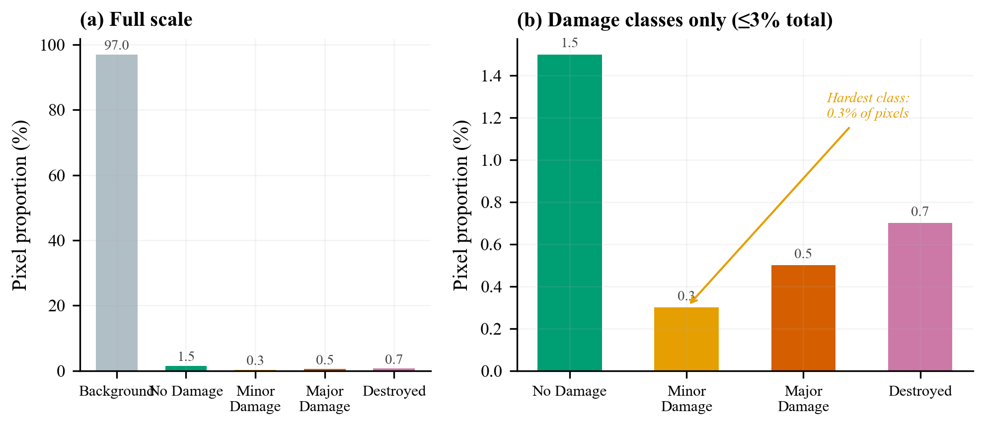
Figure 1: Class distribution. Background dominates at ~97%. All four damage classes combined occupy less than 3% of pixels.
Because of this imbalance, we use damage macro F1 (macro average of F1 for classes 1–4, excluding background) as our main metric instead of pixel accuracy.

2.4 Preprocessing
- Polygon annotations converted to pixel masks using Shapely and scikit-image
- Images resized from 1024x1024 to 512x512
- ImageNet normalisation applied (mean=[0.485, 0.456, 0.406], std=[0.229, 0.224, 0.225])

2.5 Data Augmentation
Augmentation | Probability | Purpose
Horizontal flip | 0.5 | Orientation invariance
Vertical flip | 0.2 | Orientation invariance
Random 90° rotation | 0.5 | Rotation invariance
Brightness jitter | ±0.15 | Lighting robustness
Contrast jitter | ±0.15 | Lighting robustness
Saturation jitter | ±0.10 | Colour robustness
Gaussian blur | 0.15 | Resolution robustness
Gaussian noise | 0.15 | Sensor noise robustness

3. Method

3.1 Architecture: Siamese ResNet U-Net
Our model has three parts: a shared encoder, fusion blocks, and a decoder.
Pre-disaster image ──► [Shared ResNet Encoder] ──┐
├──► FusionBlocks (×5) ──► U-Net Decoder ──► 5-class Map
Post-disaster image ──► [Shared ResNet Encoder] ──┘
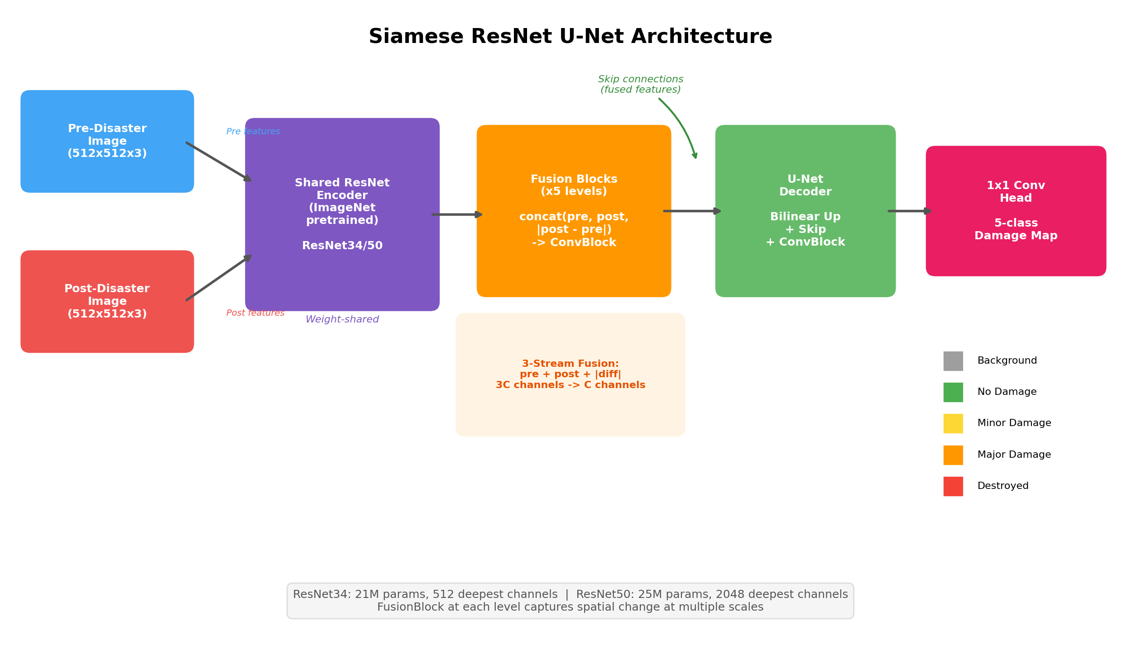
Figure 2: Model architecture. Both images pass through the same ResNet encoder. FusionBlocks combine the features at each level. The U-Net decoder produces the final 5-class damage map.

Shared Encoder
Both the pre- and post-disaster images pass through the same ResNet encoder (pretrained on ImageNet). Sharing weights ensures both images are in the same feature space. We tried two backbones:
Backbone | Parameters | Deepest Channels
ResNet34 | 21M | 512
ResNet50 | 25M | 2048 (4x wider)

Fusion Blocks
At each encoder level, we combine the pre and post features:
FusionBlock(pre, post):
diff = |post - pre| # What changed
x = concat(pre, post, diff) # Stack all three
x = ConvBlock(x) # Compress back
return x
The absolute difference |post - pre| gives the model a direct signal of what changed between the two images.

U-Net Decoder
Standard U-Net decoder with skip connections from the fused features. Each level upsamples, concatenates the skip connection, and applies two Conv-BN-ReLU blocks. The final 1x1 convolution outputs 5 classes.

3.2 Loss Function
We use Focal Loss + Dice Loss (final configuration):
Component | What it does
Focal Loss (γ=2) | Reduces the influence of easy background pixels so the model focuses on hard damage boundaries
Dice Loss | Measures region overlap, naturally handles class imbalance
Log-inverse class weights | Gives more importance to rare damage classes
Label smoothing (0.05) | Prevents overconfident predictions
Earlier experiments used Cross-Entropy instead of Focal Loss. We switched in Exp 5 because Major Damage F1 was dropping.

3.3 Two-Phase Training
This was our most important design decision:
Phase 1 (Frozen Encoder): We freeze the ResNet encoder and only train the decoder and fusion blocks. This lets the decoder learn to work with the pretrained ImageNet features without messing them up.
Phase 2 (Fine-Tuning): We unfreeze the top encoder layers with a much lower learning rate (6–30x lower than the decoder). This lets the encoder gradually adapt to satellite imagery while keeping most of what it learned from ImageNet.
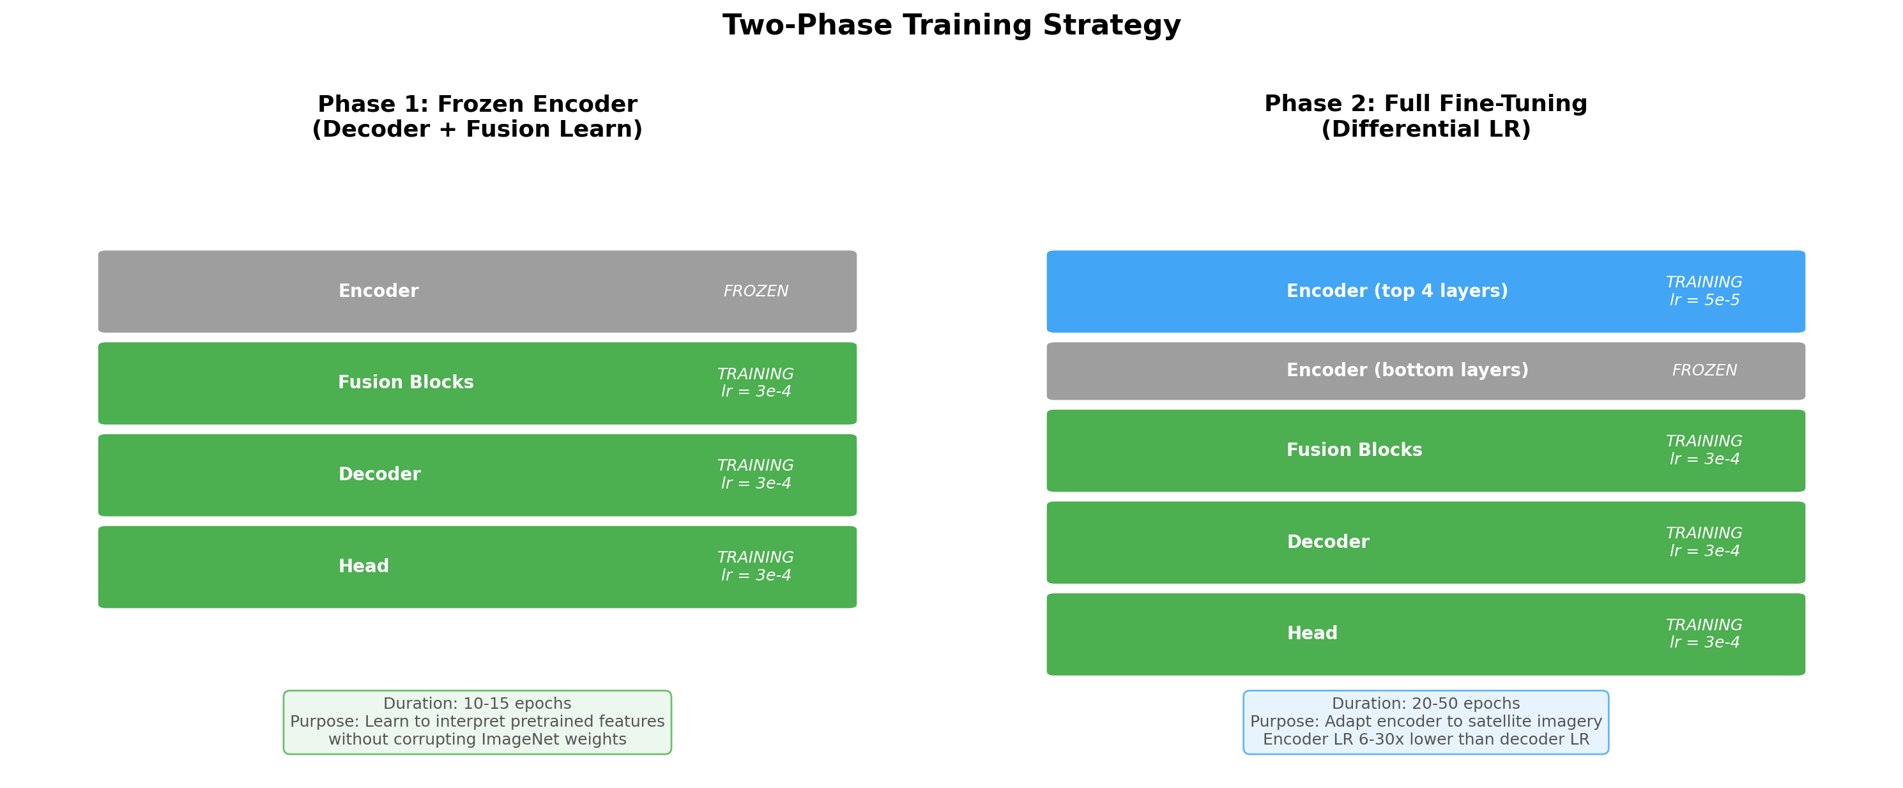
Figure 3: Two-phase training. Phase 1 freezes the encoder. Phase 2 unfreezes top layers with a lower learning rate.
We tuned these settings across experiments:
Parameter | Exp 3 | Exp 4 | Exp 5
Freeze epochs | 15 | 15 | 10
Unfrozen layers | all | 2 | 4
Encoder LR | 1e-5 | 1e-5 | 5e-5

3.4 Other Training Details
Parameter | Value
Optimiser | AdamW
Decoder LR | 3e-4
Weight decay | 0.05
Gradient clipping | 1.0
Batch size | 8 (with gradient accumulation for effective batch 32–64)
Mixed precision | FP16
Scheduler | CosineAnnealingLR
Early stopping | Patience=15 on val damage F1

4. Experiments
We ran five experiments. Each one was motivated by what we learned (or what went wrong) in the previous one.
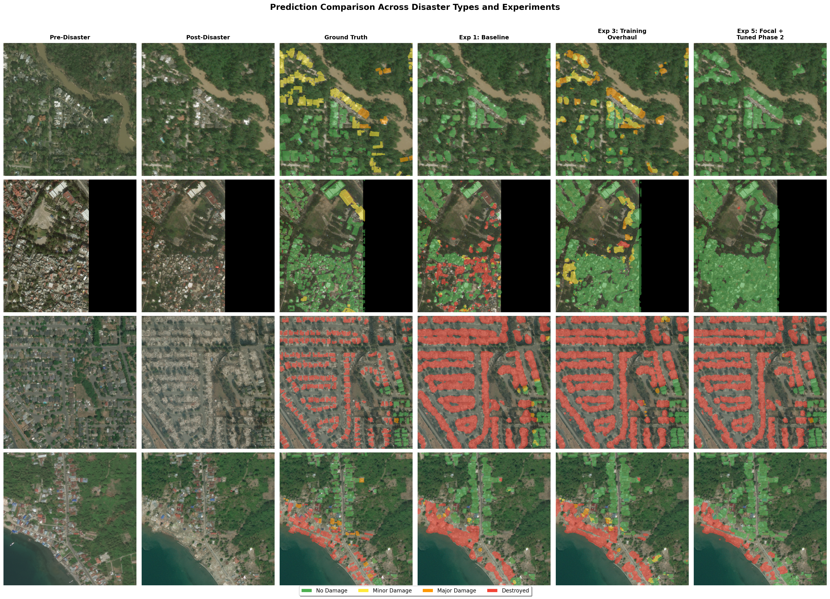
Figure 4: Predictions across disaster types. Columns show pre/post images, ground truth, and predictions from Exp 1, 3, and 5. The model gets progressively better at identifying damage.

4.1 Experiment 1: Baseline
Goal: Get a working model.
Setting | Value
Backbone | ResNet34, all layers unfrozen
Effective batch | 2
Epochs | 5
Results: mIoU = 0.359, pixel accuracy = 94.4%
What happened: 94.4% accuracy sounds good, but it just means the model is good at predicting background (which is 97% of pixels). It started overfitting by epoch 3.
Next step: Try training longer.

4.2 Experiment 2: More Epochs
Goal: Does training longer fix the problem?
Change: Increased epochs from 5 to 50. Everything else the same.
Results: mIoU = 0.394 (+9.7%), but with severe overfitting – train loss dropped to 0.63 while val loss climbed to 2.38 (a 3.8x gap).
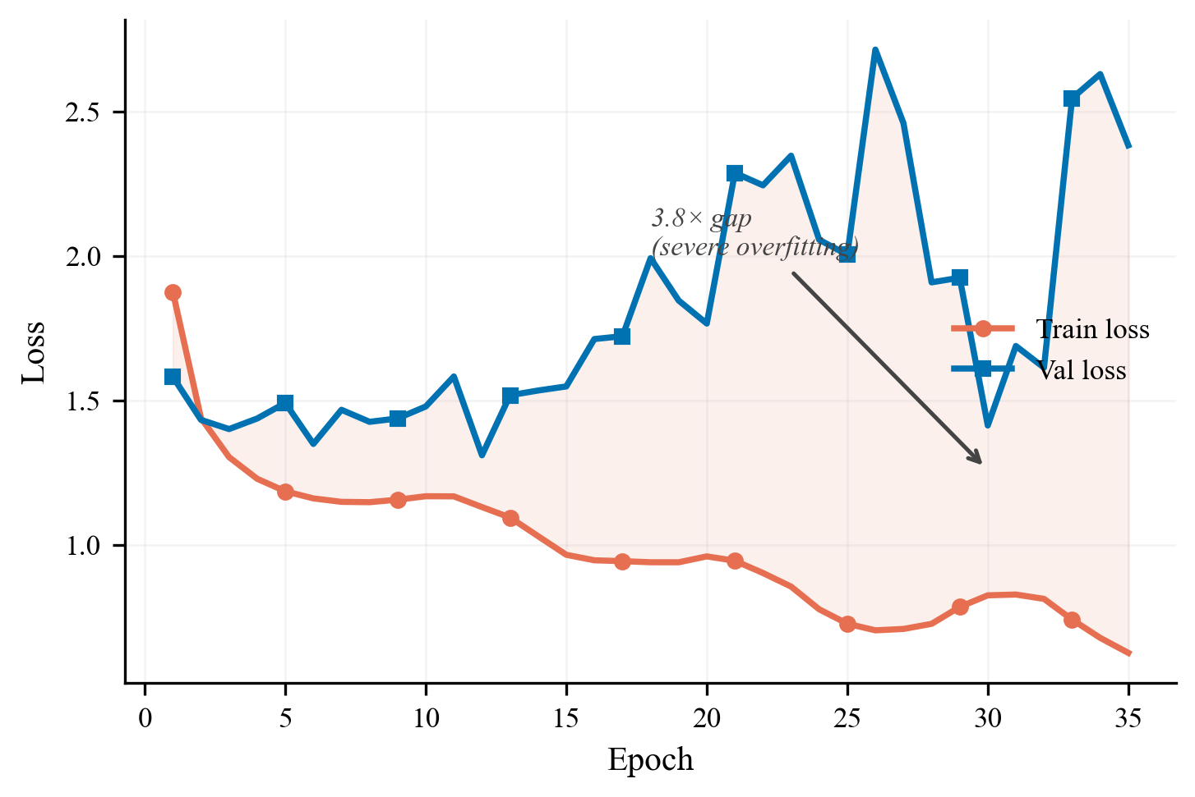
Figure 5: Exp 2 train vs val loss. The gap between the curves shows severe overfitting.
What we learned: Training longer helped a little, but the model was memorising the training data. We needed a fundamentally different approach.

4.3 Experiment 3: Training Strategy Overhaul
Goal: Fix the overfitting. No architecture changes – only training changes.
What we changed:
Change | Before | After | Why
Weight decay | 1e-4 | 0.05 (500x more) | Main overfitting fix
Encoder | All unfrozen | Phase 1 frozen, Phase 2 unfrozen | Protect pretrained features
Encoder LR | Same as decoder | 30x lower | Preserve ImageNet knowledge
Effective batch | 2 | 8 | More stable gradients
Class weights | Basic frequency inverse | Log-inverse (all samples) | Better for rare classes
Metric | mIoU | Damage macro F1 | Ignores background for honest evaluation
Results: mIoU = 0.475 (+20.6%), Damage F1 = 0.510
This was our biggest improvement – and we changed nothing about the architecture. The 500x weight decay increase was the main driver: the train-val loss gap went from 3.8x down to 1:1.
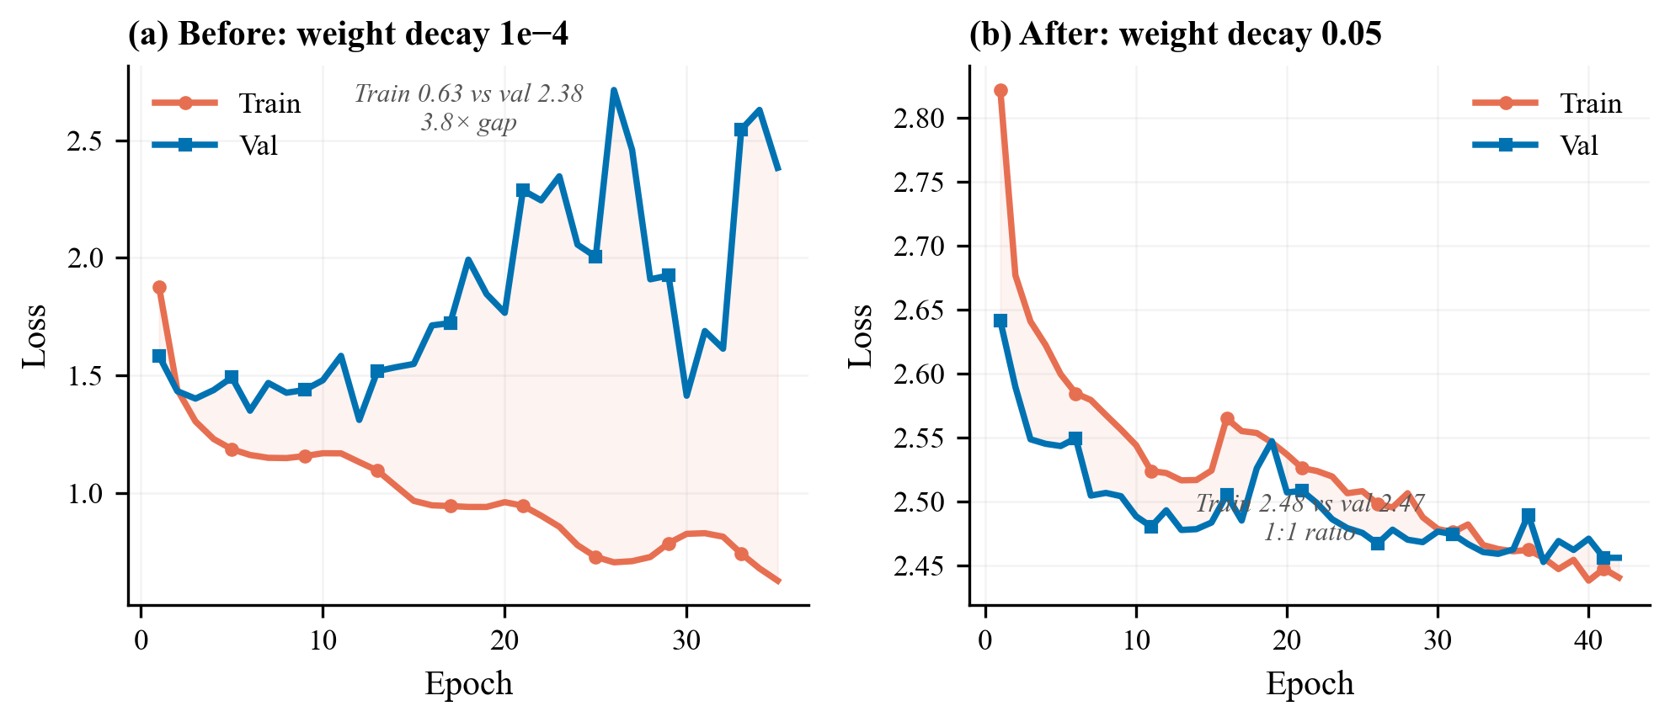
Figure 6: Before vs after. Left: Exp 2 with diverging train/val loss. Right: Exp 3 with parallel curves. Zero architecture changes.
Per-class F1:
Class | F1
No Damage | 0.672
Minor Damage | 0.283
Major Damage | 0.461
Destroyed | 0.623
New problem: Minor Damage F1 was only 0.283 – much worse than other classes. Maybe ResNet34 doesn’t have enough capacity to detect subtle damage like cracks and missing tiles?

4.4 Experiment 4: ResNet50 Backbone
Goal: Use a bigger encoder to improve Minor Damage detection.
Change: Swapped ResNet34 (21M params) for ResNet50 (25M params, 4x wider features).
Results: mIoU = 0.488 (+2.7%), Damage F1 = 0.521 (+2.2%)
The overall numbers improved slightly, but the per-class results told a different story:
Class | Exp 3 | Exp 4 | Change
No Damage | 0.672 | 0.709 | +0.037
Minor Damage | 0.283 | 0.433 | +53%
Major Damage | 0.461 | 0.384 | -17%
Destroyed | 0.623 | 0.557 | -0.066
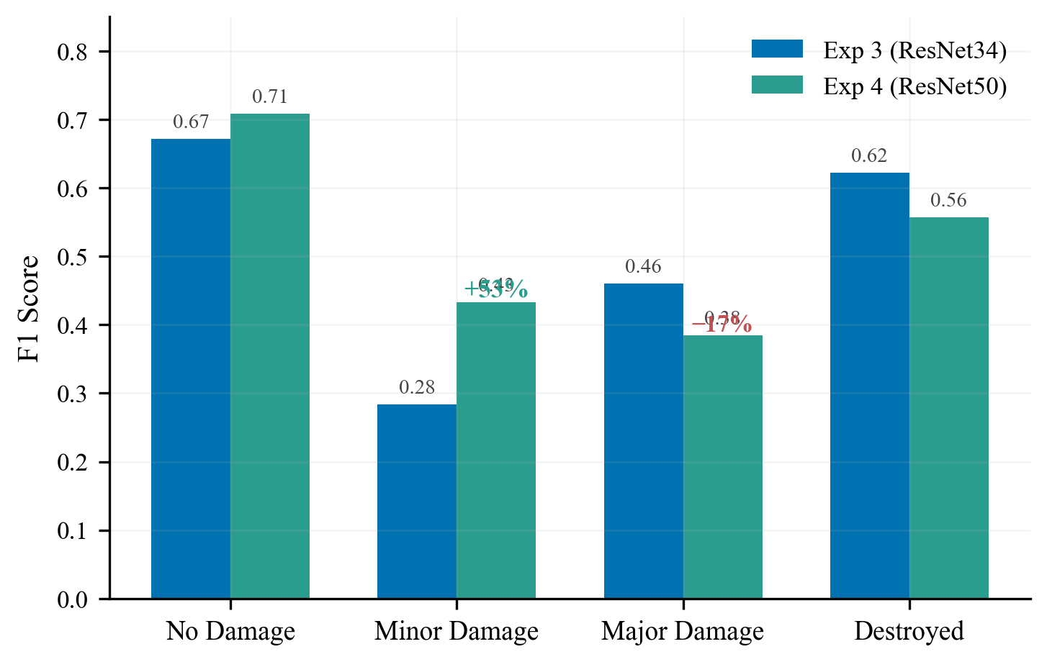
Figure 7: Per-class F1 comparison. Minor Damage jumped +53% with ResNet50, but Major Damage dropped -17%.
What happened: Minor Damage improved dramatically because ResNet50 has wider features that can capture subtle cracks. But Major Damage and Destroyed got worse – because with encoder_lr=1e-5 and only 2 layers unfrozen, the ResNet50 backbone wasn’t adapting enough to satellite imagery. It was still mostly seeing ImageNet features (cats, dogs, cars), not rubble and structural collapse.
Lesson: A bigger model isn’t automatically better. You have to let it learn.

4.5 Experiment 5: Tuned Fine-Tuning + Focal Loss
Goal: Let ResNet50 actually adapt to satellite imagery.
What we changed:
Change | Before | After | Why
Encoder LR | 1e-5 | 5e-5 (5x higher) | Let encoder adapt faster
Freeze epochs | 15 | 10 | Decoder converges earlier
Unfrozen layers | 2 | 4 | Deeper adaptation
Loss | Cross-Entropy + Dice | Focal (γ=2) + Dice | Focus on hard boundary pixels
Results (34 of 60 epochs – stopped because we ran out of GPU quota):
Metric | Value | Change vs Exp 4
mIoU | 0.494 | +0.006
Damage F1 | 0.533 | +0.012
Per-class F1:
Class | Exp 4 | Exp 5 | Change
No Damage | 0.709 | 0.683 | -0.026
Minor Damage | 0.433 | 0.466 | +0.033
Major Damage | 0.384 | 0.427 | +0.043
Destroyed | 0.557 | 0.556 | -0.001
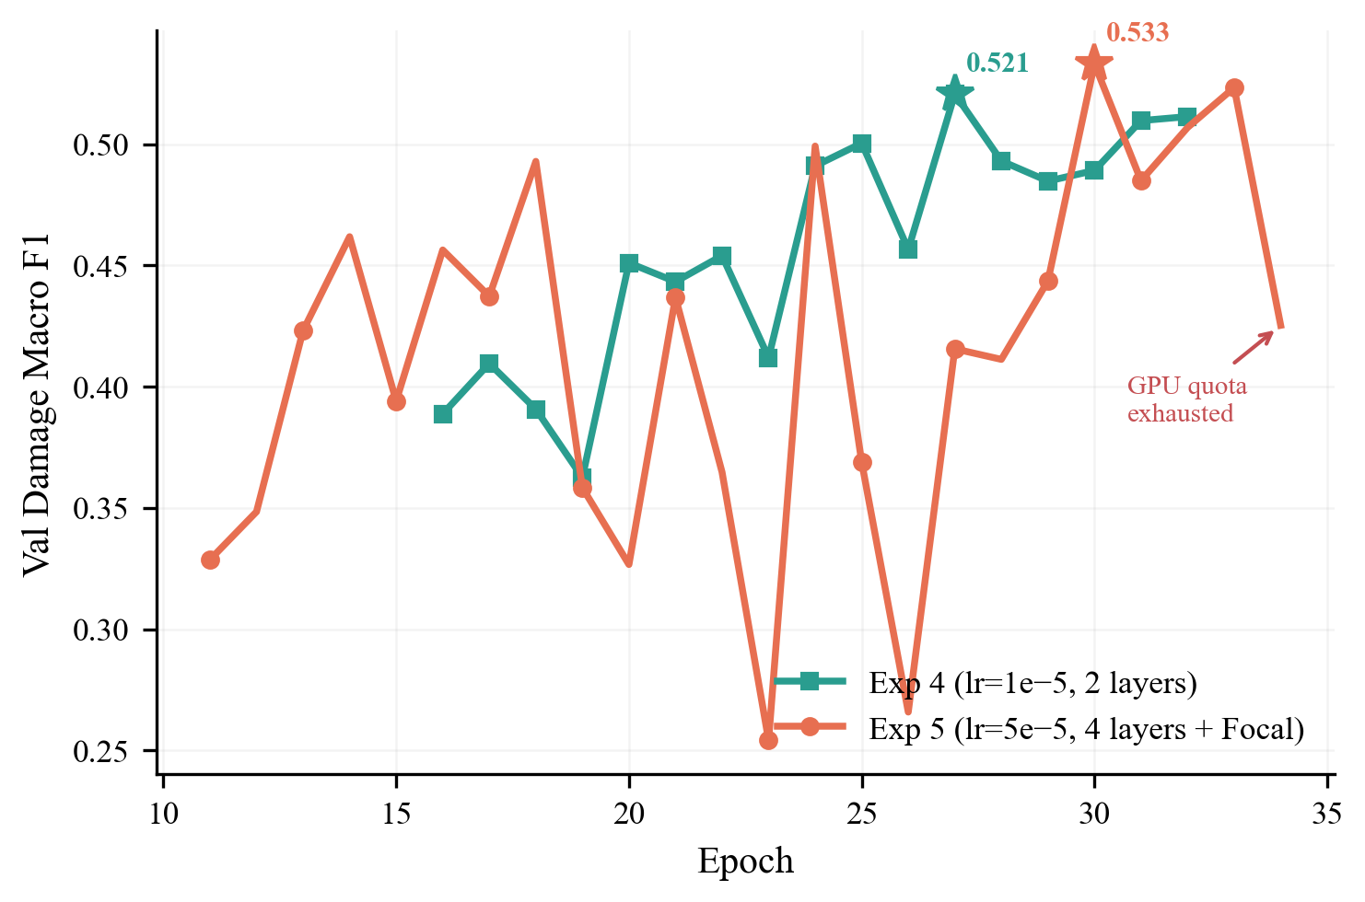
Figure 8: Exp 4 vs 5 damage F1 during Phase 2. More aggressive fine-tuning pushed Exp 5 higher.
The higher encoder LR and more unfrozen layers let ResNet50 actually learn satellite-specific features. Focal Loss helped by focusing on the hard boundary pixels between damage classes, recovering Major Damage F1.
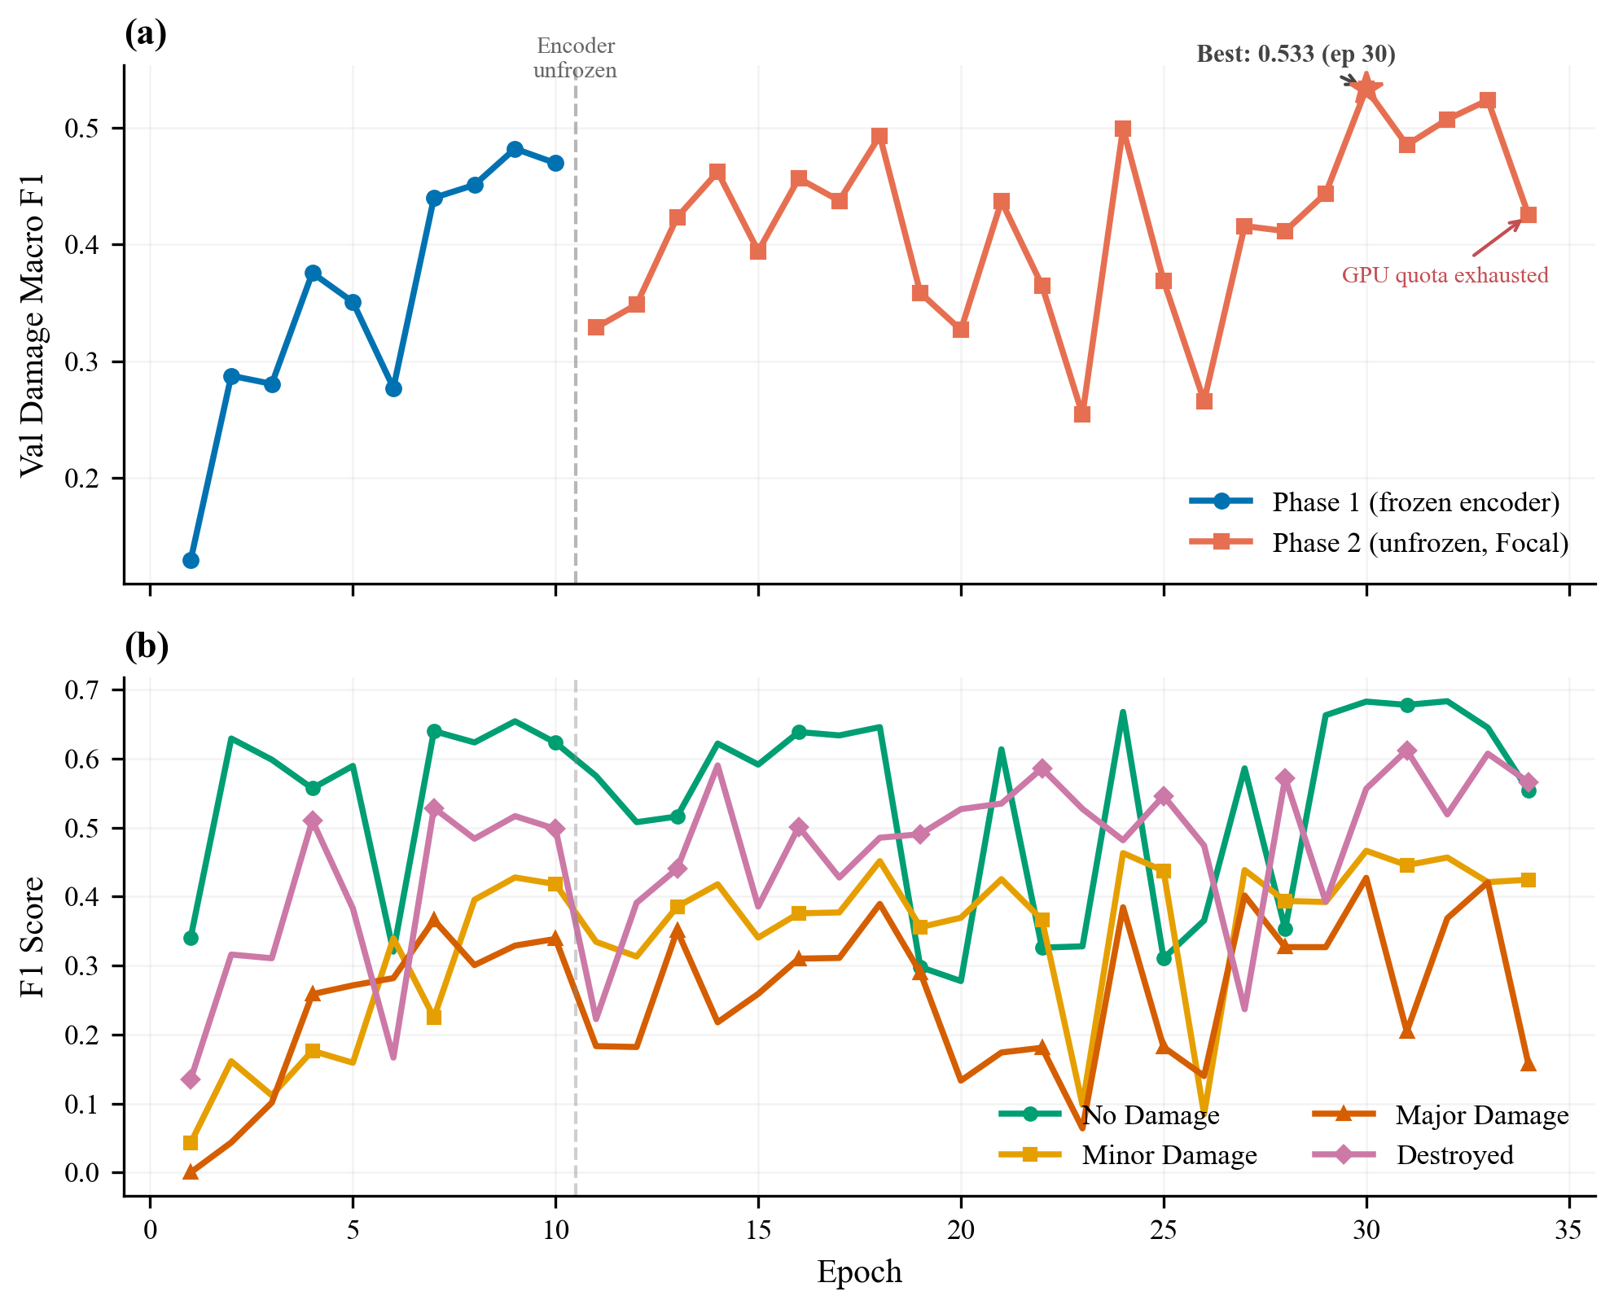
Figure 9: Exp 5 deep dive. (a) Damage F1 over training with phase boundary. (b) Per-class F1 trajectories.
Note: Training stopped at epoch 34/60 because we ran out of Kaggle GPU quota. The SUTD AI cluster was also down during this period (reported by multiple teams). The model was still improving – early stopping never triggered – so these results are a lower bound.

4.6 Results Summary
 | Exp 1 | Exp 2 | Exp 3 | Exp 4 | Exp 5
Key Change | Baseline | More epochs | Training overhaul | ResNet50 | Tuned fine-tuning + Focal
Backbone | ResNet34 | ResNet34 | ResNet34 | ResNet50 | ResNet50
Epochs | 5 | 35 | 42 | 32 | 34/60*
Val mIoU | 0.359 | 0.394 | 0.475 | 0.488 | 0.494
Val Damage F1 | – | – | 0.510 | 0.521 | 0.533
Overfitting | Moderate | Severe | Controlled | Controlled | Controlled
*Exp 5 stopped early due to GPU quota. Training was still improving.
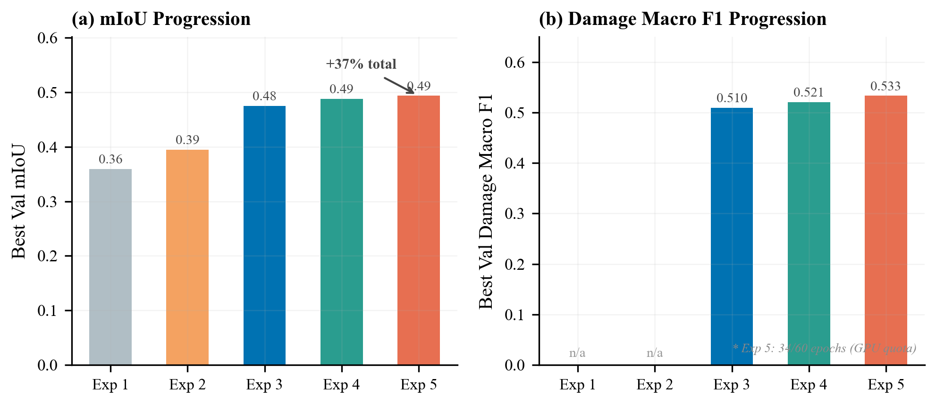
Figure 10: mIoU and Damage F1 progression across all five experiments.
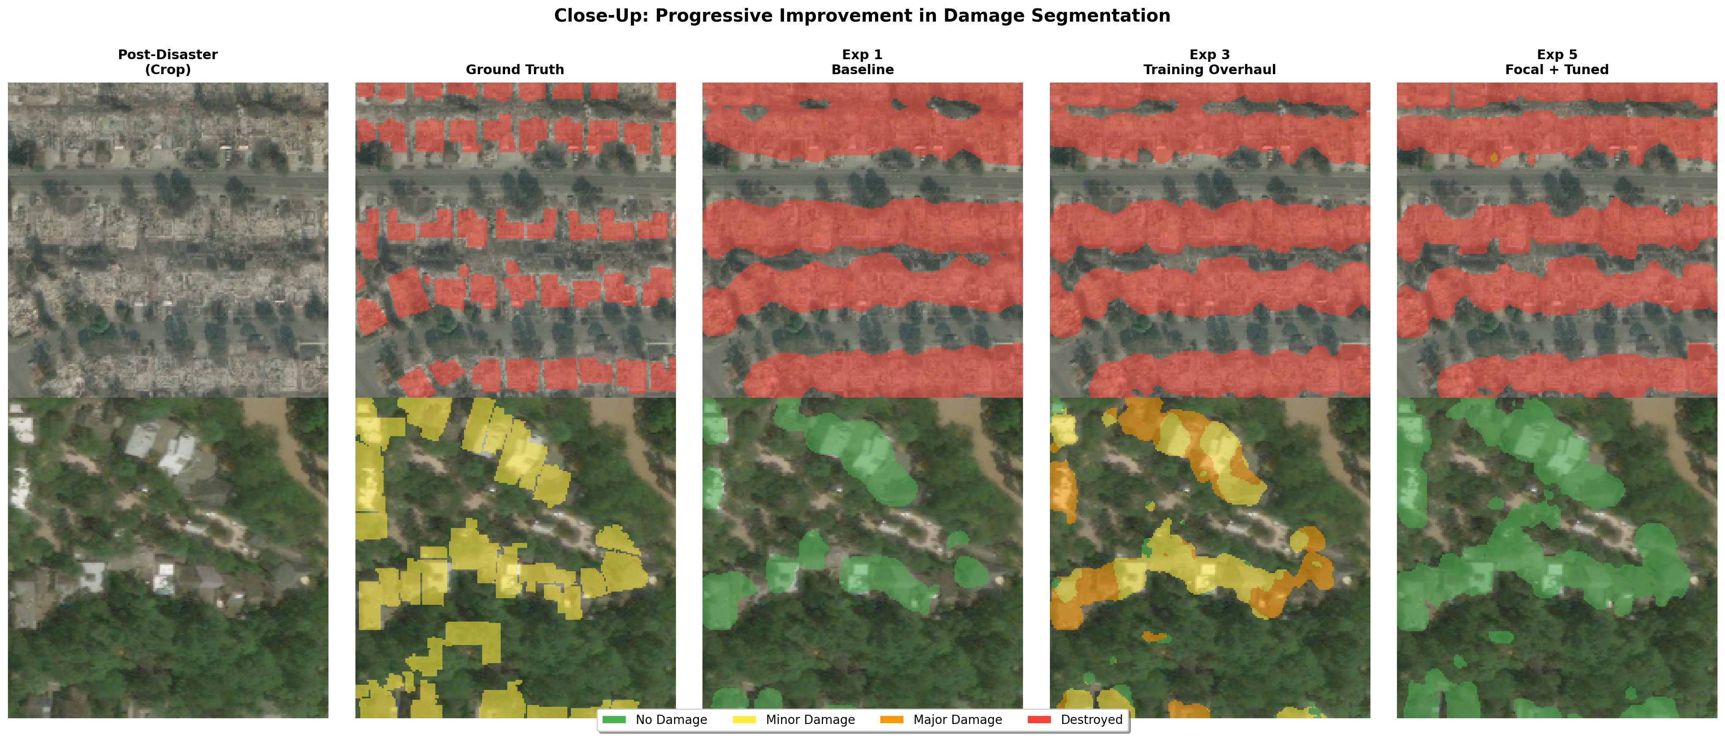
Figure 11: Close-up comparison of predictions. Fine-grained damage classification improves across experiments.
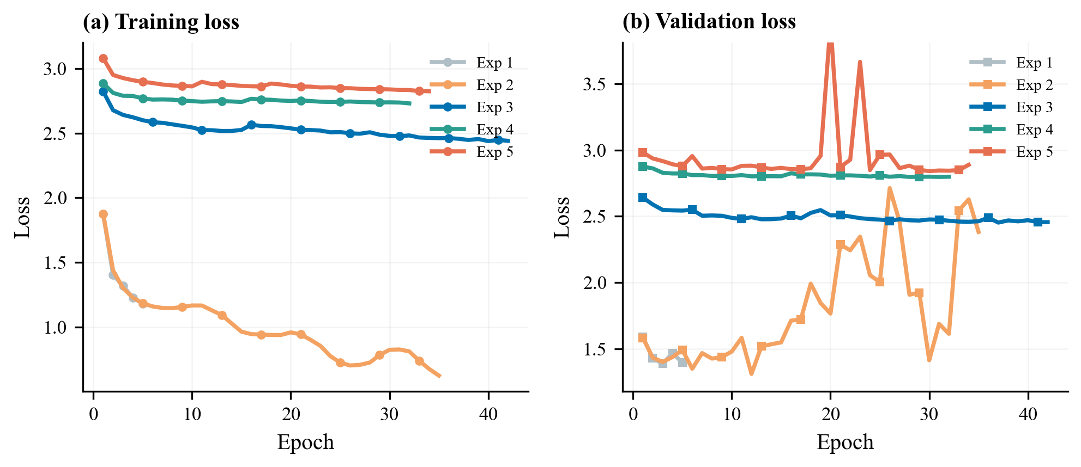
Figure 12: Train and val loss across all experiments. Overfitting decreases from Exp 1 to Exp 5.

4.7 Comparison to State-of-the-Art
Model | Damage F1 | Data | Ensemble
1st place [5] | ~0.75 | Full xBD (22K pairs) | 12 models
2nd place [6] | ~0.72 | Full xBD | 2 models
Single-model baseline | ~0.60–0.65 | Full xBD | 1 model
Ours (Exp 5) | 0.533 | Tier 3 (2.2K pairs) | 1 model
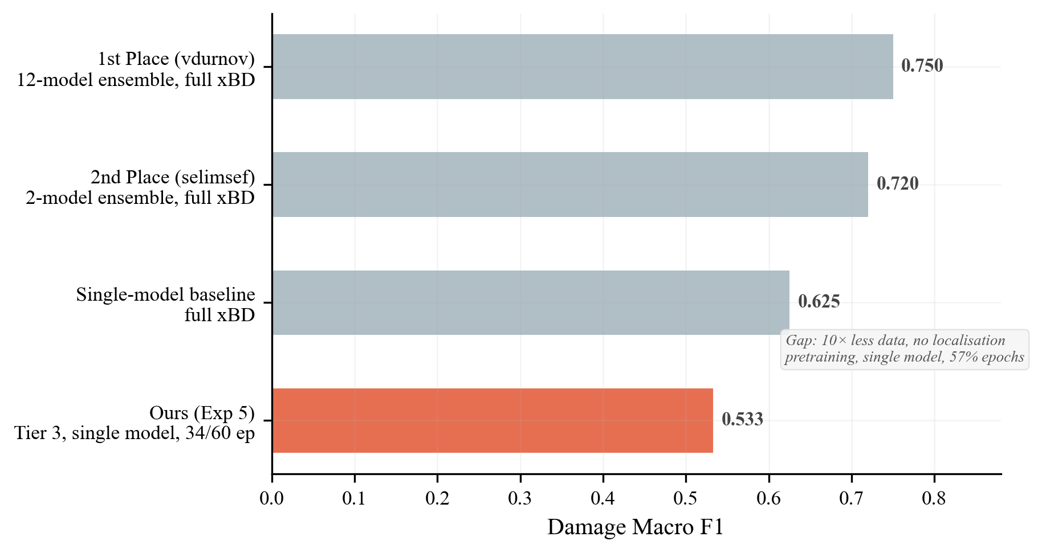
Figure 13: Comparison to competition results. The gap comes from having less data, no ensembling, no localisation pretraining, and incomplete training.
The gap is due to resource differences, not architecture:
- 10x less data – we used Tier 3 (2.2K pairs) vs the full xBD (22K pairs)
- No localisation pretraining – winners first trained a model to find buildings, then fine-tuned for damage
- Single model – no ensembling or test-time augmentation
- Incomplete training – Exp 5 only ran 57% of planned epochs
Despite this, our 38% relative mIoU improvement shows effective hyperparameter tuning, and our Minor Damage F1 (0.466) beats the typical competition winner range (0.30–0.45).

5. Analysis

5.1 What Helped Most
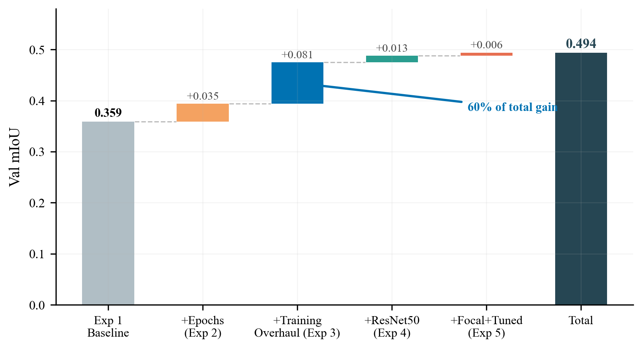
Figure 14: Waterfall chart of mIoU improvement. Training strategy (Exp 3) accounts for 60% of the total gain.
Rank | Change | Experiment | mIoU Gain | % of Total
1 | Training strategy overhaul | Exp 3 | +0.081 | 60%
2 | More epochs | Exp 2 | +0.035 | 26%
3 | Bigger backbone | Exp 4 | +0.013 | 10%
4 | Focal Loss + tuned fine-tuning | Exp 5 | +0.006 | 4%
Key takeaway: How you train matters more than what you train. The 500x weight decay increase was the single most impactful change.

5.2 Minor Damage: The Hardest Class
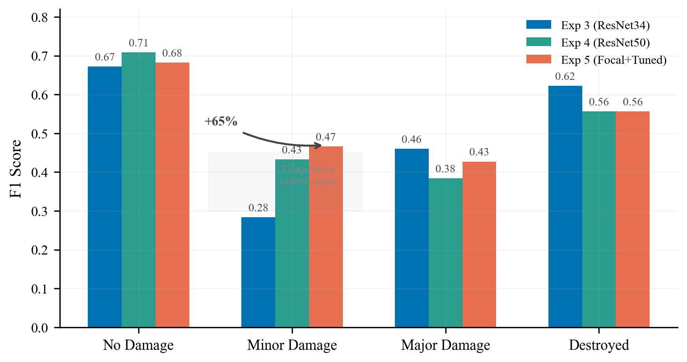
Figure 15: Per-class F1 across Exp 3/4/5. Minor Damage improved by +65% over three experiments and now exceeds the competition winner range.
Experiment | Minor Damage F1 | Change
Exp 3 (ResNet34) | 0.283 | –
Exp 4 (ResNet50) | 0.433 | +53%
Exp 5 (+ Focal) | 0.466 | +65% total
Minor Damage is hard because cracks and missing tiles are tiny at 512x512 resolution. Competition winners also struggle with this class (typically 0.30–0.45 F1). Our final 0.466 exceeds this range.

5.3 Bigger Backbone Needs Bigger Learning Rate
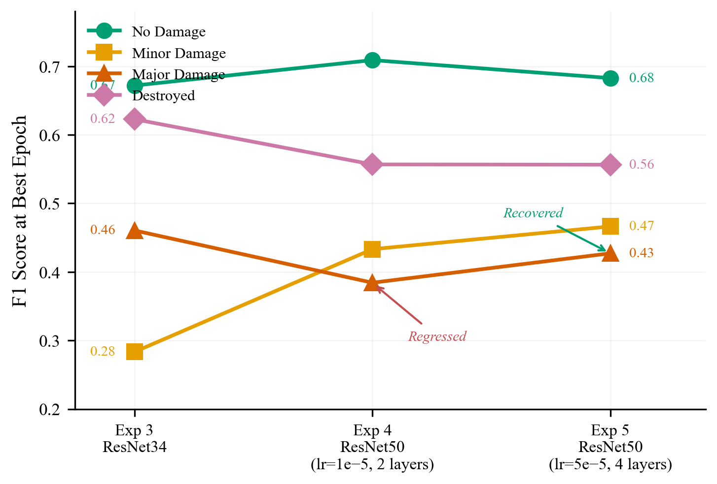
Figure 16: Per-class F1 across experiments. Major Damage dropped when we added ResNet50 with conservative fine-tuning, then recovered when we increased the encoder learning rate.
Switching to ResNet50 (Exp 4) actually made Major Damage worse (0.461 → 0.384). This happened because the encoder learning rate was too low – ResNet50 was barely adapting to satellite imagery. When we increased the encoder LR 5x and unfroze more layers in Exp 5, Major Damage recovered to 0.427.
Lesson: A bigger model with weak fine-tuning can be worse than a smaller model that is fully adapted.

5.4 What Didn’t Help
- More epochs without regularisation (Exp 2): 7x more epochs gave only +9.7% mIoU. Most of the extra compute was wasted on overfitting.
- Conservative fine-tuning (Exp 4): Keeping the encoder learning rate at 1e-5 with only 2 layers unfrozen wasted ResNet50’s extra capacity.

5.5 Failure Cases
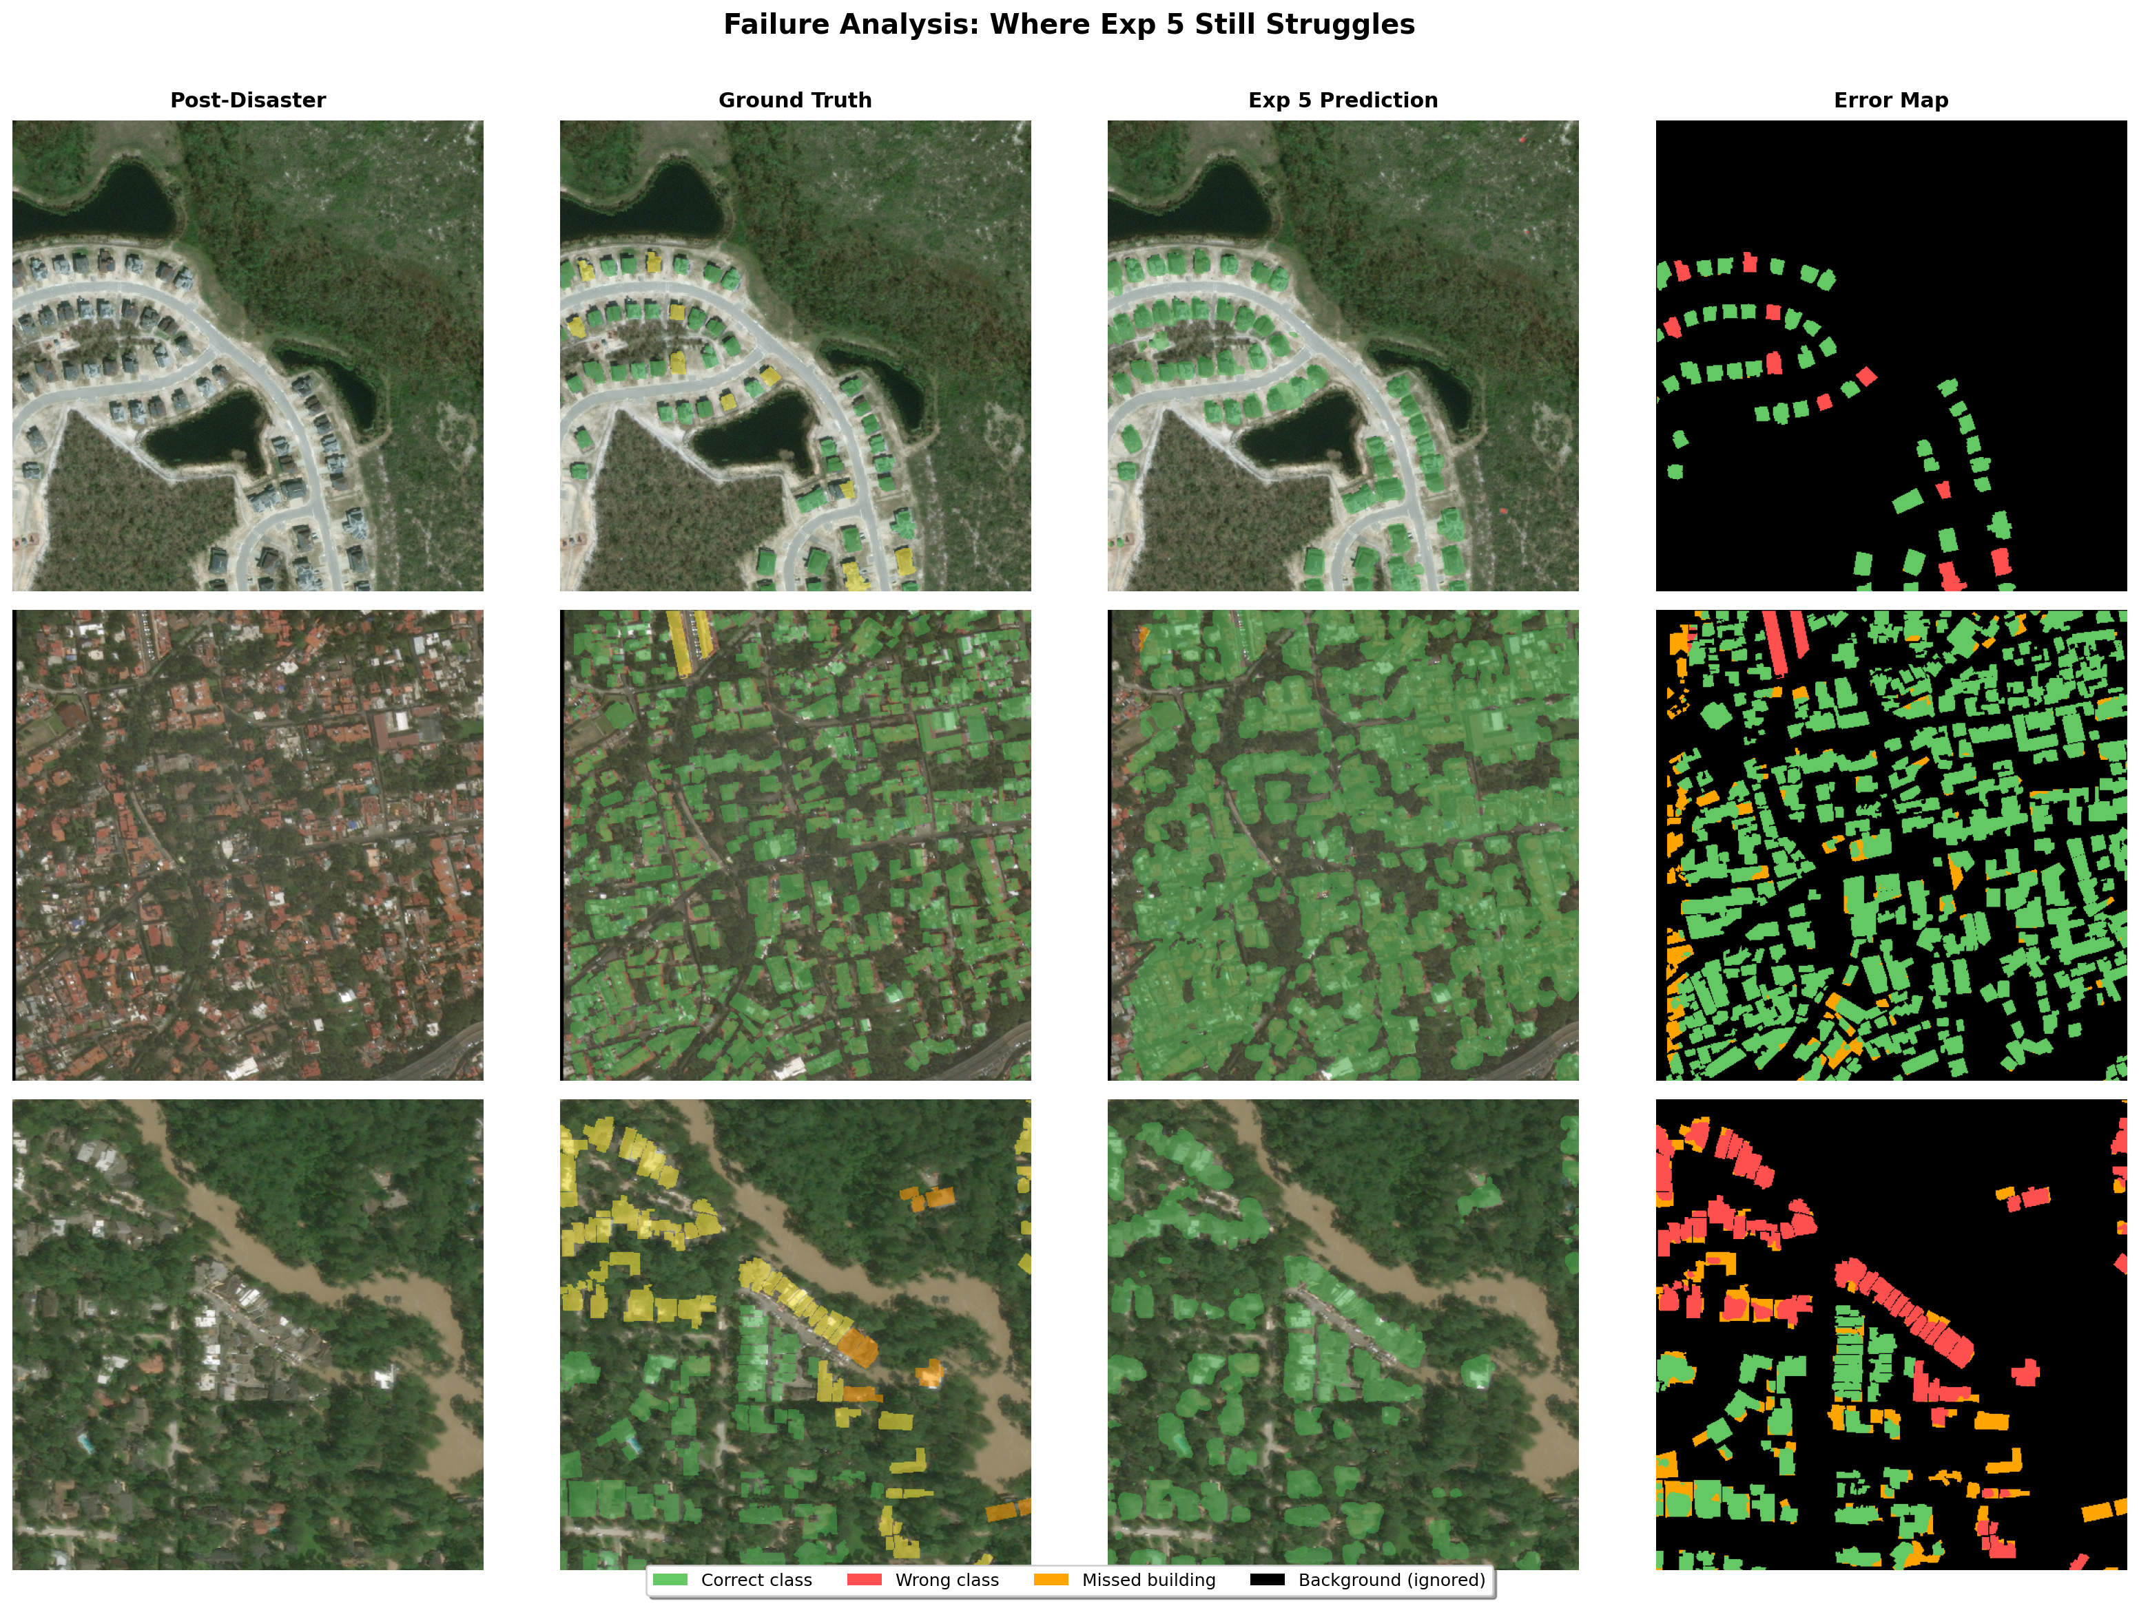
Figure 17: Where Exp 5 still fails. Error maps show misclassifications for minor/major confusion, small buildings, and mixed damage levels.
- Minor vs Major confusion: The boundary between damage levels is subjective – even human annotators disagree.
- Small buildings: Buildings that are only a few pixels wide are hard to classify at 512x512 resolution.
- Underrepresented disasters: The model performs worse on disaster types with fewer training examples.
- Phase 2 instability: Aggressive fine-tuning caused occasional validation loss spikes, though the model always recovered.
- Incomplete training: Our best model ran only 57% of planned epochs. It was still improving, so our results are a lower bound.

6. Reproducibility

6.1 Dependencies
Python 3.11+
PyTorch >= 2.0 (with CUDA)
torchvision, opencv-python, scikit-image, scikit-learn
shapely, matplotlib, numpy, tqdm
pip install torch torchvision opencv-python scikit-image scikit-learn shapely matplotlib numpy tqdm

6.2 Dataset Setup
- Download xView2 Tier 3 from Kaggle
- Place in:
data/
train/train/
images/ # ~3,732 PNGs
labels/ # JSON annotations
test/test/
images/

6.3 Training
- Open Kaggle-latest.ipynb (Kaggle) or training_script.ipynb (local)
- Set CONFIG_PATH to the experiment config:
- CONFIG_PATH = "training_runs/siamese_resunet_xview2_4/config.json"
- Run all cells. Outputs saved automatically:
  - config.json, history.json, metrics.csv
  - best_model.pt, last_model.pt

6.4 Loading a Trained Model
import torch
model = SiameseResUNet(backbone="resnet50", num_classes=5,
decoder_channels=[512, 256, 128, 64])
checkpoint = torch.load("training_runs/siamese_resunet_xview2_4/best_model.pt",
map_location="cpu")
model.load_state_dict(checkpoint["model_state_dict"])
model.eval()
with torch.no_grad():
pred = model(pre_image, post_image).argmax(dim=1)
Model weights: [Google Drive / Dropbox link]

6.5 Recreating Figures
cd "ADL Project"
python generate_figures.py
Reads metrics.csv from each experiment folder and outputs figures to images/.

6.6 Project Structure
ADL Project/
REPORT.md # This report
Kaggle-latest.ipynb # Training notebook
training_script.ipynb # Local training notebook
generate_figures.py # Recreates all figures
images/ # 17 figures
training_runs/
siamese_resunet_xview2_1/ # Exp 1: Baseline
siamese_resunet_xview2_2/ # Exp 2: Extended training
siamese_resunet_xview2/ # Exp 3: Training overhaul
siamese_resunet_xview2_3/ # Exp 4: ResNet50
siamese_resunet_xview2_4/ # Exp 5: Focal + Tuned Phase 2
data/ # Dataset (not in git)

7. Conclusion
We built a Siamese ResNet U-Net for satellite building damage segmentation, reaching a damage macro F1 of 0.533 and mIoU of 0.494 across five experiments. Three main findings:
- Training strategy matters more than architecture. The Exp 3 training overhaul gave us +20.6% mIoU with zero architecture changes. Weight decay (0.05) and two-phase encoder freezing accounted for 60% of our total improvement.
- Bigger models need proper fine-tuning. ResNet50 improved Minor Damage by +53%, but hurt Major Damage when fine-tuned too conservatively. Increasing the encoder learning rate 5x and unfreezing more layers fixed this.
- Focal Loss helps hard cases. Switching to Focal Loss directed the model toward difficult damage boundary pixels, recovering the Major Damage regression and pushing Minor Damage to 0.466 – above the competition winner range.
The gap between our result (0.533) and competition winners (0.75) comes from resource constraints: 10x less data, no ensembling, no localisation pretraining, and incomplete training.

Future Work
- Finish Exp 5 training (26 more epochs) when GPU becomes available
- Add test-time augmentation (typically +1–3% for free)
- Add building localisation head (multi-task learning)
- Train on the full xBD dataset if compute allows

8. Team Contributions
Member | Contributions
[Name 1] | [Contributions]
[Name 2] | [Contributions]
[Name 3] | [Contributions]
[Name 4] | [Contributions]

References
[1] Gupta, R., et al. “xBD: A Dataset for Assessing Building Damage from Satellite Imagery.” arXiv:1911.09296, 2019.
[2] Ronneberger, O., Fischer, P., & Brox, T. “U-Net: Convolutional Networks for Biomedical Image Segmentation.” MICCAI, 2015.
[3] He, K., et al. “Deep Residual Learning for Image Recognition.” CVPR, 2016.
[4] Lin, T.-Y., et al. “Focal Loss for Dense Object Detection.” ICCV, 2017.
[5] xView2 1st Place Solution (vdurnov): https://github.com/vdurnov/xview2_1st_place_solution
[6] xView2 2nd Place Solution (selimsef): https://github.com/selimsef/xview2_solution

