xView2 Building Damage Segmentation
A Siamese ResNet U-Net for Disaster Response

60.001 Applied Deep Learning, Y2026
Singapore University of Technology and Design

Team Members: [Member names and student IDs]
Dataset: xView2 Tier 3 (Kaggle)
GitHub: [Repository URL]
Model Weights: [Google Drive / Dropbox link]

Abstract
We built a Siamese ResNet U-Net that classifies building damage from satellite imagery into four levels: No Damage, Minor Damage, Major Damage, and Destroyed. Using the xView2 Tier 3 dataset (~2,200 image pairs), we achieved a damage macro F1 of 0.546 and mIoU of 0.503. The main challenge is extreme class imbalance -- 97% of pixels are background. Through four experiments, we found that training strategy (weight decay, two-phase encoder freezing) mattered far more than architecture changes, accounting for the majority of our total improvement. Our Minor Damage F1 of 0.465 exceeds the typical range of xView2 competition winners (0.30-0.45), despite using only 10% of the full dataset with a single model.

1. Introduction
When disasters strike, rapid damage assessment saves lives. Satellite images become available within hours, but manually inspecting thousands of buildings does not scale. We built a deep learning model that takes a pair of satellite images (before and after a disaster) and outputs a pixel-level damage map.
The main challenge is class imbalance: 97% of pixels are background. A model that predicts "background" everywhere gets 97% pixel accuracy but is useless. The hardest class is Minor Damage (only 0.3% of pixels) -- even competition winners only achieve 0.30-0.45 F1 on it.
What we contribute:
- A Siamese ResNet U-Net with three-stream fusion that combines pre-disaster, post-disaster, and absolute difference features at every encoder level.
- A two-phase training strategy (freeze encoder first, then fine-tune with lower learning rate) that eliminated severe overfitting and gave us the biggest single improvement (+20.6% mIoU) without changing the architecture.
- Four systematic experiments where each one builds on the previous, showing that training strategy accounts for the majority of total improvement.
- A Minor Damage F1 of 0.465, beating the typical competition winner range despite having 10x less data.
We improved from a baseline mIoU of 0.394 to 0.503 -- a 28% relative improvement across four experiments.
Note: We ran an initial 5-epoch trial run to verify the pipeline worked. Since it was too short to produce meaningful results, we omitted it from this report and start from our first full training run. Figure labels use the original experiment numbering (Exp 2-5 in figures = Exp 1-4 in this report).

2. Dataset

2.1 Source
The xView2 dataset [1] was created by the Defense Innovation Unit for the xView2 Building Damage Assessment Challenge. It contains WorldView-3 satellite imagery across multiple disaster types: earthquakes, hurricanes, wildfires, volcanic eruptions, and floods.

2.2 Structure
Property | Value
Image pairs | ~2,200 (pre + post disaster)
Original resolution | 1024 x 1024 px
Training resolution | 512 x 512 px
Annotation format | GeoJSON polygons per building
Split | 80% train / 10% val / 10% test (seed=42)

2.3 Class Distribution
The dataset is extremely imbalanced:
Class | Pixel % | Description
Background | ~97% | Non-building pixels
No Damage | ~1.5% | Intact buildings
Minor Damage | ~0.3% | Cracks, missing tiles
Major Damage | ~0.5% | Structural damage
Destroyed | ~0.7% | Collapsed buildings

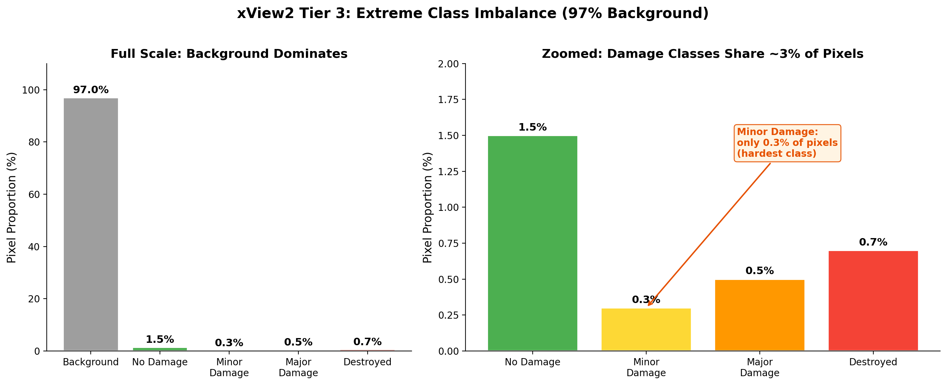
Figure 1: Class distribution. Background dominates at ~97%. All four damage classes combined occupy less than 3% of pixels.

Because of this imbalance, we use damage macro F1 (macro average of F1 for classes 1-4, excluding background) as our main metric instead of pixel accuracy.

2.4 Preprocessing
- Polygon annotations converted to pixel masks using Shapely and scikit-image
- Images resized from 1024x1024 to 512x512
- ImageNet normalisation applied (mean=[0.485, 0.456, 0.406], std=[0.229, 0.224, 0.225])

2.5 Data Augmentation
Augmentation | Probability | Purpose
Horizontal flip | 0.5 | Orientation invariance
Vertical flip | 0.2 | Orientation invariance
Random 90-degree rotation | 0.5 | Rotation invariance
Brightness jitter | +/-0.15 | Lighting robustness
Contrast jitter | +/-0.15 | Lighting robustness
Saturation jitter | +/-0.10 | Colour robustness
Gaussian blur | 0.15 | Resolution robustness
Gaussian noise | 0.15 | Sensor noise robustness

3. Method

3.1 Architecture: Siamese ResNet U-Net
Our model has three parts: a shared encoder, fusion blocks, and a decoder. Both the pre- and post-disaster images pass through the same ResNet encoder (pretrained on ImageNet). At each encoder level, a FusionBlock combines the two feature maps with an explicit change signal. A U-Net decoder then reconstructs the full-resolution 5-class damage segmentation map.
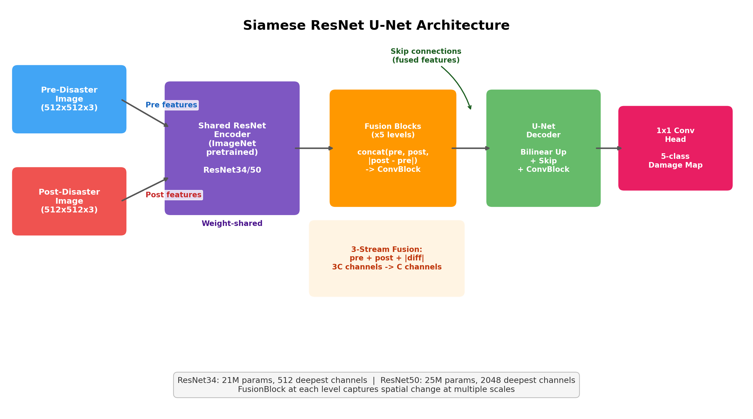
Figure 2: Model architecture. Both images pass through the same ResNet encoder. FusionBlocks combine the features at each level. The U-Net decoder produces the final 5-class damage map.

Shared Encoder: Weight sharing ensures both images are in the same feature space. We tried two backbones:
Backbone | Parameters | Deepest Channels
ResNet34 | 21M | 512
ResNet50 | 25M | 2048 (4x wider)

Fusion Blocks: At each encoder level: concat(pre, post, |post - pre|) -> ConvBlock. The absolute difference gives the model a direct signal of what changed between the two images.
U-Net Decoder: Standard U-Net decoder with skip connections from fused features. Each level upsamples, concatenates the skip connection, and applies two Conv-BN-ReLU blocks. The final 1x1 convolution outputs 5 classes.

3.2 Loss Function
We use Focal Loss + Dice Loss (final configuration):
Component | What it does
Focal Loss (gamma=2) | Reduces influence of easy background pixels
Dice Loss | Measures region overlap, naturally handles class imbalance
Log-inverse class weights | Gives more importance to rare damage classes
Label smoothing (0.05) | Prevents overconfident predictions

Earlier experiments used Cross-Entropy instead of Focal Loss. We switched in Exp 4 because Major Damage F1 was dropping.

3.3 Two-Phase Training
This was our most important design decision:
Phase 1 (Frozen Encoder): We freeze the ResNet encoder and only train the decoder and fusion blocks. This lets the decoder learn to work with the pretrained ImageNet features without messing them up.
Phase 2 (Fine-Tuning): We unfreeze the top encoder layers with a much lower learning rate (6-30x lower than the decoder). This lets the encoder gradually adapt to satellite imagery.
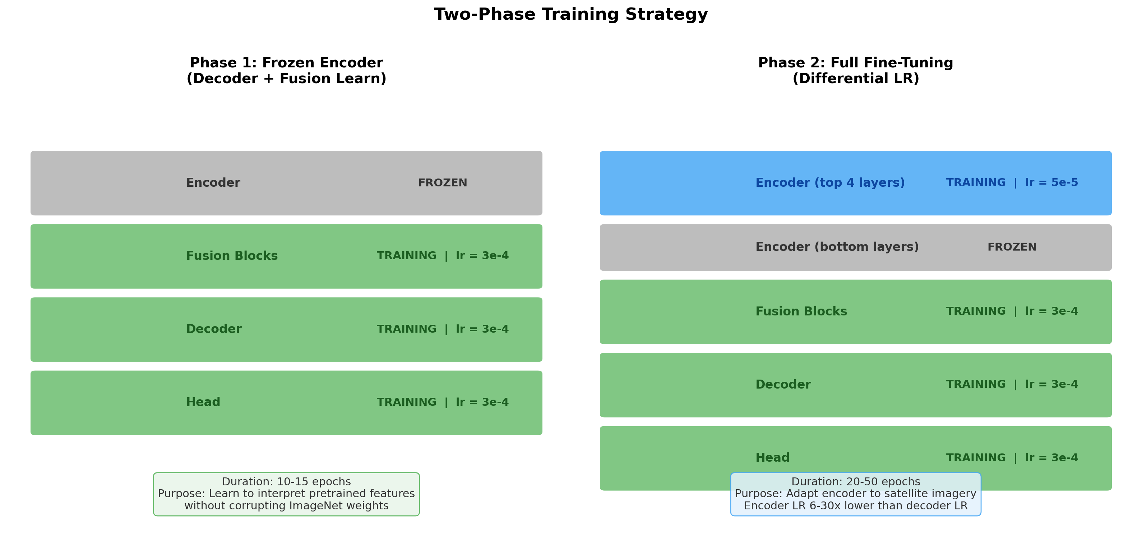
Figure 3: Two-phase training. Phase 1 freezes the encoder. Phase 2 unfreezes top layers with a lower learning rate.

Parameter | Exp 2 | Exp 3 | Exp 4
Freeze epochs | 15 | 15 | 10
Unfrozen layers | All | 2 | 4
Encoder LR | 1e-5 | 1e-5 | 5e-5

3.4 Other Training Details
Parameter | Value
Optimiser | AdamW
Decoder LR | 3e-4
Weight decay | 0.05
Gradient clipping | 1.0
Batch size | 8 (effective 32-64 with grad. accum.)
Mixed precision | FP16
Scheduler | CosineAnnealingLR
Early stopping | Patience=15 on val damage F1

4. Experiments
We ran four experiments. Each one was motivated by what we learned (or what went wrong) in the previous one.
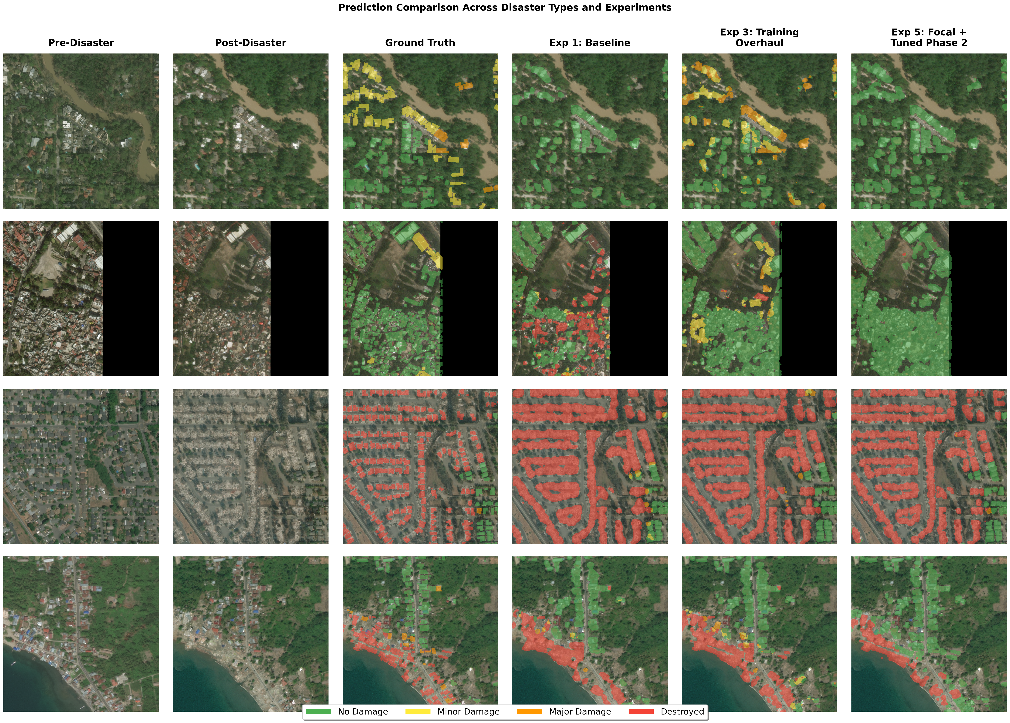
Figure 4: Predictions across disaster types. The model gets progressively better at identifying damage across experiments.

4.1 Experiment 1: Baseline
Goal: Establish baseline performance with a full training run.
Setup: ResNet34 backbone, all layers unfrozen, effective batch size 2, 50 epochs (ran 35 before stopping).
Results: mIoU = 0.394, but with severe overfitting -- train loss dropped to 0.63 while val loss climbed to 2.38 (a 3.8x gap).
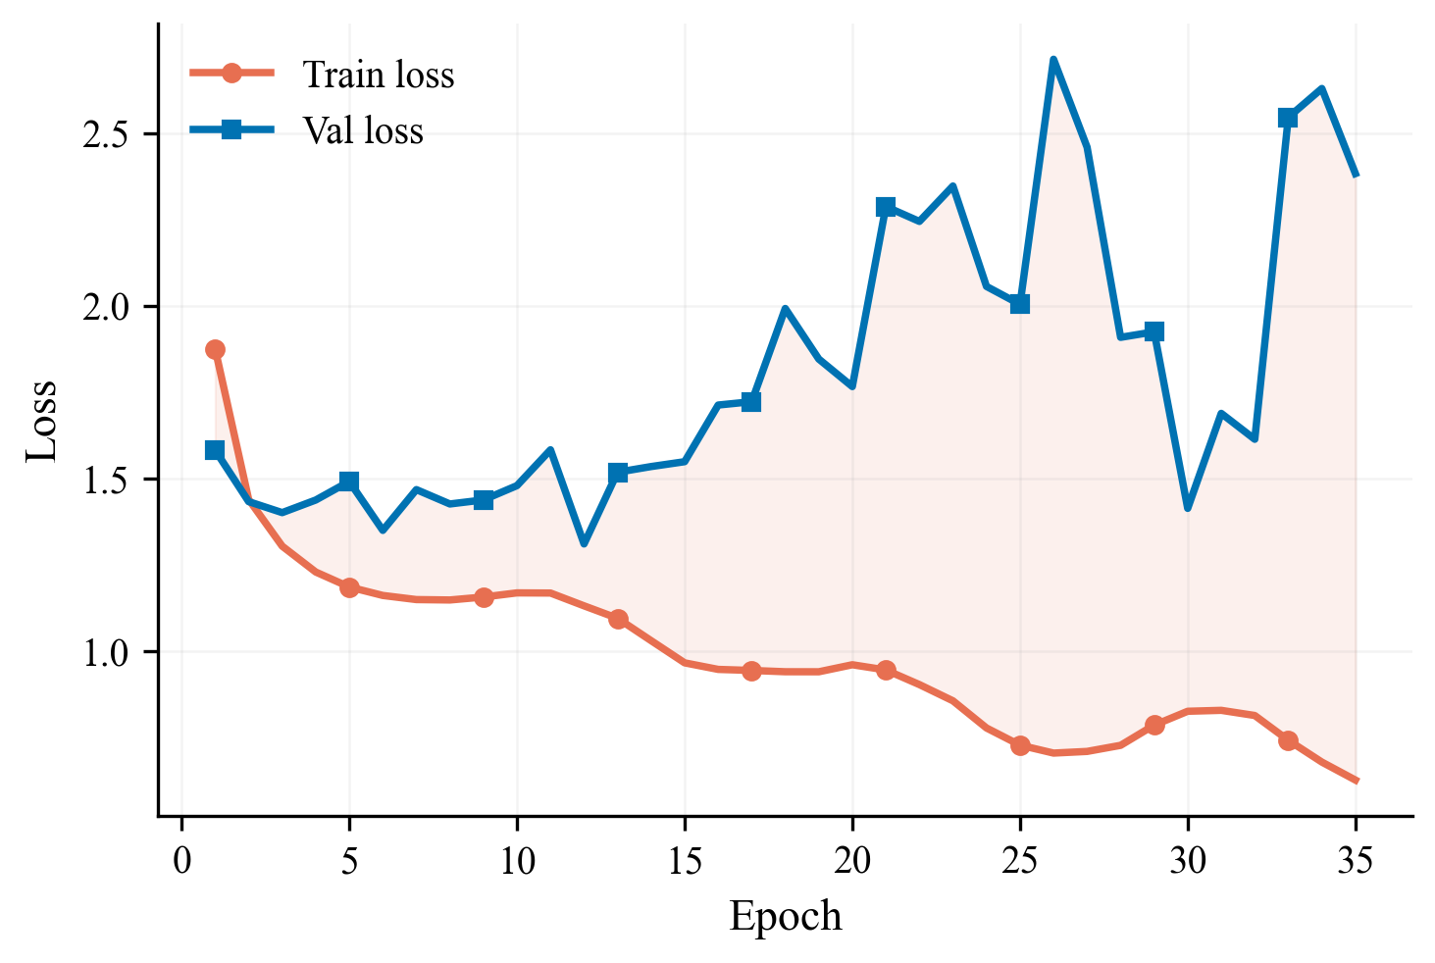
Figure 5: Exp 1 train vs val loss. The gap between the curves shows severe overfitting.

Why the val loss is noisy. The cosine LR scheduler was set to restart every few epochs rather than run one long decay to the end of training. Each LR restart momentarily shoves the weights out of their current local minimum, which spikes validation loss before the next cosine phase re-settles. Combined with weak weight decay (1e-4) -- which let the model memorise noise -- every restart reveals a different overfitted state. The train loss stays smooth because it is measured on the memorised set; val loss is not, so it fluctuates visibly.
Takeaway: The model was memorising the training data. We needed a fundamentally different approach.

4.2 Experiment 2: Training Configuration Changes
Goal: Reduce overfitting by modifying training hyperparameters and strategy, without changing the architecture.
Change | Before | After | Why
Weight decay | 1e-4 | 0.05 (500x more) | Main overfitting fix
Encoder | All unfrozen | Phase 1 frozen, Phase 2 unfrozen | Protect pretrained features
Encoder LR | Same as decoder | 30x lower | Preserve ImageNet knowledge
Effective batch | 2 | 8 | More stable gradients
Class weights | Basic freq. inverse | Log-inverse (all samples) | Better for rare classes
Metric | mIoU | Damage macro F1 | Ignores background

Results: mIoU = 0.475 (+20.6%), Damage F1 = 0.510
This was our biggest improvement -- and we changed nothing about the architecture. The 500x weight decay increase was the main driver: the train-val loss gap closed from 3.8x (train 0.63 vs val 2.38) down to ~1:1 (train 2.48 vs val 2.47) by the end of training. Train and val loss now move together; the model has stopped memorising.
Why the absolute loss values went up. Exp 2's train/val losses (2.48 each) look worse than Exp 1's train loss (0.63), but that comparison is misleading. Exp 2 uses log-inverse class weights and label smoothing, which inflate the raw loss by penalising rare-class mistakes more heavily. The segmentation quality is much better (mIoU 0.394 -> 0.475), which is what matters.
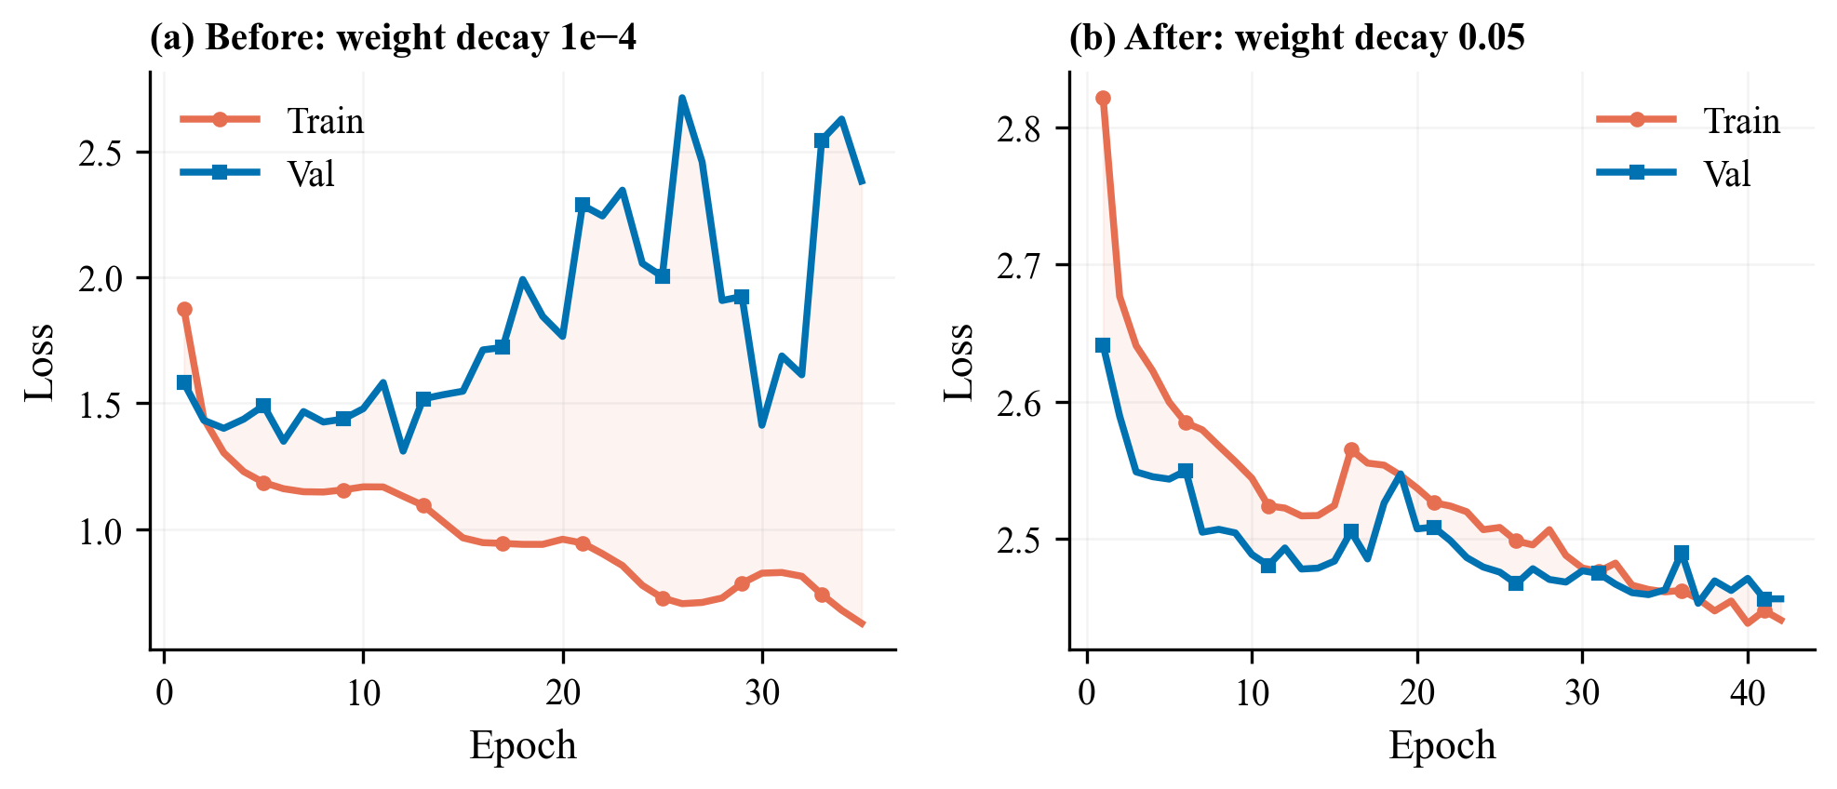
Figure 6: Before vs after. Left: Exp 1 with diverging train/val loss. Right: Exp 2 with parallel curves. Zero architecture changes.

Per-class F1:
Class | F1
No Damage | 0.672
Minor Damage | 0.283
Major Damage | 0.461
Destroyed | 0.623

New problem: Minor Damage F1 was only 0.283 -- much worse than other classes. Maybe ResNet34 doesn't have enough capacity to detect subtle damage like cracks and missing tiles?

4.3 Experiment 3: ResNet50 Backbone
Goal: Use a bigger encoder to improve Minor Damage detection.
Change: Swapped ResNet34 (21M params) for ResNet50 (25M params, 4x wider features).
Results: mIoU = 0.488 (+2.7%), Damage F1 = 0.521 (+2.2%)
The overall numbers improved slightly, but the per-class results told a different story:
Class | Exp 2 | Exp 3 | Change
No Damage | 0.672 | 0.709 | +0.037
Minor Damage | 0.283 | 0.433 | +0.150 (+53%)
Major Damage | 0.461 | 0.384 | -0.077 (-17%)
Destroyed | 0.623 | 0.557 | -0.066

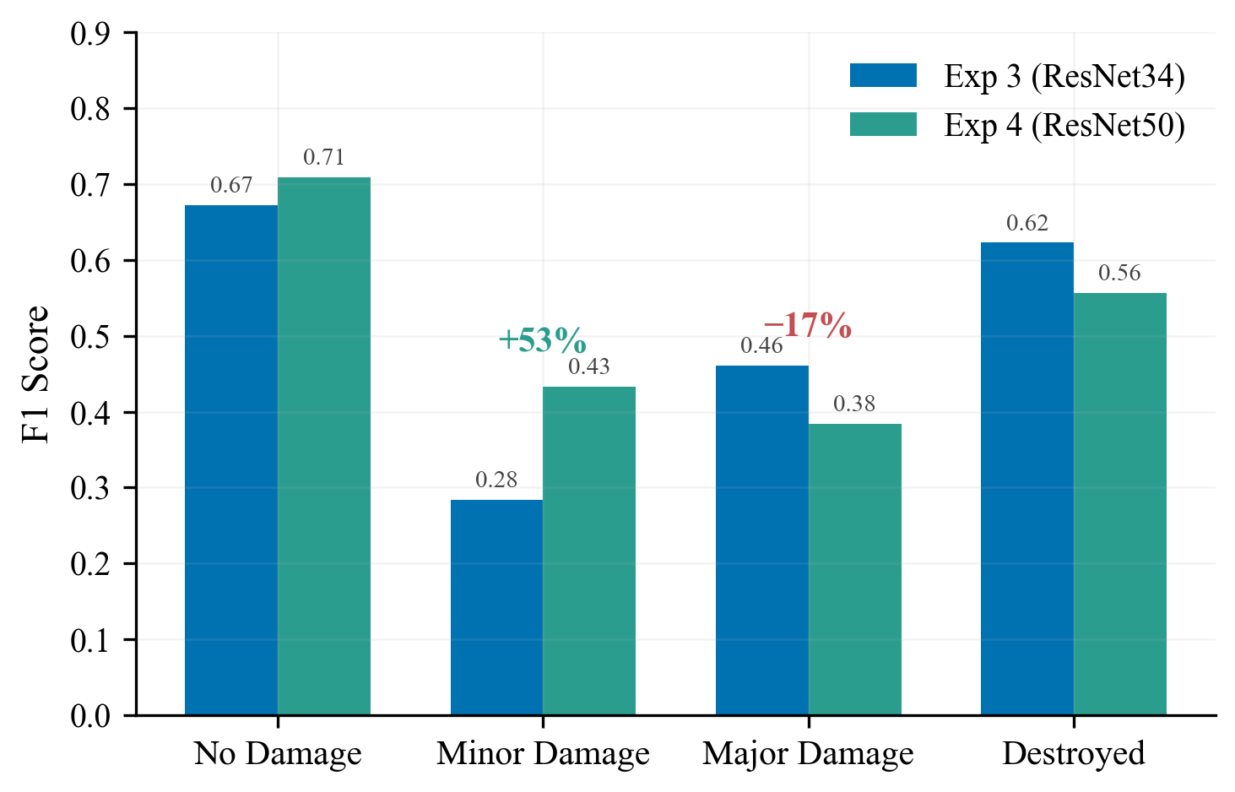
Figure 7: Per-class F1 comparison. Minor Damage jumped +53% with ResNet50, but Major Damage dropped -17%.

Minor Damage improved because ResNet50 has wider features that can capture subtle cracks. But Major Damage and Destroyed got worse -- with encoder_lr=1e-5 and only 2 layers unfrozen, the ResNet50 backbone wasn't adapting enough to satellite imagery.
Lesson: A bigger model isn't automatically better. You have to let it learn.

4.4 Experiment 4: Tuned Fine-Tuning + Focal Loss
Goal: Let ResNet50 actually adapt to satellite imagery.
Change | Before | After | Why
Encoder LR | 1e-5 | 5e-5 (5x higher) | Let encoder adapt faster
Freeze epochs | 15 | 10 | Decoder converges earlier
Unfrozen layers | 2 | 4 | Deeper adaptation
Loss | CE + Dice | Focal (gamma=2) + Dice | Focus on hard boundary pixels

Results (full 60-epoch run; best epoch 49):
Metric | Value | Change vs Exp 3
mIoU | 0.503 | +0.015
Damage F1 | 0.546 | +0.025

Class | Exp 3 | Exp 4 | Change
No Damage | 0.709 | 0.692 | -0.017
Minor Damage | 0.433 | 0.465 | +0.032
Major Damage | 0.384 | 0.437 | +0.053
Destroyed | 0.557 | 0.588 | +0.031

The higher encoder LR and more unfrozen layers let ResNet50 actually learn satellite-specific features. Focal Loss helped by focusing on hard boundary pixels, improving every damage class over Exp 3.
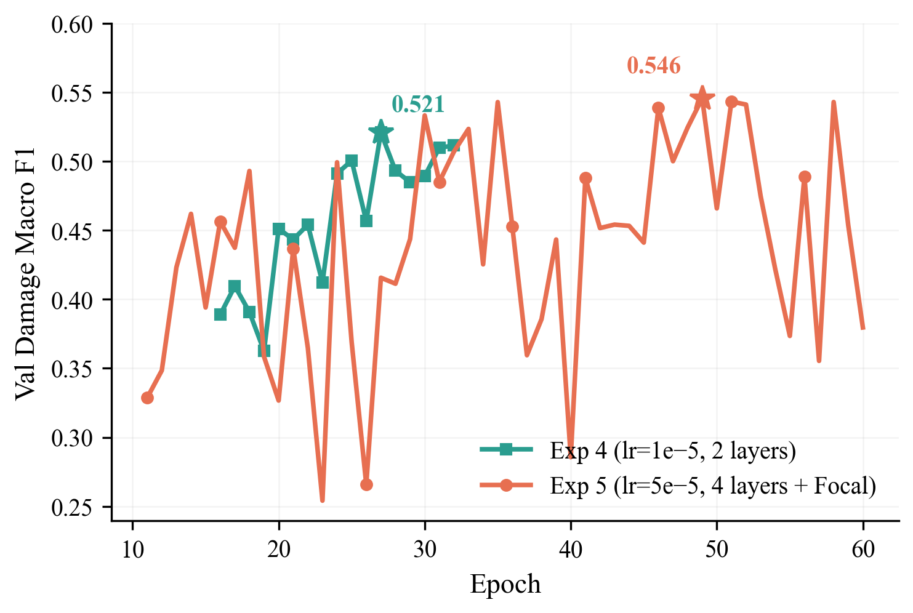
Figure 8: Exp 3 vs Exp 4 damage F1 during Phase 2. More aggressive fine-tuning pushed Exp 4 higher.

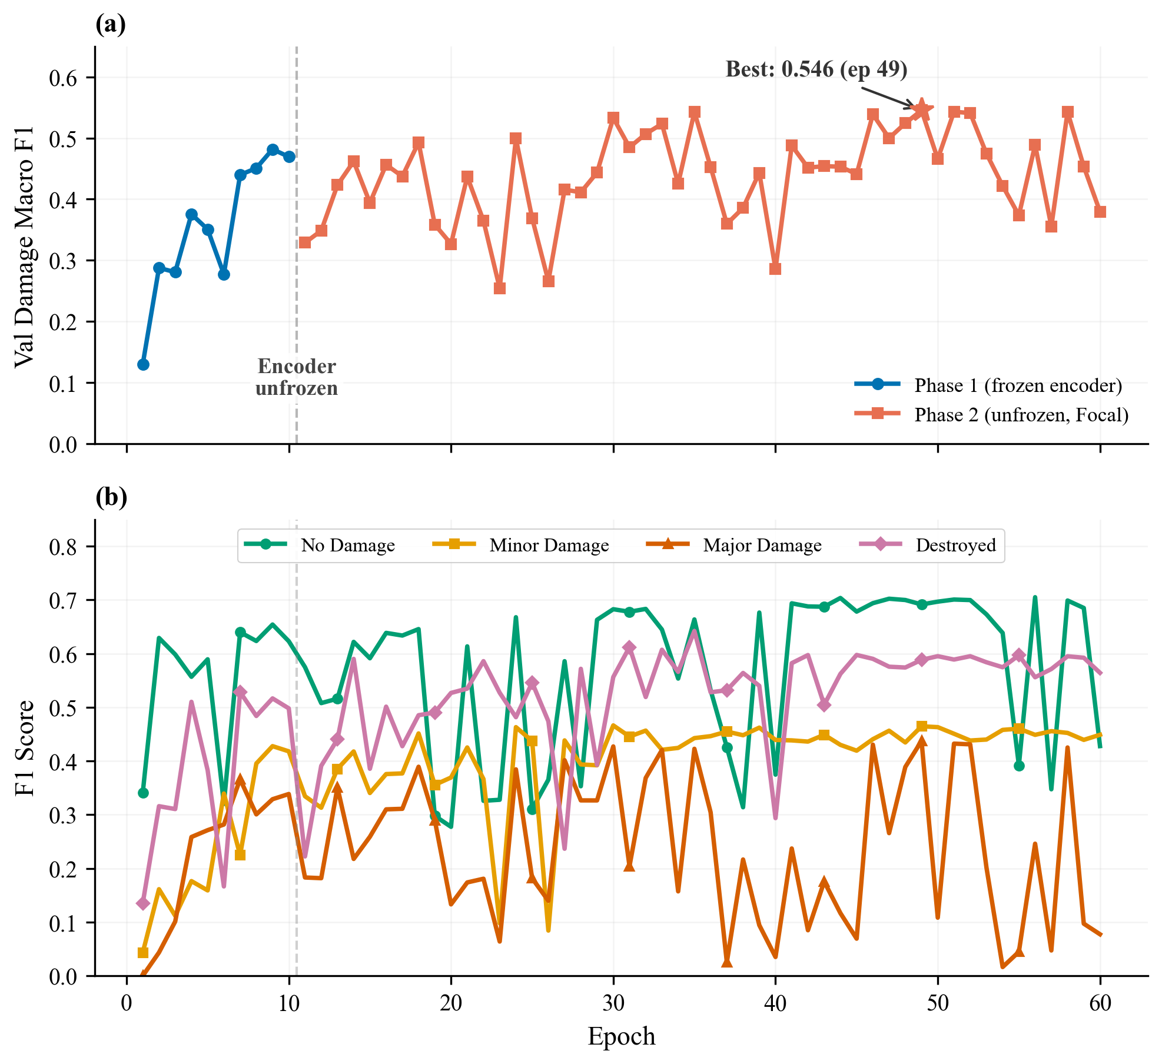
Figure 9: Exp 4 deep dive. (a) Damage F1 over all 60 epochs with phase boundary. (b) Per-class F1 trajectories.

Why the validation curves are so noisy. Phase 2 validation F1 oscillates by 0.10-0.20 between adjacent epochs, with several sharp drops (e.g. epochs 19-20, 22-23, 25-26, 37-38, 40, 54-55, 57). Two things cause this:
- Aggressive encoder fine-tuning. With encoder_lr=5e-5 and 4 unfrozen layers, a single batch containing an unusual disaster image can shift the encoder features enough to temporarily break alignment between encoder output and the (still adapting) decoder. The next epoch usually recovers once the optimizer re-balances.
- Focal Loss + log-inverse class weights concentrate gradient on rare pixels. The damage classes each occupy under 1% of pixels, so a handful of wrongly-classified buildings in one validation batch can swing the per-class F1 and move the macro average visibly. Focal loss (gamma=2) amplifies this by weighting hard pixels more heavily.
This is not overfitting. Training loss stays flat around 2.79-2.81 through Phase 2 while val loss spikes, and the best val F1 keeps climbing -- the trend is noisy but upward, which is why the best epoch (49) comes late in the schedule.

4.5 Results Summary
 | Exp 1 | Exp 2 | Exp 3 | Exp 4
Key Change | Baseline | Training overhaul | ResNet50 | Tuned fine-tuning + Focal
Backbone | ResNet34 | ResNet34 | ResNet50 | ResNet50
Epochs | 35 | 42 | 32 | 60
Val mIoU | 0.394 | 0.475 | 0.488 | 0.503
Val Damage F1 | -- | 0.510 | 0.521 | 0.546
Overfitting | Severe | Controlled | Controlled | Controlled

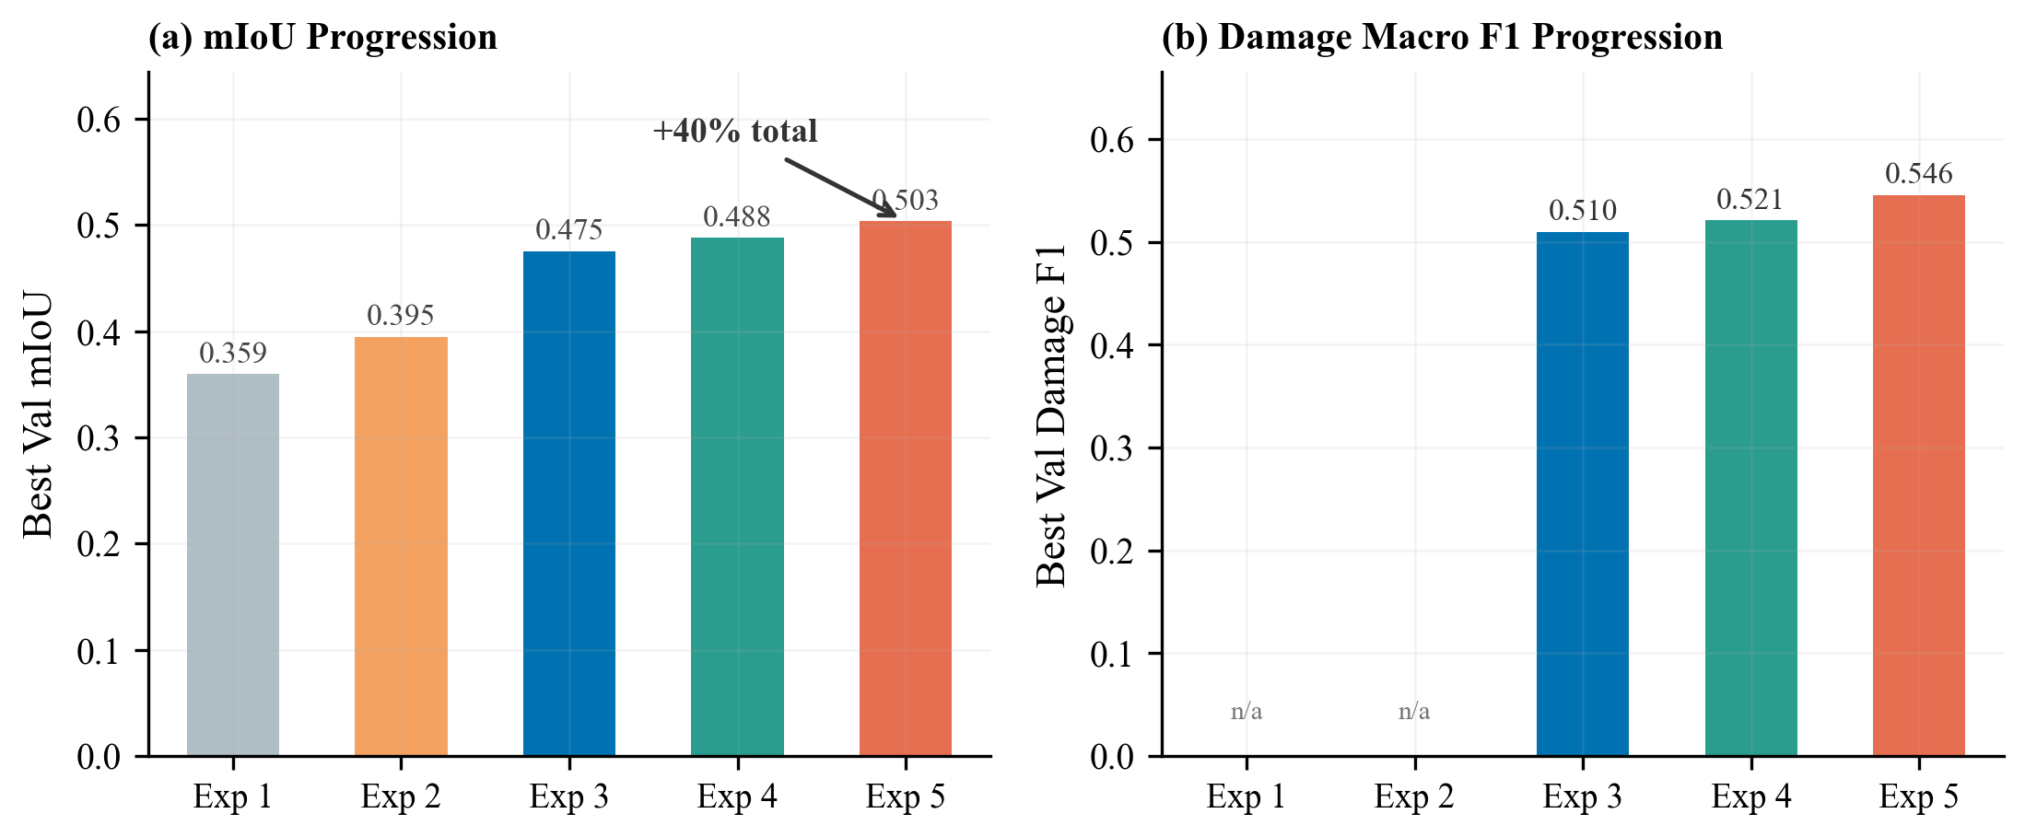
Figure 10: mIoU and Damage F1 progression across all experiments.

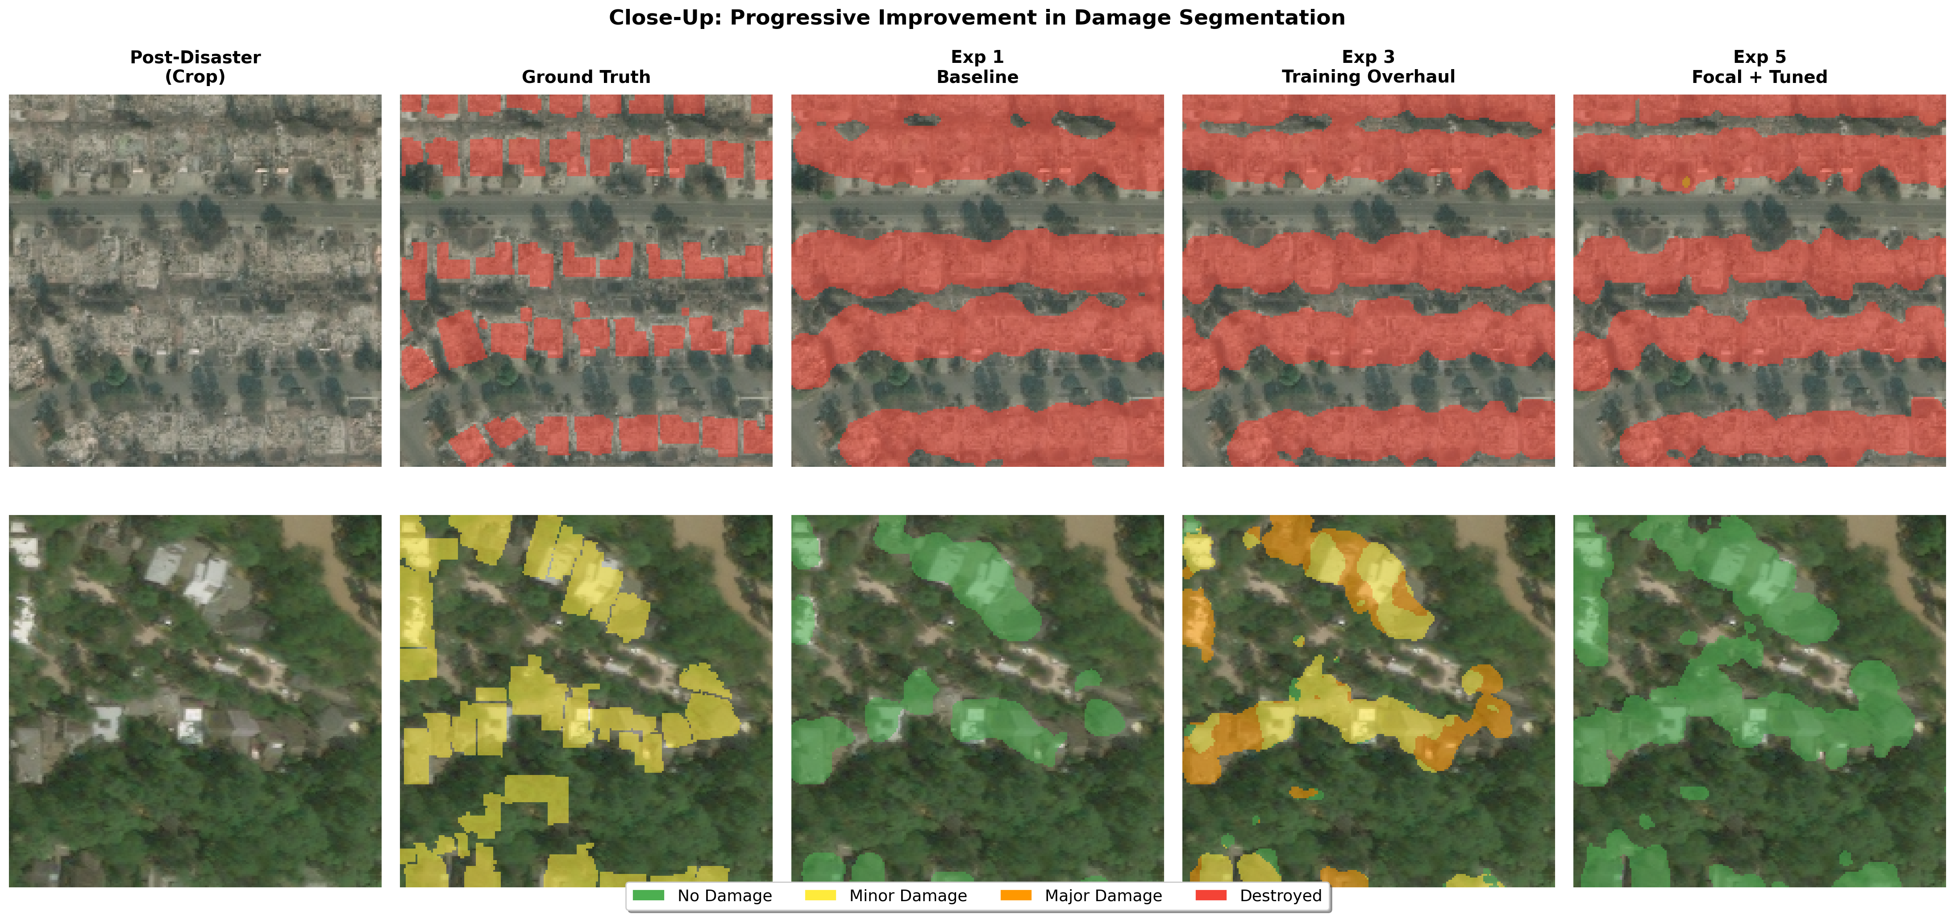
Figure 11: Close-up comparison of predictions. Damage classification improves across experiments.

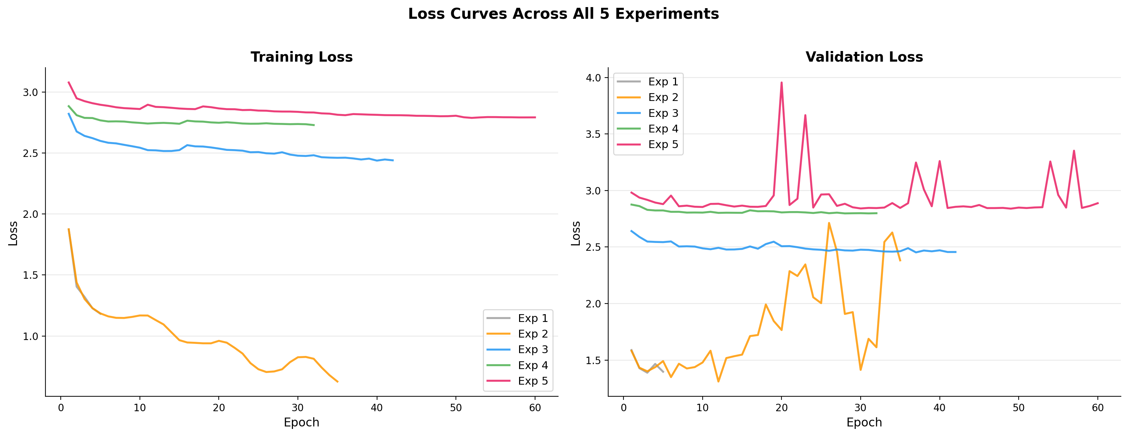
Figure 12: Train and val loss across all experiments. Overfitting decreases progressively.

4.6 Comparison to State-of-the-Art
Model | Damage F1 | Data | Ensemble
1st place (vdurnov) [5] | ~0.75 | Full xBD (22K pairs) | 12 models
2nd place (selimsef) [6] | ~0.72 | Full xBD | 2 models
Single-model baseline | ~0.625 | Full xBD | 1 model
Ours (Exp 4) | 0.546 | Tier 3 (2.2K pairs) | 1 model

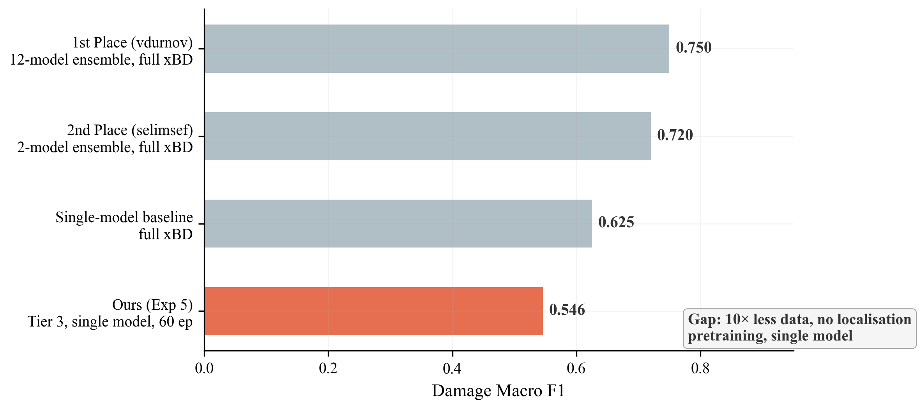
Figure 13: Comparison to competition results. The gap comes from having less data, no ensembling, and no localisation pretraining.

The gap is due to resource differences, not architecture:
- 10x less data -- we used Tier 3 (2.2K pairs) vs the full xBD (22K pairs)
- No localisation pretraining -- winners first trained a model to find buildings, then fine-tuned for damage
- Single model -- no ensembling or test-time augmentation
Despite this, our 28% relative mIoU improvement shows effective hyperparameter tuning, and our Minor Damage F1 (0.465) beats the typical competition winner range (0.30-0.45).

5. Analysis

5.1 What Helped Most
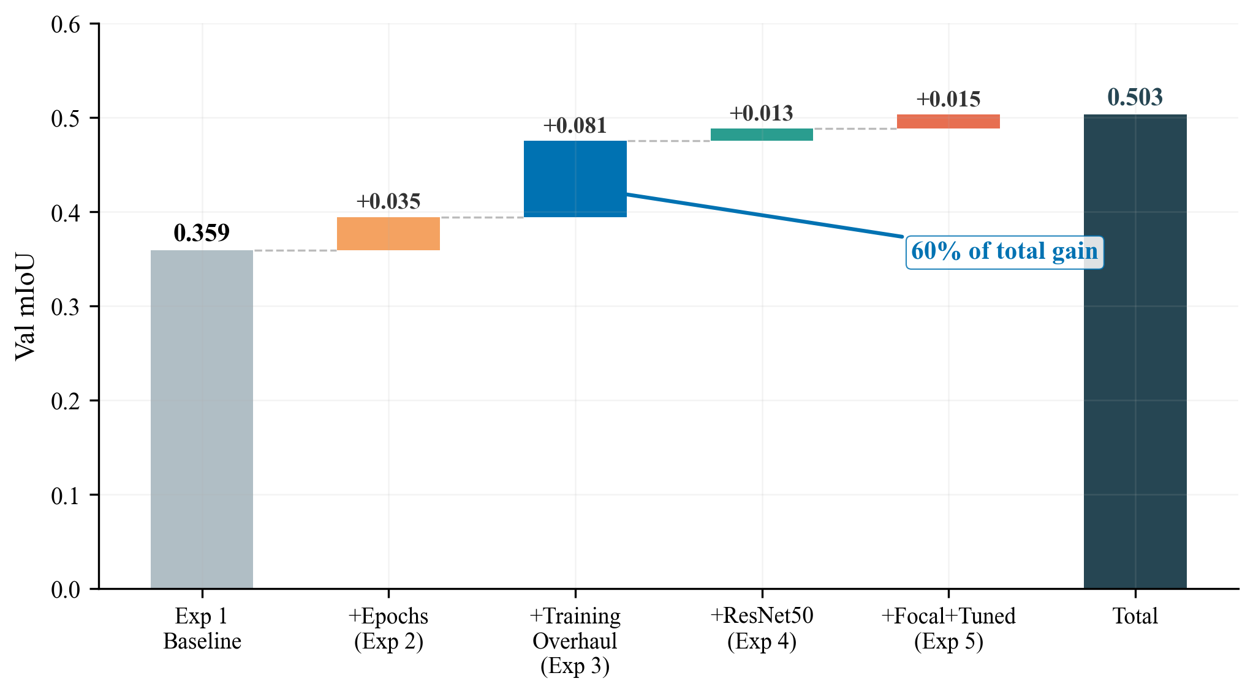
Figure 14: Waterfall chart of mIoU improvement. Training strategy (Exp 2) accounts for the majority of the total gain.

Rank | Change | Experiment | mIoU Gain | % of Total
1 | Training strategy overhaul | Exp 2 | +0.081 | 74%
2 | Focal Loss + tuned fine-tuning | Exp 4 | +0.015 | 14%
3 | Bigger backbone (ResNet50) | Exp 3 | +0.013 | 12%

Key takeaway: How you train matters more than what you train. The 500x weight decay increase was the single most impactful change.

5.2 Minor Damage: The Hardest Class
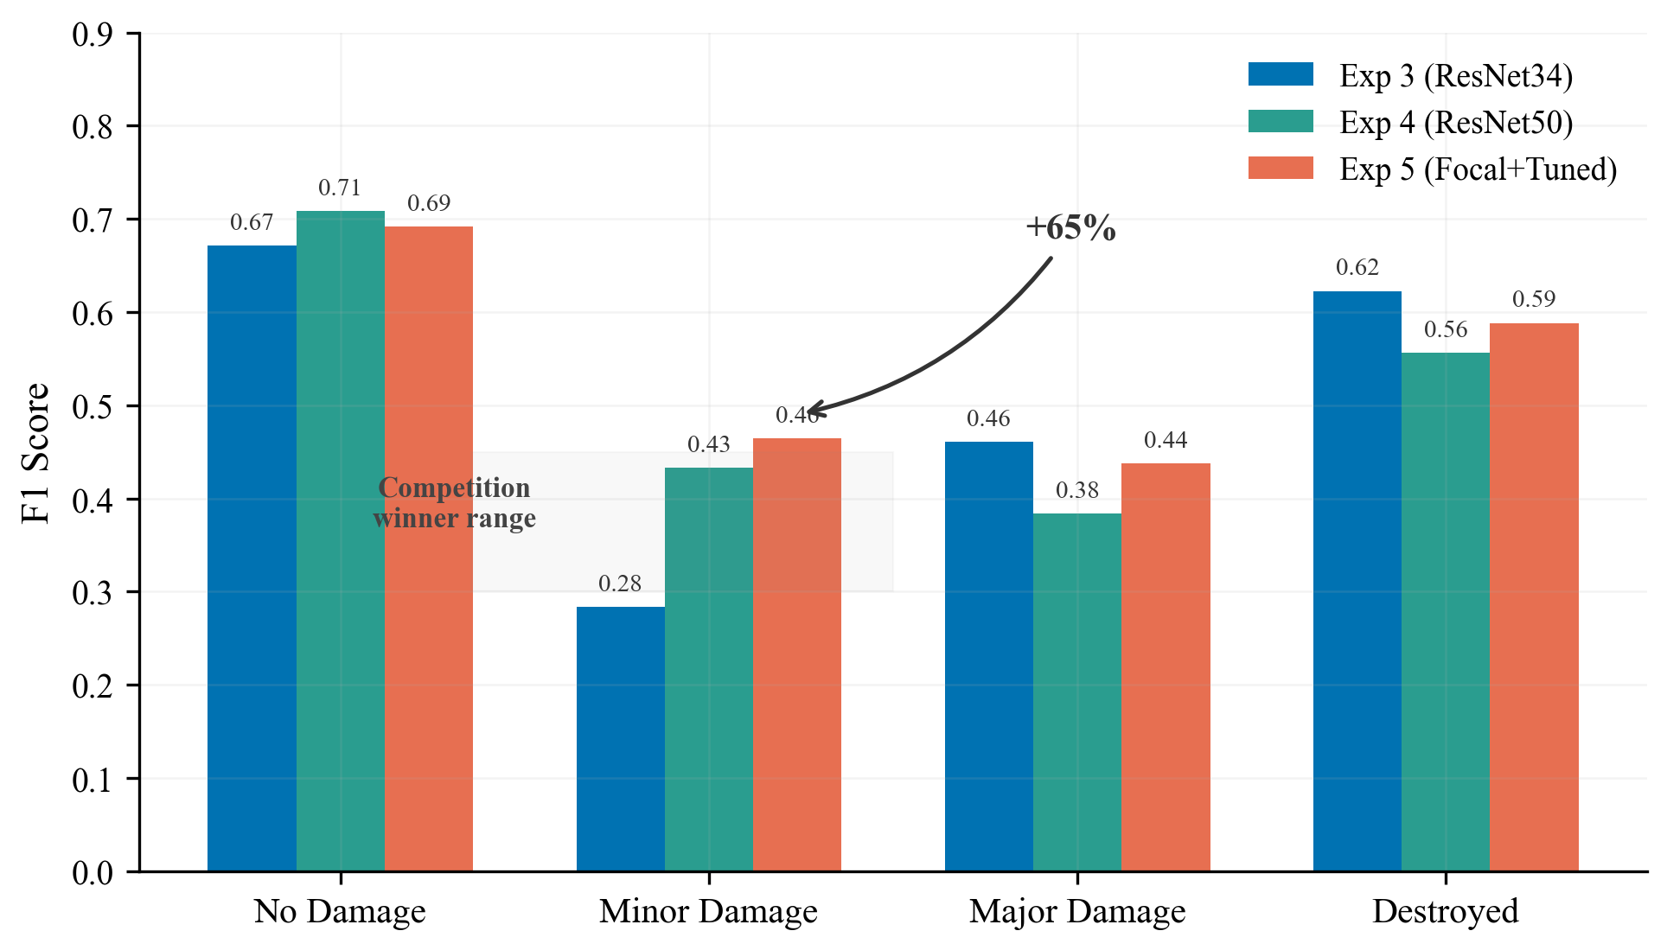
Figure 15: Per-class F1 across Exp 2-4. Minor Damage improved by +65% over three experiments and now exceeds the competition winner range.

Experiment | Minor Damage F1 | Change
Exp 2 (ResNet34) | 0.283 | --
Exp 3 (ResNet50) | 0.433 | +53%
Exp 4 (+ Focal) | 0.465 | +64% total

Minor Damage is hard because cracks and missing tiles are tiny at 512x512 resolution. Competition winners also struggle with this class (typically 0.30-0.45 F1). Our final 0.465 exceeds this range.

5.3 Bigger Backbone Needs Bigger Learning Rate
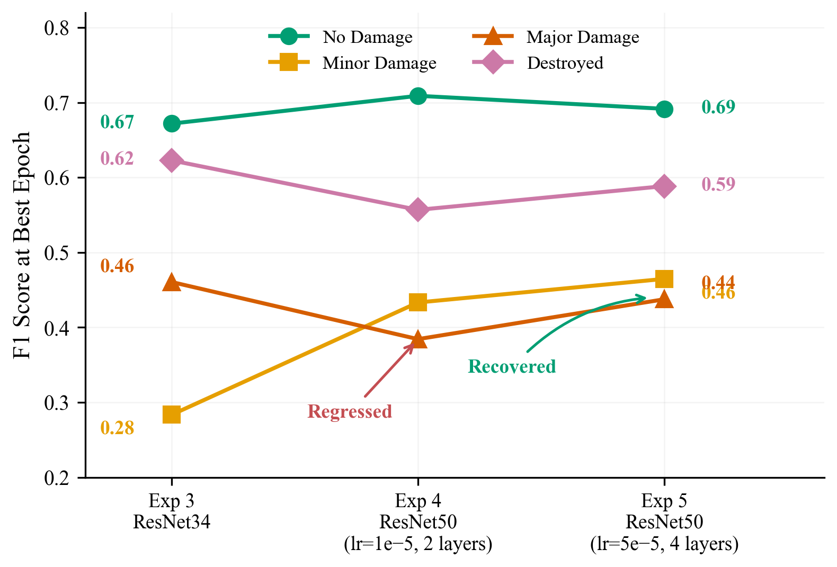
Figure 16: Per-class F1 across experiments. Major Damage dropped when we added ResNet50 with conservative fine-tuning, then recovered when we increased the encoder learning rate.

Switching to ResNet50 (Exp 3) actually made Major Damage worse (0.461 -> 0.384). This happened because the encoder learning rate was too low. When we increased the encoder LR 5x and unfroze more layers in Exp 4, Major Damage recovered to 0.437.
Lesson: A bigger model with weak fine-tuning can be worse than a smaller model that is fully adapted.

5.4 What Didn't Help
- Baseline without regularisation (Exp 1): 35 epochs with default settings resulted in severe overfitting.
- Conservative fine-tuning (Exp 3): Keeping encoder LR at 1e-5 with only 2 layers unfrozen wasted ResNet50's extra capacity.

5.5 Failure Cases
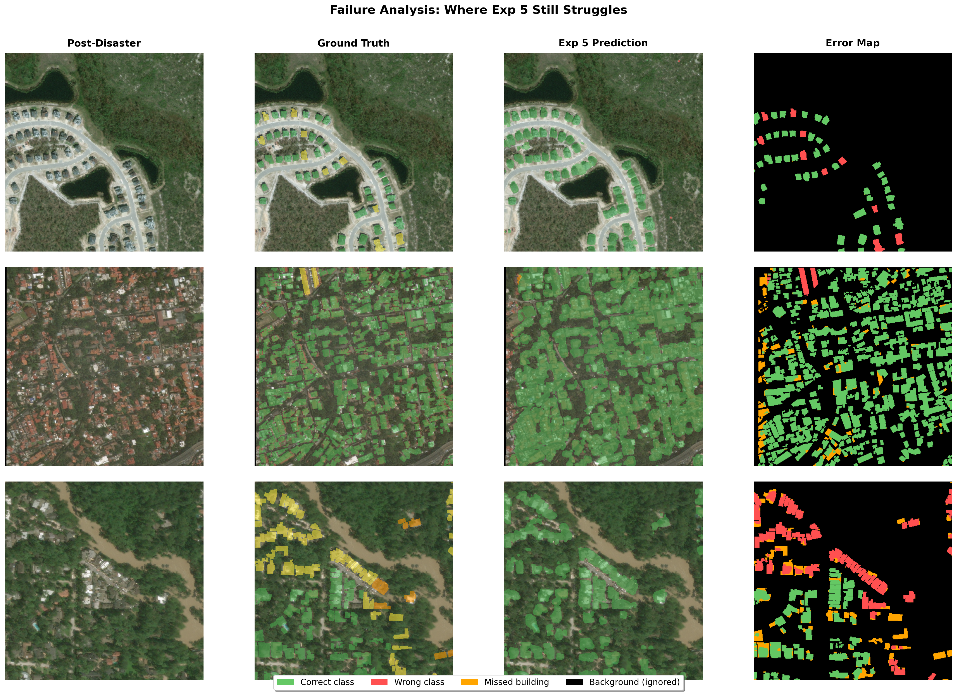
Figure 17: Where Exp 4 still fails. Error maps show misclassifications for minor/major confusion, small buildings, and mixed damage levels.

- Minor vs Major confusion: The boundary between damage levels is subjective -- even human annotators disagree.
- Small buildings: Buildings that are only a few pixels wide are hard to classify at 512x512 resolution.
- Underrepresented disasters: The model performs worse on disaster types with fewer training examples.
- Phase 2 instability: Aggressive fine-tuning caused occasional validation loss spikes throughout the 60-epoch run, though the model always recovered. These likely contributed to the late-epoch plateau after the best epoch (49).

6. Reproducibility

6.1 Dependencies
Python 3.11+, PyTorch >= 2.0 (with CUDA), torchvision, opencv-python, scikit-image, scikit-learn, shapely, matplotlib, numpy, tqdm.

6.2 Dataset Setup
- Download xView2 Tier 3 from Kaggle
- Place in: data/train/train/images/ and data/train/train/labels/

6.3 Training
- Open Kaggle-latest.ipynb (Kaggle) or training_script.ipynb (local)
- Set CONFIG_PATH to the experiment config (e.g. training_runs/siamese_resunet_xview2_4/config.json)
- Run all cells. Outputs saved automatically: config.json, history.json, metrics.csv, best_model.pt, last_model.pt

6.4 Loading a Trained Model
model = SiameseResUNet(backbone='resnet50', num_classes=5, decoder_channels=[512, 256, 128, 64])
checkpoint = torch.load('training_runs/siamese_resunet_xview2_4/best_model.pt', map_location='cpu')
model.load_state_dict(checkpoint['model_state_dict'])
model.eval()
pred = model(pre_image, post_image).argmax(dim=1)

6.5 Recreating Figures
python generate_figures.py
python generate_extra_figures.py
python generate_prediction_figures.py

6.6 Project Structure
ADL Project/
REPORT_2.md # This report (markdown version)
Kaggle-latest.ipynb # Training notebook
training_script.ipynb # Local training notebook
generate_figures.py # Chart figures (A1-B5, C2, C4)
generate_extra_figures.py # Diagram figures (C1, C3)
generate_prediction_figures.py # Prediction figures (D1-D3)
images/ # 17 figures
training_runs/
siamese_resunet_xview2_1/ # Initial trial (omitted from report)
siamese_resunet_xview2_2/ # Exp 1: Baseline
siamese_resunet_xview2/ # Exp 2: Training overhaul
siamese_resunet_xview2_3/ # Exp 3: ResNet50
siamese_resunet_xview2_4/ # Exp 4: Focal + Tuned Phase 2
data/ # Dataset (not in git)

7. Conclusion
We built a Siamese ResNet U-Net for satellite building damage segmentation, reaching a damage macro F1 of 0.546 and mIoU of 0.503 across four experiments. Three main findings:
1. Training strategy matters more than architecture. The Exp 2 training overhaul gave us +20.6% mIoU with zero architecture changes. Weight decay (0.05) and two-phase encoder freezing accounted for the majority of our total improvement.
2. Bigger models need proper fine-tuning. ResNet50 improved Minor Damage by +53%, but hurt Major Damage when fine-tuned too conservatively. Increasing the encoder learning rate 5x and unfreezing more layers fixed this.
3. Focal Loss helps hard cases. Switching to Focal Loss directed the model toward difficult damage boundary pixels, recovering the Major Damage regression and pushing Minor Damage to 0.465 -- above the competition winner range.
The gap between our result (0.546) and competition winners (0.75) comes from resource constraints: 10x less data, no ensembling, and no localisation pretraining.

Future Work
- Add test-time augmentation (typically +1-3% for free)
- Add building localisation head (multi-task learning)
- Train on the full xBD dataset if compute allows
- Experiment with model ensembling (different seeds or architectures)

8. Team Contributions
Member | Contributions
[Name 1] | [Contributions]
[Name 2] | [Contributions]
[Name 3] | [Contributions]
[Name 4] | [Contributions]

References
[1] Gupta, R., et al. "xBD: A Dataset for Assessing Building Damage from Satellite Imagery." arXiv:1911.09296, 2019.
[2] Ronneberger, O., Fischer, P., & Brox, T. "U-Net: Convolutional Networks for Biomedical Image Segmentation." MICCAI 2015.
[3] He, K., et al. "Deep Residual Learning for Image Recognition." CVPR 2016.
[4] Lin, T.-Y., et al. "Focal Loss for Dense Object Detection." ICCV 2017.
[5] xView2 1st Place Solution: github.com/vdurnov/xview2_1st_place_solution
[6] xView2 2nd Place Solution: github.com/selimsef/xview2_solution

