Gotta Go FAST GDD

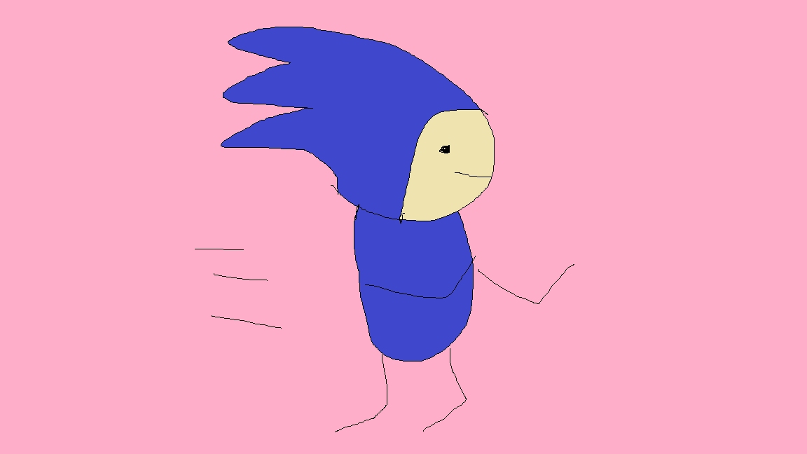

***‘Like Sonic said, gotta go FAST’*** - Darren Ferrer

This page: Table of Contents and Team Member Listing

|  |  |  |
| --- | --- | --- |
| Table of Contents  Executive Summary   * Game Overview * Technical Summary   High Concept  Unique Selling Points  Equipment   * Hardware * Software   Competitors / Similar Titles  Synopsis  Game Objectives  Game Structure  Game Play   * Game Controls * Game Camera * Maps   Player   * Characters * Metrics * States   Art   * Audio   Procedurally Generated Content   * Environment * Levels   -EndlessRunning  Wishlist  Bibliography   |  | | --- | |  | | Game Development Team Members    PRODUCER  Darren Ferrer    PRODUCTION MANAGER  Darren Ferrer    PRODUCTION COORDINATOR  Darren Ferrer  GAME DESIGNERS  Darren Ferrer  SYSTEMS/IT COORDINATOR  Darren Ferrer  PROGRAMMERS  Darren Ferrer  TECHNICAL ARTISTS  Darren Ferrer  AUDIO ENGINEERS  Darren Ferrer  UX TESTERS  Darren Ferrer |

|  |
| --- |
|  |

# Executive Summary

## Game Overview

Title: Gotta Go FAST

Platform: PC Standalone

Genre: Platformer

Rating: (10+) ESRB

Target: Casual gamer (aging from 5+)

Release date: May 9, 2020

Publisher: Darren Ferrer Co.

Description: *Gotta Go FAST* is an endless platformer game much like temple run. The player takes control of a goblin, Zolrik, who is trying to get to the other side of the bridge to find his comrades. As time goes on, he gets more impatient, leading him to go faster and faster. The only things in his way are all these boxes placed precariously on the bridge as if it were meant to impede his journey. Every 15 points, Zolrik increases his speed, in turn increasing the difficulty of the game.

## Technical Summary

*Gotta Go Fast* was developed in approximately 2 weeks by one person using the Unity game engine, the 3D modelling program Blender, as well as paint. The game also utilizes free assets from the Unity store. The total production cost of the game was an outstanding $0.00, as such the game will be released as a free game with no revenue.

# High Concept

*Gotta Go FAST* sets the player on a grassy bridge filled with boxes. The goal is to avoid the boxes at all costs and get as far as the player can, increasing in speed every 15 points. How far will you be able to go?

# Unique Selling Points

* Easy to learn
* Easy to understand
* Simple gameplay
* Kid Friendly
* For all ages
* Good time killer

# Equipment

## Hardware

Members of the team will utilize the ASUS Chromebook as the primary hardware platform for game development.

|  |  |  |  |  |
| --- | --- | --- | --- | --- |
| Product | Task | Cost | Quantity | Total |
| ASUS Chromebook | Game Development / 3D Modelling | $1,200 | 1 | $1,200 |

## Software

|  |  |  |  |  |
| --- | --- | --- | --- | --- |
| Product | Task | Cost | Quantity | Total |
| Unity Community | Game Editor / Engine | $0.00 | 1 | $0.00 |
| Blender | 3D Modelling | $0.00 | 1 | $0.00 |
| Paint | Artwork | $0.00 | 1 | $0.00 |

# Competitors / Similar Titles

Similar games to *Gotta Go Fast* are games such as *Subway Surfer* and *Temple Run*.

# Synopsis

*Gotta Go FAST* is an endless running platformer in which the player avoids boxes in attempt to go further than their previous best score. The creator pulled inspiration from Subway Surfer to create this game.

# Game Objectives

* Avoid Boxes
* Run as far as you can
* Beat your highscore

# Game Structure

The player will be spawned on a bridge in which he will start off at the base speed. As the game progresses, the player will infinitely speed up. Random bridges will be spawned from a set of bridge tiles, to create a more challenging experience for the player.

# Game Play

## Game Controls

|  |  |
| --- | --- |
| Movement | Input |
| Left | “a” or left on arrowkeys |
| Right | “d” or right on arrowkeys |

## Game Camera

*Gotta Go Fast* features a camera that follows behind the player at a fixed distance.

## Maps

There is only one map. Although there is only one map, the map is procedurally generated through prefabs, so that one play-through is not an exact match for another.

# Player

## Characters

The one and only character in *Gotta Go FAST* is a goblin named Zolrik.

## Metrics

Speed : 15 (increases by 2 every 15 points)

## States

Running: the player is stuck in a perpetual running motion

# Art

|  |  |
| --- | --- |
| Art Used | Used Where |
| Sanic by Darren Ferrer | Main Menu  Retry Screen |
| Free Night Sky by qianyuez | Skybox |
| Fantasy Monsters Zolrik by Fantasy Polygon | EndlessRunning (Character) |
| Stylized Grass Texture by LowlyPoly | EndlessRunning (Bridge ground) |
| ParticleFire by Eric Van de Kerckhove | EndlessRunning (Torches) |

## Audio

|  |  |
| --- | --- |
| Audio Name / Creator | Used For |
| God of War by Bear McCreary | Background music in EndlessRunning |
| Sonic X Theme Song by Marc Biagi | Background music in Main Menu |
| Welcome by Darren Ferrer | Credits Scene |
| Nice Try by Darren Ferrer | RetryScreen |

# Procedurally Generated Content

## Environment

The bridge that the player runs on is actually multiple bridge prefabs that is randomly spawned in for some variation in the game.

## Levels

Only one level

### EndlessRunning

|  |  |
| --- | --- |
| EndlessRunning Assets |  |
| Obstacles | Box variants |
| Environment | Bridge ground  Bridge Barriers  Bridge Connecters  Plane (black so it seems like there is an abyss underneath the player)  Torches |
| Players | Zolrik (goblin) |
| Nightsky2 | Replaced the default skybox |

# Wish List

Add a character selection screen

Possibly add a “sanic” character into the game. (the creator could not get a 3d model resembling anything like sonic)

Add a jumping feature?

Not sure how this would be implemented since jumping would make the game too easy. Will probably modify the obstacles to counteract this.

# Bibliography

|  |  |  |
| --- | --- | --- |
| Name/Creator | Type | URL (if there is one) |
| Free Night Sky by qianyuez | Asset | Unity Asset Store |
| Fantasy Monsters Zolrik by Fantasy Polygon | Asset | Unity Asset Store |
| Stylized Grass Texture by LowlyPoly | Material | Unity Asset Store |
| ParticleFire by Eric Van de Kerckhove | Material | <https://www.raywenderlich.com/138-introduction-to-unity-particle-systems> |
| God of War by Bear McCreary | Audio | <https://www.youtube.com/watch?v=jpyVfd8TyoI> |
| Sonic X Theme Song by Marc Biagi | Audio | <https://www.youtube.com/watch?v=VTHsOSGJHN0> |
| TileSpawner by N3K | Script | <https://www.epitome.cc/#/download> |
| PlayerMovement (used basics of the given script) | Script | <https://docs.unity3d.com/ScriptReference/CharacterController.Move.html> |