Super Ninja Game Design Document (GDD)

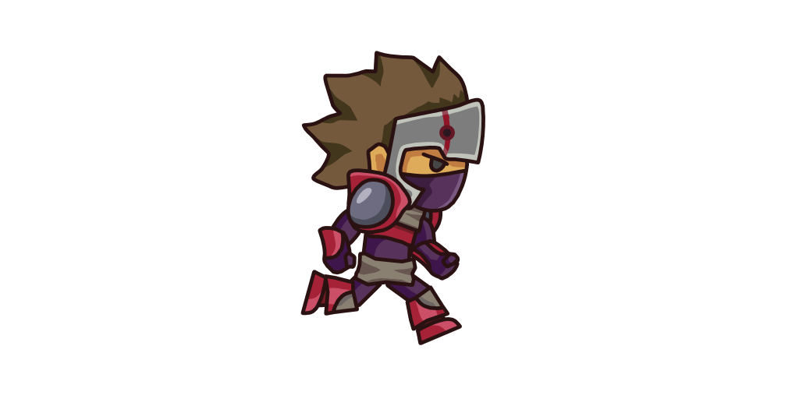

***‘ I’m Stealthy Like An Elephant ’*** – Darren Ferrer

This page: Table of Contents and Team Member Listing

|  |  |  |
| --- | --- | --- |
| Table of Contents  Executive Summary   * Game Overview * Technical Summary   High Concept  Unique Selling Points  Equipment   * Hardware * Software   Evaluation   * Game Engine * Target Platform   Work Environment   * Remote Collaboration   Assets & Scripts   * 2D Assets * Scripts * Animations   Genre  Levels   * Level 1 * Level 2 * Level 3 * Credits Screen   Competitors / Similar Titles  Synopsis  Game Objectives  Game Structure  Game Play   * Game Controls * Game Camera   Player   * Characters * Player Metrics * Player States   Art   * Setting * Audio   MVP (Minimum Viable Product)  Wishlist  Bibliography   |  | | --- | |  | | Game Development Team Members    PRODUCER  Darren Ferrer    PRODUCTION MANAGER  Darren Ferrer    PRODUCTION COORDINATOR  Darren Ferrer  GAME DESIGNERS  Darren Ferrer  SYSTEMS/IT COORDINATOR  Darren Ferrer  PROGRAMMERS  Darren Ferrer  TECHNICAL ARTISTS  Darren Ferrer  AUDIO ENGINEERS  Darren Ferrer  UX TESTERS  Darren Ferrer |

|  |
| --- |
|  |

# Executive Summary

## Game Overview

Title: Super Ninja

Platform: PC Standalone

Genre: Platformer

Rating: (10+) ESRB

Target: Casual gamer (aging from 120+)

Release date: April 11, 2020

Publisher: Darren Ferrer Co.

Description: Super Ninja is a 2D platformer where the player embodies a Ninja character. The Ninja is trying to reach the treasure at the end of the level in order to progress. The player must avoid drowning, falling to their deaths, and moving spike balls in order to succeed.

## Technical Summary

Super Ninja was developed in approximately 2 weeks by one person using the Unity game engine. Using free texture packs from the Unity asset store. The total production cost of the game did not exceed $0.00, as such the game will also be free and will generate no revenue.

The game will be deployed for PC.

# High Concept

Super Ninja sets the player in a multitude of scenarios, mostly consisting of grassy ground, water, and clouds. While dodging certain death from drowning, falling into spike pits, or swinging maces, the Ninja pursues the treasure at the end of each level!

# Unique Selling Points

* Cartoon-like graphics
* Easy to learn
* Kid friendly

# Equipment

## Hardware

Members of the team will utilize the ASUS Chromebook as the primary hardware platform for game development.

|  |  |  |  |  |
| --- | --- | --- | --- | --- |
| Product | Task | Cost | Quantity | Total |
| ASUS Chromebook | Game Development | $1,200 | 1 | $1,200 |

## Software

All the software used for the development of Super Ninja will be able to produce high end visuals, while still being able to deploy across different platforms. Not all team members will utilize all software tools. Software requirements and selections will vary based on team member roles and responsibilities.

|  |  |  |  |  |
| --- | --- | --- | --- | --- |
| Product | Task | Cost | Quantity | Total |
| Unity Community | Game Editor / Engine | $0.00 | 1 | $0.00 |

# Evaluation

## Game Engine

The game engine utilized for the development of Super Ninja is Unity simply because the ease of access to all the assets needed to create a game is integrated into the application. This is used in order to create smooth gameplay and lovable visuals.

## Target Platform

Super Ninja will be deployed to PC. The creator of this game is a new and aspiring game developer whose first game was indeed Super Ninja and does not have the knowledge required to deploy it to any other platforms. He does, however, plan to learn in the future.

# Work Environment

## Remote Collaboration

Although Super Ninja was created by a single person, the game was submitted to Rijeka in order to maintain a record as well as submit his work for his professor to see. This allows both parties to have a synched project in an organized manner.

# Assets & Scripts

## 2D Assets

|  |  |
| --- | --- |
| Asset Name & Developer | Uses |
| Free Platform Game Assets by Bayat Games | Used the cloud PNGs, background art you see in the levels and main menus, as well as the swinging mace assets |
| Ninja Sprite (Free) by Kin Ng | The main character of the game, the animations were included in the asset as well |
| Sunny Land by Ansimuz | Provided the ground textures and water animations |

## Scripts

|  |  |
| --- | --- |
| Script Name | Function |
| CharacterController2D | Controls multiple variables for the character including speed, jump height, etc. |
| CreditsToMainMenu | Transition between credits screen to the main menu screen |
| DeathZone | Restarts the level when the player dies |
| KeepAudioBetweenScenes | Keeps the music continuous throughout the levels |
| MainMenu | Contains all the functions needed in the main menu (Play, Quit, How To Play) |
| MovingPlatform | Moves a platform between 2 specific points |
| NextLevel | Transition to the next level |
| PlayerMovement | Accepts input and recognizes whether the player is jumping or moving left or right |
| SoundManager | Allows for sound effects |

## Animations

|  |  |
| --- | --- |
| Animation Folder | States |
| CoinAnimationPictures | Coin Spinning (Not used in project) |
| NinjaAnimations | Idle  Jump  Run |
| Water Animation | Flowing Water |

# Genre

Super Ninja is classified as a 2D platformer. The players of platformers must run and jump while avoiding certain obstacles. These games often have uneven terrain, varying terrain heights, even moving platforms in order to reach the end of the level. Super Ninja includes all three of these in its levels plus more in its three levels.

# Levels

## Level 1

The first level is an introductory level where the player will familiarize themselves with the game’s controls and how the game feels. There are two spike pits, that if the player falls into them will restart the level. At the end of the level sits a treasure chest where, upon contact, will send the player to the next level.

|  |  |
| --- | --- |
| **Level 1 Assets** |  |
| Obstacles | Spike Pits (2) |
| Environment | Grassy Ground  Treasure Chest |
| Players | Ninja |

## Level 2

The second level contains more of a challenge to the player, containing multiple objects that could kill them: a spinning mace, a body of water, and the ability to fall to their death. There are also moving platforms, introducing a harder difficulty traversing the level. Again, upon reaching the treasure chest, the player will be sent to the next level.

|  |  |
| --- | --- |
| **Level 2 Assets** |  |
| Obstacles | Swinging Mace  Water |
| Environment | Moving Clouds (2)  Stationary Clouds (2)  Grassy Ground  Treasure Chest |
| Players | Ninja |

## Level 3

The third level contains much less than the second level, but is what the creator considers to be the most challenging level. There are two clouds, one with the player and one with the treasure chest. In between the two clouds are two moving, swinging maces in which the player will have to jump on the moving platforms that the maces are swinging around in order to reach the end of the level. Both of the swinging maces are above a large body of water. Upon reaching the treasure chest, the player will be sent to the Credits Screen.

|  |  |
| --- | --- |
| **Level 3 Assets** |  |
| Obstacles | Water  Moving Swinging Maces (2) |
| Environment | Clouds (2)  Treasure Chest |
| Players | Ninja |

## Credits Screen

The final “level” of the game is simply a credits screen with the creator’s name in the background. The player is presented with a long pathway of clouds leading to a treasure chest which will send the player back to the man menu.

|  |  |
| --- | --- |
| **Credits Screen Assets** |  |
| Obstacles | None |
| Environment | Clouds (12)  Creator Text  Treasure Chest |
| Players | Ninja |

# Competitors / Similar Titles

Similar titles to Super Ninja are: Super Mario Bros, Sonic the Hedgehog, Little Big Planet, and Super Meat Boy. In addition, these games were inspirations to create this game.

# Synopsis

Super Ninja is a 2D platformer game in which you avoid lethal objects and falling off screen in order to progress. The creator pulled inspiration from games such as Super Mario Bros while creating this game.

# Game Objectives

The objective of the game is to avoid any obstacles that would cause your character to die and reach the treasure chest at the end of the level

# Game Structure

The player will be spawned on the left side of the screen and make their way to the treasure chest. This game presents a very simplistic gameplay in which can be reminiscent to some gamers.

Main Menu 🡪 Gameplay (3 Levels) 🡪 Credits Screen 🡪 Main Menu

# Game Play

## Game Controls

|  |  |
| --- | --- |
| Movement | Input |
| Left | Left on the arrow keys |
| Right | Right on the arrow keys |
| Jump | Up on the arrow keys |

## Game Camera

Super Ninja features a static camera.

# Player

## Characters

The exclusive character used in Super Ninja is a Ninja. His mission is to steal the treasure chest at the end of each round to fulfill the orders given to him.

## Player Metrics

Speed: 80

Jump Force: 400

Attack Damage: N/A

Time to Attack: N/A

## Player States

**Idle**: The idle animation is where the player bobs up and down.

**Running**: The movement animation will cause the player to sprint to the left or right. It will be

triggered when the player moves either left or right.

**Jumping:** The jumping animation causes the ninja to lift up one of his legs higher than the other. It will be triggered when the player presses up on the arrow keys.

# Art

## Setting

|  |  |
| --- | --- |
| Art Used | Used Where |
| Sky by Bayat Games | Main Menu Background |
| Background by Bayat Games | Level 1  Level 2  Level 3 |
| Back by Ansimuz | Credits Screen |

## Audio

|  |  |
| --- | --- |
| Audio Name / Creator | Used For |
| Woodland Fantasy by Matthew Pablo | Background Music |
| Cartoony Jump and Bounce by qubodup | Jumping Sound Effect |
| Game Over - Bad chest SFX by Oiboo | Death/Level Restart Sound Effect |

# MVP (Minimum Viable Product)

* One player to choose from (Ninja)
* Built for the PC platform

# Wishlist

Add Enemy AI

In the future, add enemy AI that patrol an area and seek out the player when they enter their immediate vicinity.

Add Double Jump Feature

Make it so the player is able to double jump, making previously hard levels easier to clear.

# Bibliography

|  |  |  |
| --- | --- | --- |
| Name/Creator | Type | URL |
| Free Platform Game Assets by Bayat Games | Asset | <https://assetstore.unity.com/packages/2d/environments/free-platform-game-assets-85838> |
| Sunny Land by Ansimuz | Asset | <https://assetstore.unity.com/packages/2d/characters/sunny-land-103349> |
| Ninja Sprite (Free) by Kin Ng | Asset | <https://assetstore.unity.com/packages/2d/characters/ninja-sprite-sheet-free-93901> |
| 2D Character Controller by Brackeys | Script | <https://github.com/Brackeys/2D-Character-Controller> |
| Player Movement by Brackeys | Script | <https://www.youtube.com/watch?v=dwcT-Dch0bA&list=PLPV2KyIb3jR6TFcFuzI2bB7TMNIIBpKMQ&index=2> |
| Moving Platform by inScope Studios | Script | <https://www.youtube.com/watch?v=4R_AdDK25kQ&list=PLX-uZVK_0K_6VXcSajfFbXDXndb6AdBLO&index=44> |
| SoundManager by ALexander Zotov | Script | <https://www.youtube.com/watch?v=8pFlnyfRfRc> |
| Woodland Fantasy by Matthew Pablo | Sound | <https://opengameart.org/content/woodland-fantasy> |
| Cartoony Jump and Bounce by qubodup | Sound | <https://opengameart.org/content/cartoony-jump-and-bounce> |
| Game Over - Bad chest SFX by Oiboo | Sound | <https://opengameart.org/content/game-over-bad-chest-sfx> |