1. SELECT bNo, fName||' '||lName name, TO_CHAR(salary, '$999,990') salary, position
2. FROM Staff
3. WHERE position = 'Secretary'
4. ORDER BY salary DESC;

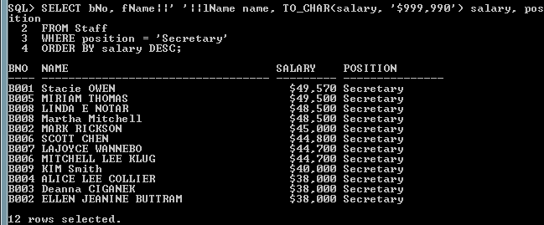

1. COLUMN name FORMAT A25
2. SELECT sNo, lName||', '||fname name, position, sex, dob, TO_CHAR(salary, '$999,990') salary, bNo
3. FROM Staff
4. WHERE bNo = 'B007'
5. ORDER BY lName ASC;

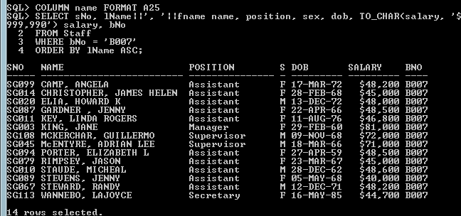

1. COLUMN name FORMAT A25
2. SELECT bNo, lName||', '||fName name, position, TO_CHAR(salary/12, '$999,990.99') monSal
3. FROM Staff
4. WHERE bNo IN ('B003','B007')
5. ORDER BY
6. CASE position
7. WHEN 'Manager' THEN 1
8. WHEN 'Secretary' THEN 2
9. WHEN 'Supervisor' THEN 3
10. WHEN 'Assistant' THEN 4
11. ELSE 0
12. END, lName ASC;

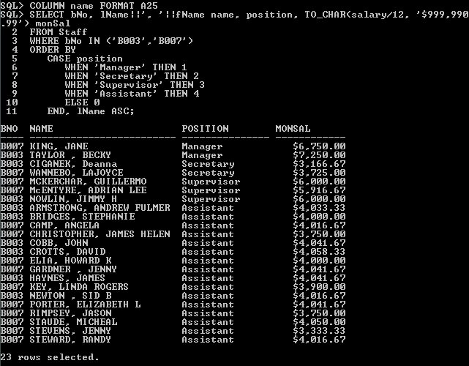

COLUMN name FORMAT A25

SELECT bNo, lName||', '||fName name, city, propCount

FROM Branch NATURAL JOIN Zip

NATURAL JOIN

(

SELECT bNo, fName, lName, COUNT(pNo) propCount

FROM Property p NATURAL JOIN Staff s

GROUP BY bNo, fName, lName

HAVING COUNT(pNo) > 26

)

ORDER BY propCount DESC;

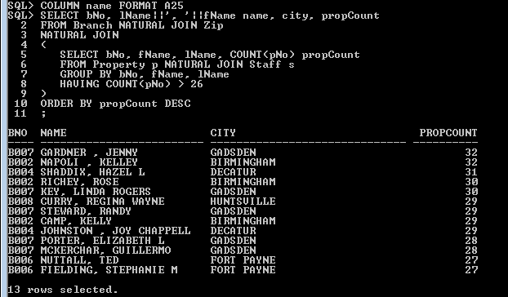

SELECT bNo,

COUNT(DECODE (position, 'Manager', bNo)) Manager,

COUNT(DECODE (position, 'Secretary', bNo)) Secretary,

COUNT(DECODE (position, 'Supervisor', bNo)) Supervisor,

COUNT(DECODE (position, 'Assistant', bNo)) Assistant

FROM Staff

GROUP BY bNo

ORDER BY bNo

;

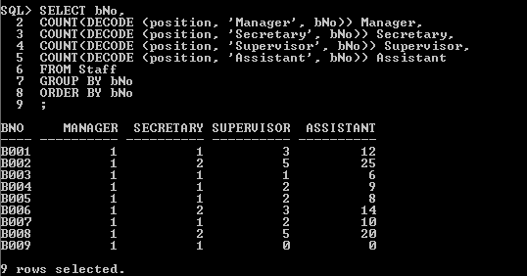

1. COLUMN name FORMAT A25
2. SELECT lName||', '||fName name, phone, COUNT(pNo) pCount
3. FROM Owner JOIN Property USING (oNo)
4. GROUP BY fName, lName, phone HAVING COUNT(pNo) > 4
5. ORDER BY pCount DESC, lName ASC;

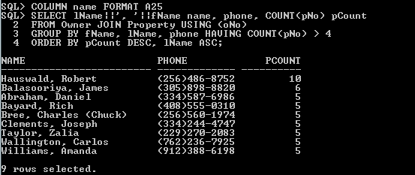

1. SELECT v.cNo, lName||', '||fName name, phone, viewDate
2. FROM Client c JOIN Viewing v ON c.cNo = v.cNo
3. WHERE pNo = 'PH0508' AND cmmt IS NULL
4. ORDER BY viewDate;

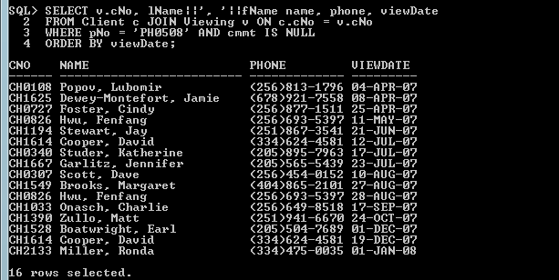

SELECT *

FROM(

SELECT fName, COUNT(fName)

FROM(

SELECT INITCAP(SUBSTR(fName, 1, INSTR(fName, ' ') - 1)) fName

FROM Staff

WHERE INSTR(fName, ' ') > 0 UNION ALL

SELECT INITCAP(fName) fName

FROM Staff

WHERE INSTR(fName, ' ') = 0 UNION ALL

SELECT INITCAP(SUBSTR(fName, 1, INSTR(fName, ' ') - 1)) fName

FROM Owner

WHERE INSTR(fName, ' ') > 0 UNION ALL

SELECT INITCAP(fName) fName

FROM Owner

WHERE INSTR(fName, ' ') = 0 UNION ALL

SELECT INITCAP(SUBSTR(fName, 1, INSTR(fName, ' ') - 1)) fName

FROM Client

WHERE INSTR(fName, ' ') > 0 UNION ALL

SELECT INITCAP(fName) fName

FROM Client

WHERE INSTR(fName, ' ') = 0)

GROUP BY fName

ORDER BY COUNT(fName) DESC)

WHERE ROWNUM <= 5;



SELECT city, COUNT(city) AS pCount

FROM Zip

NATURAL JOIN

Property

WHERE rent <= 500

GROUP BY city

HAVING COUNT(city) > 14

ORDER BY Count(city) DESC, city ASC

;

