|  |
| --- |
| **The University Accommodation Office Case Study** |
| Amber Pruitt and Darren Johnston |
| A case study on database design based for the director of a university accommodation office |
|  |



Table of Contents

Scenario 2

Business Logic and Attributes 2

Business Constraints 3

Functional Dependencies 3

ERD 4

Data Dictionary 4

Sample Input 8

Table Creation and Alteration 11

Queries 13

# Scenario

Our team is designing and implementing a database that manages on campus housing for the university. The director of the university accommodation office has asked for us to assist with the administration of the office with the database. The goal of the database is to manage the student’s payments for their housing. Information that will be recorded includes the student information, lease details, and invoice records.

# Business Logic and Attributes

Students are the most important part of the university. The information that the database puts in for the student includes a banner number, a first and last name, a mobile phone number, an email, a date of birth, a gender, and a classification. The banner number is the primary key.

A student has the opportunity to rent out a room in a hall or student apartment in the form of a lease. A lease must be negotiated at the start of each year and must last at least a semester and a maximum of a year. The information on a lease includes the lease number, the duration of the lease, the student’s banner number, the place number, the room number, and the date for the student to enter the room. The date the student plans to leave the room is also included when available. The primary key for the lease is the lease number. The banner number serves as the foreign key and it references the banner number in the Student table.

At the beginning of every semester, the student is sent an invoice for the new rental period. This invoice must have an invoice number, a lease number, a payment to be paid, and the semester that the student is being charged for. The primary key for invoice is the invoice number. The lease number is the foreign key in invoice and references the lease number in the Lease table.

# Business Constraints

Each student may only have one lease per semester; however, the student may have multiple leases over the course of their college career. Each student, lease, and invoice must have a unique number that identifies him or her.

# Functional Dependencies

1) Student

bannerNo 🡪 name, phone, email, dob, gender, classification

The banner number provides all of the information needed about the student.

2) Lease

leaseNo 🡪 duration, bannerNo, placeNo, roomNo, dateEntered, dateLeft

The lease number is needed to determine who has leased a certain room, how long they intend to lease the room, the room information, and the date the student will enter the room. You can also determine when the student plans to move out of the room, if available.

3) Invoice

invoiceNo 🡪 semester, paymentDue, leaseNo

The invoice number is needed to determine the payment of the lease. It determines the semester that the payment is for, the amount due, the room that is being paid for, and the lease that the invoice is associated with.

# ERD



# Data Dictionary

**Student Table**

**Relation Schema**

Student (bannerNo, name, phone, email, dob, gender, classificaiton)

**Primary Key**

bannerNo

**Foreign Key**

N/A

|  |  |  |  |  |  |
| --- | --- | --- | --- | --- | --- |
| **Name** | **Keys** | **Description** | **Data Type** | **Domain Characteristics** | **Required** |
| bannerNo | PK | Student’s unique identification number | 6 fixed characters | ST followed by four numbers | Yes |
| name |  | Student’s name | 25 variable characters |  | Yes |
| phone |  | Student’s mobile phone number | 10 fixed characters |  | Yes |
| email |  | Student’s email address | 25 variable characters |  | Yes |
| dob |  | Student’s date of birth | Date |  | Yes |
| gender |  | Gender of the student | 1 fixed character | Allowed values ‘M’ or ‘F’ | Yes |
| classification |  | Category of student | 9 variable characters | Allowed values ‘Freshman’, ‘Sophomore’, ‘Junior’, ‘Senior’ | Yes |

**Enterprise Constraints**

The banner number is unique for each student.

**Lease Table**

**Relation Schema**

Lease (leaseNo, duration, bannerNo, placeNo, roomNo, dateEntered, dateLeft)

**Primary Key**

leaseNo

**Foreign Key**

bannerNo references Student(bannerNo) on delete cascade

|  |  |  |  |  |  |
| --- | --- | --- | --- | --- | --- |
| **Name** | **Keys** | **Description** | **Data type** | **Domain Characteristics** | **Required** |
| leaseNo | PK | Number that identifies the lease | 6 fixed characters | LN followed by four numbers | Yes |
| duration |  | Number of semesters room is leased | 1 digit number | Allowed values ‘1’, ‘2’, or ‘3’ | Yes |
| bannerNo | FK | Student’s identifiaction number | 6 fixed characters | As for Student(bannerNo) | Yes |
| placeNo |  | Number that identifies residence | 5 fixed characters | PL followed by three numbers | Yes |
| roomNo |  | Number that identifies the room | 5 fixed characters | RM followed by three numbers | Yes |
| dateEntered |  | Date the student wishes to enter | Date |  | Yes |
| dateLeft |  | Date the student wishes to leave | Date |  | No |

**Enterprise Constraints**

Each lease number is unique, and a student may only have one lease per semester.

**Invoice Table**

**Relation Schema**

Invoices(invoiceNo, semester, paymentDue, name, placeNo, roomNo, leaseNo)

**Primary Key**

invoiceNo

**Foreign Key**

leaseNo references Lease(leaseNo) on delete cascade

|  |  |  |  |  |  |
| --- | --- | --- | --- | --- | --- |
| **Name** | **Keys** | **Description** | **Data type** | **Domain Constraints** | **Required** |
| invoiceNo | PK | Number that identifies the invoice | 5 fixed characters | IN followed by three numbers | Yes |
| semester |  | Semester that the invoice is issued for | 6 variable characters | Allowed values ‘Fall’, ‘Spring’, ‘Summer’ | Yes |
| paymentDue |  | Cost of the room | Currency |  | Yes |
| leaseNo | FK | Number that identifies the lease | 6 fixed characters | As for Lease(leaseNo) | Yes |

**Enterprise Constraints**

Each invoiceNo is unique.

# Sample Input

**Lease Data**

INSERT INTO Lease VALUES ('LN0001','ST0021', '1', 'PL032', 'RM004', TO_DATE('2013/08/02', 'yyyy/mm/dd'),TO_DATE('2014/01/01', 'yyyy/mm/dd'));

INSERT INTO Lease VALUES ('LN0999','ST0319', '3', 'PL100', 'RM101', TO_DATE('2012/01/02', 'yyyy/mm/dd'),NULL);

INSERT INTO Lease VALUES ('LN0087','ST0487', '2', 'PL022', 'RM010', TO_DATE('2012/01/02', 'yyyy/mm/dd'),TO_DATE('2012/08/01', 'yyyy/mm/dd'));

INSERT INTO Lease VALUES ('LN0792','ST1792', '3', 'PL035', 'RM052', TO_DATE('2014/05/02', 'yyyy/mm/dd'),NULL);

INSERT INTO Lease VALUES ('LN0889','ST3289', '1', 'PL001', 'RM141', TO_DATE('2012/05/02', 'yyyy/mm/dd'),TO_DATE('2012/08/01', 'yyyy/mm/dd'));

INSERT INTO Lease VALUES ('LN0132','ST4532', '1', 'PL012', 'RM011', TO_DATE('2011/08/02', 'yyyy/mm/dd'),TO_DATE('2012/01/01', 'yyyy/mm/dd'));

INSERT INTO Lease VALUES ('LN0475','ST9235', '1', 'PL028', 'RM142', TO_DATE('2010/01/02', 'yyyy/mm/dd'),TO_DATE('2010/05/01', 'yyyy/mm/dd'));

INSERT INTO Lease VALUES ('LN0091','ST8191', '2', 'PL011', 'RM002', TO_DATE('2010/08/02', 'yyyy/mm/dd'),NULL);

INSERT INTO Lease VALUES ('LN0878','ST5823', '3', 'PL040', 'RM123', TO_DATE('2014/05/02', 'yyyy/mm/dd'),TO_DATE('2015/08/01', 'yyyy/mm/dd'));

INSERT INTO Lease VALUES ('LN0211','ST2100', '3', 'PL101', 'RM023', TO_DATE('2014/05/02', 'yyyy/mm/dd'),TO_DATE('2015/08/01', 'yyyy/mm/dd'));

INSERT INTO Lease VALUES ('LN0555','ST0555', '2', 'PL021', 'RM042', TO_DATE('2012/08/02', 'yyyy/mm/dd'),TO_DATE('2013/05/01', 'yyyy/mm/dd'));

INSERT INTO Lease VALUES ('LN8000','ST1000', '1', 'PL099', 'RM093', TO_DATE('2012/08/02', 'yyyy/mm/dd'),TO_DATE('2013/01/01', 'yyyy/mm/dd'));

INSERT INTO Lease VALUES ('LN1203','ST7003', '2', 'PL070', 'RM110', TO_DATE('2011/01/02', 'yyyy/mm/dd'),TO_DATE('2011/08/01', 'yyyy/mm/dd'));

INSERT INTO Lease VALUES ('LN2208','ST4018', '3', 'PL004', 'RM132', TO_DATE('2010/01/02', 'yyyy/mm/dd'),TO_DATE('2011/01/01', 'yyyy/mm/dd'));

INSERT INTO Lease VALUES ('LN9099','ST9999', '2', 'PL099', 'RM028', TO_DATE('2010/01/02', 'yyyy/mm/dd'),NULL);

**Student Data**

INSERT INTO Student VALUES ('ST0021', 'Bob Jones', '2563202000', 'bJones3@dnc.edu',TO_DATE('1993/01/02', 'yyyy/mm/dd'),'M','Freshman');

INSERT INTO Student VALUES ('ST0319', 'Kill Bill', '3314724325', 'kBill2@dnc.edu',TO_DATE('1992/01/02', 'yyyy/mm/dd'),'M','Sophomore');

INSERT INTO Student VALUES ('ST0487', 'Silly Stan', '2057378929', 'sStan@dnc.edu',TO_DATE('1989/01/02', 'yyyy/mm/dd'),'M','Junior');

INSERT INTO Student VALUES ('ST1792', 'Momma Sanders', '2341122803', 'mSanders6@dnc.edu',TO_DATE('1995/01/02', 'yyyy/mm/dd'),'F','Junior');

INSERT INTO Student VALUES ('ST3289', 'Wormy Will', '4412347654', 'wWill2@dnc.edu',TO_DATE('1990/01/02', 'yyyy/mm/dd'),'F', 'Freshman');

INSERT INTO Student VALUES ('ST4532', 'Alex Gauss', '5269870003', 'aGuass@dnc.edu',TO_DATE('1982/01/02', 'yyyy/mm/dd'),'M','Senior' );

INSERT INTO Student VALUES ('ST9235', 'Cole Yole', '2052898382', 'cYole@dnc.edu',TO_DATE('1981/01/02', 'yyyy/mm/dd'),'M','Freshman' );

INSERT INTO Student VALUES ('ST8191', 'Phil Fish', '9988891111', 'pFish@dnc.edu',TO_DATE('1979/01/02', 'yyyy/mm/dd'),'M', 'Junior');

INSERT INTO Student VALUES ('ST5823', 'Richard Van', '7314569721', 'rVan9@dnc.edu',TO_DATE('1976/01/02', 'yyyy/mm/dd'),'M','Sophomore' );

INSERT INTO Student VALUES ('ST2100', 'Lillian K. Protega', '2891987373', 'lProtega2@dnc.edu',TO_DATE('1991/01/02', 'yyyy/mm/dd'),'F','Senior');

INSERT INTO Student VALUES ('ST0555', 'Amber Stiff', '8641285464', 'aStiff5@dnc.edu',TO_DATE('1995/01/02', 'yyyy/mm/dd'),'F', 'Junior');

INSERT INTO Student VALUES ('ST1000', 'Light Heart', '1239986366', 'lHeart@dnc.edu',TO_DATE('1988/01/02', 'yyyy/mm/dd'),'M', 'Freshman');

INSERT INTO Student VALUES ('ST7003', 'Mandy Mawhile', '2566268899', 'mMawhile2@dnc.edu',TO_DATE('1975/01/02', 'yyyy/mm/dd'),'F', 'Sophomore');

INSERT INTO Student VALUES ('ST4018', 'Hardy Rock', '5128902432', 'hRock4@dnc.edu',TO_DATE('1971/01/02', 'yyyy/mm/dd'),'M', 'Junior');

INSERT INTO Student VALUES ('ST9999', 'John Jacobs', '7538484465', 'jJacobs3@dnc.edu',TO_DATE('1991/01/02', 'yyyy/mm/dd'),'M', 'Freshman');

**Invoice Data**

INSERT INTO Invoice VALUES ('IN201', 'Fall', '362.99','LN0001');

INSERT INTO Invoice VALUES ('IN199', 'Spring', '364.23','LN0999');

INSERT INTO Invoice VALUES ('IN887', 'Spring', '262.87','LN0087');

INSERT INTO Invoice VALUES ('IN092', 'Summer', '299.63','LN0792');

INSERT INTO Invoice VALUES ('IN189', 'Summer', '398.89','LN0889');

INSERT INTO Invoice VALUES ('IN132', 'Fall', '289.11','LN0132');

INSERT INTO Invoice VALUES ('IN475', 'Spring', '300.10','LN0475');

INSERT INTO Invoice VALUES ('IN093', 'Fall', '412.13','LN0091');

INSERT INTO Invoice VALUES ('IN988', 'Summer', '401.88','LN0878');

INSERT INTO Invoice VALUES ('IN211', 'Summer', '345.18','LN0211');

INSERT INTO Invoice VALUES ('IN555', 'Fall', '322.30','LN0555');

INSERT INTO Invoice VALUES ('IN800', 'Fall', '234.98','LN8000');

INSERT INTO Invoice VALUES ('IN303', 'Spring', '373.00','LN1203');

INSERT INTO Invoice VALUES ('IN298', 'Spring', '284.11','LN2208');

INSERT INTO Invoice VALUES ('IN999', 'Spring', '302.83','LN9099');

# Table Creation and Alteration

DROP TABLE Lease CASCADE CONSTRAINTS PURGE;

CREATE TABLE Lease

(

leaseNo CHAR(6) PRIMARY KEY,

bannerNo CHAR(6) NOT NULL,

duration NUMBER(1) NOT NULL,

placeNo CHAR(5) NOT NULL,

roomNo CHAR(5) NOT NULL,

dateEntered DATE NOT NULL,

dateLeft DATE

)

;

ALTER TABLE Lease

ADD CONSTRAINT Lease_FK FOREIGN KEY(bannerNo)

REFERENCES Student(bannerNo) ON DELETE CASCADE;

DROP TABLE Student CASCADE CONSTRAINTS PURGE;

CREATE TABLE Student

(

bannerNo CHAR(6) PRIMARY KEY,

name VARCHAR2(25) NOT NULL,

phone CHAR(10) NOT NULL,

email VARCHAR2(25) NOT NULL,

dob DATE NOT NULL,

gender CHAR(1) NOT NULL,

classification VARCHAR2(9) NOT NULL

)

;

DROP TABLE Invoice CASCADE CONSTRAINTS PURGE;

CREATE TABLE Invoice

(

invoiceNo CHAR(5) PRIMARY KEY,

semester VARCHAR2(6) NOT NULL,

paymentDue NUMBER(5,2) NOT NULL,

leaseNo CHAR(6) NOT NULL

)

;

ALTER TABLE Invoice

ADD CONSTRAINT Invoice_FK FOREIGN KEY(leaseNo)

REFERENCES Lease(leaseNo) ON DELETE CASCADE;

# Queries

1. Display the details of lease agreements that begin in the summer semester.

SELECT l.leaseNo, duration, bannerNo, placeNo, roomNo, dateEntered, dateLeft

FROM Lease l LEFT OUTER JOIN Invoice i ON l.leaseNo = i.leaseNo

WHERE semester = 'Summer';

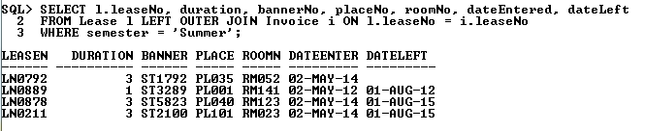

1. List the student’s name and the details of his or her apartment where the total payment due is greater than or equal to $300.

COLUMN roomNo FORMAT A8

COLUMN placeNo FORMAT A8

COLUMN name FORMAT A19

SELECT name, placeNo, roomNo, TO_CHAR(paymentDue, '$999,999.00') AS payment

FROM Student s NATURAL JOIN Lease l NATURAL JOIN Invoice i

WHERE paymentDue >= 300;

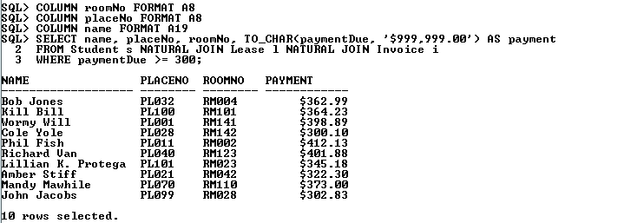

1. Display the total number of students in each student category

COLUMN classification FORMAT A15

SELECT classification, amount

FROM

(

SELECT classification, COUNT(classification) as amount

FROM Student

GROUP BY classification

UNION ALL

SELECT 'Subtotal', SUM(COUNT(classification))

FROM Student

GROUP BY classification

)

ORDER BY classification ASC;

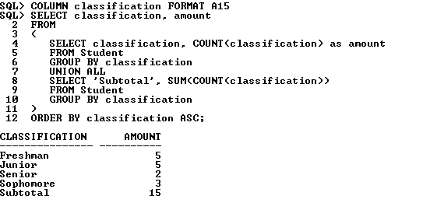

1. Display the minimum, maximum, and average payment due for the students

COLUMN Statistics FORMAT A11

SELECT 'MINIMUM' AS Statistics, TO_CHAR(paymentDue, '$999,999.00') AS Payment

FROM Invoice

WHERE paymentDue = (SELECT MIN(paymentDue) FROM Invoice)

UNION

SELECT 'MAXIMUM', TO_CHAR(paymentDue, '$999,999.00')

FROM Invoice

WHERE paymentDue = (SELECT MAX(paymentDue) FROM Invoice)

UNION

SELECT 'AVERAGE', TO_CHAR(ROUND(AVG(paymentDue),2), '$999,999.00') AS AVERAGE

FROM Invoice

;

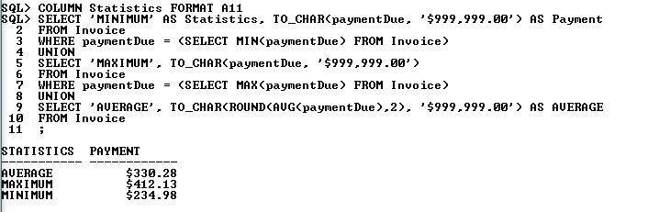

1. Display the banner number, name, age, gender, and email of students whose age is greater than or equal to 25.

COLUMN bannerNo FORMAT A8;

COLUMN name FORMAT A13;

COLUMN email FORMAT A18;

COLUMN Age FORMAT A3;

SELECT bannerNo,

name,

FLOOR(MONTHS_BETWEEN(CURRENT_DATE, dob)/12) AS Age,

gender,

email

FROM Student

WHERE FLOOR(MONTHS_BETWEEN(CURRENT_DATE, dob)/12) >= 25

ORDER BY Age DESC

;

