

Lab 5: Data Quality and Validation
SOFE 3980U - Software Quality and Project Management

Name: Darren Kosick
Student ID: 100626351
Date: April 1st 2026
GitHub
https://github.com/Darren-Kosick/SQPM_Lab5
Drive Link: https://drive.google.com/drive/folders/1C1D0iIL9fdA47ce8S7UhveBAB_MdF0_O?usp=sharing

Contents
Introduction 3
Task 1: Data Validation with Great Expectations 3
Expectation 1: ExpectColumnValuesToNotBeNull (Timestamp) 3
Expectation 2: ExpectColumnValuesToBeBetween (pedestrianLocationX_TopLeft) 3
Expectation 3: ExpectColumnValuesToBeUnique (Timestamp) 3
Task 2: Mislabeled Data Detection with CleanLab 3
How CleanLab Detects Mislabeling 3
Results and Analysis 3
Task 3: Anomaly Detection with CleanLab 4
How Anomalies Were Introduced 4
Results and Analysis 4
Conclusion 4

Introduction
This report documents the findings from Lab 5. We explored two data quality tools: Great Expectations for data validation and CleanLab for detecting mislabeled data and anomalies. Data quality is very important in machine learning pipelines. Models trained on inconsistent or mislabeled data will produce unreliable predictions.

Task 1: Data Validation with Great Expectations
Great Expectations is a tool that helps define, test and document expectations about data. In this task we validated the Labels.csv dataset using three expectations. This dataset contains records from a driving simulation, including vehicle positions and pedestrian bounding box coordinates.

Expectation 1: ExpectColumnValuesToNotBeNull (Timestamp)
This expectation checks that every row in the Timestamp column has a value. Timestamps are essential for ordering events in the driving simulation. A missing timestamp would make it impossible to determine when a particular frame was captured. This expectation passed. 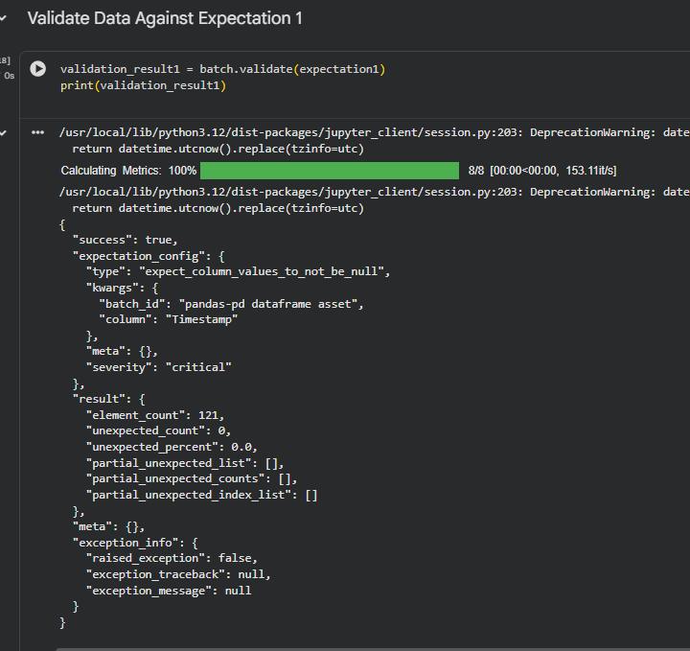

Expectation 2: ExpectColumnValuesToBeBetween (pedestrianLocationX_TopLeft)
This expectation verifies that the left X coordinate of the pedestrian bounding box is within valid image dimensions. Bounding box coordinates that fall outside the image frame would indicate annotation errors. This expectation passed.
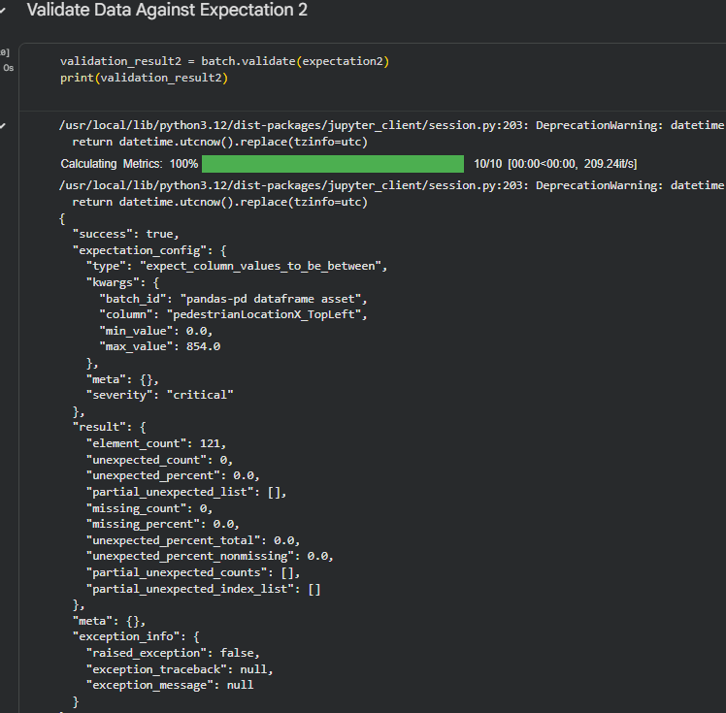

Expectation 3: ExpectColumnValuesToBeUnique (Timestamp)
This expectation checks that no two rows share the timestamp. This expectation also passed.
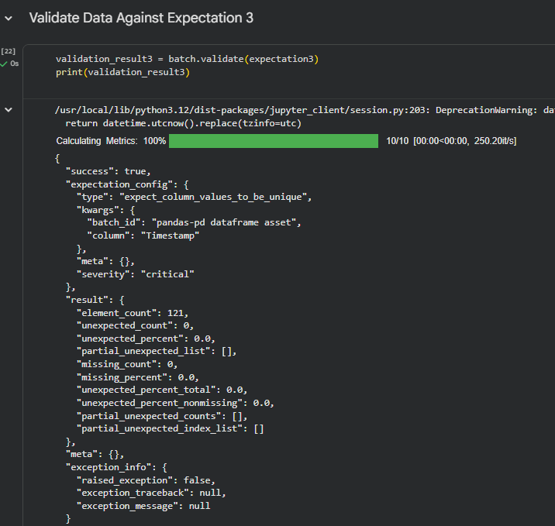

Task 2: Mislabeled Data Detection with CleanLab
In this task CleanLab was used to detect mislabeled data points in the Iris dataset. Five label errors were introduced by changing the species labels of five data points. A Random Forest classifier was trained on the dataset.

How CleanLab Detects Mislabeling
CleanLab uses learning to detect mislabeling. It computes predicted class probabilities and compares them against the given labels. When the model is consistently confident that a data point belongs to a class than its assigned label it flags that point as a suspected label issue.

Results and Analysis
CleanLab successfully identified suspected mislabeled data points. For each flagged index the output table shows the feature values, the assigned label and the label the model predicted. Mislabeled training data is particularly harmful because it teaches the model decision boundaries.
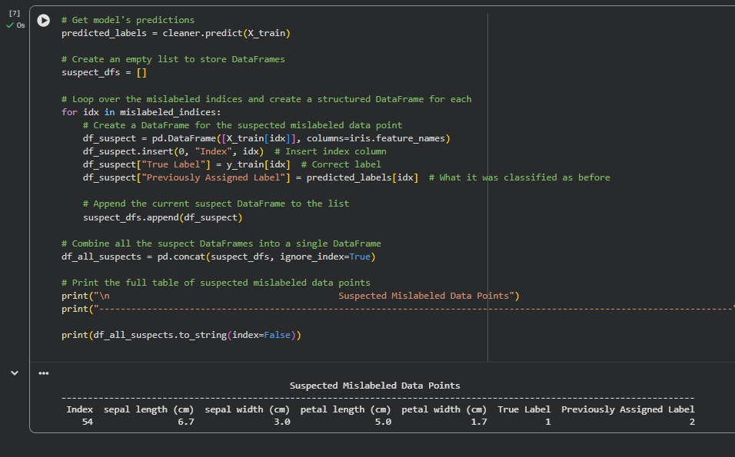

Task 3: Anomaly Detection with CleanLab
This task used CleanLab to detect anomalous data points in the Iris dataset. Ten data points were artificially corrupted by replacing their petal length values with values. CleanLearning was then applied to identify which data points appeared anomalous.

How Anomalies Were Introduced
Using numpy with a fixed random seed (42), ten indices were selected and their petal length values were replaced with values drawn uniformly from [5, 7]. This is significant because petal length is a highly discriminative feature in the Iris dataset. Setosa flowers typically have petal lengths around 1.5 cm, while Versicolor averages 4.3 cm and Virginica averages 5.6 cm. Replacing a Setosa petal length with 6.5 cm makes it look like a completely different species based on that feature alone.

Results and Analysis
CleanLab detected data points as anomalous. A couple of the detected indices overlap with the known indices. Anomaly detection is a preprocessing step in any machine learning pipeline. Anomalous data points can skew model training. Lead to poor generalization.
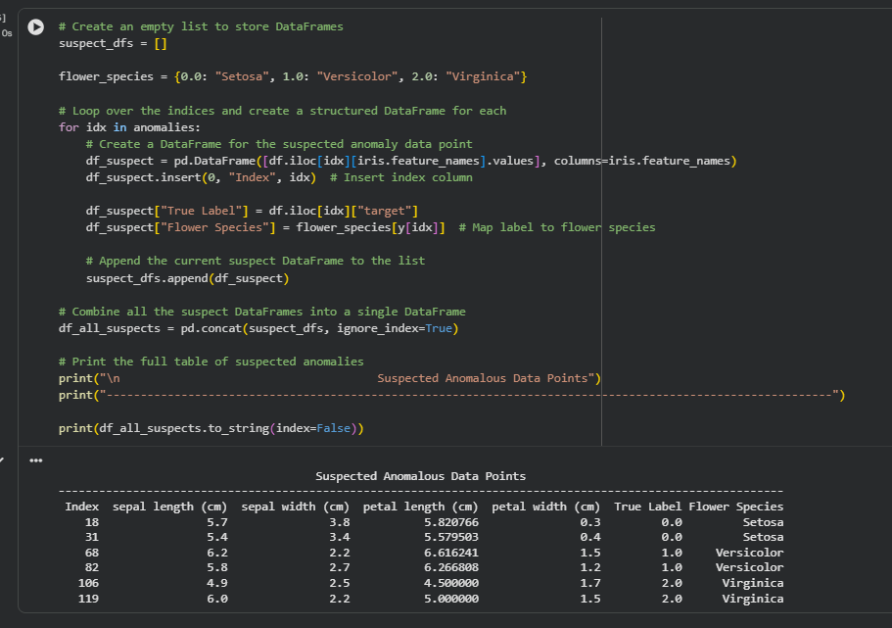

Conclusion
This lab demonstrated three approaches to data quality assurance:
- Great Expectations provides a way to define and enforce data quality rules.
- CleanLab mislabeling detection uses learning to automatically find data points whose labels are likely incorrect.
- CleanLab anomaly detection identifies data points with feature values that're inconsistent, with their class.
These tools form a data quality pipeline that can be integrated into any machine learning workflow. Investing in data quality upfront saves time and effort downstream by preventing models from learning incorrect patterns from flawed data.

