# **IE4727 Web Application Design - Project Report**

**Design project group number:** F35-DG17

**Team members:** Darren Ang Chong Wei

**Project Title:** A web portal for online purchase of fashion clothes/shoes/bags/watches

**Summary of Project:**

This project involves the development of an online shopping portal for fashion products such as clothes, shoes, bags, and watches. Users can browse through a wide range of items, organized into categories, and view detailed product information including names, descriptions, prices, and images.

The website includes a shopping cart feature, where users can add items, view their selections, and modify the cart contents before completing a purchase. Additionally, users will receive email confirmations after placing their orders and have the option to review and make changes to any customized products before confirming the purchase.

1. **Application Requirements and Specifications**
2. **Functional Requirements and Specifications**
3. **Design of the web application**

3.1 Site Map

3.2 Story Board

3.3 Wireframe

3.4 Database

Web application testing plan

1. **Implementation:**
2. **Testing of web application**
3. **Conclusion Appendices:**

Appendix :

Source Codes

## 1. Application Requirements and Specifications:

Basic Function:

R1: Users must be able to add products to a shopping cart.

R2: Users should be able to view and modify their cart before checkout.

R3: Each product should have a name, description, price, image, and category.

R4: Products should be categorized and searchable by category and keywords.

## 2. Functional Requirements and Specifications Expected content

F1: Adding Products to the Shopping Cart

Description: Users can select products from the product listing pages. Each product will have an "Add to Cart" button. When clicked, the product will be added to the user’s shopping cart, with its details (name, quantity, price)

F2: Viewing and Modifying the Cart

Description: Users can view the contents of their shopping cart by clicking a "View Cart" button, which will display a summary of added items, including product names, images, quantities, and prices. Users can modify quantities or remove items from the cart.

Implementation: The cart page will retrieve and display cart data from the backend. Users can make changes, which will be sent to the server to update the cart details in real-time.

F3: Product Details

Description: Each product listing will include detailed information such as the product name, description, price, high-quality images, and category. This information will be visible on product detail pages.

Implementation: Product details will be pulled from the database and displayed on individual product pages. Admins can manage this information via an admin panel.

F4: Product Categorization and Search

Description: Products will be categorized into distinct groups (e.g., "Shoes", "Bags") and sub-categories if necessary. A search functionality will allow users to find products by category and keywords.

Implementation: Categories will be organized in the database and displayed in a navigation menu. The search function will utilize a search algorithm to filter products based on user input and display relevant results.

## 3. Design of the web application

### 3.1 Sitemap:

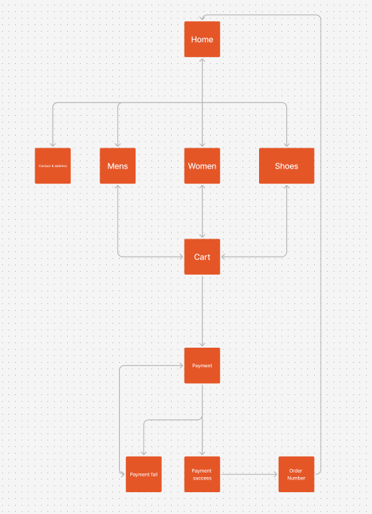

### 3.2 STORYBOARD

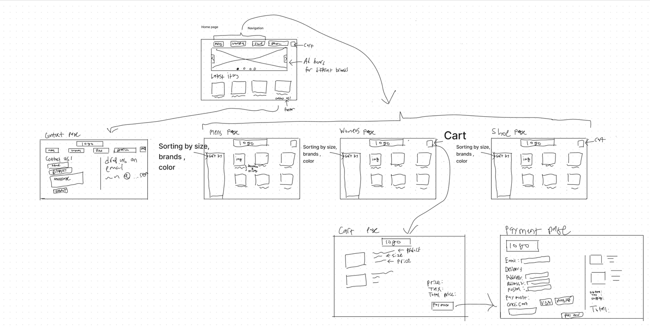

### 3.3 Wireframe:

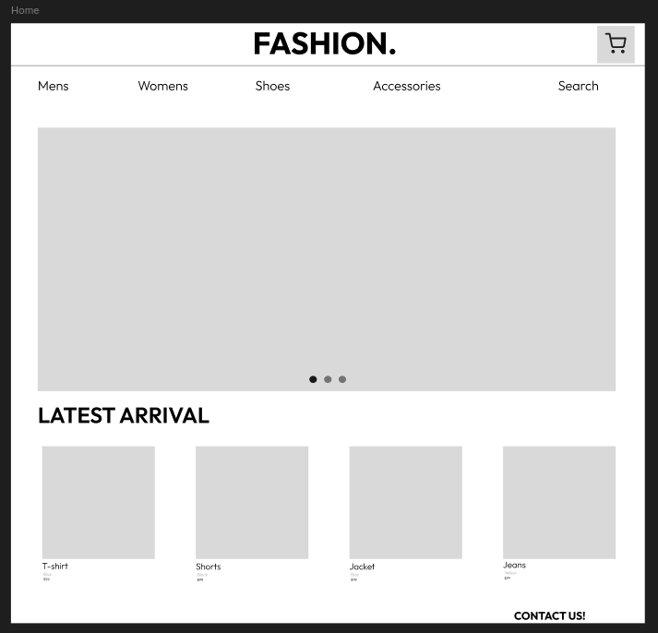

This is the Home page of the website. Where it will show the different categories of apparel and the latest arrivals.

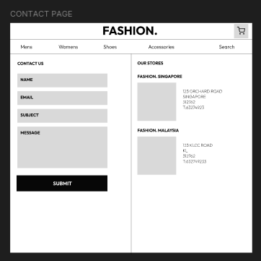

This is how the contact page will look like with a form to fill up your enquires and a submit button.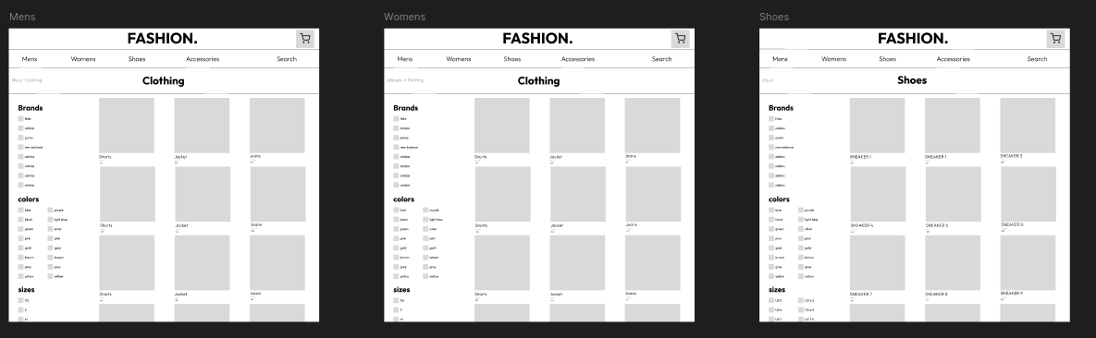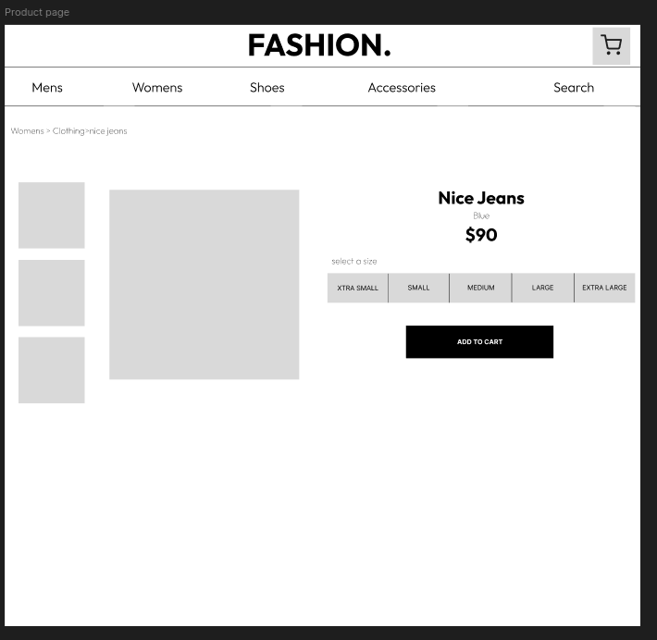This is the product page where users can view products and sort by different variance. when they click into a product they can select a size and add to cart 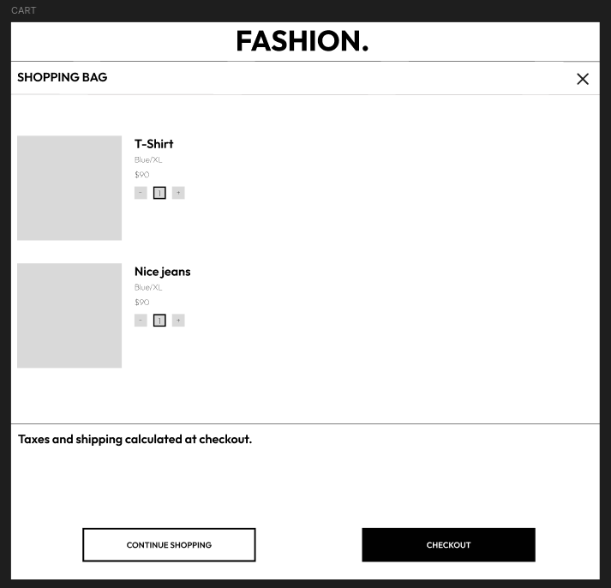

this is the shopping cart where user can see their items added to cart and modify the items

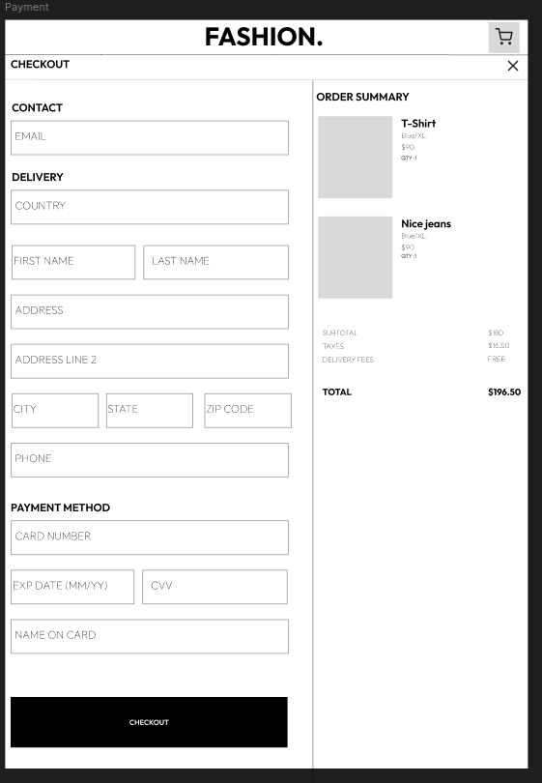

The payment page will include multiple forms to fill in your address and contact information. As for the payment method, I plan to integrate stripe Api test mod to test out. If it doesn't work, then I am going to use form validation.

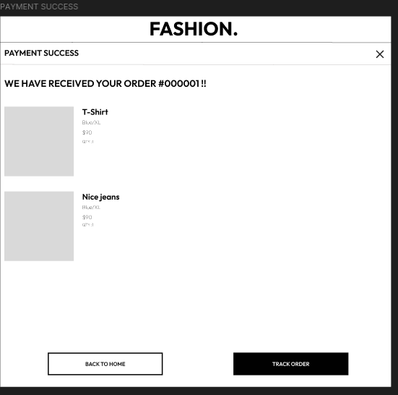

After a successful checkout, you will reach the success page. This page will show your order details such as your order number and the things you ordered. At this page, u can choose to go back to home, or track your order which will redirect you to the courier page.

## 3.4 Testing Plan:

### 3.4.1. Functional Testing

Goal: Ensure that all features function as expected.

3.4.1.1 Cart Functionality

Test: Add products in the cart.

How to Test: Try Adding items to cart and make sure that the cart is correct and does not get mixed up with random products that is not supposed to be there.

Expected Outcome: Cart displays correct items, quantities, and total price.

### 3.4.1.2 Product Variant Selection

Test: Ensure each product variant (e.g. size) is linked to the correct variant ID and displays properly on the product detail page.

How to Test: Select different variants on the product page and add to cart, and see if it displays the right product name, size, price.

Expected Outcome: The correct variant is selected, and its price and size are displayed.

### 3.4.1.3 Checkout Process

Test: Verify that the checkout page collects all necessary information (shipping address, name, etc.) and calculates the order summary correctly.

How to Test: Go to the checkout page, enter all necessary fields, and check that the summary section shows the correct item details, including prices, quantities, and images.

Expected Outcome: All fields are validated, the correct items are shown in the summary, and the checkout button leads to order submission or payment page.

### 3.4.1.4 Order submission Process

Test: Prevents it from using the previous cart after the submission of order

How to Test: Refresh the order submission page to see if it adds an order to the table.

Expected Outcome: with every order submission, the code should destroy the cart session to prevent anyone from refreshing the previous page to resubmit the order.

### 3.4.1.5 Stock Quantity Validation

Test: Prevent adding more items to the cart than available in stock.

How to Test: Add products to the cart exceeding the available quantity in the database and check if an error message is displayed.

Expected Outcome: The user cannot add more items than the available stock.

## 4. Implementation:

Describe how the pages are coded.

Coding of the web page template

Coding of the pages

Coding of the each function

### 4.1. Web Page Template Coding

The web page template includes the overall structure that is used across all pages, such as the header, footer, and the layout for specific sections like the product grid and featured products. Here's an overview of the template coding:

#### 4.1.1 HTML Structure

The core structure is based on HTML5.

Key sections of the template include:

Header: Contains the website's navigation, links to pages like "New Arrivals", "Clothing", "Footwear", etc., and user-related options like login and cart.

Main Content Area: Where the specific content (like featured products, product details, or shopping cart) is dynamically injected via PHP.

Footer: Contains links to customer service, about us, and social media profiles.

#### 4.1.2 CSS Styling

Your pages are styled using CSS to maintain consistent branding and design. This includes:

Grid Layout: For product listings, flexbox or CSS grid to ensure responsive layouts for different screen sizes.

Buttons and Links: Styled for hover effects and visual consistency.

Typography: Font styles for headings, paragraphs, product names, and prices.

### 4.2. Coding of the Pages

Each page in your project (like the home page, product detail page, and cart page) is responsible for a specific functionality. Here's how each page is coded:

#### 4.2.1 Home Page (main.php)

The home page is where users can discover new arrivals and featured products.

Key features:

Featured products are fetched from the database and displayed in a grid. A query checks if the product is marked as "featured" in the database.

PHP code to display only featured products:

<!-- Featured Products Section -->

<section class="featured-products">

<h2>Featured Products</h2>

<div class="product-grid">

<?php

// Fetch featured products

$sql = "SELECT * FROM products WHERE is_featured = 'yes' ORDER BY date_added DESC";

$result = $conn->query($sql);

if ($result->num_rows > 0) {

while ($row = $result->fetch_assoc()) {

echo '<div class="product-card">';

echo '<a href="product.php?id=' . $row['product_id'] . '">';

echo '<img src="' . $row['main_image_url'] . '" alt="' . $row['name'] . '">';

echo '<h3>' . $row['name'] . '</h3>';

echo '<p>$' . $row['price'] . '</p>';

echo '</a>'; // Closing the link

echo '</div>';

}

} else {

echo '<p>No featured products available.</p>';

}

SELECT * FROM products (table name) retrieve all columns (*) from the products table.

WHERE is_featured = 'yes' finds results to only those products with is_featured column is set to "yes," meaning they are flagged to appear in the featured section.

$result will store the outcome of the query, containing either rows of data (if any featured products exist) or an empty set (if no products are marked as featured).

$result->num_rows returns the number of rows in the result set.

If num_rows is greater than 0, it means there are products in the database that meet the criteria (is_featured = 'yes').

If there are no rows (num_rows is 0), it skips to the else part, where it displays the message: "No featured products available."

fetch_assoc() extracts the next row of data from $result as an associative array, with column names as keys like product_id, name, price, main_image_url.

$row will hold data for each product on each loop iteration, allowing you to dynamically generate HTML for each product's details.

#### 4.2.2 Listing Page (newarrivals/clothing/accessories/footwear.php)

The Listing page consist if a few pages, such as

newarrivals.php which will show all the products based on the date added in the database

clothing.php which will only show products where category column is = clothing in the database

footwear.php which will only show products where category column is = Footwear in the database

accessories.php which will only show products where category column is = Accessories in the database

// Fetch footwear products only

$sql = "SELECT * FROM products WHERE category = 'Footwear' ORDER BY date_added DESC"; // Fetch footwear only

$result = $conn->query($sql);

if ($result->num_rows > 0) {

while ($row = $result->fetch_assoc()) {

echo '<div class="product">';

echo '<a href="product.php?id=' . $row['product_id'] . '">'; // Ensure correct ID is passed

echo '<img src="' . $row['main_image_url'] . '" alt="' . $row['name'] . '">';

echo '<h2>' . $row['name'] . '</h2>';

echo '<p>' . $row['description'] . '</p>';

echo '<p>$' . $row['price'] . '</p>';

echo '</a>'; // Closing the link

echo '</div>';

}

} else {

echo 'No products found.';

}

SELECT * FROM products (table name) retrieve all columns (*) from the products table.

WHERE category = 'Footwear' finds results to only those products in the category column is set to "Footwear/ clothing/ accessories” depending on the page that is selected.

$result will store the outcome of the query, containing either rows of data (if any featured products exist) or an empty set (if no products are marked as featured).

$result->num_rows returns the number of rows in the result set.

If num_rows is greater than 0, it means there are products in the database that meet the criteria (category = 'the category of the item').

If there are no rows (num_rows is 0), it skips to the else part, where it displays the message: "No featured products available."

fetch_assoc() extracts the next row of data from $result as an associative array, with column names as keys like product_id, name, price, main_image_url.

$row will hold data for each product on each loop iteration, allowing you to dynamically generate HTML for each product's details.

<a href="..."> is an anchor tag in HTML, which creates a clickable link. And this extracts the product id and add it to the clickable link product.php?id=1 product id = 1.

#### 4.2.3 Product Page (product.php)

product.php is a page where users can view the products, look at what sizes are available and add item to cart.

// Get product ID from URL

$product_id = isset($_GET['id']) ? (int)$_GET['id'] : 0;

This line checks if the id parameter is present in the URL (e.g., product.php?id=5).

It uses $_GET['id'] to retrieve the ID and casts it to an integer for security.

If id is not present, it defaults to 0.

// Fetch main product details

$sql = "SELECT * FROM products WHERE product_id = $product_id";

$result = $conn->query($sql);

A SQL query selects all details of the product whose product_id matches $product_id.

$result = $conn->query($sql); sends this query to the database.

if ($result->num_rows > 0) {

$product = $result->fetch_assoc();

echo '<div class="product-image"><img src="' . $product['main_image_url'] . '" alt="' . $product['name'] . '"></div>';

echo '<div class="product-info">';

echo '<h2>' . $product['name'] . '</h2>';

echo '<p>' . $product['description'] . '</p>';

echo '<p>Starting at $' . number_format($product['price'], 2) . '</p>';

If a matching product is found, fetch_assoc() retrieves the details as an array.

The image, name, description, and formatted price are displayed within HTML elements.

$variant_sql = "SELECT * FROM product_variants WHERE product_id = $product_id ORDER BY size";

$variant_result = $conn->query($variant_sql);

This SQL query fetches available variants (like sizes) for the product.

Variants are sorted by size to display them in order.

If variants exist, it displays a dropdown menu for selecting a size.

if ($variant_result && $variant_result->num_rows > 0) {

echo '<label for="size">Select Size:</label>';

echo '<select id="size" name="size">';

// Loop through available variants (sizes)

while ($variant = $variant_result->fetch_assoc()) {

echo '<option value="' . $variant['variant_id'] . '">' . $variant['size'] . '</option>';

}

echo '</select>';

// Add to cart button

echo '<button onclick="addToCart()">Add to Cart</button>';

} else {

echo '<p>Out of stock.</p>';

}

echo '</div>'; // Closing product-info div

} else {

echo '<p>Product not found.</p>';

}

A while loop iterates through the results, creating <option> tags with each size.

Each option has a variant_id as its value, which can later be used to identify the selected size in the cart.

An Add to Cart button is provided if sizes are available; otherwise, it displays "Out of stock."

<script>

function addToCart() {

const selectedSize = document.querySelector('select[name="size"]').value;

const variantId = document.querySelector('select[name="size"] option:checked').value;

window.location.href = "<?php echo $_SERVER['PHP_SELF']; ?>?id=<?php echo $product_id; ?>&add_to_cart=" + variantId + "&size=" + selectedSize;

}

</script>

This defines a function addToCart() that will run when the user clicks the "Add to Cart" button.

selectedSize retrieves the value of the selected <option> in the dropdown with name="size", which represents the selected size.

variantId also retrieves the value of the checked (selected) <option> in the size dropdown, which represents the variant_id and uniquely identifies the selected size option in the database.

window.location.href changes the current page URL, effectively redirecting the user.

It includes several query parameters:

id=<?php echo $product_id; ?> - The current product's ID, passed from PHP to maintain context.

add_to_cart=" + variantId - The selected variantId, indicating which variant to add to the cart.

size=" + selectedSize - The selected size as a parameter for display or reference.

#### 4.2.4 Cart Page (cart.php)

// Update cart quantities based on user input, ensuring quantities are valid and don't exceed stock

if (isset($_POST['quantity'])) {

foreach ($_POST['quantity'] as $variant_id => $requested_quantity) {

// Enforce a minimum quantity of 1

if ($requested_quantity < 1) {

$requested_quantity = 1;

}

// Fetch the available stock for this variant from the database

$sql = "SELECT QNTY FROM product_variants WHERE variant_id = ?";

$stmt = $conn->prepare($sql);

$stmt->bind_param("i", $variant_id);

$stmt->execute();

$stmt->bind_result($available_quantity);

$stmt->fetch();

$stmt->close();

// Ensure requested quantity doesn't exceed stock

if ($requested_quantity > $available_quantity) {

$_SESSION['cart'][$variant_id]['quantity'] = $available_quantity; // Limit to max available

$_SESSION['cart'][$variant_id]['exceeds_stock'] = true; // Set flag for feedback

} else {

$_SESSION['cart'][$variant_id]['quantity'] = $requested_quantity;

unset($_SESSION['cart'][$variant_id]['exceeds_stock']); // Remove flag if within stock

}

// Remove item if quantity is 0

if ($_SESSION['cart'][$variant_id]['quantity'] == 0) {

unset($_SESSION['cart'][$variant_id]);

}

}

}

This section updates cart quantities based on user input.

If the user requests a quantity that exceeds available stock (QNTY in product_variants table), it sets the quantity to the maximum stock and flags exceeds_stock for user feedback.

If the quantity becomes zero, the item is removed from the cart.

// Fetch item details from the database based on the cart

foreach ($_SESSION['cart'] as $variant_id => $details) {

$sql = "SELECT pv.variant_id, p.name, p.description, pv.price, pv.size, pv.QNTY

FROM product_variants pv

JOIN products p ON pv.product_id = p.product_id

WHERE pv.variant_id = ?";

$stmt = $conn->prepare($sql);

$stmt->bind_param("i", $variant_id);

$stmt->execute();

$result = $stmt->get_result();

if ($result && $result->num_rows > 0) {

while ($row = $result->fetch_assoc()) {

$row['quantity'] = $details['quantity']; // Quantity in the cart

$row['exceeds_stock'] = isset($details['exceeds_stock']); // Feedback flag

$cart_items[] = $row;

$total_price += $row['price'] * $details['quantity'];

}}

This retrieves item details for each cart item from the database by joining product_variants and products tables.

It calculates the total price by multiplying each item’s price by its quantity.

#### 4.2.5 Checkout Page (checkout.php)

// Get cart items from session

$cart_items = [];

$total_price = 0;

if (isset($_SESSION['cart']) && !empty($_SESSION['cart'])) {

foreach ($_SESSION['cart'] as $variant_id => $details) {

$sql = "SELECT pv.variant_id, p.name, p.description, pv.price, pv.size ,p.main_image_url

FROM product_variants pv

JOIN products p ON pv.product_id = p.product_id

WHERE pv.variant_id = $variant_id";

$result = $conn->query($sql);

if ($result && $result->num_rows > 0) {

while ($row = $result->fetch_assoc()) {

$row['quantity'] = $details['quantity'];

$cart_items[] = $row;

$total_price += $row['price'] * $details['quantity'];

}}}}

if (isset($_SESSION['cart']) && !empty($_SESSION['cart'])) {

Checks if the cart array exists in the session and is not empty. This array is assumed to hold each product's variant_id and quantity.

Loops over each item in the session cart. Each variant_id (unique identifier for a specific product variant) and its details, like quantity, are retrieved.

Constructs an SQL query to fetch detailed information about each product variant in the cart.

Checks if there are results from the query ($result->num_rows > 0). If so, enters a loop to process each result row.

Adds quantity from the session cart to the $row array, ensuring each cart item includes its requested quantity.

Appends the full $row (with item details and quantity) to $cart_items.

Calculates the total price by adding the product of price and quantity for each item to $total_price.

#### 4.2.6 Order Page (orderconfirmation.php)

// Redirect to order confirmation page

header("Location: order_confirmation.php?order_id=$order_id");

There is a order processing php before this.

// Get the order ID from the URL

$order_id = $_GET['order_id'];

Retrieves the order_id from the URL query parameters using $_GET['order_id']. This ID is needed to fetch the specific order details from the database.

// Fetch order details from the orders table

$sql = "SELECT * FROM orders WHERE order_id = ?";

$stmt = $conn->prepare($sql);

$stmt->bind_param("i", $order_id);

$stmt->execute();

$order_result = $stmt->get_result();

$order = $order_result->fetch_assoc();

?>

Prepares an SQL query to select all columns from the orders table where the order_id matches.

Uses a prepared statement with bind_param to securely insert the order_id into the query.

Executes the query and retrieves the result, which contains details about the order.

Fetches the result as an associative array and stores it in $order.

// Fetch the order items from the order_items table

$sql_items = "SELECT oi.quantity, pv.size, pv.variant_id, p.name, pv.price, p.main_image_url

FROM order_items oi

JOIN product_variants pv ON oi.variant_id = pv.variant_id

JOIN products p ON pv.product_id = p.product_id

WHERE oi.order_id = ?";

$stmt_items = $conn->prepare($sql_items);

$stmt_items->bind_param("i", $order_id);

Prepares a second SQL query to fetch all items associated with this order from order_items, product_variants, and products.

The query retrieves item details, such as name, price, size, main_image_url, and quantity.

Executes the statement and retrieves the result set with get_result().

<?php while ($item = $result_items->fetch_assoc()): ?>

<tr>

<td><?= htmlspecialchars($item['name']); ?></td>

<td><img src="<?= htmlspecialchars($item['main_image_url']); ?>" alt="Product Image"></td>

<td><?= htmlspecialchars($item['size']); ?></td>

<td><?= htmlspecialchars($item['quantity']); ?></td>

<td>$<?= number_format($item['price'], 2); ?></td>

<td>$<?= number_format($item['price'] * $item['quantity'], 2); ?></td>

</tr>

<?php endwhile; ?>

Creates an HTML table to display each order item in rows.

For each item, displays the item that is in the order_id.

## 5. Testing of web application

## Tests Performed:

Cart Functionality:

Test: Adding various items to the cart.

Result: Items added correctly with accurate quantities and total price calculations. No unexpected items appeared in the cart, and item details (e.g., name, price, quantity) were consistently displayed as selected by the user.

### Product Variant Selection

Test: Selecting different product variants (e.g., size or color) on the product page and adding to the cart.

Result: The selected variants correctly displayed their associated attributes (name, size, price) in the cart. Each variant linked accurately to its unique identifier without errors, providing users with the correct product configurations.

### Checkout Process:

Test: Checking if the checkout page collected necessary user details and provided an accurate summary of order items.

Result: All required fields (shipping address, first and last name, postal code, etc.) were successfully validated, and the order summary accurately reflected the items, prices, and quantities. The checkout button directed users to the order submission page without any issues.

### Order Submission Process:

Test: Ensuring the cart session was destroyed upon order submission to prevent re-use.

Result: The cart session was successfully cleared after each order submission, preventing any duplicate orders when users refreshed the submission page.

### Stock Quantity Validation:

Test: Attempting to add quantities beyond available stock to the cart.

Result: The application correctly prevented users from adding items exceeding stock limits, displaying a message when stock quantities were insufficient. This ensured accurate inventory management and prevented overselling.

## 6. Conclusion

The web application has met its primary goals, with the essential features for online shopping—product selection, cart management, and checkout—functioning as intended. The next phase of development will focus on refining the user experience, user accounts, and admin order management, and improving error handling and system performance. With the current foundation in place, the project is well-positioned for further growth and scalability.

Deferred items:

Discount and Promo Code System:

A feature to apply discount or promo codes to orders has been planned but not yet developed.

Account login:

A feature for users to create an account and log in has been planned but not yet developed.

Email Confirmation:

A feature to send order confirmation to buyers email address has been planned but not yet developed.

Appendix:

Main.php :

<!DOCTYPE html>

<html lang="en">

<head>

<meta charset="UTF-8">

<meta name="viewport" content="width=device-width, initial-scale=1.0">

<title>Fashion Store</title>

<link rel="stylesheet" href="style.css">

</head>

<body>

<!-- Logo Section -->

<div class="logo-row">

<a href="Main.php">DDD</a>

</div>

<!-- Navigation Section -->

<header>

<nav>

<ul>

<li><a href="newarrivals.php">New Arrivals</a></li>

<li><a href="clothing.php">Clothing</a></li>

<li><a href="footwear.php">Footwear</a></li>

<li><a href="accessories.php">Accessories</a></li>

<li><a href="construction.html">Sale</a></li>

</ul>

</nav>

<div class="user-options">

<a href="construction.html">Login</a>

<a href="cart.php">Cart</a>

</div>

</header>

<!-- Main Section for Featured Content -->

<main>

<section class="hero">

<h1>Discover the Latest Fashion Trends</h1>

<p>Explore new arrivals, top collections, and more.</p>

<a href="newarrivals.php" class="shop-now">Shop Now</a>

</section>

<!-- Featured Products Section -->

<section class="featured-products">

<h2>Featured Products</h2>

<div class="product-grid">

<?php

// Database configuration

$servername = "localhost";

$username = "root"; // Your MySQL username

$password = ""; // Your MySQL password

$dbname = "Project"; // Your database name

// Create connection

$conn = new mysqli($servername, $username, $password, $dbname);

// Check connection

if ($conn->connect_error) {

die("Connection failed: " . $conn->connect_error);

}

// Fetch featured products

$sql = "SELECT * FROM products WHERE is_featured = 'yes' ORDER BY date_added DESC";

$result = $conn->query($sql);

if ($result->num_rows > 0) {

while ($row = $result->fetch_assoc()) {

echo '<div class="product-card">';

echo '<a href="product.php?id=' . $row['product_id'] . '">';

echo '<img src="' . $row['main_image_url'] . '" alt="' . $row['name'] . '">';

echo '<h3>' . $row['name'] . '</h3>';

echo '<p>$' . $row['price'] . '</p>';

echo '</a>'; // Closing the link

echo '</div>';

}

} else {

echo '<p>No featured products available.</p>';

}

$conn->close();

?>

</div>

</section>

</main>

<!-- Footer Section -->

<footer>

<div class="footer-container">

<div class="footer-section">

<h3>Customer Service</h3>

<ul>

<li><a href="#">Contact Us</a></li>

<li><a href="#">Shipping Information</a></li>

<li><a href="#">Returns & Exchanges</a></li>

<li><a href="#">Size Guide</a></li>

<li><a href="#">FAQs</a></li>

</ul>

</div>

<div class="footer-section">

<h3>About Us</h3>

<ul>

<li><a href="#">Our Story</a></li>

<li><a href="#">Careers</a></li>

<li><a href="#">Sustainability</a></li>

<li><a href="#">Privacy Policy</a></li>

<li><a href="#">Terms & Conditions</a></li>

</ul>

</div>

<div class="footer-section">

<h3>Follow Us</h3>

<ul class="social-media">

<li><a href="#">Instagram</a></li>

<li><a href="#">Facebook</a></li>

<li><a href="#">Twitter</a></li>

<li><a href="#">Pinterest</a></li>

</ul>

</div>

</div>

<div class="footer-bottom">

<p>&copy; 2024 DDD Fashion. All rights reserved.</p>

</div>

</footer>

</body>

</html>

Newarrivals.php :

<?php include 'cartsession.php';

$total_quantity = array_sum(array_column($_SESSION['cart'], 'quantity'));

?>

<!DOCTYPE html>

<html lang="en">

<head>

<meta charset="UTF-8">

<meta name="viewport" content="width=device-width, initial-scale=1.0">

<title>New Arrivals</title>

<link rel="stylesheet" href="style.css"> <!-- Link to your CSS file -->

</head>

<body>

<!-- Logo Section -->

<div class="logo-row">

<a href="Main.php" style="align-items: center;">DDD</a>

</div>

<!-- Navigation Section -->

<header>

<nav>

<ul>

<li><a href="newarrivals.php">New Arrivals</a></li>

<li><a href="clothing.php">Clothing</a></li>

<li><a href="footwear.php">Footwear</a></li>

<li><a href="accessories.php">Accessories</a></li>

<li><a href="construction.html">Sale</a></li>

</ul>

</nav>

<div class="user-options">

<a href="construction.html">Login</a>

<a href="cart.php">Cart (<?php echo $total_quantity; ?>)</a>

</div>

</header>

<!-- New Arrivals Banner Section -->

<section class="page-banner">

<h1>New Arrivals</h1>

<p>Discover the latest additions to our collection</p>

</section>

<div class="container">

<!-- Sidebar Section -->

<aside class="sidebar">

<h2>Sort by</h2>

<ul>

<li><a href="?sort=newest">Newest</a></li>

<li><a href="?sort=oldest">Oldest</a></li>

<li><a href="?sort=price_low">Price: Low to High</a></li>

<li><a href="?sort=price_high">Price: High to Low</a></li>

<li><a href="?sort=category">Category</a></li>

</ul>

</aside>

<!-- Product Grid Section -->

<div class="product-grid">

<?php

// Database configuration

$servername = "localhost";

$username = "root"; // Your MySQL username

$password = ""; // Your MySQL password

$dbname = "Project"; // Your database name

// Create connection

$conn = new mysqli($servername, $username, $password, $dbname);

// Check connection

if ($conn->connect_error) {

die("Connection failed: " . $conn->connect_error);

}

// Fetch the latest products based on sorting

$sort = isset($_GET['sort']) ? $_GET['sort'] : 'newest';

switch ($sort) {

case 'oldest':

$sql = "SELECT * FROM products ORDER BY date_added ASC";

break;

case 'price_low':

$sql = "SELECT * FROM products ORDER BY price ASC";

break;

case 'price_high':

$sql = "SELECT * FROM products ORDER BY price DESC";

break;

case 'category':

$sql = "SELECT * FROM products ORDER BY category ASC";

break;

case 'newest':

default:

$sql = "SELECT * FROM products ORDER BY date_added DESC";

break;

}

$result = $conn->query($sql);

if ($result->num_rows > 0) {

while ($row = $result->fetch_assoc()) {

echo '<div class="product">';

echo '<a href="product.php?id=' . $row['product_id'] . '">'; // Link to product detail page

echo '<img src="' . $row['main_image_url'] . '" alt="' . $row['name'] . '">';

echo '<h2>' . $row['name'] . '</h2>';

//echo '<p>Category: ' . $row['category'] . '</p>'; // Displaying the category

echo '<p>' . $row['description'] . '</p>';

echo '<p>$' . $row['price'] . '</p>';

echo '</a>'; // Closing the link

echo '</div>';

}

} else {

echo 'No products found.';

}

$conn->close();

?>

</div>

</div>

</body>

<footer>

<div class="footer-container">

<div class="footer-section">

<h3>Customer Service</h3>

<ul>

<li><a href="#">Contact Us</a></li>

<li><a href="#">Shipping Information</a></li>

<li><a href="#">Returns & Exchanges</a></li>

<li><a href="#">Size Guide</a></li>

<li><a href="#">FAQs</a></li>

</ul>

</div>

<div class="footer-section">

<h3>About Us</h3>

<ul>

<li><a href="#">Our Story</a></li>

<li><a href="#">Careers</a></li>

<li><a href="#">Sustainability</a></li>

<li><a href="#">Privacy Policy</a></li>

<li><a href="#">Terms & Conditions</a></li>

</ul>

</div>

<div class="footer-section">

<h3>Follow Us</h3>

<ul class="social-media">

<li><a href="#">Instagram</a></li>

<li><a href="#">Facebook</a></li>

<li><a href="#">Twitter</a></li>

<li><a href="#">Pinterest</a></li>

</ul>

</div>

</div>

<div class="footer-bottom">

<p>&copy; 2024 DDD Fashion. All rights reserved.</p>

</div>

</footer>

</html>

Clothing.php :

<?php

// Start the session to track cart information

include 'cartsession.php';

?>

<!DOCTYPE html>

<html lang="en">

<head>

<meta charset="UTF-8">

<meta name="viewport" content="width=device-width, initial-scale=1.0">

<title>Clothing</title>

<link rel="stylesheet" href="style.css"> <!-- Link to your CSS file -->

</head>

<body>

<!-- Logo Section -->

<div class="logo-row">

<a href="Main.php" style="align-items: center;">DDD</a>

</div>

<!-- Navigation Section -->

<header>

<nav>

<ul>

<li><a href="newarrivals.php">New Arrivals</a></li>

<li><a href="clothing.php">Clothing</a></li>

<li><a href="footwear.php">Footwear</a></li>

<li><a href="accessories.php">Accessories</a></li>

<li><a href="construction.html">Sale</a></li>

</ul>

</nav>

<div class="user-options">

<a href="#">Login</a>

<a href="cart.php">Cart(<?php echo isset($total_quantity) ? $total_quantity : '0'; ?>)</a>

</div>

</header>

<section class="page-banner">

<h1>Clothing</h1>

<p>Discover the latest clothing in our collection</p>

</section>

<!-- Product Grid Section -->

<div class="container">

<div class="sidebar">

<h2>Filter by</h2>

<ul>

<li><a href="clothing.php?sort=newest">Newest</a></li>

<li><a href="clothing.php?sort=oldest">Oldest</a></li>

<li><a href="clothing.php?sort=price_low">Price: Low to High</a></li>

<li><a href="clothing.php?sort=price_high">Price: High to Low</a></li>

</ul>

</div>

<div class="product-grid">

<?php

// Database configuration

$servername = "localhost";

$username = "root"; // Your MySQL username

$password = ""; // Your MySQL password

$dbname = "Project"; // Your database name

// Create connection

$conn = new mysqli($servername, $username, $password, $dbname);

// Check connection

if ($conn->connect_error) {

die("Connection failed: " . $conn->connect_error);

}

$sort = isset($_GET['sort']) ? $_GET['sort'] : 'newest';

// Fetch clothing products only

switch ($sort) {

case 'oldest':

$sql = "SELECT * FROM products WHERE category = 'Clothing' ORDER BY date_added ASC";

break;

case 'price_low':

$sql = "SELECT * FROM products WHERE category = 'Clothing' ORDER BY price ASC";

break;

case 'price_high':

$sql = "SELECT * FROM products WHERE category = 'Clothing' ORDER BY price DESC";

break;

case 'newest':

default:

$sql = "SELECT * FROM products WHERE category = 'Clothing' ORDER BY date_added DESC";

break;

}

// Fetch clothing only

$result = $conn->query($sql);

if ($result->num_rows > 0) {

while ($row = $result->fetch_assoc()) {

// Wrap each product in a link to the product page

echo '<div class="product">';

echo '<a href="product.php?id=' . $row['product_id'] . '">'; // Link to the product page

echo '<img src="' . $row['main_image_url'] . '" alt="' . $row['name'] . '">';

echo '<h2>' . $row['name'] . '</h2>';

echo '<p>Category: ' . $row['category'] . '</p>'; // Displaying the category

echo '<p>' . $row['description'] . '</p>';

echo '<p>$' . $row['price'] . '</p>';

echo '</a>'; // Closing the link

echo '</div>';

}

} else {

echo 'No products found.';

}

$conn->close();

?>

</div>

</div>

</body>

<footer>

<div class="footer-container">

<div class="footer-section">

<h3>Customer Service</h3>

<ul>

<li><a href="#">Contact Us</a></li>

<li><a href="#">Shipping Information</a></li>

<li><a href="#">Returns & Exchanges</a></li>

<li><a href="#">Size Guide</a></li>

<li><a href="#">FAQs</a></li>

</ul>

</div>

<div class="footer-section">

<h3>About Us</h3>

<ul>

<li><a href="#">Our Story</a></li>

<li><a href="#">Careers</a></li>

<li><a href="#">Sustainability</a></li>

<li><a href="#">Privacy Policy</a></li>

<li><a href="#">Terms & Conditions</a></li>

</ul>

</div>

<div class="footer-section">

<h3>Follow Us</h3>

<ul class="social-media">

<li><a href="#">Instagram</a></li>

<li><a href="#">Facebook</a></li>

<li><a href="#">Twitter</a></li>

<li><a href="#">Pinterest</a></li>

</ul>

</div>

</div>

<div class="footer-bottom">

<p>&copy; 2024 DDD Fashion. All rights reserved.</p>

</div>

</footer>

</html>

Footwear.php:

<?php

// Start the session to track cart information

include 'cartsession.php';

?>

<!DOCTYPE html>

<html lang="en">

<head>

<meta charset="UTF-8">

<meta name="viewport" content="width=device-width, initial-scale=1.0">

<title>Footwear</title>

<link rel="stylesheet" href="style.css"> <!-- Link to your CSS file -->

</head>

<body>

<!-- Logo Section -->

<div class="logo-row">

<a href="Main.php" style="align-items: center;">DDD</a>

</div>

<!-- Navigation Section -->

<header>

<nav>

<ul>

<li><a href="newarrivals.php">New Arrivals</a></li>

<li><a href="clothing.php">Clothing</a></li>

<li><a href="footwear.php">Footwear</a></li>

<li><a href="accessories.php">Accessories</a></li>

<li><a href="construction.html">Sale</a></li>

</ul>

</nav>

<div class="user-options">

<a href="construction.html">Login</a>

<a href="cart.php">Cart (<?php echo isset($total_quantity) ? $total_quantity : '0'; ?>)</a> <!-- Display total quantity from the session -->

</div>

</header>

<!-- Footwear Banner Section -->

<section class="page-banner">

<h1>Footwear</h1>

<p>Discover the latest footwear to our collection</p>

</section>

<div class="container">

<!-- Sidebar Section -->

<aside class="sidebar">

<h2>Sort by</h2>

<ul>

<li><a href="footwear.php?sort=newest">Newest</a></li>

<li><a href="footwear.php?sort=oldest">Oldest</a></li>

<li><a href="footwear.php?sort=price_low">Price: Low to High</a></li>

<li><a href="footwear.php?sort=price_high">Price: High to Low</a></li>

</ul>

</aside>

<!-- Product Grid Section -->

<div class="product-grid">

<?php

// Database configuration

$servername = "localhost";

$username = "root"; // Your MySQL username

$password = ""; // Your MySQL password

$dbname = "Project"; // Your database name

// Create connection

$conn = new mysqli($servername, $username, $password, $dbname);

// Check connection

if ($conn->connect_error) {

die("Connection failed: " . $conn->connect_error);

}

// Fetch footwear products only

$sort = isset($_GET['sort']) ? $_GET['sort'] : 'newest';

// Define the SQL query based on the sorting option

switch ($sort) {

case 'oldest':

$sql = "SELECT * FROM products WHERE category = 'Footwear' ORDER BY date_added ASC";

break;

case 'price_low':

$sql = "SELECT * FROM products WHERE category = 'Footwear' ORDER BY price ASC";

break;

case 'price_high':

$sql = "SELECT * FROM products WHERE category = 'Footwear' ORDER BY price DESC";

break;

case 'category':

$sql = "SELECT * FROM products WHERE category = 'Footwear' ORDER BY category ASC";

break;

case 'newest':

default:

$sql = "SELECT * FROM products WHERE category = 'Footwear' ORDER BY date_added DESC";

break;

}

$result = $conn->query($sql);

if ($result->num_rows > 0) {

while ($row = $result->fetch_assoc()) {

echo '<div class="product">';

echo '<a href="product.php?id=' . $row['product_id'] . '">'; // Ensure correct ID is passed

echo '<img src="' . $row['main_image_url'] . '" alt="' . $row['name'] . '">';

echo '<h2>' . $row['name'] . '</h2>';

echo '<p>' . $row['description'] . '</p>';

echo '<p>$' . $row['price'] . '</p>';

echo '</a>'; // Closing the link

echo '</div>';

}

} else {

echo 'No products found.';

}

$conn->close();

?>

</div>

</div>

</body>

<footer>

<div class="footer-container">

<div class="footer-section">

<h3>Customer Service</h3>

<ul>

<li><a href="#">Contact Us</a></li>

<li><a href="#">Shipping Information</a></li>

<li><a href="#">Returns & Exchanges</a></li>

<li><a href="#">Size Guide</a></li>

<li><a href="#">FAQs</a></li>

</ul>

</div>

<div class="footer-section">

<h3>About Us</h3>

<ul>

<li><a href="#">Our Story</a></li>

<li><a href="#">Careers</a></li>

<li><a href="#">Sustainability</a></li>

<li><a href="#">Privacy Policy</a></li>

<li><a href="#">Terms & Conditions</a></li>

</ul>

</div>

<div class="footer-section">

<h3>Follow Us</h3>

<ul class="social-media">

<li><a href="#">Instagram</a></li>

<li><a href="#">Facebook</a></li>

<li><a href="#">Twitter</a></li>

<li><a href="#">Pinterest</a></li>

</ul>

</div>

</div>

<div class="footer-bottom">

<p>&copy; 2024 DDD Fashion. All rights reserved.</p>

</div>

</footer>

</html>

Accessories.php:

<?php include 'cartsession.php';

?>

<!DOCTYPE html>

<html lang="en">

<head>

<meta charset="UTF-8">

<meta name="viewport" content="width=device-width, initial-scale=1.0">

<title>Accessories</title>

<link rel="stylesheet" href="style.css"> <!-- Link to your CSS file -->

</head>

<body>

<!-- Logo Section -->

<div class="logo-row">

<a href="Main.php" style="align-items: center;">DDD</a>

</div>

<!-- Navigation Section -->

<header>

<nav>

<ul>

<li><a href="newarrivals.php">New Arrivals</a></li>

<li><a href="clothing.php">Clothing</a></li>

<li><a href="footwear.php">Footwear</a></li>

<li><a href="accessories.php">Accessories</a></li>

<li><a href="construction.html">Sale</a></li>

</ul>

</nav>

<div class="user-options">

<a href="construction.html">Login</a>

<a href="cart.php">Cart(<?php echo isset($total_quantity) ? $total_quantity : '0'; ?>)</a>

</div>

</header>

<section class="page-banner">

<h1>Accessories</h1>

<p>Discover the latest Accessories to our collection</p>

</section>

<!-- Product Grid Section -->

<div class="container">

<div class="sidebar">

<h2>Filter by</h2>

<ul>

<li><a href="accessories.php?sort=newest">Newest</a></li>

<li><a href="accessories.php?sort=oldest">Oldest</a></li>

<li><a href="accessories.php?sort=price_low">Price: Low to High</a></li>

<li><a href="accessories.php?sort=price_high">Price: High to Low</a></li>

</ul>

</ul>

</div>

<div class="product-grid">

<?php

// Database configuration

$servername = "localhost";

$username = "root"; // Your MySQL username

$password = ""; // Your MySQL password

$dbname = "Project"; // Your database name

// Create connection

$conn = new mysqli($servername, $username, $password, $dbname);

// Check connection

if ($conn->connect_error) {

die("Connection failed: " . $conn->connect_error);

}

$sort = isset($_GET['sort']) ? $_GET['sort'] : 'newest';

// Fetch clothing products only

switch ($sort) {

case 'oldest':

$sql = "SELECT * FROM products WHERE category = 'Accessories' ORDER BY date_added ASC";

break;

case 'price_low':

$sql = "SELECT * FROM products WHERE category = 'Accessories' ORDER BY price ASC";

break;

case 'price_high':

$sql = "SELECT * FROM products WHERE category = 'Accessories' ORDER BY price DESC";

break;

case 'newest':

default:

$sql = "SELECT * FROM products WHERE category = 'Accessories' ORDER BY date_added DESC";

break;

}

// Fetch accessories products only

// Fetch accessories only

$result = $conn->query($sql);

if ($result->num_rows > 0) {

while ($row = $result->fetch_assoc()) {

echo '<div class="product">';

echo '<a href="product.php?id=' . $row['product_id'] . '">'; // Link to product detail page

echo '<img src="' . $row['main_image_url'] . '" alt="' . $row['name'] . '">';

echo '<h2>' . $row['name'] . '</h2>';

echo '<p>' . $row['description'] . '</p>';

echo '<p>$' . $row['price'] . '</p>';

echo '</a>'; // Closing the link

echo '</div>';

}

} else {

echo 'No products found.';

}

$conn->close();

?>

</div>

</div>

</body>

<footer>

<div class="footer-container">

<div class="footer-section">

<h3>Customer Service</h3>

<ul>

<li><a href="#">Contact Us</a></li>

<li><a href="#">Shipping Information</a></li>

<li><a href="#">Returns & Exchanges</a></li>

<li><a href="#">Size Guide</a></li>

<li><a href="#">FAQs</a></li>

</ul>

</div>

<div class="footer-section">

<h3>About Us</h3>

<ul>

<li><a href="#">Our Story</a></li>

<li><a href="#">Careers</a></li>

<li><a href="#">Sustainability</a></li>

<li><a href="#">Privacy Policy</a></li>

<li><a href="#">Terms & Conditions</a></li>

</ul>

</div>

<div class="footer-section">

<h3>Follow Us</h3>

<ul class="social-media">

<li><a href="#">Instagram</a></li>

<li><a href="#">Facebook</a></li>

<li><a href="#">Twitter</a></li>

<li><a href="#">Pinterest</a></li>

</ul>

</div>

</div>

<div class="footer-bottom">

<p>&copy; 2024 DDD Fashion. All rights reserved.</p>

</div>

</footer>

</html>

Cart.php :

<?php

include 'cartsession.php';

// Update cart quantities based on user input, ensuring quantities are valid and don't exceed stock

if (isset($_POST['quantity'])) {

foreach ($_POST['quantity'] as $variant_id => $requested_quantity) {

// Enforce a minimum quantity of 1

if ($requested_quantity < 1) {

$requested_quantity = 1;

}

// Fetch the available stock for this variant from the database

$sql = "SELECT QNTY FROM product_variants WHERE variant_id = ?";

$stmt = $conn->prepare($sql);

$stmt->bind_param("i", $variant_id);

$stmt->execute();

$stmt->bind_result($available_quantity);

$stmt->fetch();

$stmt->close();

// Ensure requested quantity doesn't exceed stock

if ($requested_quantity > $available_quantity) {

$_SESSION['cart'][$variant_id]['quantity'] = $available_quantity; // Limit to max available

$_SESSION['cart'][$variant_id]['exceeds_stock'] = true; // Set flag for feedback

} else {

$_SESSION['cart'][$variant_id]['quantity'] = $requested_quantity;

unset($_SESSION['cart'][$variant_id]['exceeds_stock']); // Remove flag if within stock

}

// Remove item if quantity is 0

if ($_SESSION['cart'][$variant_id]['quantity'] == 0) {

unset($_SESSION['cart'][$variant_id]);

}

}

}

// Handle emptying the cart

if (isset($_POST['empty_cart'])) {

$_SESSION['cart'] = array(); // Clear the cart

header("Location: cart.php"); // Redirect to the cart page

exit(); // Make sure to exit after redirect

}

// Fetch item details from the database based on the cart

foreach ($_SESSION['cart'] as $variant_id => $details) {

$sql = "SELECT pv.variant_id, p.name, p.description, pv.price, pv.size, pv.QNTY

FROM product_variants pv

JOIN products p ON pv.product_id = p.product_id

WHERE pv.variant_id = ?";

$stmt = $conn->prepare($sql);

$stmt->bind_param("i", $variant_id);

$stmt->execute();

$result = $stmt->get_result();

if ($result && $result->num_rows > 0) {

while ($row = $result->fetch_assoc()) {

$row['quantity'] = $details['quantity']; // Quantity in the cart

$row['exceeds_stock'] = isset($details['exceeds_stock']); // Feedback flag

$cart_items[] = $row;

$total_price += $row['price'] * $details['quantity'];

}

}

$stmt->close();

}

// Store the total price in the session

$_SESSION['total_price'] = $total_price;

// // Add to cart session

// $_SESSION['cart'][$variant_id] = $cart_item;

$conn->close();

// Calculate total quantity of items in the cart

$total_quantity = array_sum(array_column($_SESSION['cart'], 'quantity'));

?>

<!DOCTYPE html>

<html lang="en">

<head>

<meta charset="UTF-8">

<meta name="viewport" content="width=device-width, initial-scale=1.0">

<title>Shopping Cart</title>

<link rel="stylesheet" href="style.css"> <!-- Link to your CSS file -->

</head>

<body>

<!-- Logo Section -->

<div class="logo-row">

<a href="Main.html">DDD</a>

</div>

<!-- Navigation Section -->

<header>

<nav>

<ul>

<li><a href="newarrivals.php">New Arrivals</a></li>

<li><a href="clothing.php">Clothing</a></li>

<li><a href="footwear.php">Footwear</a></li>

<li><a href="accessories.php">Accessories</a></li>

<li><a href="#">Sale</a></li>

</ul>

</nav>

<div class="user-options">

<a href="#">Login</a>

<a href="cart.php">Cart (<?php echo $total_quantity; ?>)</a>

</div>

</header>

<!-- Shopping Cart Section -->

<div class="cart-container">

<h2>Your Shopping Cart</h2>

<?php if (empty($cart_items)): ?>

<p>Your cart is empty.</p>

<?php else: ?>

<form method="POST" action="cart.php" id="cart-form">

<table>

<tr>

<th>Item</th>

<th>Description</th>

<th>Size</th>

<th>Quantity</th>

<th>Price</th>

<th>Action</th>

</tr>

<?php foreach ($cart_items as $item): ?>

<tr class="cart-item">

<td><?php echo $item['name']; ?></td>

<td><?php echo $item['description']; ?></td>

<td><?php echo $item['size']; ?></td>

<td>

<input type="number" class="quantity-input"

name="quantity[<?php echo $item['variant_id']; ?>]"

value="<?php echo $item['quantity']; ?>"

min="1" max="<?php echo $item['QNTY']; ?>"

style="width: 50px;"

onchange="document.getElementById('cart-form').submit();">

<?php if ($item['exceeds_stock']): ?>

<span class="error">Max: <?php echo $item['QNTY']; ?></span>

<?php endif; ?>

</td>

<td>

$<span class="item-price"><?php echo number_format($item['price'] * $item['quantity'], 2); ?></span>

</td>

<td>

<form method="POST" action="remove_item.php" style="display:inline;">

<input type="hidden" name="variant_id" value="<?php echo $item['variant_id']; ?>">

<button type="submit" name="remove_item">Remove</button>

</form>

</td>

</tr>

<?php endforeach; ?>

</table>

<h3>Total: $<span id="total-price"><?php echo number_format($total_price, 2); ?></span></h3>

<button type="submit" name="empty_cart">Empty Cart</button>

<a href="checkout.php" class="checkout-button">Checkout</a>

</form>

<?php endif; ?>

</div>

<!-- Footer Section -->

<footer>

<div class="footer-container">

<div class="footer-section">

<h3>Customer Service</h3>

<ul>

<li><a href="#">Contact Us</a></li>

</ul>

</div>

</div>

</footer>

</body>

</html>

Checkout.php:

<?php

session_start();

include 'cartsession.php';

// Database connection

$servername = "localhost";

$username = "root";

$password = "";

$dbname = "Project";

$conn = new mysqli($servername, $username, $password, $dbname);

if ($conn->connect_error) {

die("Connection failed: " . $conn->connect_error);

}

// Get cart items from session

$cart_items = [];

$total_price = 0;

if (isset($_SESSION['cart']) && !empty($_SESSION['cart'])) {

foreach ($_SESSION['cart'] as $variant_id => $details) {

$sql = "SELECT pv.variant_id, p.name, p.description, pv.price, pv.size ,p.main_image_url

FROM product_variants pv

JOIN products p ON pv.product_id = p.product_id

WHERE pv.variant_id = $variant_id";

$result = $conn->query($sql);

if ($result && $result->num_rows > 0) {

while ($row = $result->fetch_assoc()) {

$row['quantity'] = $details['quantity'];

$cart_items[] = $row;

$total_price += $row['price'] * $details['quantity'];

}

}

}

}

$conn->close();

?>

<!DOCTYPE html>

<html lang="en">

<head>

<meta charset="UTF-8">

<meta name="viewport" content="width=device-width, initial-scale=1.0">

<title>Checkout</title>

<link rel="stylesheet" href="style.css">

<style>

/* Basic styling */

body {

font-family: Arial, sans-serif;

background-color: #f5f5f5;

margin: 0;

padding: 20px;

}

.checkout-container {

display: flex;

flex-wrap: wrap;

gap: 20px;

max-width: 900px;

margin: 0 auto;

background: #fff;

padding: 20px;

border-radius: 8px;

box-shadow: 0 4px 12px rgba(0, 0, 0, 0.1);

}

/* Columns for larger screens */

.checkout-form, .order-summary {

flex: 1 1 45%; /* Adjusts to 45% width, wraps if screen is small */

min-width: 300px;

}

/* Form styling */

.checkout-form h3, .order-summary h3 {

margin-bottom: 10px;

}

label, input, select {

display: block;

width: 100%;

margin: 5px 0;

}

input, select {

padding: 8px;

border-radius: 4px;

border: 1px solid #ccc;

}

button {

padding: 10px;

width: 100%;

background-color: #333;

color: #fff;

border: none;

cursor: pointer;

border-radius: 4px;

margin-top: 10px;

}

/* Order summary styling */

.order-summary table {

width: 100%;

border-collapse: collapse;

margin-top: 10px;

}

.order-summary th, .order-summary td {

padding: 8px;

border-bottom: 1px solid #ccc;

}

.order-summary img

{ width: 50px; height: 50px; object-fit: cover; margin-right: 10px; }

/* Responsive flex layout */

@media (max-width: 600px) {

.checkout-container {

flex-direction: column;

}

}

</style>

</head>

<body>

<!-- Logo Section -->

<div class="logo-row">

<a href="Main.php">DDD</a>

</div>

<div class="checkout-container">

<!-- Left column: Payment and Address -->

<div class="checkout-form">

<h3>Customer Information</h3>

<form action="process_checkout.php" method="POST">

<label for="country">Country:</label>

<select id="country" name="country" required>

<option value="SG">Singapore</option>

<option value="MY">Malaysia</option>

<option value="TH">Thailand</option>

<option value="IN">Indonesia</option>

</select>

<label for="firstname">First Name:</label>

<input type="text" id="firstname" name="firstname" required>

<label for="lastname">Last Name:</label>

<input type="text" id="lastname" name="lastname" required>

<label for="email">Email:</label>

<input type="email" id="email" name="email" required>

<label for="address">Shipping Address:</label>

<input type="text" id="address" name="address" required>

<label for="postal">Postal Code:</label>

<input type="text" id="postal" name="postal" required>

<!-- Payment Method Section -->

<h3>Payment Method</h3>

<label for="payment">Select Payment Method:</label>

<select id="payment" name="payment_method" onchange="togglePaymentFields()">

<option value="credit_card">Credit Card</option>

<option value="paypal">PayPal</option>

</select>

<!-- Credit Card Fields (Always visible) -->

<div id="credit-card-fields">

<label for="card_number">Card Number:</label>

<input type="text" id="card_number" name="card_number" pattern="\d{16}" maxlength="16" placeholder="1234 5678 9012 3456" oninput="formatCardNumber()" required>

<label for="expiry_date">Expiry Date (MM/YY):</label>

<input type="text" id="expiry_date" name="expiry_date" pattern="\d{2}/\d{2}" maxlength="5" placeholder="MM/YY" oninput="formatExpiryDate()" required>

<label for="cvv">CVV:</label>

<input type="text" id="cvv" name="cvv" pattern="\d{3}" maxlength="3" placeholder="123" required>

</div>

<!-- PayPal Fields (Initially hidden) -->

<div id="paypal-fields" style="display: none;">

<p>You will be redirected to PayPal for payment.</p>

</div>

<button type="submit" name="place_order">Place Order</button>

</form>

</div>

<!-- Right column: Order Summary and Discount Code -->

<div class="order-summary">

<h3>Order Summary</h3>

<table>

<tr>

<th></th>

<th>Item</th>

<th>Size</th>

<th>Quantity</th>

<th>Price</th>

<th>Subtotal</th>

</tr>

<?php if (!empty($cart_items)): ?>

<?php foreach ($cart_items as $item): ?>

<tr>

<td><img src="<?php echo $item['main_image_url']; ?>" alt="Product Image"></td>

<td><?php echo htmlspecialchars($item['name']); ?></td>

<td><?php echo htmlspecialchars($item['size']); ?></td>

<td><?php echo htmlspecialchars($item['quantity']); ?></td>

<td>$<?php echo number_format($item['price'], 2); ?></td>

<td>$<?php echo number_format($item['price'] * $item['quantity'], 2); ?></td>

</tr>

<?php endforeach; ?>

<?php else: ?>

<tr><td colspan="5">Your cart is empty.</td></tr>

<?php endif; ?>

</table>

<h3>Total: $<?php echo number_format($total_price, 2); ?></h3>

<!-- Discount Code -->

<label for="discount">Discount Code:</label>

<input type="text" id="discount" name="discount" placeholder="Enter code">

<button type="button" onclick="applyDiscount()">Apply Discount</button>

</div>

</div>

<script>

function applyDiscount() {

// Placeholder for discount code application

alert("Discount applied!");

}

</script>

<script src="updateprice.js"></script>

</body>

</html>

Processcheckout.php

<?php

include('cartsession.php');

// Check if the form is submitted

if ($_SERVER["REQUEST_METHOD"] == "POST") {

// Capture the form data

$firstname = $_POST['firstname'];

$lastname = $_POST['lastname'];

$email = $_POST['email'];

$address = $_POST['address'];

$postal = $_POST['postal'];

$payment_method = $_POST['payment_method'];

$total_price = $_SESSION['total_price'];

// Insert the order data into the `orders` table

$sql = "INSERT INTO orders (firstname, lastname, email, address, postal, payment_method, total_price)

VALUES (?, ?, ?, ?, ?, ?, ?)";

if ($stmt = $conn->prepare($sql)) {

$stmt->bind_param("ssssssd", $firstname, $lastname, $email, $address, $postal, $payment_method, $total_price);

if ($stmt->execute()) {

// Get the last inserted order_id

$order_id = $conn->insert_id;

// Now insert the items into the `order_items` table

foreach ($_SESSION['cart'] as $item) {

$variant_id = $item['variant_id'];

$quantity = $item['quantity'];

// Insert each item into the order_items table

$sql_order_items = "INSERT INTO order_items (order_id, variant_id, quantity)

VALUES (?, ?, ?)";

if ($stmt_order_items = $conn->prepare($sql_order_items)) {

$stmt_order_items->bind_param("iii", $order_id, $variant_id, $quantity);

if (!$stmt_order_items->execute()) {

echo "Error inserting order item: " . $stmt_order_items->error;

}

$stmt_order_items->close();

}

}

// Order placed successfully, now clear the session cart and total price

unset($_SESSION['cart']);

unset($_SESSION['total_price']);

// Redirect to order confirmation page

header("Location: order_confirmation.php?order_id=$order_id");

exit();

} else {

echo "Error: " . $stmt->error;

}

$stmt->close();

} else {

echo "Error preparing the statement: " . $conn->error;

}

}

$conn->close();

?>

Orderconfirmation.php:

<?php

include('cartsession.php');

// Get the order ID from the URL

$order_id = $_GET['order_id'];

// Fetch order details from the orders table

$sql = "SELECT * FROM orders WHERE order_id = ?";

$stmt = $conn->prepare($sql);

$stmt->bind_param("i", $order_id);

$stmt->execute();

$order_result = $stmt->get_result();

$order = $order_result->fetch_assoc();

?>

<!DOCTYPE html>

<html lang="en">

<head>

<meta charset="UTF-8">

<meta name="viewport" content="width=device-width, initial-scale=1.0">

<title>Thank You!</title>

<style>

.logo-row {

display: flex;

justify-content: center; /* Centers horizontally */

align-items: center; /* Centers vertically */

padding: 20px;

background-color: #333; /* Optional background color */

}

/* Style the logo link */

.logo-row a {

font-size: 2em; /* Adjust font size as needed */

color: #fff; /* Optional text color */

text-decoration: none;

font-weight: bold;

font-family: Impact, Haettenschweiler, 'Arial Narrow Bold', sans-serif;

}

/* Order Confirmation Container */

.order-confirmation-container {

width: 80%;

max-width: 700px;

background-color: #fff;

padding: 30px;

border-radius: 8px;

box-shadow: 0 4px 10px rgba(0, 0, 0, 0.1);

text-align: center;

margin: 20px auto;

}

.order-confirmation-title {

font-size: 28px;

color: #4CAF50;

margin-bottom: 10px;

}

.order-confirmation-message {

font-size: 18px;

color: #666;

margin-bottom: 20px;

}

.order-number, .total-price {

font-size: 16px;

color: #333;

margin: 5px 0;

font-weight: bold;

}

/* Additional styles to ensure high priority */

body {

font-family: monospace;

color: #151414;

background-color: #ffffff;

}

.order-items-table {

width: 100%;

margin-top: 20px;

border-collapse: collapse;

}

.order-items-table th, .order-items-table td {

padding: 10px;

text-align: left;

border-bottom: 1px solid #ddd;

}

.order-items-table th {

background-color: #f4f4f4;

}

.order-items-table img {

width: 50px;

height: 50px;

object-fit: cover;

margin-right: 15px;

}

.no-items-message {

font-size: 18px;

color: #666;

}

.error-message {

font-size: 18px;

color: red;

}

</style>

</head>

<body>

<!-- Logo -->

<div class="logo-row">

<a href="Main.php">DDD</a>

</div>

<!-- Order Confirmation Container -->

<div class="order-confirmation-container">

<?php if ($order): ?>

<h1 class="order-confirmation-title">Order Confirmation</h1>

<p class="order-confirmation-message">Thank you for your order, <?= htmlspecialchars($order['firstname']) . " " . htmlspecialchars($order['lastname']); ?>!</p>

<p class="order-number">Your order number is: <?= htmlspecialchars($order['order_id']); ?></p>

<p class="total-price">Total Price: $<?= number_format($order['total_price'], 2); ?></p>

<h2 class="order-items-title">Order Items</h2>

<?php

// Fetch the order items from the order_items table

$sql_items = "SELECT oi.quantity, pv.size, pv.variant_id, p.name, pv.price, p.main_image_url

FROM order_items oi

JOIN product_variants pv ON oi.variant_id = pv.variant_id

JOIN products p ON pv.product_id = p.product_id

WHERE oi.order_id = ?";

$stmt_items = $conn->prepare($sql_items);

$stmt_items->bind_param("i", $order_id);

if ($stmt_items->execute()) {

$result_items = $stmt_items->get_result();

if ($result_items->num_rows > 0): ?>

<table class="order-items-table">

<thead>

<tr>

<th>Product</th>

<th>Image</th>

<th>Size</th>

<th>Quantity</th>

<th>Price</th>

<th>Total</th>

</tr>

</thead>

<tbody>

<?php while ($item = $result_items->fetch_assoc()): ?>

<tr>

<td><?= htmlspecialchars($item['name']); ?></td>

<td><img src="<?= htmlspecialchars($item['main_image_url']); ?>" alt="Product Image"></td>

<td><?= htmlspecialchars($item['size']); ?></td>

<td><?= htmlspecialchars($item['quantity']); ?></td>

<td>$<?= number_format($item['price'], 2); ?></td>

<td>$<?= number_format($item['price'] * $item['quantity'], 2); ?></td>

</tr>

<?php endwhile; ?>

</tbody>

</table>

<?php else: ?>

<p class="no-items-message">No items found for this order.</p>

<?php endif;

} else {

echo "<p class='error-message'>Error fetching order items: " . $stmt_items->error . "</p>";

}

?>

<?php else: ?>

<p class="order-not-found-message">Order not found.</p>

<?php endif; ?>

</div>

</body>

</html>

<?php

// Close statements and connection

$stmt->close();

$stmt_items->close();

$conn->close();

?>

Product.php:

<?php include 'cartsession.php';

?>

<!DOCTYPE html>

<html lang="en">

<head>

<meta charset="UTF-8">

<meta name="viewport" content="width=device-width, initial-scale=1.0">

<title>Product Details</title>

<link rel="stylesheet" href="style.css"> <!-- Link to your CSS file -->

</head>

<body>

<!-- Logo Section -->

<div class="logo-row">

<a href="Main.php">DDD</a>

</div>

<!-- Navigation Section -->

<header>

<nav>

<ul>

<li><a href="newarrivals.php">New Arrivals</a></li>

<li><a href="clothing.php">Clothing</a></li>

<li><a href="footwear.php">Footwear</a></li>

<li><a href="accessories.php">Accessories</a></li>

<li><a href="#">Sale</a></li>

</ul>

</nav>

<div class="user-options">

<a href="#">Login</a>

<a href="cart.php">Cart</a>

</div>

</header>

<!-- Product Details Section -->

<div class="product-container">

<?php

session_start();

// Initialize the cart if it doesn't exist

if (!isset($_SESSION['cart'])) {

$_SESSION['cart'] = array();

}

// Flag to indicate if item was added to the cart

$item_added_message = '';

// Handle adding items to the cart

if (isset($_GET['add_to_cart'])) {

$variant_id = (int)$_GET['add_to_cart'];

$size = $_GET['size'];

if (isset($_SESSION['cart'][$variant_id])) {

$_SESSION['cart'][$variant_id]['quantity'] += 1;

} else {

$_SESSION['cart'][$variant_id] = array(

'variant_id' => $variant_id,

'size' => $size,

'quantity' => 1

);

}

$item_added_message = "Item added to cart!";

}

// Database configuration

$servername = "localhost";

$username = "root";

$password = "";

$dbname = "Project";

// Create connection

$conn = new mysqli($servername, $username, $password, $dbname);

// Check connection

if ($conn->connect_error) {

die("Connection failed: " . $conn->connect_error);

}

// Get product ID from URL

$product_id = isset($_GET['id']) ? (int)$_GET['id'] : 0;

// Fetch main product details

$sql = "SELECT * FROM products WHERE product_id = $product_id";

$result = $conn->query($sql);

if ($result->num_rows > 0) {

$product = $result->fetch_assoc();

echo '<div class="product-image"><img src="' . $product['main_image_url'] . '" alt="' . $product['name'] . '"></div>';

echo '<div class="product-info">';

echo '<h2>' . $product['name'] . '</h2>';

echo '<p>' . $product['description'] . '</p>';

echo '<p>Starting at $' . number_format($product['price'], 2) . '</p>';

// Fetch available variants for this product (sizes)

$variant_sql = "SELECT * FROM product_variants WHERE product_id = $product_id ORDER BY size";

$variant_result = $conn->query($variant_sql);

if ($variant_result && $variant_result->num_rows > 0) {

echo '<label for="size">Select Size:</label>';

echo '<select id="size" name="size">';

// Loop through available variants (sizes)

while ($variant = $variant_result->fetch_assoc()) {

echo '<option value="' . $variant['variant_id'] . '">' . $variant['size'] . '</option>';

}

echo '</select>';

// Add to cart button

echo '<button onclick="addToCart()">Add to Cart</button>';

} else {

echo '<p>Out of stock.</p>';

}

echo '</div>'; // Closing product-info div

} else {

echo '<p>Product not found.</p>';

}

$conn->close();

?>

</div>

<script>

function addToCart() {

const selectedSize = document.querySelector('select[name="size"]').value;

const variantId = document.querySelector('select[name="size"] option:checked').value;

// Add item to the cart by redirecting to the same page with 'add_to_cart' parameter

window.location.href = "<?php echo $_SERVER['PHP_SELF']; ?>?id=<?php echo $product_id; ?>&add_to_cart=" + variantId + "&size=" + selectedSize;

}

</script>

<!-- Display item added message -->

<?php if ($item_added_message): ?>

<div class="cart-message">

<p><?php echo $item_added_message; ?> <a href="cart.php">View Cart</a></p>

</div>

<?php endif; ?>

</body>

</html>

Updateprice.js

// updateprice.js

document.addEventListener("DOMContentLoaded", function () {

const quantityInputs = document.querySelectorAll(".quantity-input");

const cartForm = document.getElementById("cart-form");

const totalPriceElement = document.getElementById("total-price");

function updatePrices() {

let totalPrice = 0;

document.querySelectorAll(".cart-item").forEach(function (itemRow) {

const pricePerUnit = parseFloat(itemRow.getAttribute("data-price"));

const quantityInput = itemRow.querySelector(".quantity-input");

const itemPriceElement = itemRow.querySelector(".item-price");

const itemQuantity = parseInt(quantityInput.value);

const itemTotalPrice = pricePerUnit * itemQuantity;

itemPriceElement.textContent = itemTotalPrice.toFixed(2);

totalPrice += itemTotalPrice;

});

totalPriceElement.textContent = totalPrice.toFixed(2);

}

quantityInputs.forEach(input => {

input.addEventListener("change", function () {

cartForm.submit(); // Submit form on quantity change

});

});

});

// JavaScript function to toggle payment fields

function togglePaymentFields() {

var paymentMethod = document.getElementById("payment").value;

var creditCardFields = document.getElementById("credit-card-fields");

var paypalFields = document.getElementById("paypal-fields");

if (paymentMethod === "paypal") {

creditCardFields.style.display = "none";

paypalFields.style.display = "block";

} else {

creditCardFields.style.display = "block";

paypalFields.style.display = "none";

}

}

// Call the function once to set initial state based on the selected payment method

window.onload = function() {

togglePaymentFields(); // Set the state on page load

}

// Format card number to add spaces every 4 digits

function formatCardNumber() {

var cardNumber = document.getElementById("card_number");

var formattedCardNumber = cardNumber.value.replace(/\D/g, "").replace(/(\d{4})(?=\d)/g, "$1 ");

cardNumber.value = formattedCardNumber;

}

// Format expiry date to MM/YY and validate month (01-12)

function formatExpiryDate() {

var expiryDate = document.getElementById("expiry_date");

var inputValue = expiryDate.value.replace(/\D/g, ''); // Remove any non-numeric characters

// Limit to 4 digits max

inputValue = inputValue.substring(0, 4);

// Insert slash after first two digits (MM/YY)

if (inputValue.length > 2) {

inputValue = inputValue.substring(0, 2) + '/' + inputValue.substring(2, 4);

}

// Check if the month part is valid (01 - 12)

var month = inputValue.substring(0, 2);

if (month !== '' && (parseInt(month) < 1 || parseInt(month) > 12)) {

expiryDate.setCustomValidity("Please enter a valid month (01-12)"); // Set error message if month is invalid

} else {

expiryDate.setCustomValidity(""); // Clear error message if month is valid

}

expiryDate.value = inputValue; // Update the input field with the formatted value

}

// Limit input to numeric characters for card number, CVV, etc.

document.getElementById("cvv").addEventListener("input", function (e) {

this.value = this.value.replace(/\D/g, ''); // Only numbers allowed

});

document.getElementById("card_number").addEventListener("input", function (e) {

this.value = this.value.replace(/\D/g, ''); // Only numbers allowed

});

Style.css:

* {

margin: 0;

padding: 0;

box-sizing: border-box;

}

body {

font-family:monospace ;

color: #151414;

background-color: #ffffff; /* Set a light background for the entire page */

}

header {

display: flex;

justify-content: space-between;

align-items: center;

padding: 20px;

background-color: #040404;

color: #fff;

}

/* Center the logo container itself */

.logo-row {

display: flex;

justify-content: center; /* Centers horizontally */

align-items: center; /* Centers vertically */

padding: 20px;

background-color: #333; /* Optional background color */

}

/* Style the logo link */

.logo-row a {

font-size: 2em; /* Adjust font size as needed */

color: #fff; /* Optional text color */

text-decoration: none;

font-weight: bold;

font-family: Impact, Haettenschweiler, 'Arial Narrow Bold', sans-serif;

}

header .logo a {

color: #fff;

text-decoration: none;

font-size: 24px;

font-weight: bold;

}

header nav ul {

list-style: none;

display: flex;

}

header nav ul li {

margin: 0 15px;

}

header nav ul li a {

color: #fff;

text-decoration: none;

font-size: 16px;

}

header .user-options a {

color: #fff;

margin-left: 15px;

text-decoration: none;

}

.page-banner {

text-align: center;

padding: 40px 20px;

background-color: #f4f4f4; /* Light background color */

color: #333;

border-bottom: 1px solid #ddd; /* Subtle border */

/* margin-bottom: 0px; */

}

.page-banner h1 {

font-size: 2.5em;

margin: 0;

}

.page-banner p {

font-size: 1.2em;

color: #666;

margin-top: 10px;

}

.hero {

background-image: url("images/Mainpage.jpg"); /* Replace with the correct path to your image */

background-size: cover; /* Ensures the image covers the entire section */

background-position: center; /* Centers the image */

text-align: center;

padding: 100px 20px;

color: #fff;

}

.hero h1 {

font-size: 2.5em;

margin-bottom: 10px;

color: #fff;

}

.hero p {

font-size: 1.2em;

color: #fff;

font-weight: bolder;

}

.hero .shop-now {

display: inline-block;

padding: 10px 20px;

color: #fff;

background-color: #333;

text-decoration: none;

font-weight: bold;

margin-top: 20px;

}

.featured-products {

padding: 50px 20px; /* Existing padding */

text-align: center;

margin-top: 20px; /* Add this line for extra space */

align-items: center;

}

.featured-products h2 {

font-size: 2em;

margin-bottom: 30px;

}

.product-card{

box-sizing: border-box;

background-color: #fff; /* Match this to the page background */

padding: 15px;

width: 200px; /* Fixed width */

height: 300px; /* Fixed height */

text-align: center;

box-shadow: 0px 4px 8px rgba(0, 0, 0, 0.1);

padding: 200;

margin: 5px; /* Reduced margin around each product */

display: flex;

flex-direction: column;

justify-content: space-between; /* Ensures spacing is consistent */

transition: transform 0.2s, box-shadow 0.2s; /* Smooth transition for hover effect */

}

.product-grid {

display: grid;

padding: 15px;

grid-template-columns: repeat(auto-fit, minmax(200px, 1fr)); /* Responsive columns */

gap: 20px; /* Space between product cards */

max-width: 1200px; /* Set max width to control the grid width */

margin: 0 auto; /* Center the grid within the page */

}

.product-card img {

width: 100%;

height: 150px; /* Fixed height for images */

object-fit: cover; /* Ensures images cover the area without stretching */

border-radius: 4px; /* Optional: Add rounded corners to images */

}

/* Product container layout */

.product-container {

display: flex;

align-items: flex-start;

gap: 30px;

padding: 40px;

max-width: 1200px;

}

/* Product image styling */

.product-image img {

max-width: 100%;

height: auto;

border: 1px solid #ddd;

padding: 10px;

background-color: #f9f9f9;

}

/* Product details styling */

.product-info {

max-width: 600px;

}

.product-info h2 {

font-size: 2em;

margin-bottom: 10px;

}

.product-info p {

font-size: 1.1em;

line-height: 1.5;

color: #666;

}

.product-info label {

display: block;

margin-top: 20px;

font-weight: bold;

}

.product-info select {

padding: 8px;

margin-top: 5px;

width: 100%;

}

.product-info button {

margin-top: 20px;

padding: 10px 20px;

background-color: #333;

color: #fff;

border: none;

cursor: pointer;

font-size: 1em;

transition: background-color 0.3s ease;

}

.product-info button:hover {

background-color: #555;

}

/* Cart message styling */

.cart-message {

padding: 15px;

margin-top: 20px;

background-color: #e9f6e9;

color: #3c763d;

border: 1px solid #c8e5c8;

text-align: center;

}

.cart-message a {

color: #3c763d;

text-decoration: underline;

}

footer {

background-color: #333;

color: #fff;

padding: 40px 20px; /* Top and bottom padding */

text-align: left; /* Align text to the left */

}

.footer-container {

display: flex;

justify-content: space-between; /* Space sections evenly */

flex-wrap: wrap; /* Allow wrapping on smaller screens */

}

.footer-section {

flex: 1; /* Equal space for each section */

min-width: 200px; /* Minimum width for sections */

margin: 10px; /* Margin between sections */

}

.footer-section h3 {

font-size: 1.5em;

margin-bottom: 15px;

}

.footer-section ul {

list-style: none;

padding: 0;

}

.footer-section ul li {

margin-bottom: 10px;

}

.footer-section ul li a {

color: #fff;

text-decoration: none;

transition: color 0.3s; /* Smooth transition for hover */

}

.footer-section ul li a:hover {

color: #f4f4f4; /* Change color on hover */

}

.footer-bottom {

text-align: center; /* Center text for copyright */

margin-top: 20px;

font-size: 0.9em; /* Smaller font for copyright text */

}

/* New Arrivals Page Styles */

.container {

display: flex;

}

.sidebar {

width: 200px; /* Adjust width as needed */

padding: 20px;

background-color: #f4f4f4; /* Light background for sidebar */

}

.sidebar h2 {

font-size: 1.5em;

margin-bottom: 15px;

}

.sidebar ul {

list-style-type: none;

padding: 0;

}

.sidebar ul li {

margin-bottom: 10px;

}

.sidebar ul li a {

text-decoration: none;

color: #333;

}

.product-grid {

flex: 1; /* Allow product grid to take the remaining space */

display: flex;

flex-wrap: wrap;

justify-content: flex-start; /* Align items to the start */

padding: 20px;

}

/* Updated product card styles */

.product {

background-color: #fff; /* Match this to the page background */

padding: 15px;

width: 200px; /* Fixed width */

height: 300px; /* Fixed height */

text-align: center;

box-shadow: 0px 4px 8px rgba(0, 0, 0, 0.1);

margin: 5px; /* Reduced margin around each product */

display: flex;

flex-direction: column;

justify-content: space-between; /* Ensures spacing is consistent */

transition: transform 0.2s, box-shadow 0.2s; /* Smooth transition for hover effect */

}

.product:hover {

transform: translateY(-3px); /* Slightly lift the card */

box-shadow: 0px 6px 12px rgba(0, 0, 0, 0.2); /* Enhance shadow on hover */

}

.product img {

width: 100%;

height: 150px; /* Fixed height for images */

object-fit: cover; /* Ensures images cover the area without stretching */

border-radius: 4px; /* Optional: Add rounded corners to images */

}

.product h2 {

font-size: 1.2em;

margin: 10px 0;

}

.product p {

color: #333;

font-size: 1em;

margin-top: 5px;

}

/* Order Confirmation Container */

.order-confirmation-container {

width: 80%;

max-width: 700px;

background-color: #fff;

padding: 30px;

border-radius: 8px;

box-shadow: 0 4px 10px rgba(0, 0, 0, 0.1);

text-align: center;

}

.order-confirmation-title {

font-size: 28px;

color: #4CAF50;

margin-bottom: 10px;

}

.order-confirmation-message {

font-size: 18px;

color: #666;

margin-bottom: 20px;

}

.order-number, .total-price {

font-size: 16px;

color: #333;

margin: 5px 0;

font-weight: bold;

}

Remove_item.php

<?php

session_start();

// Check if the cart exists

if (isset($_SESSION['cart'])) {

// Check if a variant_id is provided

if (isset($_POST['variant_id'])) {

$variant_id = $_POST['variant_id'];

// Remove the item from the cart

if (isset($_SESSION['cart'][$variant_id])) {

unset($_SESSION['cart'][$variant_id]);

}

}

}

// Redirect back to the cart page

header("Location: cart.php");

exit();

?>

Cartsession.php

<?php

session_start();

// Database configuration

$servername = "localhost";

$username = "root"; // Your MySQL username

$password = ""; // Your MySQL password

$dbname = "Project"; // Your database name

// Create connection

$conn = new mysqli($servername, $username, $password, $dbname);

// Check connection

if ($conn->connect_error) {

die("Connection failed: " . $conn->connect_error);

}

// Initialize the cart if it doesn't exist

if (!isset($_SESSION['cart'])) {

$_SESSION['cart'] = array();

}

// Calculate total quantity in the cart

$total_quantity = 0;

foreach ($_SESSION['cart'] as $details) {

$total_quantity += $details['quantity']; // Sum the quantities

}

?>