Beauty & Personal Care Creator Outreach Strategy
Ongredients — Skin Barrier Calming Lotion EX | TikTok Shop Affiliate Program

1. Strategy Overview
The objective of this outreach campaign is to build a large-scale affiliate creator base for the Skin Barrier Calming Lotion EX on TikTok Shop. Rather than handpicking a small number of creators, the strategy prioritizes volume and reach — identifying all commission-based Beauty & Personal Care creators who have demonstrated real selling power in the past 30 days, and inviting them at scale via automated outreach through EUKA AI.

The campaign is structured around three EUKA Outreach Agents, each targeting a different GMV tier within the same category. This allows us to:
- Maximize total coverage across the full Beauty & Personal Care creator pool
- Tailor outreach volume and quality checks to each GMV segment
- Run a simultaneous A/B test on two one pager versions to identify which content angle drives higher reply and acceptance rates

2. EUKA Agent Configuration
Three agents are created in EUKA AI, each covering a distinct GMV band. All agents target the same category and share common baseline filters; the only variable is the GMV range and, for Agent 3, slightly stricter quality thresholds.

Agent 1 — Influu Agent1 EX Lotion BPC | $1K-10K | Version A
This is the highest-volume agent. It covers the largest pool of active sellers in the nano-to-micro creator range and serves as the primary driver of outreach scale. All creators in this segment receive One Pager Version A.

Filter | Setting
Category | Beauty & Personal Care
Last Month GMV | $1,000 – $10,000
Post Fulfillment Rate | 50 – 100%
Engagement Rate | More than 2%
Follower Count | No limit
Invitation Name: Influu EX Lotion | Agent1
Estimated creator pool: 3,000 – 5,000 creators
Target reply rate: 8 – 15%

Agent 2 — Influu Agent2 EX Lotion BPC | $10K-50K | Version B
This agent targets mid-tier creators with stronger and more consistent selling performance. The outreach volume is lower but the expected quality of engagement is higher. All creators in this segment receive One Pager Version B.

Filter | Setting
Category | Beauty & Personal Care
Last Month GMV | $10,000 – $50,000
Post Fulfillment Rate | 50 – 100%
Engagement Rate | More than 2%
Follower Count | No limit
Invitation Name: Influu EX Lotion | Agent2
Estimated creator pool: 500 – 1,000 creators
Target reply rate: 10 – 18%

Agent 3 — Influu Agent3 EX Lotion BPC | $50K+ | Premium
This agent targets high-GMV creators who represent the highest individual revenue potential. The pool is small and each creator carries significant value, so a manual review of profiles is recommended before outreach is triggered. The one pager version for this segment will be determined by the A/B test results from Agents 1 and 2.

Filter | Setting
Category | Beauty & Personal Care
Last Month GMV | $50,000 – $2,000,000
Post Fulfillment Rate | 70 – 100%
Engagement Rate | More than 3%
Follower Count | No limit
Invitation Name: Influu EX Lotion | Agent3
Estimated creator pool: 50 – 200 creators
Approach: Manual profile review before sending. One pager version to be assigned after A/B test results are available.

3. Outreach Messages
All three agents share the same message sequence. The sequence consists of one initial outreach message and two automated follow-ups. The one pager (Version A or B, depending on the agent) is attached alongside the initial message.

Target Invite (shown to creator before they open the message)
✨ Be among the first to try Ongredients' newly upgraded Skin Barrier Calming Lotion EX — the latest evolution of a product line trusted by 8M+ customers worldwide 🌎
The upgraded formula delivers 2.47x better skin transparency & 1.58x stronger barrier repair 🧴✨
We'd love to send you a gift — no pressure, just your honest experience 💕😊

Initial Message
✨ 8 million sold globally. Now upgraded — and even better. ✨

Hi [creator first name],

We're reaching out because we think you might genuinely love what we just launched 🎉
Ongredients' Skin Barrier Calming Lotion is a product line with 8M units sold worldwide 🌎 — loved by creators as a simple, effective skin-prep step before filming or makeup 🎬✨
And now, we've just released the upgraded version: Skin Barrier Calming Lotion EX 🆕

The new formula is a meaningful step up 🧴:

🧡 Peptides upgraded from 9 → 12 types, plus added Hibiscus Collagen for deeper barrier support
🚀 New Oliosome TECA technology — a next-gen delivery system that gets active ingredients deeper into skin vs. traditional formulas
📊 Clinical results show 2.47x improvement in skin transparency and 1.58x stronger barrier repair compared to the original

💌 We'd love to send you the EX version as a gift — no pressure on how you share it. If it fits your routine and you feel inspired, we'd be excited to hear your thoughts in your own voice 🌿
Let us know if you'd like to receive it 😊

Best,
Ongredients Team

Follow-up 1 — 1 day after initial message
Hi [creator first name] 👋

Just wanted to make sure our message didn't get lost in your inbox!

We're gifting a select group of creators the newly launched Skin Barrier Calming Lotion EX to try — and we'd love for you to be one of them 🌿

No catch. Just a product we think you'll genuinely enjoy — and if you love it, your audience probably will too ✨

Would you like us to send one your way? Just say the word and we'll get it out to you 😊

Best,
Ongredients Team

Follow-up 2 — 4 days after initial message
Hi [creator first name],

Last nudge from us, we promise 😊

We're closing our first wave of creator gifting for the Skin Barrier Calming Lotion EX shortly — and we still have a spot for you.

The product is brand new, the space isn't crowded yet, and creators who get in early tend to see the biggest results 📈 With 8M+ customers already loving the original and 131% GMV growth on US TikTok Shop in the past 28 days, the audience is already primed and buying.

If you'd like to try it — just reply with your shipping address and we'll send it right over 📦✨

Best,
Ongredients Team

4. One Pager Versions & A/B Test Design
Two versions of the one pager are used in this campaign. Each version is designed to lead with a different angle on the same product. The goal of the A/B test is to determine which content approach generates a higher reply rate and acceptance rate among Beauty & Personal Care creators, so the winning version can be used as the default for all future outreach — including Agent 3 and subsequent campaigns.

Agent 1 sends Version A. Agent 2 sends Version B. Results will be reviewed after 2 weeks, at which point the winning version will be assigned to Agent 3.

Version A — Sales & Commission Focus (Agent 1)
Version A leads with proof of commercial success. The design uses a bold black-and-yellow tone to convey authority and urgency. The key messages it communicates to the creator are: this product already has a proven track record (8M+ units sold, 131% GMV growth), the EX launch is a fresh opportunity to get in early, and the commission structure is clearly stated (20%). This version is designed to appeal to creators who are motivated by earning potential and want to know upfront that a product can convert.

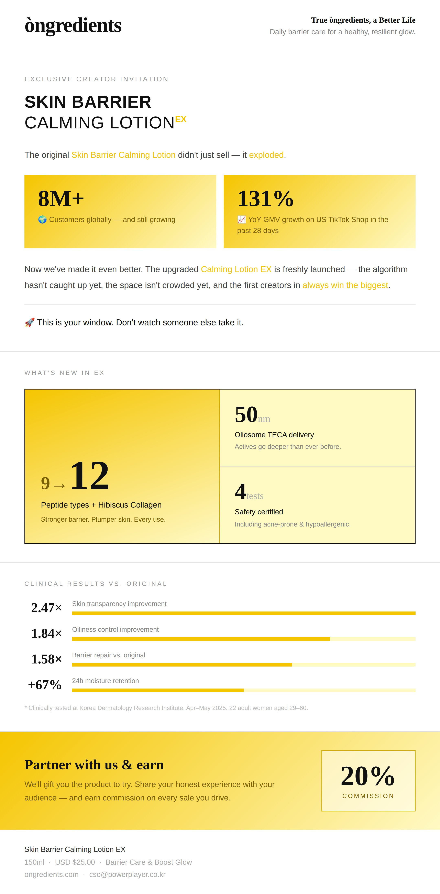

Version B — Product & Ingredient Focus (Agent 2)
Version B leads with the product itself. The design uses a warm cream-and-gold palette that feels closer to a premium skincare brand. The key messages are: the formula is clinically upgraded (hydration, barrier, radiance metrics), it is suitable for sensitive and acne-prone skin, and it is versatile enough for skincare routines, pre-makeup prep, and content creation. This version is designed to appeal to creators who prioritize product quality and authenticity, and who want to understand what they are putting in front of their audience before saying yes.

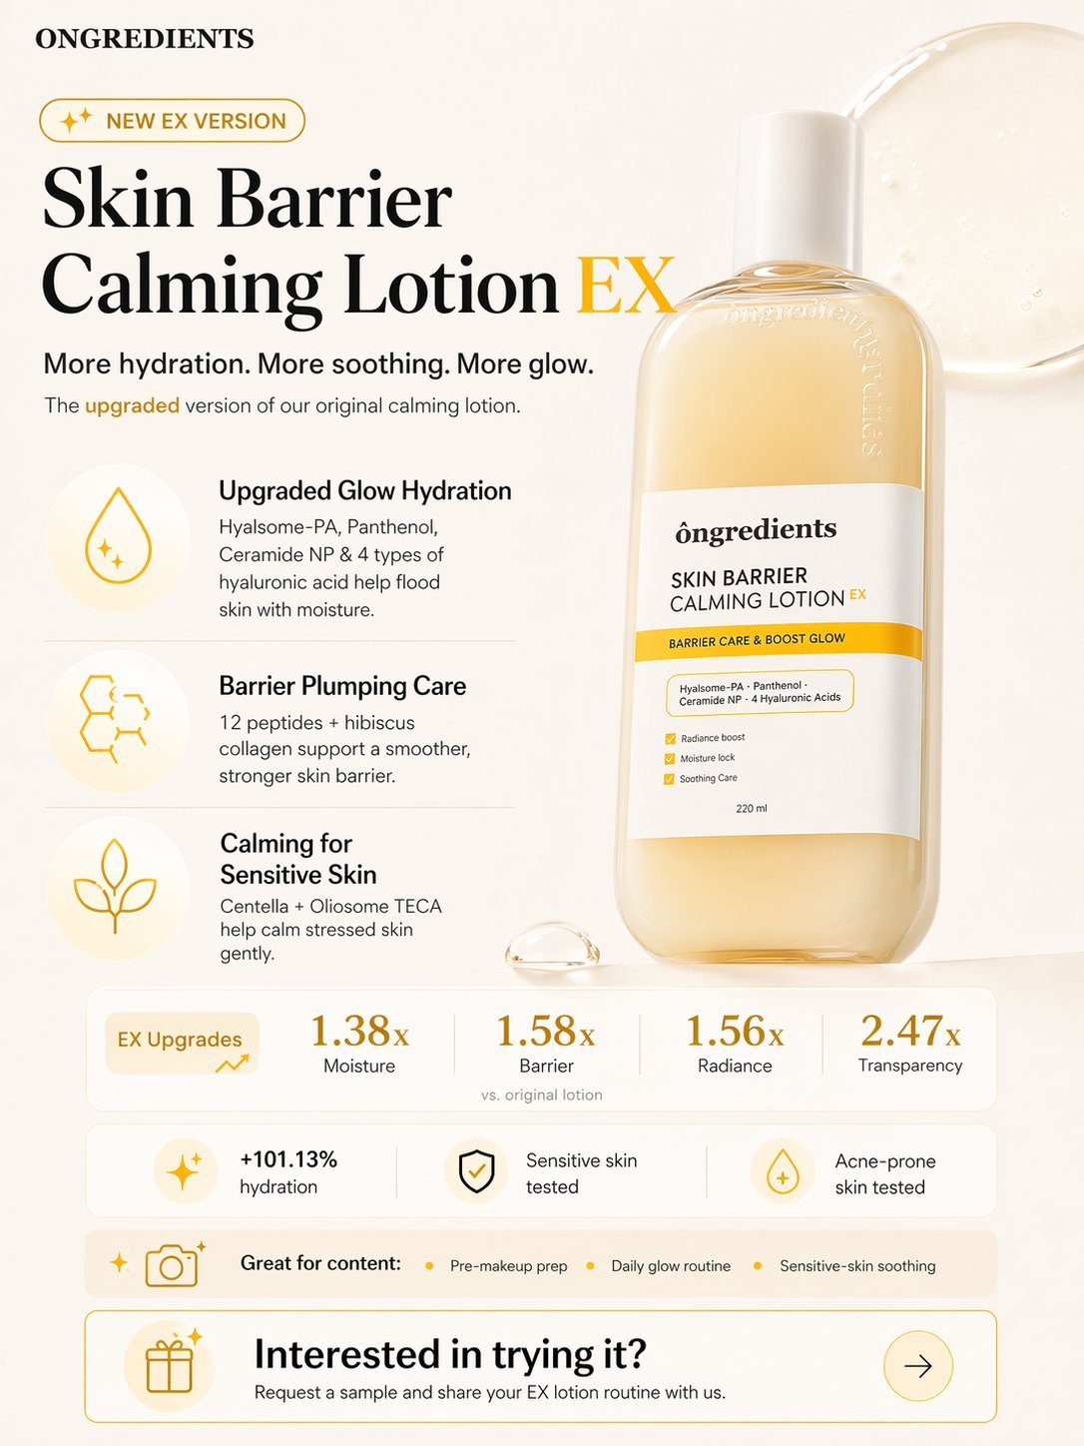

5. Expected Results & Success Metrics

Filter | Setting
Agent 1 — creator pool | 3,000 – 5,000 creators
Agent 1 — target reply rate | 8 – 15%
Agent 2 — creator pool | 500 – 1,000 creators
Agent 2 — target reply rate | 10 – 18%
Agent 3 — creator pool | 50 – 200 creators (manual review)
A/B test evaluation window | 2 weeks from launch
A/B test primary metric | Reply rate (Agent 1 vs. Agent 2)
A/B test secondary metric | Collab acceptance rate
Minimum sample size per version | 300 creators (for statistical significance)
Agent 3 one pager decision | Winning version from A/B test

After the 2-week evaluation window, the version with the higher reply rate and acceptance rate becomes the default one pager for all future Ongredients outreach on TikTok Shop.

