**Project Report**

|  |  |
| --- | --- |
| **Product Name** | Advanced Certificate in Web Development |
| **Qualification Name (ITSF)** | NICF-Advanced Certificate in Infocomm Technology (Software & Applications) |
| **Product Name** | NICF-UI Frameworks |
| **Module Name (ITSF)** | NICF-UI Frameworks |

|  |  |  |  |
| --- | --- | --- | --- |
| **Student name** | | **Assessor name** | |
| Darren Farrell | | Khin ma ma cho | |
| **Date issued** | **Completion date** | | **Submitted on** |
|  | 21/12/2022 | | 21/12/2022 |
|  | | | |
| **Project title** | **Design & Develop Front End Community Portal RIA application.** | | |

|  |
| --- |
| **Learner declaration** |
| I certify that the work submitted for this assignment is my own and research sources are fully acknowledged.    Student signature: Date:18/12/2022 |

**Content**

1. Project background
2. Project Objectives
3. Business Process & Solution Architecture
4. Task 1
5. Task 2
6. Task 3
7. Task 4
8. Task 5
9. Task 6
10. Task 7
11. Task 8
12. Task 9
13. Task 10
14. **Project Background**

You have been contacted by “ABC Jobs Pte Ltd” to create and design a community platform for software developer. We need to design and develop a community portal similar to LinkedIn. The website should be able to register, search other user, login, request for forgotten password and update their profile Information. We need to make a prototype of this project using axure rp10.

1. **Project Objective**

You are required to design a prototype of a community portal website and its feature. This Project considers the skills required to design, develop, implement & document Angular based community portal website using JEE. The backend section of the website will be developed in Module 5 using JEE. For this project, students have to develop the functioning prototype using Axure RP10 and document the process

Tools & platform used

* Axure RP10
* Figma
* <https://thispersondoesnotexist.com/>
* <https://www.flaticon.com/>
* Web browser
* Draw.io

# Business Process & Solution Architecture

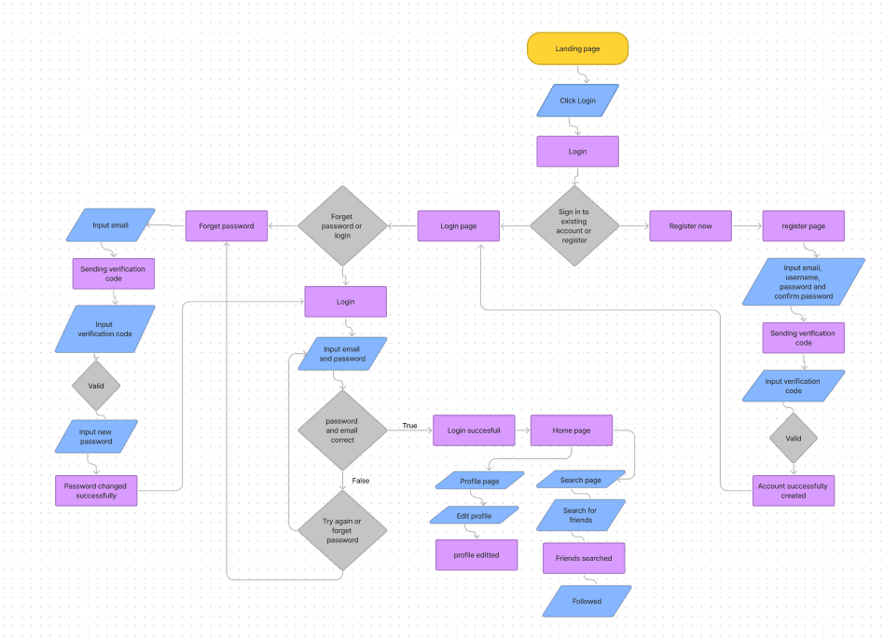

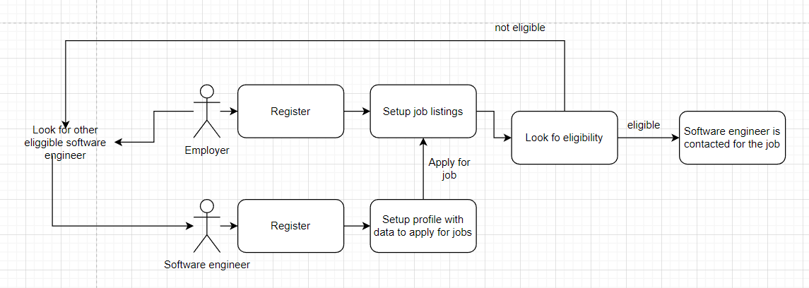

Business process

1. **Task 1**

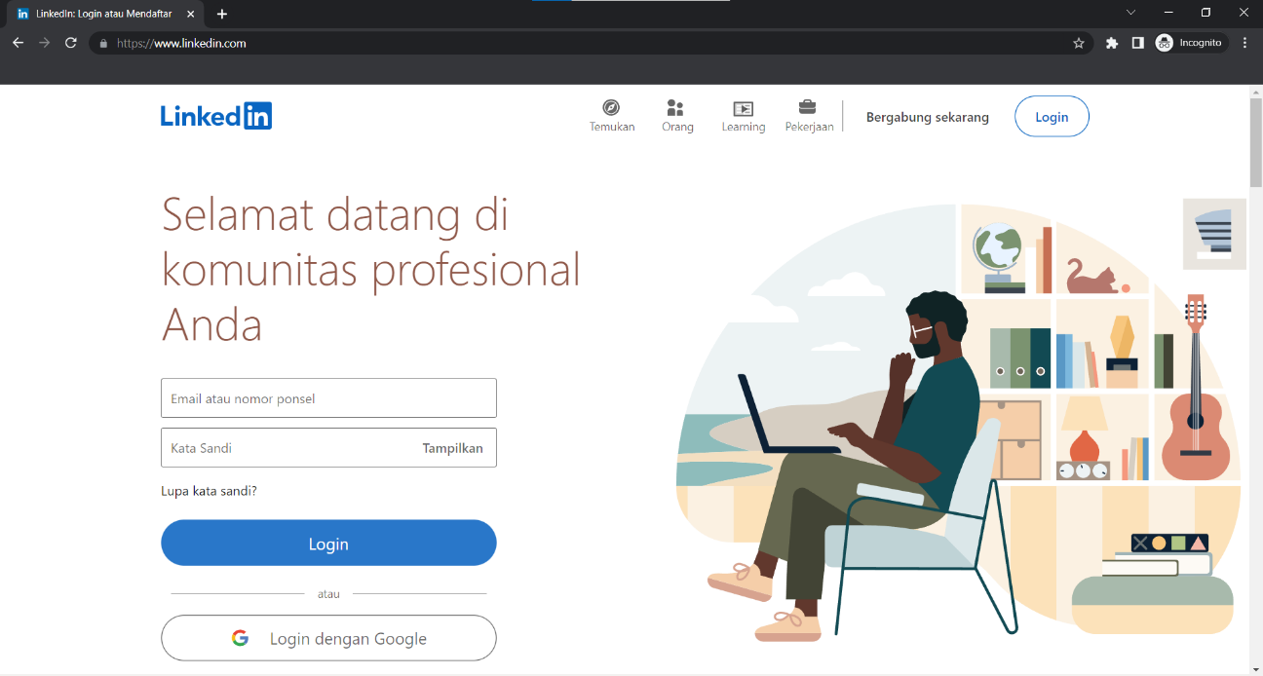

* Surveys: Online or in-person surveys can be used to obtain detailed information about user preferences, experiences, and opinions. This can be a cheap and easy way to gather information on what works.
* User testing: User testing involves seeing and recording users while they use a product or service, and it can give important insights into how users interact with and utilize the website and ensure that there isn’t any confusion completing the intended task.
* Interviews: Similar to surveys we can also interview people to obtain detailed feedback about their experiences, confusion, trouble, and their opinion about the prototype. This can be done before or after the product design.

The technique that I’m going to use is user testing, user testing is a pretty good feedback-gathering technique because I can see where the user is having a pretty hard time during the exploration of the prototype and I can make a note to improve upon the prototype

Linkedin.com

LinkedIn is a community portal and job searching platform that allows users to connect with professionals, search and apply for jobs, and access a variety of resources and tools related to career development. LinkedIn has a very simple and intuitive user interface and design. It is a very user-friendly site with a straightforward navigation structure. For example, the registration process is very straightforward, you just have to input a few fields form and follow their instruction to register an account. But you do have to agree to some privacy policy.

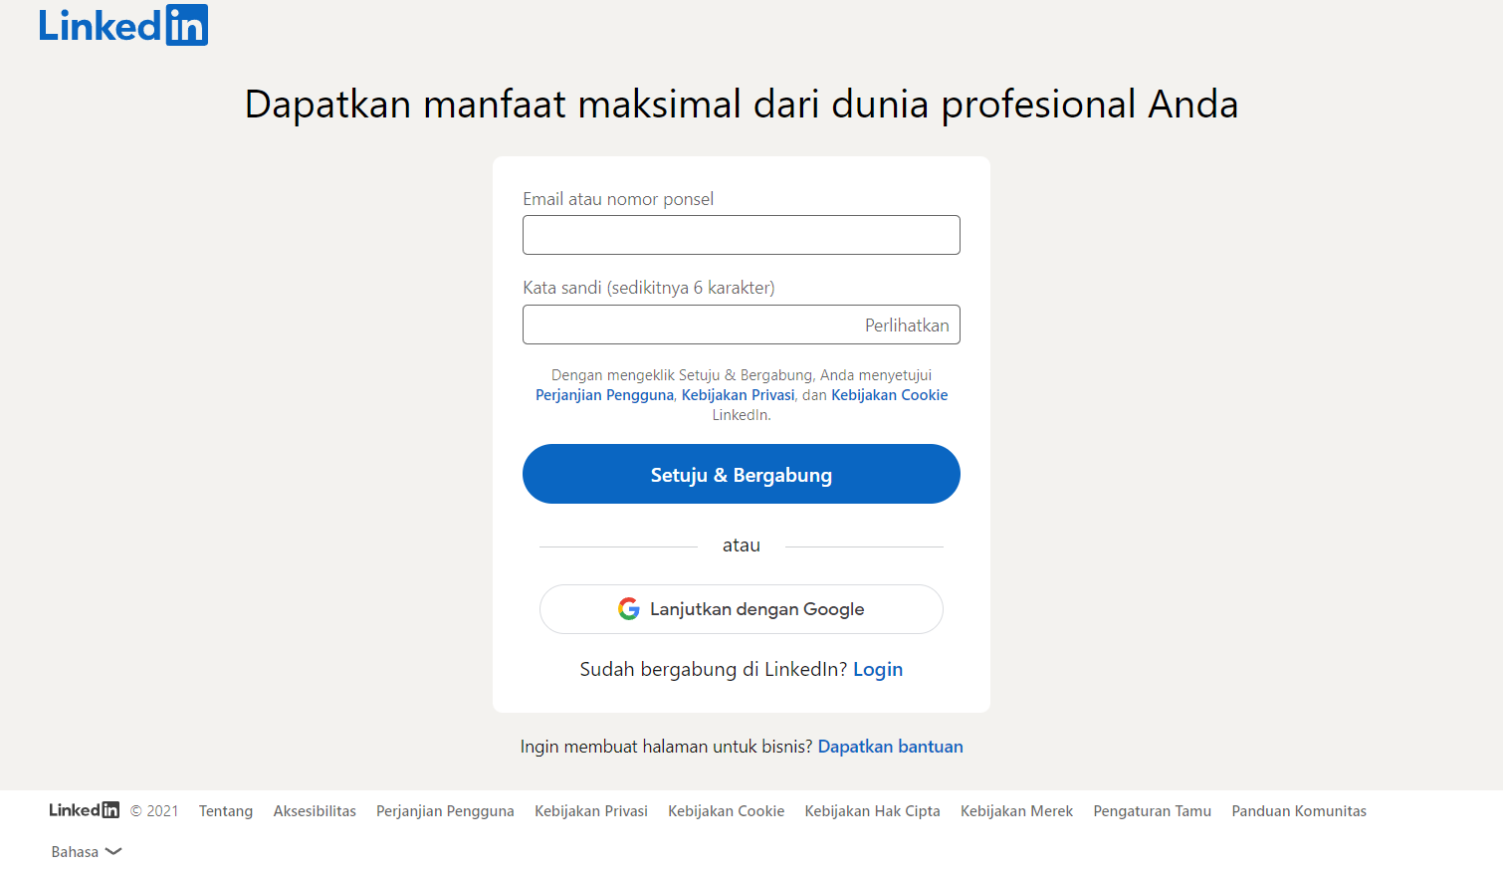

# 

Although LinkedIn has a lot of weaknesses LinkedIn is an exceptional community portal for users trying to connect with others and has a lot of features that makes it one of the most well-known community portal out there.

Jobcase.com

Jobcase is a social networking platform that is used by millions that allow users to connect with potential employer and find job opportunities with useful tools to better help them in their job search. Users can follow others and organizations and see what's hot on the topic they’re following, user can also interact with posts by liking, commenting, or following them. Jobcase also has a very simple and intuitive layout that is easy for users to understand and navigate.

# 

On the left side you can find the navbar that includes most of the features that you want to see while navigating jobcase. Also they have a navbar at the top in which you can find more common feature

You can explore your community feed, see who you might be interested in to follow, your notification, messages, groups, organization, find job and profile.

Overall jobcase has a very nice user interface which makes navigating the website more enjoyable. Jobcase is also an exceptional community portal website where you can connect with people through groups organization and other people to receive the latest news on them.

# Task 2

1. Discuss, study and analyse the user experience based on the observations done in Task 1.

2. Study the experience for 2 to 3 scenarios

3. Include it as part of Project Report

Task Statement:

Solution:

1. LinkedIn

The first website I visit is LinkedIn. LinkedIn is a very clean website that uses a simple modern and intuitive design. It has a clear hierarchy of information with the important information displayed prominently. Its simple design successfully satisfies the requirements of its target market, which is mostly made up of professionals eager to network with one another and look for career prospects. But as with many other websites, the UI of LinkedIn is far from perfect. With many information and navigation on the home page, it can be quite a daunting task to explore all of the features the website has to offer, in other words, it might overwhelm some people and deter them from using the website. The feature in this website is working as intended with minimal confusion. You can search for people and jobs easily with the search feature. You can also manage your post and profile easily in the profile page.

First scenario: Registering an account

LinkedIn has a very simple and intuitive registration process you just have to input some text field and click on next until your account is made. As a plus, you can also register with a google account that you probably have which makes the registration process as simple as possible. You might have to verify a security check but that’s a simple test. After you input some fields it will ask whether you’re here for a new job or are you here to grow in the job you’re currently in. This makes it so that LinkedIn knows what you’re there for and suggests things to you accordingly.

You are also asked what is your most recent job in which you’re probably going to get suggested jobs/people in similar industries that you’re in. You can also opt to put that you’re a student. This gets confusing if you’re unemployed without prior experience. You’re not a student yet you also don’t have any recent job title. This can be a problem for some people LinkedIn should make it so that you could skip that part and edit that part later on in your career. In the last part, you will be asked where you’re residing, probably so that they could suggest jobs and people close to your area. All in all the registration process is straightforward enough and it asks you relevant things tailored to make your experience on the website as close to perfect as it can get.

Second scenario: Forget password

LinkedIn has a very simple forget password procedure. First you have to click on the forget password in the login page, then you will be redirected to a page where you have to type in the email address that you register with and they will send you a 6 digit code to your email address. You just have to put the 6 digit code in the field provided and you get to choose your new password. This is a very simple and intuitive design in which there won’t be any confusion in the user. You can also opt to logout of all devices in case your account was hacked.

1. Jobcase

The second website I visit is Jobcase. Jobcase also has a clean and modern UI. You can easily find what you’re looking for by navigating in Jobcase. The design is simple and intuitive. Jobcase has a responsive design that works well with different screen sizes and types. A clean and simple UI is probably the best choice for a Networking and job-finding site. When you first open the site you will be greeted with the home page where you can find the navigation. You can find the navbar at the top of the page and on the left side to open the hidden menu. Each navigation is easy to understand and setting up your profile is easy and intuitive, you can even skip that part. They give you suggestions for groups and jobs based on your information, which is a great way to find content suitable to you. Searching for a job is easy you just typed in what job is suitable. You can also interact with post people made by liking or commenting on their posts.

First scenario: Registering an account

Jobcase has a very simple way to register an account. You just need to input your name email and password and boom you’re on the website. Nobody should have any problem registering an account with Jobcase. But they don’t ask you to verify your email so people can easily fake their email address and they don’t verify your password so if you typed in the wrong password or misspell your password then you’re in trouble.  After the registration, you should probably complete your profile with your work experience and education section but you can do this later. You can also simplify this even more by using an existing gmail account.

Second scenario: Forget password

The forget password procedure is also very simple and anyone can easily do this. All you have to do is enter your email address, and after that, you will be sent an email with a link to reset your password. In the link, you can just enter a new password and confirm the password. This is straightforward and easy to do. But it does require the use of 1 uppercase letter and one special character which you don’t have to put in the registration process so that part is a bit confusing. After you’ve reset your password you can log in again with your current password.

# Task 3

Task Statement:

1. Discuss, study and analyse the user experience based on the observations done in Task 1.

2. Study the experience for 2 to 3 scenarios

3. Include it as part of Project Report

LinkedIn

|  |  |
| --- | --- |
| Expectation | Realities |
| Registration finish in under 3 minutes | The registration process is very easy and intuitive so there are no problem finishing it in under 3 minutes |
| Login finish in under 30 seconds | The login is easy enough to do in under 30 second if you remember correctly your login information |
| Forget password finish in under 1 minute | The forget password is straightforward and easy enough to do in under 1 minutes. |
| Searching for other users | Searching for other users is easy and intuitive and easy to perform |

Jobcase

|  |  |
| --- | --- |
| Expectation | Realities |
| Registration finish in under 2 minutes | The registration process is very easy and intuitive so there are no problem finishing it in under 2 minutes |
| Login finish in under 30 seconds | The login is easy enough to do in under 30 second if you remember correctly your login information |
| Forget password finish in under 1 minute | The forget password is straightforward and easy enough to do in under 1 minutes. |
| Searching for other users | Searching for other users is intuitive and easy to perform |

level of user engagement & stickiness with the product.

People comes back to LinkedIn regularly to connect with others and stay updated in their industry. I think it’s more or less the same with Jobcase with people coming back to stay updated on their industry and their organization. Overall, they’re both very successful website with users coming back to their website everday.

# Task 4

Task Statement:

1. Develop & document 3 metrics to measure the user experience.

2. Create Bootstrap HTML along with angular pages for the proposed pages and get feedback from mentor and document them.

3. Document it as part of Project Presentation

The 3 metrics I will be using to measure the user experience on my prototype are:

* Task success Rate

I will measure the task success rate of my prototype. I will measure if the 3 users can complete the task I have given or not. The result will be in percentage and which part of the task did they failed on

* Time on task

I will measure the time taken to complete a task. I will count the average time taken to complete the task. The lower the time the better user experience the prototype has.

* Net promoter score

I will measure how likely is it that they will recommend the brand to a friend. The user will answer on a 1-10 scale and the score will be averaged.

Solution

# Task 5

1. Create the steps in User Interaction process for various scenario.

2. Create a flow chart for user interaction.

3. Document it as part of Project Presentation

Solution

Scenario 1 – Login

1. User click on the Login button on the landing page
2. In the login page input the correct email and password
3. Click login button
4. If the login is successful then the user will get redirected to the login success page
5. Press continue to go to home page

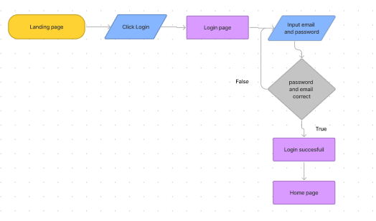

Scenario 2 – register an account

1. User click on the login
2. Press the register now button
3. Input Email, Full name, Password, and Confirm Password
4. Press register now
5. Input the 4 digit code
6. Press confirm
7. Register success

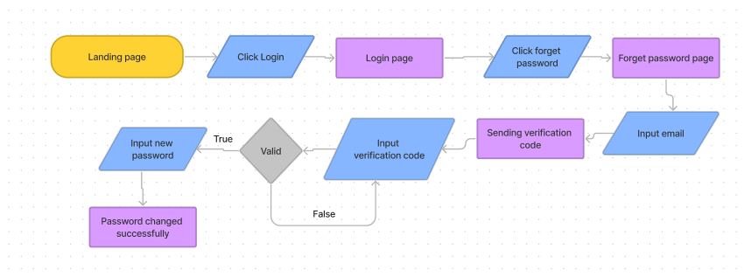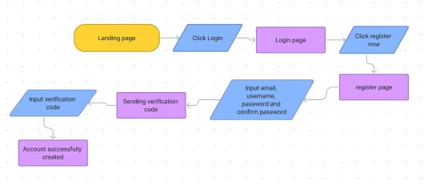

Scenario 3 – forget password

1. Click login
2. Press the forget password button
3. Input email that is used to register
4. Click reset password
5. Check email for 4 digit code
6. Input the 4 digit code
7. Type the new password
8. Click change
9. Password successfully changed

# Task 6

1. In the Websites study’s get the general user response from one other user.

2. Document the general user response to the product as part of Project Presentation.

Task Statement: Solution

User response from Joseph Adriel a computer science student on LinkedIn and Jobcase:

“LinkedIn is a website that I don’t use that often. LinkedIn is a job finding website that I will probably use once I have graduated later. The layout is easy to navigate and I don’t have any problem finding things I want. But when I first started using LinkedIn there are too many navigation all at once so I need to adjust by researching on what I need to do on google. I haven’t used LinkedIn in a long time so I need to reset my password as I have forgotten. The process is simple enough and I’m able to change my password in under 1 minute.”

“I have never use Jobcase before so I need to register. The registration process is simple, they don’t require a lot of data for me to input. I have never heard of Jobcase before so this is very new to me. The welcome page is pretty simple I can go straight to job searching or finding my friends which is helpful. The website is layout and functionality is similar to LinkedIn. I think the community section is pretty intriguing there are a lot of helpful people sharing their experiences to one another. I think that they have a pretty great community on Jobcase

# Task 7

1. Create a Prototype for the proposed system, with at least 5 screens 2. Get the user response and classify them to various types. 3. Screen capture the prototype and include it as part of Project Presentation

Task Statement Solution

|  |  |
| --- | --- |
| Landing page | Widget:   1. Login button – This button will take you to the login page |
| Login page | 1. Email text field – for the user to put their email 2. Password text field – for the user to put their password 3. Forget password button – This button will redirect you to the forget password page 4. Login button – this will logged the user in if they put the correct email and password 5. Register now button – this will redirect you to the registration page |
| Login success page | 1. Continue button – this will take you to the home page. 2. Navbar with home and profile page – when click will get you to home or profile page. |
| Register page | 1. There is email, full name, password, confirm password text field for the user to put the corresponding data. 2. Register now button – this button will register the user if they put the correct information 3. Login button – this button will take you back to the login page |
| Register confirmation | 1. The text field for you to put the 4 digit code 2. The confirm button – this will confirm your 4 digit number and will register your account |
| Register success | 1. Login button – once you’ve successfully registered you will want to go back to the login page to login. |
| Forget password page | 1. Email text field – for the user to put the email that they’ve registered with 2. Reset password button – to send the 4 digit code to their email 3. Back button – to go back to the login page |
| Forget password confirmation | 1. The text field for you to put the 4 digit code 2. The confirm button – this will confirm your 4 digit number and will redirect you to the new password page |
| New password page | 1. Password and confirm password text field- they must be the same 2. Change button – check if the password match if the password match then will redirect to the change password success page |
| Change password success | 1. Login button – this will redirect you back to the login page so that you can login. |
| Home page | 1. Navbar with home and profile page – when click will get you to home or profile page. 2. View profile button – This will redirect you to your profile page 3. Save button – this will turn to saved when clicked 4. See more job – not implemented 5. Start a post – This will redirect you to the content posting page 6. Post from friends – here you will see your friends post 7. Connect with friends – here you will see people who you might know you can click on their name to go to their profile page (which is the others profile page) 8. Follow button – this will turn to followed when clicked 9. Search for people – this will redirect you to the search user page 10. Log out button – to log out |
| Content posting page | 1. Navbar with home and profile page – when click will get you to home or profile page. 2. Tile and content field – this is where you will make your post 3. Attachment – not implemented 4. Create – this will redirect you to the home page ( the post feature is not implemented yet ) |
| View profile page | 1. Navbar with home and profile page – when click will get you to home or profile page. 2. Edit profile button – this will make the hidden group not hidden 3. The full name, location Education, current job field – This is where you can edit your profile. 4. Save – save the changes made 5. X button – close the popup |
| Search user page | 1. Navbar with home and profile page – when click will get you to home or profile page. 2. Search field – this is where you can search people 3. People you may know – here you will see people who you might know you can click on their name to go to their profile page (which is the others profile page) 4. Follow button – this will turn to followed when clicked |
| Others profile page | 1. Navbar with home and profile page – when click will get you to home or profile page. 2. Follow button – this will turn to followed when clicked |

|  |  |  |  |
| --- | --- | --- | --- |
| Scenario | login | Reset password | Register |
| Joseph – computer science student @ binus university | Login is easy and take as much time as expected | Reset password is easy to understand and take as much time as expected | Registration takes as much time as expected |
| Simeon – System information student @ binus university | Login is easy and take as much time as expected | Reset password is straightforward and takes less time than expected | Registration takes less time than expected |
| Jonathan – electrical engineering student @ university of indonesia | Login is easy and take as much time as expected | Reset password takes less time than expected | Registration takes as much time as exppected |

# Task 8

1. Demonstrate and let the users give feedback on prototype and document them 2. Make suggestions to improve the user experience and implement them in the prototype 3. Include it as part of Project Presentation

Task Statement Solution

|  |  |  |
| --- | --- | --- |
| Users | Observation | Feedback |
| Joseph (CS student) | * Never really uses the profile button on navbar * Never went to profile of others * Confused on why the log out button is out of place * Didn’t really get to the footer | * “the website is good enough and easy to navigate through” |
| Simeon (SI student) | * Never uses the profile button on navbar * Gets confused on the edit profile * Tried to press on the profile picture to go to others profile page * Gets confused then press the name to go to others profile | * “It’s a pretty simple design but I like it overall” |
| Jonathan (Electrical engineering student) | * Never uses the profile button on navbar * Tried to press the follow us button on the footer * Tried to press privacy policy page on the footer | * I Think that the design is too simple but it is easy enough to navigate |

|  |  |  |  |
| --- | --- | --- | --- |
| No | Problem | Action taken | Solution |
| 1 | Profile button did not get used | No | I think it’s pretty convenient to have profile button at the top right |
| 2 | Never went to others profile | Yes | Make the profile picture clickable also |
| 3 | Log out button out of place | yes | Make the logout button on view profile page |
| 4 | Did not get to footer | No | They just need to scroll to the bottom |
| 5 | Edit profile confusion | yes | When click save they now the popup automatically dissapear |
| 6 | Press profile picture | Yes | Make the profile picture clickable also |
| 7 | footer | no | I haven’t implemented the privacy policy page nor the social media |

Task 9

1. Create 3 Usability tests and execute the usability tests with a user

2. Get the users use the modified prototype

3. Gather feedback and measure its technical viability and effectiveness

4. Include it as part of Project Report

Scenario 1

Login

|  |  |  |  |  |
| --- | --- | --- | --- | --- |
| No. | User | TSR | TOT | NPS |
| 1 | Joseph | Success | 22 second | 8 |
| 2 | Simeon | Success | 19 second | 8 |
| 3 | Jonathan | Success | 20 second | 7 |
| Average |  | 100% | 20,3 second | 7,6 |

Observation : They all completed the task without any problem, they all went into the login page and logged in without any obstacle and they take around the same time as expected.

Scenario 2

Register

|  |  |  |  |  |
| --- | --- | --- | --- | --- |
| No. | User | TSR | TOT | NPS |
| 1 | Joseph | Success | 58 second | 8 |
| 2 | Simeon | Success | 48 second | 8 |
| 3 | Jonathan | Success | 51 second | 7 |
| Average |  | 100% | 52,3 second | 7,6 |

Observation : They all completed the task but two of them (Joseph and Jonathan) got stuck in the password form validation. Jonathan put in 5 letter password and had to retype and Joseph had to retype the password because it didn’t match. But their time was around the same as expected which is around 50-60 seconds

Scenario 3

Forget password

|  |  |  |  |  |
| --- | --- | --- | --- | --- |
| No. | User | TSR | TOT | NPS |
| 1 | Joseph | Success | 44 second | 8 |
| 2 | Simeon | Success | 40 second | 8 |
| 3 | Jonathan | Success | 39 second | 7 |
| Average |  | 100% | 41 second | 7,6 |

Observation : They all completed the task easily. I expected the forget password to done in 40-45 second so they were take as much time as I expected. But there were no confusion or obstacle.

|  |  |  |
| --- | --- | --- |
| no | User | Feedback |
| 1 | Joseph | The design is pretty simple but it gets the job done. |
| 2 | Simeon | The user interface is simple and easy to navigate |
| 3 | Jonathan | It’s a cool website |