Final

Program 1

# Author == "Darren Isaacson"

# This program calculates the cost of a flight and displays information into a final total.

def main():

try:

suitcase, tickets, = getInput() # Gathers Info amount

tickets, suitcase, ticketCost, suitcaseCost, totalforTickets, totalforSuitcases, extraFees, taxCost, totalCost = calculateTotal(suitcase,tickets) # Calculates the totals

displayOutput(tickets,suitcase,ticketCost,suitcaseCost,totalforTickets,totalforSuitcases,extraFees,taxCost,totalCost) # Displays totals.

except:

print("There was an error somewhere. Please reopen the program.")

def getInput():

# The point of this while loop is to put the user in a continuous loop for input validation

while True:

try:

while True:

# Loop for just the ticket validation

numTickets = int(input("How many tickets are you looking to purchase? Limit is 5. Enter here:"))

if numTickets > 5: # If it is greater than 5

print("Limit of tickets is 5! Please enter in the correct amount.")

else:

break

while True:

# Loop for just the suitcase validation

numSuitcase = int(input("How many suitcases are you looking to bring with? Enter here:"))

if numSuitcase > numTickets * 2: # if it is greater than number of tickers * 2

print("You can only have 2 suitcases per ticket. Please enter in the correct amount of suicases.")

else:

break

except ValueError: # In case they use anything other than numbers

print("You Cannot put any letters or special characters, only numbers please.")

continue

else:

return numTickets, numSuitcase

def calculateTotal(suitcase,tickets):

ticketCost = 300

suitcaseCost = 25

extraFees = 100

totalforTickets = tickets * (ticketCost) # Calculate ticket

totalforSuitcases = suitcase * suitcaseCost # Calculate suitcase

taxCost = (totalforTickets + totalforSuitcases) * 1.075 # Calculate tax

totalCost = taxCost + (extraFees * tickets) # Calculate total values

return tickets,suitcase,ticketCost,suitcaseCost,totalforTickets,totalforSuitcases,extraFees,taxCost,totalCost

def displayOutput(tickets,suitcase,ticketCost,suitcaseCost,totalforTickets,totalforSuitcases,extraFees,taxCost,totalCost):

# Display in a nice table.

print("{:<10}{:<10}{:<20}{:<20}{:<15}{:<30}{:<25}{:<25}{:<25}".format("Tickets", "Suitcases", "Cost Per Ticket", "Cost Per Suitcase", "Ticket Total","Suitcase Total", "Fee Per Ticket","Price with tax", "Total",))

print("{:<10}{:<10}{:<20}{:<20}{:<15}{:<30}{:<25}{:<25}{:<25}". format(tickets,suitcase,ticketCost,suitcaseCost,totalforTickets,totalforSuitcases,extraFees,taxCost,totalCost))

main()

Output

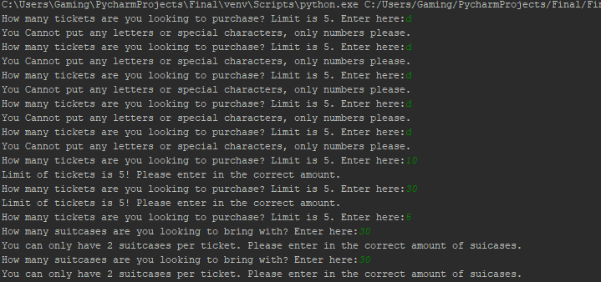

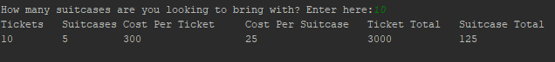

Cut in half for sizing.



Program 2

# Author = "Darren Isaacson"

# This program is designed to find the social security numbers in a sentence.

import re

def main():

while True:

sentence = getInput()

Ssn = regexChecker(sentence)

displayOutput(Ssn)

another = input("Would you like to try another sentence? Press the enter key if you would like to try another.")

if another == '':

continue

else:

print("Thank you for using the program.")

break

def getInput():

ssnSentence = input("Please enter in your sentence here:")

return ssnSentence

def regexChecker(sentence):

regSSNRegEx = re.compile(r'.\d\d\d.\d\d.\d\d\d\d')

myMessage = regSSNRegEx.search(sentence)

if myMessage == None:

ssn = "Doesnt exist."

return ssn

else:

ssn = myMessage.group()

return ssn

def displayOutput(Ssn):

print("Social Secuirty Nummber = " + Ssn)

main()

Output

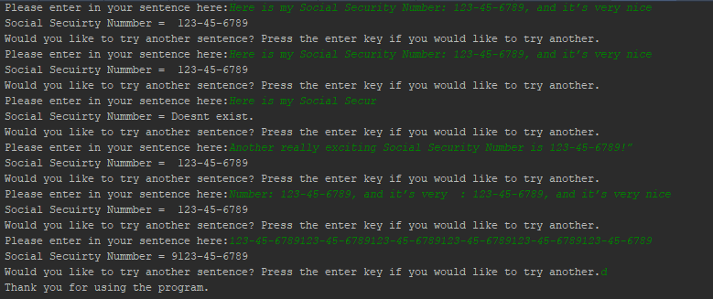

Program 3

# author == "Darren Isaacson"

# This program is designed to create a file that contains information that user inputs.

import csv

def main():

userlist = getInput() # Gets user input

csvConverter(userlist) # Coverts into a csv

tableConverter() # Coverts into a table

def getInput():

dataList = [] # main datalist for each line

while True:

try:

# Continuous loop to enter more lines as needed. For every Input it appends to its own list. Then that list is saved to a bigger list

userInfo = []

name = input("Enter in your Name:") # Name

userInfo.append(name)

street = input("Enter in your Street address:") # Street

userInfo.append(street)

email = input("Enter in your Email:") # Email

userInfo.append(email)

phone = int(input("Enter in your phone number:")) # Phone

userInfo.append(phone)

dataList.append(userInfo) # saved into a bigger list

another = input("Would you like to enter another line of numbers? Press enter to enter another line. Otherwise enter any other key:") # Break input

if another == '':

print('--------------------------------------------------------------')

else:

break

except ValueError:

print("You cannot put letters for the phone input. Please try again")

return dataList

def csvConverter(list):

fileList = open('User Info.csv', 'w', newline='') # Writes a new file called User info

for row in range(len(list)): # for each list within the list it writes a new line.

fileWriter = csv.writer(fileList)

fileWriter.writerow(list[row])

fileList.close() # Closes list

def tableConverter():

title = ['Name','Street','Email','Phone'] # Put titles within a list so that it looks nice.

print('{:<30} {:<30} {:<30} {:<15} '.format(*title)) # Format for nice output

table = open("User Info.csv") # Opens the file

csv_table = csv.reader(table) # Puts it in view mode

for row in csv_table: # Row = for every right. Think of it as a row and column from excel.

print('{:<30} {:<30} {:<30} {:<15} '.format(*row)) # {:15} is a spacing holder.

main()

Output

