Install/Setup CDK

1. If you do not have an account with the Red Hat Developer Program, you will need to create one.
2. Go to https://developers.redhat.com/products/cdk/download/ and download the cdk (named something similar to "cdk-3.2.0-1-minishift-windows-amd64.exe") for your OS.

Note: This is NOT the actual cdk. This is the minishift install. Minishift will appear to run correctly without the actual CDK installed, but it is incorrect.

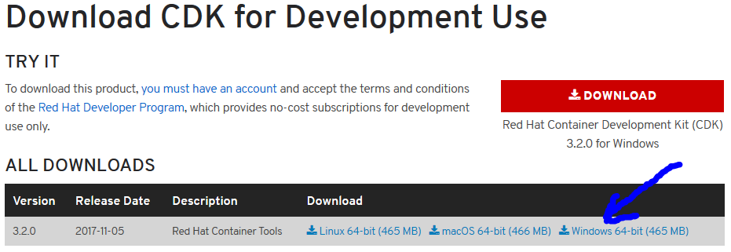

1. Create a new folder at "c:\minishift" (IT HAS to be the c: drive).
2. Save the "cdk-3.2.0-1-minishift-windows-amd64.exe" file, renamed to “minishift.exe”, to c:\minishift folder; or place file in c:\minishift folder and rename the file to “minishift.exe”.

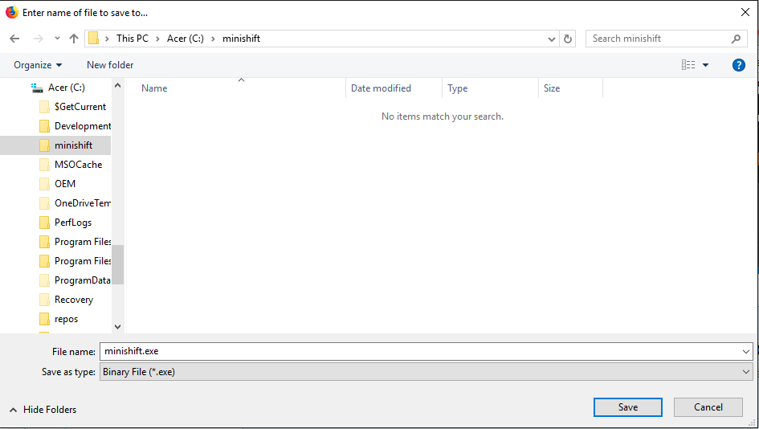

1. Go to https://developers.redhat.com/products/cdk/hello-world/
   1. Click on the proper tab for your OS.

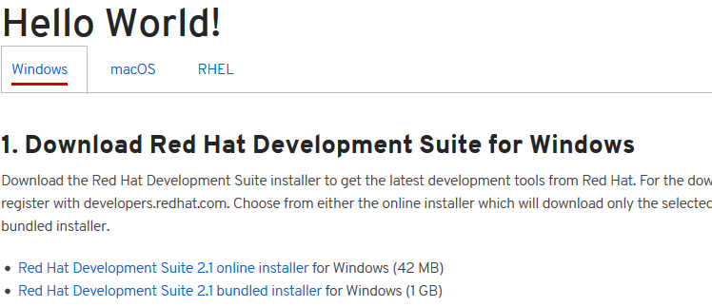

1. Click on the installer you want to use (The file to be saved will be named something similar to "devsuite-2.0.1-GA-bundle-installer.exe").
2. Run this installer.
   1. IMPORTANT: create a new folder “c:\DevelopmentSuite” (Must be right on c:\ ) and use this as your ‘installation folder’.

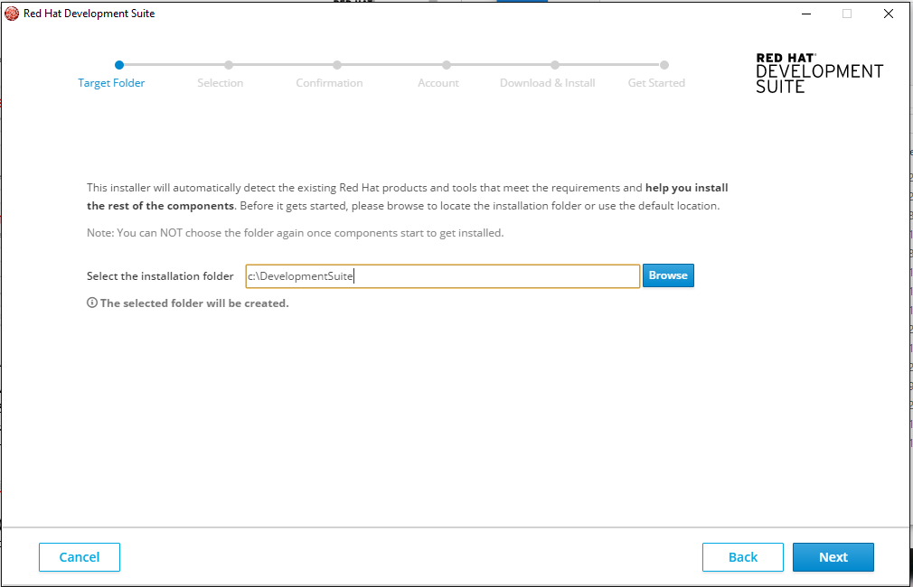

1. You will be presented with a list of optional features to install:
   1. Here you want to select “OPENJDK”, “RED HAT CONTAINER DEVELOPMENT KIT”, “KOMPOSE” and “ORACLE VIRTUALBOX”. (You may select other features if desired)

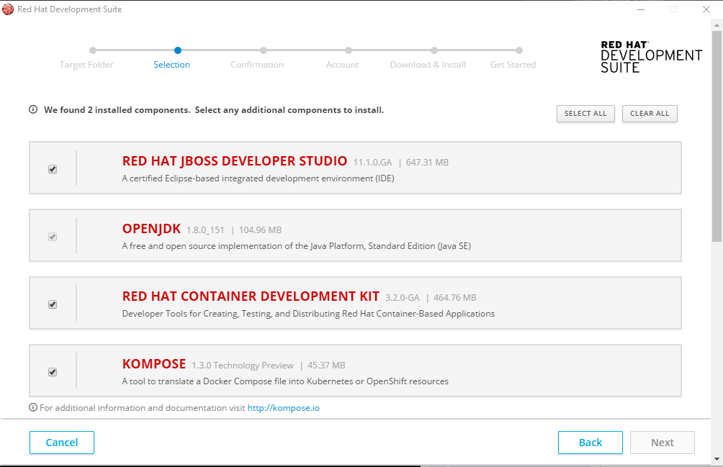

1. If in Windows go to "Environment Variables"
   1. Add System variables MINISHIFT_USERNAME and MINISHIFT_PASSWORD. Use your RedHat credentials for these values.
   2. Edit "Path" to include "c:\minishift;"
2. Open a cmd window. Type "minishift setup-cdk". Or run minishiftConfig.bat instead of the following steps.
   1. If you are using VirtualBox (Most likely) type "minishift config set vm-driver virtualbox". This will eliminate having to specify VirtualBox every time you start minishift.

At this point you should be able to open VirtualBox and see a machine named “minishift”:

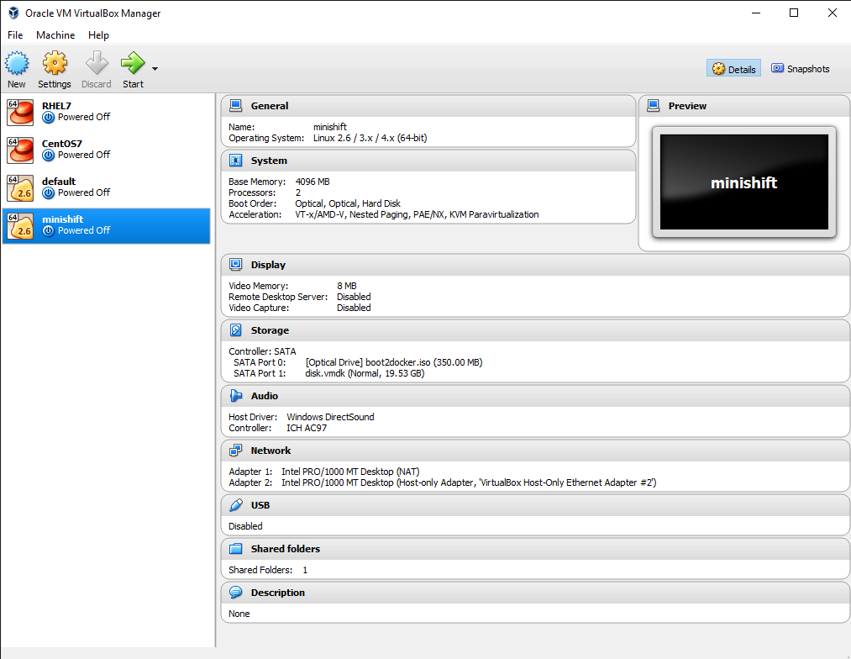

Also, a “.minishift folder should have popped up in your C:\\users\username\ folder.

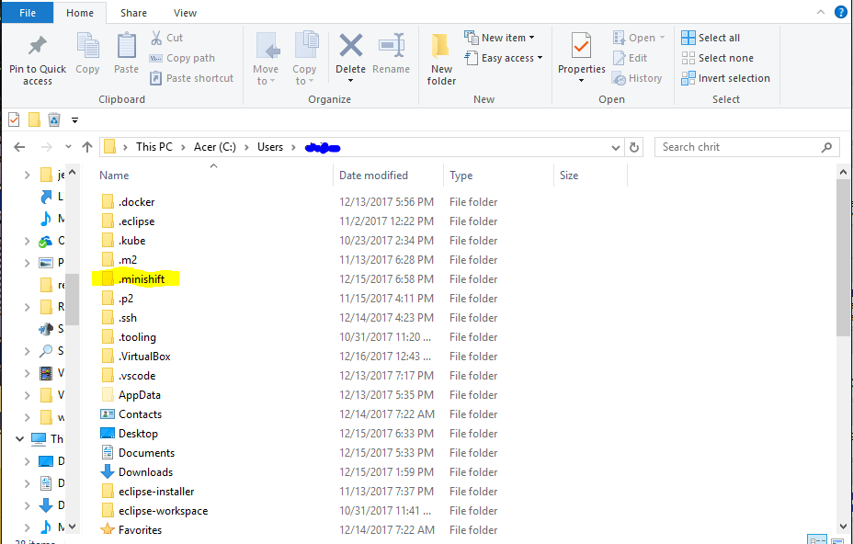

* 1. If you want to increase the memory the cdk is using, type something like "minishift config set memory 12288".
  2. In a Windows environment type "minishift hostfolder add --users-share". This is to setup a drive to be shared between minishift and your local hard drive.

You will be prompted for the following:

Mountpoint [/mnt/sda1/Users]: <just hit the"Enter" key, unless you want to change where it is in minishift>

Username: <type your login name for your computer (on my personal machine it is bryantaustin13@yahoo.com)>

Password: <type the password to login to your machine.>

Domain: <type "Enter">

Minishift will respond back with "Added: Users"

Then type "minishift hostfolder mount Users" // special note!: If you get a "FAIL" when trying to mount see Troubleshooting #2 below.

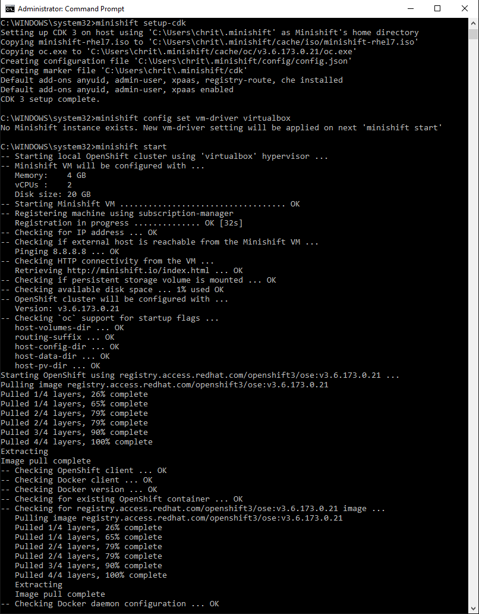

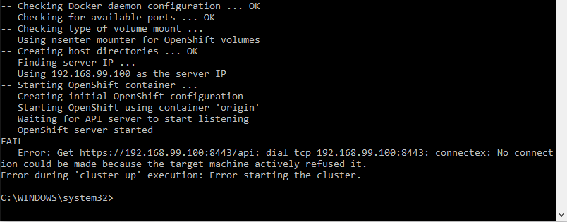

E. Type "minishift start". Allow VirtualBox to make it's changes.

7. Once minishift stops loading, type "minishift oc-env". Go back into "Environmental Variables" and edit the system "Path" to include the results.

Troubleshooting:

1. If you ssh into minishift ("minishft ssh") and get weird characters in directory listings for file names or go

into vi for a new file and get strange characters, then you have not installed the actual CDK. See step 3. If

you have installed the devsuite and are getting this, delete the c:\users\<your home>\.minishift and .kube directories,

rerun "minishift setup-cdk", run all the config settings and try again.

2. I got a "FAIL" when trying to mount, because of my password. Some special characters seem to throw minishift a

loop. If you get FAIL try typing "minishift hostfolder mount Users --show-libmachine-logs -v 5" This should show

a verbose log of minishift trying to mount the drive you setup. Look for errors here and try to fix. In my case

my password had ":)" in it as part of special characters. It gave me the error of " SSH cmd err, output: exit status 1: bash: -c: line 0: syntax error near unexpected token `)' ".

I retried the mount command and entered my password escaping the ')' like ":\)". That worked. Your situation might be different.

3. When starting minishift in the future, after running "minishift start" to mount "Users" you must type "minishift hostfolder mount Users". Otherwise minishift

sees the hostfolder, but nothing is mounted there and Users has nothing in it.

Build Client Gateway

1. Install CDK.

2. "minishift ssh" Then run the following:

docker run -it -v /mnt/sda1/Users:/utils java:8-jdk

3. That creates a container and installs java 1.8, mounts the shared drive as /utils inside that container and then runs the container.

4. Inside that container run the following:

A. Install maven:

cd /usr/local

wget http://www-eu.apache.org/dist/maven/maven-3/3.5.2/binaries/apache-maven-3.5.2-bin.tar.gz

tar xzf apache-maven-3.5.2-bin.tar.gz

ln -s apache-maven-3.5.2 maven

apt-get update

apt-get -y install vim // this installs vim so you can edit files

vi /etc/profile.d/maven.sh

export M2_HOME=/usr/local/maven

export PATH=${M2_HOME}/bin:${PATH}

source /etc/profile.d/maven.sh

vi ~/.bashrc // so each time you start a shell maven gets set.

export M2_HOME=/usr/local/maven

export PATH=${M2_HOME}/bin:${PATH}

B. Alternatively

Before running "minishift ssh", download serverConfig.sh into your users directory on your hard drive (the directory you mounted above).

cd /utils

cp /mnt/sda1/Users/serverConfig.sh .

source ./serverConfig.sh

C. git is installed already

git clone https://<username>@bitbucket.vetsez.net/scm/das/das.git <enter pasword when prompted>

5. copy appsaitccgw.xml to das/nodejs/vlerdas-installer/src/main/assembly

keep a copy of the original appsaitc.xml

and copy appsaitccgw.xml to appsaitc.xml

copy pomcgw.xml to das/nodejs/vlerdas-installer

keep a copy of the original pom.xml

and copy pomcgw.xml to pom.xml

then build: sh build-test.sh (or use one of the other build scripts).

This should build AppConfig, VLER DAS Installer, and ClientGateway jars.

Create Node.js and NPM development environment

1. Install CDK

2. Download nodeConfig.sh into your C:/Users directory on your hard drive (the directory you mounted in the CDK install).

3. "minishift ssh"

4. Run the following:

A. docker run -ti --name nodejs -v /mnt/sda1/Users:/Users rhel

B. cd /Users

C. type "source ./nodeConfig.sh"

(or type "curl -sL https://rpm.nodesource.com/setup_8.x | bash -" then type "yum install -y nodejs")

D. Nodejs and NPM should be installed and ready to go.