Again, this is java specific code. My code will probably just be in C, so don’t worry too much about syntax and focus on summerizing the bigger chunks.

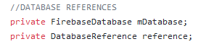🡨just a basic reference to a database

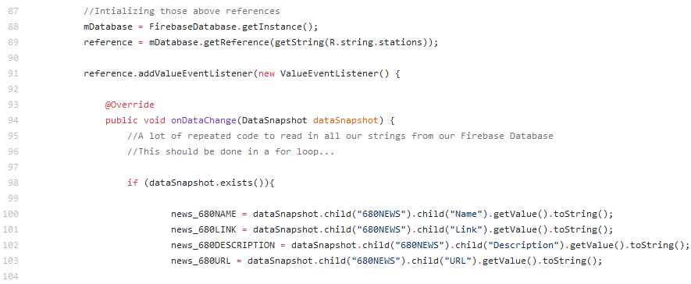

^^This is the main logic here for grabbing the info from Firebase and adding to variables which are used next to “construct” the actual radio station objects.

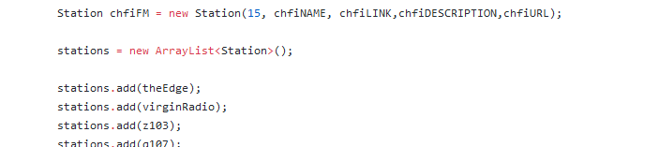

^^Here like the above clip, I cut out all the repeat code. important part are the first three lines of code.

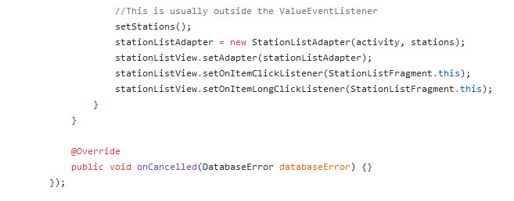

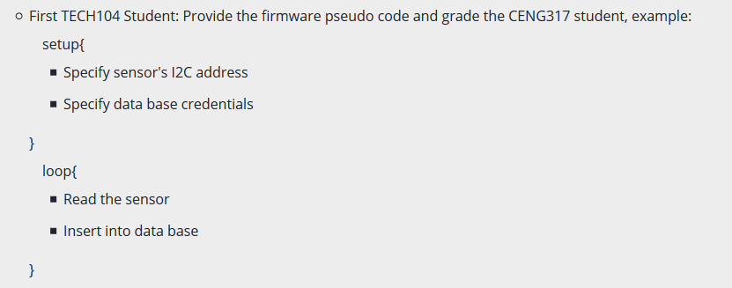

I don’t if you have any info on how to write pseudocode…and I think I already showed you this but just in case.