**G00326934 – Darren Regan**

**Design Document**

# Overview

A Multi-Function Application to test implementation of an API, some Graphics Programming and additional features

# Goals / Features

* Use an API accessing data with a GET request
* Display API JSON data in a ListView/ScrollView
* Use SkiaSharp Graphics, a 2D graphics engine made by google used in chrome, firefox and android
* Use SkiaSharp to make a clock or stopwatch
* Add a Notes/Quick Notes/Todo System by using SQLite for learning purposes.
* Add a Simple WebView with X website with simple features, Back, Forward, Reload

# User Goals

* User will first see some sort of Clock/Digital Clock/Stopwatch on application launch
* User should have a navigation page to switch between Pages/Views
* User should be able entry a desired entry into a box, i.e. (movie title, city, etc.)
* User should be able to navigate to a WebView which has a specific website set i.e. (learnonline.gmit.ie, amazon.co.uk, etc)

## Start Screen – Clock using SkiaSharp Graphics engine

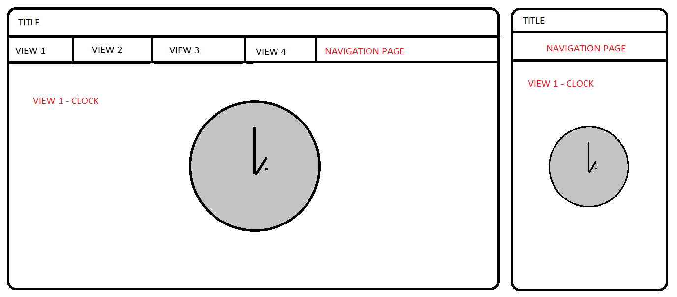

## VIEW 2 for JSON data i.e. Movie details or weather info for city

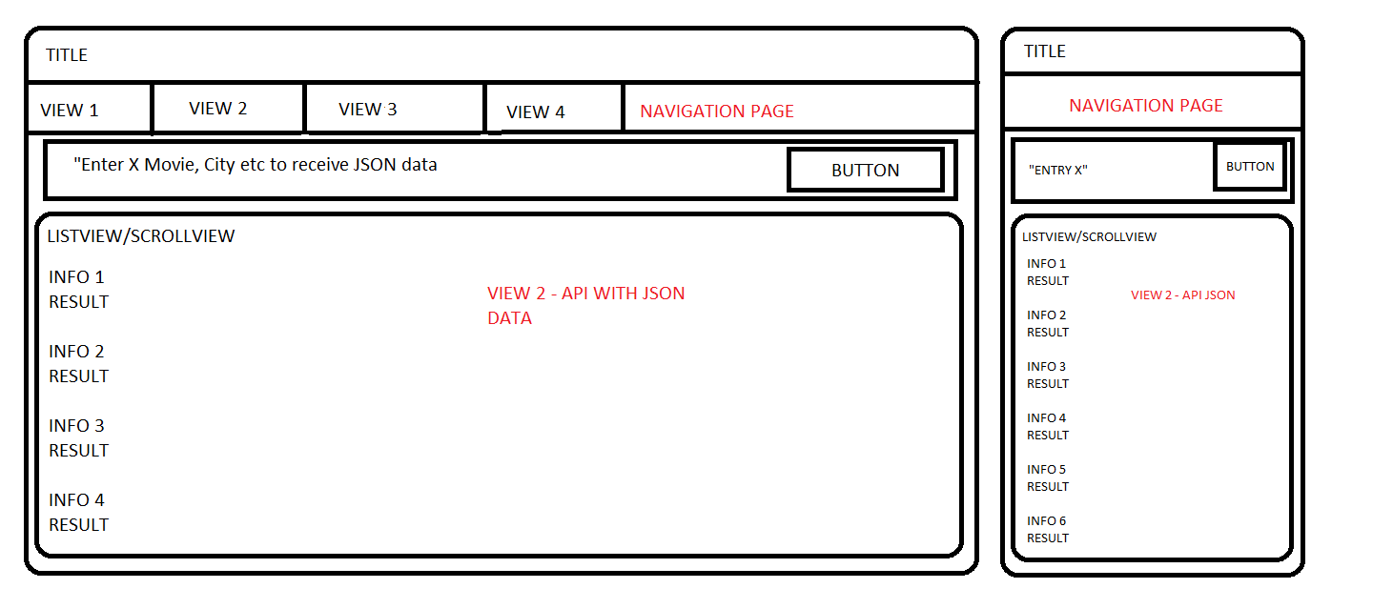

## VIEW 3 - WEBVIEW

