TECHNICAL REORT

First Response Emergency Drone

Darren Quinn

X14357446  
x14357556@student.ncirl.ie

*National College of Ireland*

*BSc in Computing*

*2017/2018*

**Table of Contents**

Executive Summary 5

1 Introduction 6

1.1 Background 6

1.2 Aims 7

1.3 Technologies 7

1.4 Structure 7

2 System 8

2.1.1.1 Functional requirements 8

2.1.1.2 Use Case Diagram 8

2.1.1.2.1 Requirement 1: Use Application 9

2.1.1.2.1.1 Description & Priority 9

2.1.1.2.1.2 Use Case 9

2.1.1.2.2 Requirement 2: Drone Select 10

2.1.1.2.2.1 Description & Priority 10

2.1.1.2.2.2 Use Case 10

2.1.1.2.3 Requirement 3: Input Location Data 12

2.1.1.2.3.1 Description & Priority 12

2.1.1.2.3.2 Use Case 12

2.1.1.2.4 Requirement 4: Deploy Drone 14

2.1.1.2.4.1 Description & Priority 14

2.1.1.2.4.2 Use Case 14

2.1.1.2.5 Requirement 5: Deploy Sensor 16

2.1.1.2.5.1 Description & Priority 16

2.1.1.2.5.2 Use Case 16

2.1.1.2.6 Requirement 6: Drone Recovery 18

2.1.1.2.6.1 Description & Priority 18

2.1.1.2.6.2 Use Case 18

2.1.1.2.7 Requirement 7: Return Drone 20

2.1.1.2.7.1 Description & Priority 20

2.1.1.2.7.2 Use Case 20

2.1.2 Non-Functional Requirements 22

2.1.2.1.1 Performance/Response time requirement 22

2.1.2.1.2 Availability requirement 22

2.1.2.1.3 Recover requirement 22

2.1.2.1.4 Security requirement 22

2.1.2.1.5 Reliability requirement 23

2.1.2.1.6 Maintainability requirement 23

2.1.2.1.7 Extensibility requirement 23

2.2 Design and Architecture 23

2.3 Implementation 23

2.4 Graphical User Interface (GUI) Layout 23

2.5 Testing 23

2.6 Customer testing 24

2.7 Evaluation 24

3 Conclusions 25

4 Further development or research 25

5 References 25

6 Appendix 26

6.1 Project Proposal 26

6.1.1 Project Plan 26

6.2 Monthly Journals 26

6.3 Other Material Used 26

# Executive Summary

The First Response Emergency Drone (FRED), is a raspberry pi controlled drone connected to an android application. The drone is equipped with a flight controller, a raspberry pi (zero or three), various sensors, all connected back to the controlling application.

The problem that we are addressing is how to utilize the time between the initial reporting of an incident and the arrival of the responding team. Once the responding team arrives they have a vague idea of how to approach the situation, however, planning and understanding the situation on arrival uses up essential time which could ultimately decide what the outcome of the situation may be.

The solution we have come up with to address this problem is to create a medium in which the responding team could fully utilize their time by assessing the situation before they can arrive. How can this be achieved?

With the ever expanding uses of technology nowadays, I have come up with the idea of using a drone as a first response information provider. I will be creating a drone that is connected to a raspberry pi, with the use of a flight controller, we will be able to send the drone to the location that it is intended to be. I will be creating an application that will be accompanying the drone, this application will be controlling the drone by selecting / activating the drone, entering the location it is intended to go to, converting the address into latitude and longitude coordinates for an accurate location, activating sensors and returning the drone back to its base station. This will allow the response team to plan accordingly based on the information that the drone can provide, this can potentially change the outcome of an emergency, possibly saving lives also reducing the severity of injuries and damage caused.

# Introduction

The project we are creating is the First Response Emergency Drone (FRED). This is an emergency service drone that is used to survey the area in which the drone is sent to. The drone is controlled by an application that is manned by the responding emergency team. After the drone arrives at the determined area, the attached sensors are then activated, sending vital information to response team, allowing them to act accordingly to the situation, planning on the way to avoid any interval between arrival and acting.

The intention of this system is to successfully create a fully autonomous drone that can travel to any given coordinates within a certain radius, regardless of any obstacles in its path. Further on from this the drone must be able to successfully communicate back and forth between the drone itself and the application. Without these functionalities the drone would not be able to live up to its potential or purpose.

## Background

Drones or Unmanned Aerial Vehicles (UAVs), have become widely used in modern society. The market surrounding drones has exploded in recent years. Originally, drones or UAVs were used for military purposes, however, the commercialisation of drones came about around 2012 - 2013. This began a huge new area of opportunity for people and businesses.

For example, Amazon have been considering using drones as a method of delivering their packages to the buyers. This would be an “Amazon Prime” feature called “Amazon Prime Air”. The purpose of this concept is to deliver packages that are under five pounds to its destination in less than thirty minutes. The fact that businesses can utilize this technology to enhance their services is a huge benefit to anyone who avails of it.

On a day to day basis, people have become accustomed to seeing these drones used in people's everyday life. The basic concept of what a drone can do can be repurposed to have infinitely different purposes and benefits to society. For example, Traffic detection, emergency services aid, package delivery, filming etc..

Drones were initially used for military reasons. For example, the US military used drones for surveillance as they can fly for long periods of time at controlled speeds and heights. Drone have also been armed to be remotely used against their adversaries.

The Irish Emergency Services consists of An Garda Síochána, the ambulance, fire services and the Irish Coast Guard. These services are also known as the “blue light” services. There are two well-known numbers used to contact these services in the event of an emergency; 112 and 999. 112 is the emergency service number that will work anywhere in Europe.

Where did the concept of the ambulance come from?

The concept of an ambulance dates back to almost 900 AD where the Anglo-Saxons created a cart which contained a hammock to transport injured or sick people. The Normans would carry the individual suspended between two horses. That further evolved to using horse drawn wagons or carriages which were used until the invention of cars came about in the 20th century.

I chose this concept to try and combine the two concepts to create something that could help the emergency services and the Irish citizens. This is an important topic to me as I have previously known people who have been in certain emergency situations, however, the emergency services teams were unable to respond quick enough as they did not fully grasp the gravity of the situation. The application and drone we are creating is something that will hopefully prevent the lull between emergency services and action being taken.

## Aims

Through this project there are there are certain aims in which I wish to fulfil.

* To create a fully autonomous drone, capable of receiving location instructions and travelling to this location with the ability to manoeuvre around any obstacles.
* To successfully gain the knowledge and skills to create a fully functioning drone, also using a flight controller, raspberry pi.
* To create a fully functioning application, capable of communicating with the drone through a network.
* To implement a variety of functioning sensors and returning all data to the accompanying application.

## Technologies

To assemble my drone and join the other components I will have to research tutorials to become familiar with the hardware and other parts I may need to use. I will also have to learn how to use specialty tools such as a soldering iron and how to design parts to be printed using a 3D printer. I will need to invest time researching the information and tutorials as I do not have previous experience in these areas, however it is something I am eager to get involved with.

I will be using Android Studio to create the accompanying application. To code this application, I will be using Java. Java is the primary programming language that I have studied while in college, I feel I have the knowledge to be able to construct a fully functioning and presentable application, similar to what I will have planned in the wireframes I will create.

The code I will be writing for the Raspberry Pi (zero) to instruct the drone where to go will be written most likely in python. There will be further research needed to fully understand what exactly is needed in the implementation of the drone / pi communication.

## Structure

The system will delineate the functional requirements and the non-functional requirements, this will show how the system must be used, almost like an instruction manual, also how the system should behave. This also contains the section in which we will be drawing out the design and architecture of the system. The implementation section shows how I plan to implement certain pieces of code, algorithms, classes or functions, and an explanation of each. The GUI section will contain screenshots and explanations of what each interface is used for and why it is designed the way it is. Continuing in the system chapter testing, customer testing and evaluation. The testing will contain a test plan for the user to show how the system / project will be tested, on from that the customer testing will be showing the system applied in a real-world situation or a simulation of that sort of environment. Finally, the evaluation describes the findings from both sets of testing, discussing the limitations of the system, its performance and correctness.

The conclusions discuss the advantages and disadvantages of the project or system as a whole, also what opportunities this system has to branch out into to evolve or improve and its limitations.

Further development or research into this project may open one’s eyes to new opportunities or weaknesses in the development of the project also show where the uses of this project could venture to.

The references section will contain any and all citation for any external sources used for the development of any part of the project, documentation or otherwise.

The appendix contains previously completed work, giving context to the project itself and the initial concept.

# System

## Functional requirements

1. The user should be able enter admin details to access the application and access its features.
2. The user should be able to select a drone and enter a location changing the location to coordinates through the use of an API.
3. The drone must accept the request and travel to the destination, steering clear of all obstacles.
4. The drone must use sensors to retrieve data from the area.
5. The data retrieved by the sensors must be returned to the application via on board internet connection.
6. When the services are no longer required, the drone must return to its station, as instructed on the application.
7. If the drone’s battery levels reach a certain point, it must return to its recharge point / station to prevent drone loss / recovery efforts.

### Use Case Diagram

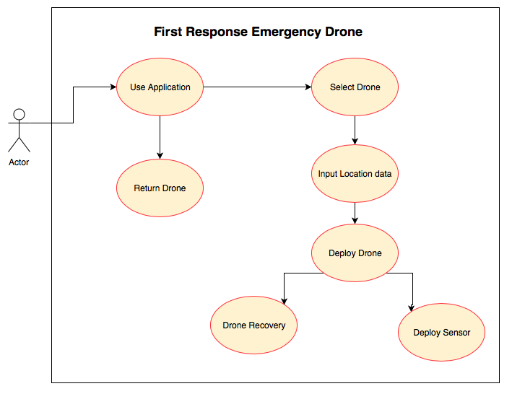

The use case diagram as shown above provides a brief overview of the functional requirements that my system will have. The response team will interact with the application by inputting a location, which will then convert the address into longitude and latitude coordinates to give a more accurate location. When the drone arrives at the location the response team can deploy the sensors and communicate their findings through the application. After the drone is no longer needed, the drone is then instructed to return to its base station through the app. Also, that if the drone’s battery is almost depleted, it will return the base station in ample time before it loses all power and crashes.

### Requirement 1: Use Application

#### Description & Priority

Use application is the highest priority requirement in this project. Without this requirement, the users will not be able to access the system to then further access other features. The user enters the admin credentials before being granted access to the application.

#### Use Case

Use Application.

**Scope**

The scope of this use case is to access the application.

**Description**

This use case describes the accessing of the system.

**Use Case Diagram**

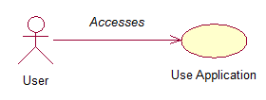

**Flow Description**

**Precondition**

The system is dormant, awaiting stimulus.

**Activation**

This use case starts when a user selects the application.

**Main flow**

1. The user selects the application.
2. The system resumes from its dormant state.
3. The system prompts the user to enter in details.
4. The user enters admin details (Admin name and Password).
5. Access is granted.
6. The use case ends.

**Exceptional flow**

E1 : Wrong Credentials

1. The user enters incorrect credentials.
2. The system denies access.
3. The use case continues at position 3 of the main flow.

**Termination**

The system has the logout / exit function available to the user, upon selection a confirmation prompt will come up before the system exit.

**Post condition**

The system goes into a wait state

### Requirement 2: Drone Select

#### Description & Priority

The drone select requirement describes the options the user has available to the for the drone selection. Each base station should have a choice of two or three drones minimum. This is a high priority requirement as without this requirement, no further requirements can be accessed.

#### Use Case

Drone Select

**Scope**

The scope of this use case is the selection of a drone.

**Description**

This use case describes what a user must do when selecting a drone.

**Use Case Diagram**

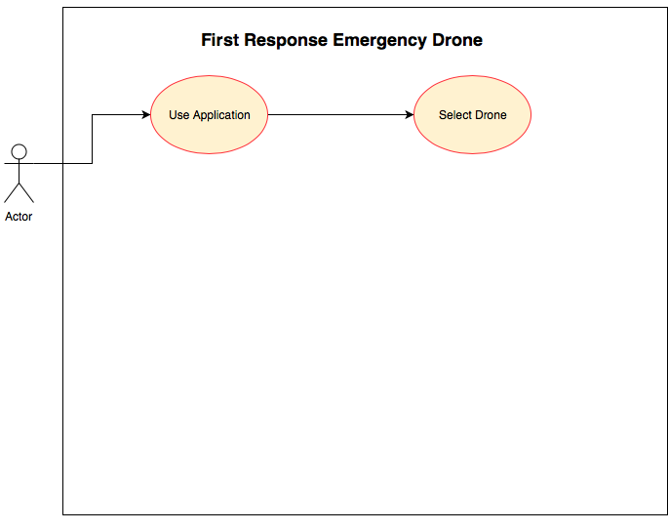

**Flow Description**

**Precondition**

The application displays the main activity, awaiting instruction.

**Activation**

This use case starts when a user selects ‘Drone Select’ from the main activity.

**Main flow**

1. The user selects ‘Drone Select’ from the main activity.
2. The system opens the drone select menu.
3. The user selects a drone from the available drones.
4. The system prompts the user for confirmation of drone selection.
5. The user confirms the drone selection.
6. The system activates the drone.
7. Use case ends.

**Alternate flow**

A1 : Alternate drone selection.

1. The user selects a drone.
2. The system returns that a drone is already in use.
3. The user selects an alternate drone.
4. The use case continues at position 9 of the main flow.

**Exceptional flow**

E1 : No drone available.

1. The user selects each drone.
2. The system returns, no drones available.
3. The use case continues at position 13 of the main flow.

**Termination**

The system presents the next activity after the drone is selected.

**Post condition**

The system awaits further instruction

### Requirement 3: Input Location Data

#### Description & Priority

The Input Location Data requirement involves the use of an API which converts an address to latitude and longitude coordinates. This requirement instructs the drone on where it must go.

#### Use Case

Input Location Data

**Scope**

The scope of this use case is the input of the location data to the system.

**Description**

This use case describes the input of the location data and what is done with the information.

**Use Case Diagram**

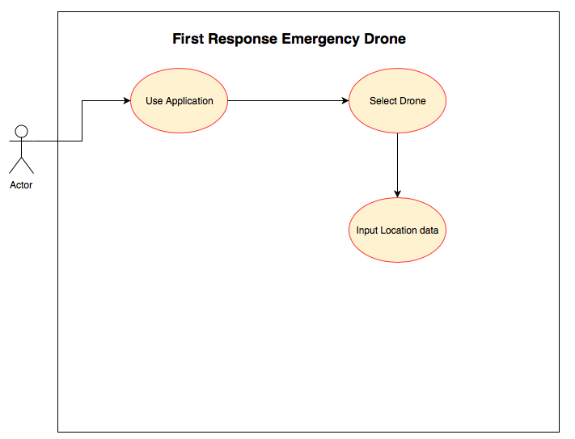

**Flow Description**

**Precondition**

The application displays the location input field, awaiting instruction.

**Activation**

This use case starts when a user selects input field for the location.

**Main flow**

1. The user enters an address for the drone to travel to.
2. The system searches for all instances of this address.
3. The system then changes the addresses found to longitude and latitude.
4. The user selects the correct location.
5. Use case ends.

**Alternate flow**

A1 : Alternate location input.

1. The user inputs longitude and latitude coordinates directly to the application.
2. The system recognises the location.
3. The use case continues at position 8 of the main flow.

**Exceptional flow**

E1 : No location available.

1. The user enters location.
2. The system returns, no location available.
3. The use case continues at position 14 of the main flow.

**Termination**

The system prepares to send the location to the drone.

**Post condition**

The system awaits further instruction

### Requirement 4: Deploy Drone

#### Description & Priority

The deploy drone requirement delineates the process of the drone becoming active and travelling to its desired accurate location.

#### Use Case

Deploy Drone

**Scope**

The scope of this use case is the deployment of the drone.

**Description**

This use case describes the process one must follow to successfully deploy the drone.

**Use Case Diagram**

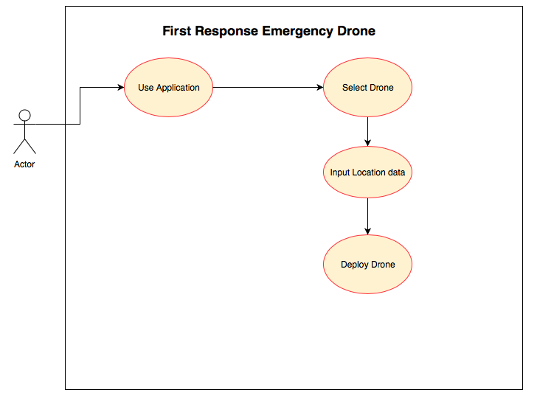

**Flow Description**

**Precondition**

The drone is active, awaiting instruction.

**Activation**

This use case starts when the drone is sent the coordinates.

**Main flow**

1. The system sends the coordinates to the drone.
2. The drone flies upwards to an appropriate height
3. The drone then follows the intended route.
4. The drone then arrives at the location.
5. Use case ends.

**Alternate flow**

A1 : The drone reaches an obstacle.

1. The system then realises it must make its way around the obstacle
2. The drone traverses the obstacle.
3. The use case continues at position 21 of the main flow.

**Exceptional flow**

E1 : The drone does not activate.

1. The system sends the information to the drone.
2. The drone fails to activate.
3. The use case continues at position 23 of the main flow.

**Termination**

The system presents the next activity after the drone arrives at the location.

**Post condition**

The system awaits further instruction

### Requirement 5: Deploy Sensor

#### Description & Priority

The deploy sensor requirement describes the process of the user choosing the sensors and receiving data from that the sensors retrieve and send to the application.

#### Use Case

Deploy Sensor

**Scope**

The scope of this use case is the deployment of the sensors.

**Description**

This use case describes the process one must follow to successfully deploy the sensors and the retrieval of the data.

**Use Case Diagram**

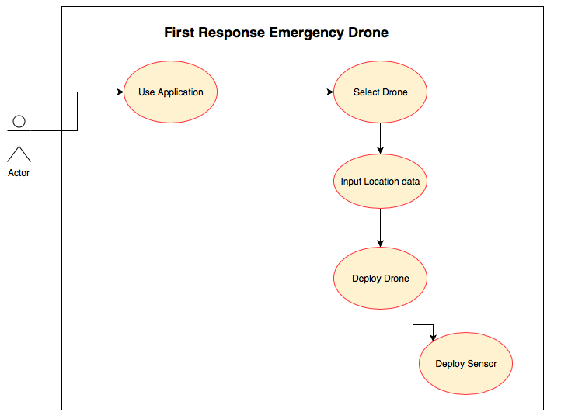

**Flow Description**

**Precondition**

The application displays the sensors activity, the drone is awaiting instruction.

**Activation**

This use case starts when a user selects the sensors to become active.

**Main flow**

1. The user selects the sensors to become active.
2. The system activates the sensors.
3. The system retrieves the data from the situation through the use of the sensors.
4. The system sends the data via dweet.io, or through the use of the raspberry pi sensors sending the data, live.
5. Use case ends.

**Exceptional flow**

E1 : The sensors fail.

1. The system alerts that the sensors fail to function.
2. The user re-selects the sensor activation.
3. The use case continues at position 25 of the main flow.

**Termination**

The system sends all data to the application and sensors are disabled.

**Post condition**

The system awaits further instruction.

### Requirement 6: Drone Recovery

#### Description & Priority

The drone recovery requirement is used to prevent the loss or manual recovery of the drone.

#### Use Case

Drone Recovery

**Scope**

The scope of this use case is the recovery of the drone.

**Description**

This use case describes the case is which the drone makes the decision to return to its base station.

**Use Case Diagram**

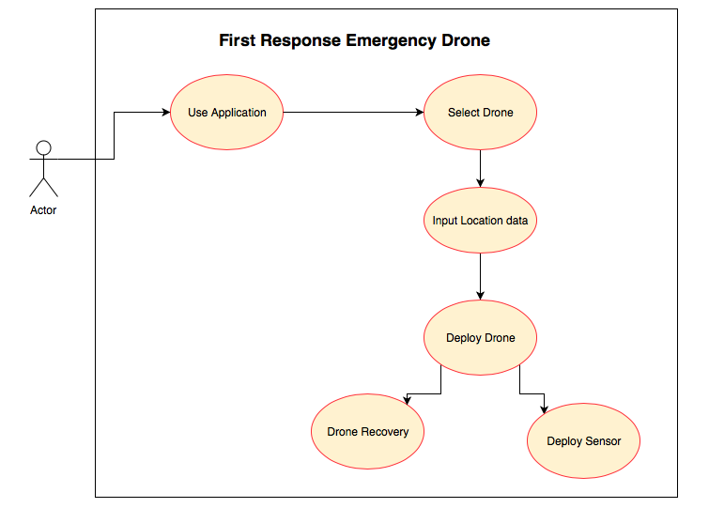

**Flow Description**

**Precondition**

The drone is conducting its intended functionalities.

**Activation**

This use case starts when the system detects a system error or reaches a battery level threshold.

**Main flow**

1. The system detects that the battery has breached a certain threshold.
2. The system instructs the drone to return to its base station for the drones battery to recharge.
3. Use case ends.

**Alternate flow**

A1 : System error detection.

1. The system detects a system error.
2. The system alerts that there is an error and returns the drone to the base station.
3. The use case continues at position 31 of the main flow.

**Exceptional flow**

E1 : Drone is no longer able to fly.

1. The system detects an error or the battery has depleted.
2. The drone lands / crashes.
3. The user / recovery team retrieves the drone.
4. The use case continues at position 31 of the main flow.

**Termination**

The drone has returned to the base station.

**Post condition**

The system is dormant.

### Requirement 7: Return Drone

#### Description & Priority

The return drone requirement describes how the user requests the drone to return to the base station through the use of the application.

#### Use Case

Return Drone

**Scope**

The scope of this use case is the returning of the drone.

**Description**

This use case describes the process one must follow to return the drone to the base location.

**Use Case Diagram**

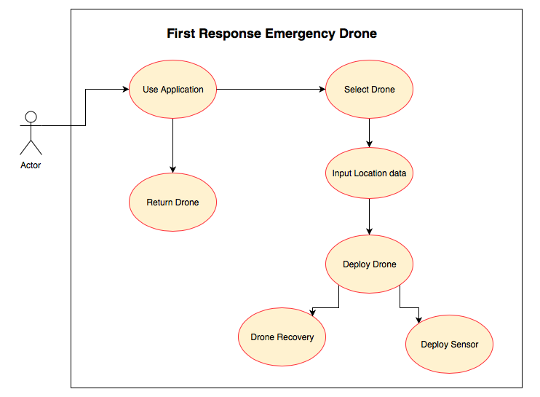

**Flow Description**

**Precondition**

The drone’s sensors have just been deactivated after the response team has arrived.

**Activation**

This use case is activated when the drone is no longer needed, and the user selects the termination options.

**Main flow**

1. The user selects the option to return the drone from its journey.
2. The system prompts the user with a confirmation option.
3. The user confirms the returning of the drone.
4. The system allows the drone to make its way back to the base station.
5. Use case ends.

**Exceptional flow**

E1 : The exceptional flow is as seen above in Drone Recovery.

**Termination**

The drone has returned to the base station.

**Post condition**

The system is dormant.

## Non-Functional Requirements

### Performance/Response time requirement

The First Response Emergency Drone when activated shouldn’t have any delay when activated. When the drone is selected on the application, the drone becomes active. When the drone receives the longitude and latitude coordinates the drone should take flight and make its way to the given location almost instantly. The only factor that might cause delay in the response time is network delay. The performance of the drone can potentially be hindered by the weather conditions.

### Availability requirement

Hypothetically, the availability of the drones should be at all times, this is for the reason that the emergency services can be called at any time and in these situations the drone would have to be on hand. To improve the availability of the drones, the number of drones on sight would have to be increased and paired with the system.

### Recover requirement

When the drone has been deployed by the response team and either the hardware or software fails due to a loss of connectivity or hardware issues / damage, depending on what part of the software that fails, the drone will fail and ultimately stop functioning. In the event that there is still power going to the drone, I hope to have the system reboot and resume its intended flight path, if this is not the case, the drone would hypothetically have a tag that would allow it to be found and retrieved.

### Security requirement

The only way this system can be accessed is through the use of admin credentials.

### Reliability requirement

Ideally with no interference there should be no downtime on this system, the only time a drone would not be able to function is when the battery is to be recharged, however when using this system there would be more than one drone and any one location available for use.

### Maintainability requirement

The drones would take minimal maintainability. With regards to the system, the application’s UI could possibly be updated from time to time also the parts on the drone must be kept up to scratch to prevent any breakdowns.

### Extensibility requirement

The code that will be written for the project will have the potential to be extended to add on extra sensors or to be repurposed for other uses.

## Design and Architecture

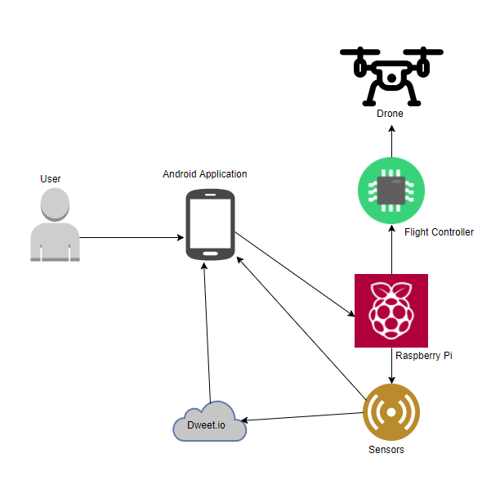

As seen in the diagram above, the system follows a certain order which is the following. The user interacts with the application, which instructs the raspberry pi to activate the flight controller which in turn activates the drone and its motors. The application also instructs the raspberry pi to activate the sensors which will either send data directly to the application or dweet the findings to dweet.io, which is then pulled down, onto the application.

## Implementation

Implementing the code for this system was comprised of many different sources. The integral part of this project was creating a platform that could live stream.

‘raspivid -o - -t 0 -hf -w 1920 -h 1080 |cvlc -vvv stream:///dev/stdin --sout ‘#standard{access=http, mux=ts, dst=:8160}’ :demux=h264’

The above snippet of code is a command that is executed on the raspberry pi in the terminal. This begins the streaming from the raspberry pi camera over the network and sets the resolution to 1920x1080 and sets the port to :8160.

The network in easily accessed through VLC media player as all one has to do is enter the network link (<http://192.168.43.62:8160>). However, I created a mobile application that has the link hard coded into the code, so that when the phone detects that the stream is running, over the network the stream can be displayed on the mobile application by using a combination of a media player and a surface view to display the stream. Without a surface view the media player cannot show the video stream. The combination of the media player and the surface view is similar to the video view, however I found it more effective to use the media player as I tried and failed in an attempt to show the stream in the video view.

I also attempted to implement a programmatic screenshot function, the screenshot was able to be taken, however, when attempted to be loaded into an image view, it would not load for an unknown reason, upon further development and research, I am sure this problem can be rectified. The code is already prepared and is present within the application.

## Graphical User Interface (GUI) Layout

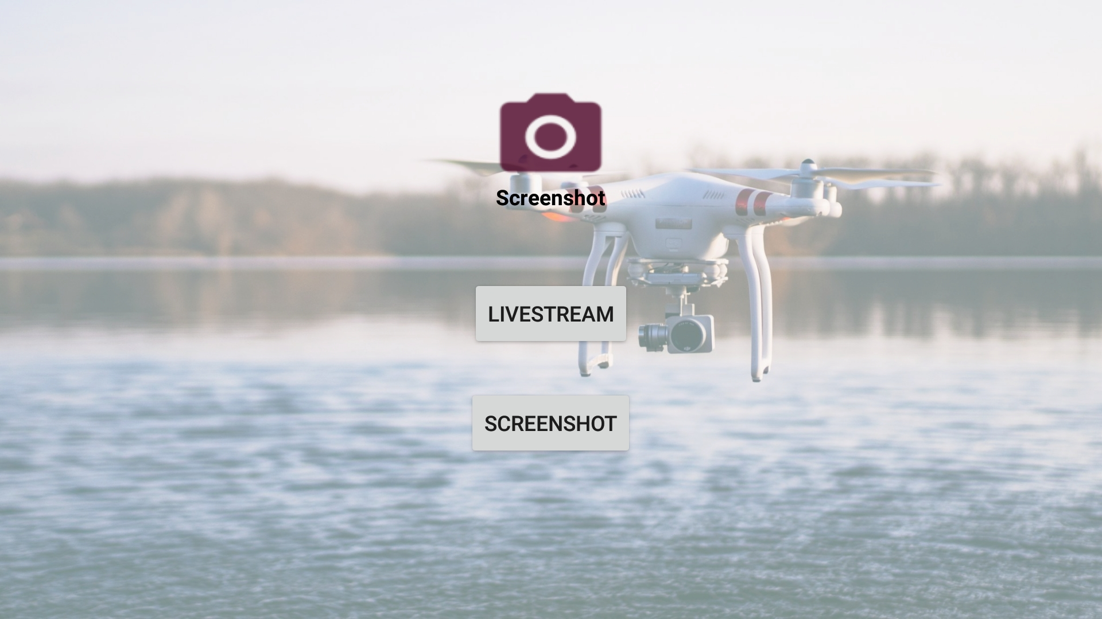

Above shows the home screen for the drone live streaming application. The Livestream button will create the connection to the already running live stream over the network link (http://912.168.43.62:8160). Once the connection is made, the image below which was screenshotted via the android phone is shown, as you can see the camera is quite pixelated however as movement stops the picture becomes clearer.

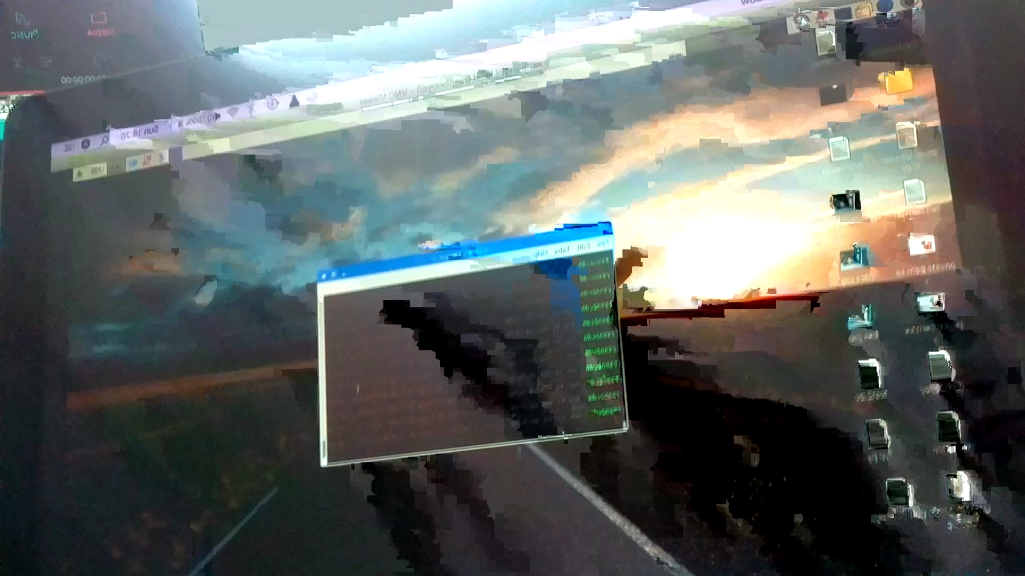

The camera icon is there to take a screenshot of the layout and everything it encompases, it is converted into a bitmap and is written to a canvas and saved in the phone memory. I had intended to display screenshots from the live stream into an imageview that users could see when they access the display activity through the screenshot page button. Unfortunately I was unable to re-access the image taken and then to view the imageview which would have been a nice feature to have to accompany the live stream.

In the second image, one can see the raspberry pi desktop. To allow the stream to begin there is only one command and one interface the user has to deal with and that is the terminal. As explained in the Implementation section, the aforementioned command is entered to determine the resolution and port that has to be accessed to view such a stream.

## Testing

To test this system first I had to decide what factors I had to consider needed to be tested. When creating the system, I had to test parts of the code that were integral to the core purpose of the project. Creating the connection to the stream and displaying the stream live on the mobile application took many different attempts and a lot of research. Once that had successfully been created the stream was tested for latency, clarity and fitting the image to the view. I was explain the testing in order.

The standard in which I have chosen to compare this to is YouTube live streaming. According to the following link the streaming latency for ultra low streaming latency for youtube is now just a couple seconds prior to this setting this being approximately 10 seconds, it’s now approximately half of the estimated time. (<https://youtube-creators.googleblog.com/2017/09/youtube-live-faster-easier-and-more.html>)

The latency between the live scene and the stream on my mobile application is approximately 3-4 seconds. The connection is over a http network and IP (<http://192.168.43.62:8160>) and accessed through the port 8160.

The image clarity is based on the quality of the camera. The camera I was using was a raspberry pi camera. The resolution I am using is 1920x1080 and this looks quite well on the mobile application. The only issue is that when the camera moves parts become pixelated before settling.

The stream image is fit to the surface view and is best viewed in a landscape position, however when in a portrait position the image becomes distorted so to combat this, I have set in the manifest that the screen orientation for the application should be landscape.

## Customer testing - Customer Interview

Customer testing was not applicable to this project. The aim of this project was to aid the emergency services, in place of customer testing, I conducted an interview with a drone pilot from the Dublin Fire Brigade (DFB) and Ambulance.

The interview took place in Tara Street Fire Station, the Headquarters of the Dublin Fire Brigade. The interview took place over approximately one hour and consisted of predetermined questions I had planned to ask, also I was shown images and clips from the footage that was taken by the drone that the DFB use.

Between what I wanted to create and what the DFB use, there are some similarities and many differences. For example, the systems that the DFB have available to them are much more advanced and varied in comparison to what I was able to use. However the principle of live streaming from the drone to a device is the core similarity.

To begin the interview I asked the drone pilot about his history in the DFB and what his position entails.

This particular gentleman is a firefighter / paramedic and has been working with the Dublin fire brigade for the past thirteen years. His job also includes being a drone pilot and working as a part of the social media / communications section. He then explained that there is a huge crossover between the drone work and his communications work. If the drone takes an image or picture of a fire that is in the public's interest, it is uploaded to social media and reassures the public that they are at the scene and working on combating the fire and to give clarity about what the situation actually entails. Then proceeded to explain through the use of an example of a situation where the public had began to speculate that there was a plane crash while the fire was caused naturally.

I then asked if the drone used was manually controlled or if the drone was autonomous.

The drone they used is manually controlled. The DFB have drone pilots who are licenced with the Irish Aviation Authority (IAA) and have a certificate of competency to say that they are allowed to fly their drones. They also have Specific Operating Permission (SOP) with the IAA to confirm that they to not perform autonomous flights, a person is always manning the drone and that the drone is always in their Visual Line Of Sight (VLOS).

On a site, for example if there is a forest fire near a residential area or pylons belonging to an electrical company, the firefighters must try assess the situation, however from the ground level view, they shall be looking at a wall of smoke, buildings and wires. They are at quite a disadvantage and need to assess the situation quickly to minimize damage. The use of a drone on site is to give the captain on the ground another point of view. A way to get a clearer look at the fire, what dangers are about and what can be done to quickly combat this situation.

This was but one example of the uses of drones to aid emergency services which is touched on later in the interview.

At this point I was shown images and clips from the professionally made drones and cameras that they were using. The drone is controlled and transmits to and IPad which the pilot uses to determine altitude and where drone goes to.

How the firefighters determine when to send for the drone assistance is usually on request from the captain in order to better assess the situation. The captain contacts the control room requesting the aerial unit and one of the seven available drone pilots will head to the scene. When the pilot has arrived at the scene they will set up beside the captain and give them an birdseye view of the location. Without the assistance of the aerial unit, the captain must attempt to create a mental picture of the fire and the area, in what way the fire is traveling and what dangers there are to peoples lives or properties.

In Dublin in accordance with the IAA airspace laws, anyone can fly a drone under certain rules similar to the following. Anyone can fly a drone under 50 feet, a drone must not be flown over a building that does not belong to you or near large groups of people (twelve or more people). The DFB pilots have an agreement with air traffic control that if they must fly over 50 feet they will inform them and they will either grant them permission or not.

The information provided to air traffic control by the DFB pilot is where he will be flying, why he is there, how long he plans on flying and how high he plans to go. Once the flight is completed air traffic control is notified and the aerial unit returns to HQ. Very rarely will a flight go over 200 feet. The extra altitude is such an advantage to the firefighters as it offers so much information, they captain gets a visual overview and everything is in frame. The firefighters use reference points such as roads or landmarks to determine where they are in reference to the fire.

Sometimes in the event that there’s a police helicopter at the scene and an aerial unit is requested, air traffic control must be contacted to ask the police helicopter to leave the scene so that the drone may enter the airspace. Manned aviation always has priority over unmanned, air traffic control will also inform any manned aviation vehicles that there are drones operating in a certain location.

In the event of a training flight the DFB send an application to air traffic control to go over the 50 foot limit a couple days in advance to allow them to train new pilots or if there’s an emergency flight, one must call air traffic control to inform them.

To conclude the interview I asked if there was any features or additions that ideally he would like added to the system they use and the use of the drones on site. I offered my ideas in situations and asked for feedback on the usefulness of the idea to see of the further development or research of my project would be useful or viable.

The addition of features that the pilot suggested were as follows followed by personal notes on each;

* Coldproof Batteries - Drone batteries take a couple minutes to warm up (above 15℃), as the batteries need to be over a certain temperature to work appropriately.
* Weatherproof Drones - In Ireland the weather is quite volatile, often windy or raining, a drone capable of functioning properly in these conditions without being compromised.
* Advanced Thermal Camera - The DFB has access to a thermal camera, however, for situations involving smaller more accurate details to get a clearer image, this feature would be greatly beneficial.
* Goggles for Drone Camera - This feature is similar to a VR (Virtual Reality) headset, that when you look around, the camera will follow one’s head movements, the captain could look around at the situation below getting a clear image of the situation below.
* Daylight Capable Screen - Screens that are optimised to be used in daylight of an appropriate size for captains and pilots to view the transmission with ease.
* Lamination Printer - To instantly send an image to be printed at the control room or on site to show a still image of the location and fires.

I enquired about in the event of a burning building or a situation where there was the possibility of civilian casualties, was there the potential when using a thermal camera to differentiate between the fires and human body temperature readings. I was pleased to find out that there is the functionality to see between certain temperatures, aiming between 30℃ and 50℃ at approximately bodily temperature. The DFB currently do not have access to this technology as of yet.

Another potential idea I thought could benefit the emergency services or the guards would be to operate smaller drones, the current drones used are approximately one square foot. The use of smaller more compact drones would potentially allow the drone to be sent into a building in any given situation. Discussions have been held and the fact that there is a lot of heavy concrete and metals that may cause interference to the drone and transmission. They are yet to properly explore this option but they believe it is a hugely helpful and promising idea that may be explored further.

To further that idea, I talked about a speaker being on the drones, to reassure any victims inside a burning building for example, announcing that the fire department are at the scene and will be taking immediate action. The pilot really appreciated this idea and instantly had an example in which it would have been extremely useful. In the Grenfell tower fire, at 00.54 AM when the fire began and the fire department arrived at the scene, they advised the people to stay inside and that they were coming to get them. However at 02:40 AM, they had to change their call to say to get out of the building if possible. Would a drone with a powerful speaker attached or build in have made a difference? Would the victims have been able to hear the calls from the authorities better? They would not know for sure, however a feature like that could potentially be very useful and possibly save lives.

This concluded the interview as I felt I fully understood how the use of drones in the emergency services are currently being used and how they can be improved going forward and in what way my project can evolve in the future with further development and research.

## Evaluation

The system was evaluated based on completeness in comparison to the description of the project. The aim of the project was aimed around building an autonomous drone, however, as the project progressed, the scope of the project changed dramatically based on what I had available to me. The idea of building a drone became less of a reality the further the project progressed. Without enough money to purchase parts immediately, viable electronics experience and a limited amount of time in order to create such a system from the ground up with no assistance. Regardless, the self built drone was not paramount, as this could easily be substituted for a manual drone, which I have come to understand is more preferred by the emergency services. Having full control of where the drone looks and better control in the eyes of the IAA.

The system I have created clearly displays live video over a network to a mobile application I have created. This is the main part of the project, I am happy to have completed this part however I have tried and failed to create a programmatic displaying of a screenshot of the live stream. If I was to have used a drone I created, the entire system would need to be powered by two raspberry pi’s. The processing power it would need to run the live stream and power the drone would be too much. I may not have been able to run the drone system however it would have been ergonomically viable as two pi’s would have been needed and I was unable to build the drone in question.

I am happy that the project completes its main function however to make up for the lack of extra features I spent my time contacting the DFB to gain worthwhile insight into what their systems would need in the future. I feel as this project is a proof of concept, I believe that the research and information is as valuable as the completed physical work.

Below is an image of what hardware was used, not including laptops and mobile phones. This consists of a raspberry pi 3, a raspberry pi camera, a DJI Phantom DJ6 drone and controller and 2200mAh LiPo batteries to power the drone.

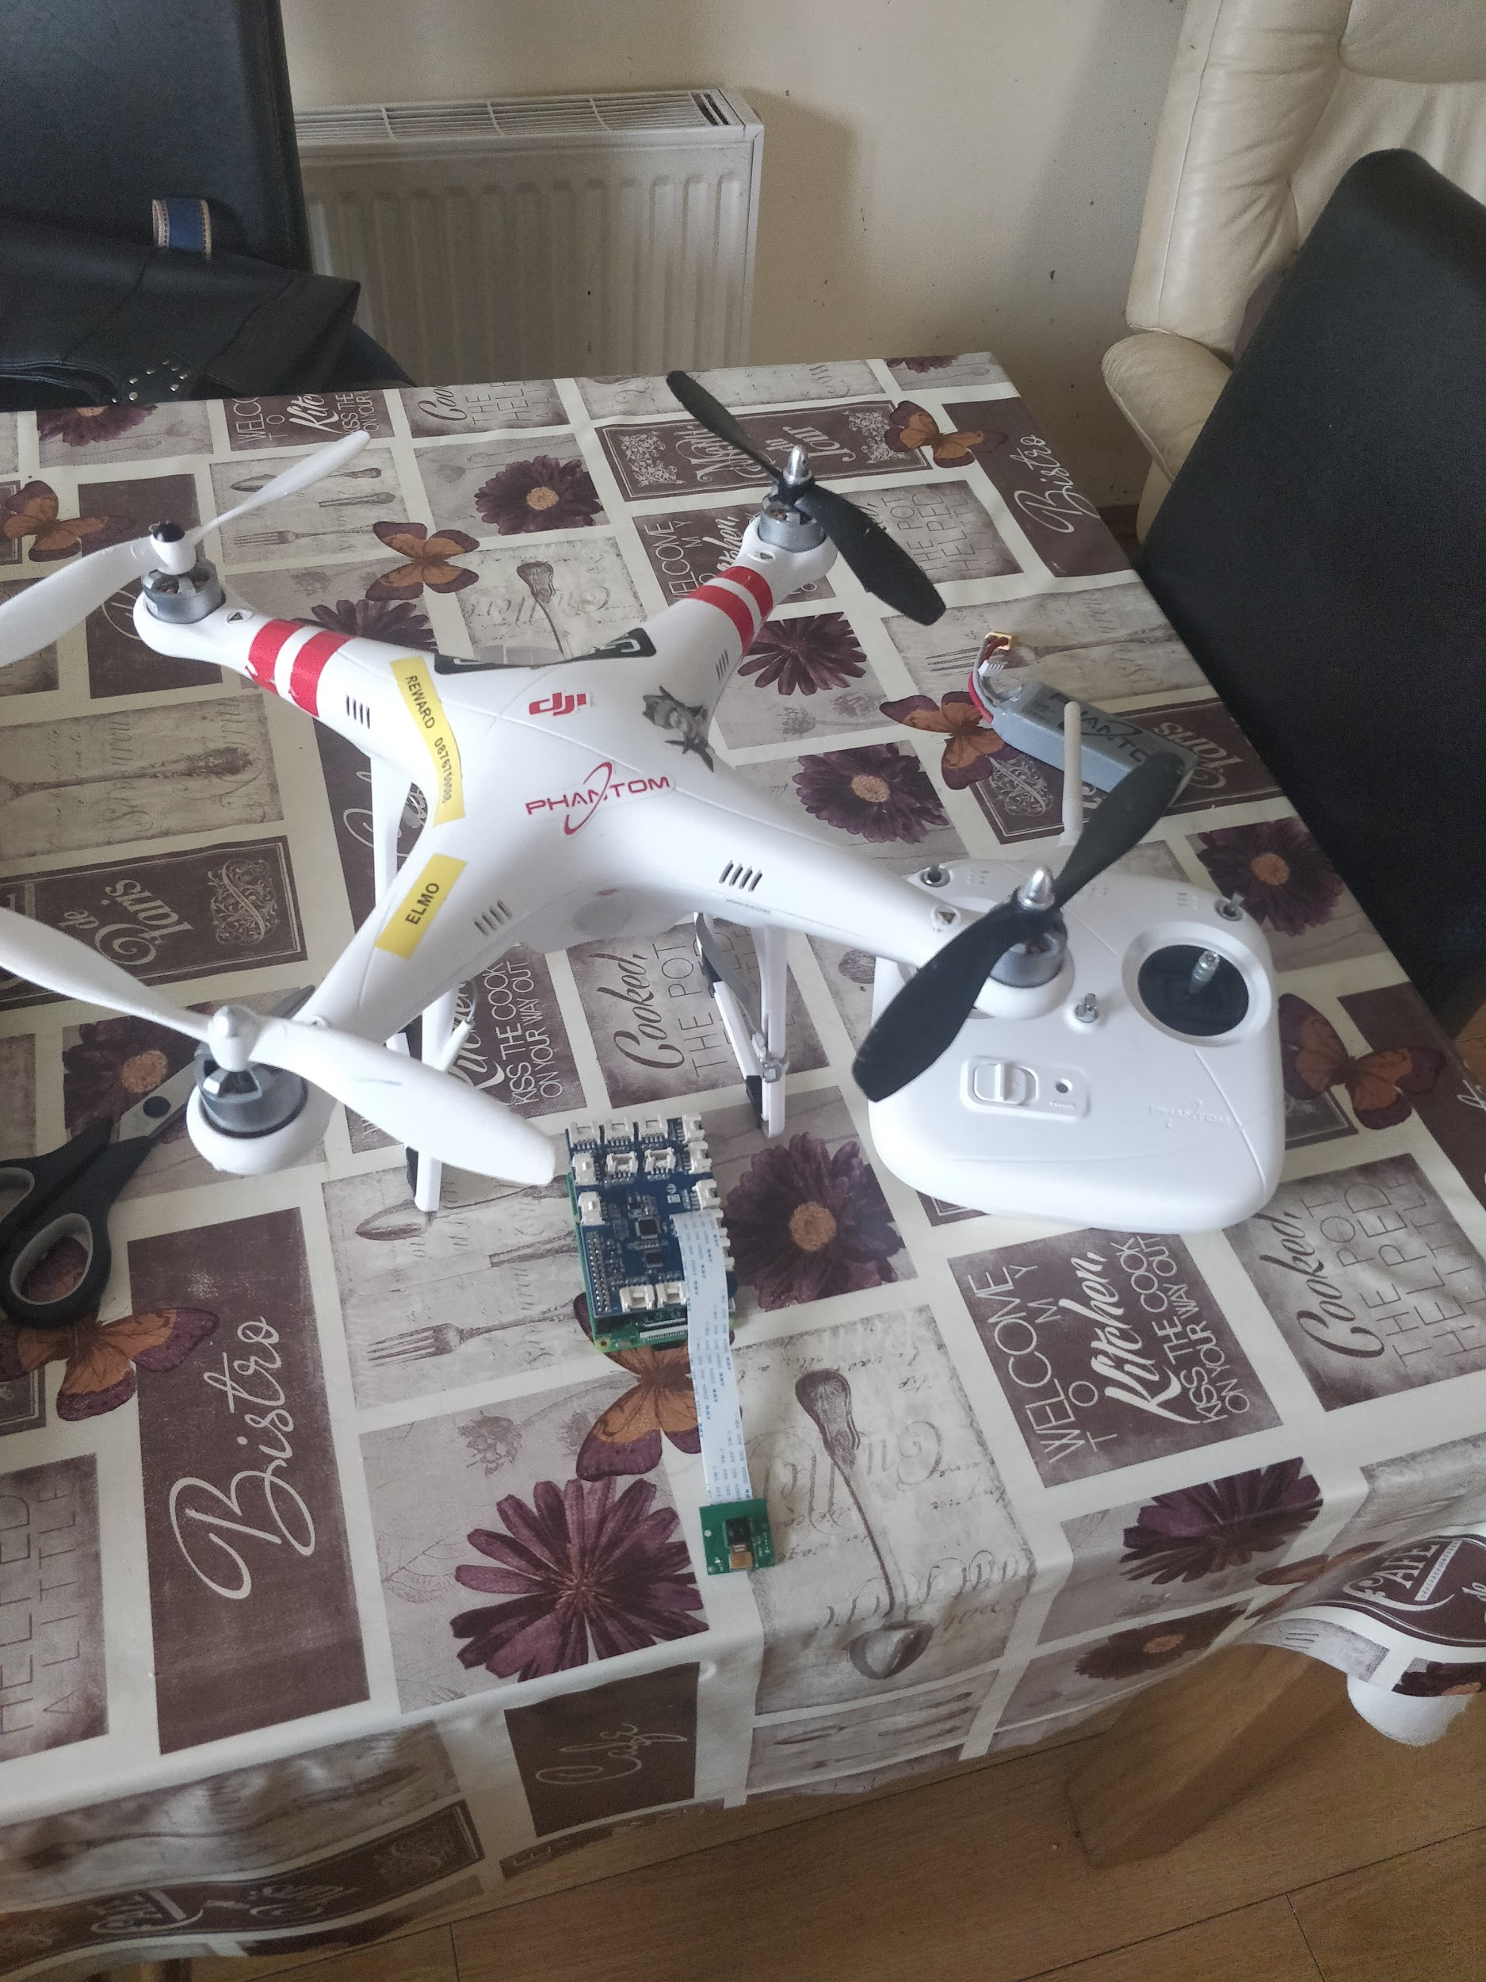

# Conclusions

The advantages of this project are that it is simple to execute and is open to the addition of new features in the future. The project was not over complicated to the point where new features could not be added, this give the project a clean platform to build upon. The stream quality on the mobile device is good, showing what needs to be seen clearly however can be pixelated before setting in some cases. The disadvantages of the project are that it finished outside of the original scope. The scope of any project evolves and changes as project progresses, mine is no different. A limitation of this particular project is the range at which it can currently go, as I am working with a raspberry pi, the internet connection used is of a mobile network. However if using more high end hardware such as what the DFB use, streaming would be done using light bridge which has a much larger distance and can consistently retain a high quality transmission.

# Further development or research

In the future with more time, development, research, funding and creativity, the possibilities are endless. The emerging technology would allow countless avenues of further development. From the interview I conducted I gathered some ideas along with some ideas of my own such as creating small drones to enter buildings, the same system, only smaller, getting to places larger drones cannot safely get to. Advanced Thermal Imaging drones, being able to remotely set what temperatures you want to be able to see in the event of a situation where a person is being looked for or is in danger. Weather proofing the drone, allowing it to operate within the ever volatile irish weather. Drones with powerful speakers attached to quickly and more effectively reach in danger civilians.

# References

Android, S. (2018). *Saving and Reading Bitmaps/Images from Internal memory in Android*. [online] Stack Overflow. Available at: https://stackoverflow.com/questions/17674634/saving-and-reading-bitmaps-images-from-internal-memory-in-android [Accessed 19 Aug. 2018].

battlefield, H. (2018). *Here's how commercial drones grew out of the battlefield*. [online] Business Insider. Available at: http://uk.businessinsider.com/a-history-of-commercial-drones-2016-12?r=US&IR=T [Accessed 19 Aug. 2018].

Dublincity.ie. (2018). *Dublin Fire Rescue and Emergency Ambulance Service | Dublin City Council*. [online] Available at: http://www.dublincity.ie/main-menu-services/dublin-fire-brigade-and-ambulance-service [Accessed 19 Aug. 2018].

horizontal?, H. (2018). *How to make a SurfaceView always horizontal?*. [online] Stack Overflow. Available at: https://stackoverflow.com/questions/2750814/how-to-make-a-surfaceview-always-horizontal [Accessed 19 Aug. 2018].

screenshot?, H. (2018). *How to programmatically take a screenshot?*. [online] Stack Overflow. Available at: https://stackoverflow.com/questions/2661536/how-to-programmatically-take-a-screenshot [Accessed 19 Aug. 2018].

YouTube Creator Blog. (2018). *YouTube Live: faster, easier and more accessible*. [online] Available at: https://youtube-creators.googleblog.com/2017/09/youtube-live-faster-easier-and-more.html [Accessed 19 Aug. 2018].

YouTube. (2018). *Android Capture ScreenShot and Save In SD Card [Programmatically]*. [online] Available at: https://www.youtube.com/watch?v=nJ5Wu4XyzbY&t=420s [Accessed 19 Aug. 2018].

YouTube. (2018). *Android Studio Tutorial - Streaming Video*. [online] Available at: https://www.youtube.com/watch?v=oEgpGv2CF1U [Accessed 19 Aug. 2018].

YouTube. (2018). *Raspberry Pi camera module streaming video to another computer*. [online] Available at: https://www.youtube.com/watch?v=JjPsW-7FUng [Accessed 19 Aug. 2018].

# Appendix

## Project Proposal

Project Proposal

**First Response Emergency Drone**

Darren Quinn, x14357556, darren.quinn@ncirl.ie

BSc (Hons) in Computing

Internet of Things

27/10/17

# Objectives

The objective my final year project is to create an autonomous first response drone to quickly react to and assess an emergency situation. Below I will explain the concept of this project and the objectives I wish to achieve at the end of the year, to present an outstanding and possibly life saving idea.

* A fully autonomous drone, capable of identifying and traversing obstacles or structures.
* An application to send such information to and receive from the drone.
* Implementing sensors to enable the drone to assess the information and return findings.

The term autonomous generally means, ‘self-governing’. In terms of this project, when an incident is reported at an address, the drone is to make its way to the given address as quick as possible, however the drone must be able to identify obstacles and understand how to traverse these obstacles.

The first response aspect of this project is to aid the Irish emergency services. Including, but not limited to, the fire brigade, coast guard and the ambulance. In my opinion I feel that this concept could help inform the emergency services of the situation at hand. Through this added information that the first response emergency drone can provide, the life of a citizen could be saved, or risk of illness, injury or death could be greatly reduced, due to the reduced time it will take on time for the team to decide on an appropriate course of action.

With the fact that drones will be used, there is only so much communication that can be made between the response team and the drone. One might wonder, would the drones be redundant? However, equipped with the correct hardware the drones will be able to provide essential information to the team. For example, a camera, to photograph the scene (car crash, injury. etc) giving more precise details of the situation, sensors to aid the drone to be autonomous, potentially a live feed camera.

The drone will be controlled by a mobile application that will connect to a raspberry pi (zero) through WIFI. The application will allow the transfer of the data that is obtained by the drone, showing captured images, accident information and other pieces of information. The address is passed to the raspberry pi that directs the drone by converting the address into accurate latitude and longitude coordinates.

I intend to have a semi functioning, built prototype by Christmas to present to a panel of lecturers. This prototype will show the built quadcopter with the attached raspberry pi zero allowing it to move to directed position, along with a prototype application.

# Background

Drones or Unmanned Aerial Vehicles (UAVs), have become widely used in modern society. The market surrounding drones has exploded in recent years. Originally, drones or UAVs were used for military purposes, however, the commercialisation of drones came about around 2012 - 2013. This began a huge new area of opportunity for people and businesses.

For example, Amazon have been considering using drones as a method of delivering their packages to the buyers. This would be an “Amazon Prime” feature called “Amazon Prime Air”. The purpose of this concept is to deliver packages that are under five pounds to its destination in less than thirty minutes. The fact that businesses can utilize this technology to enhance their services is a huge benefit to anyone who avails of it.

On a day to day basis, people have become accustomed to seeing these drones used in people's everyday life. The basic concept of what a drone can do can be repurposed to have infinitely different purposes and benefits to society. For example, Traffic detection, emergency services aid, package delivery, filming etc..

Drones were initially used for military reasons. For example, the US military used drones for surveillance as they can fly for long periods of time at controlled speeds and heights. Drone have also been armed to be remotely used against their adversaries.

The Irish Emergency Services consists of An Garda Síochána, the ambulance, fire services and the Irish Coast Guard. These services are also known as the “blue light” services. There are two well-known numbers used to contact these services in the event of an emergency; 112 and 999. 112 is the emergency service number that will work anywhere in Europe.

Where did the concept of the ambulance come from?

The concept of an ambulance dates back to almost 900 AD where the Anglo-Saxons created a cart which contained a hammock to transport injured or sick people. The Normans would carry the individual suspended between two horses. That further evolved to using horse drawn wagons or carriages which were used until the invention of cars came about in the 20th century.

# Technical Approach

After coming to the final conclusion of what my project would be and what its purpose would be, I began to plan each part of the project and how I would approach the work required over the coming year. Through the use of a gantt chart and WBS (Work Breakdown Structure), I will be able to visually represent what should be completed at certain points throughout the year. This will aid me in keeping to the schedule and creating a functioning project in the required amount of time.

**Plan**

Firstly, I will have to research what technologies I will need to use to enable my project to work. I will be using a raspberry pi (zero), which will communicate with a drone, which will allow the drone to navigate itself to the location in question. I will be creating an android application to send this information to the pi to tell the drone that it has to move and communicate its findings. Like most projects, I will construct a SWOT analysis as this will allow me to identify the Strengths, Weaknesses, Opportunities and Threats that this project may face. Through the use of online sources and resources I have available to me in the college, I believe I will successfully find all the information I need to find.

**Design**

Design plays a large part in the success of my project. The drone will have to be an appropriate size and be powerful enough to carry the pi and the sensors attached. I will need to sketch a couple designs and possibly create my own pieces to allow the drone to be as efficient as possible. If the attached hardware is too heavy, the drone will be slow and ineffective. The designs will be tried and tested to see if they have contrasting effects on the drone’s performance. A number of factors will have to be considered such as weather, weight, obstacles and size.

Also I will be creating an application with a relatively simple interface as its purpose is to send the drone to the correct location and to receive the information being relayed by the drone/pi. After the prototypes have been created, the designs may have to be refined and re-done based on the feedback from my supervisor and the judges in the mid-point presentation. Once the designs have been completed, the project will be in a good position to forward with.

**Build**

Building the project will require research into to connecting the pi, sensors and drone. This will require the use of some special resources such as a soldering iron and possibly a 3D printer. The application will be build using Android Studio, I will have to save the application in various stages of the application’s development in the event that I need to go back to a previous version.

**Test**

This project will be tested in many different stages of its development. After each iteration, the code and hardware will be tested and checked for errors or bugs, which will result in changes to fix the code to allow the project to function and fulfil its potential. I will also have my code tested by external users such as lecturers and my supervisor.

**Review**

Upon reviewing my application, its functionality and design, at this point, I will discuss any changes that may be required of me for the project with my supervisor and possibly external testers. With the remaining time after I’ve finished creating my project, I will extensively test my project to ensure that in can potentially pass most tests that it must endure.

**Launch**

When it comes to the final presentation of the project, I would expect my project to be fully functioning. As the project progresses the scope and requirements may change or evolve however the purpose of the project will remain the same to fulfil the intended outcome.

# Special resources required

This project will contain a combination of both hardware and software, both of which I am new to. To create the mobile application, I will be using Android Studio, this is a program that I am not overly familiar with, however, I use the program in another module and intend on comprehensively understanding the way the application is used.

I will have to research tutorials to be able to create the code for the making of the project, to allow the app and pi to communicate.

Most of the other resources I will need to successfully create this project are based around hardware such as the following.

* A drone frame / motors to construct the main component of the project.
* Raspberry Pi (zero) to connect the application and the drone.
* Laptop to use Android Studio on.
* Soldering Iron to attach parts to the drone.
* 3D printer to construct parts for the drone.

# 6.1.1 Project Plan

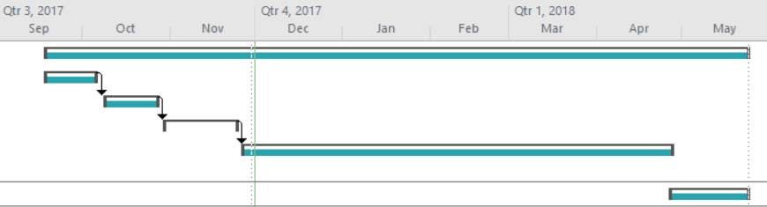

Above is a Gantt chart, displaying the main objectives over the course of this project.

**Work Breakdown Structure**

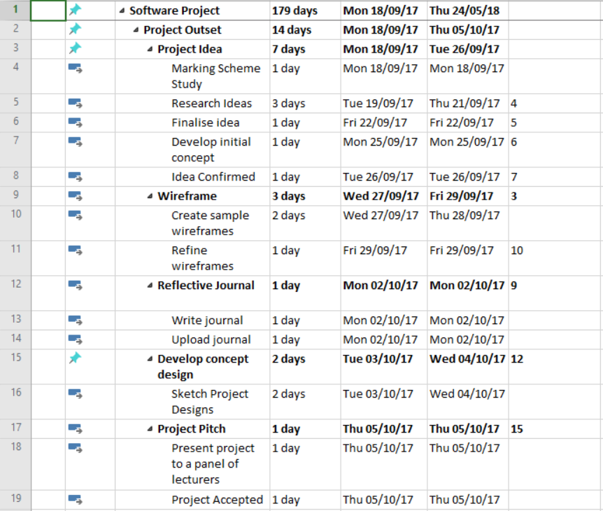

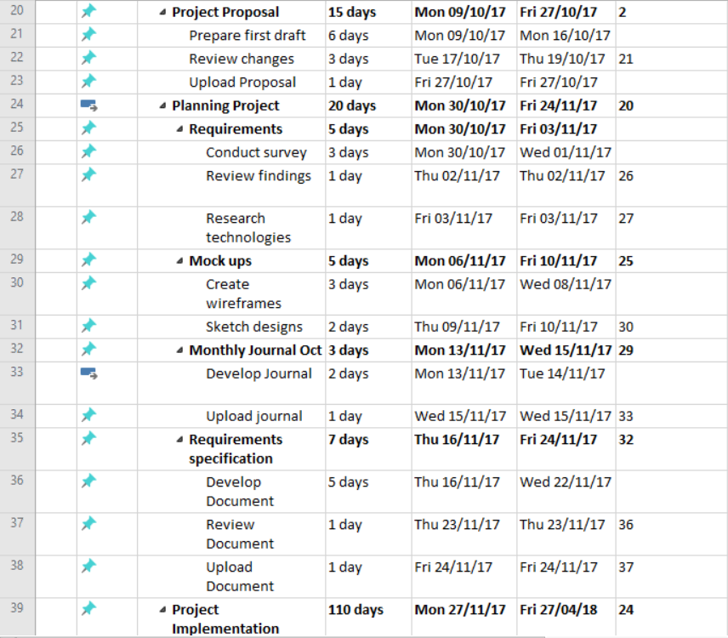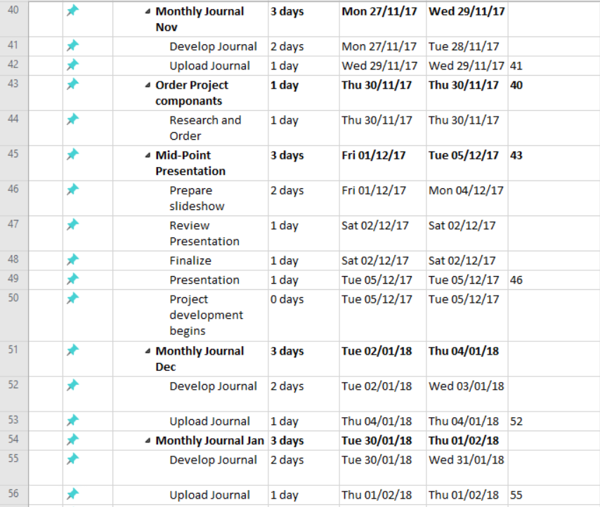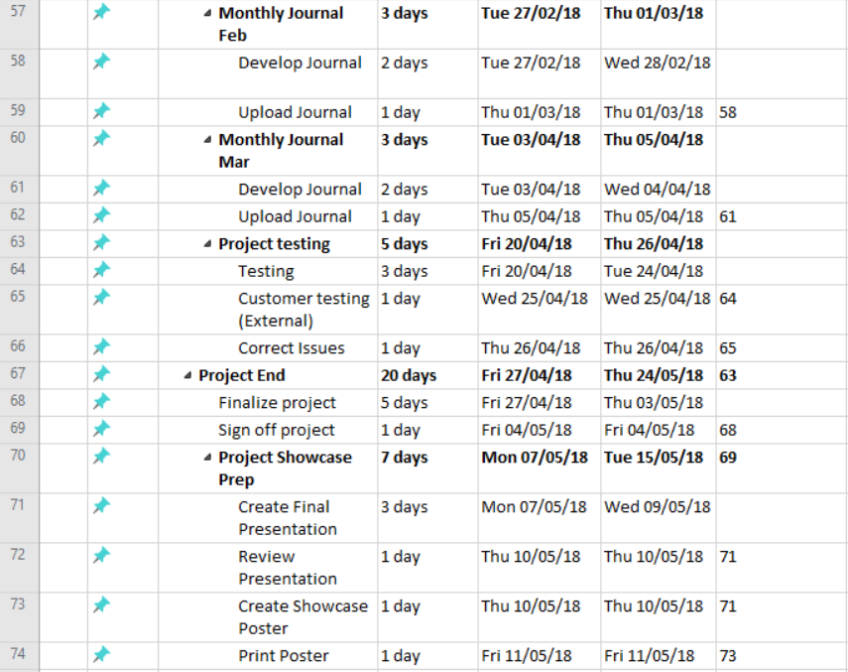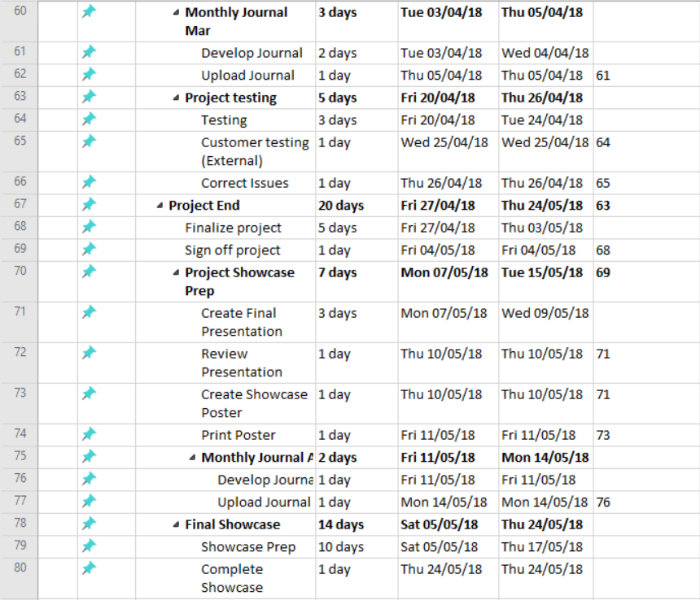

# Technical Details

To assemble my drone and join the other components I will have to research tutorials to become familiar with the hardware and other parts I may need to use. I will also have to learn how to use specialty tools such as a soldering iron and how to design parts to be printed using a 3D printer. I will need to invest time researching the information and tutorials as I do not have previous experience in these areas, however it is something I am eager to get involved with.

I will be using Android Studio to create the accompanying application. To code this application, I will be using Java. Java is the primary programming language that I have studied while in college, I feel I have the knowledge to be able to construct a fully functioning and presentable application, similar to what I will have planned in the wireframes I will create.

The code I will be writing for the Raspberry Pi (zero) to instruct the drone where to go will be written most likely in python. There will be further research needed to fully understand what exactly is needed in the implementation of the drone / pi communication.

# Evaluation

To test the drone and its intended abilities I will be testing each of the intended functionalities I wish for the project to have as a whole. I will be testing the drone’s ability to follow the coordinates, the ability to communicate between the application and the pi, the relaying of information to the application and the ability for the drone to be able to avoid obstacles. Further testing requirements will be finalised after I deploy a survey to the general public to aid in honing my requirements. Upon receiving all of this information, I believe that this will help in the choosing of the requirements, functional and non-functional. While testing I will of course have to adhere to the rules put in place by the IAA for drones.

I will be meeting with my supervisor throughout the coming months, discussing the development and the progress being made. For the midpoint presentation, I hope to have the hardware in my possession and to have begun the creation of the software (application). Through continuous testing with my supervisor and various lecturers, I hope to create a fully functional project that can live up to its potential. Any bugs or errors that are found during this testing will have to be addressed promptly to keep on schedule according to the WBS and Gantt chart that I have made.

All changes and upgrades that are made will be completed before the end of the development stage of the project in April 2018. After the project has been fully tested, all final changes are made, and all documents / code has been submitted, I will prepare for the final presentation and the showcase. I will ensure there are no further adjustments to be made and that the project is fully finished to the standard I hoped for it to be.

## Monthly Journals

Reflective Journal

Student name: Darren Quinn

Programme (e.g., BSc in Computing): BSHCIoT4

Month: September

# My Achievements

This month I began forming my idea for the project. The idea I came up with was an autonomous First Response Emergency Drone, powered and directed by a raspberry pi or an Arduino. Each member of the class had to present their idea to a panel of lecturers who acted as judges to listen to the idea and see if the presented project has the potential to be a worthwhile final year project. I presented my initial idea to the three lecturers; Dominic Carr, Glenn Ward and Vikas Sahni. My initial idea of a security patrol drone was initially met with confused faces as the purpose of the project was unclear. After discussing ideas in which the project could progress to something more, the idea was accepted with revisions. However, after the idea had been accepted, I began to change my idea into something similar, however with an alternative purpose.

# My Reflection

I felt that presenting the idea to the lecturers was a very beneficial process as for the students in the class and myself. We would be able to see if the projects we had intended on pursuing were acceptable to continue on with or if they needed to be revised or rejected. I felt this gave me a new perspective on how my project could expand or be repurposed.

Even though my idea was not accepted right off the bat, I feel that this helped me think of other ways in which I could approach this project.

# Intended Changes

Next month, I will try to meet with my assigned supervisor to discuss deadlines and the project idea.

I realised that I need to create a project proposal document that is to be uploaded before the end of October.

Reflective Journal

Student name: Darren Quinn

Programme (e.g., BSc in Computing): BSHCIoT4

Month: October

# My Achievements

This month I met with my supervisor, we discussed the idea which had previously been accepted by the lecturers. As I am in the IoT stream I like the idea of using the drone and raspberry pi or Arduino to receive and send info from the drone which would be consistent regardless of the project's purpose. Throughout the meeting we discussed what would be expected of me in the outcomes of the project, and what would be the best. After I had finished discussing the possibilities of what the purpose of my project would be with my supervisor (Cristian Rusu). However, after the meeting, I had come to the conclusion of what I wanted my projected, an autonomous First Response Emergency Drone.

I began my project proposal which was to be uploaded on Friday the 27th, due to factors out of my control I was not able to complete it on time with it to be read over by the supervisor, however I made contact with my supervisor to make him aware and made arrangements for him to read it once it is completed.

# My Reflection

I felt I personally need to work more on time management. While working part time and trying to complete other important projects there doesn’t seem to always be time to complete everything. I will need to carefully map out what time I will be able to commit to certain projects and commitments each week in order to stay on top of my deadlines to help me stay on track to create a good project.

I was not successful in uploading on time, however this is something that I have taken on board and will not allow to happen again.

# Intended Changes

Next month, I will be completing the requirements specifications while acquiring hardware to put the project together.

I realised that I need to find the correct hardware and begin creating that along with the software (application). I will begin creating the application through android studios.

Reflective Journal

Student name: Darren Quinn

Programme (e.g., BSc in Computing): BSHCIoT4

Month: November

# My Achievements

This month, I was able to meet with my supervisor to discuss the progress of the project and what steps needed to be taken and completed by the mid-point presentation. We concluded that a working prototype would be ideal, also containing a well written technical document with a deep understanding of the project and how it is meant to work. I understood this would take a lot of work that I was willing to put into the project.

My contributions to the projects included in depth research into airspace laws involving drones, adding my project proposal and Gantt chart to my document. I also put together a list of items I would need to successfully create my drone, however with no prior experience in drone building or electronics, this will be a extremely difficult task to undertake. The parts are also quite costly and therefore it may be difficult to obtain certain parts unfortunately.

# My Reflection

I felt, it worked well to plan ahead and have an understanding of what I would need to complete under certain time constraints.

# Intended Changes

Next month, I will try to have a prototype that shows off the mobile application and some parts of the drone that I will have acquired by the mid-point presentation.

I realised that I need to work faster and commit more time to college work, however I find that to be very difficult when one must work to sustain themselves and enable them to go to college and feed themselves. Also, with the sheer amount of projects with looming deadlines all in quick succession, there isn’t enough time to spend on the software project, unfortunately with deadlines arriving sooner that the software projects mid-point deadline, other projects will take priority. I believe this is a fault of the college that results from a lack of coordination from the lecturers with regards to the estimated workload.

Reflective Journal

Student name: Darren Quinn

Programme (e.g., BSc in Computing): BSHCIoT4

Month: December

# My Achievements

This month cites the time in which the mid-point presentation takes place along with the winter break. In this time, I completed my first draft of my technical document, this was to show all of the thought and research that was put into the project up until this point.

In this time, I completed a document which displayed a decent understanding of the project and created a presentation for the mid-point presentation. I was unable to create a fully functioning prototype as I had not received all parts by this stage. I had the raspberry pi and a raspberry pi zero to show what I would be using to run the system and allowing the sensors to gather information. I also created a basic application supported by wireframes in my presentation.

I presented to a panel of two lecturers who critiqued my project and asked questions with regards to the development of the project and situations in which the system could be taken to. I feel like I answered their questions adequately, however I did run slightly overtime on the presentation. Time management is important in these situations to keep to the allocated time slot and not to ramble on about unimportant details.

# My Reflection

I felt, it worked well to plan my slides and practice presenting my project in private so to not stutter or make mistakes in the presentation. The lecturers gave me some difficult questions to answer which I was able to answer in some cases but struggled to answer in other cases as I did not think it applicable to my project, but it should have been a question I should have considered.

However, I was not successful in procuring the parts I needed to give the lecturers a visual representation of what I wanted to create for the project.

# Intended Changes

Next month, I will try to procure the parts of the drone, January is the exam time, so a lot of time has to be devoted to studying for the exams. I realised that I need to make more progress on the physical drone and the software as the deadline for the project was approaching quicker than anticipated. However, without my equipment, there isn’t anything to work on.

Reflective Journal

Student name: Darren Quinn

Programme (e.g., BSc in Computing): BSHCIoT4

Month: January

# My Achievements

This month was dedicated to study and exams so unfortunately not a lot of work was completed. My parts have not yet arrived, I got in contact with the companies to find out when the parts would arrive. I studied the parts I ordered to see how I needed to connect them and successfully build the drone.

# My Reflection

I am weary of the use of a self built drone. The power from one single raspberry pi and my inexperience with electronics does not fill me with confidence for me to have the system and the drone powered and controlled. When all parts have arrived I will attempt to build the drone and the system, however, if I am not successful in this, I may have to explore alternative options.

# Intended Changes

Next month, I will try to work on the software and parts if/when they arrive. I want to develop the application to at least contain the basic activities, ready to input all features to coincide with the system and show the information gathered.

Reflective Journal

Student name: Darren Quinn

Programme (e.g., BSc in Computing): BSHCIoT4

Month: July

# My Achievements

This month, I was able to get back on track with the software project. Between February and June, there was minimal work completed on the software project due to important projects and a lot of independent learning that was required. I had to deal with a lot of personal issues during this time before I was able to get back on track and back to work on my project. I had deferred two projects, one of which was IoT Application Development and the other was the Software Projects. IoT Application Development had an upload that was due two weeks prior to the Software Project upload which gives me minimal time to complete a project worthy of a good mark.

My contributions to the projects included assessing the project tasks that need to be completed, sorting a time frame in which I will complete each task and how they are to be completed. I also made contact with Dublin Fire Brigade in order to interview their drone pilot to get a feel for what the emergency services need in terms of functionality and features in their drones.

# My Reflection

It worked well to set deadlines and then make sure that I had a comprehensive list of tasks to complete within those deadlines. This helps to keep within time constraints and potentially reduce stress in time sensitive situations such as this.

# Intended Changes

Next month, I will try to complete my project to the best of my ability and creating a poster and well written document in order to show the work I have put into this project.

Reflective Journal

Student name: Darren Quinn

Programme (e.g., BSc in Computing): BSHCIoT4

Month: August

# My Achievements

This month, I was able to finally complete my final project, I worked endlessly on android studio, testing python scripts, and in terminal commands. The final weeks became very stressful due to multiple hardware issues involving system OS errors on my laptop but fortunately I was able to continue on a laptop that I had borrowed. I am proud to say that I have finally completed my final project and put hours upon hours into my work, some sleepless nights were required just to ensure that failings in some parts could hopefully be made up for in others.

My contributions to the projects included creating the mobile application, establishing the stream creating the stream connection and implementing the system with a manually controlled drone to provide a visual for the user to see what the proof of concept is aiming towards. I had hoped to build more parts to the project such as the drone however, I lacked the skills and knowledge to correctly allow me to create a drone. However as a proof of concept I hope that my research backed up by the system I have created can show what the project has the potential to become.

# My Reflection

Though I was not successful in keeping exactly to my original brief, I did my best to keep to the beginning idea by creating a system that live streams over a mobile network which is accompanied by a drone to prove that this system has the potential to evolve into a more advanced system, with time, research, funding, I could have access to more high end technology and would not have to rely on a mobile internet connection.

## Other Material Used

Below shows the survey I deployed early on in the project, this survey delineated what requirements the project would likely have and if the project itself was viable. The scope of the project may have changed but the most important functionality remained true to the project, Live Feed Video.

