Darreon Tolen

CSD 325

Module 8.2

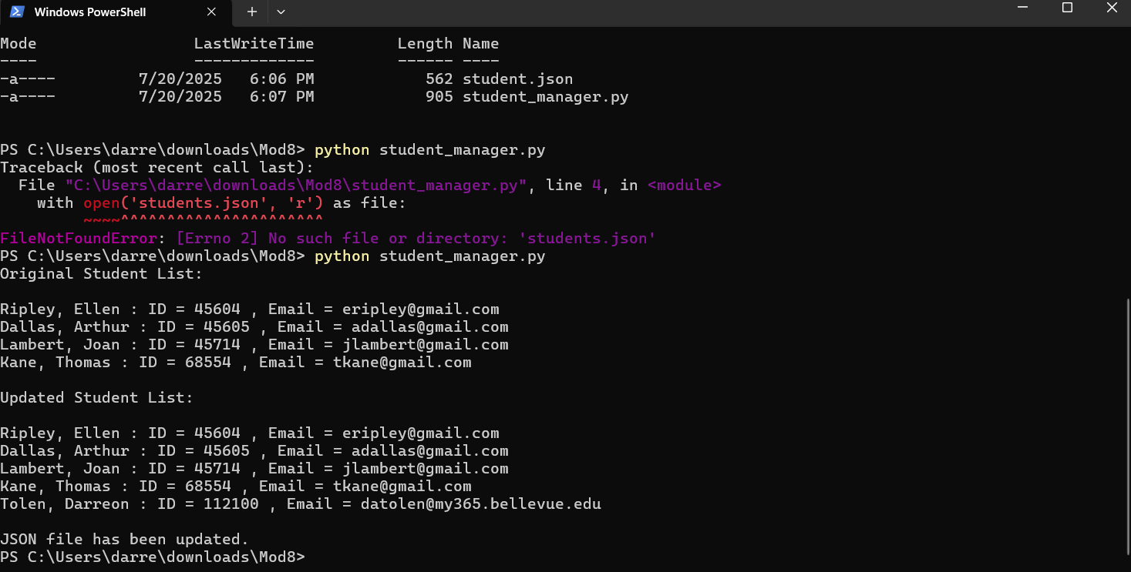

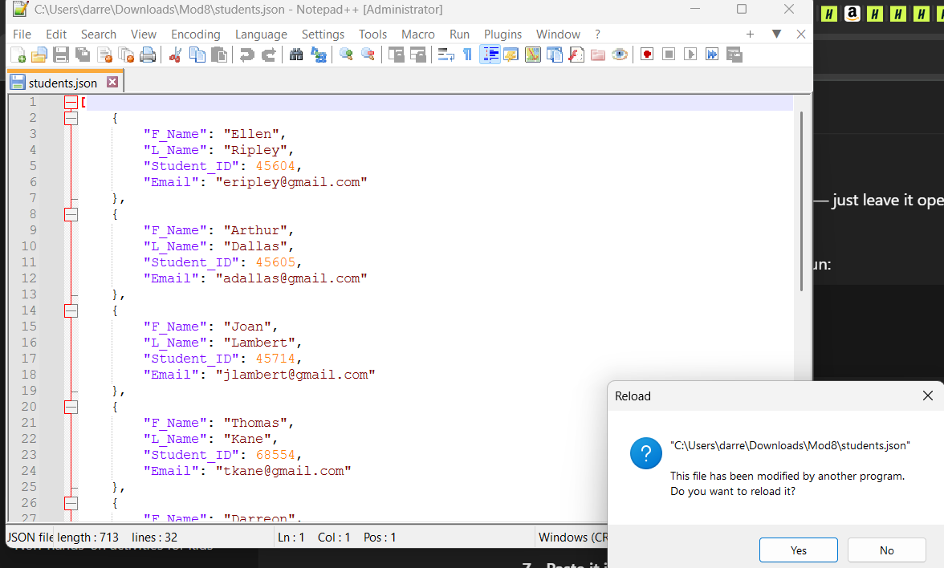

[

{

"F_Name": "Ellen",

"L_Name": "Ripley",

"Student_ID": 45604,

"Email": "eripley@gmail.com"

},

{

"F_Name": "Arthur",

"L_Name": "Dallas",

"Student_ID": 45605,

"Email": "adallas@gmail.com"

},

{

"F_Name": "Joan",

"L_Name": "Lambert",

"Student_ID": 45714,

"Email": "jlambert@gmail.com"

},

{

"F_Name": "Thomas",

"L_Name": "Kane",

"Student_ID": 68554,

"Email": "tkane@gmail.com"

},

{

"F_Name": "Darreon",

"L_Name": "Tolen",

"Student_ID": 112100,

"Email": "datolen@my365.bellevue.edu"

},

{

"F_Name": "Darreon",

"L_Name": "Tolen",

"Student_ID": 112100,

"Email": "datolen@my365.bellevue.edu"

}

]