Project: | Todo Application
Course: | CSD380-T301 DevOps
Description: | Functional test cases for the Todo web application based on the Todo Business Requirements.
Date: | 2026/01/17
To complete the test case plan, fill out the information for Project, Course, Description and Date in the header below.
.
TABLE OF CONTENTS
Test Case: 1 & 2 2
Test Case: 2 Continued, 3, & 4 3
Test Case: 4 Continued & 5 4

For each test, the developer should: provide a test description, a test objective, the developer name and date tested. For each step, fill out the actions to be taken and describe the expected results, and indicate yes or no for each step depending upon the result. The peer tester should provide their name, date tested, indicate yes or no for each step depending upon the result, and a screenshot (thumbnail) of the result.

Test 1 | View a list of todo task items (Requirement 1)
 | Test Objective: Verify users can view a list of todo task items without page errors. | Developer: Natasha Foreman  Date tested: 2026/01/17 | Peer tester: Darreon Tolen  Date tested: 2026/01/19
Step | Action | Expected results: | Developer pass/fail | Tester pass/fail  + Screenshot
1 | Open the todo application. | The application loads successfully. | Pass | Yes-Launch the todo application
2 | Observe the main list area. | A list area for todo items is visible. | Pass | Yes-View todo list section
3 | If items exist, confirm they appear in a list. | Existing todo items display as a list. | Pass | Yes-If items exist, confirm they appear in a list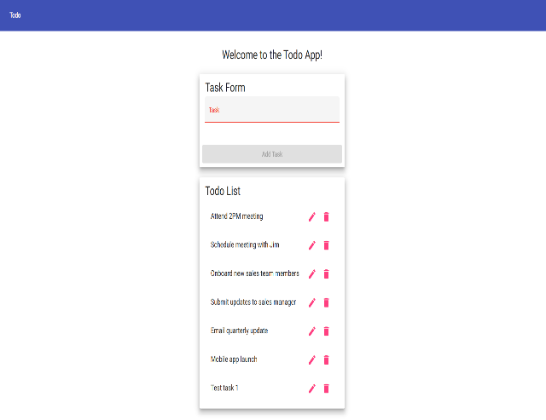
Comments | Results should be recorded for each step using the pass/fail columns. If a step fails, capture a screenshot and note what happened versus the expected result. These notes help developers reproduce the issue and confirm the fix during retesting.

Test 2 | Create a new todo task item (Requirement 2)
 | Test Objective: Verify users can create a new todo task item using valid input. | Developer: Natasha Foreman  Date tested: 2026/01/17 | Peer tester: Darreon Tolen  Date tested: 2026/01/19
Step | Action | Expected results: | Developer pass/fail | Tester pass/fail
1 | Locate the "new task" input field. | The input field is visible and enabled. | Pass | Yes-Find task input field
2 | Enter "Buy groceries". | The text appears in the input field. | Pass | Yes-Enter valid todo text
3 | Submit the form. | The form submits without errors. | Pass | Yes-Submit new task
4 | Observe the todo list. | A new item "Buy groceries" appears in the list. | Pass | Yes-Confirm task appears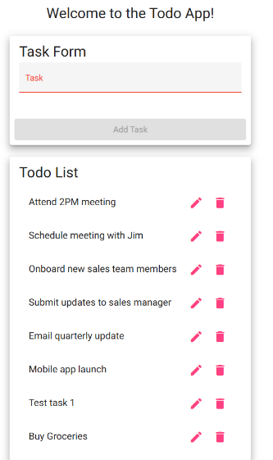
Comments | Results should be recorded for each step using the pass/fail columns. If a step fails, capture a screenshot and note what happened versus the expected result. These notes help developers reproduce the issue and confirm the fix during retesting.

Test 3 | Prevent submitting create form with blank task (Requirement 6)
 | Test Objective: Verify the create form cannot be submitted when the todo item is blank. | Developer: Natasha Foreman  Date tested: 2026/01/17 | Peer tester: Darreon Tolen  Date tested: 2026/01/19
Step | Action | Expected results: | Developer pass/fail | Tester pass/fail
1 | Locate the "new task" input field. | The input field is visible and enabled. | Pass | Yes-Access task input
2 | Ensure the field is blank. | The input field is empty. | Pass | Yes-Clear input field
3 | Submit the form. | Submission is blocked and no item is created. | Pass | Yes-Attempt empty submission
Comments | Results should be recorded for each step using the pass/fail columns. If a step fails, capture a screenshot and note what happened versus the expected result. These notes help developers reproduce the issue and confirm the fix during retesting.

Test 4 | Edit a todo task item (Requirement 3)
 | Test Objective: Verify users can edit an existing todo item and save changes. | Developer: Natasha Foreman  Date tested: 2026/01/17 | Peer tester: Darreon Tolen  Date tested: 2026/01/19
Step | Action | Expected results: | Developer pass/fail | Tester pass/fail
1 | Identify an existing todo item in the list. | An existing item is available to edit. | Pass | Yes-Select existing task
2 | Click the Edit control for that item. | The item opens in edit mode. | Pass | Yes-Enter edit mode
3 | Update the text to "Buy groceries and milk". | The updated text appears in the edit field. | Pass | Yes-Modify task content
4 | Save/submit the edit. | The edit saves without errors. | Pass | Yes-Save task changes
5 | Return to the list view. | The updated item text is shown in the list. | Pass | Yes-View updated task 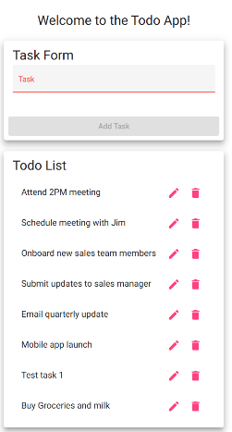
Comments | Results should be recorded for each step using the pass/fail columns. If a step fails, capture a screenshot and note what happened versus the expected result. These notes help developers reproduce the issue and confirm the fix during retesting.

Test 5 | Prevent submitting edit form with blank task (Requirement 7)
 | Test Objective: Verify the edit form cannot be submitted when the todo item is blank. | Developer: Natasha Foreman  Date tested: 2026/01/17 | Peer tester: Darreon Tolen  Date tested: 2026/01/19
Step | Action | Expected results: | Developer pass/fail | Tester pass/fail
1 | Open edit mode for an existing todo item. | An Edit mode is displayed for the selected item.item is available to edit. | Pass | Yes-Open task editor
2 | Clear the todo text field so it is blank. | The edit field is empty. | Pass | Yes-Remove task text
3 | Attempt to save/submit the edit. | Saving is blocked and the item remains unchanged. | Pass | Yes-Attempt invalid save 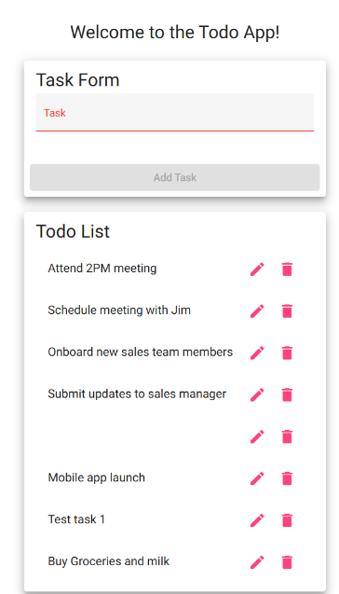
Comments | Results should be recorded for each step using the pass/fail columns. If a step fails, capture a screenshot and note what happened versus the expected result. These notes help developers reproduce the issue and confirm the fix during retesting.

