**Reports/Queries**

**Business Report 1:** Vehicle Parts

**Report Description:** Provide a report that will list the specific parts used on a vehicle.

**Report Description:** The vehicle parts report will provide Herrera Fabricating with details including which parts were used on a specific vehicle during a service. This report will help keep track of inventory and future services that deal with issues or services surrounding the part that was installed.

**SQL Code:**

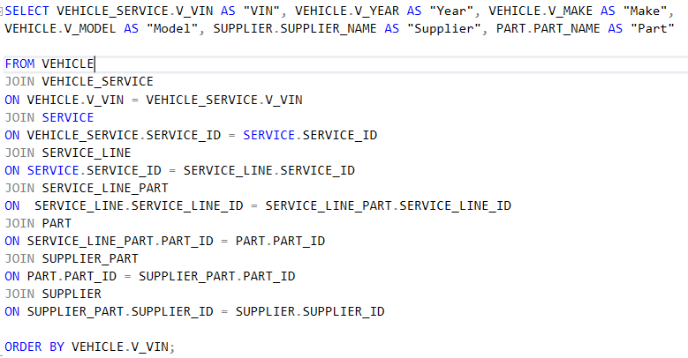

**Report/Query Results**

|  |  |  |  |  |  |
| --- | --- | --- | --- | --- | --- |
| **VIN** | **Year** | **Make** | **Model** | **Supplier** | **Part** |
| 19XFA1F5XBE087240 | 2014 | Chevrolet | Taho | Hendrickson | Catalytic Converter |
| 19XFB2F55DE061070 | 2015 | Chevrolet | Imlapa | Fleetrite | Muffler |
| 1B3AL56R72N189204 | 2017 | Honda | Civic | Hendrickson | Catalytic Converter |
| 1C3EL46X65N505015 | 2011 | Ford | Focus | Fruitland Manufacturing | Axle |
| 1C6RR6GT9ES365442 | 2020 | Chevrolet | Tacuma | Airman Products | Radiator |
| 1D7HE22K26S555758 | 2019 | Chevrolet | Camaro | HIAB | Engine Fan |
| 1D7HU18298S536471 | 2009 | Jeep | Cherokee | HIAB | Engine Fan |
| 1D7RB1GPXAS185874 | 2011 | Ford | Escort | Link Manufacturing, Ltd | Piston |
| 1FAFP10P2XW141576 | 2017 | Honda | Civic | Hendrickson | Catalytic Converter |
| 1FMFU20576LA76257 | 2012 | Jeep | Wrangler | Ridewell Suspensions | Battery |
| 1FMJU1J57BEF16835 | 2019 | Ford | Mustang | Dayton Parts, LLC | Shock Absorbers |
| 1FTFW1EF5DFA79986 | 2016 | Ford | Expedition | Buyers Products Company | A/C Compressor |
| 1FTMF1EF8DKG22066 | 2011 | Mazda | B4000 | Airman Products | Radiator |
| 1FTWW31P05ED12447 | 2010 | Mazda | B4000 | Fleetrite | Muffler |
| 1G11B5SL4FF178012 | 2016 | Honda | Accord | Ridewell Suspensions | Battery |
| 1G1AS18H097240712 | 2011 | Honda | Civic | US Tarp | Spark Plug |
| 1G1JC6SH2F4127313 | 2019 | Chevrolet | Camaro | HIAB | Engine Fan |
| 1G4HP54K014129658 | 2019 | Ford | Explorer | Dayton Parts, LLC | Shock Absorbers |
| 1G8ZS57N87F203073 | 2017 | Honda | Civic | Anthony Liftgates, Inc | Air Filter |
| 1GBGC24R8XR717525 | 2015 | Chevrolet | Imlapa | US Tarp | Spark Plug |
| 1GCHK23U91F117999 | 2011 | Chevrolet | Tacuma | Anthony Liftgates, Inc | Air Filter |
| 1GCRCPEA9CZ281529 | 2009 | Chevrolet | Taho | Buyers Products Company | A/C Compressor |
| 1GKFK16ZX4J375043 | 2019 | Chevrolet | Imlapa | US Tarp | Spark Plug |
| 1GNEC13T64R214542 | 2013 | Ford | Focus | Fleetrite | Muffler |
| 1GNSCBE05DR309007 | 2007 | Ford | Explorer | Kyrish Truck Centers | Car Jack |
| 1GNSCJE09DR285966 | 2011 | Ford | Focus | Transwest Trucks | Alternator |
| 1HGCG5658WA121470 | 2010 | Chevrolet | Tacuma | SSAB | Power Steering Fluid |
| 1HGCR2F71DA276241 | 2019 | Ford | Explorer | Buyers Products Company | A/C Compressor |
| 1J4RR4GG7BC787547 | 2011 | Honda | Civic | Air Liquide | Fuel Injector |
| 1N4AA51E09C843514 | 2011 | Chevrolet | Tacuma | Rush Truck Center - Austin | Clutch |
| 1N4AB41DXXC760684 | 2015 | Jeep | Wrangler | Black Rose Steel & Trading | Brakes |
| 1N4AL3AP7FN348114 | 2010 | Ford | Focus | Kyrish Truck Centers | Car Jack |
| 1N6AA07A86N544349 | 2015 | Honda | Civic | W&C - Watson & Chalin | Spare Tire |
| 1VWAP7A38DC019544 | 2014 | Arctic Cat | DVX 90 | US Tarp | Spark Plug |
| 1VWBH7A34CC000747 | 2016 | Ford | Expedition | Transwest Trucks | Alternator |
| 2A4RR5DG9BR730946 | 2012 | Ford | Focus | Fleetrite | Muffler |
| 2B3HD46Z82H110282 | 2018 | Honda | Accord | Hendrickson | Catalytic Converter |
| 2C4RC1CG2CR171436 | 2014 | Ford | Focus | Rush Truck Center - Austin | Clutch |
| 2FMDK4JC4DBB89814 | 2019 | Ford | Mustang | SSAB | Power Steering Fluid |
| 2FMGK5BC0ABD73600 | 2013 | Chevrolet | Camaro | Buyers Products Company | A/C Compressor |
| 2G61N5S34D9234666 | 2009 | Chevrolet | Imlapa | Ridewell Suspensions | Battery |
| 2HGFA165X6H554023 | 2011 | Honda | Civic | Fleetrite | Muffler |
| 2HGFB2F59CH525577 | 2019 | Honda | Accord | Air Liquide | Fuel Injector |
| 2T2GA31U84C045001 | 2009 | Ford | Escort | Fruitland Manufacturing | Axle |
| 3GCPKSE74DG113610 | 2014 | Ford | Escort | Dayton Parts, LLC | Shock Absorbers |
| 3GSCL33P68S652273 | 2015 | Jeep | Wrangler | HIAB | Engine Fan |
| 3GTU2VEC3EG428370 | 2011 | CAN-AM | DS 90 X | US Tarp | Spark Plug |
| 3MZBM1L73FM114959 | 2020 | Jeep | Cherokee | United Truck Centers | Tire Pressure Gauge |
| 3N1AB6AP1AL632607 | 2012 | Jeep | Cherokee | Kyrish Truck Centers | Car Jack |
| 3N1AB6AP9CL737656 | 2015 | Ford | Focus | Anthony Liftgates, Inc | Air Filter |
| 3N1CN7AP7FL826328 | 2007 | Ford | LCF | Link Manufacturing, Ltd | Piston |
| 3VW7T7AT4DM893975 | 2009 | Ford | Escort | Hendrickson | Catalytic Converter |
| 3VW7T7AT5DM873833 | 2016 | Ford | Escort | Dayton Parts, LLC | Shock Absorbers |
| 4A3AC34G71E114809 | 2016 | Honda | Accord | Jackrabbit Steel Products, Inc | Transmission |
| 4E3AK54FXSE191774 | 2014 | Jeep | Cherokee | SSAB | Power Steering Fluid |
| 4JGBB75E06A044143 | 2011 | Ford | Explorer | HIAB | Engine Fan |
| 4JGBF7BE5BA602135 | 2019 | Ford | Mustang | Kyrish Truck Centers | Car Jack |
| 4S3BG6856W7636770 | 2017 | Ford | Escort | US Tarp | Spark Plug |
| 4T1BG22K8YU652783 | 2016 | Honda | Accord | Link Manufacturing, Ltd | Piston |
| 4T4BE46K38R098862 | 2012 | Honda | Civic | Fleetrite | Muffler |
| 4T4BF1FK0CR295850 | 2019 | Chevrolet | Taho | Black Rose Steel & Trading | Brakes |
| 4USBT33493LS81728 | 2012 | Ford | Expedition | Rush Truck Center - Austin | Clutch |
| 4V4JDBRF8TR809309 | 2011 | Honda | Civic | Fleetrite | Muffler |
| 5FNYF3H28EB098129 | 2018 | Chevrolet | Tacuma | Transwest Trucks | Alternator |
| 5GZDV03L56D125276 | 2019 | Chevrolet | Camaro | Black Rose Steel & Trading | Brakes |
| 5J6YH28593L059584 | 2019 | Chevrolet | Camaro | Anthony Liftgates, Inc | Air Filter |
| 5J8TB4H5XFL010719 | 2011 | Chevrolet | Imlapa | Jackrabbit Steel Products, Inc | Transmission |
| 5N1AA0NC2EN603445 | 2020 | Chevrolet | Taho | US Tarp | Spark Plug |
| 5N1AR2MN5EC639066 | 2009 | Chevrolet | Taho | Buyers Products Company | A/C Compressor |
| 5NPEB4AC7DH761732 | 2014 | Ford | Escort | HIAB | Engine Fan |
| 5NPEC4AC5BH273745 | 2013 | Chevrolet | Camaro | Black Rose Steel & Trading | Brakes |
| 5XXGM4A75CG006305 | 2010 | Ford | Explorer | Fruitland Manufacturing | Axle |
| JM1CR293890323205 | 2012 | Ford | Focus | Airman Products | Radiator |
| JNKHF14C0MT090653 | 2012 | Honda | Accord | Kyrish Truck Centers | Car Jack |
| JTDKB20U273296665 | 2015 | Ford | Focus | Black Rose Steel & Trading | Brakes |
| JTDKB20U977678801 | 2017 | Honda | Civic | Fruitland Manufacturing | Axle |
| JTNBF3EK9A3098931 | 2017 | Chevrolet | Taho | US Tarp | Spark Plug |
| KM8JUCAG9FU908109 | 2019 | Ford | Mustang | Jackrabbit Steel Products, Inc | Transmission |
| KMHDH4AE2FU276480 | 2015 | Ford | Focus | Rush Truck Center - Austin | Clutch |
| KNDJE723177340233 | 2011 | Chevrolet | Tacuma | Jackrabbit Steel Products, Inc | Transmission |
| SALAA25425A337143 | 2017 | Ford | Escort | Air Liquide | Fuel Injector |
| WAUEFGFF4F1066642 | 2016 | Honda | Accord | Jackrabbit Steel Products, Inc | Transmission |

**Business Report 2:** Revenue Report

**Report Description:** Provide the total revenue from one specific Invoice.

**Report Description:** The revenue report will provide Herrera Fabricating with revenue details from one invoice. This report will help with accounting and provide better insight when preparing income statements.

**SQL Code:**

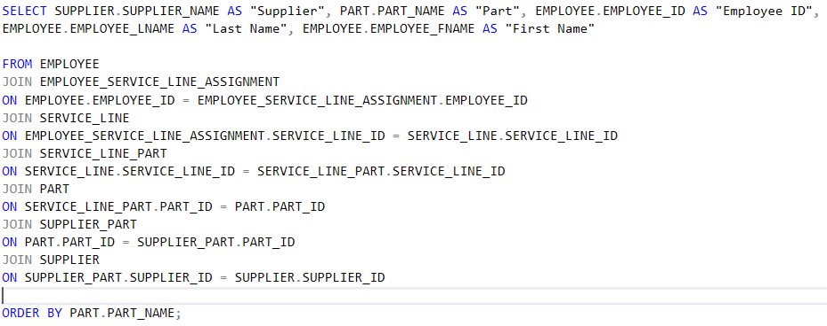

**Report/Query Results**

**Business Report 3:** Employee Part Report

**Report Description:** Display employees that have worked with specific parts.

**Report Description:** The employee part report will provide Herrera Fabricating with better service planning that increases speed and quality of services. This is achieved by viewing which employees has experience with specific parts.

**SQL Code:**

**Report/Query Results**

**Business Report 4:** Inactive Customer Report

**Report Description:** Display customers that have not had a service completed in over a year.

**Report Description:** The inactive customer report will provide Herrera Fabricating with all customers that have not had a service completed over a year. The report can be used to contact customers to have them return for another quality service or find why they have not returned to potentially improve business.

**SQL Code:**

**Report/Query Results**

**DATA**

**Vehicle**

**Supplier**

**Supplier part**

**Part**

**Service line part**

**Service line**

**Service order**

**Service**

**Vehicle service**

**Vehicle**

**Invoice**

**Invoice Payment**

**Payment**

**Payment Revenue**

**Account_Revenue**