1. Analysis Overview: The point of this analysis is to help Alphabet Soup select the applicants for funding with the best chance of success in their ventures.
2. Data Preprocessing
   1. The target variable was the IS_SUCCESSFUL column of the data, which contains values 1 (for success) and 2 (for failure).
   2. The feature variables for the model are APPLICATION_TYPE, AFFILIATION, CLASSIFICATION, USE_CASE, ORGANIZATION, STATUS INCOME_AMT, SPECIAL_CONSIDERATIONS, and the ASK_AMT columns.
   3. The only column that was removed are the EIN and NAME columns, as they do not have any meaningful effect on the target variable. Those variables are simply identifying variables for each entry of the data, which isn’t needed for the model.
3. Compiling, Training, and Evaluating the Model
   1. Attempt #1
      1. 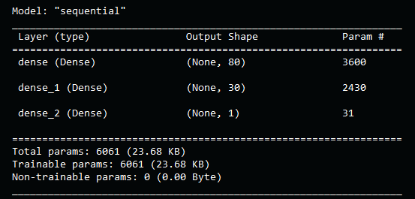
      2. The reason I chose 80 and 30 for the neurons was just because those numbers were in my mind from a book I was reading. I had to start somewhere and knowing it would be changed and optimized later, I didn’t worry much about the original number. As for the layers I just like to start with two and work from there.
      3. 
      4. The Result did not achieve the target accuracy.
   2. Attempt #2
      1. 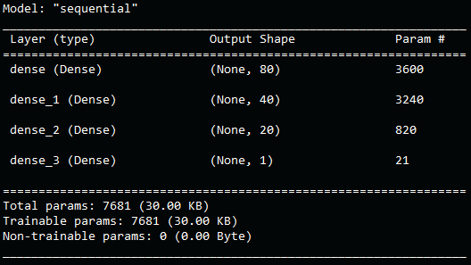
      2. For this attempt I added a new layer and changed the number of neurons to 80, 40, and 20. I also changed the number of epochs from 100 to 200.
      3. 
      4. I was surprised that the result ended up being less accurate, as I had previously thought adding more layers, neurons, and epochs would always increase accuracy.
   3. Attempt #3
      1. 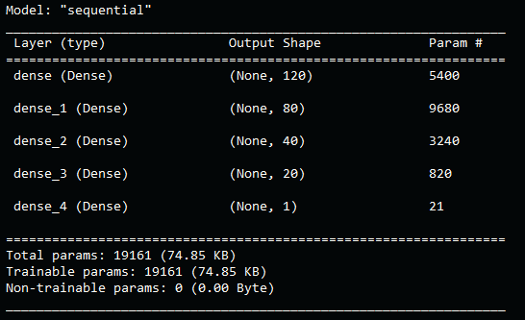
      2. For this attempt I added a new layer and changed the number of neurons to 120, 80, 40, and 20. I also changed the number of epochs from 200 to 150. The Reason for lowering the number of epochs from 200 was to decrease computing power to counter act the extra layer and more neurons.
      3. 
      4. Again, I was surprised to see that the result got even further away from the target accuracy. In hindsight I would have liked my past self to increase the number of epochs to have a more consistent increase in the three parameters throughout the attempts.
4. Summary
   1. Overall, I failed to achieve the desired target accuracy. I believe that changing the binning of APPLICATION_TYPE column would have a more impactful effect on accuracy, by reducing the variation in data in that column. I would also like to try a few different functions for the hidden layers to see if that could also increase the accuracy of the model.