1. **Start the search with initial state (4, 3).**

?- solved43(Path), print(Path).

**//”Path” is one possible path of the solution with initial state (4, 3) and end state (2, Y).**

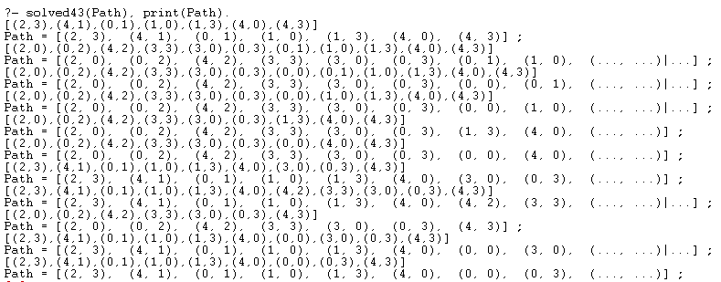

1. **Start the search with initial state (0, 3).**

?- solved03(Path), print(Path).

**//”Path” is one possible path of the solution with initial state (0, 3) and end state (2, Y).**

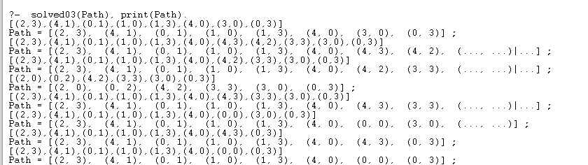

1. **Start the search with initial state (4, 0).**

?- solved40(Path), print(Path).

**//”Path” is one possible path of the solution with initial state (4, 0) and end state (2, Y).**

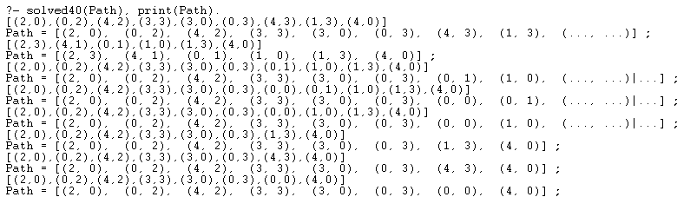

1. **Start the search with initial state (0, 0).**

?- solved00(Path), print(Path).

**//”Path” is one possible path of the solution with initial state (0,0) and end state (2, Y).**

