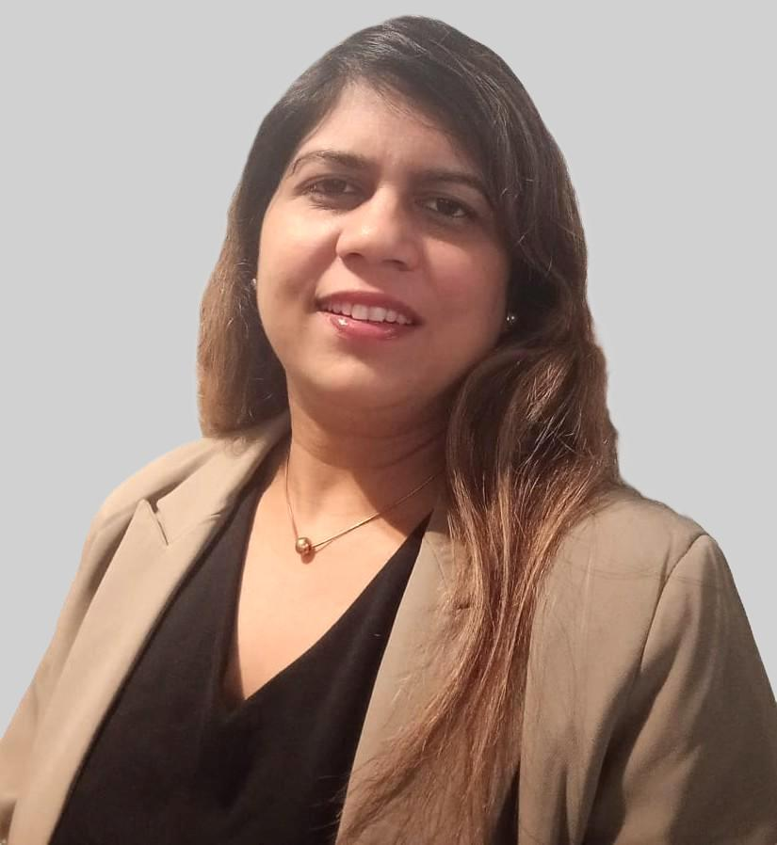
Darsana K S
Technical Writer | Documentation Specialist

Budapest, Hungary | darsana13@gmail.com | +36307424506
 https://www.linkedin.com/in/darsana-ks
Portfolio: https://darsanaks.github.io/DarsanaKS/

Date of Birth: 13 Nov 1980
Nationality: Indian

Summary
Versatile and adaptable English Technical Writer skilled in simplifying complex software platform details into clear and concise documentation.
- 9+years of software documentation and 5+ years of tech editing experience.
- Proficient in creating user manuals, API docs, and other tech docs with ownership of docs.
- Experienced in documentation strategy, tooling, and docs website creation using MK Docs.
- Efficient in collaborating with SMEs, DevOps, QA, Project Managers, delivery leads, and other stakeholders.
- Managed documentation and mentored the docs team by preparing templates, style guides, standards, best practices, and review processes.
Skills
- Documentation: User manual, API guide, developer guides, installation and deployment procedure, release notes, use case, case study, FAQ etc. Templates, styles, doc standards, review process, etc.
- Tools: MS Office, VS Code, Git, JIRA, Confluence, Markdown, YAML, HTML, CSS, JS, Python, MK Docs, MS Visio, SnagIT, Greenshot, Postman, Swagger, EIQ Platform.
- Technology: Experienced and interested in the latest domains like RPA, AI, ML, RAG, LLM, Gen AI, AI Agents, prompt engineering, etc.
- Testing: Manual testing, API testing, user experience testing, and UI/ UX validations.
- Soft Skills: Strong collaborative, analytical, and task management skills. Good verbal and written communication (English).
Education
- PG Diploma in Computer Applications, 2006 | LBS Institute of Science and Technology, India
- M. Sc. Mathematics, 2005 | University of Calicut (H+), India
Certifications

- Product Management Essentials, 2026
- AI Overview Specialization, 2026
- GenAI in Testing and Documentation, 2026
- Markdown and Git, 2024
- Microcopy (UX), 2024
- API documentation, 2023
- Technical Writing, 2018

Work Experience
Jul 2021 to Present (5Y+)
Documentation Specialist/Technical Writer || EvoluteIQ Solutions Pvt. Ltd., Bangalore, India
- Creating documentation for the EIQ Platform (SaaS version, eiq360.ai available in Google Marketplace).
- Collaboration with the DevOps, testing team, QA, PMs, and other stakeholders.
- Managing, creating, and maintaining the docs environment, reporting and tracking UI, functional, and UX-related product issues.
- Documentation strategy, tooling, and online site creation using Markdown, HTML, CSS, YAML, JavaScript (using MK Docs Material theme).
- Mentoring team, preparing templates, style guides, documentation standards, best practices, and managing review processes.
- Tracking and updating the documentation in sync with the build updates and managing the documentation repository.
March 2018 to July 2021 (3Y 3M)
Technical Writer || Jenesys Technologies Pvt. Ltd., Bangalore, India
- Writing user manuals for the software application (content, procedures, MSTP style) in an Agile SDLC environment (Windows, Android, and iOS platforms).
- Writing and editing FRS, design documents, workflow, use cases, user stories, business portfolios, and proposals by collaboratively working with the management, business analysis, development, testing, and implementation teams.
- Updating CRs, creating BPMN, workflows, infographics, mock-ups, etc.
- Testing applications, writing test cases, and raising bugs in bug tracking tools.
November 2016 to March 2018 (1Y 4M)
Content Writer || Commit Technologies Pvt. Ltd., Mumbai (Location: Bangalore), India
- Writing manuals, help files, FAQs, etc., for the software product.
- Creating reports, tutorials, case studies, infographics, and technology-based content.
- Collaboration with the business analysis, testing, and implementation teams.
- Editing and structuring the content for grammar, language, punctuation, spelling, etc.
October 2015 to October 2016 (1Y 0M)
Editor || HS Brands International Pvt. Ltd., Bangalore, India
- Writing and editing of market research audit reports provided by the fieldwork team.
- Validation and cross-verification of reports to check authenticity and contradictions.
- Proofreading, grammar checking, structuring, and QA.
- Automobile audits, price checks, integrity checks, brand loyalty checks, customer experience, brand promoter evaluation, etc.
November 2012 to September 2015 (2Y 10M)
Maternity and Child Care || Career Break
- Taken a break for pregnancy, maternity, and child care.
- October 2014 – June 2015 – Partially worked as an Editor.
August 2009 to October 2012 (3Y 2M)
Technical Editor || SR Nova (Currently, Nova Techset) Pvt. Ltd., Bangalore, India
- Typesetting of scientific, technological, and mathematical journals (thesis and research reports).
- Article inward inspection, proofreading, editing, graphics checking, and style checking.
- Technical editing, copy editing, pagination, layout check, validation, and QA.
December 2008 to August 2009 (0Y 8M)
E-Content Specialist || Shiv e-Publishing Technologies Pvt. Ltd., Bangalore, India
- QA and editing of XML files using XMetal.
- Content checking, structuring, editing, and applying style tags.
May 2006 to August 2008 (2Y 3M)
Editor || Macmillan Publishing Solutions Pvt Ltd., Bangalore, India
- Typesetting of academic, scientific, technological, medical, and mathematical journals (international theses, research reports, abstracts, and supplements).
- Proofreading, editing, and creating style guides as per customer specifications.
- Technical editing, copy editing, pagination, layout checking, proof collation, issue compilation, validation, and QA by managing schedule and quality of production and dispatches.
Personal Information
Languages: English, German (Basic-A1), Hindi, Malayalam, Kannada, Tamil.
Hobbies: Drawing, Badminton, Cooking.
Marital Status: Married | Children: 1
Current RP Address: Hungary, 1097 Budapest, Toth Kalman Utca, 33B, 2.8.
Declaration
I hereby declare that all the information provided above is true to the best of my knowledge and can be supported by relevant documents. I give consent to process my personal data for the purposes of recruitment in accordance with applicable data protection laws. I can provide references for verification purposes.


