Sample
Intelligent Business Automation Platform
API Doc
Webservice APIs
Version 5.1


Copyright
Copyright © 2024. All rights reserved.

© All copyright and other property in this document and its contents are confidential and proprietary to the original Organization. No part of these materials should be reproduced, published, transmitted, or distributed in any form or by any means, electronic, mechanical, photocopying, recording, or otherwise, or stored in any information storage or retrieval system of any nature nor should the materials be disclosed to third parties without the prior written authorization of the original Organization.

Table of Contents
1. Webservice API Overview 5
1.1. About Webservice API 5
1.2. Purpose 5
1.3. HTTP Status Codes 5
1.4. Permissions 5
2. Webservice REST APIs 7
2.1. webServiceLookupByName 7
2.1.1. Description 7
2.1.2. Method 7
2.1.3. End Point / Request URL 7
2.1.4. Headers 7
2.1.5. Request Payload 7
2.1.6. Table of Parameters 7
2.1.7. Response Body 8
2.1.8. Failure Response Body 8
2.1.9. cURL 8
2.2. Example 9

Webservice API Overview

About Webservice API
An Application and Process flow within that application is associated with an organization created in the Platform. The webservice API can call the webservice in the background without initiating the process flow associated with that webservice.
For example consider:
When a process flow calls another process flow for the purpose of executing a webservice, it creates multiple instances of that flow on each execution. This avoid the creation of multiple instances webservice API is used.

Purpose
This documentation helps you familiarize yourself with the webservice API resources (organization specific) and how to use them.

HTTP Status Codes
Status Code | Description
200 | Ok Success
404 | Not Found
500 | Error
401 | Unauthorized

Permissions
This is an exposed API in the platform.
Based on the API requests the permission for the user differs.

Webservice REST APIs

webServiceLookupByName

Description
To call a web service without initiating a process flow in the organization.

Method
POST

End Point / Request URL
http://{domain_name}/nbt-qengine-service/ web-service-lookup/webServiceLookupByName

Headers
Key | Value
Content-Type | application/json
access_token | Provide the access token.  Get access token from the Platform exposed API List.

Request Payload

{
"organizationId": 36607,
"userId":54554,
"applicationName": "AppKR",
"workflowName": "WebServiceCall_ByLookupAPI",
"webServiceName": "Service_SignIn",
"cacheVariables": [{"name":"email","value":"name@platform.com"}]
}

Table of Parameters
Parameter | Description
organizationId | Provide the organization Id. Get OrganizationId from the Platform exposed API List or from the JS library documentation.
userId | Provide the user Id. Get userId and OrganizationId from the Platform exposed API List or from the JS library documentation.
applicationName | Provide the application name.
workflowName | Provide the process flow name in the application.
webServiceName | Provide the webservice entity name that you created within the process flow.
cacheVariables | The value of the cacheVariables can vary as per your variable details.  - name: name of the variable.  - value: value of the variable.  The variable name and value can be obtained as per requirement.  For example:  Value can be passed from run time form UI.

Response Body
The following is an example of success response.
"{\"success\":true,\"data\":{\"access_token\":\"503dda40-bfc9-4d2d-9746-a018521089ef\",\"expires_in\":3,\"token_type\":\"api\"},\"statusCode\":200}"

Failure Response Body
The following is an error message (failure response) for not having the specified application in the specified organization in the platform.
{
"success": false,
"requestIdentifier": null,
"errors": [
{
"title": "Error Messages",
"messages": [
"Webservice LookUp Failed[application (TestApp) not-found-or-not-active]"
]
}
],
"statusCode": 500
}

cURL
curl --location 'http://{domain_name}/nbt-qengine-service/web-service-lookup/webServiceLookupByName' \
--header 'Content-Type: application/json' \
--header 'access_token: 35fae748-5f4b-4797-9f24-c4f5128abb26' \
--header 'Cookie: JSESSIONID=9954543DAE59E6810561331DD3A25CDD.worker1; COOKIE_SUPPORT=true; GUEST_LANGUAGE_ID=en_US; JSESSIONID=B029FABDE0E02E3C0F24B6A7BAC901B6.worker1' \
--data '{
"organizationId": 36607,
"userId":54554,
"applicationName": "AppKR",
"workflowName": "WebServiceCall_ByLookupAPI",
"webServiceName": "Service_SignIn",
"cacheVariables": [{"name":"email","value":"name@platform.com"}]
}'

Example
Follow the steps below for getting Variable value from DB for the execution of webservice API.

- Create a Database script entity of type DB Lookup for fetching a desired output at runtime.
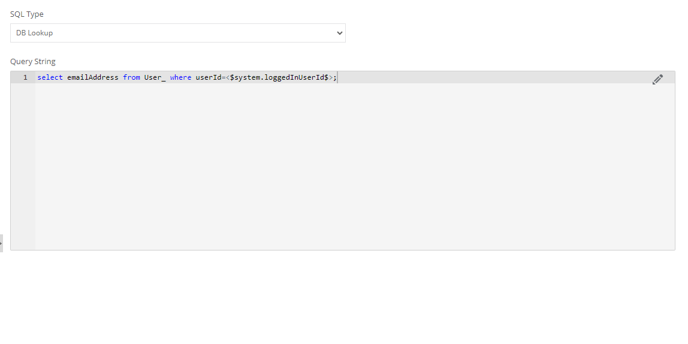
Figure 2.1: DB Lookup Query for the Database script
- Create a variable. Configure the DB Lookup to the variable by selecting the Database script created.
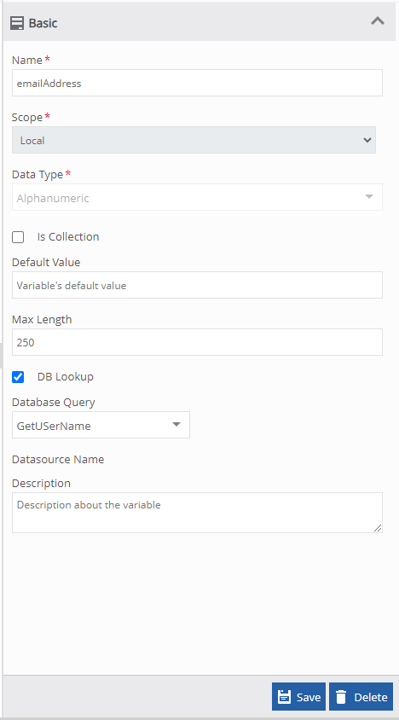
Figure 2.2: Creating a variable - Selecting DB Lookup and mapping database script to the variable
- Create a Webservice entity and provide the required configuration details. The Database script entity and webservice entity must be in the same process flow. The body of the webservice detail (payload) may have process variables.
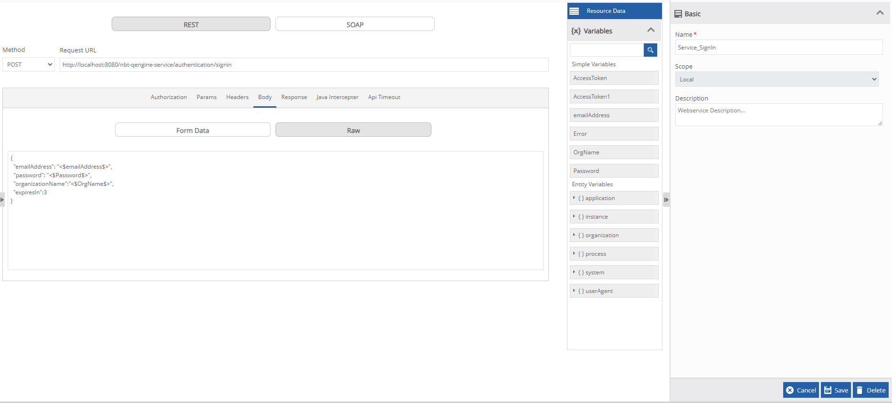
Figure 2.3: Creating webservice entity with the necessary variables as per requirement
- Create a valid process flow and deploy it. It is not necessary to include any specific activity as part of this process flow. It can be any simple flow.
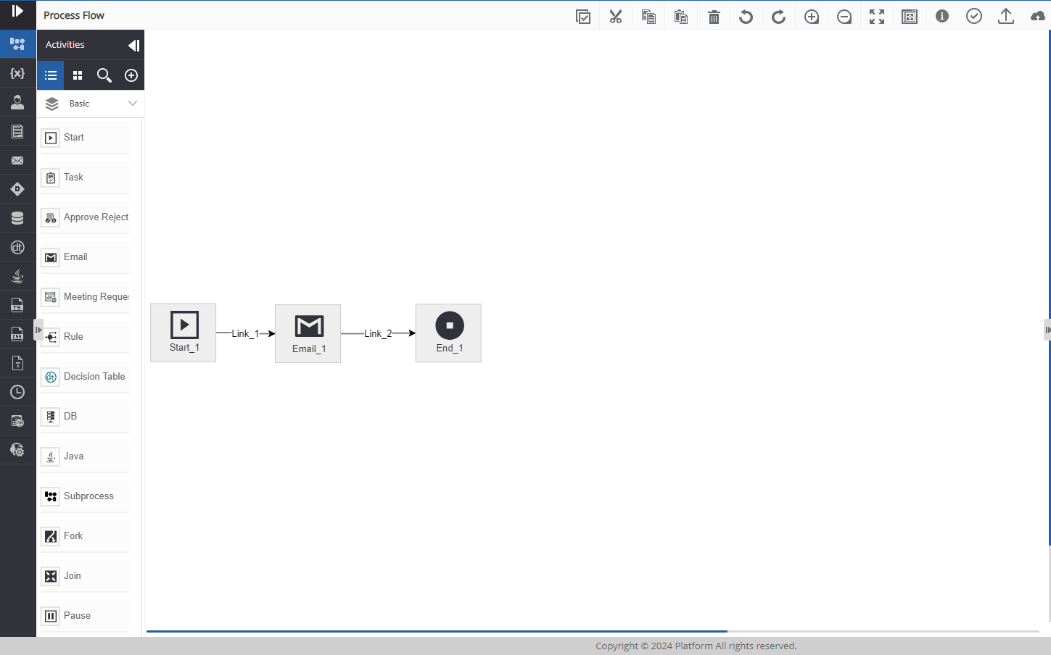
Figure 2.4: Process flow
- Execute the webserviceLookupByName API.
The API execution order is as follows:
- Variables entities are identified.
- Database script is executed. Result set is stored in the variable to which the DB lookup is configured.
- Webservice entity is executed. The variables in the webservice entity is resolved by taking the values from the variables.

