2019
Submitted By

1/1/2019

Proposal for Designing Wind Turbine
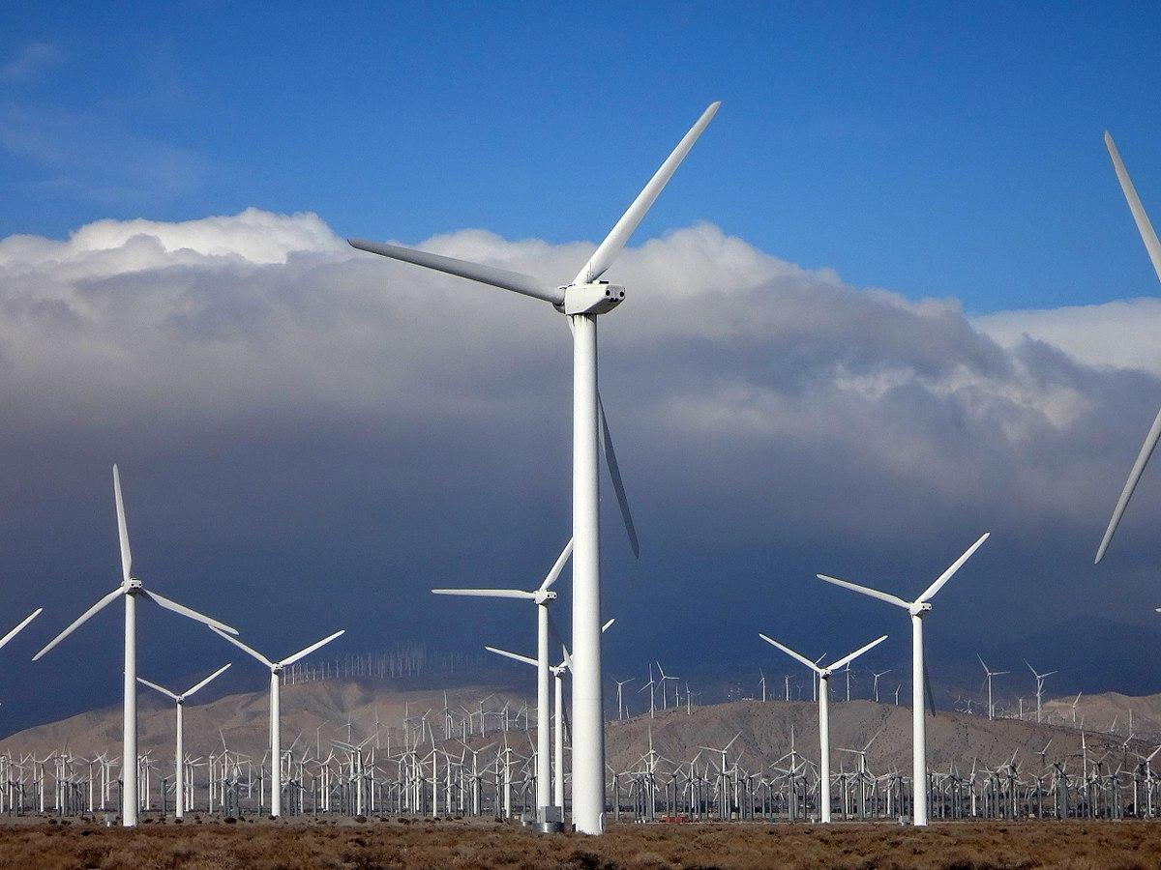

Table of Contents
1 Executive Summary 4
2 Business Requirement Summary 4
2.1 Functional Requirements 4
2.2 Non-Functional Requirements 4
3 Scope of the Solution 4
4 Proposed Architecture and Solution Approach 5
4.1 Architecture 5
4.2 Solution Approach 5
5 Technology Strengths 5
5.1 Technologies 5
5.2 Tools Used 5
5.3 Resources and Experience 5
6 Sofware Development and Implementation 5
6.1 Process 5
6.2 QA 5
6.3 Build and Release 5
6.4 Hosting and Deployment 5
7 Project Management and Administration 6
7.1 Project Manager 6
7.2 Project Phases 6
7.3 Communication Path 6
7.4 Coordination and Tracking 6
7.5 Stakeholders 6
8 Deliverables 6
9 Benefits of The Solution 6
10 Effort 6
11 License 6
12 Costing 7
13 About xxx 7
14 Case Study 1 – Wind Turbine Designing 7

Executive Summary
XXX is a leading Engineering Solutions Company <about the company>

The company approaches Cyient for a solution to overcome the long-term social, and environmental impacts by reducing wind turbine downtime and optimize Nacelle ventilation design through thermal analysis and alternative design concepts.
As part of this program, Cyient, a global provider of engineering, manufacturing, data analytics, networks and operations solutions, proposes a design solution to optimise the challenginging factors. Our design cycle comprises concept design and selection, preliminary design including material selection and sub-system design, and detailed design of modules, assemblies, geometric dimensioning, and design optimization. Cyient’s iterative design process validates design specifications at each stage of the life cycle.

Business Requirement Summary
The desired outcome of the process design is to meet the design constraints that include functional, non functional specifications to reduce the wind turbine downtime and to optimise the Nacelle ventilation design.

Functional Requirements

Non-Functional Requirements

Scope of the Solution
The scope includes the design, development, and deployment of the design mechanism for turbine. The proposed solution aims to provide the stakeholders with the highest level of Security and xxxx.
xxxx

Proposed Architecture and Solution Approach

Architecture
The solution architecture design.
<PIC - Infographics>
<Description>

Solution Approach
<Description about the approach or process flow for achieving the desired solution>

Technology Strengths

Technologies

Tools Used

Resources and Experience

Sofware Development and Implementation

Process

QA

Build and Release

Hosting and Deployment

Project Management and Administration

Project Manager

Project Phases

Communication Path

Coordination and Tracking

Stakeholders

Deliverables

Benefits of The Solution
- Reduced engine noise by 50% and supported double-digit improvement in fuel efficiency.

Effort
Sl No. | Task Description | Effort  (Hours) | Rate ($) | Total ($)
1
2
3

License

Sl No. | License Description | Rate ($)/Unit
1
2
3

Costing

About xxx
Cyient is a global provider of engineering, manufacturing, data analytics, networks and operations solutions. We collaborate with our clients to achieve more and shape a better tomorrow. With decades of experience, Cyient is well positioned to solve problems. Our solutions include product development and life cycle support, process and network engineering, and data transformation and analytics. We provide expertise in the aerospace, consumer, energy, medical, oil and gas, mining, heavy equipment, semiconductor, rail transportation, telecom and utilities industries.
Our embedded electronics engineering design services have resulted in significant benefits for customers. Our cross-functional team has rich experience in mechanical, structural, electrical, and embedded hardware and software engineering aspects for reliable product design. Cyient offers a structured series of tests to evaluate the functional and environmental aspects as well as the reliability of components before final approvals by certification authorities.
We are currently collaborating with gas and wind turbine OEMs as well as a nuclear reactor manufacturer to further enhance electricity generation capabilities. We are approved by the US (DOE) and Indian (DAE) regulatory bodies to undertake nuclear engineering projects.

Case Study 1 – Wind Turbine Designing
The Client
The client, a leading Engineering Solutions company, <about the company>
Business Case/The Challenge
The company approached Cyient for a solution to overcome the long-term social, and environmental impacts by reducing wind turbine downtime and optimize Nacelle ventilation design through thermal analysis and alternative design concepts.
As part of this program, Cyient, a global provider of engineering, manufacturing, data analytics, networks and operations solutions, proposed a design solution to optimise the challenginging factors.
Xxx’s Solution
Our design cycle comprised the concept design and selection, preliminary design including material selection and sub-system design, and detailed design of modules, assemblies, geometric dimensioning, and design optimization.
<about the solution>
Cyient’s iterative design process validated the design specifications at each stage of the life cycle.
<concluding remark about the solution>
Benefits
- Xx
- xx
What’s Next?

