**ISyE8900 Project Proposal**

Chi Zhang

Georgia Institute of Technology

**Introduction**

In this project, we implement a nonparametric approach for modeling curves in the FICC market using various manifold learning methods. The main focus will be the following three original curves and two spread curves derived from the former: US Treasury Zero (Forward) Rate Curve, 3-month US LIBOR Zero (Forward) Rate Curve, 3-month SOFR Zero (Forward) Rate Curve; Swap Spread (LIBOR - Treasury), Basis Spread (LIBOR - SOFR). If time permits, will explore more interesting term structures (e.g. brent oil forward price, EURUSD forward rate).

**Literature Review**

While term structure modeling has been well developed in past decades in the Treasury markets, advances in modeling the swap term structure or the spread term structure are comparatively small. Besides, for the purposes of managing risk or hedging derivatives, it is very common to see structural changes in local term structure areas, we would like to explore more advanced statistical approaches in the time series forecasting step to produce an adaptive term structure forecasting framework. Diebold and Li (2006) use the AR family models to obtain encouraging results for long-horizon ex-ante forecasts by reformulating the Nelson and Siegel (1987) model. Duffee (2002) argues the random walk model is superior to the previous affine term structure models. Apart from these general parametric models, economists have also tried add some exogenous macroeconomic variables (e.g. real activity, inflation, and fed funds rate) to improve the predicting power, such as Ang and Piazzesi (2003) and Diebold, Rudebusch and Aruoba (2006). Though a large part of term structure model specification has been deployed, a uniform conclusion with regard to the factor selection has not been achieved yet.

As the booming of model machine learning techniques, some elementary dimension reduction techniques like PCA have been applied in the fixed income market, such as Steeley (1990) and Litterman and Scheinkman (1991). Practitioners usually interpret the principle components as level, slope, and curvature effects. To link the factors with more understandable economic instances in the financial markets, Duffie and Singleton (1997) propose a multi-factor model for IRS (interest rate swap) that accommodates counterparty default risk and liquidity differences between the Treasury and Swap markets. By extending this work, Liu, Longstaff and Mandell (2006) estimate a five factor model to analyze swap spreads.

Since the movements of interest rates have been shown depend on the absolute level of rates: the curve behavior at low is different from the behavior when rates are high. This the limitation of PCA: encoding a great amount of information regarding curve shapes into a covariance matrix. To better capture the non-linear relationship among neighbor tenors, Kondratyev (2018) (<https://github.com/DarseZ/CurveFrcst-Using-ManifoldLrn/blob/main/papers/ANNLearnCurveDynamics.pdf>) proposes a neural networks based term structure algorithm for brent oil forward price and USD swap curve.

To the best of our current knowledge, there is no work that aimed to forecast the spread term structure using non-linear dimension reduction (manifold learning). Inspired by the work of Kondratyev, we believe the heterogeneity of temporal evolution will be better captured by manifold learning compared with the linear PCA method. For the time series forecasting, we would like to extend the AR family model into two directions: (1) find a GARCH family model (e.g. E-GARCH) which could yield a feasible if not optimal model specification to capture the volatility pattern of the low dimensional representations; (2) find a state space model (e.g. Kalman filter) which could produce as much adaptability as possible.

**Problem formulation and Application**

Build curves and simulation:

From the website of Fed Reserve Bank of New York (<https://www.newyorkfed.org/>), we get the functional parameters of the Nelson-Siegel-Svensson structural models for Treasury instantaneous forward rates as described in Svensson (1994). Then, using the calibrated parameters, we could construct the zero (forward) rate curve by plugging the maturity index into the zero rate expression.

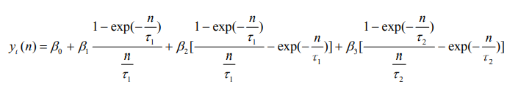



The data format should be daily data with continuous maturity spectrum from 1m to 30y (360 dimensions). To make it consistent with the following two swap curves, we re-sample it to get a weekly dataset with discrete maturity spectrum from 3m to 30y (120 dimensions).

For the LIBOR and SOFR curves, we directly download them from Bloomberg terminal by manually changing “As of Date” variable. If time permits, we will replicate the whole curve bootstrapping pipeline to get these curves using market instruments prices (deposits, futures/forwards, swaps).

For the preparation of accuracy and trading strategies backtesing, we take a parametric model, the Ornstein-Uhlenbeck process, to estimate the parameters of underlying interest rates process for Treasury, LIBOR, and SOFR respectively. With the calibrated process, we simulate a large number of realizations (e.g. 10,000).



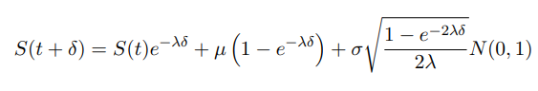

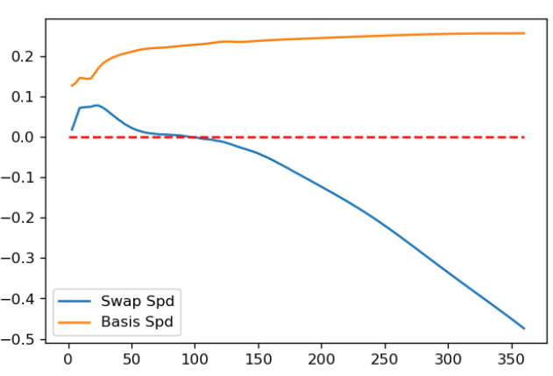

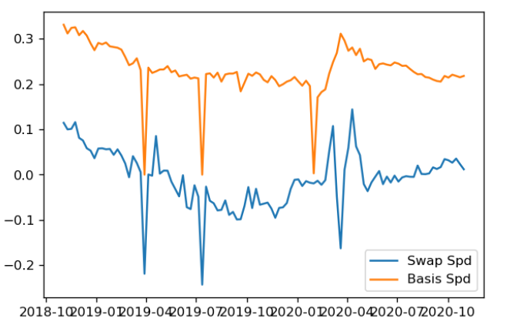

The data preparation could be seen in <https://github.com/DarseZ/CurveFrcst-Using-ManifoldLrn/blob/main/CurveBuild.ipynb>

We would keep add most recent data points (dates) into the dataset as the project moved forward.

Dimension deduction:

Start from baseline classical methods (PCA), then move to advanced methods according to the survey by Huo, Ni, Smith (2004): semi-classical methods (MDS), manifold searching methods (LLE). Finally, we also conduct experiments using the state-of-art algorithm: t-distributed Stochastic Neighbor Embedding (t-SNE). It converts similarities between data points to joint probabilities and tries to minimize the K-L divergence between the joint probabilities of the low-dimensional embedding and the high-dimensional data.

The dimension reduction part could be seen in <https://github.com/DarseZ/CurveFrcst-Using-ManifoldLrn/blob/main/DmnsRdct_StateFrcst.ipynb>

As we try to model non-linear relationship among different tenors, the low-dim representations may not be that interpretable as the parametric framework or the baseline PCA approach. This is the cost of improving prediction power.

Time series forecasting for each univariate low dimensional coordinate:

Our objective is to predict the most likely curve transformation given its observed shape at a particular moment in time.

Start from AR family models, then move to GARCH family models, finally add Kalman filter or more general state space models to refine and finalize the adaptive forecasting engine. As a comparison, we will also implement a basic neutral network taking PTx(t) as input (k dim) and PTx(t+ $Δt$) as output (k dim), and test the forecasting power with differently data frequency (1 week, 2 week, and etc.)

If time permits, we will try a perturbation test (add a specific tenor into the input of the neutral net), the visualize how the entire curve will be impacted by the exogenous impulse after time interval $Δt$. For the counterparty in dimension reduction based approaches (e.g. PCA, MDS, LLE, t-SNE), the procedure is as follows: (1) estimate reduced representations and loadings for each tenor using original curve, (2) re-estimate the reduced representations using perturbed curve, (3) compute the inverse transform using original loadings and new reduced representations.

Performance evaluation:

According to the work by Oliver Blaskowitz (2009), we define a statistical measure and an economic measure to evaluate the forecasting performance. For the statistical measure, we focus on the changes of particular swap rates or linear combination of swap rates. The henriksson-merton (hm) statistics is the conditional probability of correctly forecasting a positive or negative value of first-order difference given a positive or negative realization at the future. A successfully forecasting scheme should deliver hm-statistics in excess of unity.



For the economic measure, we backtest three systematic curve trading strategies based on the model forecasting.

The level trading signal will be 0.33*2yr + 0.33*5yr + 0.33*10yr:

If we predict the signal is going to increase at next period (average level increases), then float leg payment will increase, we will build a float leg receiver position.

The fly trading signal will be -0.5*2yr + 0.5*10yr:

If we predict the signal is going to increase at next period (curve slope increases), then float leg payment of 10yr will increase relative to the 2yr, we will build a float leg receiver position of 10yr and a float leg payer position of 2yr.

The butterfly trading signal will be 0.25*2yr – 0.5*5yt + 0.25*10yr:

If we predict the signal is going to increase at next period (curve curvature increases), then float leg payment of 10yr and 2yr will increase relative to the 2yr, we will build a float leg receiver position of 10yr and 2yr and a float leg payer position of 2yr.

By holding the corresponding swap portfolio for one-period (a week) suggested by the trading signal, we will get three cumulative PnL plot for each given model specification. This will help us identify the difference between different algorithms in predicting specific patterns of curve dynamics.

**Results**

**Discussion**

**References**

[1] Chen J, Deng S J, Huo X. Electricity price curve modeling and forecasting by manifold learning[J]. IEEE Transactions on Power Systems, 2008, 23(3): 877-888.

[2] Huo X, Ni X S, Smith A K. A survey of manifold-based learning methods[J]. Recent advances in data mining of enterprise data, 2007: 691-745.

[3] Blaskowitz O J. A forecast evaluation of PCA-based adaptive forecasting schemes for the EURIBOR swap term structure[D]. Christian-Albrechts Universität Kiel, 2009.

[4] Sack B P, Wright J, Gürkaynak R. The US Treasury yield curve: 1961 to the present[R]. Board of Governors of the Federal Reserve System (US), 2006.

[5] Kondratyev A. Learning curve dynamics with artificial neural networks[J]. Available at SSRN 3041232, 2018.