**Organization Structure**

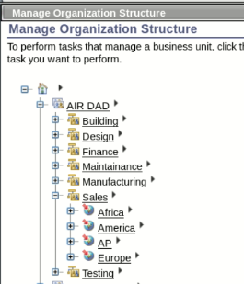

**Roles**

Admin Role (Static)

Fixed number of admins only

Supervisor Role (Dynamic)

Planning to accommodate more supervisors

**Users**

* Admins (3)
  + AIR Dhairya
  + AIR Darsh
  + AIR Aayushi
* Supervisor(7)
  + Design Supervisor
  + Manufacturing Supervisor
  + Building Supervisor
  + Testing Supervisor
  + Sales Supervisor
  + Maintenance Supervisor
  + Finance Supervisor
* Employees(374)
  + Design (19)
  + Manufacturing (39)
  + Building (102)
  + Testing (57)
  + Sales (41)
  + Maintenance (53)
  + Finance (65)

**Policy**

* Identity Policy
* Provisioning Policy
* Password Policy

**Future Implementation**

* Creation of Separation of duty policy
* Creation of Adoption policy