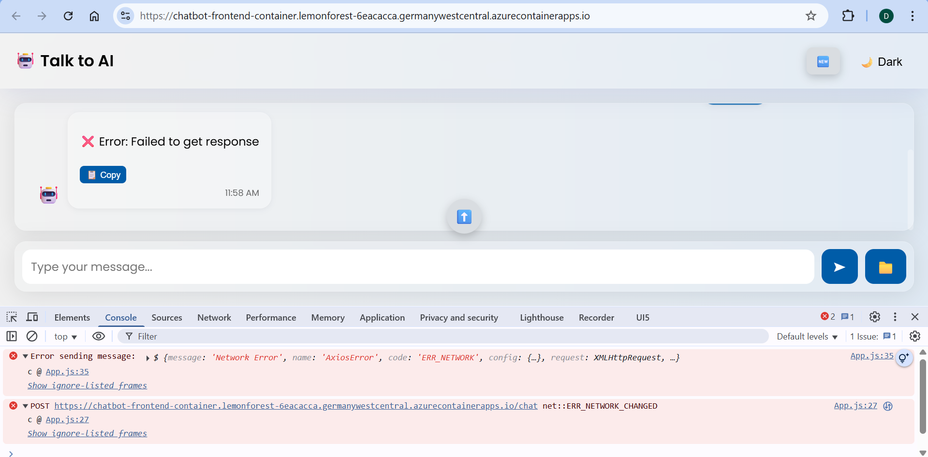

06/18/2025, 06:33:25



Deactivated apps/v1.Deployment k8se-apps/chatbot-frontend-container--0000004 from 1 to 0

06/18/2025, 06:33:25



Container 'chatbot-frontend-container' was terminated with exit code '' and reason 'ManuallyStopped'

06/18/2025, 06:27:38



Successfully pulled image "reactchatbot.azurecr.io/chatbot-frontend:latest" in 20.56s. Image size: 20971520 bytes.

06/18/2025, 06:27:38



Started container 'chatbot-frontend-container'

06/18/2025, 06:27:38



Created container 'chatbot-frontend-container'

06/18/2025, 06:27:34



Pulling image 'reactchatbot.azurecr.io/chatbot-frontend:latest'

06/18/2025, 06:27:17



Scaled apps/v1.Deployment k8se-apps/chatbot-frontend-container--0000004 from 0 to 1, triggered by

06/18/2025, 06:27:17



Replica 'chatbot-frontend-container--0000004-6987c9b698-5rtdj' has been scheduled to run on a node.

06/18/2025, 06:25:25



Deactivated apps/v1.Deployment k8se-apps/chatbot-frontend-container--0000004 from 1 to 0

06/18/2025, 06:25:25



Container 'chatbot-frontend-container' was terminated with exit code '' and reason 'ManuallyStopped'

06/18/2025, 06:16:55



Successfully pulled image "reactchatbot.azurecr.io/chatbot-frontend:latest" in 20.41s. Image size: 20971520 bytes.

06/18/2025, 06:16:55



Started container 'chatbot-frontend-container'

06/18/2025, 06:16:55



Created container 'chatbot-frontend-container'

06/18/2025, 06:16:51



Pulling image 'reactchatbot.azurecr.io/chatbot-frontend:latest'

06/18/2025, 06:16:34



Replica 'chatbot-frontend-container--0000004-6987c9b698-6szvl' has been scheduled to run on a node.

06/18/2025, 05:56:36



Container 'chatbot-backend-container' was terminated with exit code '' and reason 'ManuallyStopped'

06/18/2025, 05:56:35



Deactivated apps/v1.Deployment k8se-apps/chatbot-backend-container--0000010 from 1 to 0

06/18/2025, 05:53:10



KEDA is stopping the watch for revision 'chatbot-backend-container--0000009' to monitor scale operations for this revision

06/18/2025, 05:53:10



ScaledObject was removed from KEDA watch and would not be auto-scaled.

06/18/2025, 05:52:41



Successfully provisioned revision 'chatbot-backend-container--0000010'

06/18/2025, 05:52:39



Updating revision : chatbot-backend-container--0000010

06/18/2025, 05:52:06



Created container 'chatbot-backend-container'

06/18/2025, 05:52:06



Started container 'chatbot-backend-container'