Mongo:-

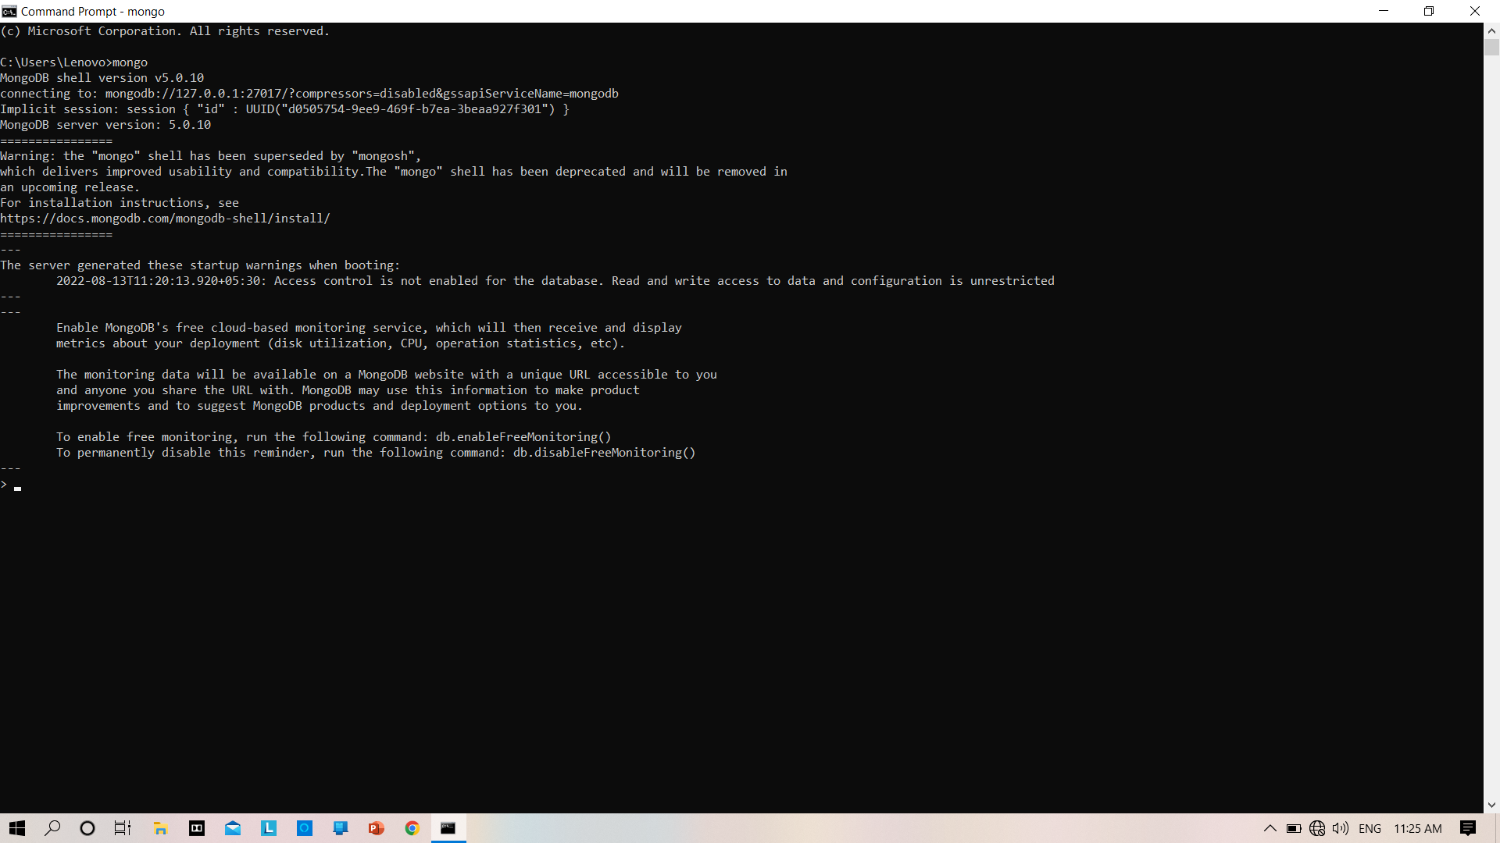

Show dbs:-

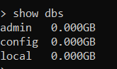

Use databasename:-

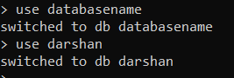

Db.creatCollection(“”) :-



Show Collections :-



Insert:-





find() :-



findOne() :-

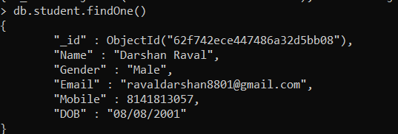

find().pretty():-

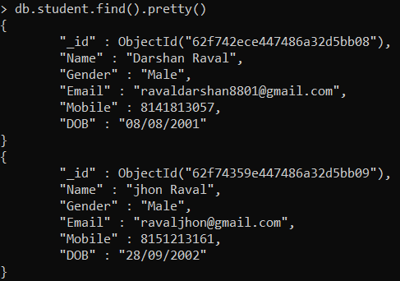

find({name:”a”}) :-



drop() :-

