Innovative Assignment
Digital electronics (2CS507)

Group members
Jimish Makwana - 22BCE125
Darsh Jodhani - 22BCE129

Aim - Braille to text converter

Braille representation :
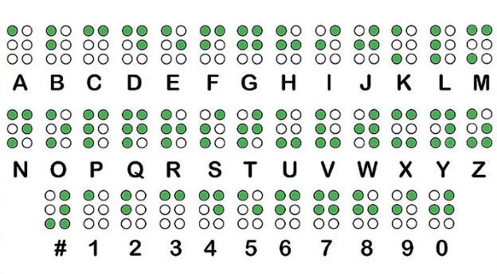

Explaination :
Steps
- Braille to Binary
- Binary to Text(16 Segment Display)
- Braille to Binary

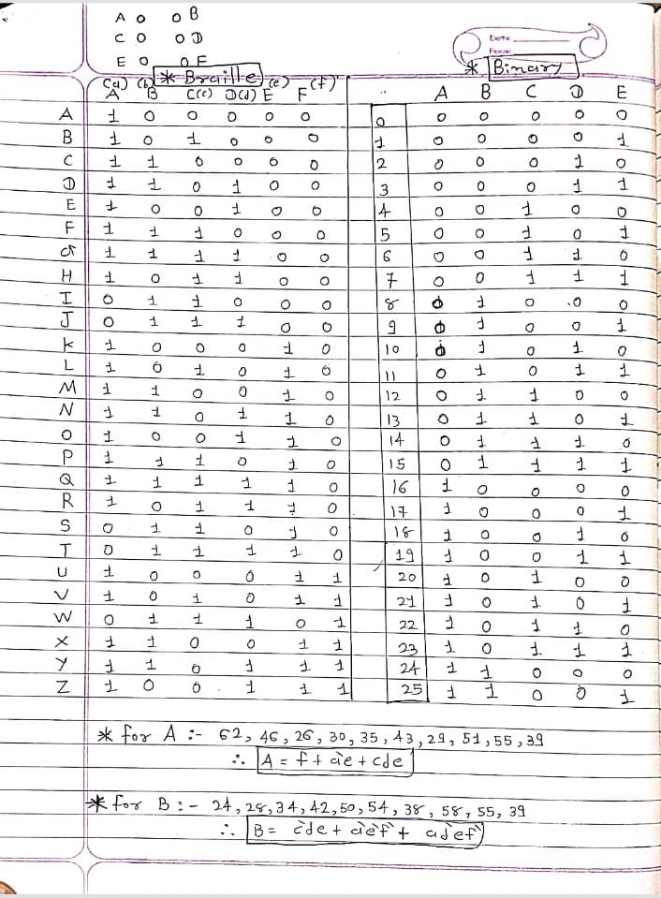



- Binary to Text(16 Segment Display)

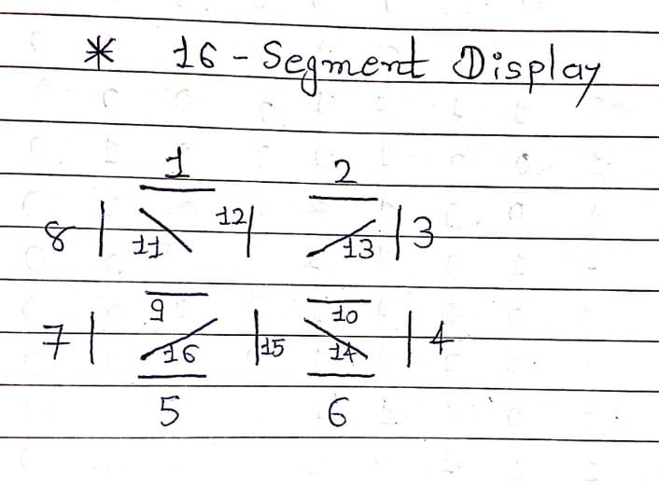

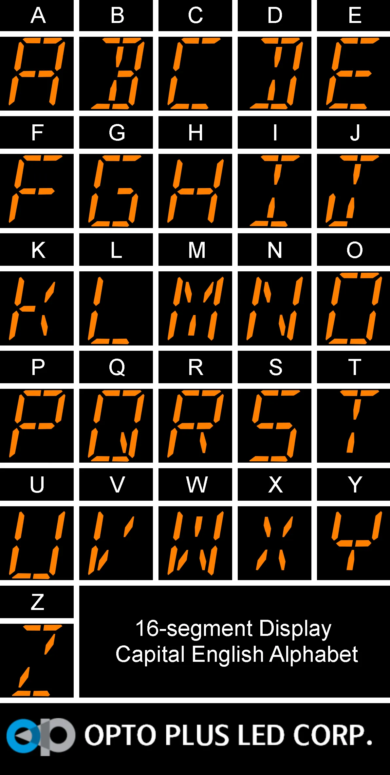
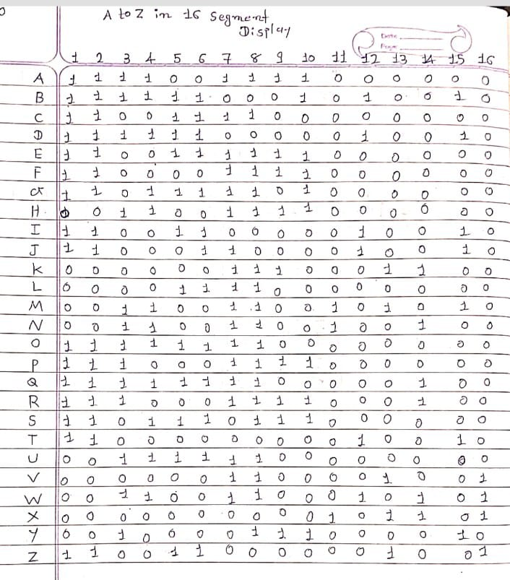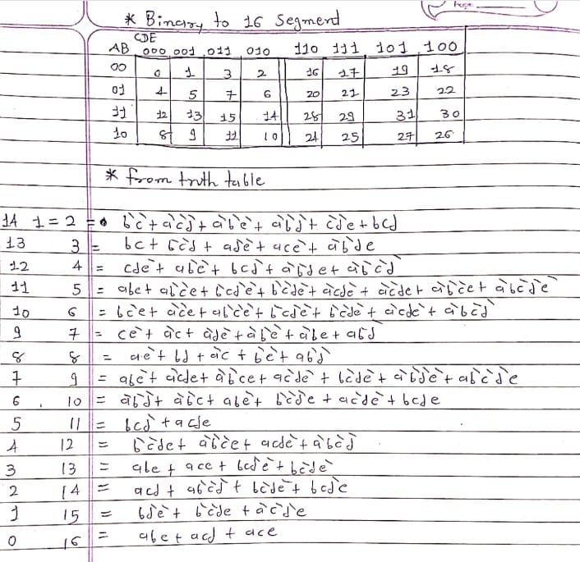

Circuit :
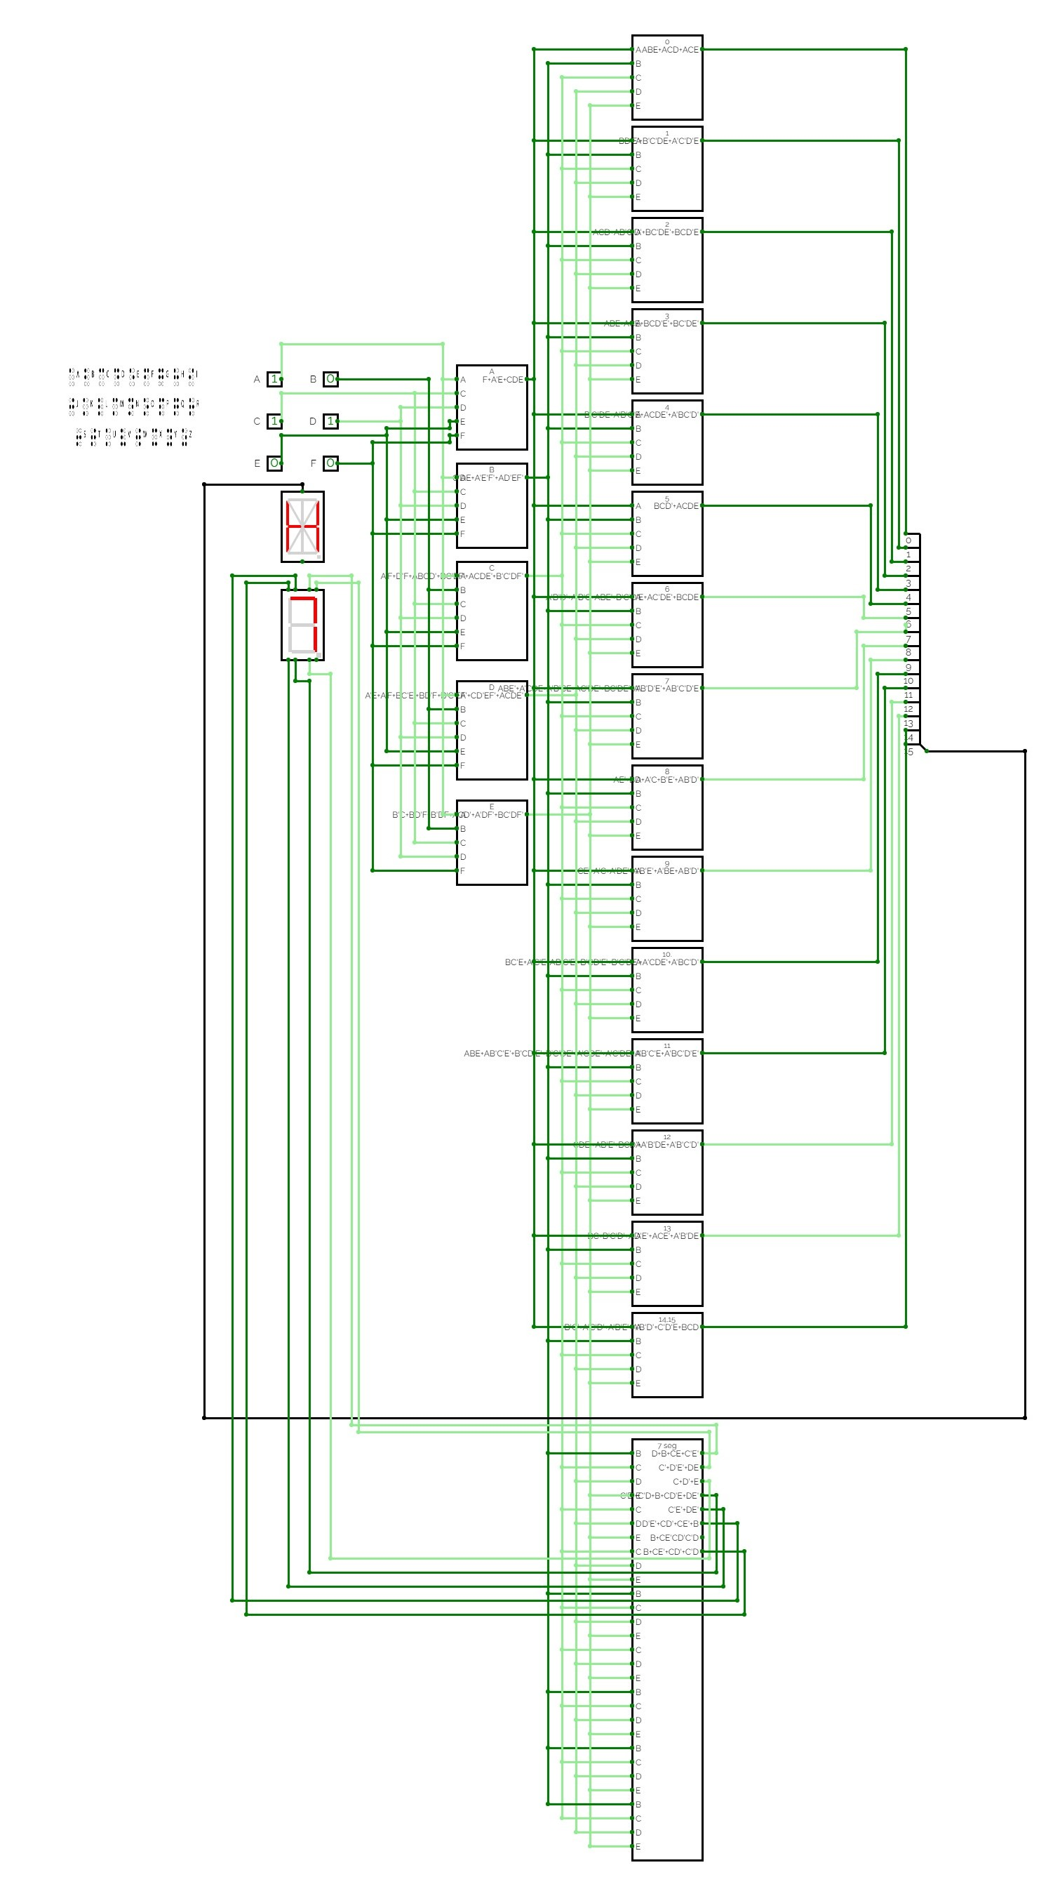
Application :
- One such application is to convert an image of paper Braille to text, translate Braille to text and text to Braille, and look up Braille contractions.
- Another application is to produce a high-quality embossed Braille textbook from an original publisher file using Liblouis, an open-source Braille translator.

Benefits:

Accessibility: The primary advantage is enhancing accessibility for visually impaired individuals. This converter would enable them to easily convert Braille characters into readable text, fostering inclusivity.

Educational Tool: It can serve as an educational tool for learning and practicing Braille. Students can use the simulator to understand the correspondence between Braille symbols and standard text.

Cost-Effective: Online simulators often eliminate the need for physical hardware, making the implementation cost-effective. This allows for wider dissemination and adoption.

Customization: Online simulators can be easily updated and customized. You can add features like different language support, learning modes, or even integration with other assistive technologies.

Limitations:

Hardware Limitations: Online simulators might not fully replicate the hardware aspects of a real-world Braille display. Hardware-specific issues or nuances may not be accurately represented.

Real-world Interaction: The tactile aspect of Braille is crucial for users to feel and interpret the characters. Simulators lack the physical interaction, potentially limiting the user experience compared to a physical Braille display.
Internet Dependency: Online simulators rely on an internet connection. This can be a limitation in areas with poor connectivity, hindering the availability of the tool when needed.

Learning Curve: Users, especially those unfamiliar with digital electronics, might face a learning curve in understanding how to operate the simulator effectively. Providing user-friendly interfaces and instructions becomes crucial.

Limited Physical Feedback: Unlike a real Braille display, which provides immediate physical feedback, an online simulator relies on visual feedback. This could be a drawback for users who heavily rely on tactile sensations.

