DEPARTMENT OF COMPUTER ENGINEERING
NBA Accredited
ACADEMIC YEAR 2025-26
Complex Engineering Problem Report
Subject: Big Data Analytics Sem: VII
Name of Student: YOUR NAME
Student ID: YOUR ID
Class/Div: BE/B - confirm
Task:
Design and implement a real-time analytics pipeline for a Smart City Transportation System that processes live data from multiple sources such as GPS trackers, IoT sensors, and weather data to predict traffic congestion and suggest alternate routes dynamically.
Title: Real-Time Analytics using Apache Spark Streaming
Problem Statement:
To develop a real-time data processing system using Apache Spark Streaming (Structured Streaming API) that collects and analyses GPS, IoT-sensor and weather data to provide congestion updates every five seconds, forecasts congestion 60 seconds ahead, and recommends alternate routes when the usual route becomes slow. The system also detects suspected accidents from the stream, and analytics are reported with R (ggplot2, Shiny). Because live city feeds are not available to students, the three data sources are produced by a simulator that also records the hidden true congestion level, which allows the accuracy of the pipeline to be measured.
Sustainability Context:
- Congestion-aware routing can reduce idling time, and therefore fuel use and local air pollution; in our demonstration an accident on one road led to a suggested detour that saves X minutes on the Andheri-Dadar trip (measured in the dashboard).
- Supports SDG 11 - Sustainable Cities and Communities (target 11.2: safe, affordable, sustainable transport systems).
- Gives transport authorities a live, data-driven view of where capacity is lost (accidents, rain) so that signal timing, public-transport and enforcement resources can be directed there.
Tools and Technologies:
- Data Ingestion: Apache Kafka 3.8 (KRaft mode), three input topics and one output topic
- Processing: Apache Spark 3.5.3 Structured Streaming (event-time windows, watermark, de-duplication, checkpointing) and Spark MLlib (RandomForest classifier, Gradient-Boosted-Tree forecaster)
- Storage: Parquet files (columnar data lake) with Spark checkpoints; HDFS-compatible - only the path changes on a cluster
- Visualization: Streamlit + Plotly live dashboard reading the Kafka output topic; R with ggplot2 (report) and Shiny (interactive analytics) reading the exported CSV
- Routing: A* and Dijkstra route search on a live-weighted road graph (Python, NetworkX)
- Programming Languages: Python 3.11 (PySpark, pandas, kafka-python) and R 4.x (ggplot2, Shiny, dplyr)
- Deployment: Docker Compose (one command starts the whole system on Windows)
Note: HDFS and Tableau/Power BI were not used. HDFS offers no benefit on a single laptop, and Tableau/Power BI cannot consume a live Kafka stream; Parquet and Streamlit were used instead.
Architecture Diagram
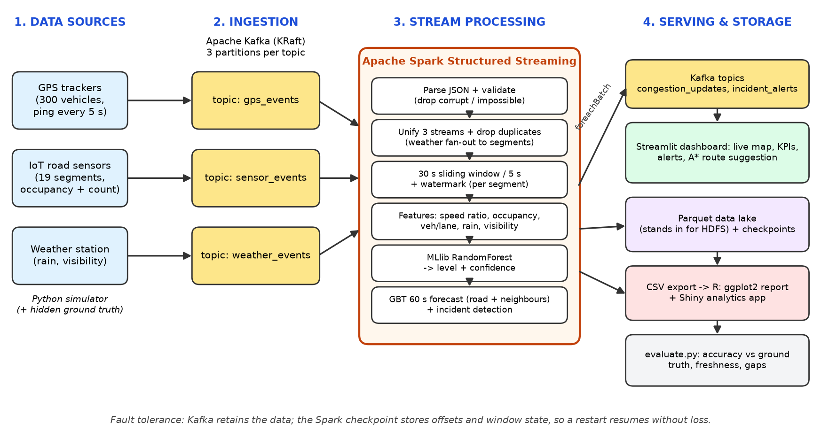
Data flow: simulator → Kafka (gps_events, sensor_events, weather_events) → Spark Structured Streaming (validate, de-duplicate, window, features, MLlib classifier, GBT forecaster, incident detection) → Kafka (congestion_updates, incident_alerts) → dashboard and A* route planner; results are also written to a Parquet data lake and a CSV that the R analytics read.
Code/Programs:
Key parts of the implementation (full source in the project folder, src/cgls/).
1. Windowed aggregation of the unified GPS + sensor + weather stream (streaming/job.py)
def window_aggregate(events: DataFrame) -> DataFrame:
return (events.withWatermark("event_ts", config.WATERMARK)
.dropDuplicates(["dedup_key", "event_ts"]) # network retries: same message twice -> once
.groupBy(F.window("event_ts", config.WINDOW_DURATION, config.SLIDE_DURATION), "segment_id")
.agg(F.avg("speed_kmph").alias("avg_speed_kmph"),
F.count("speed_kmph").alias("gps_pings"),
F.approx_count_distinct("vehicle_id").alias("vehicles"),
F.avg("occupancy_pct").alias("avg_occ"),
F.avg("vehicle_count").alias("avg_vc"),
F.avg("rain_mm_hr").alias("rain_mm_hr_raw"),
F.avg("visibility_km").alias("vis_raw")))
2. Prediction with the trained MLlib RandomForest (streaming/job.py)
def predict(feat: DataFrame, model: PipelineModel) -> DataFrame:
p = model.transform(feat).withColumn("proba", vector_to_array("probability"))
score = sum(F.col("proba")[i] * LEVEL_MIDPOINTS[i] for i in range(4))
return (p.withColumn("level", F.col("prediction").cast("int"))
.withColumn("confidence", F.array_max("proba"))
.withColumn("score", score)
.select("segment_id", "name", "window_start_ms", "window_end_ms",
"avg_speed_kmph", "free_flow_kmph", "speed_ratio", "occupancy_pct", "veh_per_lane",
"rain_mm_hr", "visibility_km", "gps_pings", "vehicles", "level", "confidence", "score"))
3. Incident detection rule and learned forecast input (streaming/job.py, ml/forecaster.py)
# incident: speed collapses while sensor occupancy jumps
if not active and drop >= 0.20 and rise >= 15.0 and speed_ratio < 0.65:
raise_alert(segment) # published once on Kafka topic incident_alerts

# forecast features: own history + neighbouring roads + weather -> GBT predicts congestion 60 s ahead
FORECAST_FEATURES = ["speed_ratio", "occupancy_pct", "speed_ratio_l15", "speed_ratio_l30", "speed_ratio_l45",
"occupancy_l15", "occupancy_l30", "occupancy_l45", "rain_mm_hr", "visibility_km",
"nb_mean_ratio", "nb_min_ratio"]
4. Starting the streaming query with checkpointing (streaming/job.py)
query = (result.writeStream.outputMode("append")
.foreachBatch(BatchProcessor(spark))
.option("checkpointLocation", "/checkpoints/congestion_v1")
.trigger(processingTime="5 seconds")
.start())
query.awaitTermination()
5. A* route search with an admissible heuristic (routing.py)
def search(g: nx.Graph, origin: str, dest: str, use_heuristic: bool = True):
"""A* (use_heuristic=True) or Dijkstra (False). Returns (Route, number_of_nodes_expanded)."""
h = _heuristic if use_heuristic else (lambda a, b: 0.0)
best = {origin: 0.0}
parent: dict[str, str] = {}
heap = [(h(origin, dest), 0.0, origin)]
done: set[str] = set()
while heap:
_, cost, u = heapq.heappop(heap)
if u in done:
continue
done.add(u)
if u == dest:
path = [u]
while path[-1] in parent:
path.append(parent[path[-1]])
return _as_route(g, path[::-1]), len(done)
for v in g[u]:
nc = cost + g[u][v]["minutes"]
if nc < best.get(v, float("inf")):
best[v], parent[v] = nc, u
heapq.heappush(heap, (nc + h(v, dest), nc, v))
6. R: congestion heat map with ggplot2 (r/analysis.R)
p1 <- ggplot(df, aes(time, factor(name, levels = road_order), fill = score)) +
geom_tile() +
scale_fill_gradientn(colours = unname(LEVEL_COL), limits = c(0, 1), name = "congestion score",
values = rescale(c(0, 0.25, 0.5, 0.75))) +
labs(title = "Congestion heat map", subtitle = "each tile = one 30 s window, one road", x = "time (UTC)", y = NULL) +
theme_cgls()
Expected Screenshots:
Sample of the console output printed by the Spark job every five seconds (format to expect; replace it with your own screenshot):
============================================================================================================
Batch 13 | window ending 2026-10-03 14:23:55 UTC | 19 window rows | result is 11.6s old
============================================================================================================
segment road gps speed km/h occ % rain NOW conf in 60s
S05 Santacruz-Bandra 102 12.9 90.0 1.2 SEVERE 100% SEVERE
S06 Bandra-Mahim 58 23.9 55.0 1.2 HEAVY 84% HEAVY
S15 Bandra-Kurla 74 30.2 53.0 1.2 MODERATE 68% HEAVY
S01 Borivali-Malad 103 44.3 38.0 1.2 MODERATE 97% MODERATE
Insert screenshot 1: docker compose ps - all services running
Insert screenshot 2: Spark console table - normal traffic
Insert screenshot 3: Spark console table - accident on S05 (SEVERE)
Insert screenshot 4: Live dashboard - normal traffic
Insert screenshot 5: Live dashboard - accident, with suggested alternate route and minutes saved
Insert screenshot 6: Spark UI, Structured Streaming tab (input rate, batch duration)
Insert screenshot 7: Kafka console-consumer showing messages of the input topics and congestion_updates
Insert screenshot 8: File Explorer - Parquet data lake (data/lake/segment_congestion)
Insert screenshot 9: Model training output (accuracy vs. speed-only baseline)
Insert screenshot 10: Forecaster training output (GBT vs. baselines)
Insert screenshot 11: Console line 'INCIDENT SUSPECTED' and the red alert on the dashboard
Insert screenshot 12: R: ggplot2 charts (heat map, incident timeline, forecast quality) and the Shiny app
Testing & Validation:
Fill the 'Actual Result' column only with what you observed when you ran each test (commands in README.md, section 5).
Test Case Scenario | Expected Result | Actual Result
1. Stream simulated GPS, sensor and weather data through Kafka | A new congestion table for all 19 roads every 5 s; result age about 10-12 s | observed batch interval and 'result is N s old'
2. Send corrupt records (invalid JSON, speed -5 or 999, missing segment) | Records are dropped; the job keeps running | observed
3. Simulated accident on Santacruz-Bandra (S05) | S05 reaches HEAVY within about 30-40 s; incident alert within about 60 s; no alert on other roads | seconds until HEAVY / until alert; false alarms
4. Route Andheri → Dadar before and during the accident | Suggested route changes and shows minutes saved | usual vs. best route, minutes
5. Heavy rain (12 mm/h) starts | Rain value rises; congestion estimates increase | observed
6. Kill the Spark container for ~40 s, then restart it | Resumes from the checkpoint; no gaps in 5-second windows | window_sequence_gaps = ?
7. Increase input from ~100 to ~1000 messages/s | Batch duration stays below the 5 s trigger | input rate, batch duration, result age
8. Compare estimates with simulator ground truth (evaluate.py) | High accuracy for 'now'; forecast compared with naive baseline | accuracy now / forecast / baseline / freshness p50, p95
9. Run automated tests (pytest) | All tests pass | N passed ?
10. Send every GPS message twice (network retry) | A 30 s window counts each ping once | observed / test passes
11. Compare the GBT forecaster with 'nothing changes' and linear-trend baselines on unseen simulated worlds | GBT has lower error | RMSE and level accuracy of the three
12. A* versus Dijkstra on random speed patterns | Same route cost; A* expands no more junctions | automated test result
13. Generate the R report and open the Shiny app | 8 PNG charts; app refreshes by itself | observed

Conclusion:
A real-time pipeline built on Kafka and Spark Structured Streaming ingests three heterogeneous streams, validates them, aggregates them in 30-second event-time windows that slide every five seconds, and uses a Spark MLlib RandomForest to estimate the congestion level of each road, a Gradient-Boosted-Tree model to forecast it 60 seconds ahead from the road's own history and its neighbours, and a rule to flag suspected accidents. On simulated data the estimate matched the hidden true level in X% of windows (a speed-only rule: Y%), and results were published about Z seconds after the end of each window; the 60-second forecast had an error of E1 against E2 for the naive 'nothing changes' guess. A dashboard and an A*-based route planner turn the live estimates into alternate-route suggestions; during a simulated accident the suggested detour saved M minutes. Checkpointing allowed the job to restart after a forced failure without gaps. R (ggplot2 and Shiny) provided the exploratory analytics on the exported results.
Limitations: the data is simulated and the model is trained on synthetic data; the 60-second trend forecast performed better than / about the same as the naive baseline but the gain is modest because most congestion simply persists; the incident rule is hand-tuned; Spark ran in local mode, so multi-machine scaling was not demonstrated. Future work: real city feeds, an ML forecaster on lagged features, a Spark cluster, an LSTM forecaster, MQTT-connected sensors, and routing that accounts for the effect of many drivers rerouting at once. Apache Flink was considered for stream processing; Spark Structured Streaming was used because the problem statement specifies Spark and it provides the required event-time windows, watermarks and checkpointing.

