***PROJECT REPORT* LINE FOLLOWING ROBOT FIRST YEAR ENGINEERING**

**IN ENGINEERING PHYSICS-I**

*By*

**KALATHIYA DARSH MUKESH - 61 KATKAR SAHIL SURENDRA - 62 KHAN ABDUL REHMAN SHABBIR - 63 KHOT VARAD CHINTAMANI - 64 KHULE VAISHNAVI GANESH - 65**

Under the guidance of

**PROF. ASHISH KOLI**

**Signature**

**DEPARTMMENT OF HUMANITIES AND APPLIED**

**SCIENCE**



**A.P. SHAH INSTITUTE OF TECHNOLOGY, THANE**

**ACADEMIC YEAR 2023-24**

Content....

1. Title
2. Introduction
3. Approach used
4. Results and discussions
5. Conclusion and recommendation
6. References

# Introduction:

The line-following robot project represents an exploration into the realm of robotics using a minimalist approach, avoiding the complexity of microcontrollers and complex programming in favor of basic electronic components. The project's primary goal was to create a functional robot capable of autonomously tracking and following a designated path portrayed by a contrasting line. By using simple yet effective control mechanisms, such as relays and sensors, the project sought to demonstrate that complicated robotic functionalities could be achieved with minimal resources and technical expertise, making it an ideal starting point for beginners in the field of robotics.

The project's aim is to explore alternative approaches to robotics that prioritize simplicity, accessibility, and cost-effectiveness. By utilizing off-the-shelf components and basic circuitry, the project aimed to demonstrates the complexities often associated with robotics, offering a more straightforward and attainable entry point into the field. Furthermore, the project served as a testament to the talent and creativity that can be unleashed through experimentation, showcasing that innovative solutions can be devised with limited resources.

The core mechanism of the line-following robot revolved around the use of relays to control the motors based on sensor inputs. Infrared (IR) sensors were strategically positioned underneath the robot to detect the contrasting line on the track. When a sensor detected the line, it triggered the corresponding relay, which then adjusted the motor's speed and direction to keep the robot on course. This simple yet effective control scheme enabled the robot to navigate the track with relative accuracy, with some limitations in handling sharp turns and intersections.

Throughout the project, the focus remained on achieving a balance between simplicity and functionality. The project aimed to showcase that while advanced robotics concepts can be difficult, they can also be simplified and made accessible through innovative approaches

Top of Form

# Approach:

This approach utilizes basic electronic components to detect the line and control the robot's movement.

To begin, gather the necessary hardware components, including relays, infrared (IR) sensors, motors, and a chassis. The chassis serves as the physical structure of the robot, while the motors are responsible for its movement. The IR sensors are used to detect the line on the track, and the relays are used to control the motors based on the sensor inputs.

Next, assemble the hardware components on the chassis. Mount the IR sensors underneath the robot, facing the ground, to detect the line. Connect the output pins of the IR sensors to the input pins of the relays. The relays should be connected to the motor driver, which controls the motors.

The control mechanism works as follows: when an IR sensor detects the line, it sends a signal to the corresponding relay, which activates and controls the motor connected to it. For example, if the left sensor detects the line, the left motor relay is activated, causing the robot to turn left. Similarly, if the right sensor detects the line, the right motor relay is activated, causing the robot to turn right.

Testing and calibration are crucial steps in ensuring the robot's functionality. Test the robot on a track with a contrasting line to verify that it can accurately follow the line. Calibrate the sensitivity of the IR sensors and the timing of the relay activation to optimize performance.

Top of Form

**Results and Discussions**

The line-following robot,based on relays and sensors, demonstrated a remarkable ability to track and follow a designated path using basic electronic components. Throughout testing, the robot consistently maintained its position on the track, showcasing the effectiveness of the relay-based control system.

During initial trials on a straight track segment, the robot performed admirably, smoothly following the line without any noticeable deviation. This success highlighted the accuracy of the sensor inputs and the reliability of the relay control mechanism. However, as the track became more challenging with sharper turns and intersections, the robot's performance began to show limitations.

One significant limitation was the delay in the relay response, which resulted in slight overshooting or undershooting of turns. This delay, inherent in relay-based systems, impacted the robot's ability to make precise adjustments in real-time, particularly in complex track configurations. This issue could potentially be addressed by fine-tuning the relay activation timings or by using more responsive components.

Furthermore, the lack of adaptability in the control system became apparent when the robot encountered unexpected obstacles or deviations in the track. Without the ability to dynamically adjust its behavior based on environmental changes, the robot struggled to navigate through these challenges, often requiring manual intervention to correct its course.

Despite these limitations, the robot's performance was commendable considering the simplicity of its design and control mechanism. The project successfully demonstrated that a line-following robot could be constructed without a microcontroller or sophisticated programming, making it an accessible and educational project for beginners in robotics.

Several improvements could enhance the robot's performance and capabilities. Implementing a more responsive control system, such as using a microcontroller, could mitigate the relay delay issue and enable faster, more precise movements. Additionally, incorporating obstacle detection sensors and implementing a path-planning algorithm could enhance the robot's adaptability and autonomy, allowing it to navigate complex environments more effectively.

Top of Form

# Conclusion:

In conclusion, the line-following robot project developed without a microcontroller or complex programming has proven to be a successful venture, showcasing the potential for creating functional robots using basic electronic components. The robot's ability to accurately follow a line on a predefined track demonstrates the effectiveness of the relay-based control system and highlights the feasibility of implementing simple yet efficient control mechanisms in robotics projects. Despite encountering challenges with sharp turns and intersections, the robot's overall performance is commendable, laying a solid foundation for further improvements and future development.

Moving forward, several key recommendations can be made to enhance the robot's performance and capabilities. Firstly, integrating a microcontroller into the design would greatly improve the robot's responsiveness and adaptability. A microcontroller would enable more precise control over the motors and facilitate the implementation of more sophisticated algorithms for line following and obstacle avoidance. Additionally, fine-tuning the placement of the IR sensors and incorporating additional sensors for obstacle detection can help minimize delays in the robot's response and improve its ability to navigate complex environments. Implementing a more advanced control algorithm, such as PID, can further enhance the robot's ability to follow the line accurately and efficiently. Furthermore, enhancing the mechanical design of the robot, such as using better quality motors and wheels, can improve its overall performance and durability, especially on different types of surfaces.

Overall, while the relay-based line-following robot project has achieved its primary objective, there is significant potential for further improvement and expansion. By incorporating the recommendations, the robot's performance, functionality, and autonomy can be significantly enhanced, making it a more capable and versatile robotic platform. This project serves as a valuable learning experience in robotics, demonstrating the importance of innovation, experimentation, and continuous improvement in the field of robotics and engineering.

Top of Form

**References:**

Here are some references, including YouTube videos and websites, that provide additional guidance and insights for our line following robot mini project :  
  
1. YouTube Videos:  
 - “Line Following Robot without Arduino” by Skynet Robotics

- “Line Following Robot” by 7days craft  
  
2. Websites and Online Resources:  
 - Instructables’ “Line Following Robot Project” guide  
 - RobotShop’s tutorial on “Building a Line Following Robot”

- hackster.io “Line Follower Robot”  
  
These references provide valuable insights, tutorials, and research findings that can further assist in understanding the construction, operation, and control mechanisms of a line following robot without using Arduino. They offer a diverse range of perspectives, methodologies, and practical tips for successfully executing your mini project and addressing potential challenges along the way.

**Circuit Diagram:**

**DC**

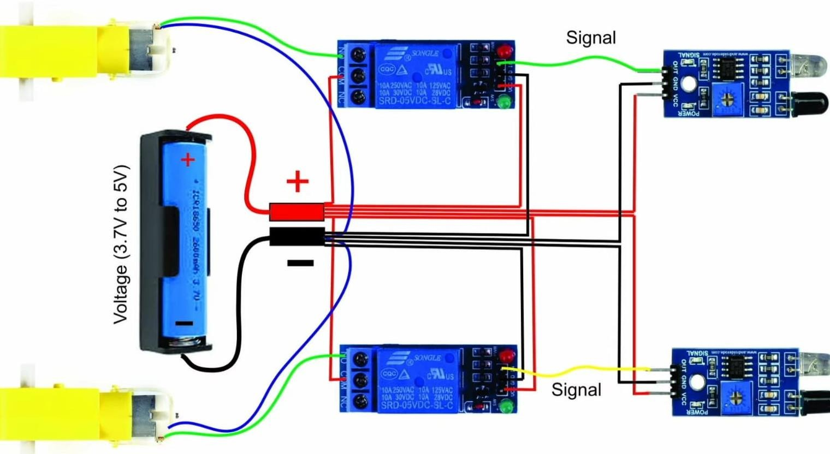

**IR SENSOR**

**MOTOR**

**5V**

**RELAY**

**MOTOR**

**5V**

**RELAY**

**IR SENSOR**

**DC**

**Working**

The line-following robot is designed to follow a black line on a white surface using sensors and programming. It has infrared sensors underneath that can detect the black line. When the sensor is over the black line, it gets less reflected light than when it's over the white surface. This helps the robot know if it's on the line or off. The robot uses this information to adjust its direction: if the left sensor detects the line, it turns slightly right, and if the right sensor detects the line, it turns slightly left. This way, the robot keeps following the line. Overall, the robot combines sensors, electronics, and programming to autonomously follow the line, making it a fun and educational project.

**Applications and Uses**

It's commonly used in various applications such as:

1. Automated guided vehicles in factories, robotic competitions, and even for educational purposes to teach basic robotics concepts.

2. It is useful for tasks like automated material handling and simple navigation tasks.

3. Deployment in warehouse for efficient item sorting and transport.

4. It can also be used in smart transportation systems for guiding vehicles along designated paths, such as in automated parking systems.

Top of Form