Create A data Base :

**$sql = "CREATE DATABASE dbdarsh";**

**$result = mysqli_query($conn, $sql);**

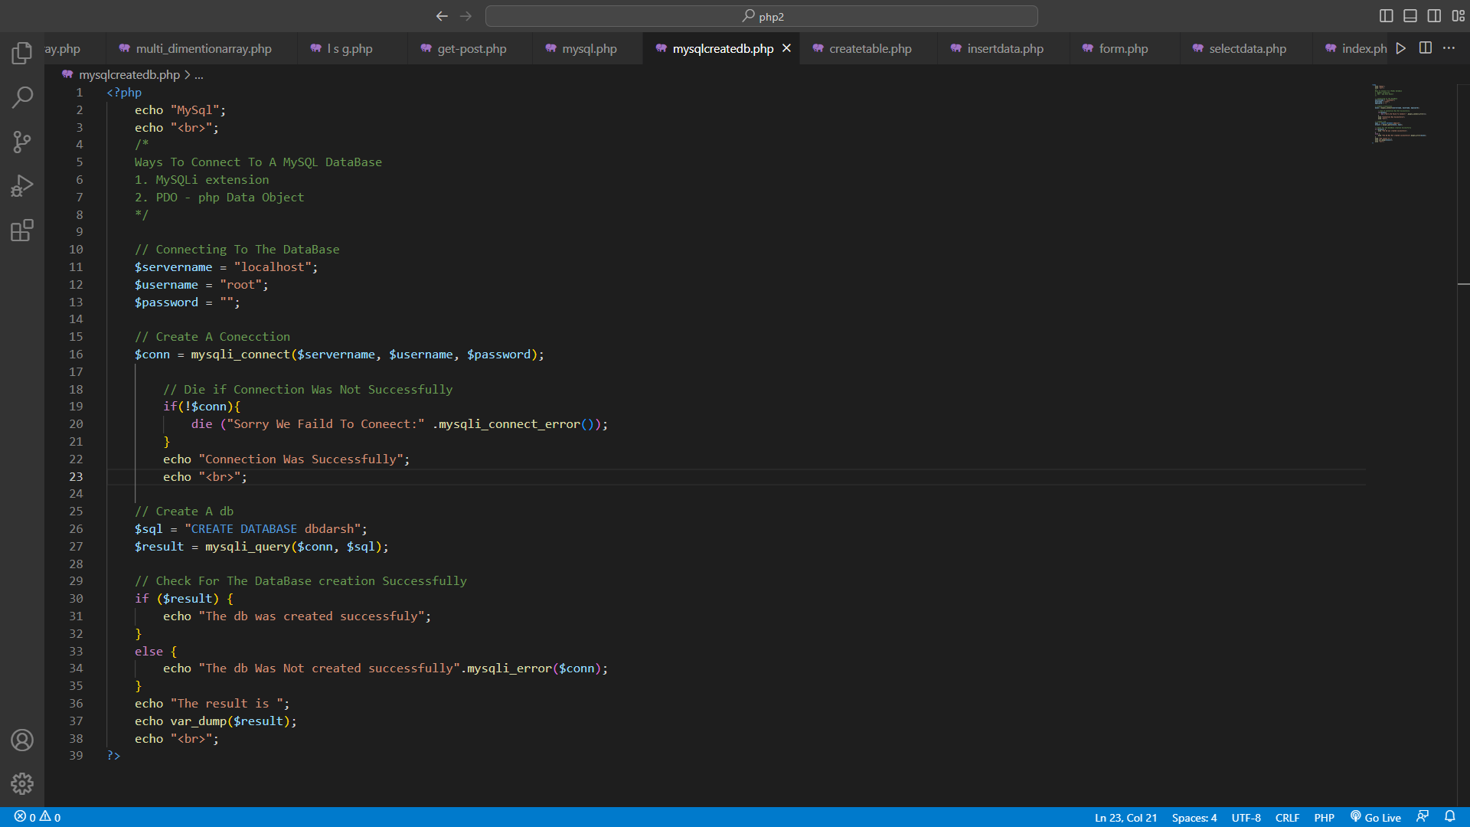

Create A Table :

$sql = "CREATE TABLE `phptrip` (`sno` INT NOT NULL AUTO_INCREMENT , `name` VARCHAR(255) NOT NULL , `dest` VARCHAR(11) NOT NULL , PRIMARY KEY (`sno`))";

$result = mysqli_query($conn, $sql);