Enterprise Log Intelligence Platform
Conceptual Architecture Blueprint
Agentic Root-Cause-Analysis Engine
A component and data-flow view of the RCA engine: a deterministic reduction stage that collapses high-volume multi-tenant logs into a small, cited evidence set, and an agentic stage that plans retrieval and narrates verified findings.
System | Enterprise Log Intelligence Platform — Root Cause Analysis Engine
Document | Conceptual Architecture Blueprint
Reference | ARC-RCA-001
Version | 1.0
Status | Issued for review
Date | 18 June 2026
Owner / Author | Darshak Kakani
Intended audience | Platform Engineering · Site Reliability · Applied AI
Classification | Confidential
Revision history
Version | Date | Author | Summary
1.0 | 18 June 2026 | Darshak Kakani | Initial design, prototype and validation against both incident scenarios.
Confidential. For internal review only.

Table of Contents

1. Purpose & Organising Idea
This blueprint shows how the components fit together; the companion Technical Design Document explains why. The single organising idea:
A deterministic reduction stage collapses the haystack before any AI touches it; the AI then plans retrieval and narrates verified evidence.

2. System Overview
Raw multi-tenant streams flow through a deterministic ingestion plane into a three-plane store; a LangGraph agent queries that store and synthesises a cited answer. No raw log line ever reaches the LLM.
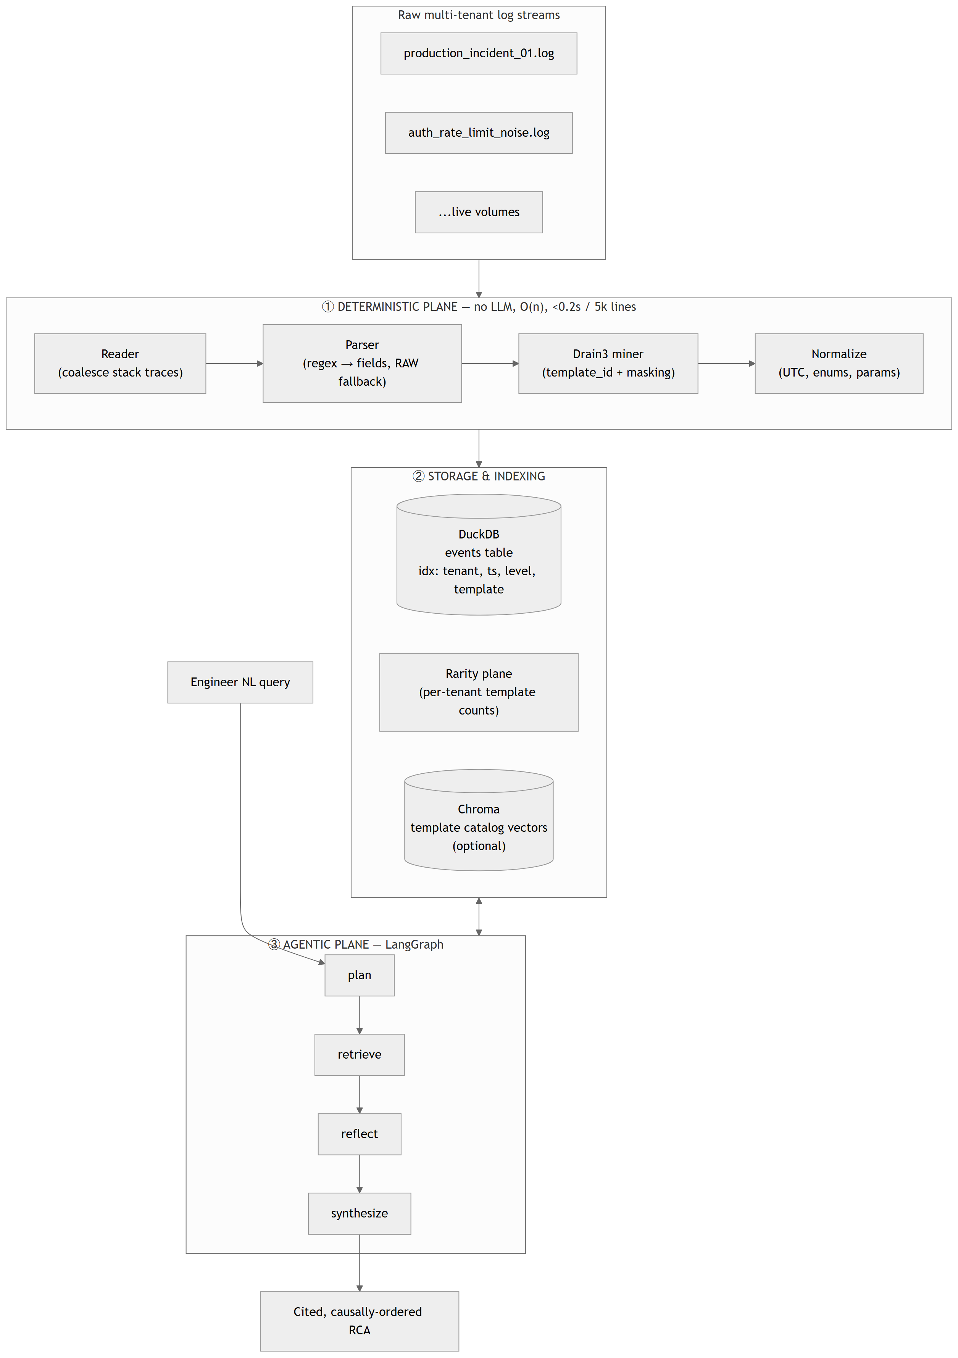
Figure 1 — End-to-end system overview: deterministic plane → storage & indexing → agentic plane.

3. The Deterministic ↔ LLM Boundary
The core design decision. Anything exact (parse, filter, count, sort, classify by time) is code; only query interpretation and narration are the model’s — and narration is verified against retrieved evidence before it is trusted.
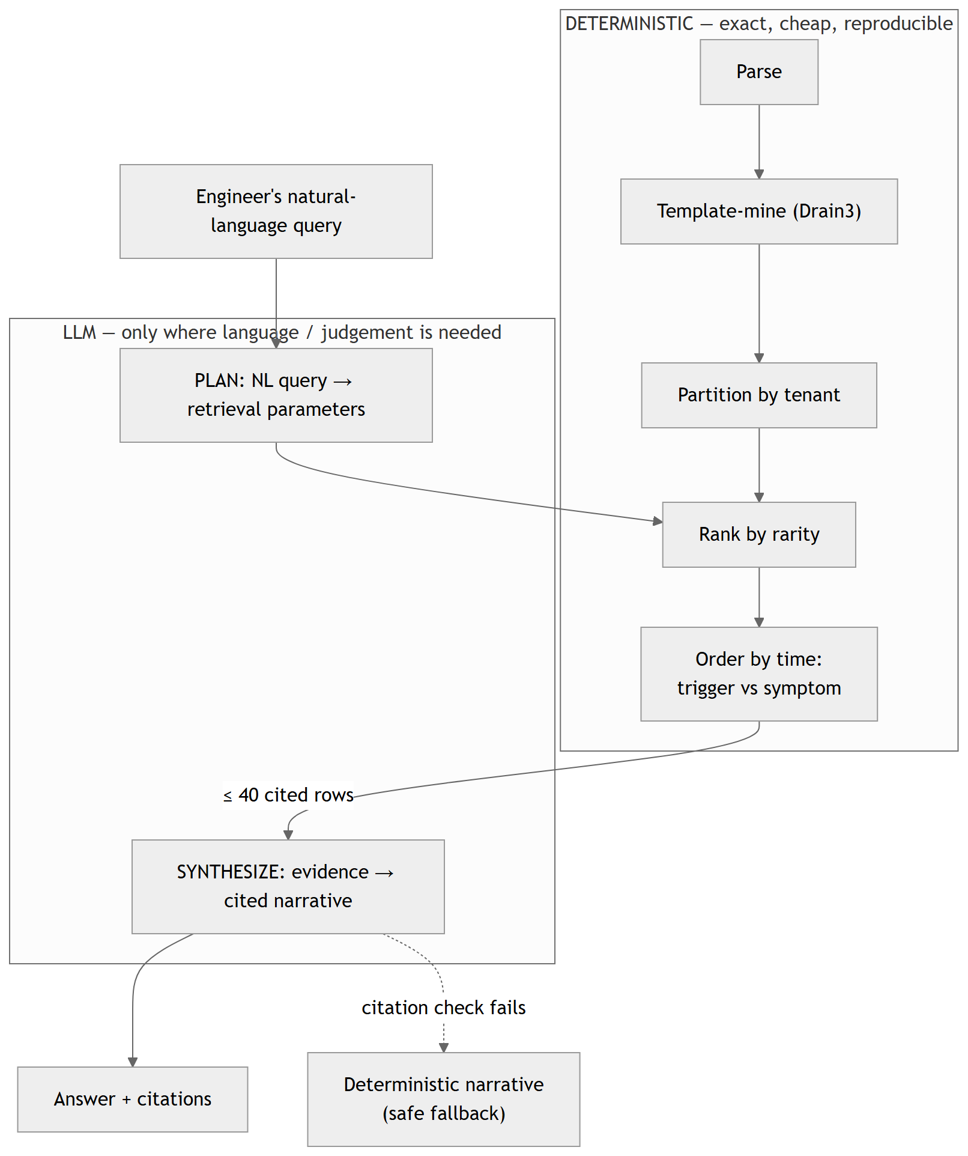
Figure 2 — Division of labour: deterministic operations feed a bounded, cited evidence set to the LLM; failed citation checks fall back to a deterministic narrative.

4. Agent Retrieval Loop
The agent is a four-state machine. plan extracts retrieval parameters (rejecting invented tenants); retrieve runs deterministic tools and is symptom-anchored to defeat the “16:10” trap; reflect widens scope once if nothing surfaced; synthesize produces an evidence-grounded, citation-verified narrative.
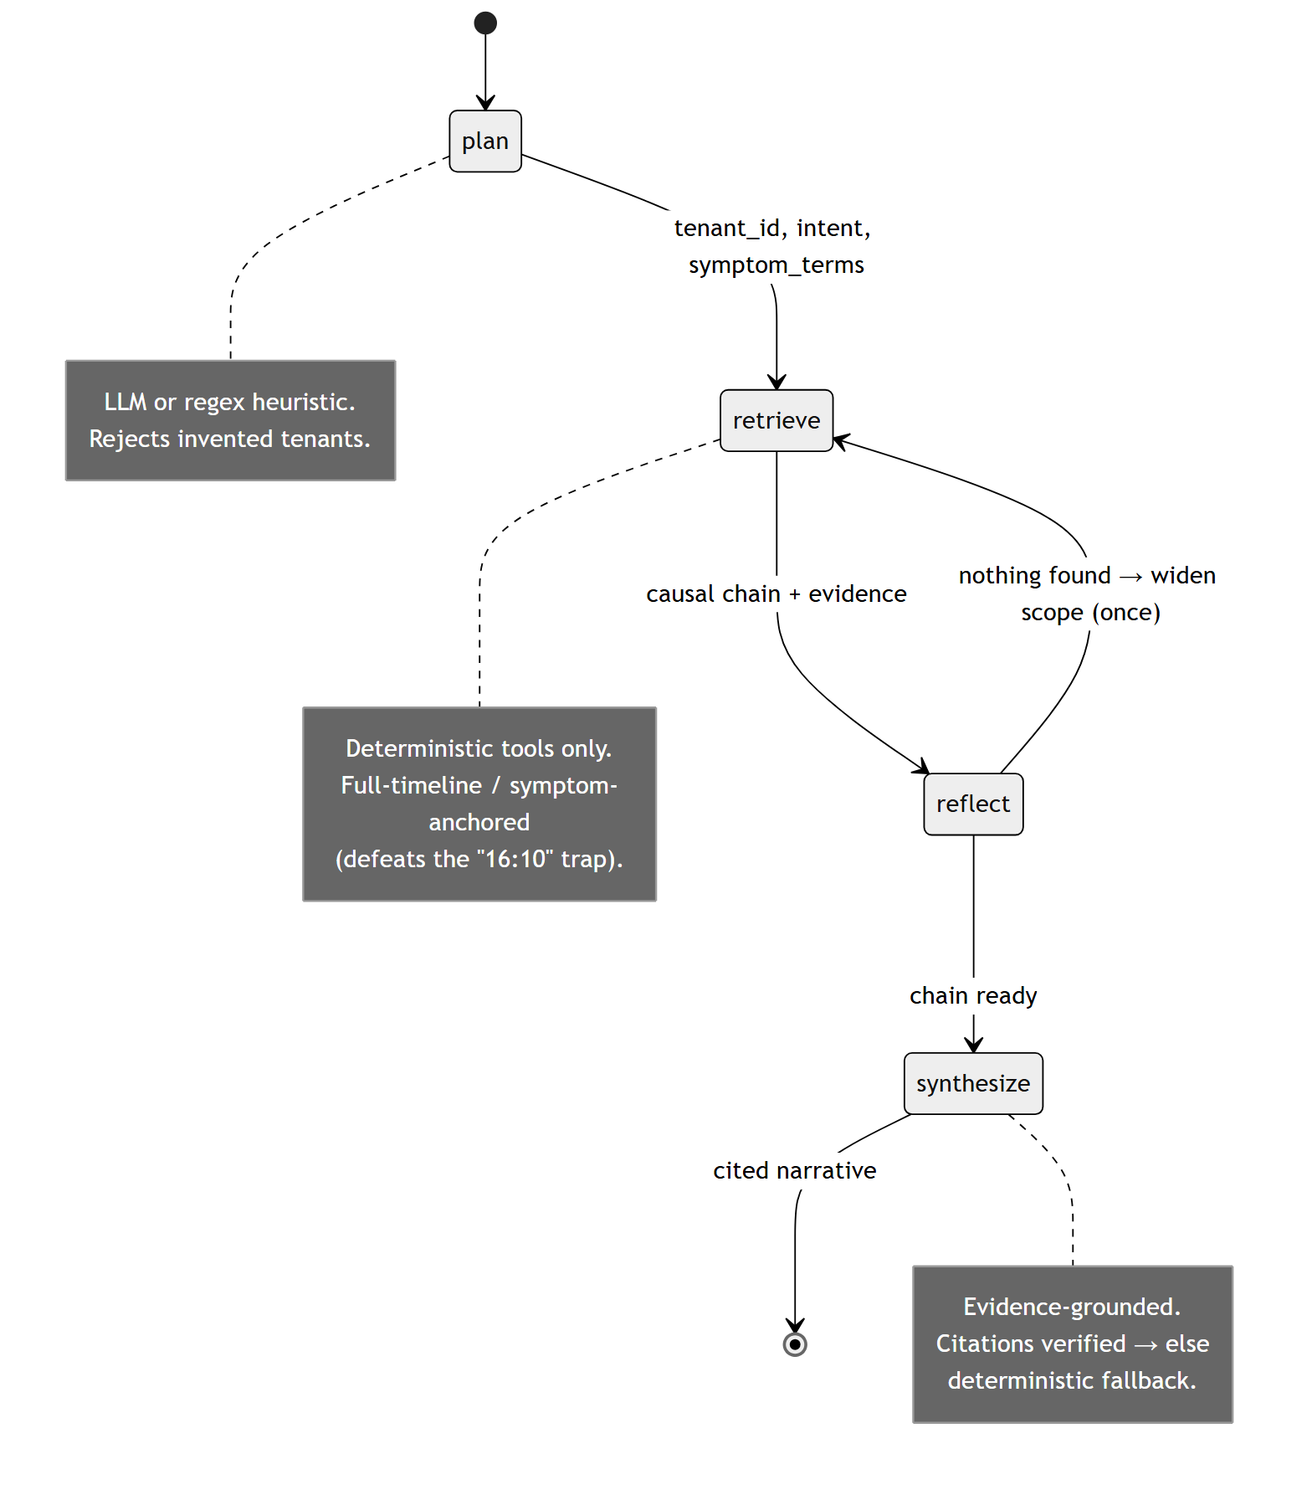
Figure 3 — LangGraph state machine: plan → retrieve → reflect → synthesize.

5. Scenario 1 — Chronological Trigger Extraction
Rarity ranking floats the 1-line connection-pool timeout above the 237-line 503 flood; a causal-window check proves the trigger preceded the symptoms.
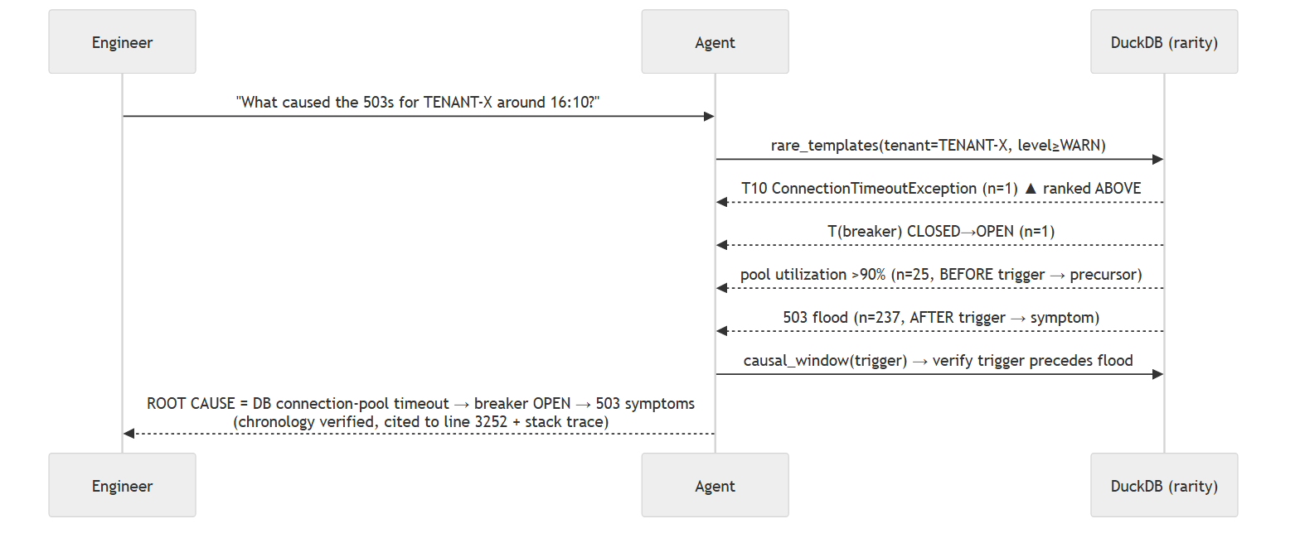
Figure 4 — TENANT-X: isolating the low-frequency initiator from the dense downstream 503 flood.

6. Scenario 2 — High-Volume Noise Demultiplexing
Tenant partitioning makes the buried 2-line TENANT-Z anomaly trivially findable and keeps TENANT-Y’s 1,799-line flood out of the context window entirely.
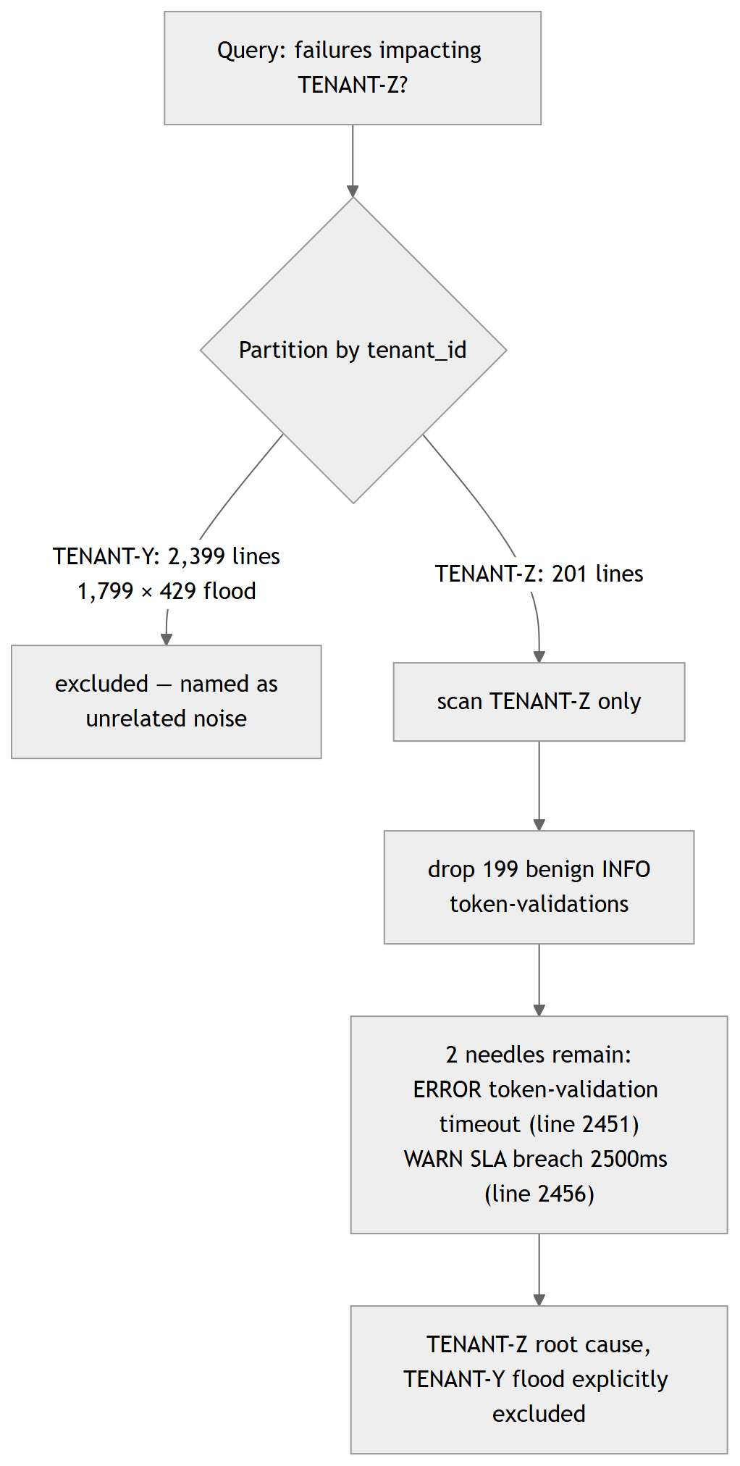
Figure 5 — TENANT-Z vs TENANT-Y: partition-first demultiplexing avoids false-positive correlation.

7. Data Lineage & Anti-Hallucination
Every sentence in the final report is traceable to a verbatim log line; an unsupported citation can never survive into the answer.
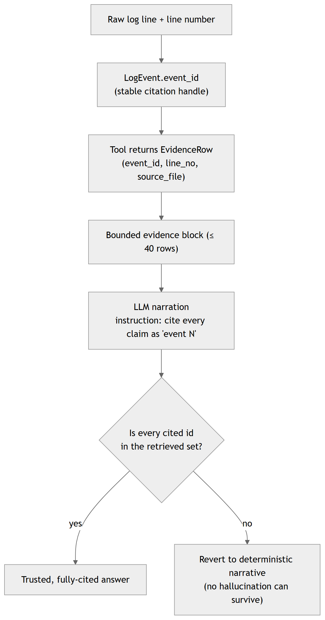
Figure 6 — Lineage chain: raw line → event_id → tool → bounded context → narration → citation check → trusted answer or deterministic fallback.

8. Deployment View (Prototype → Production)
The prototype runs fully on a laptop (embedded DuckDB, in-process Chroma, BYOK LLM). The same interfaces scale to a streaming, multi-worker production topology.
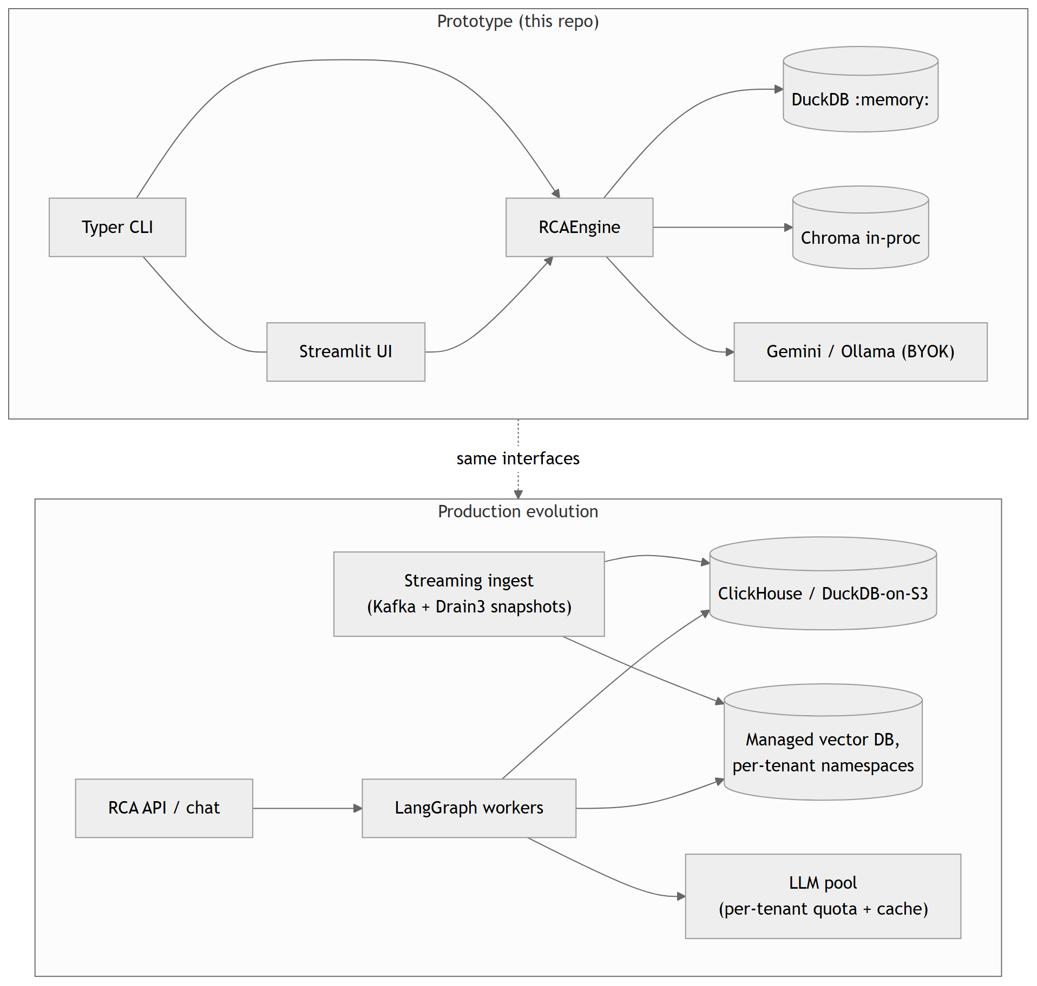
Figure 7 — Evolution from the local prototype to a production streaming/serving topology behind identical interfaces.

9. Component Responsibilities (Quick Reference)
Module | Responsibility
ingest/ (reader, parser, drain_miner, normalize) | Deterministic raw→canonical LogEvent pipeline
store/ (schema, duckdb_store, vector_store) | Three indexing planes: structural, rarity, semantic
agent/ (llm_provider, tools, prompts, graph) | BYOK provider + retrieval tools + LangGraph loop
synth/ (causal, report, lineage) | Verifiable causal chain + cited report + citation guard
cli.py / webapp.py / pipeline.py | Interfaces and one-call wiring

