Screens and Book View
Booklet View · phases 2 and 3 · 4 October 2026
This document records the discussion of 4 October 2026 about signing in and entering data, and the second and third build steps that followed: the editing screens and the book view. The page-flip animation is not part of this step.

1. What was decided
- Accounts: only an admin creates user accounts.
- Signing in: one sign-in page is used by both admins and users. What a person can do after signing in depends on their role.
- Entering data: a user can upload an Excel or CSV file, or add tables and columns and type the data in directly. Uploading a photo of a paper page stays in the plan as the last upload stage.
- Showing data: once the tables are entered or edited, they are read as a book.
One point to confirm. The request was for a "sign-up page for both the admin and the user". Because only an admin creates accounts, this was built as a sign-in page, with no page where a visitor registers by themselves. If self-registration is wanted, it can be added.

2. What was built
Screen | What it does
Sign in | Username and password, for admins and users alike.
Books | The shelf. Each book is shown as a cover. An admin sees every user’s books, with the owner’s name under each.
Book | The tables of one book along the top, and the chosen table below as a grid to type into. Upload, add table, book settings and "Read as book" are here.
Read as book | The book on its own, with nothing else on the screen.
Trash | Everything that was deleted, each with a Restore button.
Users | Admin only. Create accounts, change roles, switch an account on or off, set a new password.

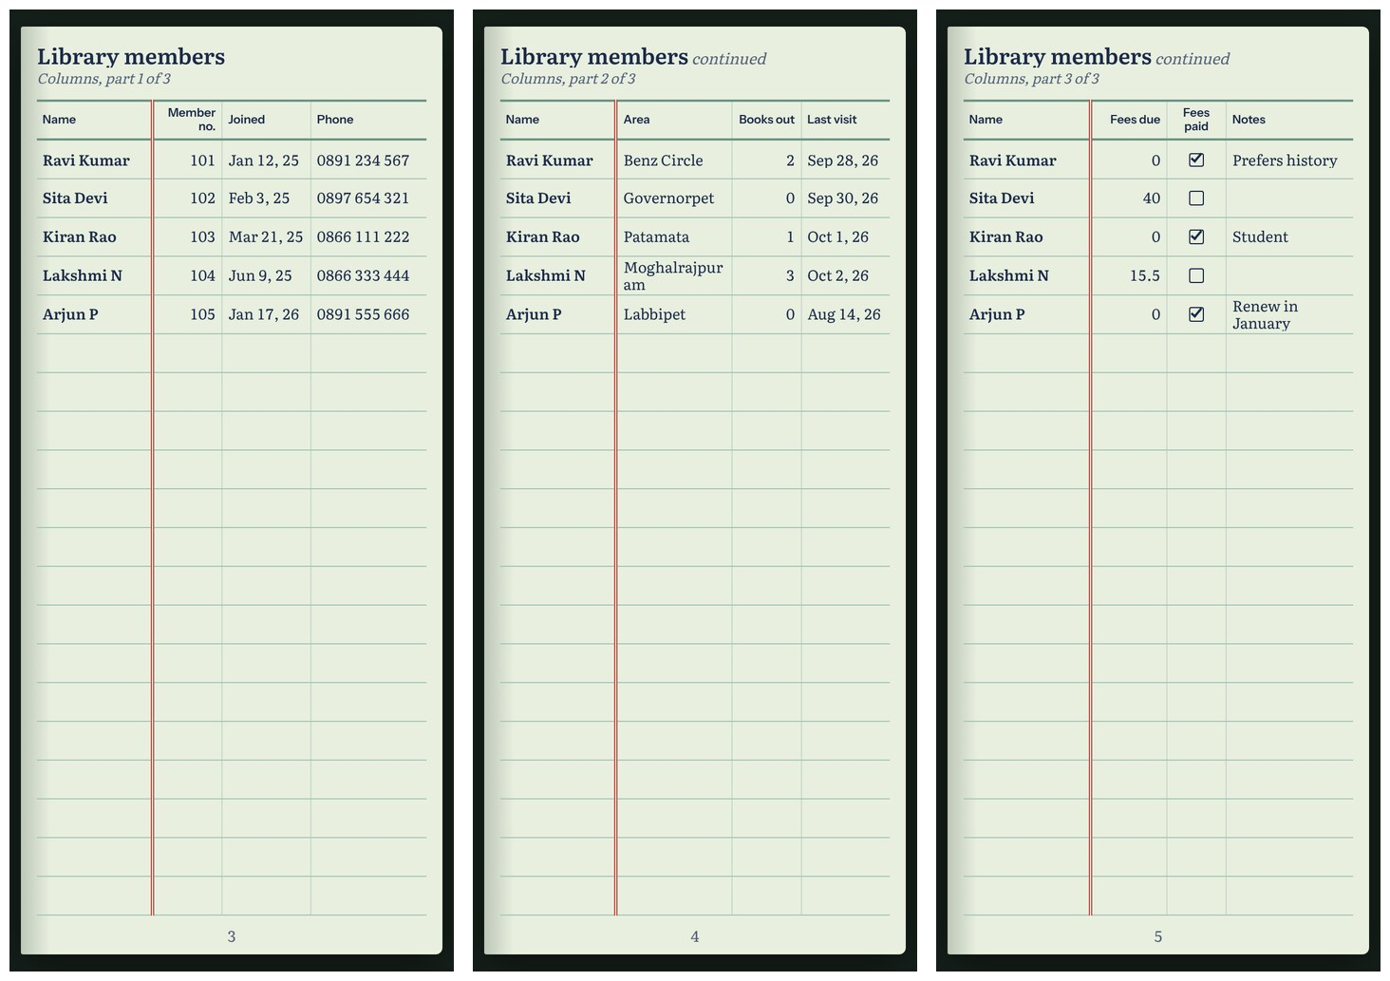
A ten-column table on a phone: three pages, with the Name column repeated on each, left of the red margin line.

3. How to run it
- Start the Python backend in one terminal (document 03 has the first-time setup).
- Start the screens in a second terminal.
- Open http://localhost:5173 in a browser and sign in.

Terminal 1: backend
cd python_code
source .venv/bin/activate
python manage.py runserver

Terminal 2: screens
cd frontend
npm install
npm run dev
Node.js 18 or newer is needed for the second terminal. npm install is only needed the first time. To open the site from a phone on the same Wi-Fi, use npm run dev:phone and open the Network address it prints.

4. Editing tables

Adding and changing
- Tables: "Add table" creates one. "Table settings" renames it or moves it earlier or later in the book.
- Columns: "Add column" asks for a name and a type. Pressing a column’s heading opens that column, to rename it, change its type, or move it left or right.
- Rows: "Add row" adds an empty row. Type into any cell; the change is saved when you leave the cell. Pressing a row’s number opens that row, to move it up or down.
- Upload: "Upload Excel or CSV" creates a new table from the file and opens it.
- A value that does not fit its column, such as letters in a number column, is refused. The cell is marked and a message names the column.

Deleting
- No delete button is visible in the normal view.
- To delete a book, table, column or row, open it first. "Delete this…" is at the bottom of its window.
- Pressing it does not delete. It shows what will be removed, for example: Column "Size" with 3 filled cells, with two buttons, Delete and Keep.
- After Delete, the item is in the Trash and can be restored.

5. The book

What the reader sees
- A cloth cover with the book’s title, then a contents page, then each table starting on a new page.
- Pale green ledger paper with ruled lines and a page number at the foot of each page.
- The first column of every table sits left of a red margin line and is repeated on every continuation page.
- Rows are ruled to the bottom of the page even when the table is short, as in a paper ledger.

Turning pages
On | How
Phone or tablet | Swipe left or right, or tap the left or right edge.
Laptop or desktop | Arrow keys, or click the left or right edge.
Any device | Tap or click the middle of the page to show "Close book" and the page number. Tap again to hide it.

The page changes at once for now. The turning-page animation is the next phase.

Fitting the screen
- The site measures the screen and works out the size of one page, then how many columns and rows fit on it. Nothing is fixed.
- A phone shows one page with about four columns. A laptop shows two pages side by side with about four columns on each.
- Columns share the width by what they hold: words get more room than numbers, and a checkbox gets the least.
- A value too long for its column runs onto a second line inside the row. Anything longer than two lines is cut short.
- Turning a phone sideways or resizing the window lays the book out again and keeps the reader at the same rows.
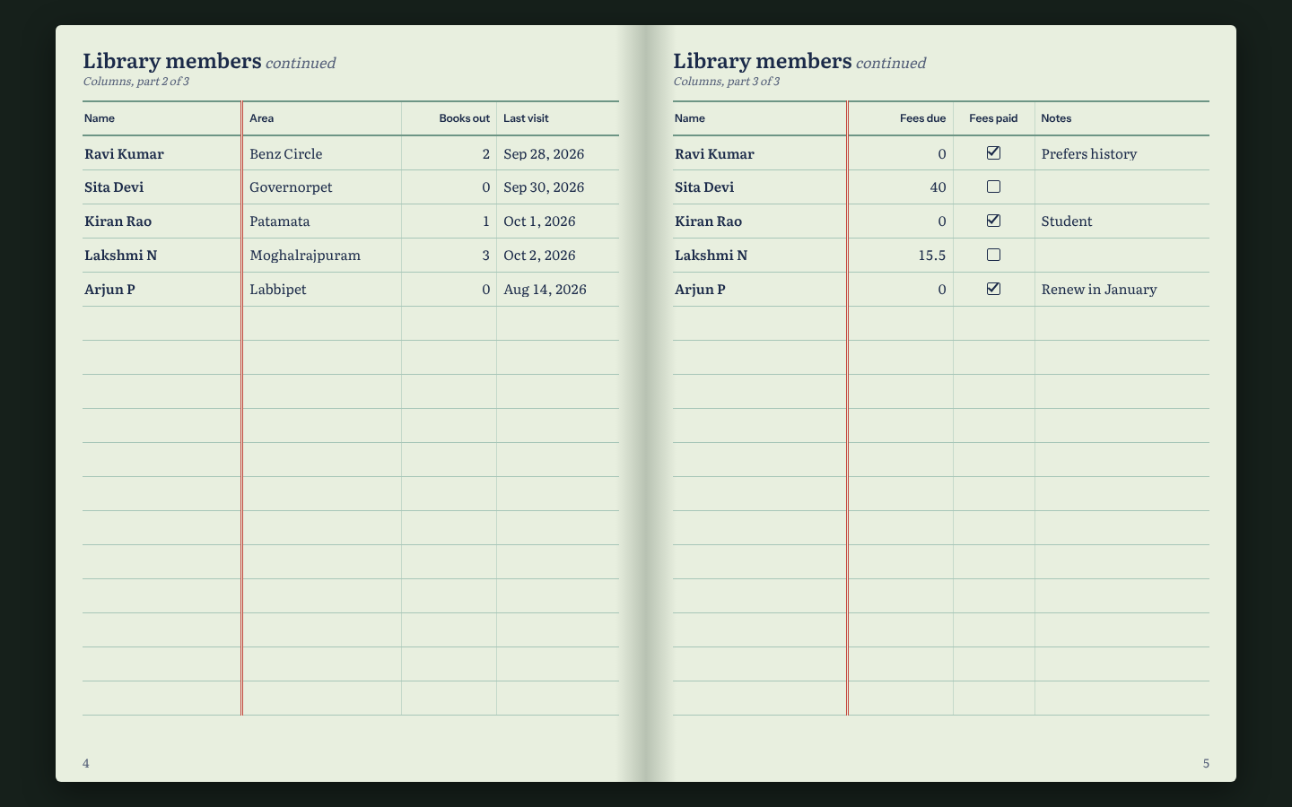
The same table on a laptop: two pages side by side.

6. What was checked
- 29 checks were run in a real browser, at phone, tablet and laptop sizes, and all passed. They cover signing in, a wrong password, creating a book, adding a table, columns and rows, typing values, a refused value, upload, renaming, delete with confirmation, restore from trash, the book pages and the repeated first column, user management, and one user being unable to open another user’s book.
- The 60 backend tests still pass. No Python code changed in this step.
- Not checked: the browser used was Chromium only. The site has not yet been opened on a real iPhone or Android phone, or in Safari.

7. Known limits
- No turning-page animation yet.
- On a laptop, the two halves of a wide table do not always land on facing pages, because the contents page takes the first left-hand page. This belongs to the device-compatibility phase.
- An admin creates books for themselves only. Creating a book for another user is possible through the API but has no button yet.
- Upload accepts Excel and CSV only. Word, PDF and photos come later.

8. Where the code is
File | What is in it
frontend/src/App.jsx | The list of screens and who may open them.
frontend/src/api.js | Sends requests to the Python backend.
frontend/src/auth.jsx | Remembers who is signed in.
frontend/src/pages/SignIn.jsx | The sign-in page.
frontend/src/pages/Books.jsx | The shelf of books.
frontend/src/pages/Book.jsx | One book: tables, upload, settings.
frontend/src/components/TableEditor.jsx | The grid for typing into a table.
frontend/src/components/Dialog.jsx | Windows, name forms and the delete confirmation.
frontend/src/pages/Reader.jsx | The book view and page turning.
frontend/src/pages/Trash.jsx | The trash.
frontend/src/pages/Users.jsx | User management for admins.
frontend/src/styles.css | All colours, type and layout.

9. Next step
Phase 4 adds the turning-page animation, starting with phones on iOS and Android. Before it starts, the site should be opened once on a real phone to confirm the page sizes feel right.

