Page Turning
Booklet View · phase 4 · 4 October 2026
This document records phase 4, built on 4 October 2026: pages that turn like the pages of a real book. The feel of the book is the centre of this project, so this step is to be judged on a real phone.

1. What it does
- Drag: put a finger on the page and drag. The page lifts and curls, following the finger, with the next page showing underneath and a shadow along the fold.
- Let go: if the page was dragged far enough, it finishes turning. If not, it falls back.
- Swipe: a quick swipe left or right turns one page.
- Tap: a tap on the right edge turns forward, on the left edge turns back. A tap in the middle shows the "Close book" bar.
- Covers: the front and back covers are stiff. They swing open like a board, and do not curl.
- Contents: tapping a table in the contents page turns the book to that table.
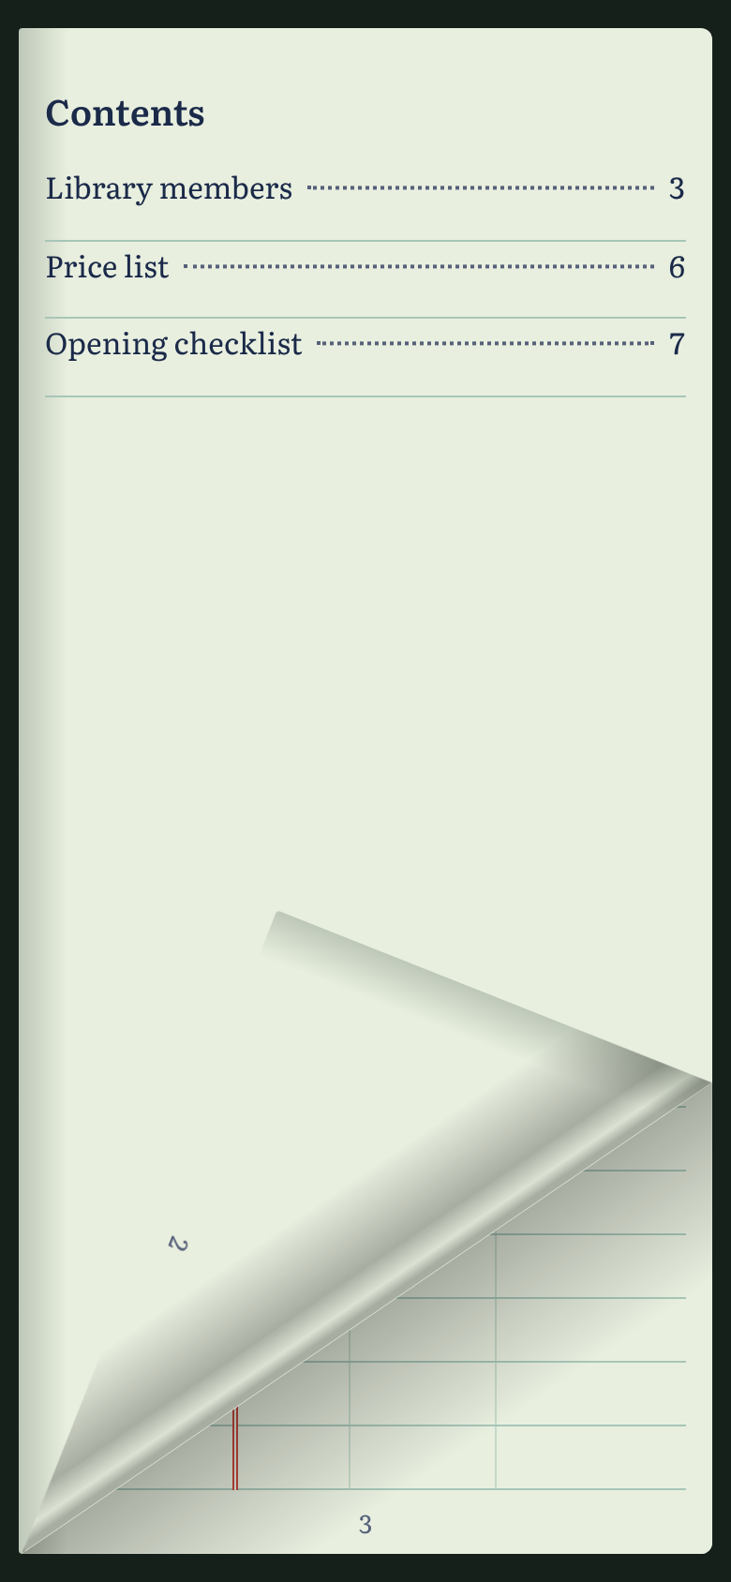
A page being dragged on a phone.

2. Phone and laptop
 | Phone | Laptop
Pages showing | One | Two, side by side
Turn by | Drag, swipe, tap an edge | Drag with the mouse, click an edge, arrow keys
Closed book | Fills the screen | Rests in the middle; slides aside as it opens
Corners | No hover on a touch screen | A corner lifts when the mouse is over it

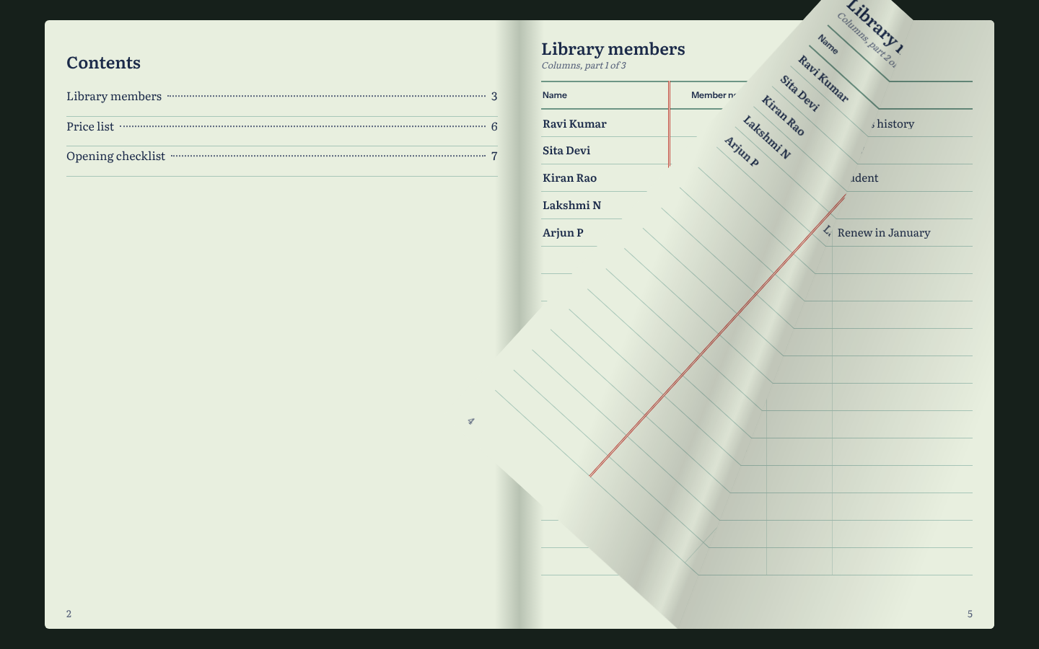
A page being dragged on a laptop. The back of the page shows the next page of the table.

3. How it is built
- The turning effect comes from an open-source library, StPageFlip (page-flip, MIT licence). It works in any modern browser, so the same code serves iPhone, Android, iPad and desktop.
- The library owns the page elements and moves them. React fills each page with its content.
- Two things were changed in how the library ends a touch:
- Finishing a drag. The library finishes a turn only when the page is dragged past the spine, which on a phone is off the edge of the screen. Now a turn finishes once the finger has moved 18% of the page width, or 90 pixels, whichever is smaller.
- Taps. The library turns the page on any tap. Taps are now handled by the reader, so the middle of the page can open the menu.
- A blank ruled page is added before the back cover when needed, so the book has an even number of sides and closes properly.
- For people who have "reduce motion" switched on in their device settings, pages change without the animation.

4. Also fixed in this step
- In the editing grid, a message about a refused value could be wiped by another cell saving at the same moment. It now stays until that cell is corrected.
- Both Mac launchers now update the project’s packages every time they start, so a change like this one is picked up without extra steps.

5. What was checked
- 44 browser checks pass at phone, tablet and laptop sizes. The new ones cover: a tap turning the page, a slow drag showing the page mid-turn and landing on the next page, swipes forward and back through the whole book, the menu, the contents links, turning the phone sideways, a mouse drag on the laptop, edge clicks, arrow keys, and Home and End.
- Not checked: this was tested in one desktop browser pretending to be a phone. How the drag feels under a real finger on an iPhone and on an Android phone has not been tested. That is the test to do next.

6. Known limits
- Turning a phone sideways shows one small page, not two. A two-page view needs a screen at least 960 pixels wide.
- On a laptop, the two halves of a wide table do not always land on facing pages.
- Every page of a book is built when it opens. A book with hundreds of pages may open slowly on an old phone.
- While a page is turning, a second tap is ignored until it lands.

