HOLISTIC REPORTS AND THEIR INTERPRETATIONS:

- NADI TARANGINI
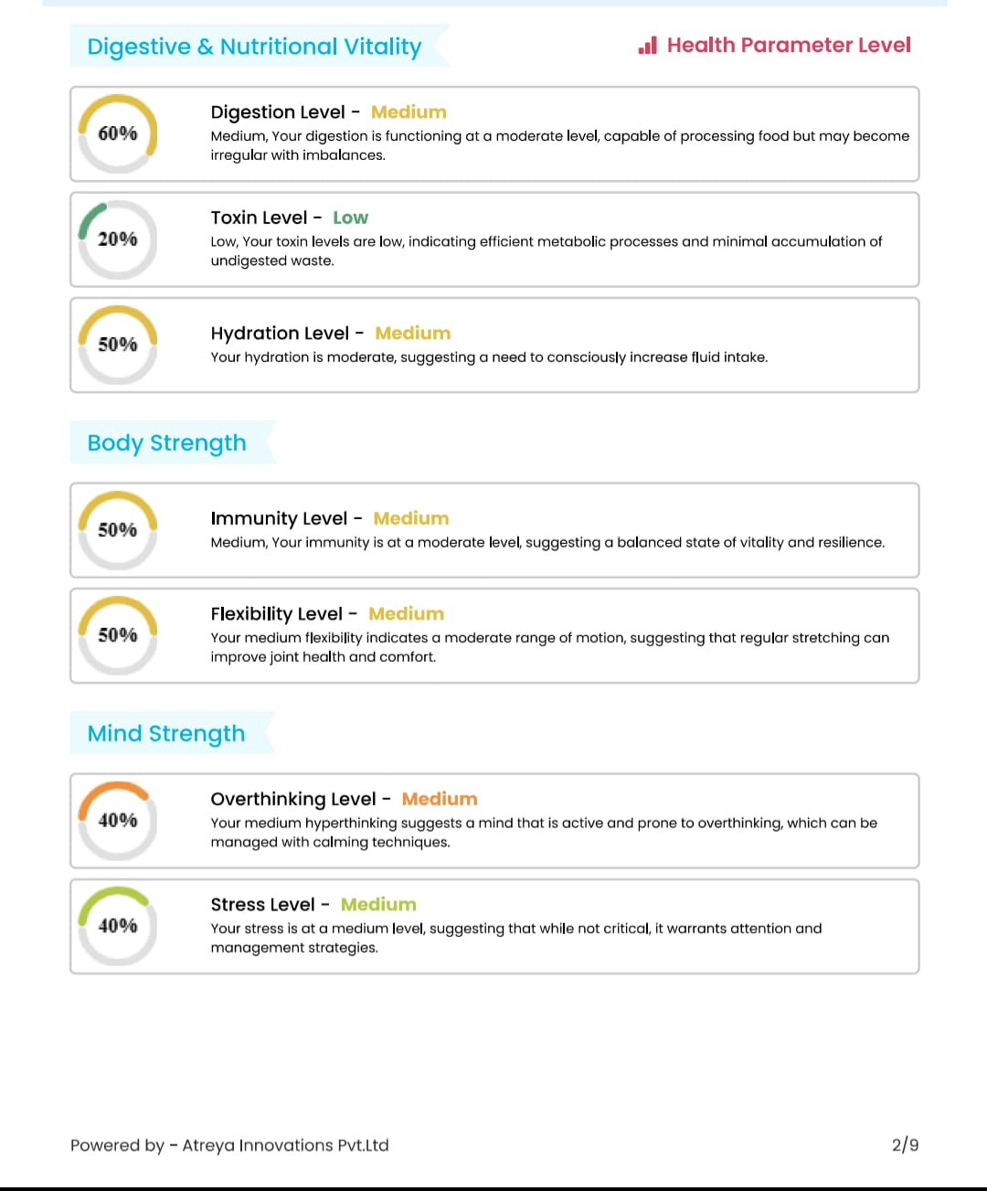

- PHYSICAL:
Health parameter | Range | interpretation
Digestive level | 100-80% - high  80- 40% - medium  Below 40% - low | High- excess of pitta( teeksnagni) , hyper metabolism  Low- mandagni (low digestive capacity) , poor nutrient absorption , bloating
Toxin level |  | High – high accumulation of metabolic toxin , manda agni ( low digestive capacity) ,systemic toxicity  Low – efficient metabolism
Hydration level |  | High –electrolyte balance, removal of ama (toxins), balanced state of agni ( digestive fire) and kapha  Low- cellular dehydration , toxin accumilation
Immunity level |  | High – strong cellular resilience , strong agni and optimal ojas , positive psychological resilience  Low – tissue exhaustion , mental fatigue , depletion in ojas
Flexibility level |  | High – optimal lubricated joints  Low - less lubrication, restricted range of motion

- PSYCHOLOGICAL:
Health parameter | Range
Overthinking level | 100-80% - high  80- 40% - medium  Below 40% - low | High - Hyperactive nervous system , anxiety  Low – calm mental state
Stress level |  | High – locked in sympathetic state , physical stress , mental anxiety  Low - Calm, clear mind, emotional stability

- BIOWELL
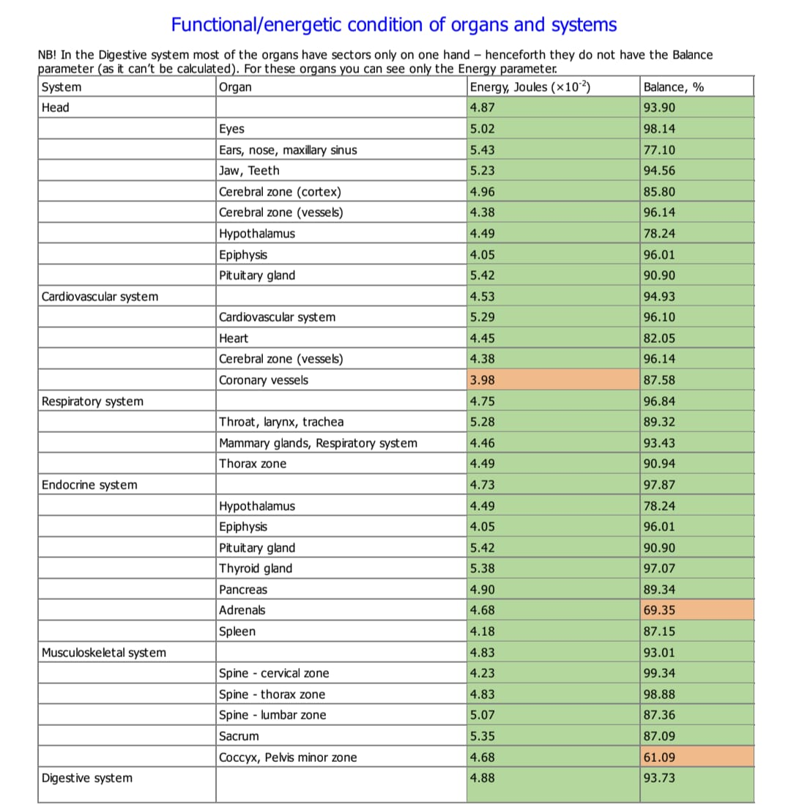

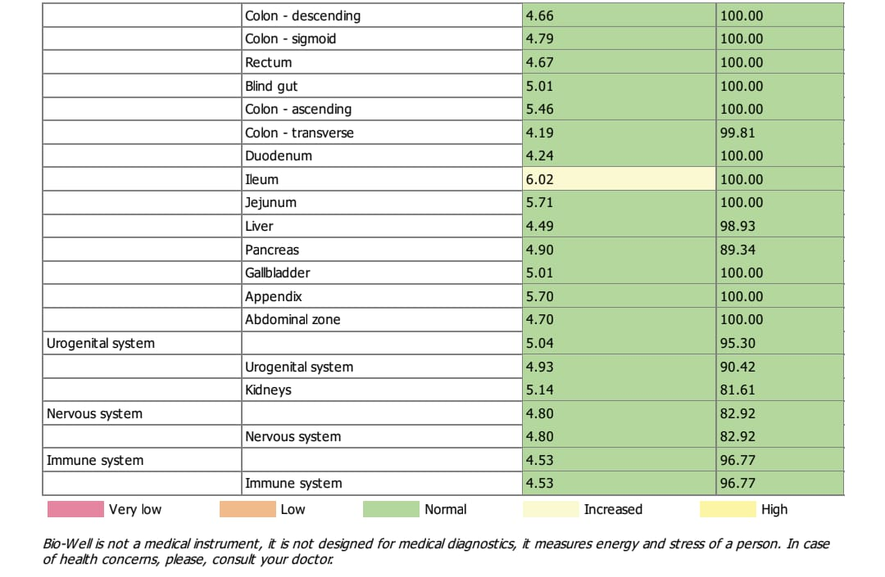

ENERGY LEVEL | ENERGY STATUS | RISK FACTOR | INTERPRETATION
0 - 2 Joules (×10-2) | Very low energy | Mild to moderate risk | Dysfunction of inner organs and systems , Malfunction of vegetative balance , Metabolic disturbance
2 - 4 Joules (×10-2) | low energy |  | Tiredness , Irritability , Decreasing of adaptation, Hard to compensate disease , Deficiency of energy.
4 - 6 Joules (×10-2) | optimal energy | normal | Optimal adaptation, Balanced power inputs and energy consumption
6 - 8 Joules (×10-2) | increased energy | Low risk to mild risk | Physiological tension, reflected high load on the system, Over reaction ,Activation of systems and organs; State of a healer during work.
8 - 10 Joules (×10-2) | heightened energy |  | Significant tension/stress of adaptation and energy-supply systems, Hyper reaction with possible derangement of adaptation , Presence of inflammatory processes in the body.

- PSYCHOLOGICAL :

Balance between sympathetic /parasympathetic nervous system
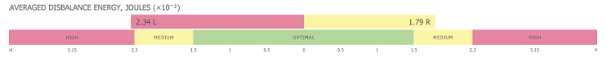

0-1.5x10-2 joules | Optimal | optimal disbalance between sympathetic/parasympathetic nervous systems
1.5-2.3 ×10-2 Joules | Medium | temporary adaptation of the organism to the internal or external processes
2.3 ×10-2 Joules and higher | High | adaptation to some extreme conditions, or internal problems.

- PSYCHOSPIRITUAL ANALYSIS
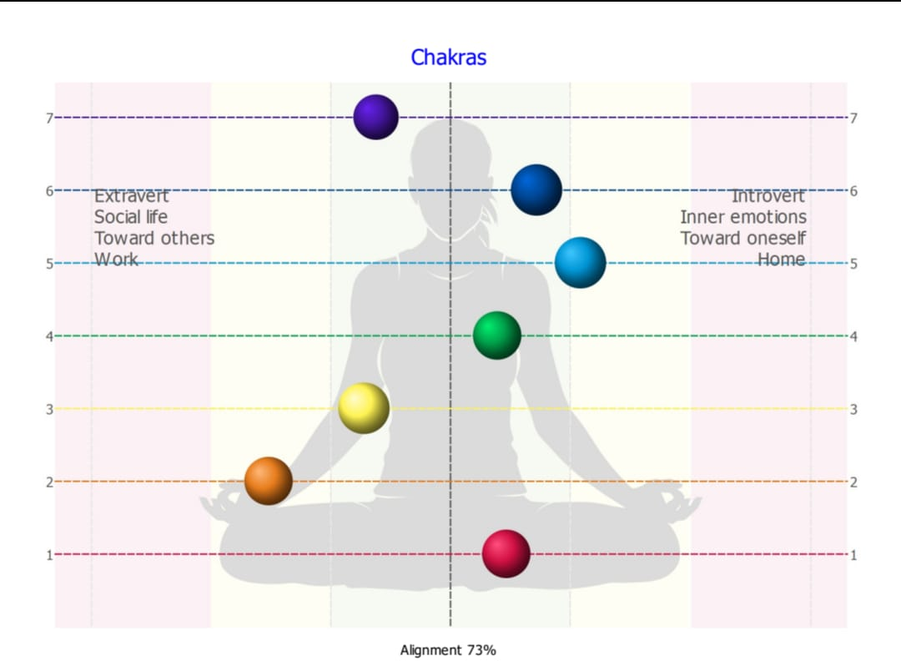
Chakras name | description | percentage | Range
muladara | self-confidence, sexual power | 84 % | 100-80% - normal  80-60% - mild deviation  60-30% - moderate deviation  Below 30% - extreme
swadistana | material work, job or home | 48 %
manipura | wilingness to solve problems | 75 %
anahatha | love, sympathy, empathy. | 87 %
vishudda | non-material work | 64 %
agna | approach to solving tasks and search of information | 76 %
sahasrara | relations with God, fanatic or atheist | 78 %

- HRV and ECG :

Parameter | Observed Values | (Spandan pro)Standard values | interpretation
PR Interval | 138ms | 100 ms - 200 ms | - HYPER- hyperkalaemia ,AV-nodal blocking( aging tissue, conductive system fibrosis), MI, vagal surge  - HYPO- During exercise, adrenaline surge
QRS Interval | 89ms | 60 ms - 120 ms | - HYPER- slim built  Bundle Branch Blocks (BBB), hyperkalaemia, severe tricyclic antidepressant overdose, VT, LVH  - HYPO – common in athletes, adult
QT Interval | 332ms | 300 ms - 450 ms | - HYPO- adrenaline surge  hypercalcemia ,hyperkalaemia, digitalis toxicity  - HYPER-electrolyte deficiencies (hypokalaemia, hypomagnesemia, hypocalcaemia), structural heart disease
QTc Interval | 285ms | 300 ms - 450 ms | - HYPO- hypercalcemia, hyperthermia , SNS impairment  - HYPER- (mild) alcohol consumption ,ALD, ANS impairment
Heart Rate | 88bpm | 60 bpm - 100 bpm | - Bradycardia-sinus node dysfunction ,hypothyroidism, hypothermia, ADE, allergies  - Tachycardia-physiological due to exercise, stress, fever, dehydration, or pain , caffeine , nicotine , adrenaline surge  hyperthyroidism, anaemia, SVT , VT

- INBODY : BODY COMPOSITION ANALYSER

Parameter | Observed value | Standard range | Interpretation
Visceral fat | 10Lv | 1– 9 Lv- Healthy / normal  10 -14Lv - Elevated / Early  Warning  15 -19Lv - high Risk  20 Lv or higher - very high  risk | - Healthy - Low metabolic risk.  - Elevated /early warning - Borderline cardiovascular risk  - High risk - High metabolic risk. Strongly linked with hidden insulin resistance, systemic inflammation, and fatty liver disease.  - Very high risk - Severe risk. Immediate lifestyle or medical clinical intervention is highly advised.
Skeletal muscle mass | 31.7kg | below 31.5 kg - Hypo-  muscular  31.5 kg to 38.5 kg – Normo-  muscular.  Above 38.5 kg – hyper-  muscular | - Hypo muscular - Insufficient metabolic muscle tissue. Linked to a slower metabolic rate and higher susceptibility to visceral fat storage  - Normo muscular - Adequate muscle volume to support regular daily tasks, mobility, and structural skeletal protection  - Hyper muscular - An exceptional amount of active muscle. Considerably boosts baseline caloric burn and insulin sensitivity.
Body fat mass | 24.7kg | Below 10.5 kg- Low.  10.5 kg to 16.8 kg – Healthy  /Balanced  .Above 16.8 kg - High Fat | - Low - Fat Below standard physiological requirements. Can impact hormone production and energy levels  - Healthy - Provides optimal organ insulation, energy storage, and metabolic function  - High fat : Associated with increased systemic inflammation, joint stress, and metabolic strain.
BMI | 26.4kg/m2 | Below 18.5- Underweight  18.5 – 24.9 - Healthy  25.0 – 29.9 - Overweight  30.0 or Higher- Obesity | - Underweight -May indicate a risk for malnutrition, compromised immunefunction, or other health issues.  - Healthy – Weight Generally associated with optimal health outcomes and a lower risk of chronic diseases.  - Overweight - indicate an increased risk for conditions like high blood pressure, diabetes, and heart disease  - Obesity - Indicates a significantly higher risk for serious health conditions including sleep apnea, joint pain, and cardiovascular disease.

- BIORESONENCE
Energy level |  | Functional status | Interpretation
1 | 100-90 % | Optimal base line | Optimal:Perfect cellular reserve capacity. Highest level of tissue adaptability.
2 | 89 – 75% | Healthy Balanced | Healthy: active functioning. Tissue adapts smoothly to environmental inputs.
3 | 74 – 60% | Normal | Adequate: but the cells are actively processing a mild metabolic or lifestyle load.
4 | 59 – 40% | Hyper-Function | Acute Stress: Cellular irritation or functional overload. The system is working overtime to compensate for a stressor.
5 | 39 – 20% | Hypo-Function | Energetic Depletion :Severe tissue exhaustion. Cell regeneration is slowing down; tissue is losing its self-regulating power.
6 | Below 20% | Decompensation | Cellular Exhaustion: Deep energetic blockages or cellular fatigue. The tissue has exhausted its adaptive energy reserves.

- DMIT FINGER PRINT :
- PERSONALITY : STEADY/COMPLIANT/DOMINENT/ INFLUENTAL
- STEADY : The compassionate and the peaceful; people oriented, loyal, friendly, hardworking and a great team player but tends to avoid change, confrontation, risk taking and assertiveness
- COMPLIANT : The wise ,logical, mathematical minded, methodological and sometimes seen as perfectionist. can be slow to make decisions and inflexible if rules and logic says otherwise .they are not big risk takers but love
- DOMINENT : The bold , dominant, stimulated by challenge, decisive and direct. Eagles can be blunt/stubborn and lose sight of Peacock The peacock loves to talk; being the centre of attention has the big picture and can become insensitive to other people needs. Natural archiver
- INFLUENTAL : loves to talk; being the centre of attention has the big picture and can become insensitive to other people needs. passion/enthusiasm and is happy/optimistic. can be accused of talking too much, and aren’t good with detail and time control

- TFRC VALUE: (Total fingerprint ridge count):
TFRC VALUE | INTERPRETATION
Below 60 | Very low potential
61-100 | Low potential
101-140 | Average potential
141-180 | Good potential
181 and above | Excellent potential

- BRAIN DOMINENCE:
LEFT: RIGHT:
LEFT | RIGHT
Analytical Brain, Self Awareness & Logical | Creative & Emotional Brain, Interpersonal Intelligence
Controls fine motor skill based activities | Controls gross motor skills based activities
Alphabets, Words, Language, & Grammar | Color, images, creativity, imagination, mental reading
Major role in academic performance | Major role in Creative activities
Convergent thinker, concentrate better | Divergent thinker, difficult to concentrate at one point
Responds to verbal instructions | Physically present but mentally absent
Planning, organization & Differentiation | Interpersonal, Understanding Others, Team building
Controlling feelings & emotions | Full of feelings, emotions & creativity

