NAME:Darshan Kabade
ROLL NO:20

1) Insertion:
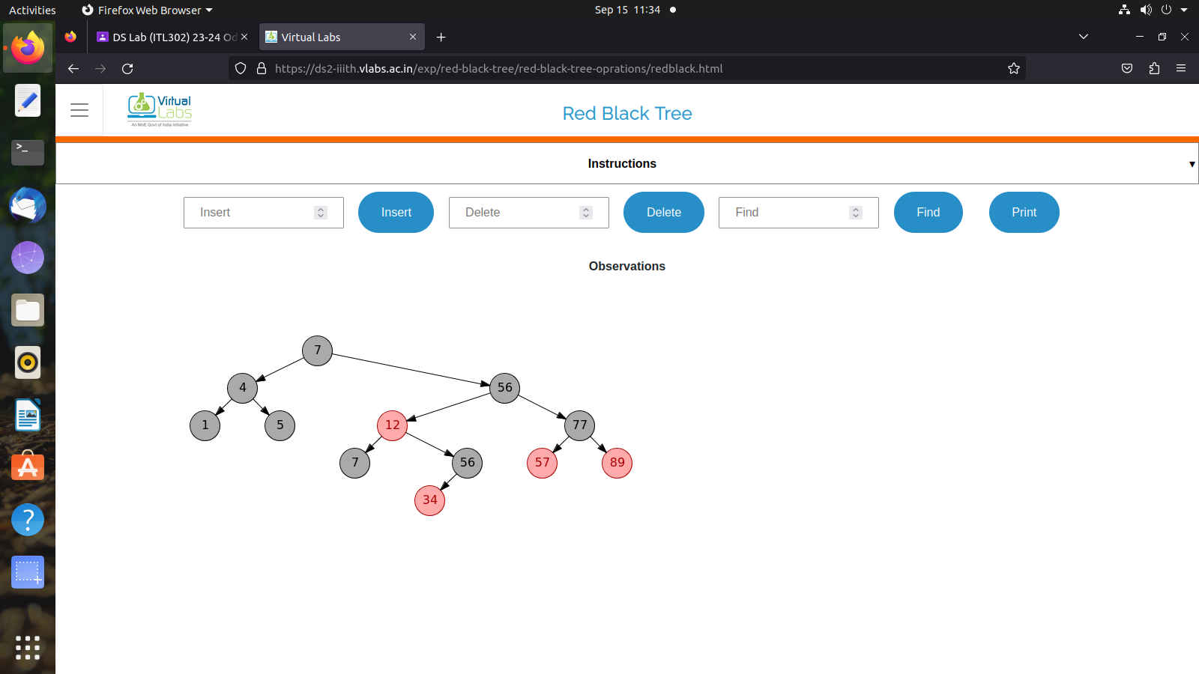
2) Deletion:
