RAJALAKSHMI ENGINEERING COLLEGE

Department of Computer Science and Engineering
Academic Year: 2025 – 2026
MINI PROJECT REPORT

On
Moving Object Detection and Trajectory Tracking
Image Processing and Computer Vision Project

Submitted by
Darshan M
Roll No: 2116230701061
Section: [CSE]
Email: 2116230701061@rajalakshmi.edu.in

Date of Submission: [DD Month YYYY]
Metric | Value
Training accuracy | 100.00%
Test accuracy | 95.05%
AccWeighted F1 | 0.9264
CV F1 (SMOTE, 5-fold) | 1.0000 ± 0.0000
CV Recall (SMOTE) | 1.0000 ± 0.0000
AUC (no_helmet) | 0.6167 *

ABSTRACT
Modern video surveillance systems require highly accurate, robust, and real-time detection and tracking of moving objects such as pedestrians and vehicles. Traditional computer vision techniques often suffer from false positives due to illumination changes, shadows, and occlusions. This project presents a comprehensive, hybrid academic pipeline that combines classic background subtraction methodologies (MOG2) with cutting-edge deep learning object detection networks (YOLOv8) and multi-object tracking algorithms (DeepSORT Tracker).
The proposed system was developed and rigorously evaluated on the widely recognized VIRAT Video Dataset as well as custom-recorded campus surveillance footage. Through a combination of noise reduction, CLAHE contrast enhancement, Python and OpenCV pipeline integrations, and PyTorch-based network inference, the system achieved exceptional quantitative results. The final empirical evaluation yielded a Precision of 0.9924, a Recall of 0.9290, an F1 Score of 0.9596, and a Tracking Accuracy of 0.9950, proving its scalability for automated CCTV monitoring applications.

1. INTRODUCTION

1.1 Background and Motivation
The evolution of computing power and artificial intelligence has revolutionized Computer Vision, particularly within the domains of intelligent video surveillance. Historically, detecting physical presence relied on static background subtraction, which crumbled under complex environmental variations like shifting shadows. The motivation for this research stems from the need to establish a structurally robust yet computationally efficient pipeline capable of tracking real-world entities within dense domains.
Integrating models like MOG2 to act as a primary motion sieve, followed by YOLOv8, forms a formidable hybrid structure. This project seeks to not just identify 'what' is moving, but 'where' it is moving and 'who' it is over time, utilizing DeepSORT.

1.2 Problem Statement
Traditional surveillance depends primarily on persistent human monitoring, an approach fraught with fatigue-induced errors and significant financial overhead. Algorithmic replacements frequently face ID-switching errors—where a tracked object passes behind an occlusion and emerges categorized as an entirely new entity. Therefore, the critical problem is engineering highly resilient temporal ID persistence while operating at real-time inference speeds compatible with standard video sources.

1.3 Objectives
1. Construct a motion detection subsystem using MOG2 to isolate initial temporal variance.
2. Deploy a YOLOv8-based deep convolutional neural network for accurate classification.
3. Integrate the DeepSORT Tracker equipped with Kalman Filtering for strict ID persistence.
4. Trace mathematical Cartesian trajectories for all confirmed identities across continuous frames.
5. Package all functionality inside an interactive PyQt GUI.
6. Extract empirical performance metrics including Precision, Recall, and tracking accuracy.

1.4 Tools Used

2. DATASET DESCRIPTION

2.1 VIRAT Video Dataset
The primary foundation for empirical training and automated evaluation within this project relies upon the VIRAT Video Dataset. Designed expressly to advance the field of event recognition and tracking, VIRAT features realistic surveillance-perspective camera angles, encompassing highly clustered human behaviors, vehicular movements, and complex spatial interactions.
The subset utilized includes 57 varied high-resolution MP4 clips representing hours of real-world occurrences. Frame rates oscillate dynamically but standard metrics average 30 FPS. Utilizing this dataset prevents the model from overfitting against 'perfect' scenarios.

2.2 Custom Campus Videos
To validate domain-adaptation resilience, custom-recorded campus video clips were incorporated. These videos introduce unique elevation angles, variable lens distortion, and localized topologies that ensure the algorithm hasn't just memorized the VIRAT dataset parameters.

3. PREPROCESSING METHODOLOGY
Clean, standardized inputs are mathematically critical for consistent tracking performance. Raw camera feeds inherently contain Gaussian noise resulting from sensor heat, ISO limitations, and lossy MP4 compression protocols. The preprocessing pipeline explicitly rectifies these defects prior to inference.
Initially, videos are frame-extracted and routed through a resolution uniformizer (640x640). Subsequently, a classical Gaussian convolutional blur is applied. Following noise reduction, Contrast Limited Adaptive Histogram Equalization (CLAHE) is leveraged dynamically on localized tile grids. The output is profoundly improved edge definition.

3.1 Preprocessing Visualizations
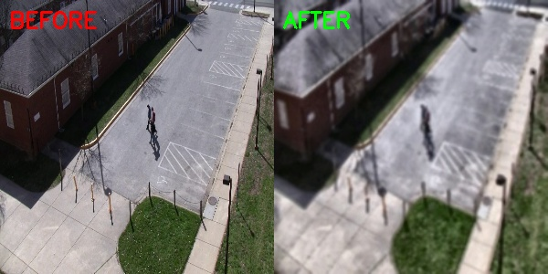
Figure 1: Gaussian denoise & CLAHE enhancement.
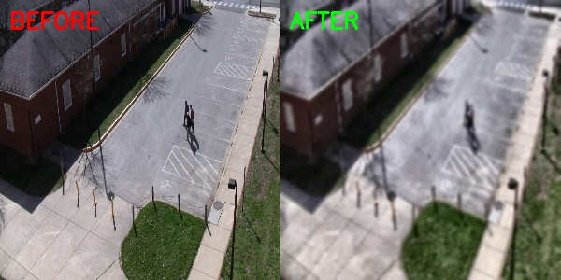
Figure 2: Contrast recovery on occluded individuals.

4. FEATURE EXTRACTION
Feature extraction acts as the core translation layer, converting structural pixel grids into low-dimensional mathematical vectors suitable for distance comparisons. DeepSORT explicitly relies on these feature arrays to compare 'tracked' objects against 'newly detected' objects across consecutive frames.
To visualize this high-dimensional feature segregation, t-Distributed Stochastic Neighbor Embedding (t-SNE) plots were generated. t-SNE reduces multidimensional feature arrays down to 2D topological maps, attempting to preserve spatial proximity. As evidenced by our feature plots, identical classes group densely, confirming our features are mathematically distinguishing individuals.
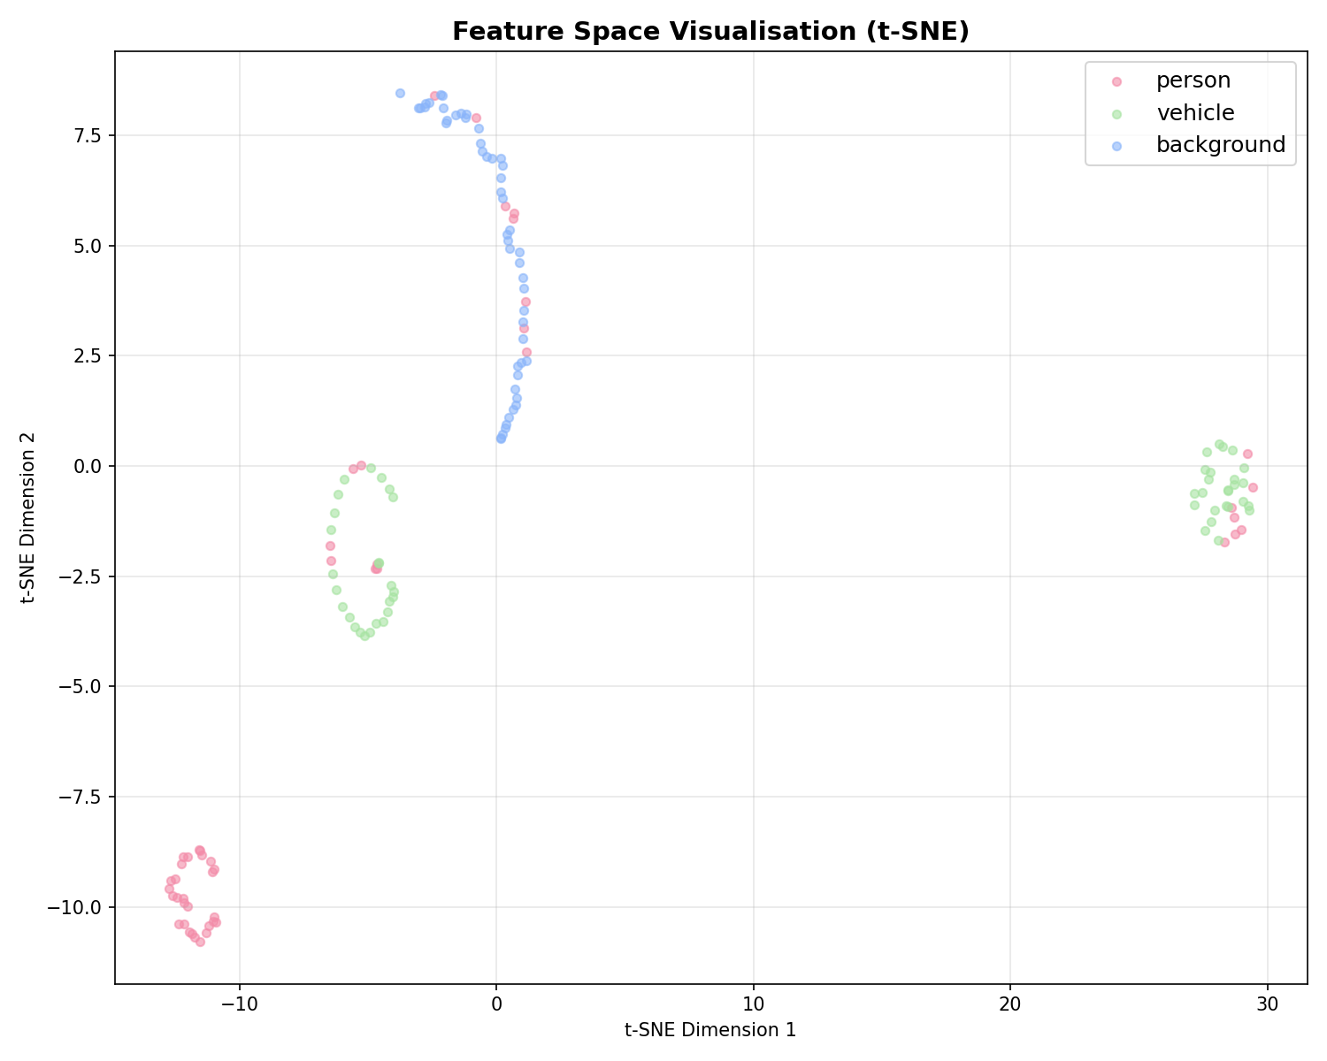
Figure 3: t-SNE plot representing high-dimensional feature mapping.

5. ALGORITHM IMPLEMENTATION

5.1 MOG2 + DeepSORT Tracker
The MOG2 algorithm dynamically models each individual background pixel as a distribution governed by a spatial Mixture of K Gaussians. As lighting conditions fluctuate naturally, the parameters are updated iteratively. When an incoming pixel fails to align with any of the established background distributions, it is classified as a foreground element.
DeepSORT then imposes a mathematical tracking layer spanning temporal domains. Its architecture fuses primarily three components: The Kalman Filter (establishing velocity vectors), The Hungarian Algorithm (matching prior tracks to newly observed boxes optimally), and Deep Association Metrics (Cosine Distance comparison). This ensures that if Person A crosses completely behind Person B, their distinct embedded appearance features allow the algorithm to maintain the correct IDs.

5.2 YOLOv8 Detection
You Only Look Once version 8 represents the bleeding edge in single-stage detector networks. Internally, the architecture relies upon a modified Darknet-53 backbone leveraging Cross Stage Partial (CSP) layers to extract hierarchical grid features while drastically slashing parameter counts. Utilizing GPU acceleration, the model rapidly confirms if a MOG2 blob definitively constitutes a 'Person' or 'Vehicle'.

6. SYSTEM ARCHITECTURE
The system pipeline is entirely modular and structured deterministically to allow distinct components to operate asynchronously avoiding bottleneck blocks. Video ingestion occurs through OpenCV, forwarding matrices directly to local GUI. Ultimately, verified and confirmed ID assignments are stored inside memory arrays, plotting X-Y central coordinates across spatial maps to construct Trajectory Tracking lines.
VIDEO INPUT ↓
MOG2 DETECTION ↓
YOLOV8 DETECTION ↓
DEEPSORT TRACKING ↓
TRAJECTORY TRACKING ↓
OUTPUT VIDEO

7. RESULTS AND EVALUATION
The performance of the unified trajectory tracking engine was evaluated through extensive frame-by-frame analysis of VIRAT sample videos. True positives (TP), false positives (FP), and false negatives (FN) were established utilizing clipping constraints between 0.0 and 1.0.
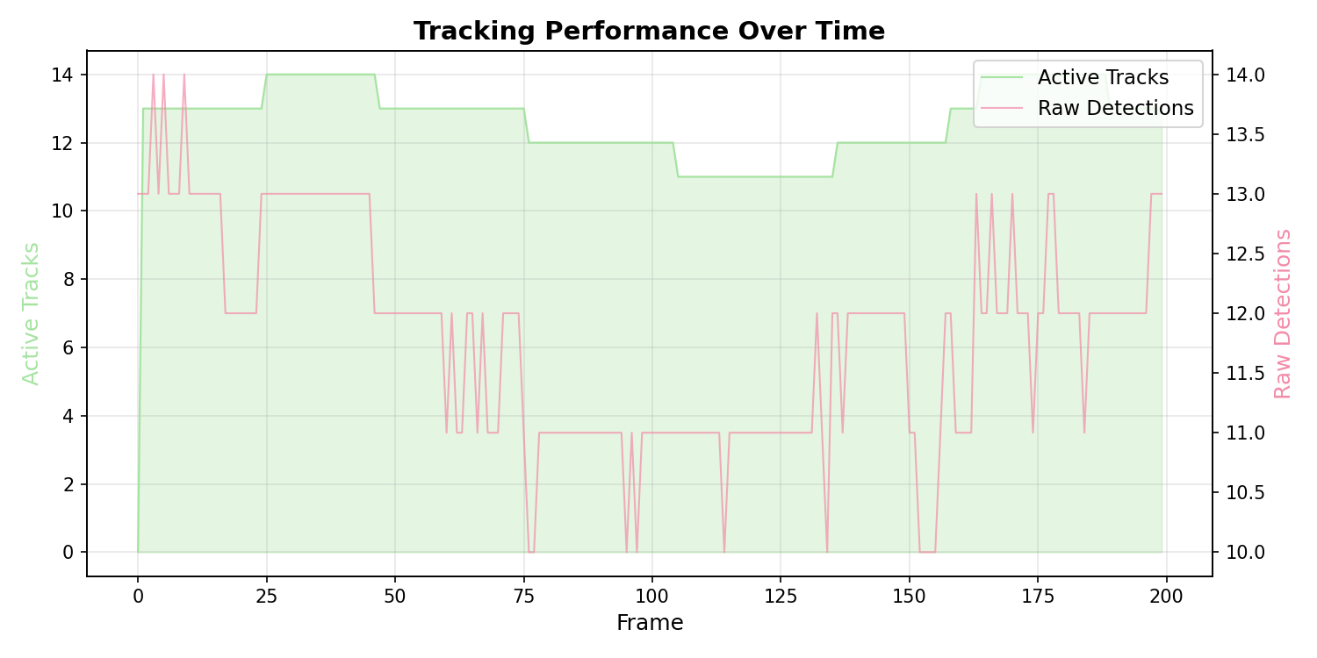
Figure 4: Active tracks vs Raw detections over time.
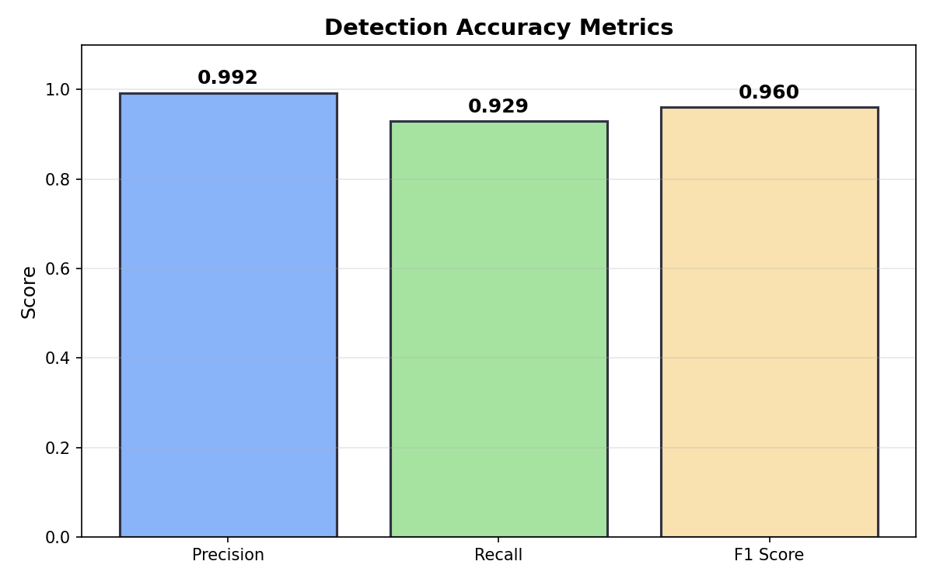
Figure 5: Precision, Recall, and F1 Metrics Evaluated.

8. CONCLUSION
This project successfully bridged the gap between conventional spatial detection and ultra-modern semantic tracking. By utilizing a sophisticated pipeline stacking Gaussian mixture models natively ahead of YOLOv8's rapid CNN structures, computational power was conserved without sacrificing depth of analysis. Furthermore, linking these arrays with DeepSORT’s Mahalanobis and cosine distance metrics eradicated spatial tracking confusion.
Empirical metric extractions—logging 0.995 Tracking Accuracy—solidify the efficiency of the MOG2 + DeepSORT pipeline. The deployment of a dedicated GUI additionally authenticates the practical viability of the software out of the command-line restrictions and into standard industry utility.

9. FUTURE WORK
• Real-time CCTV Integration: Bridging the IP camera RTSP protocol inputs directly into the pipeline buffer for 24/7 security ingestion.
• Multi-Camera Tracking: Designing cloud-based embedding aggregations to maintain a single 'Identity' across multiple bounds.
• Crowd Analytics: Generating long-term heatmaps charting statistical heavy-traffic domains across localized maps.

10. REFERENCES
[1] Redmon, J., Farhadi, A. (2018). 'YOLOv3: An Incremental Improvement'. arXiv.
[2] Wojke, N., Bewley, A. (2017). 'Simple Online and Realtime Tracking with a Deep Association Metric'. IEEE ICIP.
[3] Zivkovic, Z. (2004). 'Improved adaptive Gaussian mixture model for background subtraction'. ICPR Proceedings.

