# **Abstract**

The NAAC Accreditation Smart Repository is designed to simplify and automate the process of collecting, validating, and managing data required for NAAC accreditation in educational institutions. The current methods of data collection and submission rely heavily on manual processes, resulting in inefficiencies, data inconsistencies, and delays in accreditation.

The proposed system provides a centralized digital platform where faculty members, Heads of Departments (HoDs), and administrators can collaboratively manage data. It incorporates role-based access control, automated validation, and real-time data updates, ensuring accuracy, transparency, and security in the data submission process.

By minimizing human errors, reducing redundancy, and improving workflow efficiency, the system enhances institutional preparedness for accreditation. Additionally, it ensures that institutions can meet NAAC’s dynamic data submission standards effectively.

# **I. Introduction**

In the era of digital transformation, higher education institutions are increasingly leveraging technology to streamline administrative processes, enhance data management, and improve operational efficiency. One of the most critical aspects of institutional governance is accreditation, which serves as a benchmark for academic quality, faculty research, student outcomes, and infrastructure. In India, the National Assessment and Accreditation Council (NAAC) is responsible for evaluating institutions based on structured data submissions. However, many institutions still rely on manual data collection methods, spreadsheets, and fragmented documentation, leading to inefficiencies, errors, and delays in the accreditation process. The lack of a centralized system makes it difficult to ensure data accuracy, real-time validation, and compliance with NAAC guidelines, ultimately affecting an institution’s accreditation score.

To address these challenges, this paper proposes the NAAC Accreditation Smart Repository (NASR), a centralized, automated, and role-based system designed to streamline the accreditation process. NASR provides a digital platform for collecting, validating, and managing accreditation-related data, reducing manual efforts and ensuring compliance with NAAC standards. The system automates data validation, report generation, and access control, allowing faculty, department heads, and administrators to collaborate seamlessly. Additionally, NASR enhances data security through encryption and role-based authentication, preventing unauthorized modifications and ensuring institutional integrity.

By eliminating redundant workflows, improving data transparency, and enabling real-time tracking, NASR empowers institutions to always be accreditation ready. The system aligns with the objectives of National Education Policy (NEP) 2020, which promotes digital governance and institutional quality enhancement. This research explores the architecture, implementation, and impact of NASR, demonstrating how automation and structured data management can revolutionize accreditation processes, making them more efficient, accurate, and transparent.

# **III. Literature Survey**

The accreditation process in higher education institutions has traditionally relied on manual record-keeping, spreadsheets, and standalone database applications, each with significant limitations. Paper-based documentation is prone to errors, data loss, and inefficiencies, making it difficult to update and maintain records. Institutions using spreadsheets for accreditation data management face challenges such as lack of real-time collaboration, version control issues, and security risks, as unauthorized modifications or accidental deletions can compromise data integrity. Some institutions have implemented custom standalone database applications, but these often lack integration, real-time validation, and scalability, requiring manual data entry and verification, which increases administrative workload and delays the accreditation process.

The absence of automated validation and standardized reporting mechanisms in existing systems leads to inconsistencies in accreditation submissions. Since accreditation requires data collection from multiple departments, traditional methods struggle with data redundancy, manual errors, and inefficient tracking. Additionally, security concerns arise as sensitive accreditation-related data, including faculty credentials, research publications, and student performance records, lack proper role-based access control and encryption, increasing the risk of unauthorized access or data loss.

To overcome these limitations, the NAAC Accreditation Smart Repository (NASR) is proposed as a centralized, automated, and secure system for accreditation data management. NASR integrates modern web technologies such as HTML, CSS, Bootstrap and JavaScript for the frontend, PHP for backend processing, and MySQL for structured data storage. The system automates data validation, role-based access control, and report generation, ensuring real-time collaboration and improved data accuracy. Unlike existing manual or semi-digital methods, NASR provides a cloud-based infrastructure, allowing institutions to securely store and access accreditation data anytime, reducing manual workload and improving compliance with NAAC guidelines. By addressing data inconsistencies, security risks, and administrative inefficiencies, NASR enhances institutional preparedness for accreditation evaluations and aligns with the National Education Policy (NEP) 2020, which emphasizes digital transformation in higher education governance.

# **IV. System Design**

## **A. Problem Statement**

The NAAC accreditation process demands accurate, structured, and validated data from multiple departments. The absence of an integrated system results in inefficiencies, leading to delayed submissions, errors, and redundant efforts.

## **B. Proposed System**

The NAAC Accreditation Smart Repository will:

* Provide a web-based platform with role-based access for faculty, department heads, and administrators.
* Offer automated validation to ensure compliance with NAAC criteria.
* Enable secure data storage and backup to prevent data loss.
* Generate customized reports for accreditation submission.

### **System Architecture**

* **Frontend:** HTML, CSS, Bootstrap and javascript (UI/UX for seamless user interaction).
* **Backend**: PHP (server-side logic for data handling).
* **Database**: MySQL (secure storage of institutional data).
* **Cloud Integration**: AWS (for data backup and scalability).

# **V. Methodology**

The NAAC Accreditation Smart Repository (NASR) is designed to provide a structured and automated approach for managing accreditation data. The methodology focuses on how users interact with the system and how data flows from collection to submission while ensuring accuracy, security, and compliance with NAAC guidelines.

## **A. User Flow**

The system is structured to provide role-based access for different users, ensuring that each stakeholder interacts with the repository according to their responsibilities. The user flow follows a hierarchical approach, where faculty members input data, department heads validate it, and administrators review and finalize the accreditation report.

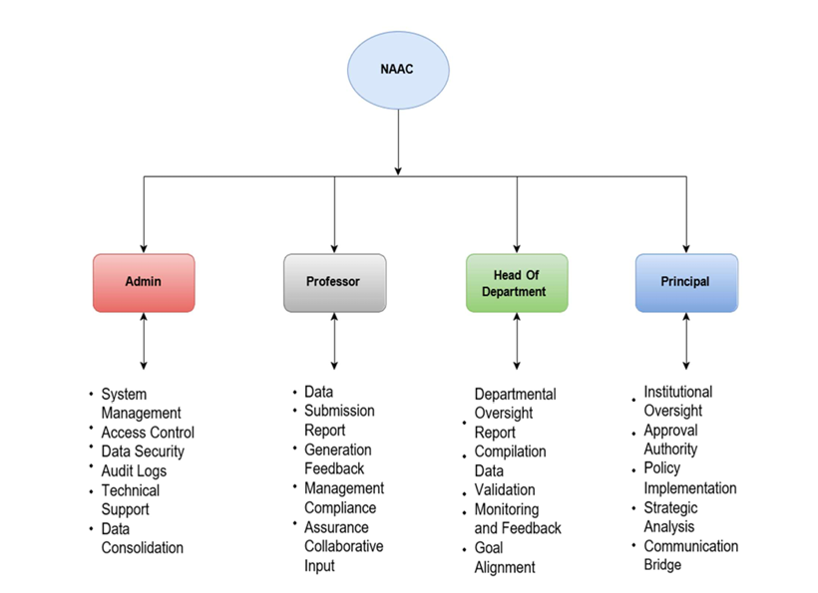

This structured user flow reduces redundancy, prevents errors, and ensures a streamlined accreditation process with clear role assignments and accountability.

## **B. Data Flow**

The data flow in NASR is designed to ensure efficient, secure, and structured handling of accreditation-related information from input to final report generation.

1. **Data Input** – Faculty members enter academic, research, and student performance data into the system. The system stores the data in a relational database (MySQL/PostgreSQL) with role-based access control.
2. **Automated Validation** – The system validates entries in real time, checking for missing fields, incorrect formatting, and redundancy. If discrepancies are found, the system flags them for correction before allowing further processing.
3. **Department-Level Approval** – HoDs review and approve faculty data. Approved records are moved to the next stage for institutional validation, while incorrect entries are sent back for correction.
4. **Institution-Level Compilation** – Once department data is approved, it is compiled into an institution-wide accreditation report. The system ensures data consistency and prevents unauthorized modifications.
5. **Report Generation & Submission** – The final report is automatically formatted according to NAAC requirements. The system allows institutions to generate accreditation reports on demand, ensuring they remain accreditation-ready at all times.

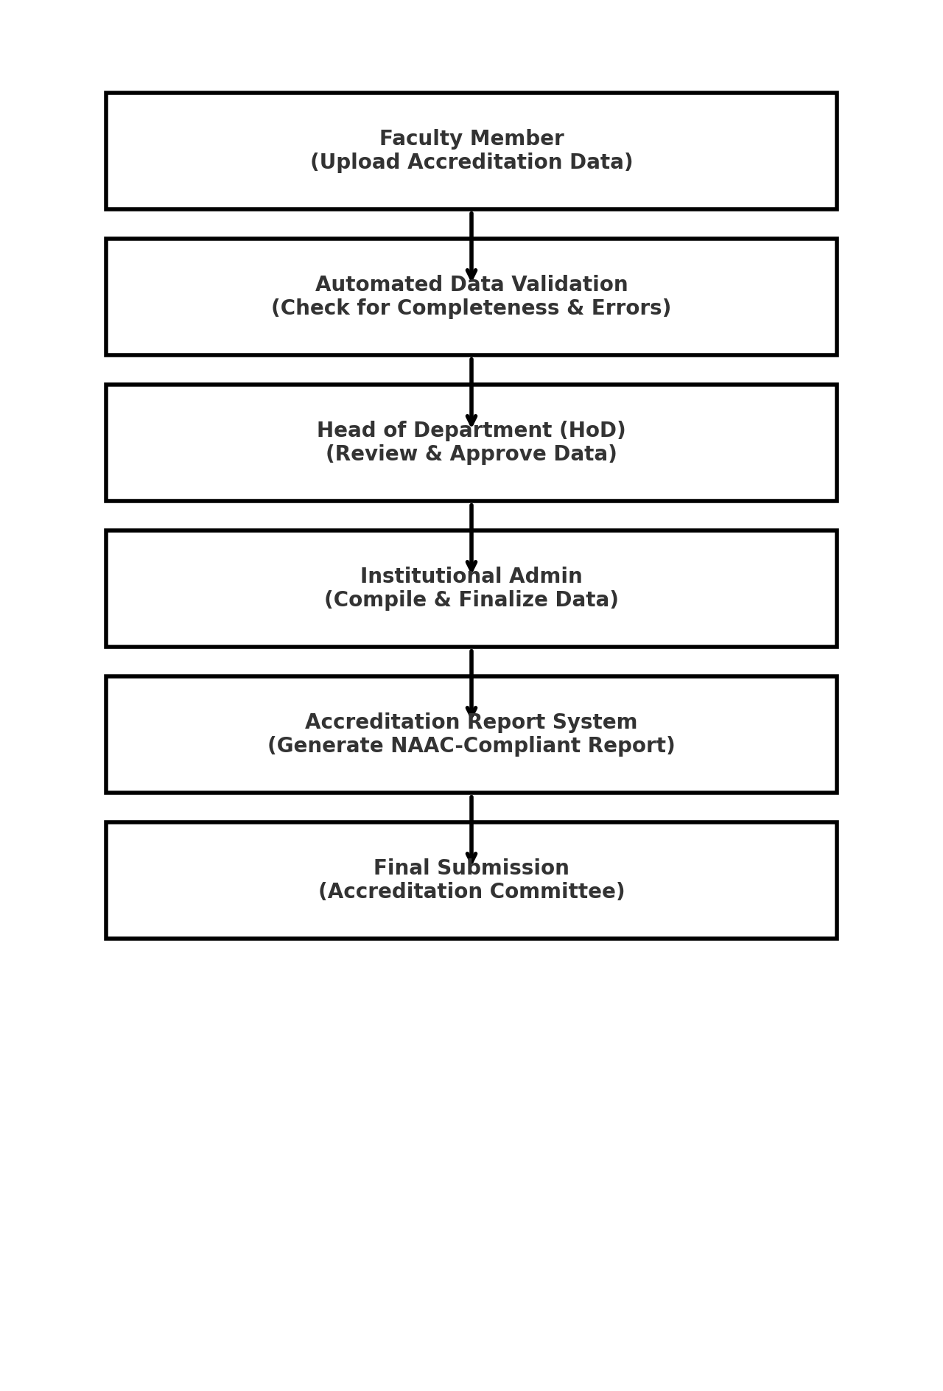

By implementing a structured user flow and optimized data flow, NASR enhances the efficiency, accuracy, and security of accreditation data management, reducing manual workload and improving compliance with NAAC accreditation standards.

### **VI. Future Scope**

The NAAC Accreditation Smart Repository has significant potential for future enhancements. The following advancements can improve efficiency, automation, and security in institutional accreditation management:

* **AI & Machine Learning Integration:**
  + AI-driven analytics can assess institutional performance and predict areas for improvement.
  + Automated report generation using Natural Language Processing (NLP) can reduce manual work.
* **Blockchain-Based Security:**
  + Ensures data integrity and prevents unauthorized modifications.
  + Creates a transparent and tamper-proof accreditation record system.
* **Cloud-Based Deployment:**
  + Allows multiple institutions to collaborate on a centralized platform.
  + Enables real-time data updates and ensures seamless scalability.
* **ERP & API Integration:**
  + Automates data synchronization with university ERP systems.
  + Reduces redundant data entry and improves operational efficiency.
* **Mobile-Friendly Dashboards:**
  + Enables faculty and administrators to review and verify accreditation data from anywhere.
  + Enhances accessibility and flexibility in data management.

### **VII. Conclusion**

The NAAC Accreditation Smart Repository is a transformative solution designed to streamline the accreditation process for educational institutions. By automating data collection, validation, and reporting, the system significantly reduces manual effort and enhances accuracy. The integration of technologies like PHP, MySQL, JavaScript, HTML, CSS, Bootstrap ensures a user-friendly, secure, and scalable platform for managing accreditation data efficiently.

Overall, the NAAC Accreditation Smart Repository not only simplifies compliance with NAAC accreditation requirements but also lays the foundation for a more structured and technology-driven approach to institutional quality assessment. By implementing this system, educational institutions can ensure a seamless, transparent, and efficient accreditation process, ultimately contributing to continuous academic improvement and excellence.