**1. Traffic source analysis**

**1.1 Identifying the major traffic sources**

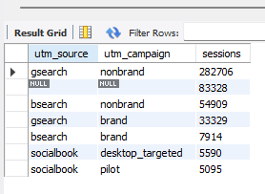

**Observation:**The result shows that the company's major traffic sources are “gsearch utm_source” and “nonbrand utm_campaign”. The second highest traffic to the website is through organic and direct search without any paid campaigns.

**1.2 Traffic to order conversion**

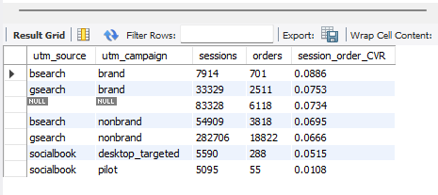

**Observation:** Bsearch utm_source with brand utm_campaign has the most session to order conversation rate of 8.86% followed by gsearch – brand and organic/direct search. Socialbook-desktop_targeted and socialbook-pilot has the lowest. Hence it might be a good idea to decrease the budget for those campaigns and allocate it to others.

**2. Website performance and analysis**

**2.1 website pages sessions comparision**

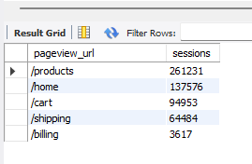

**Observation:** It seems like the product and home pages get most of the traffic among the five major pages listed. It will be a great idea to focus on enhancing these two pages for the best customer experience.

**2.2 A/B testing with a new lander page**

A new website page with the name ‘lander-1’ was added to the website on June 19, 2012. A full conversation funnel is analyzed between the home page and the new lander-1 page between June 19, 2012 and July 28, 2012.

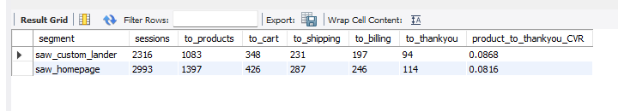

**Observation:** It seems like the original homepage still has more sessions than the custom lander page but the conversation rate from the customer selecting products to buying it is higher for the custom lander page. The custom lander page has a conversation rate of 8.68% whereas for the homepage it is 8.16%. Customers seem to be liking the new lander page and are more likely to purchase product when directed through the new lander page.

**3. Business patterns and analyzing seasonality**

**3.1 Analyzing quarterly session to order conversation rate, revenue per order and revenue per session**

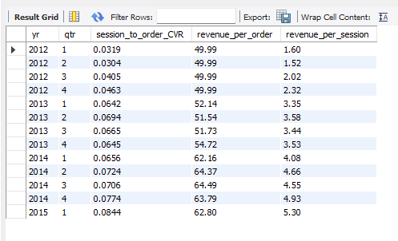

**Observation:** The session to order conversation looks great for the business as it has grown from 3.2% since starting the business in 2012 to 8.4% in the most recent quarter of 2015. Similarly, we see a drastic increase in revenue per order and revenue per session as well.

**3.2 Analyzing revenue by product and seasonality**

**Observation:** We see a spike in sales in the months November and December, every year for all the products and hence. The trend is most probably because of the holiday season as online retail attracts more customers. We also see high revenue in February months for the product lovebear. The product was targeted at couples for gifts. So, we see a large spike in revenue around Valentine’s Day.

**3.3 Company's yearly growth in revenue**

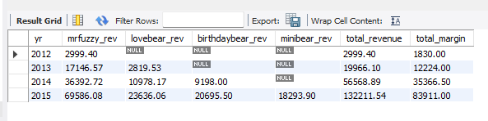

**Observation:** Overall, the company seems to have increased its total revenue and margin since its start in 2012. The business seems profitable, and the increasing revenue trend seems promising.