**SDLC: Building Software the Right Way**

**Infographic Overview**

This infographic depicts the Software Development Life Cycle (SDLC) as a circular process with five interconnected phases: Requirements, Design, Implementation, Testing, and Deployment. Each phase is illustrated with an icon and a brief explanation of its purpose. Arrows flow between the phases, emphasizing the iterative and collaborative nature of SDLC.

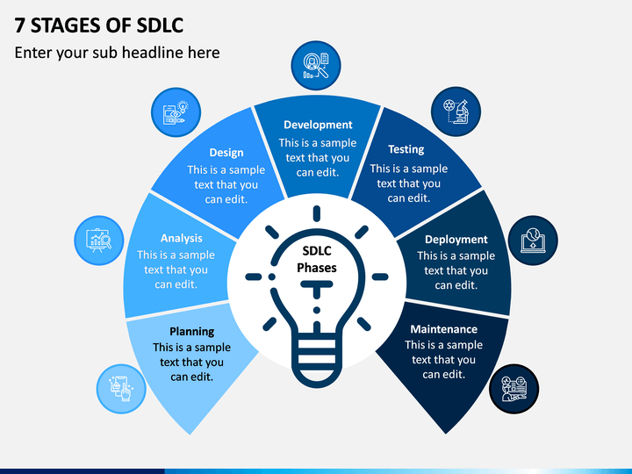

*Building High-Quality Software Through Collaboration*

**Phase 1: Requirements (Blueprint)**

* **Icon:** Hammer and Drafting Board
* **Description:** This phase gathers user needs and translates them into functional specifications. It's the foundation for the entire project.

**Phase 2: Design (Architecture)**

* **Icon:** Gears and Circuit Board
* **Description:** Based on requirements, the system architecture and user interface are designed, ensuring functionality and a positive user experience.

**Phase 3: Implementation (Building)**

* **Icon:** Coding Lines
* **Description:** Developers write code based on the design, bringing the software to life.

**Phase 4: Testing (Quality Check)**

* **Icon:** Magnifying Glass
* **Description:** The software is rigorously tested to identify and fix bugs before deployment.

**Phase 5: Deployment (Launch)**

* **Icon:** Rocket Launching
* **Description:** The software is released to the target environment, making it available to users.

**Interconnectivity Arrows:**

* **Requirements to Design:** Flowing from Requirements to Design signifies that design decisions are based on well-defined user needs.
* **Design to Implementation:** Flowing from Design to Implementation highlights coding based on the established architecture and UI design.
* **Implementation to Testing:** Flowing from Implementation to Testing indicates that the completed code undergoes thorough testing.
* **Testing to Deployment:** Flowing from Testing to Deployment signifies that only well-tested software gets deployed.
* **Deployment to Requirements:** A dotted arrow flows from Deployment back to Requirements, indicating that user feedback after launch may inform future requirement updates.