Agile Principles:

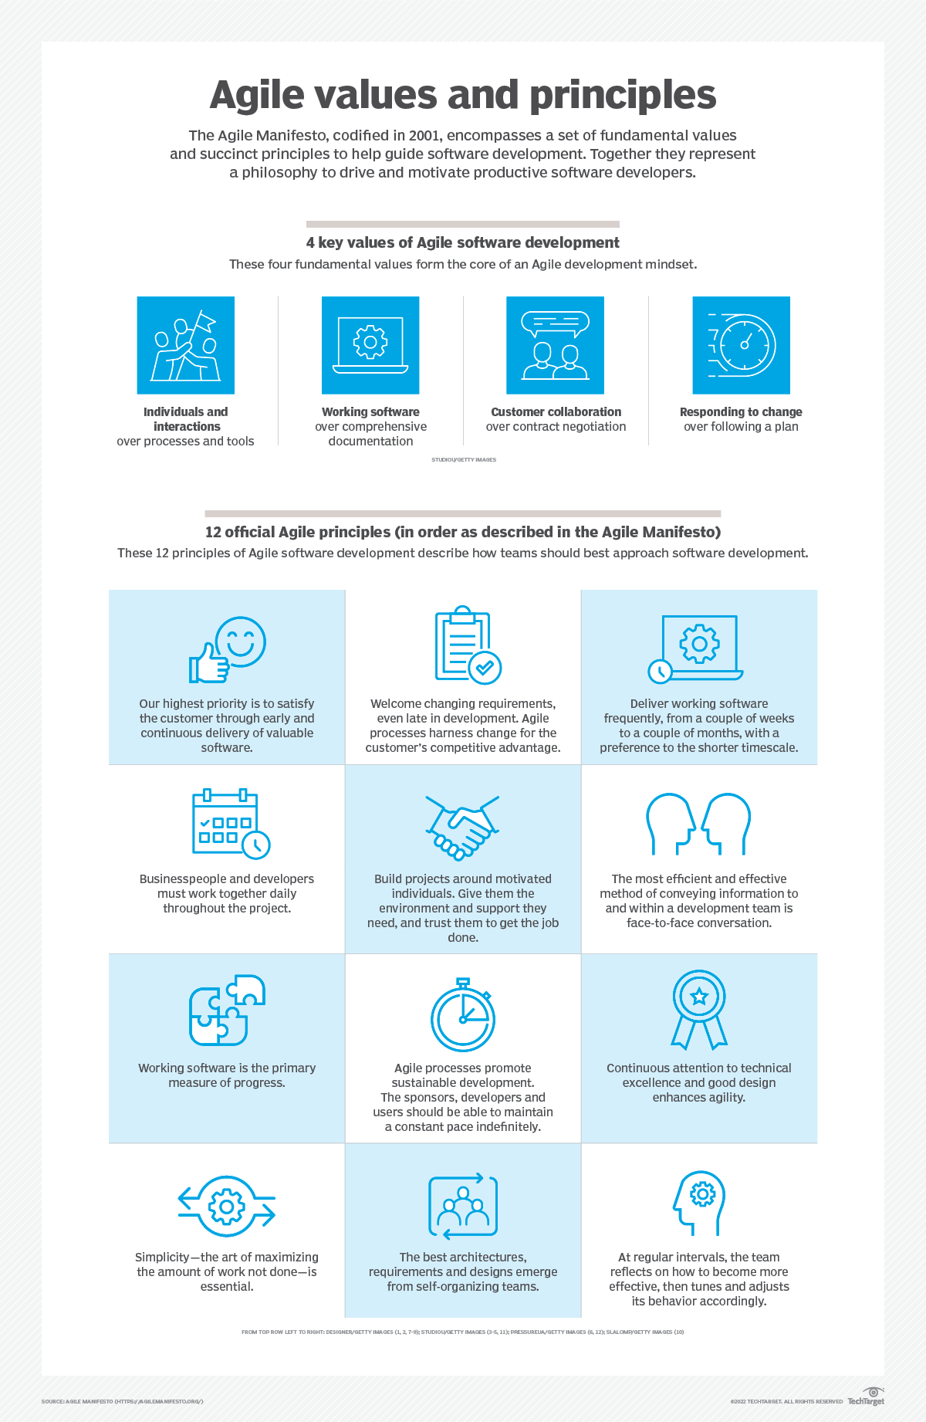

• **Customer Satisfaction Through Early and Continuous Delivery:**  
This principle emphasizes delivering working software frequently, in short iterations. This allows for early feedback from customers, ensuring the final product aligns with their needs and expectations.

• **Welcome Changing Requirements:**  
Agile embraces the idea that requirements may evolve throughout the development process. Instead of rigidly sticking to a pre-defined plan, Agile teams adapt to these changes to deliver the most valuable product possible.

• **Deliver Working Software Frequently:**  
The focus here is on prioritizing the delivery of functional software in short cycles (weeks to a few months). This allows for continuous feedback integration and course correction if needed.

• **Business People and Developers Collaborate Daily:**  
Close collaboration between those who define the business needs (business people) and those who build the product (developers) is crucial for success. Daily interaction ensures everyone is on the same page and potential issues are addressed quickly.

• **Build Projects Around Motivated Individuals:**  
Agile recognizes that motivated and empowered individuals are the heart of successful projects. This principle emphasizes creating an environment that fosters ownership and trust, allowing team members to excel.

• **Face-to-Face Interaction is the Most Efficient and Effective:**  
Direct communication through face-to-face interactions is considered the most effective way for Agile teams to collaborate and solve problems. This can be achieved through daily stand-up meetings or other in-person discussions.

• **Working Software is the Primary Measure of Progress:**  
In Agile, the focus is on having a demonstrably functional product as the key indicator of progress. Extensive documentation, while valuable, is secondary to having a working product that can be reviewed and improved upon.

• **Agile Processes Promote Sustainable Development:**  
Agile methodologies aim to create a development pace that can be maintained for the long term. This avoids burnout and ensures the team can consistently deliver value without compromising quality.

• **Continuous Attention to Technical Excellence and Good Design:**  
Agile doesn't mean sacrificing quality for speed. This principle highlights the importance of prioritizing good coding practices and design principles to create a maintainable and well-structured codebase.

• **Simplicity—the Art of Maximizing the Amount of Work Not Done—is Essential:**  
Agile promotes a focus on doing only what's necessary. Avoid unnecessary complexity in the development process and focus on delivering the core value of the product.

• **The Best Architectures, Requirements, and Designs Emerge from Self-Organizing Teams:**  
Agile empowers teams to make decisions and manage their workload without constant micromanagement. This fosters ownership and encourages teams to find the most effective approaches for themselves.

• **At Regular Intervals, the Team Reflects on How to Become More Effective, Then Tunes and Adjusts Its Behavior Accordingly:**  
Agile is a continuous improvement process. Regular reflection allows teams to assess their effectiveness and identify areas for improvement. This allows the team to constantly adapt and refine their approach.