Phase Change Material (PCM) for Thermal Comfort in Textiles

Md Izghan Adan (2023TT10374)
Darshan Mujalde (2022TT11364)

TXL750 Assignment
4th October, 2026

1. Introduction

1.1 Background
Clothing sits between the skin and the air around it, so it has a big effect on how warm or cool a person feels. In his review of smart textiles, Mondal discusses the idea of thermal comfort, clothing for cold environments, and the link between phase change materials and clothing comfort [1]. Another review points out that warm and cool discomfort of the whole body is described with the PMV and PPD indices, and that it is hard to create surroundings that please everyone because people differ from one another [2]. This assignment looks at one way textile scientists try to improve thermal comfort: adding phase change materials, or PCMs, to fabrics and garments.
Phase change materials take advantage of latent heat, which is heat that a material can store or release over a narrow temperature range [1]. A PCM absorbs energy during heating while the phase change takes place, and it releases energy to the surroundings during the reverse cooling process [1]. In textiles, the PCM changes phase when it meets heat from the body or from outside. It takes in extra heat and helps keep a steady microclimate between the fabric and the skin. When the temperature drops, the PCM freezes and gives the heat back to the wearer [2]. Figure 1 shows this idea in a simple way.
PCMs matter to the textile industry because they are used in many product areas. A recent review reports that PCM-integrated cloth was first developed by NASA to keep a steady temperature in space, and that it is now widely used to improve thermal comfort in many different environments [3]. The same review lists space wear, medical textiles, sportswear, bedding, buildings, flame-retardant cloth, car interiors and footwear as application areas, and it reports that sportswear brands such as Nike and Adidas have used PCM in their products [3]. It also quotes a market report which says the PCM market was worth USD 1.66 billion in 2021 and is expected to reach USD 5.1 billion by 2030, a yearly growth rate of about 15% [3].
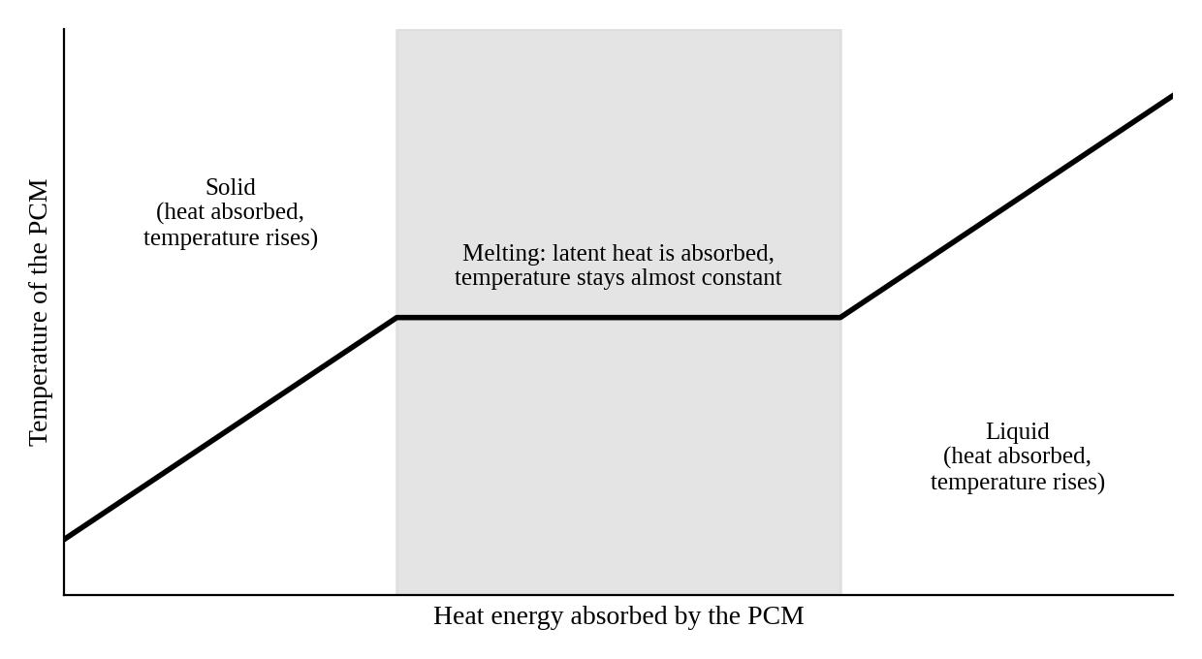
Figure 1. Simple schematic of a PCM being heated (based on the principle in [3]; not measured data).
Research interest has grown as well. In a search of the Scopus database for the term “PCM textile”, the authors of that review found 3198 publications between March 2010 and March 2024. Only 48 of them were published in 2010, while 460 were published in 2022 [3]. The aim of this assignment is to summarise what published research says about PCMs for thermal comfort in textiles, to describe how PCM textiles are developed and tested, and to compare two published case studies.

2. Literature Review

2.1 Existing Research and Developments
Work on PCM clothing is not new. An early study from 2001 by Shim, McCullough and Jones used one-layer and two-layer body suits made from a fabric and foam laminate, with and without PCM microcapsules. The suits were put on a thermal manikin, and the heat loss from the manikin was measured as it moved from a warm chamber to a cold chamber and back again [5]. The authors found that the heating and cooling effects lasted about 15 minutes, and they concluded that PCMs in clothing give only a small, temporary heating or cooling effect when the surrounding temperature changes [5].
Many review papers have followed. Pritom and co-authors reviewed how PCMs are made, what their main features are, and how they are used in smart textiles, and they also discuss the benefits and challenges of using them [4]. Shahid and co-authors describe several earlier reviews and point out that each had its own limits. One looked at organic PCMs in cloth, one covered synthesis, mechanism and classification but gave no details about applications, one looked at polymer-based PCMs, one looked at microencapsulated PCM applications, and one covered fabrication, characterisation and environmental impact [3]. Other reviews include an overview of organic PCMs and their textile uses by Sarier and Onder [7], and a review by Iqbal and co-authors that covers organic and inorganic PCMs, encapsulation methods, testing methods and how PCMs are added to fibres and fabric pads [6]. The review on fabrication, classification and environmental impact by Hossain and co-authors is also part of this group [2].
A second line of research looks at how PCM garments work on the human body, especially cooling vests. Gao, Kuklane and Holmér tested PCM cooling vests on a heated thermal manikin in a climatic chamber, using PCMs that melt at 24, 28 and 32 °C and manikin temperatures of 34 and 38 °C [8]. They found that the cooling rate rose as the temperature gap between the manikin and the PCM melting point became larger. They suggested that the gap should be more than 6 °C when PCM vests are used in hot climates. With the same temperature gap, the cooling rate was mainly set by the area covered, and the length of the cooling effect depended on the mass of PCM and its latent heat [8].
Zhao and co-authors then looked at sweat. They used a pre-wetted fabric skin on a thermal manikin to copy sweating from the torso, and tested three cooling vests with PCMs melting at 21, 24 and 28 °C under a military clothing set [9]. In one of the two hot climates tested (called HH in the paper), all three vests cooled the torso well. In the other (called HD), the cooling benefit was negative. In both climates the vests greatly limited cooling by sweat evaporation [9]. This shows that a PCM garment does not work alone; the climate and the clothing around it also matter.

2.2 Key Findings
The most important findings from the literature reviewed above can be listed as follows:
- PCMs work by storing and releasing latent heat over a narrow temperature range, which can help keep the microclimate near the skin steady [1], [2].
- In an early manikin test, the heating and cooling effect of PCM clothing lasted only about 15 minutes, so the effect is real but temporary [5].
- For cooling vests, the temperature gap between the body and the PCM, the covered area, the PCM mass and the latent heat all decide how well the vest cools and for how long [8].
- Sweat evaporation and the type of climate can change the result a lot, because the vests can block evaporative cooling [9].
- Reviews list several challenges: low thermal conductivity of PCMs, keeping breathability and flexibility, moisture control, washing durability, and cost [3].

3. Product Development / Methodology

3.1 Choosing the PCM
The first step in developing a PCM textile is choosing the PCM. Shahid and co-authors group PCMs by chemical type into organic, inorganic and eutectic materials [3]. Figure 2 shows this grouping and Table 1 gives some typical values reported in the same review.
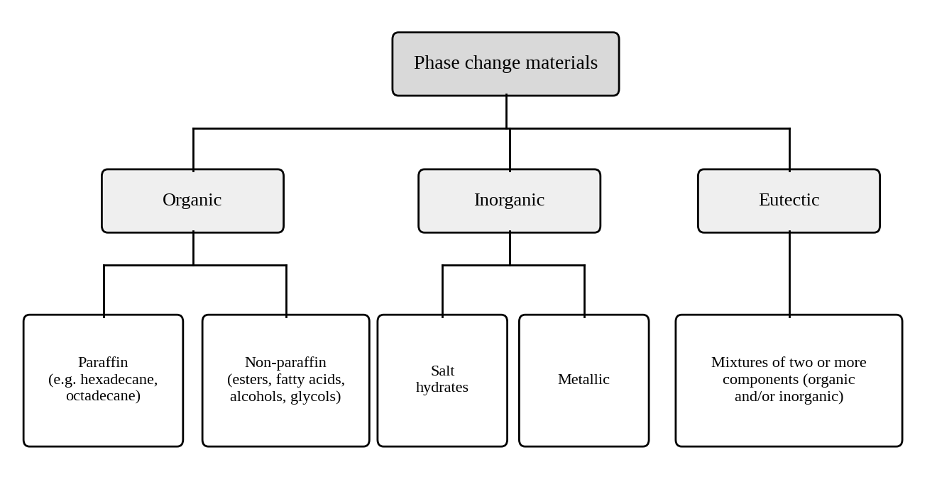
Figure 2. Main types of PCMs used in textiles (based on the classification given in [3]).
Organic PCMs include paraffins and non-paraffin materials such as esters, fatty acids, alcohols and glycols. Paraffin wax is noted for high latent heat storage, chemical stability and low cost, and polyethylene glycol is valued in the textile and medical industries for its heat storage, stability and low toxicity [3]. Inorganic PCMs are mainly salt hydrates and metallic materials. Salt hydrates store a lot of heat at a low cost, but they have problems such as phase separation and supercooling [3]. Eutectic PCMs are mixtures of two or more components that solidify together at a temperature lower than any of the single components [3].
Table 1. Some PCMs and their reported properties (values as collected in [3]; the ranges are wide because they come from different studies and products).
PCM | Transition temperature range (°C) | Thermal conductivity (W/m·K) | Reported uses
Paraffin wax | 20 to 70 | 0.2–0.3 | Food packaging, building materials, textiles
Vegetable oils | −10 to 70 | 0.13–0.18 | Thermal energy storage, textiles
Lauric acid | 43 to 46 | 0.2–0.5 | Thermal energy storage, pharmaceuticals
Stearic acid | 50 to 70 | 0.2–0.5 | Textiles, thermal energy storage
Salt hydrates | −20 to 100 | 0.5–2.0 | HVAC systems, thermal energy storage
Outlast PCM | 20 to 30 | Varies | Textiles, bedding

The right melting temperature depends on how the product will be used. For example, a study reported in the review by Shahid and co-authors says PCMs with melting points of 20–25 °C should be used for polyester fabrics in building uses [3]. The cooling vest studies discussed later in this assignment tested melting points from 0 °C up to 30 °C [11], [12].

3.2 Putting the PCM into the Textile
PCMs can be added to cloth in several ways. According to Shahid and co-authors, PCMIC (PCM-integrated cloth) is made by methods such as melt spinning, lamination, coating, fibre extrusion, finishing, injection moulding, foam production and bicomponent synthesis [3]. Table 2 summarises five common routes and their good and bad points as described in that review.
Table 2. Ways of adding PCM to textiles (summarised from [3]).
Method | Advantages | Disadvantages
Encapsulation | Spreads the PCM evenly in the fabric and allows controlled release of heat | Can change the hand feel; capsules may break during making or use, so the effect fades
Coating | Easy to do and suited to industry; works on many fabrics | Can wear off with washing; hard to spread evenly, which may cause uneven temperature control
Impregnation | Better contact between PCM and fibres; less effect on hand feel than encapsulation | Needs special equipment and raises cost; depends on how well the PCM sticks to the fibre
Electrospinning | Fine control of PCM spread at the nanoscale | Complex and costly; needs special equipment and skill
Weaving or knitting PCM fibres | Stable performance because the PCM is part of the fabric structure | Limited to certain fabric designs; stiff or dense PCM fibres may affect drape and stretch

Some of the methods are used to make the PCM part of the fibre itself. In one example reported in the same review, polypropylene fibres were made by melt spinning with PCM in the core of a bicomponent yarn. The PCM share ranged from 22% to 64% by volume, and the fibre reached a latent heat of 22.2 J/g, which the authors describe as nearly three times that of modern fibres [3].

3.3 Testing Routes
After the PCM textile is made, it is tested in stages. The first group of tests looks at the material itself. Shahid and co-authors describe scanning electron microscopy (SEM) to see how the PCM is spread in the fabric, thermogravimetric analysis (TGA) to check heat stability, and differential scanning calorimetry (DSC) to measure how much energy the material can store and at which temperatures the phase change happens [3]. Thermal conductivity is also measured because it affects how heat moves from the body to the surroundings [3].
The second group of tests checks comfort and usability. Air permeability is measured because it strongly affects breathability and comfort, and the PCM can change the fabric structure and so change airflow [3]. Moisture absorption and mechanical tests (tensile, flexing and abrasion) show whether the fabric still behaves well and can stand up to handling and cleaning [3].
The third group tests the whole garment. A heated thermal manikin in a climatic chamber is one option, as in the studies by Shim and co-authors [5], Gao and co-authors [8] and Zhao and co-authors [9]. The final step is a trial with human volunteers, as in the cooling vest studies in Section 4. Each step answers a different question.

3.4 Latest Advancements
Recent work tries to fix the weak points of PCMs, especially low thermal conductivity and leakage. Shahid and co-authors list advanced fibre-making methods, including blend, coaxial and emulsion electrospinning and centrifugal spinning, that have been used to put PCMs into very fine fibres for thermal regulation [3]. They also report that aramid cloths coated with PCM and topped with aerogel showed better flame resistance, and that Nomex cloths coated with PCM and aerogel gave better thermal protection and comfort [3].
Another example is the work of Zeighampour, Khoddami and Dolez. They aimed to make a flexible thermal regulation fibrous structure with better thermal conductivity, a suitable phase transition temperature, good thermal endurance and no leakage [10]. They used a shape-stabilized nanocomposite PCM deposited on a polyester nonwoven fabric. The coated fabric had increased thermal conductivity and no PCM leakage during thermal cycles, which the authors say is important for practical heat storage use [10]. Looking ahead, Shahid and co-authors expect more use of nanotechnology, smart textile technology such as sensors for real-time heat control, and PCMs that are biocompatible and biodegradable [3].

3.5 Benefits and Challenges
The reviewed papers describe clear benefits. PCMs offer latent heat storage, a narrow working temperature range, high energy storage density, long life and good fit with textile processing [3]. Built into a garment, a PCM can take up extra heat from the body, which keeps the microclimate from overheating and lowers the need for heavy sweating [3]. PCMs may also lower the need for mechanical heating and cooling systems, which saves energy [3].
The same papers also list challenges. The effect is temporary, as the early manikin tests showed [5]. PCMs usually have low thermal conductivity, so heat moves slowly, and adding conductive materials such as carbon nanotubes can raise the cost [3]. Fitting the PCM into a garment while keeping breathability, flexibility and moisture control is difficult [3]. Coatings can wear off with washing, and microcapsules can break [3]. Shahid and co-authors also say that commercial PCMs often show poor phase reversal and stability problems, and that at the end of their life PCMs must be disposed of or recycled to reduce the environmental load [3]. Pritom and co-authors also discuss the benefits and challenges of using PCMs [4]. Table 3 gives a short summary.
Table 3. Summary of benefits and challenges of PCM textiles (from [3], [5] and [9]).
Benefits | Challenges
Stores and releases latent heat at a narrow temperature range | Effect lasts only a short time [5]
Can keep the microclimate near the skin steady | Low thermal conductivity; fixes can add cost
Reusable and suits textile processing | Washing durability; microcapsules can break
May reduce the need for heating and cooling systems | May limit sweat evaporation in some climates [9]

4. Case Studies / Examples

4.1 Case Study 1: PCM Cooling Vests for Heat Strain in Fire-fighting Clothing
The first case study is a human trial of PCM cooling vests. Gao, Kuklane and Holmér wanted to check if the cooling effects they had seen on a thermal manikin would also appear on people in extreme heat [11]. The volunteers wore cooling vests with PCMs melting at 24 °C or 28 °C together with fire-fighting clothing and equipment, so there were three test groups: vest 24, vest 28 and a control group without a vest. They walked on a treadmill at 5 km/h in a climatic chamber with an air temperature of 55 °C, relative humidity of 30% and air speed of 0.4 m/s [11].
The vest with the lower melting temperature (24 °C) cooled the torso and the mean skin temperature more strongly than the 28 °C vest. Both vests reduced the peak rise in core body temperature during the resting recovery period. However, neither vest had a significant effect on the rise in core temperature during exercise in the heat. The authors suggest testing PCMs with even lower melting temperatures, such as 15 °C, and a larger covering area [11].
A later study by House and co-authors supports and extends these results. Ten male volunteers wore fire-fighting clothing while exercising and then recovering in 40 °C air, using vests with PCMs that melt at 0, 10, 20 and 30 °C [12]. Compared with a control condition, only the 0 °C and 10 °C vests cooled the body during exercise (40 W and 29 W). All four vests cooled the body during rest, at 69, 66, 55 and 29 W for the 0, 10, 20 and 30 °C vests [12]. The volunteers preferred the 10 °C vest, because the 0 °C vest caused temporary redness of the skin underneath. The authors concluded that a vest melting at 10 °C seemed the most suitable choice for combined work and rest periods [12].

4.2 Case Study 2: MPCM-printed Cotton Fabric for Hospital Bed Sheets
The second case study is a product development study. Shahid, Saha, Miah and Hossain point out that patients who stay in bed in a hospital face a serious risk of bed sores and that a normal bed sheet does not reduce this risk [13]. They also say that they found no earlier work that prepared and tested hospital bed sheets with microencapsulated PCM (MPCM) applied by screen printing [13]. Their aim was to develop such a sheet from cotton fabric.
The base fabric was 100% cotton with a 2/1 twill weave and a weight of 410 GSM. The MPCM had a core of paraffin wax (70%) and a shell of poly-methyl methacrylate (30%). The microcapsules were mixed into a printing paste, printed onto the fabric through a screen, and dried at room temperature [13]. The capsule diameters were between about 4 and 9 micrometres, with an average of 7.429 micrometres [13].
The team tested the sample with SEM, TGA, DSC and FTIR, and also measured thermal conductivity, moisture management, tensile strength and surface roughness [13]. TGA showed that the treated fabric lost weight more slowly than the untreated fabric. DSC showed that melting started at 20 °C and ended at 30 °C. The thermal conductivity was slightly higher with MPCM (0.1761 W/m·K) than without it (0.1681 W/m·K). The breaking force was 679 N for the treated fabric and 502 N for the untreated fabric [13]. The authors concluded that the samples have great potential for use as hospital bed sheets to prevent bed sores [13]. It should be noted that the tests described in the paper are laboratory material tests, and the paper does not report trials with patients.

4.3 Analysis
The two case studies are quite different. The first is about a garment worn by working people in extreme heat, and it measures body temperature and cooling power. The second is about a fabric for bedding, and it measures material properties. Table 4 compares them.
Table 4. Comparison of the two case studies.
Point | Case 1: PCM cooling vests [11], [12] | Case 2: MPCM bed sheet [13]
Purpose | Reduce heat strain in fire-fighting clothing | Improve temperature control of a hospital bed sheet to help prevent bed sores
PCM form | PCM packs in a vest worn over the body | Microcapsules printed on cotton fabric
PCM melting range | 0 to 30 °C tested in the vest studies | Melting from 20 to 30 °C (DSC)
How tested | Volunteers on a treadmill and at rest in a hot climatic chamber | Laboratory tests on fabric samples (SEM, TGA, DSC, FTIR, and others)
Main result | Lower melting points cooled better; cooling was larger during rest than during exercise [11], [12] | Treated fabric lost weight more slowly in TGA, melted between 20 and 30 °C (DSC) and had a higher breaking force
Main limit | No significant effect on the rise in core temperature during exercise [11] | No patient trial reported

Several points can be learned from comparing the two. First, in both cases the melting range of the PCM was tied to the use. The vest studies show that the melting point changes how much cooling the wearer gets, with lower melting points giving more cooling in the hot test [11], [12]. The bed sheet study used a PCM that melts between 20 and 30 °C [13]. Second, in both cases the amount of PCM sets a limit. The vests gave more cooling during rest than during exercise [12], and in the 55 °C test they did not significantly reduce the rise in core temperature during exercise [11]. This matches the earlier finding that the length of cooling depends on PCM mass and latent heat [8].
Third, comfort and fabric behaviour matter as much as heat storage. In Case 2 the authors tested moisture management and mechanical properties, not only heat storage, and the printed fabric had a higher breaking force than the plain fabric [13]. In Case 1, comfort showed up in a different way: the volunteers preferred the 10 °C vest over the 0 °C vest, which caused temporary skin redness [12]. Fourth, the type of test decides how strong the conclusion can be. Case 1 includes human volunteers, so its conclusions are about real body responses. Case 2 only has laboratory results, so its claim of “great potential” still needs testing with users. Together, the cases show that a PCM product needs both good materials and good testing.

5. Conclusion

5.1 Summary
This assignment looked at phase change materials for thermal comfort in textiles. PCMs store and release latent heat over a narrow temperature range, and they have been used in clothing, bedding, medical textiles, sportswear and other products [1], [3]. Published research shows that PCMs can help the wearer, but the effect is temporary and depends on factors such as melting temperature, amount of PCM, covered area and climate [5], [8], [9]. PCMs can be made from organic, inorganic or eutectic materials and can be added to textiles by encapsulation, coating, impregnation, electrospinning, or weaving and knitting [3]. The two case studies showed that lower-melting PCM vests cooled people better in the heat tests and that a printed MPCM cotton fabric could be made and characterised in the laboratory [11], [12], [13].

5.2 Recommendations
Based on the findings of the research discussed above, the following recommendations can be made. First, the PCM melting temperature should be matched with the real use. For cooling garments in hot climates, a temperature gap of more than 6 °C between the body and the PCM has been suggested [8]. Second, new PCM textiles should be tested on people as well as in the laboratory, because the vest studies show that body results can differ from material results [11], [12]. Third, washing durability and breathability should be checked, since coatings can wear off and capsules can break [3]. Fourth, research should continue on raising thermal conductivity while keeping the fabric flexible, as in the shape-stabilized nanocomposite work [10]. Fifth, the full life of the product, including disposal and recycling, should be considered [3]. Finally, users should be given realistic expectations, because the heating or cooling effect of PCM clothing is temporary [5].

5.3 Final Thoughts
PCM textiles are a useful tool for thermal comfort, but they are not a complete answer on their own. The published studies show real benefits in cooling vests and promising results in laboratory fabric development. They also show clear limits. The growth in the number of papers and in the market suggests that interest will continue [3]. If researchers keep working on conductivity, durability, comfort and sustainability, PCM textiles can become more reliable and more widely used.

6. References
[1] Mondal S. Phase change materials for smart textiles – An overview. Applied Thermal Engineering. 2008;28(11–12):1536–1550. doi:10.1016/j.applthermaleng.2007.08.009
[2] Hossain MT, Shahid MA, Ali MY, Saha S, Jamal MSI, Habib A. Fabrications, classifications, and environmental impact of PCM-incorporated textiles: current state and future outlook. ACS Omega. 2023;8(48):45164–45176. doi:10.1021/acsomega.3c05702
[3] Shahid MA, Hossain MT, Hossain I, Limon MGM, Rabbani M, Rahim A. Research and development on phase change material-integrated cloth: a review. Journal of Industrial Textiles. 2024;54. doi:10.1177/15280837241262518
[4] Pritom MM, Islam MA, Moshwan MM, Hossain A, Hasan MZ, Siddiquee MAB, Asif AKMAH. Phase change materials in textiles: synthesis, properties, types and applications – a critical review. Textile Research Journal. 2024;94(23–24):2763–2779. doi:10.1177/00405175241246822
[5] Shim H, McCullough EA, Jones BW. Using phase change materials in clothing. Textile Research Journal. 2001;71(6):495–502. doi:10.1177/004051750107100605
[6] Iqbal K, et al. Phase change materials, their synthesis and application in textiles – a review. Journal of the Textile Institute. 2019;110:625–638. doi:10.1080/00405000.2018.1548088
[7] Sarier N, Onder E. Organic phase change materials and their textile applications: an overview. Thermochimica Acta. 2012;540:7–60. doi:10.1016/j.tca.2012.04.013
[8] Gao C, Kuklane K, Holmér I. Cooling vests with phase change material packs: the effects of temperature gradient, mass and covering area. Ergonomics. 2010;53(5):716–723. doi:10.1080/00140130903581649
[9] Zhao M, Gao C, Wang F, Kuklane K, Holmér I, Li J. The torso cooling of vests incorporated with phase change materials: a sweat evaporation perspective. Textile Research Journal. 2013;83(4). doi:10.1177/0040517512460294
[10] Zeighampour F, Khoddami A, Dolez PI. Innovative flexible thermal storage textile using nanocomposite shape-stabilized phase change materials. Fashion and Textiles. 2023;10:43. doi:10.1186/s40691-023-00363-7
[11] Gao C, Kuklane K, Holmér I. Cooling vests with phase change materials: the effects of melting temperature on heat strain alleviation in an extremely hot environment. European Journal of Applied Physiology. 2011;111(6):1207–1216. doi:10.1007/s00421-010-1748-4
[12] House JR, Lunt HC, Taylor R, Milligan G, Lyons JA, House CM. The impact of a phase-change cooling vest on heat strain and the effect of different cooling pack melting temperatures. European Journal of Applied Physiology. 2013;113(5):1223–1231. doi:10.1007/s00421-012-2534-2
[13] Shahid MA, Saha C, Miah MS, Hossain MT. Incorporation of MPCM on cotton fabric for potential application in hospital bed sheet. Heliyon. 2023;9(6):e16412. doi:10.1016/j.heliyon.2023.e16412

