DEVOPS _ NOTES

<!-- what is deops -->
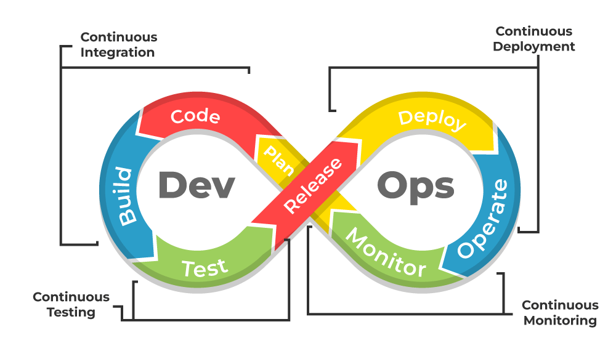
DevOps is a set of practices that combines software development (Dev) and IT operations (Ops) to streamline the process of delivering software applications. It aims to improve collaboration, communication, and automation between development teams and operations teams to ensure faster and more reliable software delivery.

DevOps practices include continuous integration, continuous delivery, continuous monitoring, and continuous improvement. These practices enable teams to work together more effectively, reduce the time to market, and improve the quality of software applications.

EC2 (Elastic Compute Cloud)
EC2 stands for Elastic Compute Cloud.

Resizable computing capacity means you can increase or decrease the processing power based on your workload, avoiding overpaying or lacking resources.

**EC2 stands for Amazon Elastic Compute Cloud, a core service of AWS.
**
Amazon EC2 (Elastic Compute Cloud) is a cloud service provided by AWS that allows us to create and use virtual servers on the internet.

It is used to run applications, websites, and services without buying physical servers.

--> EC2 helps to:

Avoid overload and under-utilization of servers

Increase or decrease computing power whenever needed

Pay only for the resources we use

EC2 is:

Scalable – we can increase or decrease CPU, memory, and instances

Flexible – supports different operating systems and configurations

Reliable – runs on AWS global infrastructure

Very Simple One-Line Definition (Interview)

EC2 is a service that provides virtual servers in the cloud where we can run applications and scale resources based on demand.

Example (Easy to Understand)

Traffic is low → use 1 EC2 instance

Traffic is high → add more EC2 instances

Traffic reduces → remove extra instances

This way, performance is maintained and cost is saved.

--> **SDLDC(software development life cycle)** is stuctured followed by development team to plan,build,test,deploy and maintain the sofware application.

>> Ther are 6 phases or stage in SDLC:

1. Planning, 2.defining/Analysis, 3. Design, 4. building/Implementation, 5. Testing, 6. deploying/ Maintenance.

--> SDLC stands for Software Development Life Cycle.

--> SDLC is a process used by the software industry to design, develop, and test high-quality software.

--> SDLC is a series of steps or phases that a software project goes through, from initial planning to final deployment.

--> SDLC is a structured approach that helps to ensure that software is developed efficiently and effectively.

1. Planning: The first phase of SDLC involves defining the project scope, objectives, and resources required to complete the project.
2. Defining/Analysis: In this phase, the requirements of the software are gathered and analyzed to determine the functional and non-functional requirements of the software.
SRS (Software Requirements Specification) is a document that describes the requirements of the software.
A detailed Software Requirement Specification (SRS) document is created to define what needs to be built.
3. Design: In this phase, the software architecture and design are created to meet the requirements gathered in the previous phase.
esigning Architecture
Traditional SDLC

System and software design documents are created based on requirements. This includes both high-level (HLD) and low-level design (LLD).
4. Building/Implementation: In this phase, the software is developed using the design created in the previous phase.
5. Testing: In this phase, the software is tested to ensure that it meets the requirements and is free from defects.
6. Deploying/ Maintenance: In this phase, the software is deployed to the production environment and maintained to ensure that it continues to meet the requirements and is free from defects.
1. Deployment: The software is deployed to the production environment.
2.

