
Department of Computer Science & Engineering

A Report on
Blockchain-Enabled Secure Framework for Pre-Release Movie Distribution with Leak Traceability
Blockchain and Distributed app Development - 23CSE635

Submitted in partial fulfillment of the requirements for the award of the degree of

Bachelor of Engineering in Computer Science & Engineering

By

Darshan B M 1MS24CS401

Under the guidance of

Mrs. Uzma Taj
Assistant Professor

M S RAMAIAH INSTITUTE OF TECHNOLOGY
(Autonomous Institute, Affiliated to VTU)
BANGALORE-560054
www.msrit.edu
April-2026

Department of Computer Science and Engineering

M S Ramaiah Institute of Technology
(Autonomous Institute, Affiliated to VTU)

Bangalore – 54

CERTIFICATE

This is to certify that Darshan B M (1MS24CS401) have completed the “Blockchain-Enabled Secure Framework for Pre-Release Movie Distribution with Leak Traceability” as part of Blockchain and Distributed app Development - 23CSE635 course. I declare that the entire content embodied in this B.E CSE, 6th semester report contents are not copied.

Submitted by Guided by
Darshan B M | 1MS24CS401

Mrs. Uzma Taj
Assistant Professor
Dept. of CSE, RIT

Department of Computer Science and Engineering

M S Ramaiah Institute of Technology
(Autonomous Institute, Affiliated to VTU)

Bangalore – 54

Evaluation Sheet

USN | Name | Literature survey and Explanation Skills  (5) | Coding & Documentation  (5) | Total Marks  (10)
1MS24CS401 | Darshan B M

Evaluated By

Name: Mrs. Uzma Taj
Designation: Assistant Professor
Department: Computer Science & Engineering, RIT
Signature:

Table of Contents

Sl No | Content | Page No
 | Abstract | 1
 | Introduction | 2
 | Literature study | 3
 | Coding | 4-5
 | Results snapshots and discussion | 6-8
 | Conclusion | 9
 | References | 10
 | Literature Survey Proofs | 11-12

ABSTRACT

This project presents a blockchain-enabled secure framework for pre-release movie distribution, designed to address the critical issue of unauthorized leaks in the film industry. Traditional digital distribution lacks accountability, making it difficult to trace the source of leaked content.

The proposed system integrates personalized watermarking, role-based access control, and blockchain-based non-repudiation to ensure traceability and security. Each authorized reviewer receives a uniquely watermarked copy of the movie, embedding identifiable information. In the event of a leak, the system performs multi-stage watermark extraction and identifies the responsible user with a defined confidence level.

To strengthen trust, all access assignments and interactions are recorded on a blockchain network, ensuring an immutable audit trail. The system supports both streaming (controlled access) and download (offline access), balancing usability and security.

This framework demonstrates how combining watermark-based traceability with blockchain verification can significantly improve accountability in digital media distribution, acting as a deterrent against piracy.

INTRODUCTION

The rapid growth of digital content distribution has significantly increased the risk of unauthorized duplication and piracy, especially in the movie industry. Pre-release distribution to reviewers, critics, and regulatory bodies is essential, yet it exposes content to potential leaks.

Existing systems rely on basic access control mechanisms, which fail to provide traceability and accountability once content is leaked. Without reliable tracking, studios cannot identify the source of leaks, leading to substantial financial losses.

This project addresses these challenges by proposing a system that ensures:

- Controlled distribution through authenticated access
- Traceability using personalized watermarking
- Accountability via blockchain-based logging
- Leak detection through multi-stage analysis

The system introduces two key ideas:

- Each user receives a uniquely identifiable version of the content
- Every distribution event is permanently recorded on blockchain

Unlike traditional systems, this approach links digital content ownership, access history, and identity verification, making it possible to trace leaks back to specific users.

LITERATURE STUDY

This project builds upon concepts from multiple domains:

1. Digital Rights Management (DRM)

Traditional DRM systems focus on restricting access and preventing duplication. However, they often fail when content is captured externally (e.g., screen recording).

Limitation: Prevention-focused, not accountability-focused.

2. Digital Watermarking Techniques

Watermarking embeds identifiable information into media files.

Visible watermarking: Simple but removable
Invisible watermarking: More robust but complex

Gap: Most systems do not integrate watermarking with user identity tracking in a verifiable way.

3. Blockchain for Security and Audit Trails

Blockchain provides:
- Immutability
- Transparency
- Non-repudiation

It has been used in:
- Supply chain tracking
- Digital identity verification

Gap: Limited integration with media distribution and watermark validation.

4. Existing Media Distribution Systems

Platforms like Netflix or internal studio systems:
- Use encryption and DRM
- Do not provide leak traceability to specific users

CODING

The system follows a full-stack architecture:

Backend (FastAPI)
- Handles authentication, authorization, and business logic
- Implements REST APIs for:
- Movie upload
- Access assignment
- Streaming & download
- Leak detection

Frontend (React)
- Provides dashboards for producers and reviewers
- Implements:
- Video streaming player
- Dynamic watermark overlay

Database (SQLite)
Stores:
- Users
- Movies
- Access control records
- Leak detection logs

Core Modules

1. Watermarking Module
- Generates watermark using SHA-256:
watermark_id = hash(user_id + movie_id + timestamp)
- Embeds watermark into video using FFmpeg
- Supports extraction via:
- Metadata
- OCR-based frame analysis

2. Blockchain Module
- Uses Ethereum (Ganache)
- Smart contract logs:
- Movie registration
- Access assignment
- Download/stream events

3. Streaming Module
- Sends video in chunks
- Adds dynamic watermark overlay:
- Timestamp updates
- Position rotation

4. Leak Detection Module

- Three-stage detection:

- Metadata extraction
- Database matching
- Frame analysis (OCR)

- Outputs:

- User ID
- Confidence level
- Blockchain verification

RESULTS SNAPSHOTS AND DISCUSSION

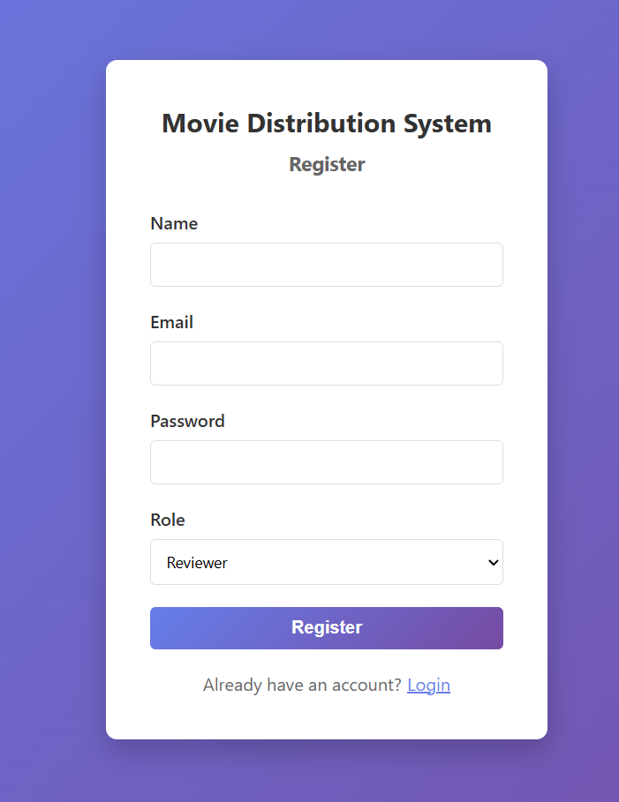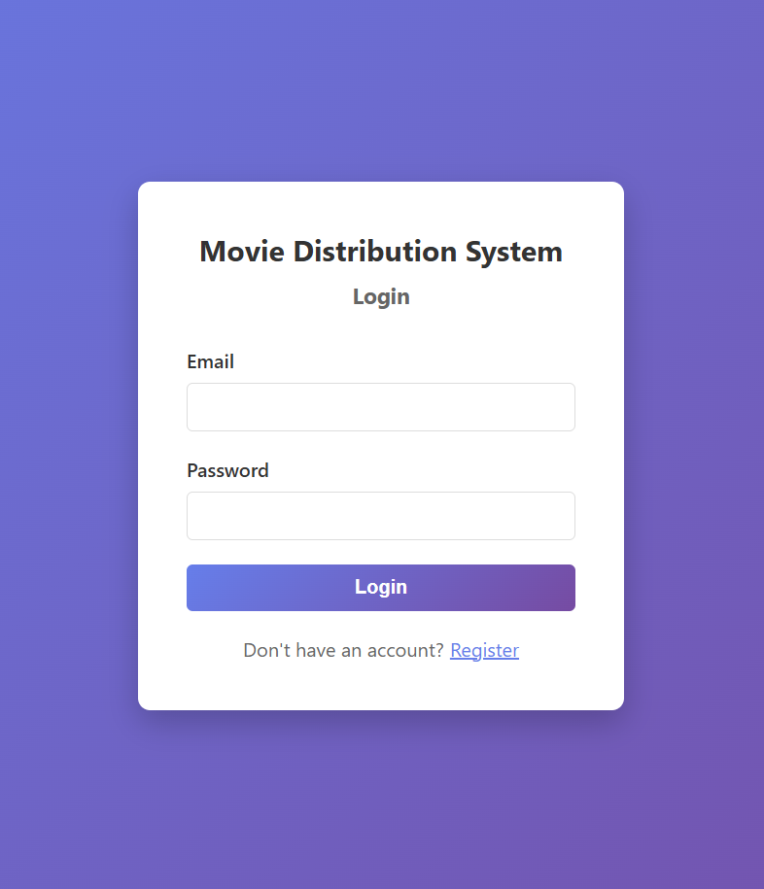
Fig . 1: User registration/login

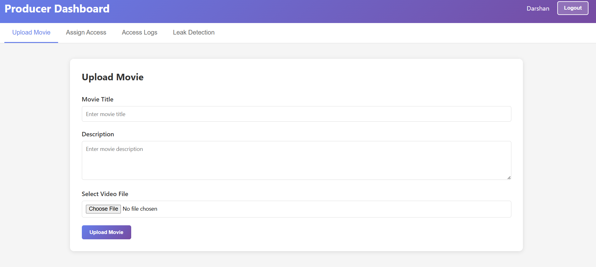
Fig . 2: Movie upload

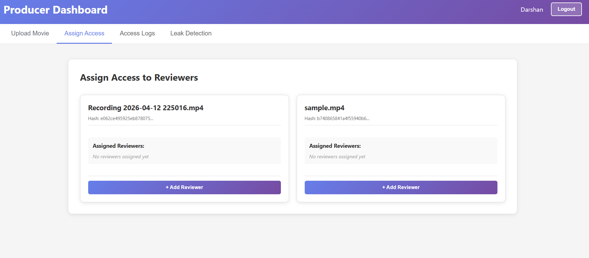
Fig . 3: Access assignment

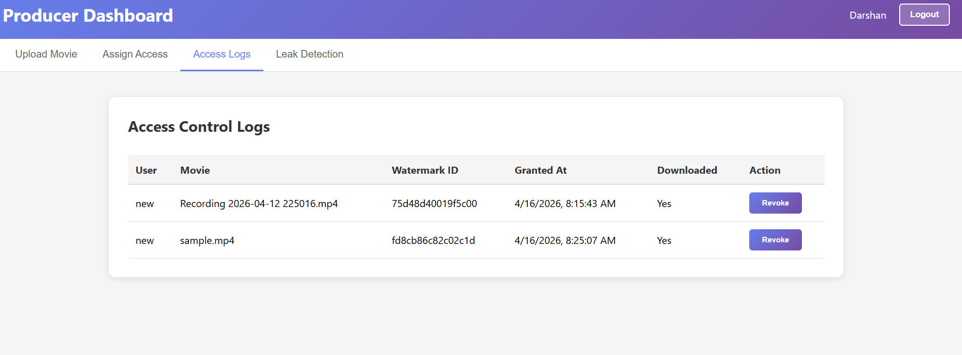
Fig . 4: Blockchain transaction logs

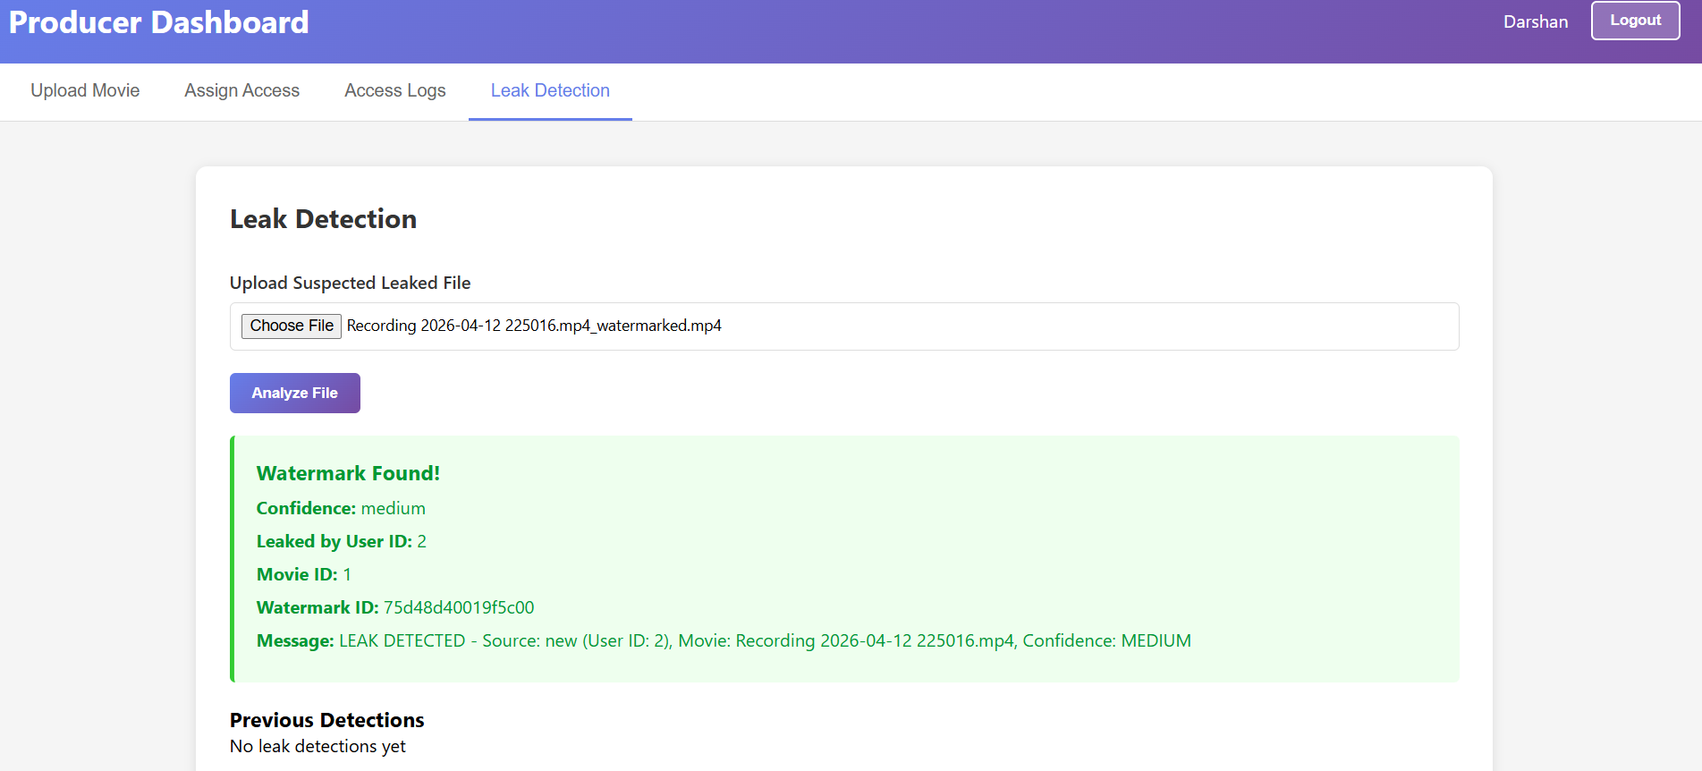
Fig . 5: Leak detection result

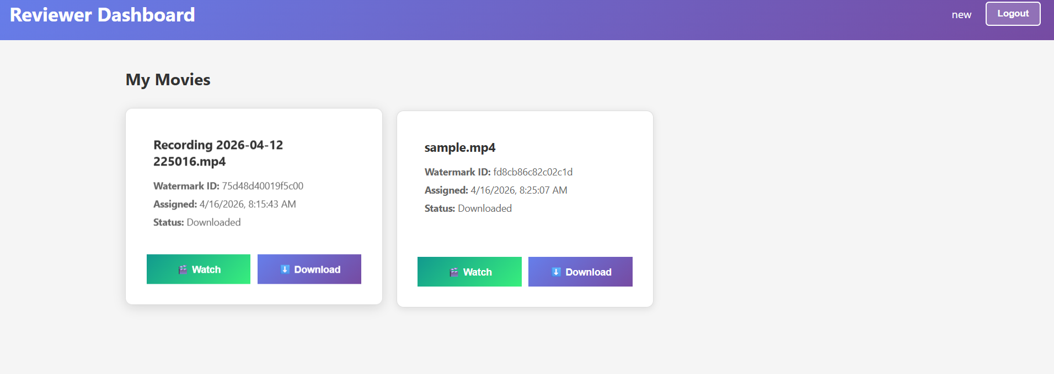
Fig . 6: Downloaded video

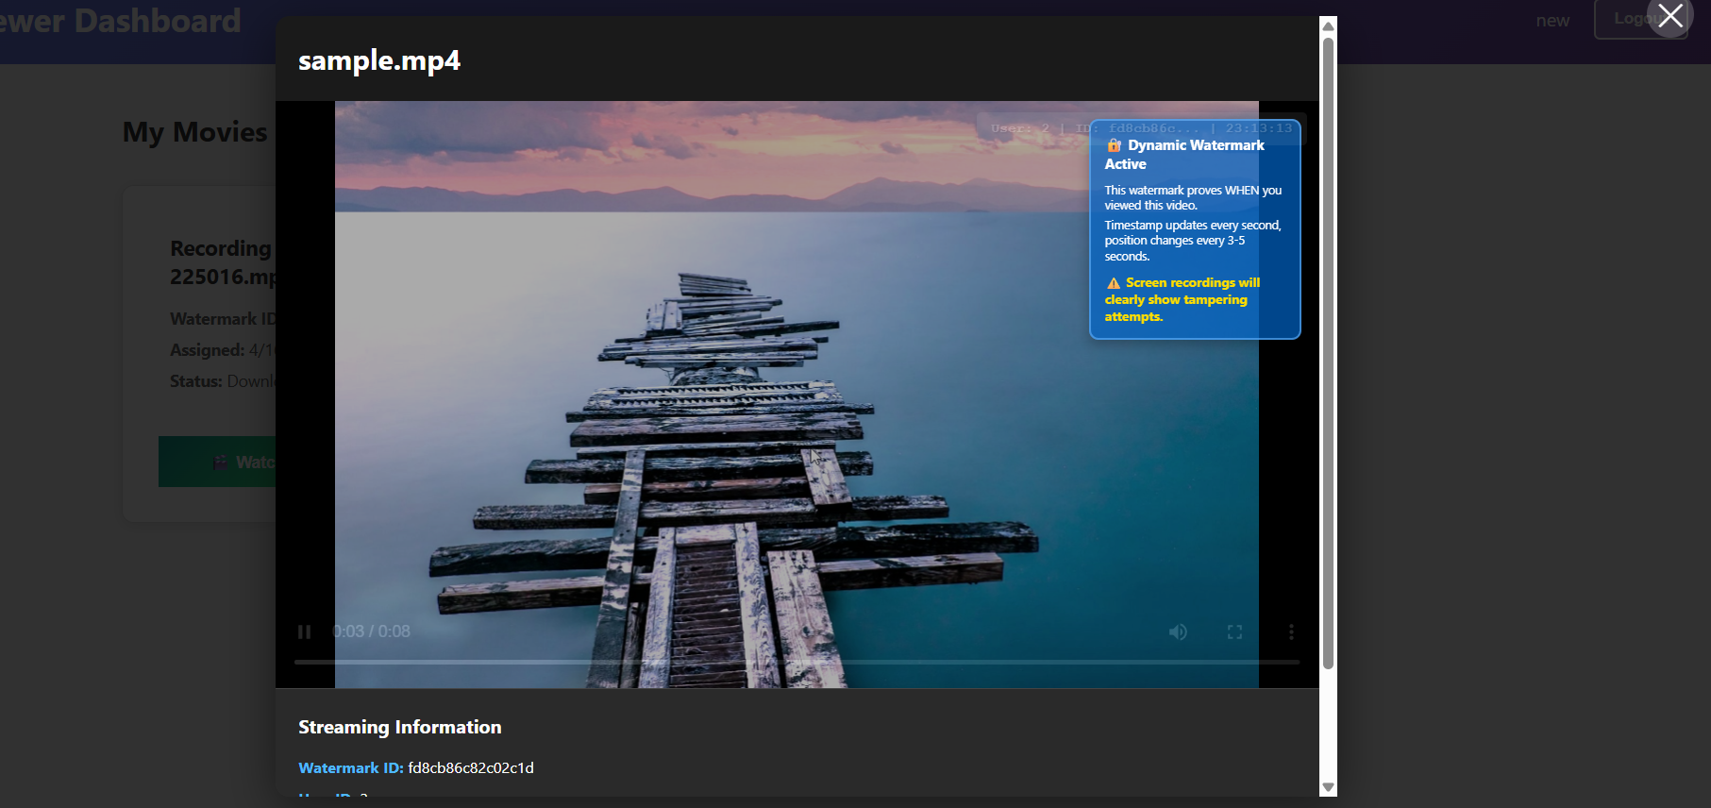
Fig . 7: Streaming with watermark

The system successfully demonstrates:

✔ Secure distribution of pre-release movies
✔ Unique watermark generation for each user
✔ Real-time streaming with dynamic watermark
✔ Accurate leak detection with confidence scoring
✔ Blockchain-based verification of access records

CONCLUSION

This project presents a practical framework for accountable media distribution, combining watermarking and blockchain technologies.

Unlike traditional systems that focus solely on preventing unauthorized access, this approach ensures that any leak can be traced back to a specific user, supported by immutable blockchain records.

The system demonstrates that:

- Accountability is more achievable than absolute prevention
- Blockchain can strengthen trust in digital distribution systems
- Multi-layered security improves reliability

Future improvements may include:

- Invisible watermarking techniques
- Integration with real blockchain networks
- AI-based watermark detection

REFERENCES

[1] S. Narvekar, S. Patil, P. Motghare, T. Panaskar, and R. Pawar,“Blockchain-Enabled Intellectual Property Management: A Comprehensive Framework for Digital Rights Protection,”in Proc. IEEE Int. Conf. on Blockchain and Distributed Systems Security (ICBDS), Kolhapur, India, 2025.

[2] A. Al-Mahmood, S. M. Al-Hakeem, M. T. Mahmood, A. M. Hussein, I. A. Kurdi, H. A. Fadel, A. A. Ismael, and S. Algburi,“Blockchain for Intellectual Property Protection: Securing Digital Content Ownership and Rights Management,”in Proc. 3rd Int. Conf. on Business Analytics for Technology and Security (ICBATS), IEEE, 2025.

[3] J. Gao, H. Yu, X. Zhu, and X. Li,“Blockchain-Based Digital Rights Management Scheme via Multi-Authority Ciphertext-Policy Attribute-Based Encryption and Proxy Re-Encryption,”IEEE Systems Journal, vol. 15, no. 4, pp. 5233–5241, Dec. 2021.

[4] Z. Lu, Y. Shi, R. Tao, and Z. Zhang,“Blockchain for Digital Rights Management of Design Works,”in Proc. IEEE, 2019, pp. 596–602.

[5] Z. Ma, W. Jiang, J. Chen, and Y. Zhang,“Blockchain-Based Intellectual Property Protection in Digital Content Distribution,”IEEE Transactions on Information Forensics and Security, vol. 18, pp. 1279–1292, 2023.

LITERATURE SURVEY PROOFS

- Blockchain-Based Digital Rights Management Scheme via Multi-Authority Ciphertext-Policy Attribute-Based Encryption and Proxy Re-Encryption
Abstract - This paper proposes a blockchain-based DRM system that integrates multi-authority CP-ABE (Ciphertext Policy Attribute Based Encryption) and proxy re-encryption. The system eliminates reliance on centralized third parties by using smart contracts for fair key exchange. Digital content is encrypted using fine-grained access control policies. An agent can re-encrypt content for different users without accessing the original data. Two blockchains are used—one for smart contract fairness and another for storing rights metadata. The scheme ensures confidentiality, collusion resistance, privacy protection, and fairness in digital rights transactions.

Future Enhancement –
- Improve scalability of multi-authority encryption.
- Reduce computational overhead of bilinear pairing operations.
- Optimize storage cost on blockchain.
- Integrate more efficient privacy-preserving mechanisms.
- Adapt system for large multimedia content like video streaming.

2. Blockchain for Digital Rights Management of Design Works
Abstract - This paper proposes a blockchain-based DRM system specifically for digital design works. The system separates publicly displayable content (design effect) from confidential production details. Only hash values of sensitive files are stored on blockchain, while actual files remain off-chain. Smart contracts automate ownership transfer and trading. A novel Proof-of-Delivery (PoD) mechanism verifies authenticity and fairness during digital transactions. The scheme improves traceability, confidentiality, and trading fairness compared to traditional DRM systems.
Future Enhancement –
- Improve private key protection mechanism.
- Enhance decentralized identity verification.
- Strengthen PoD without requiring private key submission.
- Improve usability for non-technical users.
- Expand compatibility with larger digital content types.

3. Blockchain for Intellectual Property Protection: Securing Digital Content Ownership and Rights Management
Abstract - This paper presents a blockchain-based intellectual property protection framework for securing digital ownership and rights management. It utilizes Ethereum smart contracts and decentralized storage systems to record ownership, enforce rights, and automate royalty distribution. The system improves transparency, reduces intermediaries, and ensures tamper-proof copyright records. It aims to address issues such as piracy, ownership disputes, and inefficiencies in traditional DRM systems.

Future Enhancement –
- Integrate AI for automated infringement detection.
- Improve cross-platform interoperability.
- Address regulatory and legal compliance challenges.
- Enhance scalability for large-scale media applications.
- Reduce blockchain energy consumption.

