**Complaint Management System**

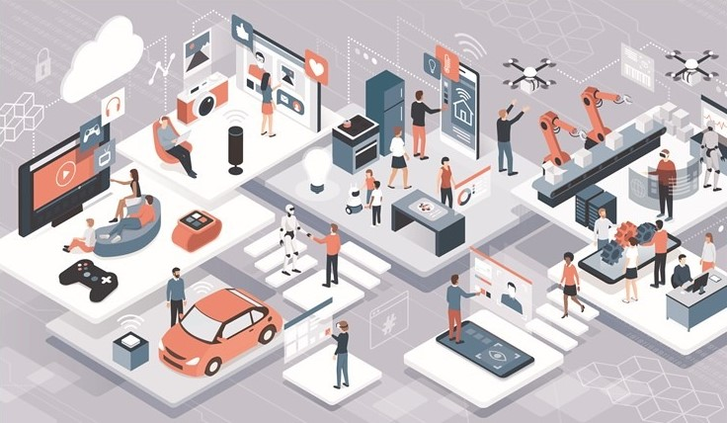

**Created by**

**19IT141 – Tank Parimal Kishorbbhai**

**19IT143 – Tarsariya Darshan Hareshbhai**

**Department : Information Technology**

**College : Chandubhai S Patel Institute of Technology**

**University : CHARUSAT University**

**Abstract**

We present the Complaint management system project. The project provides an offline way to working in any windows system. This project has access for user and admin both. With this project user and administrator can easily coordinate and monitoring the complaints . The complaint management system is technique for create , modify , analyzing and manage the bunch of complaints. Best feature of the complaint management system is the statistics of Dashboard.

**1. Introduction**

The main purpose of this Complaint Management system is focus on the issues for different internal system. This project will help for reduces the communication cost between the staffs and to provide the efficient service. This system which could enhance the day to day activities with efficiency and correctness. Complaint Management System could help for the way of solving the problems faced by the public by saving time and without corruption. Complaint Management System work for many different national groups, for people of different socio-economic classes, different ages and religions, and especially for contract workers and immigrant workers, health care, in faith-based organizations, in schools, in political organizations, in the military and in many specialized occupations.

Complaint Management System is work on three module.

[1] User

[2] Administrator

[3] Dashboard

**2. Objective**

The Objective of Complaint Management System will be easy to communicate , flexible, according to changes , controlling redundancy , less time for the user and administrator. Also the Dashboard provide effective performance of any organization or system. The Dashboard identify and target the problem and monitoring with statistics.

**3. System**

In the first module the user has different features. All features are describe as below.