SUN1 WLC (Wireless LAN Controller)
- Login to SUN1 WLC console using login link https://172.16.250.50/
- Login credential saved in Team pass.
- After login you will get the Monitoring Page
Under Monitoring Go to Wireless Setting WLAN Users Local MAC Addresses add new Mac Address.
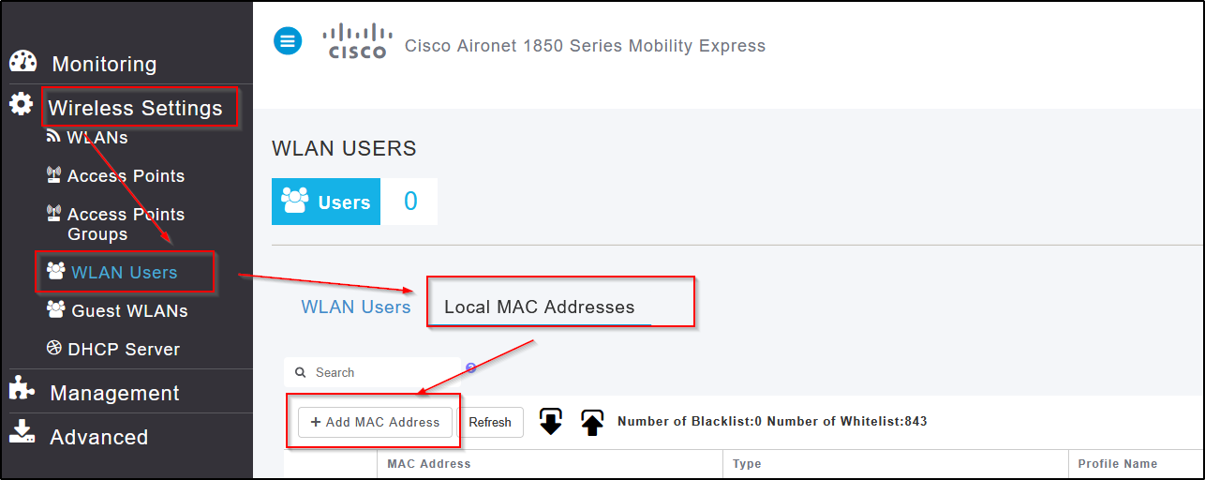
- Adding New Mac Addresses to WLC
Click on Add Mac Address you will get the new Tab to add the Mac Details and Wi-Fi Details
- Mac Address: 00_a1_b2_c3_d4_e5
- Description : Hostname or Device Name
- Type : Whitelist (Default )
- Profile Name : Mentioned the particular Wi-Fi
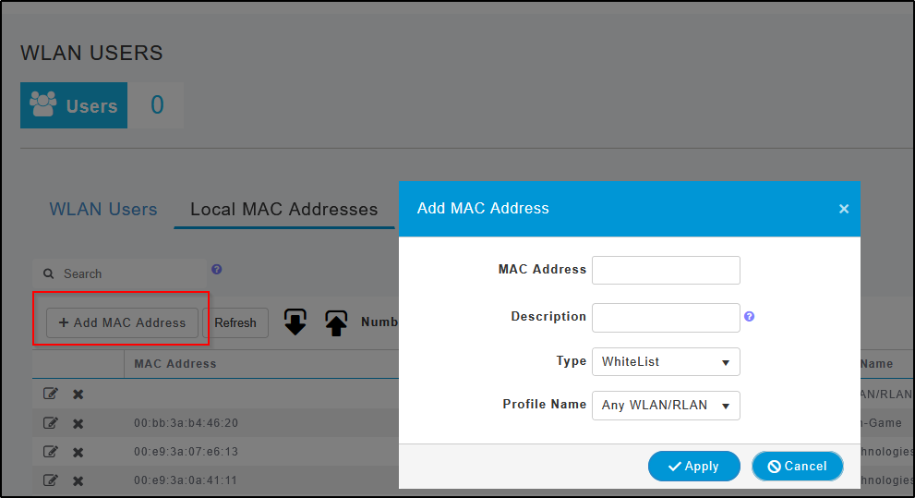

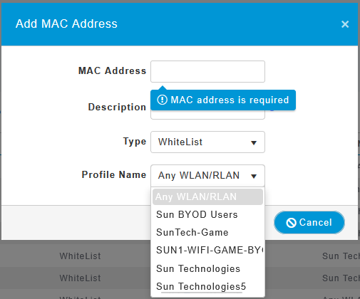
Guest (Temp) Wi-Fi Creation
- Login to SUN1 WLC console using login link https://172.16.250.50/
- Login credential saved in Team pass.
- After login you will get the Dashboard Page
Under Dashboard Go to Wireless Setting WLAN Users WLAN UsersAdd WLAN User.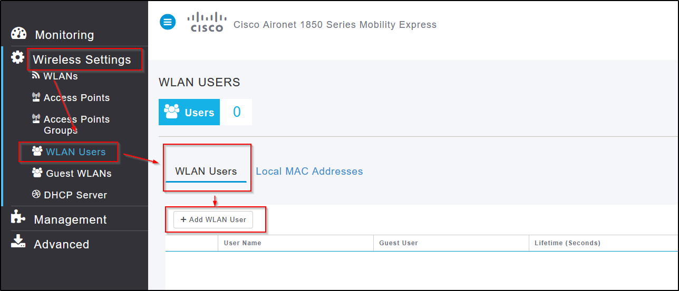
- Click on WLAN Users Add WLAN Users Add the Details
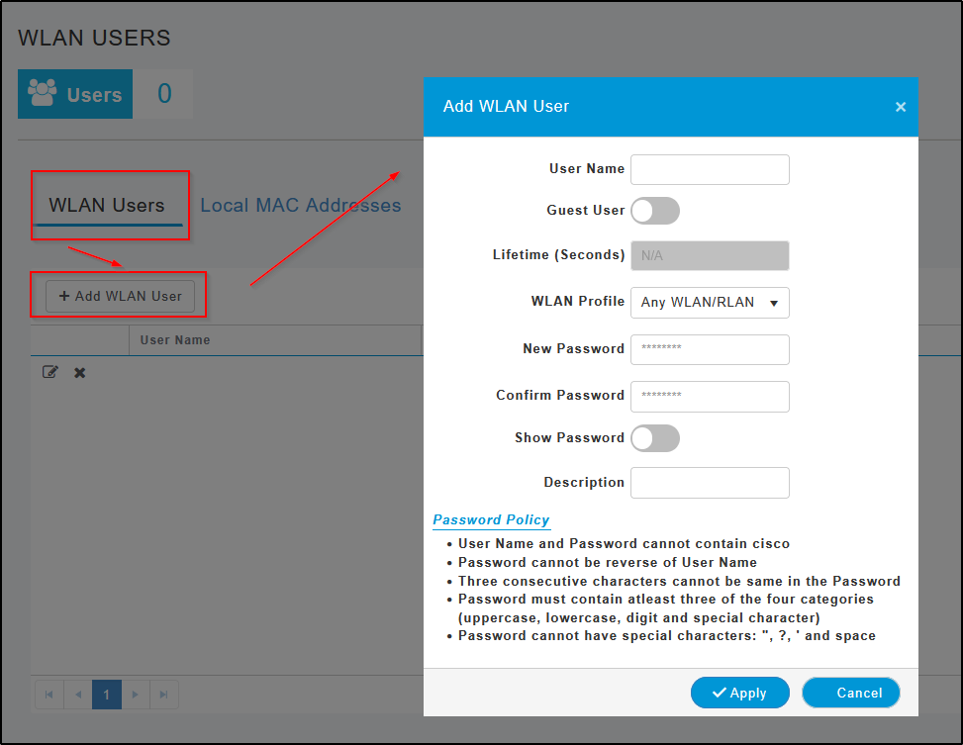
- User Name: Guest_Wi-Fi
- Guest User : Enable
- Lifetime(Sec) : Mentioned the Sec
- WLAN Profile : Sun Technologies Guest
- New Password : Create a password (Password must contain at least three of the four categories uppercase, lowercase, digit and special character)
- Confirm Password: Same password
- Description : Mentioned the Details
SUN3 WLC (Wireless LAN Controller)
- Login to SUN1 WLC console using login link https://172.16.250.56/
- Login credential saved in Team pass.
- After login you will get the Dashboard Page
Under Dashboard Go to Configuration Security AAAAAA AdvancedDevice Authenticationadd
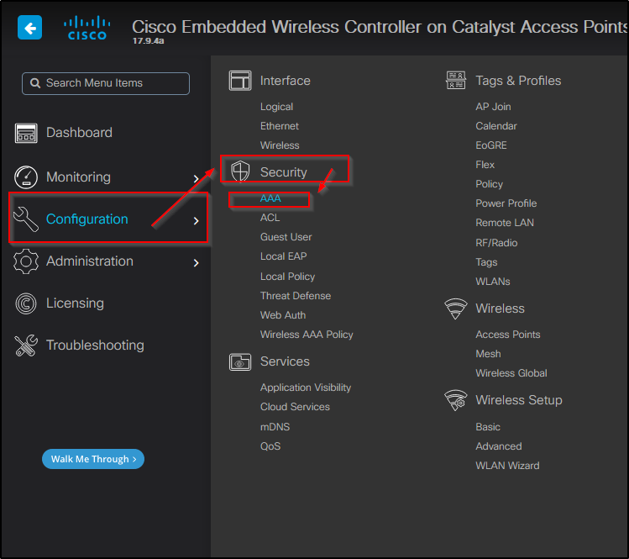
- After that click on AAA Advanced
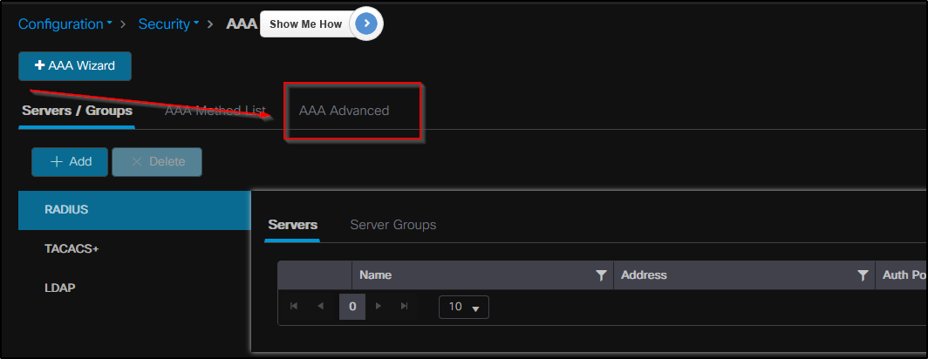

- After that click on Device Authentication
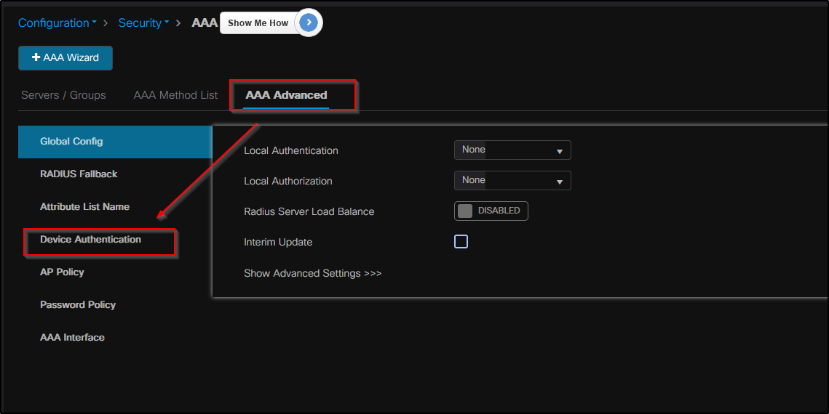
- After Device authentication Add Add the Details
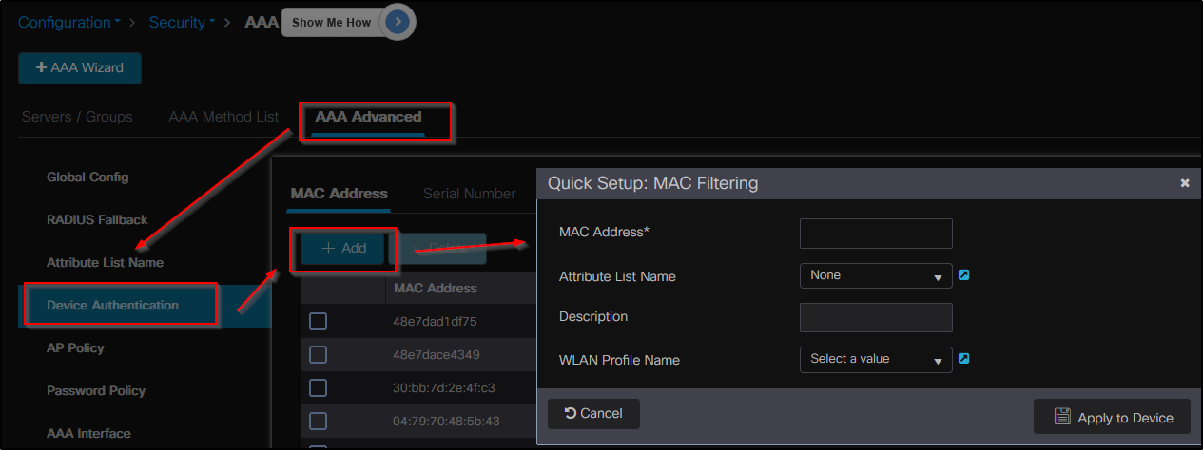

Note:
- SUN1 it Should be on aa:bb:cc:dd:ee:ff
- SUN3 aabbccddeeff (Format)

