Week 3 – 2:

--Coding-C-Language Features-Optional.

ROLL NO.:241501039

Name: Darshan Abinav RK

Q1) Write a program that determines the name of a shape from it's number of sides. Read the

number of sides from the user and then report the appropriate name as part of a

meaningful message. Your program should support shapes with anywhere from 3 up to

(and including) 10 sides. If a number of sides outside of this range is entered then your

program should display an appropriate error message.

Sample Input 1

3

Sample Output 1

Triangle

Sample Input 2

7

Sample Output 2

Heptagon

Sample Input 3

11

Sample Output 3

The number of sides is not supported.

Code:

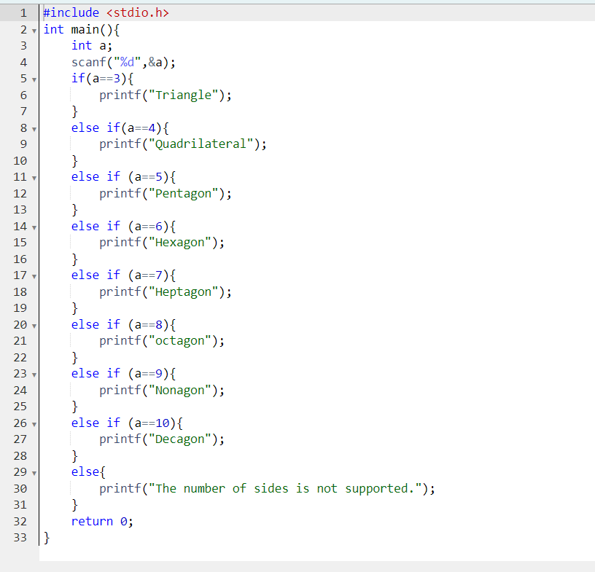

OUTPUT:

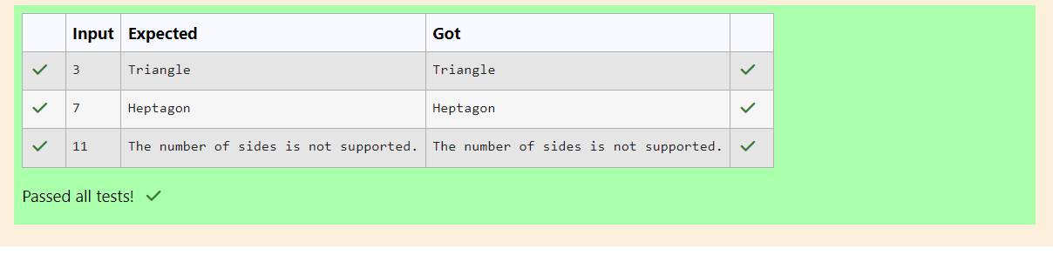

Q2) The Chinese zodiac assigns animals to years in a 12-year cycle. One 12-year cycle is

shown in the table below. The pattern repeats from there, with 2012 being another year of

the Dragon, and 1999 being another year of the Hare.

Year Animal

2000 Dragon

2001 Snake

2002 Horse

2003 Sheep

2004 Monkey

2005 Rooster

2006 Dog

2007 Pig

2008 Rat

2009 Ox

2010 Tiger

2011 Hare

Write a program that reads a year from the user and displays the animal associated with

that year. Your program should work correctly for any year greater than or equal to zero,

not just the ones listed in the table.

Sample Input 1

2004

Sample Output 1

Monkey

Sample Input 2

2010

Sample Output 2

Tiger

Code:

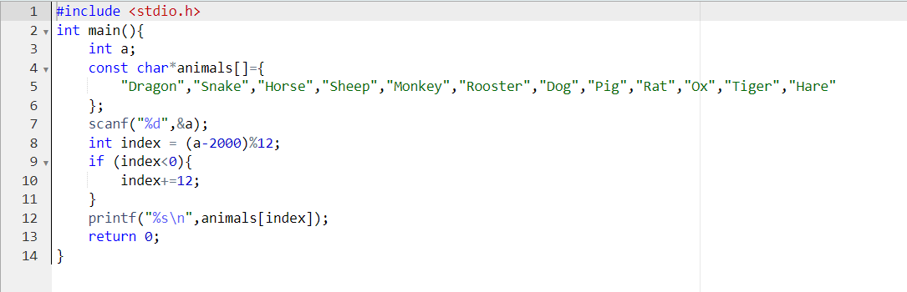

OUTPUT:

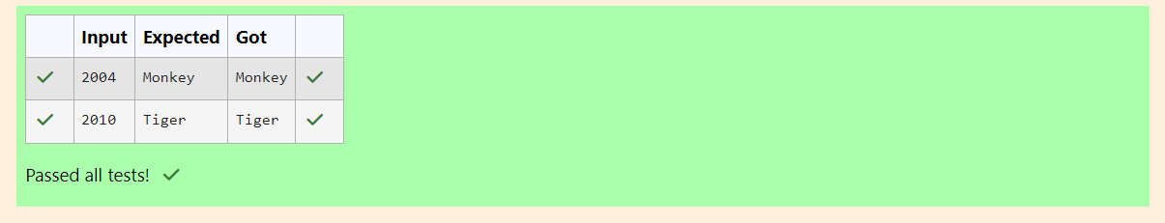

Q3) 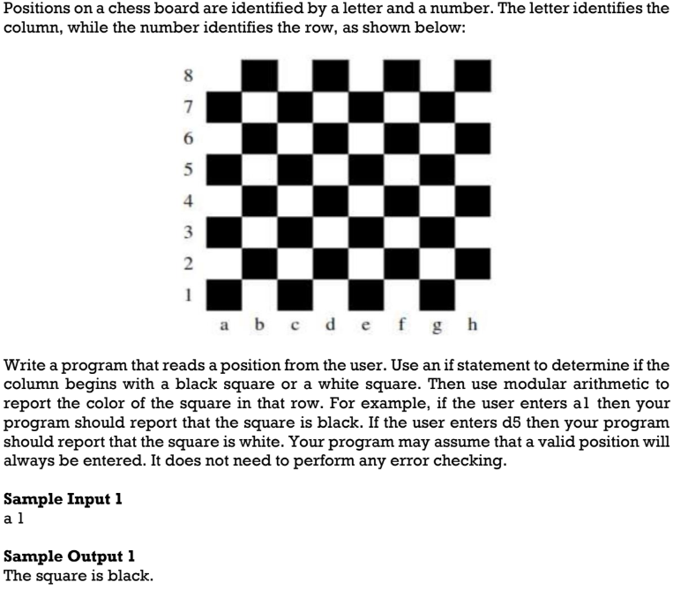

Code:

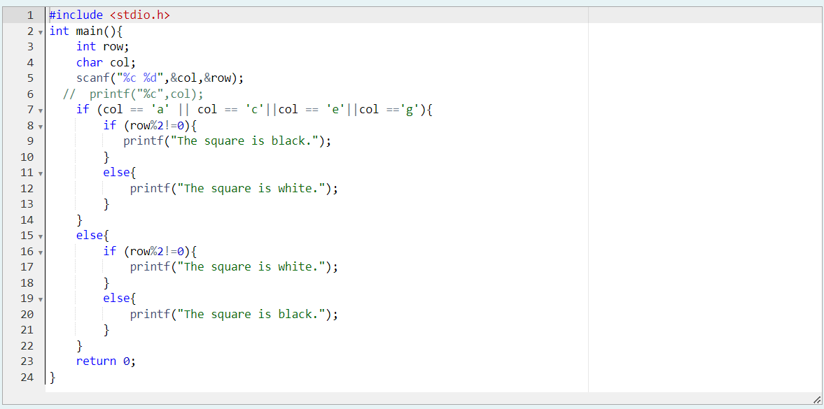

OUTPUT:

