Appendix C — Sign-off

 | Client (DAVKAWT) | Vendor (Creative Mark)
Name | Subhash Singh Thallur | Darshan Choudhari
Designation | Member (Admin Comtt) | Project Head
Signature | Singhthakur | 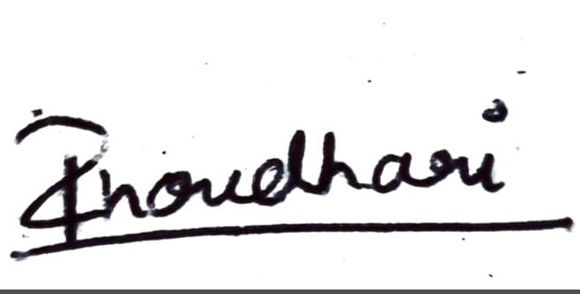
Date | 22/05/26 | 23/05/26

End of Document.

